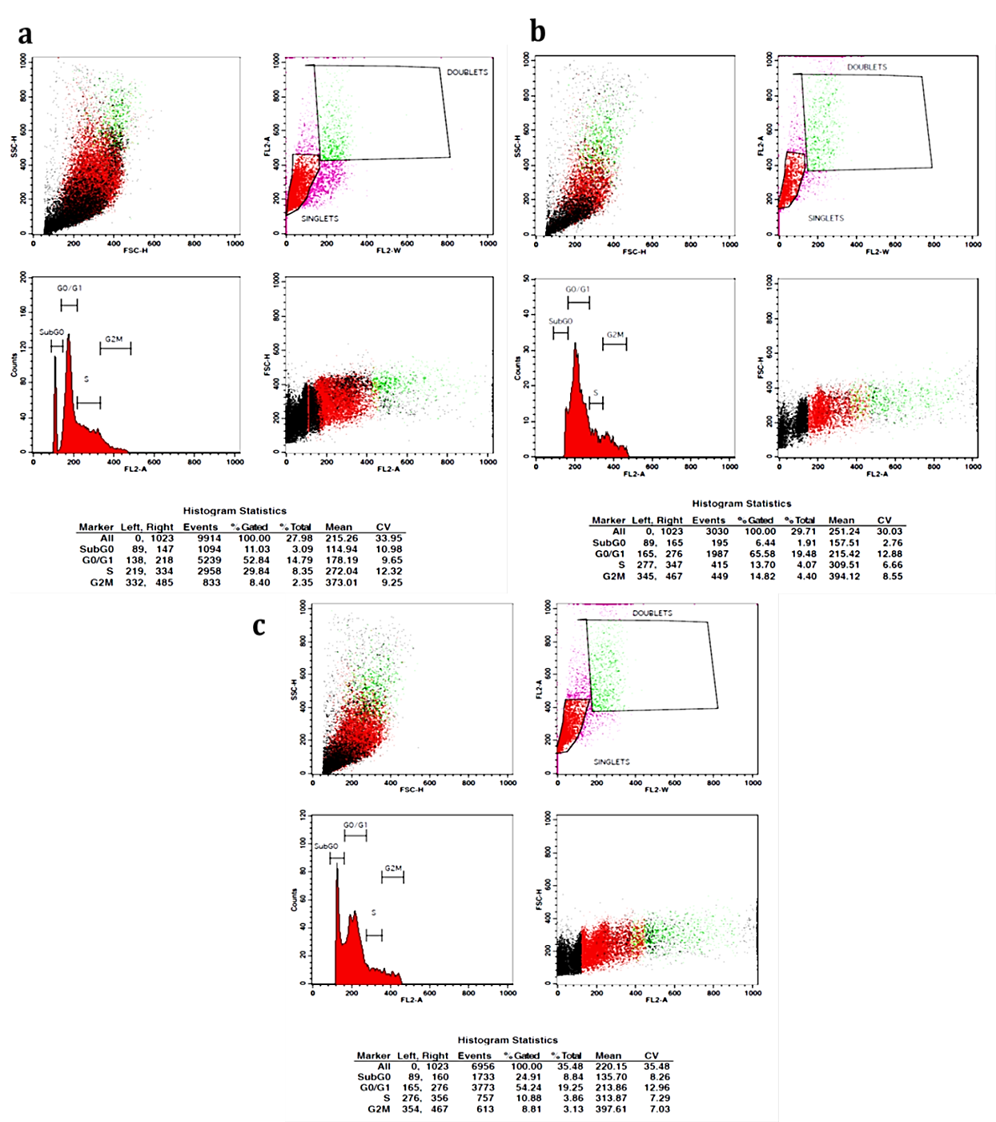

Fig. S1 Cell cycle study of H1975 cells treated with AgNPs by flow cytometry method. a. H1975 untreated cells used as control; b. H1975 cells exposed at 250 µg/ml of AgNPs; c. H1975 cells exposed at 350 µg/ml of AgNPs from A. nilgiricum leaf extract.

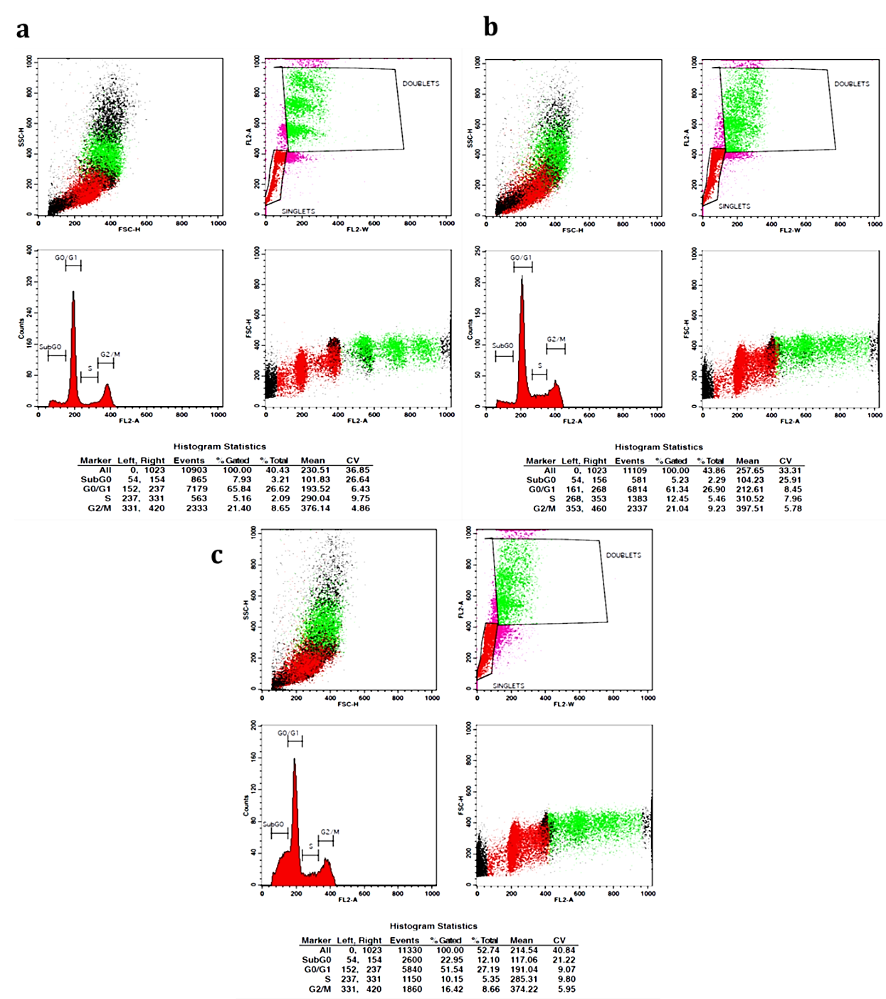

Fig. S2 Cell cycle study of MCF-7 cells treated with AgNPs by flow cytometry method. a. MCF-7 untreated cells used as control; b. MCF-7 cells exposed at 250 µg/ml of AgNPs; c. MCF-7 cells exposed at 350 µg/ml of AgNPs from A. nilgiricum leaf extract.

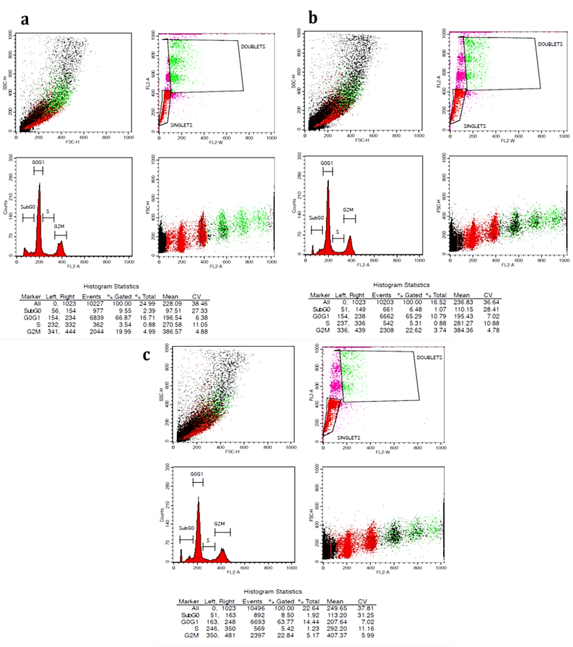

Fig. S3 Cell cycle study of HEP-G2 cell line treated with AgNPs by flow cytometry method. a. HEP-G2 untreated cells used as control; b. HEP-G2 cells exposed at 250 µg/ml of AgNPs; c. HEP-G2 cells exposed at 320 µg/ml of AgNPs from A. nilgiricum leaf extract.

