Supplementary Information
Mechanoreceptive soft robotic molluscoids made of granular hydrogel-based organoelectronics
Antonia Georgopoulou, Nana Obayashi, Francesca Bono, Lorenzo Lucherini, Josie Hughes,
Esther Amstad*

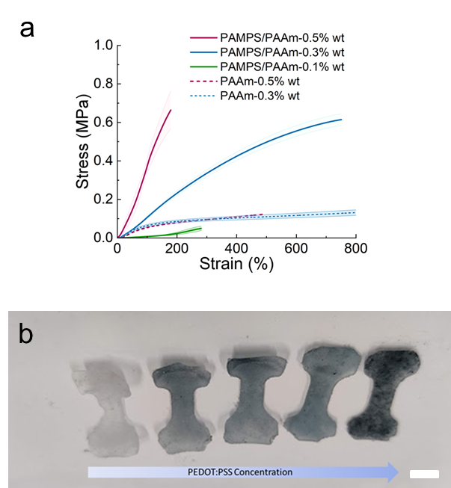
Fig. S1. a) Stress-strain curves of DNGHs (continuous line) and bulk PAAm (dotted line) hydrogels as a function of the MBA concentration used as a crosslinker in the PAAm precursor solution. The MBA crosslinker was 0.1% wt (green), 0.3% wt (blue) and 1.6% wt (magenta) with respect to the AAM monomer b) Photograph of R-DNGHs functionalized in solutions containing 0, 0.027, 0.054, 0.108, 0.215 wt% PEDOT :PSS. All samples have been thermally crosslinked (scale bar 1.6 cm).

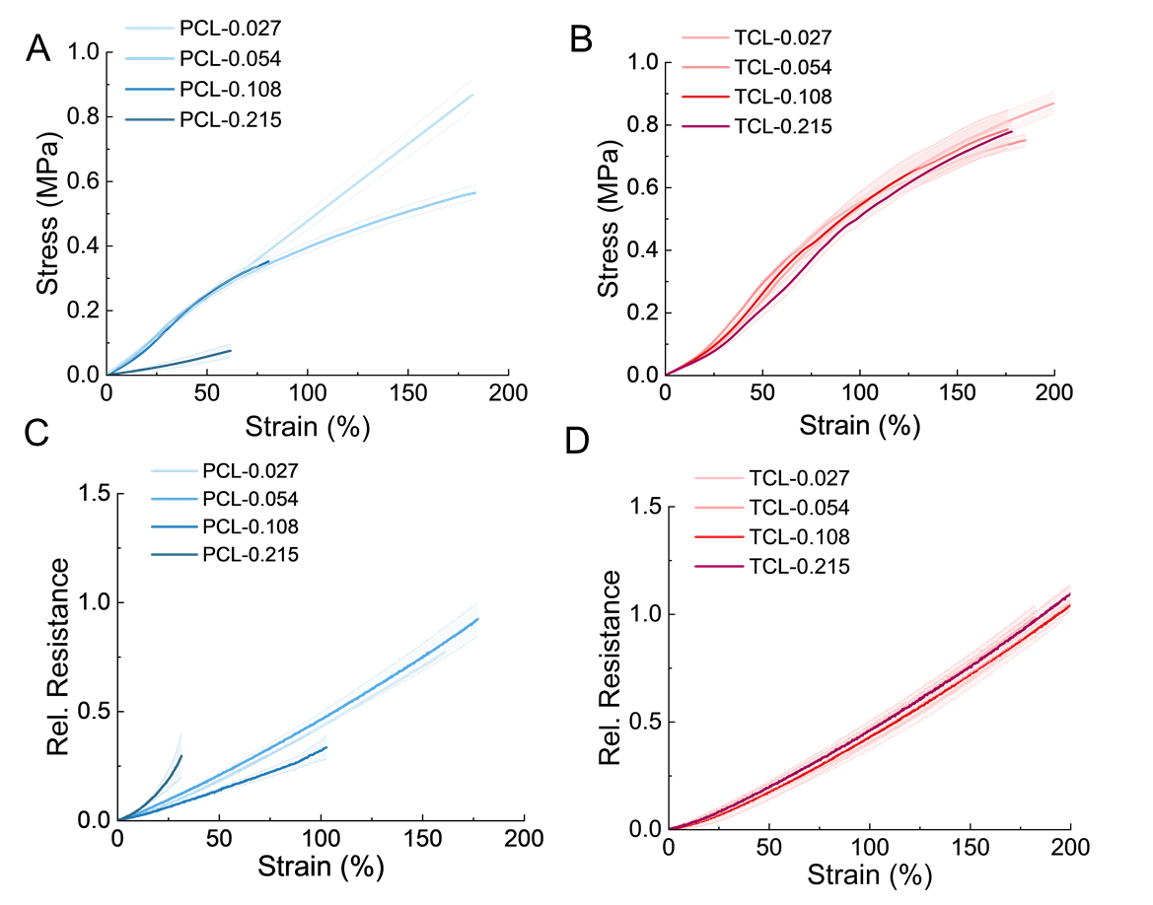
Fig. S2. (A, B) Stress-strain response and (C, D) relative resistance-strain response of R-DNGHs functionalized in solutions containing 0.027 wt%, 0.054 wt%, 0.108 wt% and 0.215wt% PEDOT:PSS The 2nd network was formed through A, C) photocrosslinking (PCL) and B, D) thermal crosslinking (TCL).

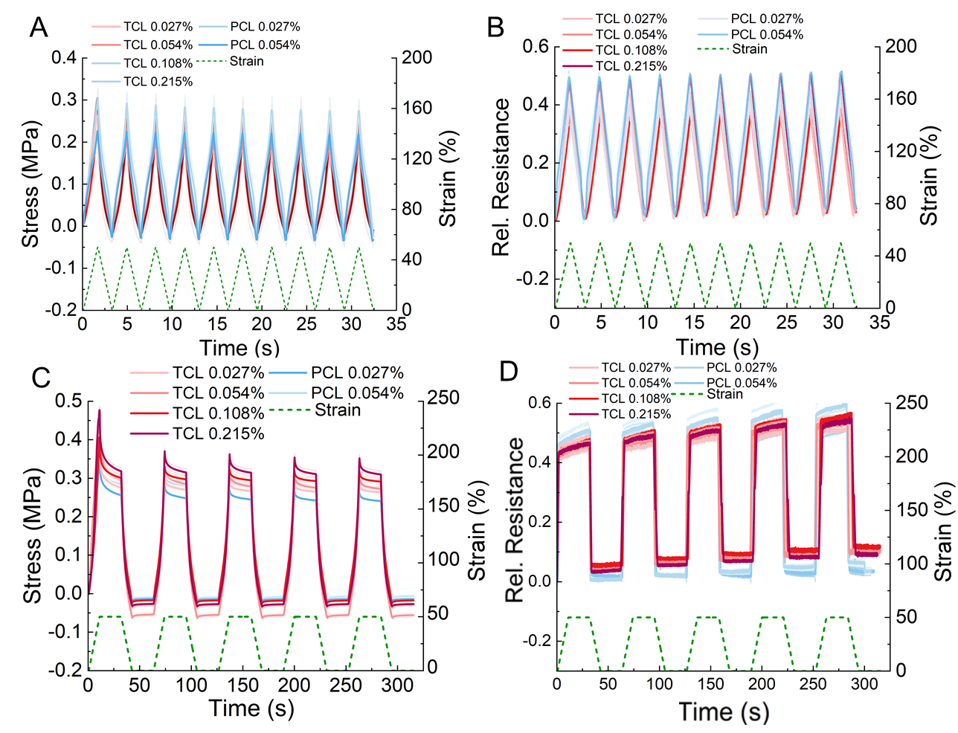
Fig. S3. A) Stress response and B) relative resistance-strain response during a dynamic tensile test with 10 cycles between 0-50% strain performed on R-DNGHs functionalized in solutions containing 0.027 wt%, 0.054 wt%, 0.108 wt% and 0.215wt% PEDOT:PSS. The 2nd network was formed through photocrosslinking (blue) and thermal crosslinking (red). C) Stress response and D) relative resistance-strain response during a quasi-static tensile test with five cycles between 0-50% strain with 10 s dwell time at maximum and minimum strains performed on R-DNGHs having been functionalized in solutions containing 0.027 wt%, 0.054 wt%, 0.108 wt% and 0.215wt% PEDOT :PSS prepared through photocrosslinking (blue) and thermal crosslinking (red).
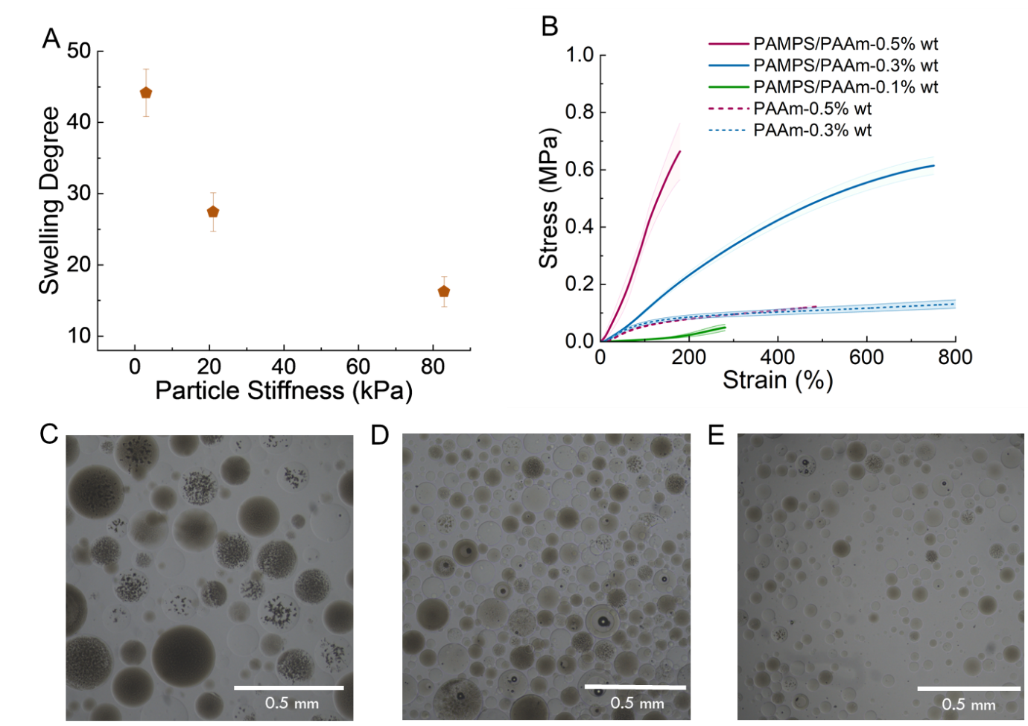
Fig. S4. Swelling of microgels. A) Degree of swelling of microgels, calculated as the percentage difference of the diameter of dry and soaked PAMPS microgels with a stiffness of 3 kPa, 21 kPa and 83 kPa. B) Stress-strain plots for PAMPS/PAAm and PAAm hydrogels without PEDOT:PSS functionalization with different crosslinker concentrations. Optical micrographs of PAMPS microgels with a Young’s modulus of C) 8 kPa (S) D) 21 kPa (M) E) 83 kPa (H).
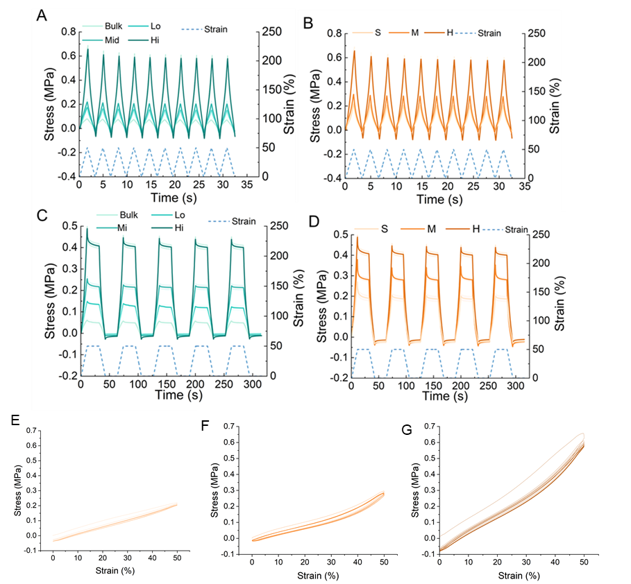
Fig. S5. Stress-time response during a dynamic tensile test with ten cycles between 0-50% strain for A) bulk PAAm and R-DNGHs containing 0.8 (Lo), 1.6 (Mi) and 3.2(Hi) wt.% of stiff microgels and B) containing 3.2 wt% microgels that are soft (S), medium (M) and hard (H). Stress response during a quasi-static tensile test with five cycles between 0-50% strain with 10 s dwell time at maximum and minimum strains for C) bulk PAAm, and R-DNGHs that contain 0.8 (Lo), 1.6 (Mi) and 3.2(Hi) wt.% microgels and D) R-DNGHs containing 3.2 wt% microgels that are soft (S), medium (M) and hard (H). For the investigation of the microgel concentration, R-DNGHs containing 0 (bulk), 0.8 (Lo), 1.6 (Mi) and 3.2(Hi) wt.% stiff particles (83 kPa) were used. Soft microgels possess a Young’s modulus of 3 kPa (S), medium ones 21 kPa (M) and hard ones 83 kPa (H). E, F, G) Stress-strain response of R-DNGHs containing 3.2 wt% microgels with a Young’s modulus of E) 3 kPa (S) F) 21 kPa (M) and G) 83 kPa (H) during the dynamic tensile test with ten cycles between 0-50% strain.

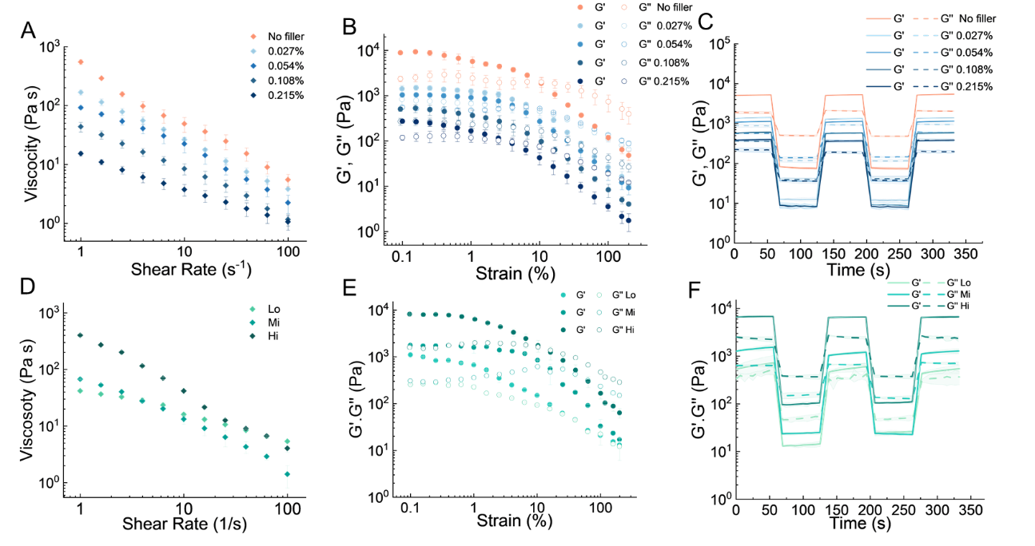
Fig. S6. Rheological characterization of inks composed of 3.2 wt% microgels as a function of the PEDOT:PSS concentration they have been functionalized with. A) Frequency B) amplitude sweeps and C) shear recovery curves. The orange colour symbolizes DNGHs that do not contain any PEDOT:PSS and the darkness of blue increases for increasing concentrations of PEDOT:PSS present in the second network solution. D) Shear thinning E) amplitude sweep and F) shear recovery curves of inks composed of 0.8 wt% (Lo), 1.6 wt%(Mi) and 3.2 wt% (Hi) microgels with a stiffness of 83 kPa. The darkness of green symbolizes the increasing concentration of microgels in the R-DNGH. The PEDOT:PSS concentration in the functionalizing solution is 0.027% wt.
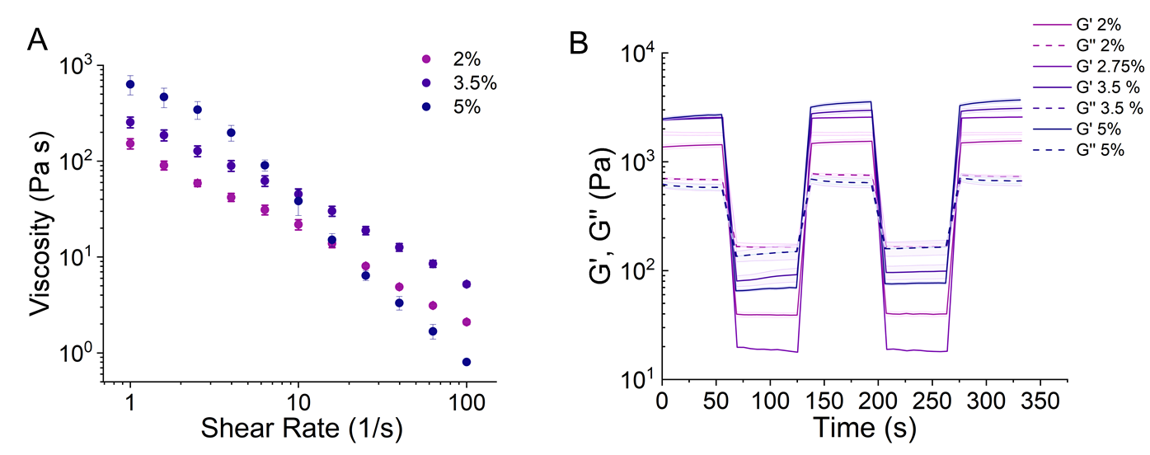
Fig. S7. A) Frequency sweep and B) shear recovery curves of inks composed of PAMPS microgels, as a function of the MBA concentration (from light to dark violet : 2 %, 3.5 % and 5% in molar ratio to AMPS monomer concentration) used to prepare the microgels.
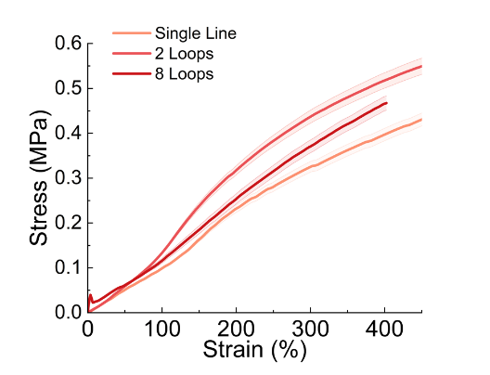
Fig. S8. Stress-strain response of DNGHs composed of middle stiff microgels containing a R-DNGH-based sensor that has been printed as a straight line (orange), 2 zig-zag loops (red), and 8 zig-zag loops (maroon).
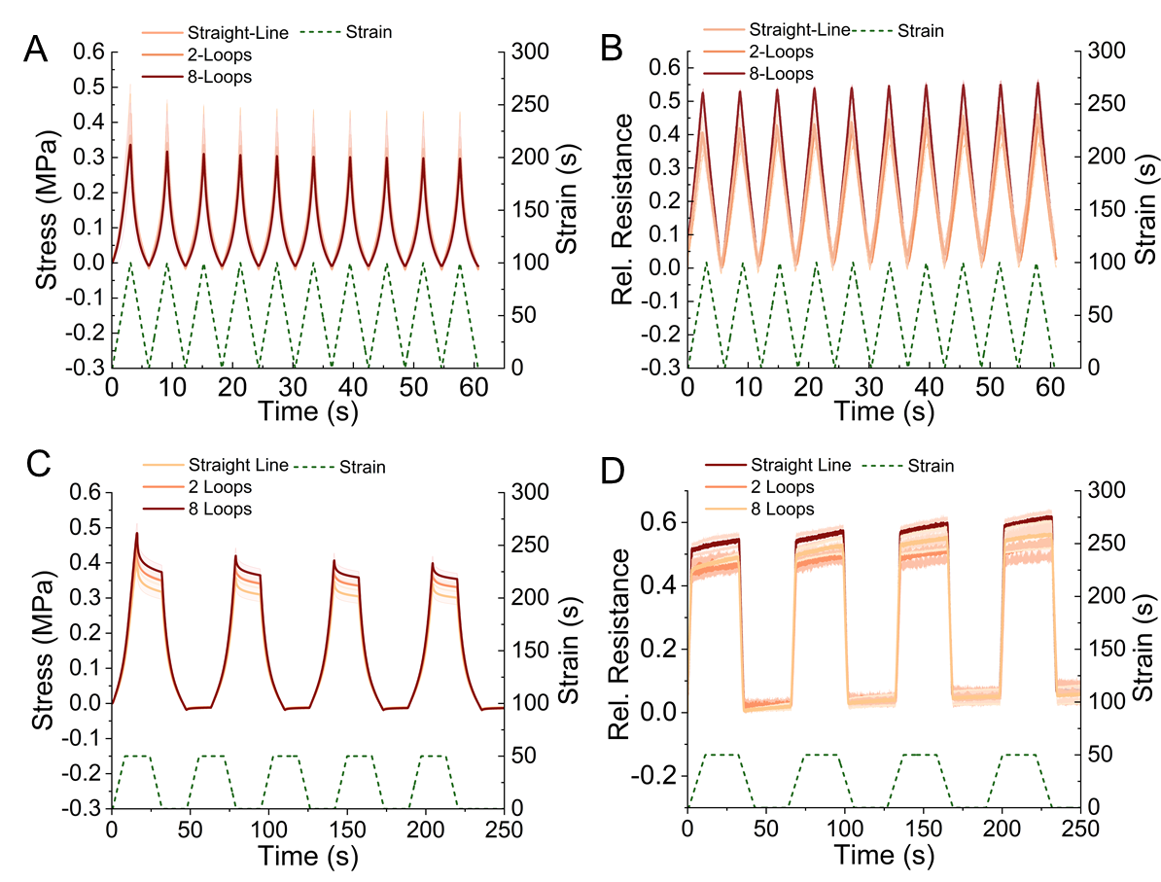
Fig. S9. A) Stress and B) relative resistance-time response during a dynamic tensile test with ten cycles between 0-50% strain and C) stress and D) relative resistance-time response during the quasi-static test of five cycles between 0-50% strain with 30 s hold time at maximum and minimum strains for DNGHs made of middle stiff microgels that contain a R-DNGH-based sensor, which has been 3D printed as a straight line (brown), 2 zig-zag loops (orange), and 8 zig-zag loops (yellow). The R-DNGH consists of 3.2 wt% microgels with a Young’s modulus of 83 kPa. The strain-time curve is shown as the green line.
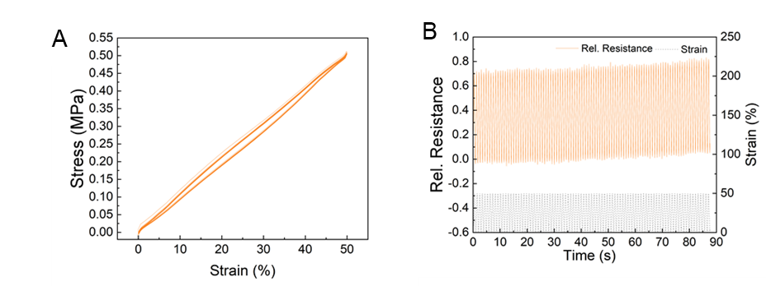
Fig. S10. A) Stress and B) relative resistance-time response during a dynamic tensile test with ten cycles between 0-50% strain. for DNGHs made of middle stiff microgels that contain a R-DNGH-based sensor, which has been 3D printed as 8 zig-zag loops (yellow). The R-DNGH consists of 3.2 wt% microgels with a Young’s modulus of 83 kPa. The strain-time curve is shown as the dotted black line.
Table S1. Shore hardness values of DNGHs containing microgels with a Young’s modulus of 3 kPa (S), medium ones 21 kPa (M) and hard ones 83 kPa (H) ones in high packing density (3.2% wt.)
Microgel Stiffness (kPA) | Shore hardness A of DNGH
3 | 4
21 | 10
83 | 14.5

