Supplemental Materials

Supplementary Table 1 | Clinical trial sites and number of enrolled patients at each site in patients with consensus and forced adjudication of the infection status and in those evaluable for the prognostic endpoint
 | Consensus Adjudication  (N=729) | Forced Adjudication  (N=1,222) | Prognostic Population  (N=1,120)
Site, n (%)
101 - Baystate Medical Center | 62 (8.5%) | 90 (7.4%) | 83 (7.4%)
102 - Texas Tech University Health Sciences Center - El Paso | 55 (7.5%) | 69 (5.6%) | 67 (6.0%)
103 - University of Kentucky | 45 (6.2%) | 72 (5.9%) | 72 (6.4%)
104 - Henry Ford Hospital | 31 (4.3%) | 46 (3.8%) | 44 (3.9%)
105 - University of Pittsburgh | 41 (5.6%) | 78 (6.4%) | 61 (5.4%)
106 - University of Iowa | 97 (13.3%) | 168 (13.7%) | 153 (13.7%)
107 - Emory University | 6 (0.8%) | 11 (0.9%) | 5 (0.4%)
108 - University of Southern California | 8 (1.1%) | 14 (1.1%) | 14 (1.3%)
109 - Medical College of Wisconsin | 50 (6.9%) | 87 (7.1%) | 83 (7.4%)
110 - Hackensack Meridian Health | 2 (0.3%) | 2 (0.2%) | 2 (0.2%)
111 - MedStar Health Research Institute | 11 (1.5%) | 16 (1.3%) | 15 (1.3%)
112 - Johns Hopkins Hospital | 43 (5.9%) | 83 (6.8%) | 74 (6.6%)
113 - Mayo Clinic - Rochester | 75 (10.3%) | 124 (10.1%) | 118 (10.5%)
114 - Washington University | 50 (6.9%) | 92 (7.5%) | 83 (7.4%)
115 - Vanderbilt University Medical Center | 3 (0.4%) | 3 (0.2%) | 3 (0.3%)
117 - University of South Alabama | 1 (0.1%) | 1 (0.1%) | 0 (0.0%)
118 - University of Athens -Greece | 4 (0.5%) | 14 (1.1%) | 14 (1.3%)
119 - University of California Davis Medical Center | 14 (1.9%) | 33 (2.7%) | 31 (2.8%)
120 - Cleveland Clinic | 24 (3.3%) | 41 (3.4%) | 37 (3.3%)
121 - University of Florida (UF) - Jacksonville | 92 (12.6%) | 147 (12.0%) | 133 (11.9%)
125 - Geisinger Health | 5 (0.7%) | 9 (0.7%) | 8 (0.7%)
135 – Beth Israel Deaconess Medical Center | 10 (1.4%) | 22 (1.8%) | 20 (1.8%)

Supplementary Table 2 | Infection status and accuracy of the TriVerity test in patient with forced adjudication. a, infection status and anatomical localization of bacterial and viral infections. b, accuracy of the TriVerity Test for the diagnosis of bacterial infection; c, accuracy of the TriVerity test for the diagnosis of viral infections

a
 | Type of Infection/  Anatomical Location of Infection² | % (n/N)
Type of Infection | Bacterial Infection | 58.1% (710/1222)
 | Viral Infection | 20.0% (244/1222)
 | Viral-Bacterial Coinfection | 2.5% (31/1222)
 | Noninfected | 19.4% (237/1222)
Bacterial Infection¹ | Blood | 14.0% (104/741)
 | Central Nervous System | 0.4% (3/741)
 | Gastrointestinal Tract | 13.5% (100/741)
 | Joint | 1.2% (9/741)
 | Respiratory Tract | 16.7% (124/741)
 | Skin or Soft Tissue | 33.3% (247/741)
 | Urinary Tract | 26.9% (199/741)
 | Unknown/ Other | 19.2% (142/741)
Viral Infection¹ | Blood | 0.4% (1/275)
 | Central Nervous System | 1.8% (5/275)
 | Gastrointestinal Tract | 8.7% (24/275)
 | Respiratory Tract | 85.1% (234/275)
 | Skin or Soft Tissue | 2.2% (6/275)
 | Unknown/ Other | 7.3% (20/275)
¹ Participants may have multiple sources.
² Anatomical location of infection was determined by clinical adjudicators after review of
the clinical adjudication report.

b
TriVerity Bacterial  Band | Clinically Adjudicated Bacterial Infection |  | Sensitivity  (%) | Specificity  (%) | Likeli-hood Ratio  (80% CI) | Relative Frequency of Result  (% in Band) | Probability of Bacterial Infection (%)
TriVerity Bacterial  Band | Yes  (N) | No  (N)
Very high | 226 | 28 | 30.5 | 94.2 | 5.24  (4.16–6.52) | 20.8 | 89.0
High | 184 | 61 | 24.8 | 87.3 | 1.96  (1.63–2.35) | 20 | 75.1
Moderate | 142 | 97 | 19.2 | 79.8 | 0.95  (0.84–1.11) | 19.6 | 59.4
Low | 157 | 167 | 78.8 | 34.7 | 0.61  (0.52–0.67) | 26.5 | 48.5
Very low | 32 | 128 | 95.7 | 26.6 | 0.16  (0.13–0.20) | 13.1 | 20.0

c
TriVerity Viral  Band | Clinically Adjudicated Viral  Infection |  | Sensitivity  (%) | Specificity  (%) | Likeli-hood Ratio  (80% CI) | Relative Frequency of Result  (% in Band) | Probability of Viral Infection (%)
TriVerity Viral  Band | Yes  (N) | No  (N)
Very high | 128 | 22 | 46.5 | 97.7 | 20.04  (16.00–26.31) | 12.3 | 85.3
High | 35 | 59 | 12.7 | 93.8 | 2.04  (1.50 - 2.65) | 7.7 | 37.2
Moderate | 40 | 144 | 14.5 | 84.8 | 0.96  (0.77–1.26) | 15.1 | 21.7
Low | 41 | 295 | 85.1 | 31.2 | 0.48  (0.37–0.56) | 27.5 | 12.2
Very low | 31 | 427 | 88.7 | 45.1 | 0.25  (0.20–0.31) | 37.5 | 6.8

Supplementary Table 3 | Results of laboratory tests in participants at the time of enrollment.
a, white blood cell counts or percentages; b, C-reactive protein, procalcitonin and lactate concentrations
a
White Blood Cell Counts | Diagnostic Population: Consensus  (N=729) | Diagnostic Population:  Forced  (N=1,222) | Prognostic  Population  (N=1,120)
Eosinophils (%)
N | 653 | 1087 | 995
Mean (SD) | 0.8 (1.26) | 1.0 (1.68) | 1.0 (1.72)
Median (Range) | 0.3 (0.0, 10.0) | 0.4 (0.0, 24.0) | 0.4 (0.0, 24.0)
Leukocytes (10⁹/L)
N | 709 | 1179 | 1081
Mean (SD) | 11.8 (6.19) | 11.7 (6.06) | 11.7 (6.07)
Median (Range) | 10.9 (0.7, 41.4) | 10.7 (0.7, 41.4) | 10.7 (0.7, 41.4)
Lymphocytes (%)
N | 689 | 1140 | 1046
Mean (SD) | 12.5 (9.26) | 13.7 (10.21) | 13.5 (10.21)
Median (Range) | 10.0 (0.0, 53.7) | 11.1 (0.0, 72.0) | 11.0 (0.0, 72.0)
Monocytes (%)
N | 688 | 1139 | 1045
Mean (SD) | 7.3 (3.84) | 7.6 (4.47) | 7.6 (4.56)
Median (Range) | 7.0 (0.0, 44.9) | 7.0 (0.0, 60.9) | 7.0 (0.0, 60.9)
Neutrophils (%)
N | 687 | 1138 | 1045
Mean (SD) | 76.9 (12.91) | 75.7 (13.60) | 75.8 (13.76)
Median (Range) | 79.2 (3.0, 98.2) | 78.0 (3.0, 98.2) | 78.0 (3.0, 98.2)
Neutrophils Bands (%)
N | 138 | 192 | 183
Mean (SD) | 6.6 (12.13) | 6.2 (12.10) | 6.0 (11.90)
Median (Range) | 1.1 (0.0, 92.0) | 1.0 (0.0, 92.0) | 1.0 (0.0, 92.0)
b
C-Reactive Protein, Procalcitonin and Lactate Concentrations | Diagnostic Population: Consensus  (N=729) | Diagnostic Population:  Forced  (N=1222) | Prognostic Population  (N=1120)
C-Reactive Protein (mg/dL)
N | 714 | 1200 | 1100
Mean (SD) | 10.3 (10.39) | 8.9 (9.65) | 9.1 (9.70)
Median (Range) | 6.7 (0.2, 49.4) | 5.3 (0.1, 49.4) | 5.4 (0.1, 49.4)
Procalcitonin (ng/mL)
N | 711 | 1186 | 1091
Mean (SD) | 4.6 (16.69) | 3.0 (13.14) | 3.2 (13.55)
Median (Range) | 0.2 (0.0, 238.4) | 0.2 (0.0, 238.4) | 0.2 (0.0, 238.4)
Lactate (mmol/L)
N | 702 | 1155 | 1058
Mean (SD) | 1.8 (1.51) | 1.9 (1.61) | 1.9 (1.66)
Median (Range) | 1.4 (0.4, 16.0) | 1.5 (0.4, 16.0) | 1.4 (0.4, 16.0)

Supplementary Table 4 | Healthcare utilization by patient population
 | Consensus Adjudication  (N=729) | Forced Adjudication  (N=1,222) | Prognostic  Population  (N=1,120)
Discharged to Home, n (%) | 171 (23.5%) | 333 (27.3%) | 286 (25.5%)
Admitted to Ward, n (%) | 417 (57.2%) | 662 (54.2%) | 615 (54.9%)
Admitted to ICU, n (%) | 98 (13.4%) | 158 (12.9%) | 155 (13.8%)
Admitted to Telemetry/Observation/Step Down Unit, n (%) | 79 (10.8%) | 123 (10.1%) | 117 (10.4%)
Transferred Out of Hospital to Another Facility, n (%) | 8 (1.1%) | 12 (1.0%) | 12 (1.1%)
Other, n (%) | 2 (0.3%) | 4 (0.3%) | 3 (0.3%)
Length of ED Stay (hours), n (%)
Less than 1 hour | 1 (0.1%) | 4 (0.3%) | 3 (0.3%)
1-5 hours | 240 (32.9%) | 415 (34.0%) | 386 (34.5%)
6-24 hours | 430 (59.0%) | 695 (56.9%) | 634 (56.6%)
25-48 hours | 44 (6.0%) | 84 (6.9%) | 75 (6.7%)
49-72 hours | 14 (1.9%) | 24 (2.0%) | 22 (2.0%)
Length of ICU Stay (days)
N | 95 | 154 | 151
Mean (SD) | 5.7 (6.42) | 6.0 (6.67) | 6.1 (6.71)
Median (Range) | 3.0 (0.0, 28.0) | 4.0 (0.0, 28.0) | 4.0 (0.0, 28.0)
Length of Hospital Stay (days)
N | 632 | 1029 | 958
Mean (SD) | 6.3 (6.40) | 6.0 (6.36) | 6.3 (6.51)
Median (Range) | 4.0 (1.0, 29.0) | 4.0 (1.0, 29.0) | 4.0 (1.0, 29.0)

Supplementary Table 5 | Clinical outcomes
Clinical Outcome | Total¹ | Viral Infection | Bacterial Infection | Viral- Bacterial Coinfection | Non-infected
 | N=1,120  n (%) | N=220  n (%) | N=658  n (%) | N=30  n (%) | N=212  n (%)
“ICU-level care”² (Primary Severity Endpoint)
Need for Mechanical Ventilation, Vasopressor Use, and/or Renal Replacement Therapy within 7 days | 122 (10.89%) | 8 (3.64%) | 89 (13.53%) | 10 (33.33%) | 15 (7.08%)
Mechanical Ventilation | 63 (51.64%) | 3 (37.50%) | 48 (53.93%) | 5 (50.00%) | 7 (46.67%)
Renal Replacement Therapy | 23 (18.85%) | 2 (25.00%) | 15 (16.85%) | 1 (10.00%) | 5 (33.33%)
Vasopressor Use | 99 (81.15%) | 5 (62.50%) | 74 (83.15%) | 9 (90.00%) | 11 (73.33%)
Overall Intensive Care Unit Use
ICU Admission With or Without Mechanical Ventilation, Vasopressor Use, and/or Renal Replacement Therapy | 147 (13.13%) | 13 (5.91%) | 102 (15.50%) | 9 (30.00%) | 23 (10.85%)
ICU Admission With Mechanical Ventilation, Vasopressor Use, and/or Renal Replacement Therapy | 98 (66.67%) | 6 (46.15%) | 71 (69.61%) | 8 (88.89%) | 13 (56.52%)
ICU Admission Without Mechanical Ventilation, Vasopressor Use, and/or Renal Replacement Therapy | 49 (33.33%) | 7 (53.85%) | 31 (30.39%) | 1 (11.11%) | 10 (43.48%)
¹ Results shown are for the prognostic population (n=1,120)
² Defined as the need for mechanical ventilation, vasopressor use, and/or renal replacement therapy

Supplementary Table 6 | AUROC of the TriVerity bacterial result for the diagnosis of bacterial infections compared to commonly used biomarkers. A, Overall AUROC and 80% CI of the TriVerity bacterial results vs. C-reactive protein, procalcitonin and white blood cell count. B, Comparison of AUROC of TriVerity bacterial result vs. procalcitonin across different races
a
Test/Biomarker | N | AUROC¹  80% CI  (Lower - Upper) | p-value
TriVerity  Bacterial score  C-reactive Protein | 649 | 0.83(0.80 – 0.87) | <0.0001
TriVerity  Bacterial score  C-reactive Protein | 649 | 0.72(0.68 - 0.77) | <0.0001
TriVerity  Bacterial score  Procalcitonin | 655 | 0.83(0.79 – 0.86) | <0.0001
TriVerity  Bacterial score  Procalcitonin | 655 | 0.69(0.65 – 0.72) | <0.0001
TriVerity  Bacterial score  White Blood Cell Count | 686 | 0.82(0.79 - 0.85) | <0.0001
TriVerity  Bacterial score  White Blood Cell Count | 686 | 0.75 (0.72 – 0.79) | <0.0001

b
Race | N | AUROC¹  80% CI  (lower – upper)
Race | N | TriVerity Bacterial Result | Procalcitonin | p-value
Black/African American | 196 | 0.83  (0.79 - 0.86) | 0.63  (0.58 - 0.68) | <0.0001
White | 419 | 0.82  (0.79 - 0.84) | 0.74  (0.70 - 0.77) | 0.001
Other¹ | 40 | 0.92  (0.87 - 0.97) | 0.57  (0.42 - 0.68) | <0.0001
¹ using consensus adjudication as the reference standard

Supplementary Table 7 | Accuracy of bacterial (a) and viral (b) TriVerity results stratified by patient immune status

a
Clinically Adjudicated
Bacterial Infection
Population | TriVerity Bacterial Band | Yes  n (%) | No  n (%) | Likelihood Ratio  (80% CI) | AUROC  (80% CI)
Immunosuppressed Patients | Very high | 42 (93.33%) | 3 (6.67%) | 5.87  (3.67-18.03) | 0.80  (0.75-0.85)
Immunosuppressed Patients | High | 17 (70.83%) | 7 (29.17%) | 1.02  (0.64-1.90) | 0.80  (0.75-0.85)
Immunosuppressed Patients | Moderate | 18 (75.00%) | 6 (25.00%) | 1.26  (0.71-2.41) | 0.80  (0.75-0.85)
Immunosuppressed Patients | Low | 13 (54.17%) | 11 (45.83%) | 0.5  (0.30-0.81) | 0.80  (0.75-0.85)
Immunosuppressed Patients | Very low | 3 (20.00%) | 12 (80.00%) | 0.10  (0.04-0.23) | 0.80  (0.75-0.85)
Immunocompetent Patients | Very high | 123 (93.18%) | 9 (6.82%) | 8.56  (5.71-13.32) | 0.83  (0.81-0.85)
Immunocompetent Patients | High | 90 (83.33%) | 18 (16.67%) | 3.13  (2.35-4.38) | 0.83  (0.81-0.85)
Immunocompetent Patients | Moderate | 72 (64.29%) | 40 (35.71%) | 1.13  (0.91-1.46) | 0.83  (0.81-0.85)
Immunocompetent Patients | Low | 72 (47.06%) | 81 (52.94%) | 0.56  (0.47-0.65) | 0.83  (0.81-0.85)
Immunocompetent Patients | Very low | 10 (10.87%) | 82 (89.13%) | 0.08  (0.05-0.11) | 0.83  (0.81-0.85)

b
Clinically Adjudicated
Viral Infection
Population | TriVerity  Viral Band | Yes  n (%) |  | No  n (%) |  | Likelihood Ratio  (80% CI) |  | AUROC  (80% CI)
Immunosuppressed Cohort | Very high | 14 (87.50%) |  | 2 (12.50%) |  | 29.96  (14.53-76.65) |  | 0.89  (0.86-0.95)
Immunosuppressed Cohort | High | 4 (40.00%) |  | 6 (60.00%) |  | 2.85  (1.11-5.65)
Immunosuppressed Cohort | Moderate | 2 (10.53%) |  | 17 (89.47%) |  | 0.5  (0-0.97)
Immunosuppressed Cohort | Low | 3 (9.38%) |  | 29 (90.63%) |  | 0.44  (0.20-0.76)
Immunosuppressed Cohort | Very low | 2 (3.64%) |  | 53 (96.36%) |  | 0.16  (0-0.31)
Immunocompetent Cohort | Very high | 91 (93.81%) |  | 6 (6.19%) |  | 44.4  (26.68-101.10) |  | 0.91  (0.89-0.94)
Immunocompetent Cohort | High | 21 (43.75%) |  | 27 (56.25%) |  | 2.28  (1.69-3.07)
Immunocompetent Cohort | Moderate | 20 (24.39%) |  | 62 (75.61%) |  | 0.94  (0.71-1.27)
Immunocompetent Cohort | Low | 14 (9.27%) |  | 137 (90.73%) |  | 0.3  (0.19-0.38)
Immunocompetent Cohort | Very low | 6 (2.74%) |  | 213 (97.26%) |  | 0.08  (0.04-0.13)

Supplementary Table 8 | Accuracy of Different Lactate Concentration Ranges for the Prediction of Need for Mechanical Ventilation, Vasopressors, and/or RRT Within 7-Days of Presentation in the Emergency Department. a, Accuracy for Different Lactate Concentration Ranges, b, Sensitivity Compared to TriVerity Illness Severity

a
 | Need for Mechanical Ventilation, Vasopressors, and/or RRT Within 7 Days
Lactate Concentration  Band | Yes  (N) | No  (N) | Sensitivity  (%) | Specificity  (%) | Likelihood Ratio | Relative Frequency  of Result  (% in Band)
> 4 ng/ml | 32 | 39 | 26.7 | 95.8 | 6.41  (4.77 - 8.49) | 6.7
2-4 ng/ml | 48 | 165 | 40 | 82.4 | 2.27  (1.85 - 2.77) | 20.1
< 2 ng/ml | 40 | 734 | 66.7 | 78.3 | 0.43  (0.34 - 0.49) | 73.2

b
 |  | “ICU-Level-Care”¹ |  | No “ICU-Level-Care”¹
 |  | Lactate Concentration (ng/ml) ²
 |  | >4 | <2 | >4 | <2
TriVerity Severity Result³ | Very high | 9 | 3 | 4 | 5
TriVerity Severity Result³ | High | 10 | 13 | 14 | 81
TriVerity Severity Result³ | Low | 3 | 6 | 4 | 227
TriVerity Severity Result³ | Very low | 1 | 4 | 9 | 292
¹ “ICU-level care”: Need for mechanical ventilation, vasopressors and/or renal-replacement therapy within 7 days of
presentation in the emergency department
² Lactate results displayed without the middle range from 2-4 ng/ml
³ TriVerity result displayed without the moderate interpretation band

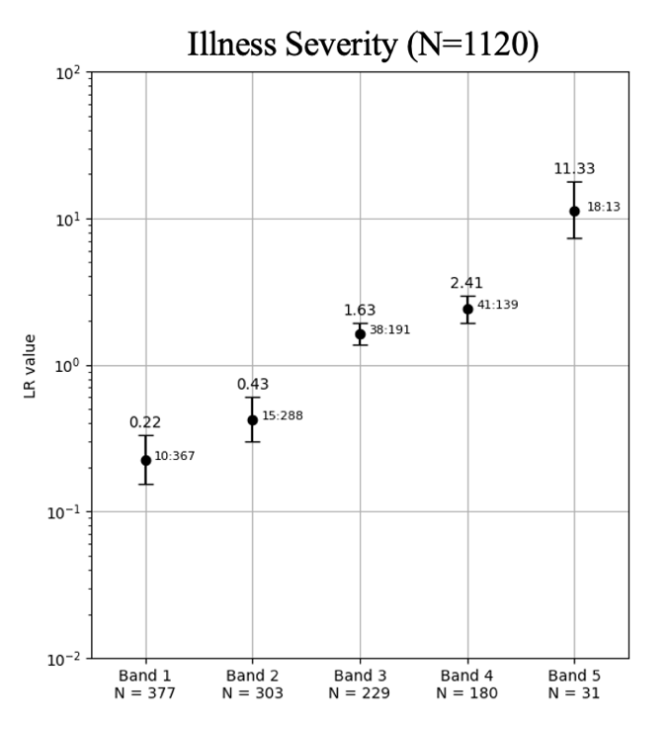
Supplementary Fig. 1 | Likelihood ratios by TriVerity interpretation band for
illness severity

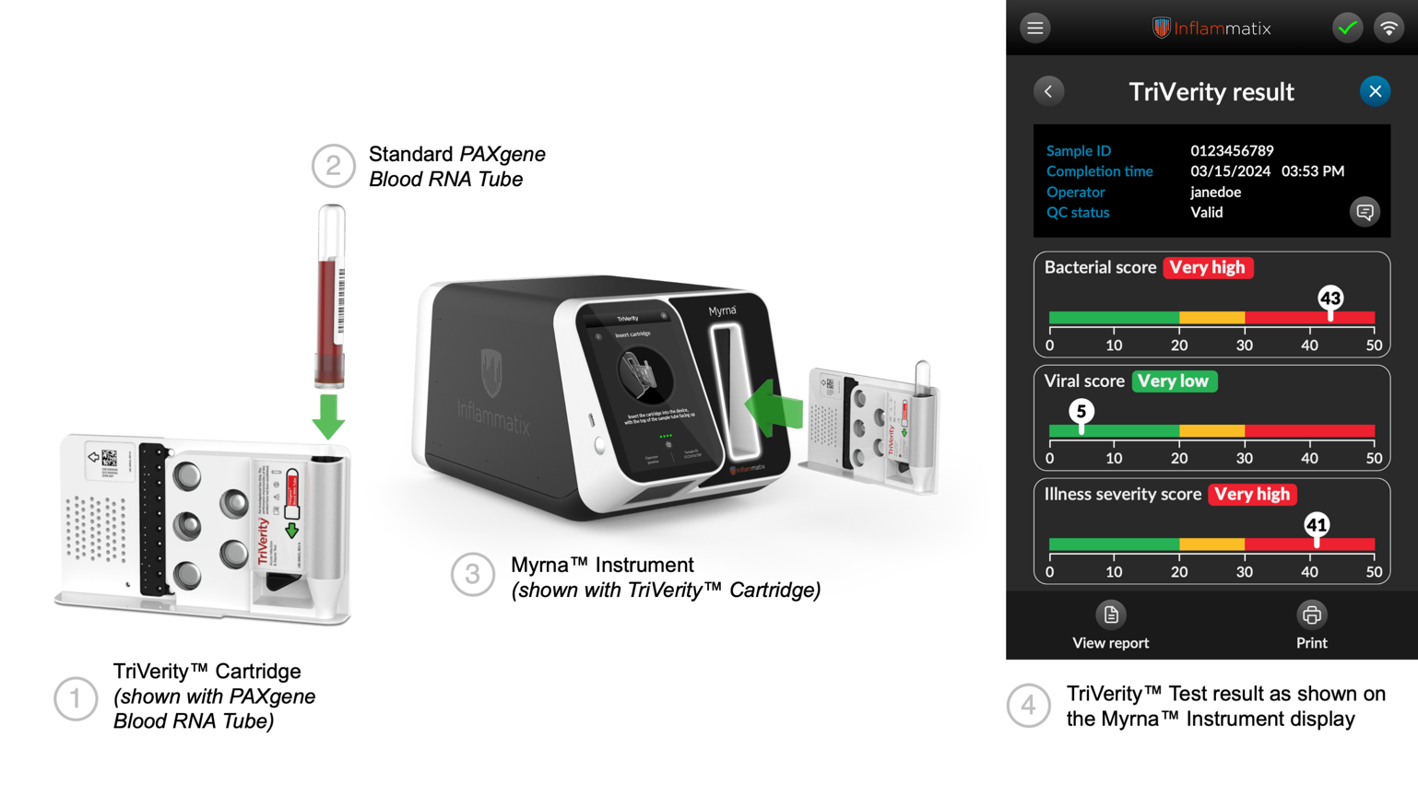

Supplementary Fig. 2 | TriVerity System with TriVerity cartridge, Myrna Instrument and TriVerity Test result readouts
Note: TriVerity Test result for a patient sample showing a Very high Bacterial Score (43), Very low Viral Score (5), and Very high Illness Severity Score (41) suggesting the presence of a very severe bacterial infection but ruling out a viral infection.

