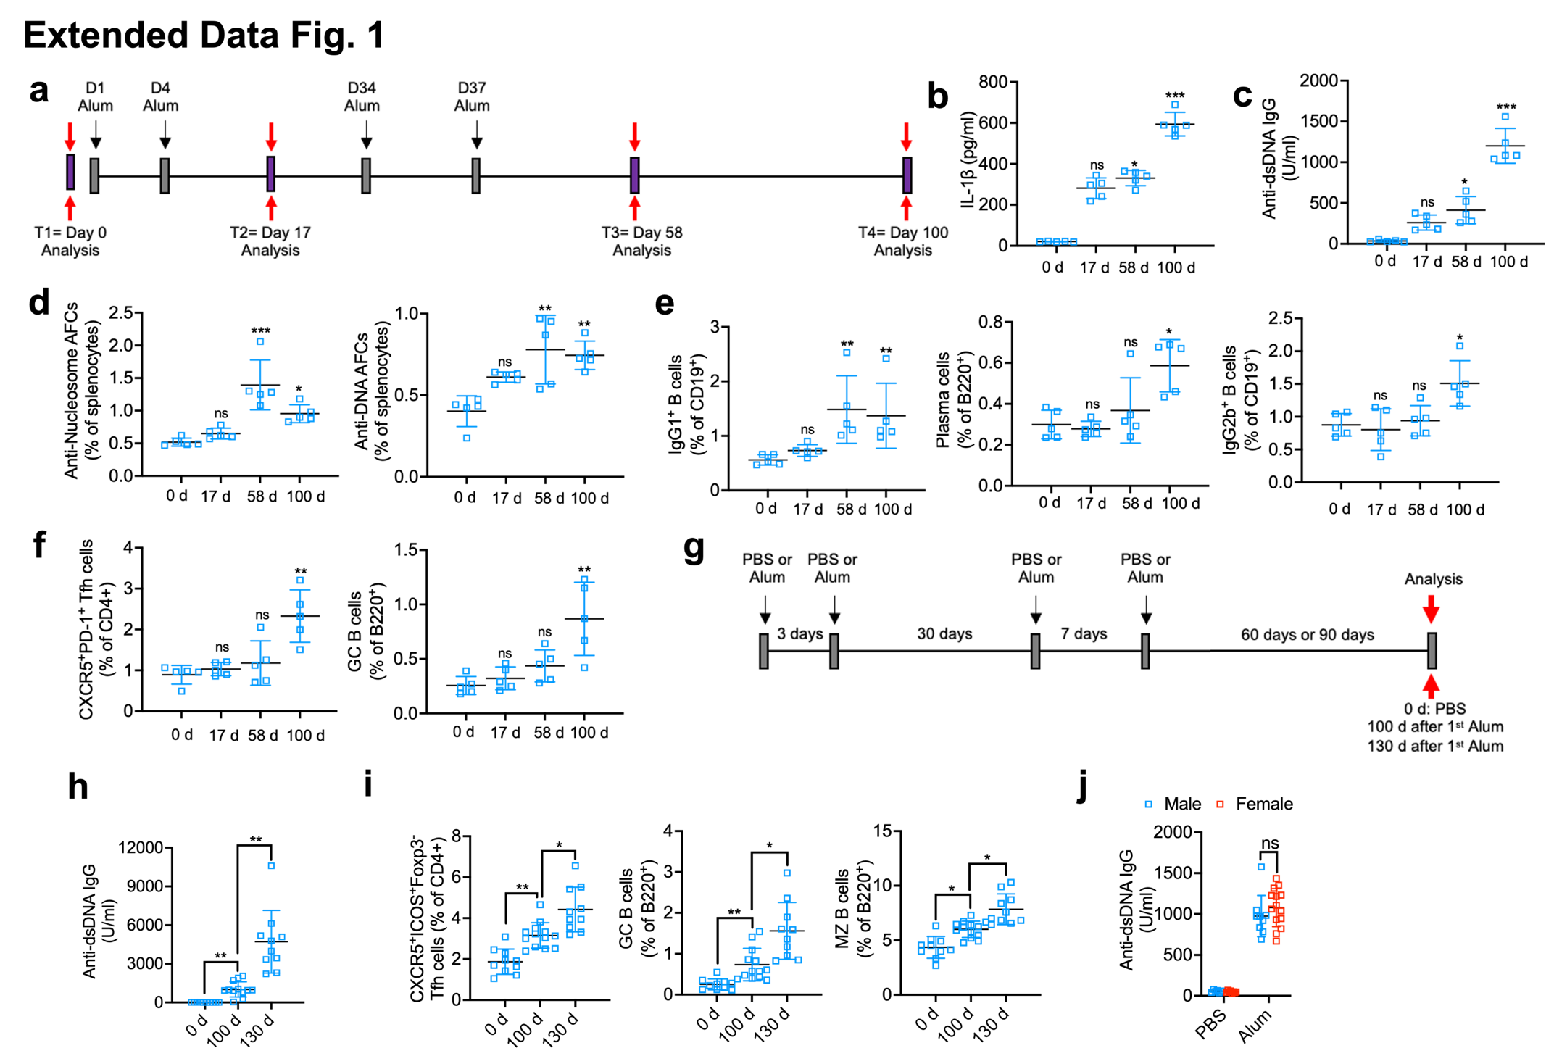
Extended Data Fig. 1: Alum injections induce pathological autoantibody production.
a, Treatment and analysis scheme. Age-matched female mice were i.p. injected with PBS or alum (1 mg/mouse) and analyzed as indicated (n=5/group). b,c, ELISA of serum IL-1β (b) and anti-dsDNA IgG (c). d-f, FC percentages of splenic nucleosome- or DNA-reactive antibody-forming cells (AFCs) (d), IgM–IgG1⁺CD19⁺ B, plasma cells (PC, B220^{int}CD138⁺CD3⁻) and IgM–IgG2b⁺CD19⁺ B cells (e), Tfh cells (CXCR5⁺PD1⁺CD44⁺CD4⁺) and GC B cells (GL7⁺CD38⁻B220⁺CD3⁻CD11b⁻CD11c⁻) (f). g, Treatment and analysis scheme of female mice used in h,i (n=10/0 d, n=13/100 d, n=10/130 d). h, ELISA of serum anti-dsDNA IgG. i, FC percentages of splenic Tfh cells (CXCR5⁺ICOS⁺Foxp3⁻CD4⁺), GC B and MZ B cells (CD21^{hi}CD23⁻B220⁺). j, ELISA of serum anti-dsDNA IgG 100 days after the 1st alum injection as in g (male: n=6/PBS, n=9/Alum; Female: n=8/PBS, n=14/Alum).
Results in (b-f and h-j) are mean ± SD. ∗ P<0.05, ∗∗ P<0.01, ∗∗∗ P<0.001. ns, not significant. Kruskal–Wallis test (b-f, h and i) and two-way ANOVA with Tukey multiple-comparison test (j).
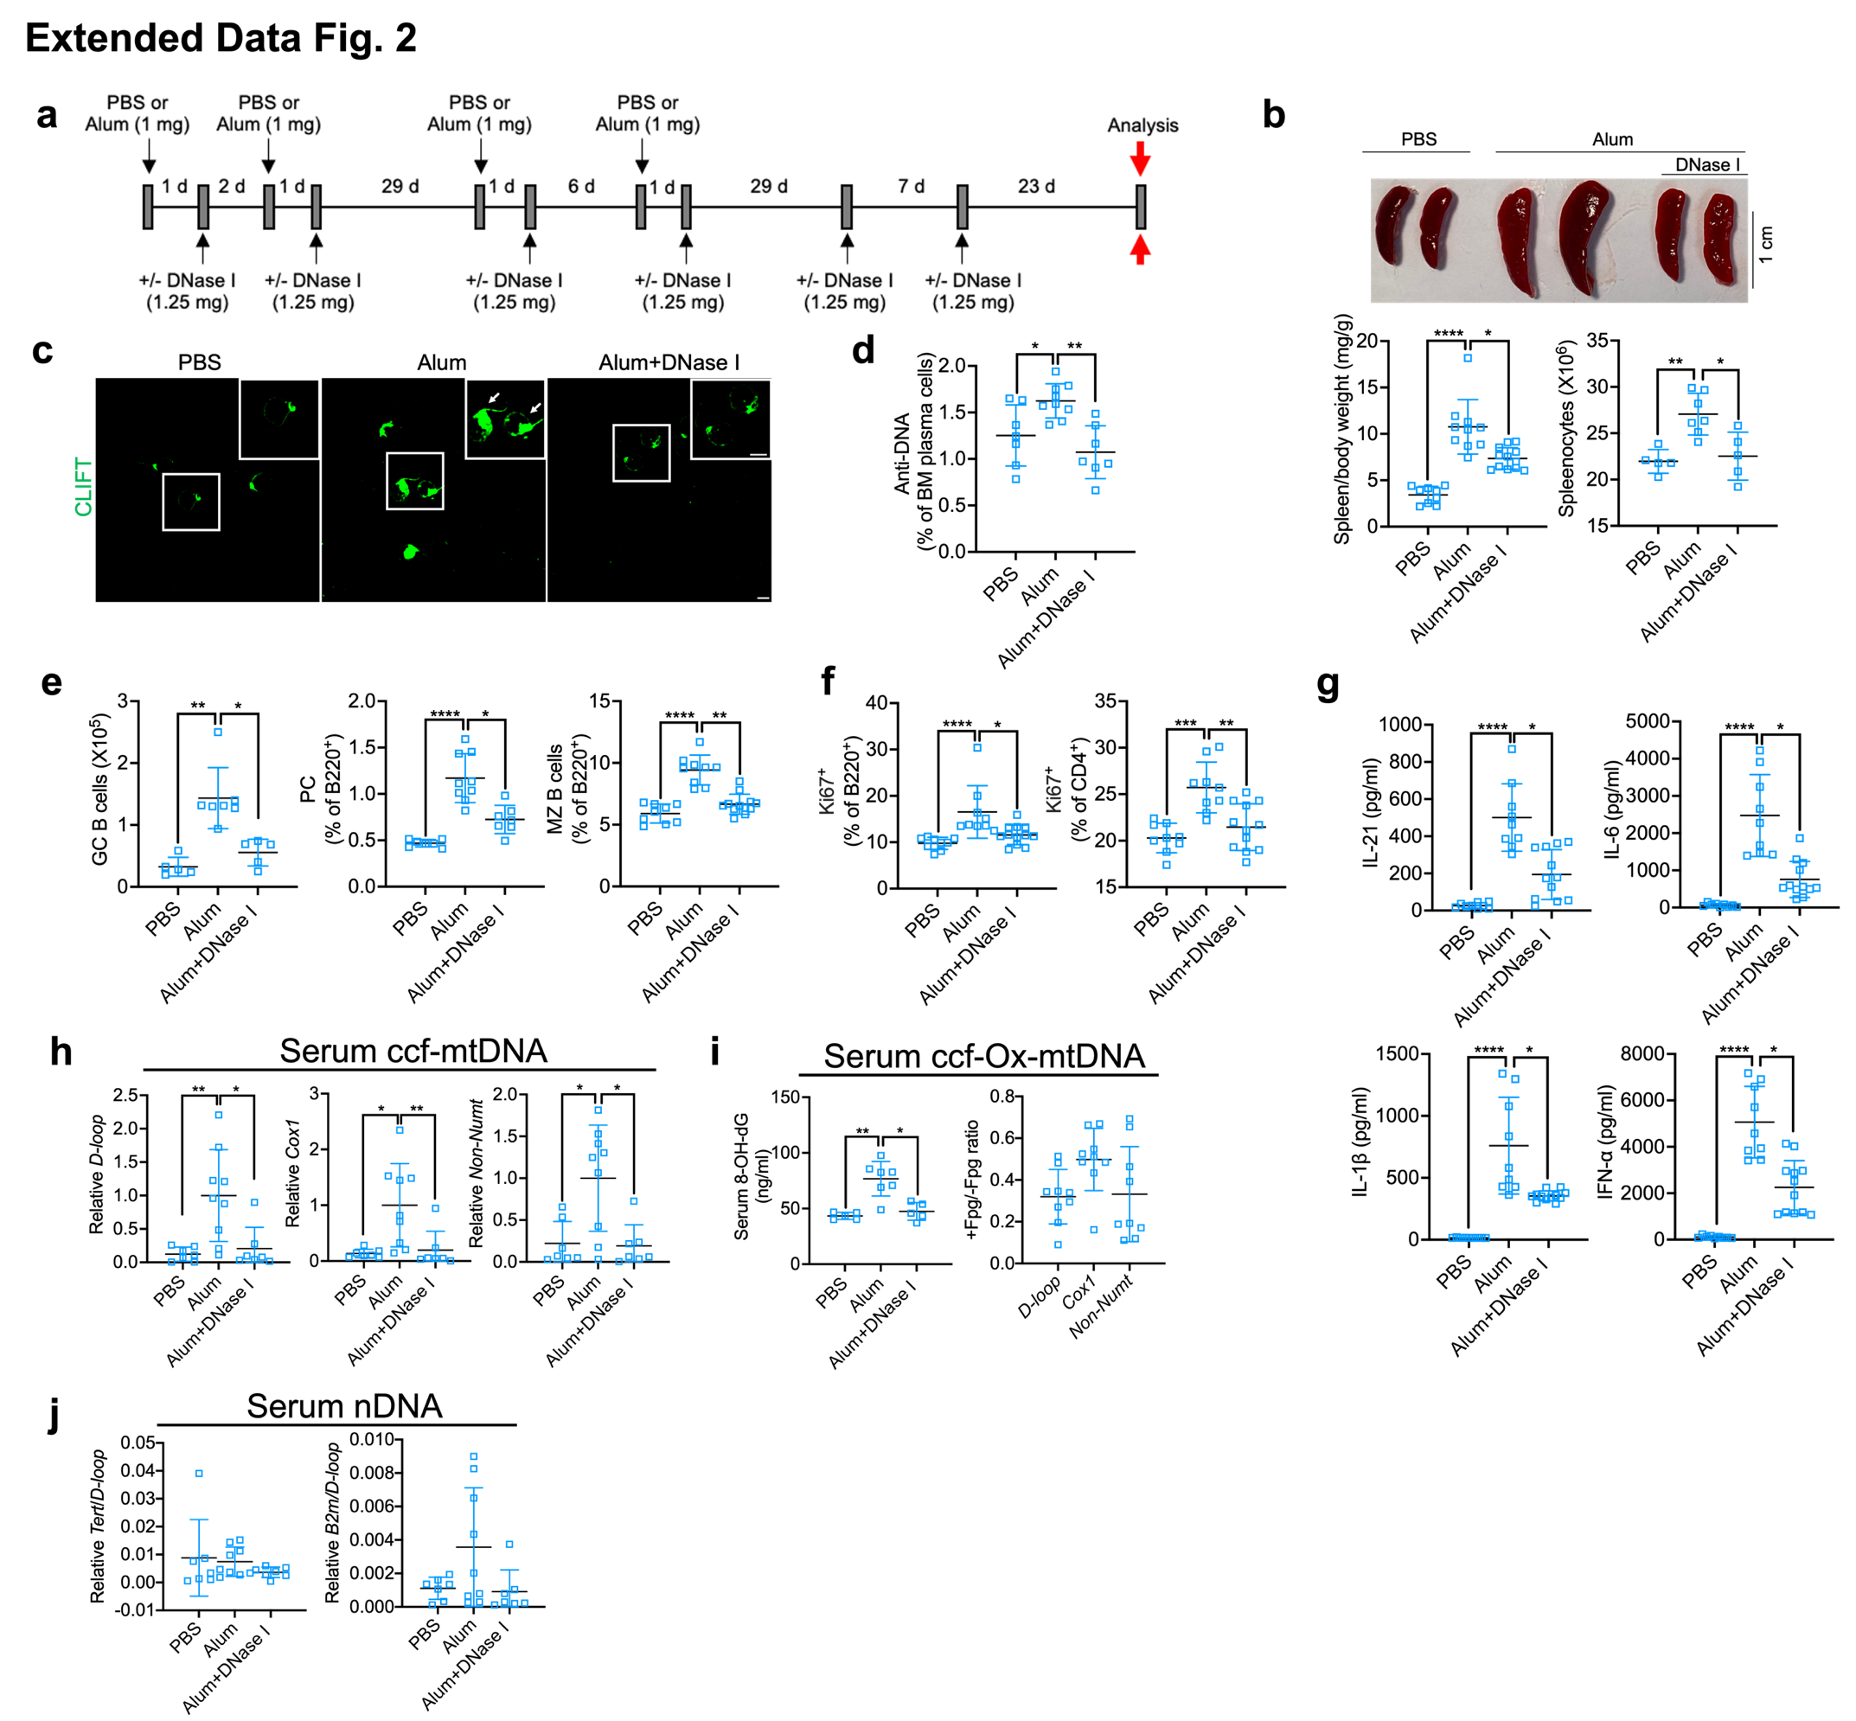
Extended Data Fig. 2: DNase I injections blunt alum-induced autoimmunity.
a, Treatment and analysis scheme of male mice (n=5 or 9/PBS, n=7 or 9/alum, n=5, 7 or 12/alum+DNase I). b, Spleen gross morphology, mass to body weight ratio and absolute splenocyte numbers. Scale bar, 1 cm. c, CLIFT assay of serum anti-dsDNA IgG. Scale bar, 20 μm. d, Frequencies of bone-marrow (BM) anti-mtDNA AFCs in total plasma cells. e, GC B cell number and frequencies of PC and MZ B cells in the spleens. f, Percentages of splenic proliferating Ki67⁺ B220⁺cells and CD4⁺ T cells. g, ELISA of serum IL-21, IL-6, IL-1β and IFN-α. h, Relative amounts of circulating mtDNA. i, 8-Oxo-dG containing DNA amounts and ratio of Fpg-treated (+) to nontreated (−) circulating mtDNA, indicating the fraction of non-Ox-mtDNA (Fpg-resistant) in mtDNA (D-loop, Cox1 and Non-Numt). j, Ratio of serum nDNA (Tert or B2m) to mtDNA (D-loop).
Results in (b and d-j) are mean ± SD. ∗ P<0.05, ∗∗ P<0.01, ∗∗∗ P<0.001, ∗∗∗∗ P<0.0001. Kruskal–Wallis test.
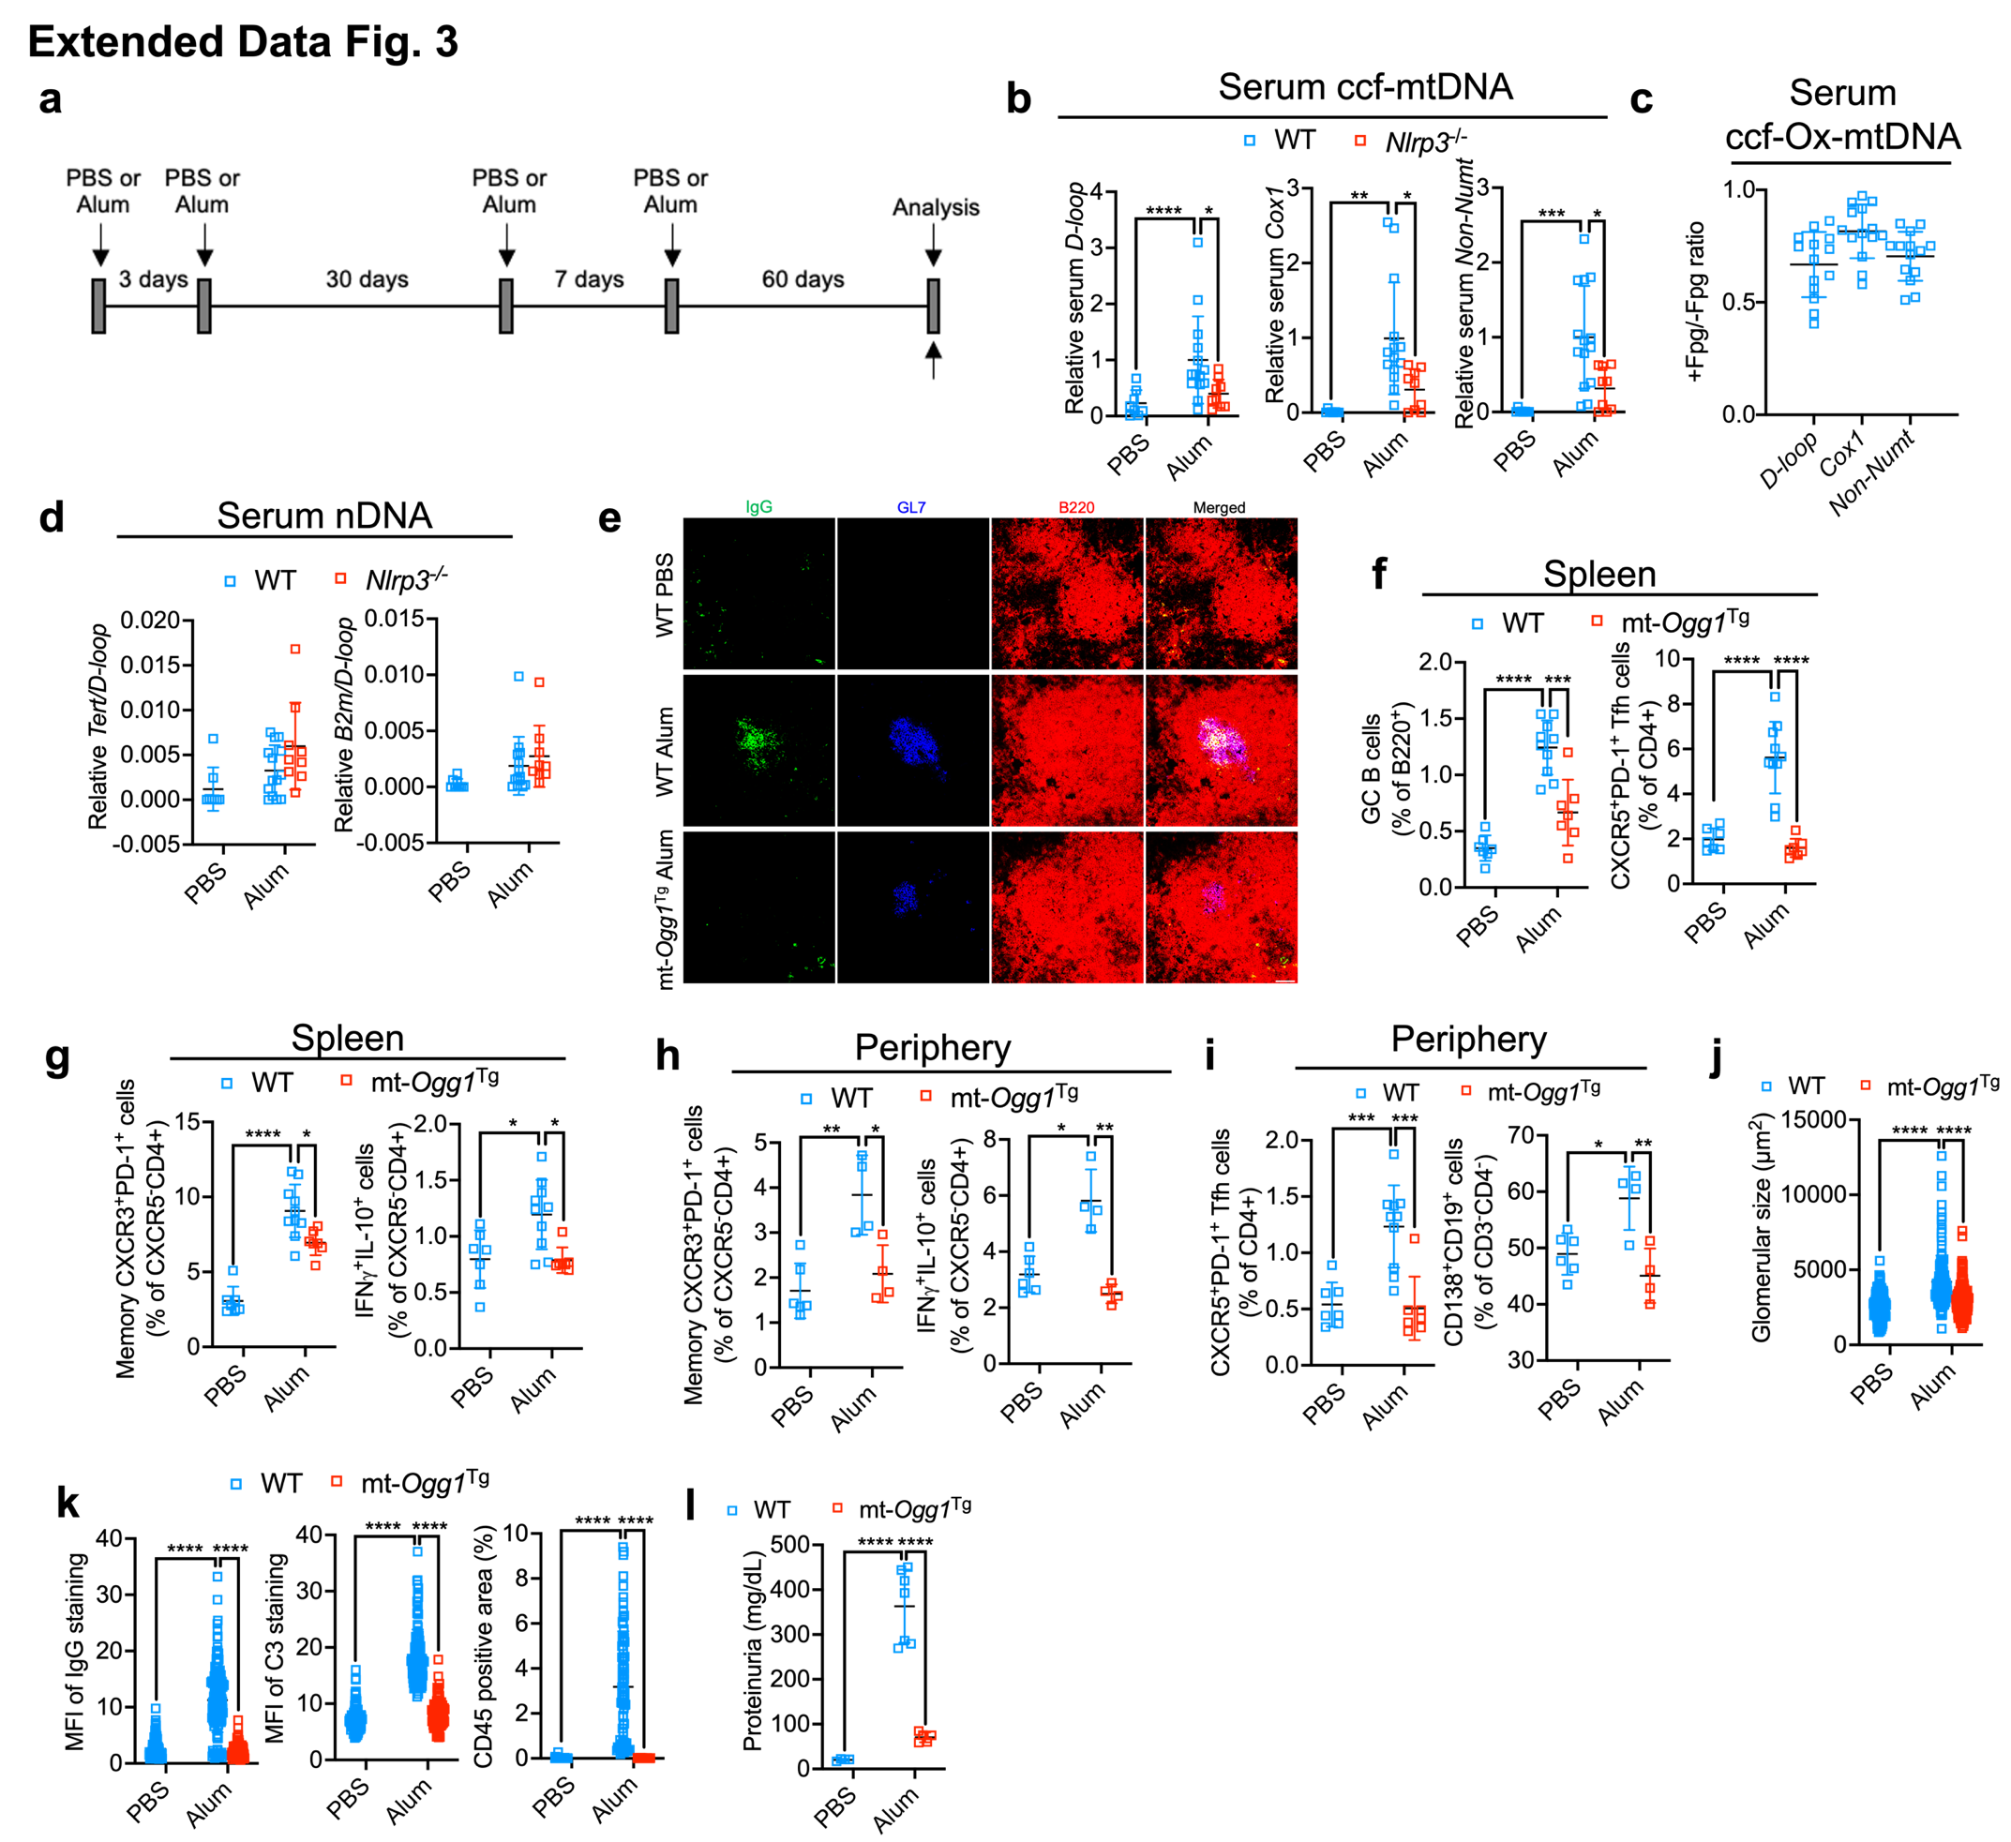
Extended Data Fig. 3: Alum-induced autoimmunity depends on NLRP3 and mtDNA oxidation.
a, Treatment and analysis scheme of WT & Nlrp3^{−/−} (n=8/WT PBS; n=14/WT alum; n=9/Nlrp3^{-/-} alum, b-d) and WT & mt-Ogg1^{Tg} (n=7/WT PBS, n=10/WT alum, n=7/mt-Ogg1^{Tg} alum, e-g) female mice. b-d, Relative amounts of circulating ccf-mtDNA (b), ratio of Fpg-treated (+) to nontreated (−) circulating ccf-mtDNA (c), and nDNA (Tert or B2m) to mtDNA (D-loop) ratio (d) in WT and Nlrp3^{-/-} mice. e, IF of IgG (green), GL7 (blue) and B220 (red) stained spleen sections. Scale bar, 50 μm. f, Percentages of splenic GC B and Tfh cells. g, Percentages of splenic CXCR5⁻CXCR3⁺PD-1⁺CD4⁺ and IFNγ⁺IL10⁺CXCR5⁻CD4⁺ memory T cells. h, Percentages of blood CXCR5⁻CXCR3⁺PD-1⁺CD4⁺ T helper and IFNγ⁺IL10⁺CXCR5⁻CD4⁺ T memory (n=6/WT PBS, n=4/WT Alum, n=4/mt-Ogg1^{Tg} Alum). i, Percentages of blood Tfh cells (n= 7/WT PBS, n=10/WT Alum, n=7/mt-Ogg1^{Tg} Alum) and CD138⁺CD19⁺CD3⁻CD4⁻ cells (n=6/WT PBS, n=4/WT Alum, n=4/mt-Ogg1^{Tg} Alum). j, Glomeruli sizes in H&E-stained kidney sections (n>165). k, MFI of IgG (n>123), C3 deposits (n>100) and area (in %) occupied by CD45⁺ cells (n>71) in kidney sections. l, Urinary protein ELISA (n=4/WT PBS, n=7/WT Alum, n=5/mt-Ogg1^{Tg} Alum.
Results in (b-d and f-l) are mean ± SD. ∗ P<0.05, ∗∗ P<0.01, ∗∗∗ P<0.001, ∗∗∗∗ P<0.0001. Two-way ANOVA with Tukey multiple-comparison test.
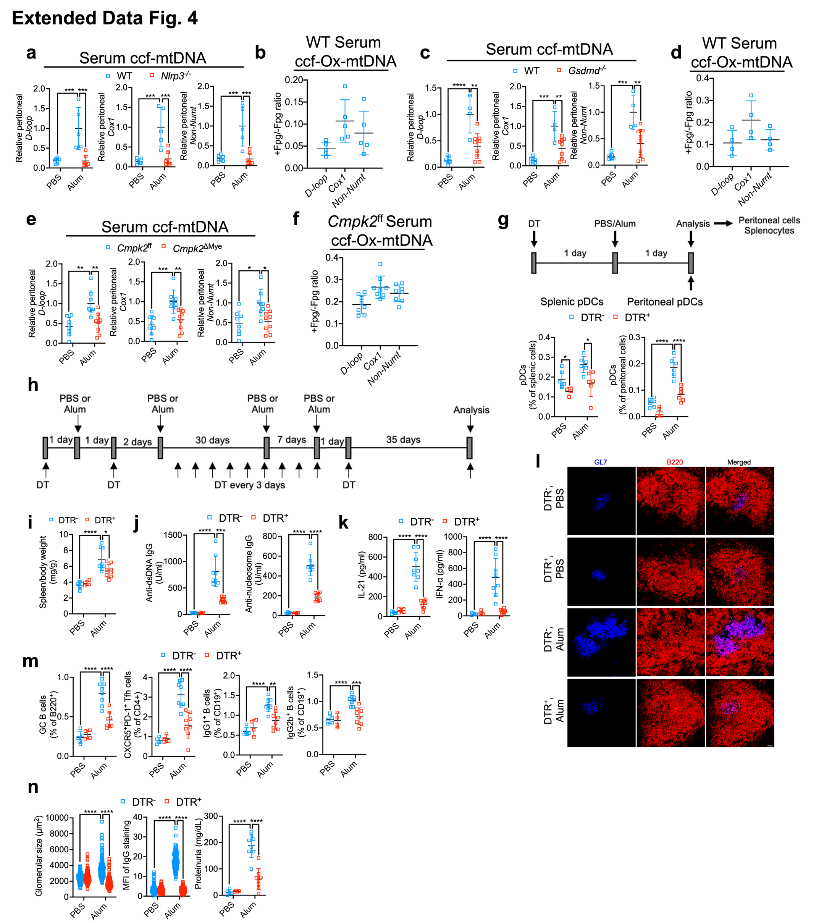
Extended Data Fig. 4: Alum induced ccf-Ox-mtDNA is sensed by functionally important peritoneal pDC.
a-f, Relative amounts of peritoneal mtDNA (a,c and e), and non-Ox-mtDNA (Fpg-resistant) (b,d and f) 24 h after PBS or alum injection into the indicated mouse strains in Fig. 3f, g and i. g, Treatment and analysis scheme (short-term). BDCA2-DTR⁻ and BDCA2-DTR⁺ male mice were i.p. injected with DT (100 ng/mice), followed by PBS (n=6/BDCA2-DTR⁻ and n=4/BDCA2-DTR⁺) or alum (n=6/genotype) injections and FC analyses of splenic and peritoneal pDC after 24 h. h, Treatment and analysis scheme (long term) for i-n. Alum-treated BDCA2-DTR⁻ and BDCA2-DTR⁺ female mice were repetitively injected with PBS (n=5/BDCA2-DTR⁻ and n=4/BDCA2-DTR⁺) or alum (n=8/genotype) and analyzed. i, Spleen mass to body weight ratio. j, k, ELISA of serum anti-dsDNA and anti-nucleosome IgGs (j), IL-21 and IFN-α (k). l, IF of GL7 (blue) and B220 (red) stained spleen sections. Scale bar, 50 μm. m, FC frequencies of splenic GC B, Tfh, IgG1⁺IgM⁻CD19⁺ and IgG2b⁺IgM⁻CD19⁺ cells. n, Sizes of glomeruli (n>122) in H&E-stained kidney sections, MFI of kidney IgG deposits (n>102) and urinary protein ELISA.
Results in (a-g, i-k, m and n) are mean ± SD. ∗ P<0.05, ∗∗ P<0.01, ∗∗∗ P<0.001, ∗∗∗∗ P<0.0001. Two-way ANOVA with Tukey multiple-comparison test.
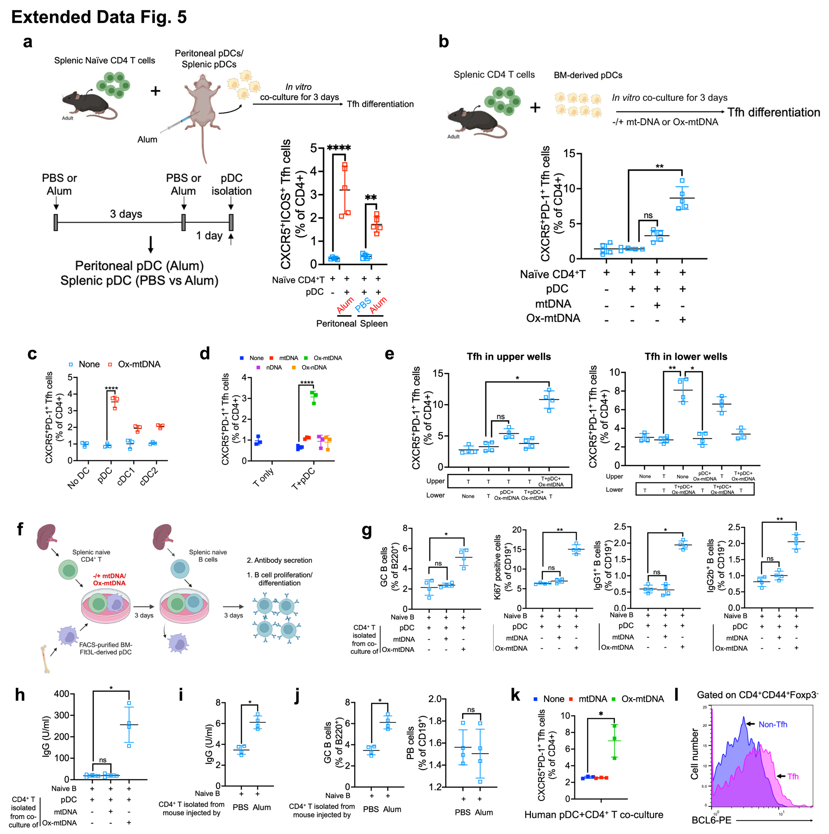
Extended Data Fig. 5: Ox-mtDNA treatment of mouse and human pDC enables ex-vivo induction of Tfh differentiation.
a, Naïve splenic CD4⁺ T cells (CD4⁺CD25⁻CD62L^{hi}CD44^{lo} T, see gating strategy in Supplementary Fig. 4a) were co-cultured with purified peritoneal or splenic pDC collected 24 h after two alum injections (72 h apart) at a 5:1 ratio. Splenic pDC isolated after PBS injection were used as negative control. After 3 days of co-culture, Tfh (CXCR5⁺ICOS⁺CD44⁺Foxp3⁻CD4⁺) generation was analyzed (n=5). b, Naïve splenic CD4⁺ T cells were co-cultured with FACS-sorted Flt3L-induced pDC (CD11c⁺CD11b⁻B220⁺BST2⁺Siglec-H⁺, see gating strategy in Supplementary Fig. 4b) at a 5:1 ratio, -/+ non-oxidized or UV-oxidized mtDNA (50 μg) for 3 days. The percentages of differentiated Tfh cells (CXCR5⁺PD1⁺CD44⁺CD4⁺) were analyzed (n=5). c,d, FC analyses of Tfh (CXCR5⁺PD-1⁺CD44⁺Foxp3⁻CD4⁺) generation by naïve splenic CD4⁺ T cells co-cultured with either FACS-sorted Flt3L-induced pDC, cDC1, or cDC2, -/+ Ox-mtDNA (c) or with pDC incubated with different types of DNA (d) (n=3). e, Naïve CD4⁺ T cells were cultured in transwell plates separately from or together with FACS-sorted Flt3L-induced pDC incubated with Ox-mtDNA for 3 days. Tfh differentiation in either the upper (left) or lower (right) wells was FC analyzed (n=4). f, Treatment and analysis scheme for g,h. Naïve CD4⁺ T cells were co-cultured with FACS-sorted Flt3L-induced pDC, -/+ mtDNA or Ox-mtDNA. After 3 days, CD4⁺ T were isolated and co-cultured with naïve splenic B cells at 1:7 ratio for 3 more days, after which B cell proliferation, differentiation and IgG secretion were analyzed. g,h, Percentages of GC B, proliferative (Ki67⁺CD19⁺CD3⁻), IgG1⁺IgM⁻CD19⁺ and IgG2b⁺IgM⁻CD19⁺ B cells (g) and ELISA of secreted IgG (h) (n=4). i,j, Secreted IgG (i) and GC B cells and plasmablasts (PB; CD138^{hi}B220^{lo}IgD⁻CD3⁻CD19⁺, j) 3 days after co-culture of naïve splenic B cells with CD4⁺ T cells from PBS or alum injected mice (n=4). k,l, Freshly isolated pDC and CD4⁺ T cells were purified from healthy human blood (buffy coats) and were co-cultured for 3 days, -/+ mtDNA or Ox-mtDNA, as in b. Generation of Tfh cells (k) and intracellular BCL6 expression in Tfh and non-Tfh cells pre-gated on CD4⁺CD44⁺Foxp3⁻ cells of Ox-mtDNA treated cells (l) were FC analyzed (n=3 samples in 3 independent experiments).
Results are mean ± SD. ∗ P<0.05, ∗∗ P<0.01, ∗∗∗∗ P<0.0001. ns, not significant. Kruskal–Wallis test (b, e and g-j) and two-way ANOVA with Tukey multiple-comparison test (a, c, d and k).
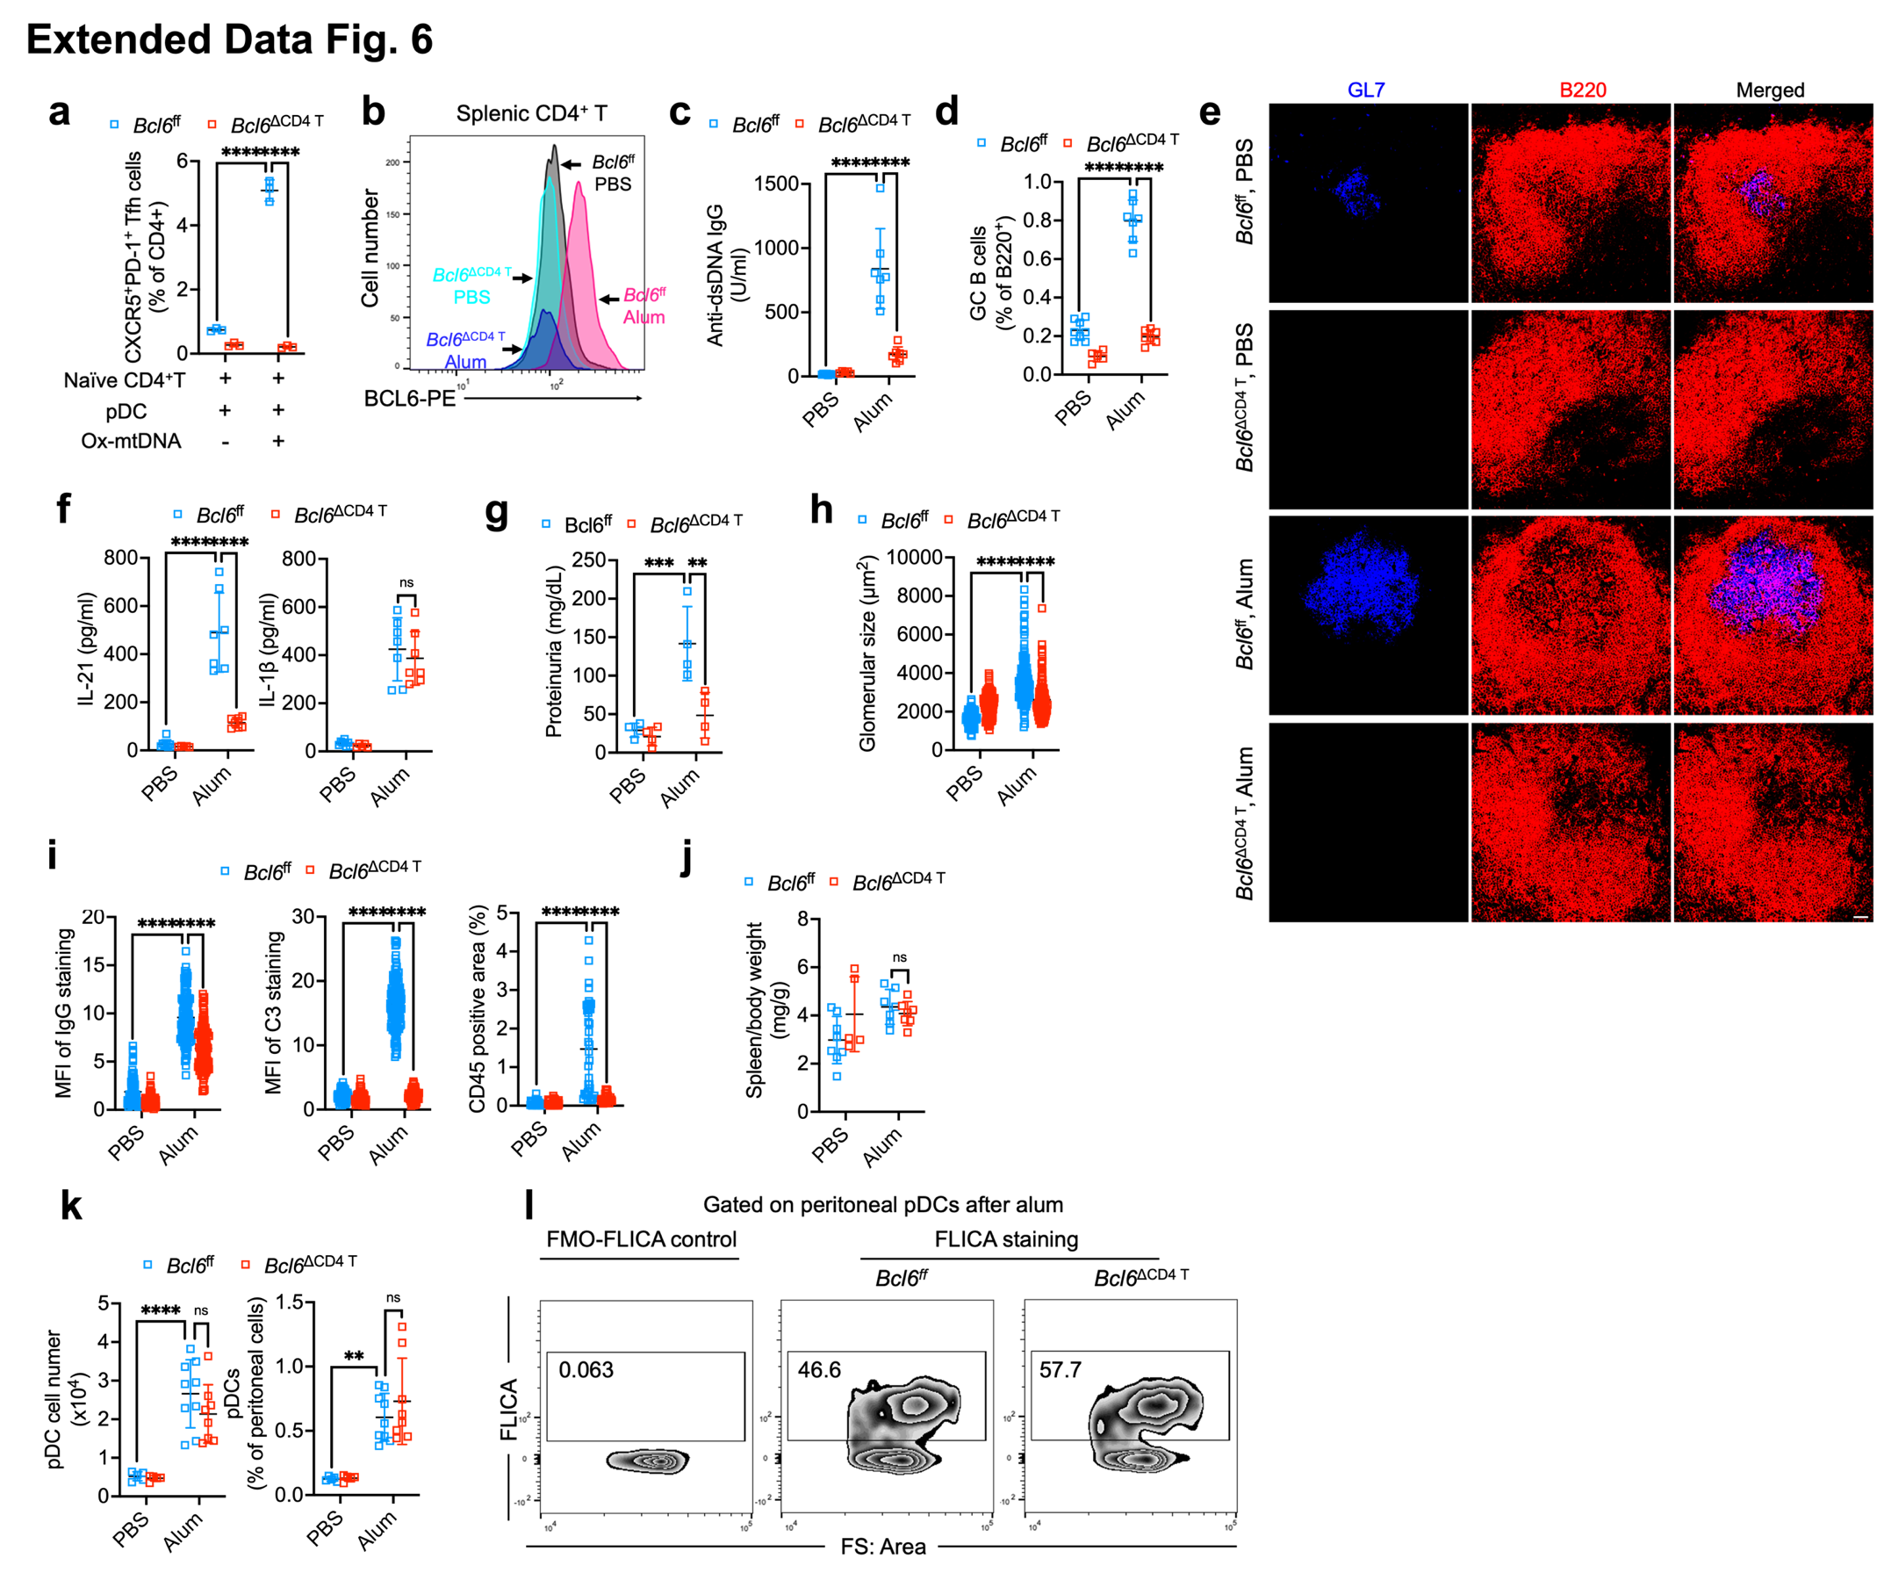
Extended Data Fig. 6: Alum-induced Ox-mtDNA-dependent autoimmunity relies on Tfh cells.
a, Tfh frequencies after ex-vivo co-culture of murine Bcl6^{ff} and Bcl6^{ΔCD4} naïve splenic CD4⁺ T cells with FACS-sorted B6 BM-Flt3L-induced pDC, -/+ Ox-mtDNA for 3 days (n=3). b-j, Analyses of alum-induced autoimmunity in Bcl6^{ff} and Bcl6^{ΔCD4} males treated as in Extended Data Fig. 3a (n=8/Bcl6^{ff} PBS; n=7/Bcl6^{ff} Alum; n=5/Bcl6^{ΔCD4} PBS; n=7/Bcl6^{ΔCD4} Alum). Intracellular BCL6 staining of splenic CD4⁺ T cells (b), serum anti-dsDNA IgG (c), FC analyses of splenic GC B frequencies (d), IF of GL7 (blue) and B220 (red) stained spleen sections (Scale bar, 50 μm, e), serum IL-21 and IL-1β (f), urinary protein ELISA (g), sizes of glomeruli in kidney sections (n=123, h), MFI of renal IgG deposits (n=120) and C3 (n=120) and renal area (in %) occupied by CD45⁺ cells (n=29/Bcl6^{ff} PBS; n=39/Bcl6^{ff} Alum; n=33/Bcl6^{ΔCD4} PBS; n=32/Bcl6^{ΔCD4} Alum) (i) and spleen mass to body weight ratio (j). k, Numbers and percentages of peritoneal pDC 24 h after PBS or alum injection into Bcl6^{ff} and Bcl6^{ΔCD4} males (n=5/Bcl6^{ff} PBS; n=8/Bcl6^{ff} Alum; n=5/Bcl6^{ΔCD4} PBS; n=9/Bcl6^{ΔCD4} Alum). l, Active Casp1 (FLICA^{hi}) in pre-gated peritoneal pDC 24 h after alum injections into Bcl6^{ff} and Bcl6^{ΔCD4} males (representative of 3 independent experiments). FMO, fluorescence minus one.
Results in (a, c, d, f-k) are mean ± SD. ∗∗ P<0.01, ∗∗∗ P<0.001, ∗∗∗∗ P<0.0001. ns, not significant. Two-way ANOVA with Tukey multiple-comparison test.
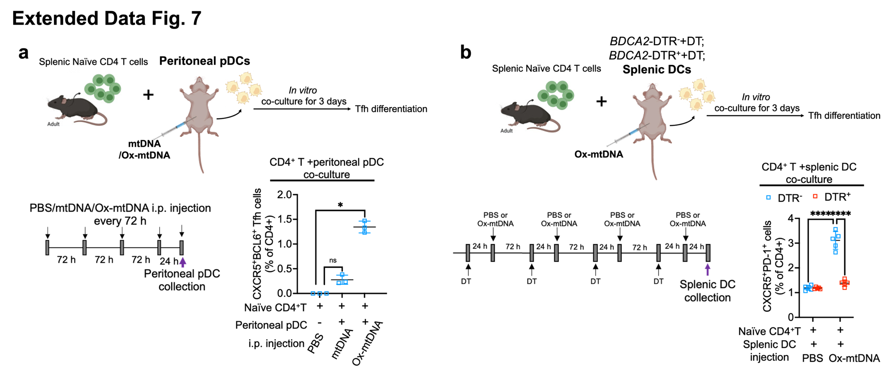
Extended Data Fig. 7: Ox-mtDNA injections enable primary pDC induce Tfh differentiation.
a, Naïve B6 splenic CD4⁺ T cells were co-cultured with purified peritoneal pDC collected 24 h after 4 repetitive mtDNA or Ox-mtDNA injections (72 h apart) into B6 mice. No peritoneal pDC were present after PBS injection. After 3 days of co-culture, Tfh (CXCR5⁺BCL6⁺Foxp3⁻CD44⁺CD4⁺) generation was analyzed (n=3). b, Naïve B6 splenic CD4⁺ T cells were co-cultured with purified splenic DC collected 24 h after 4 repetitive PBS or Ox-mtDNA injections into DT treated BDCA2-DTR⁻ and BDCA2-DTR⁺ mice. After 3 days of co-culture, Tfh generation was analyzed (n=5).
Results are mean ± SD. ∗ P<0.05, ∗∗∗∗ P<0.0001. ns, not significant. Kruskal–Wallis test (a) and two-way ANOVA with Tukey multiple-comparison test (b).
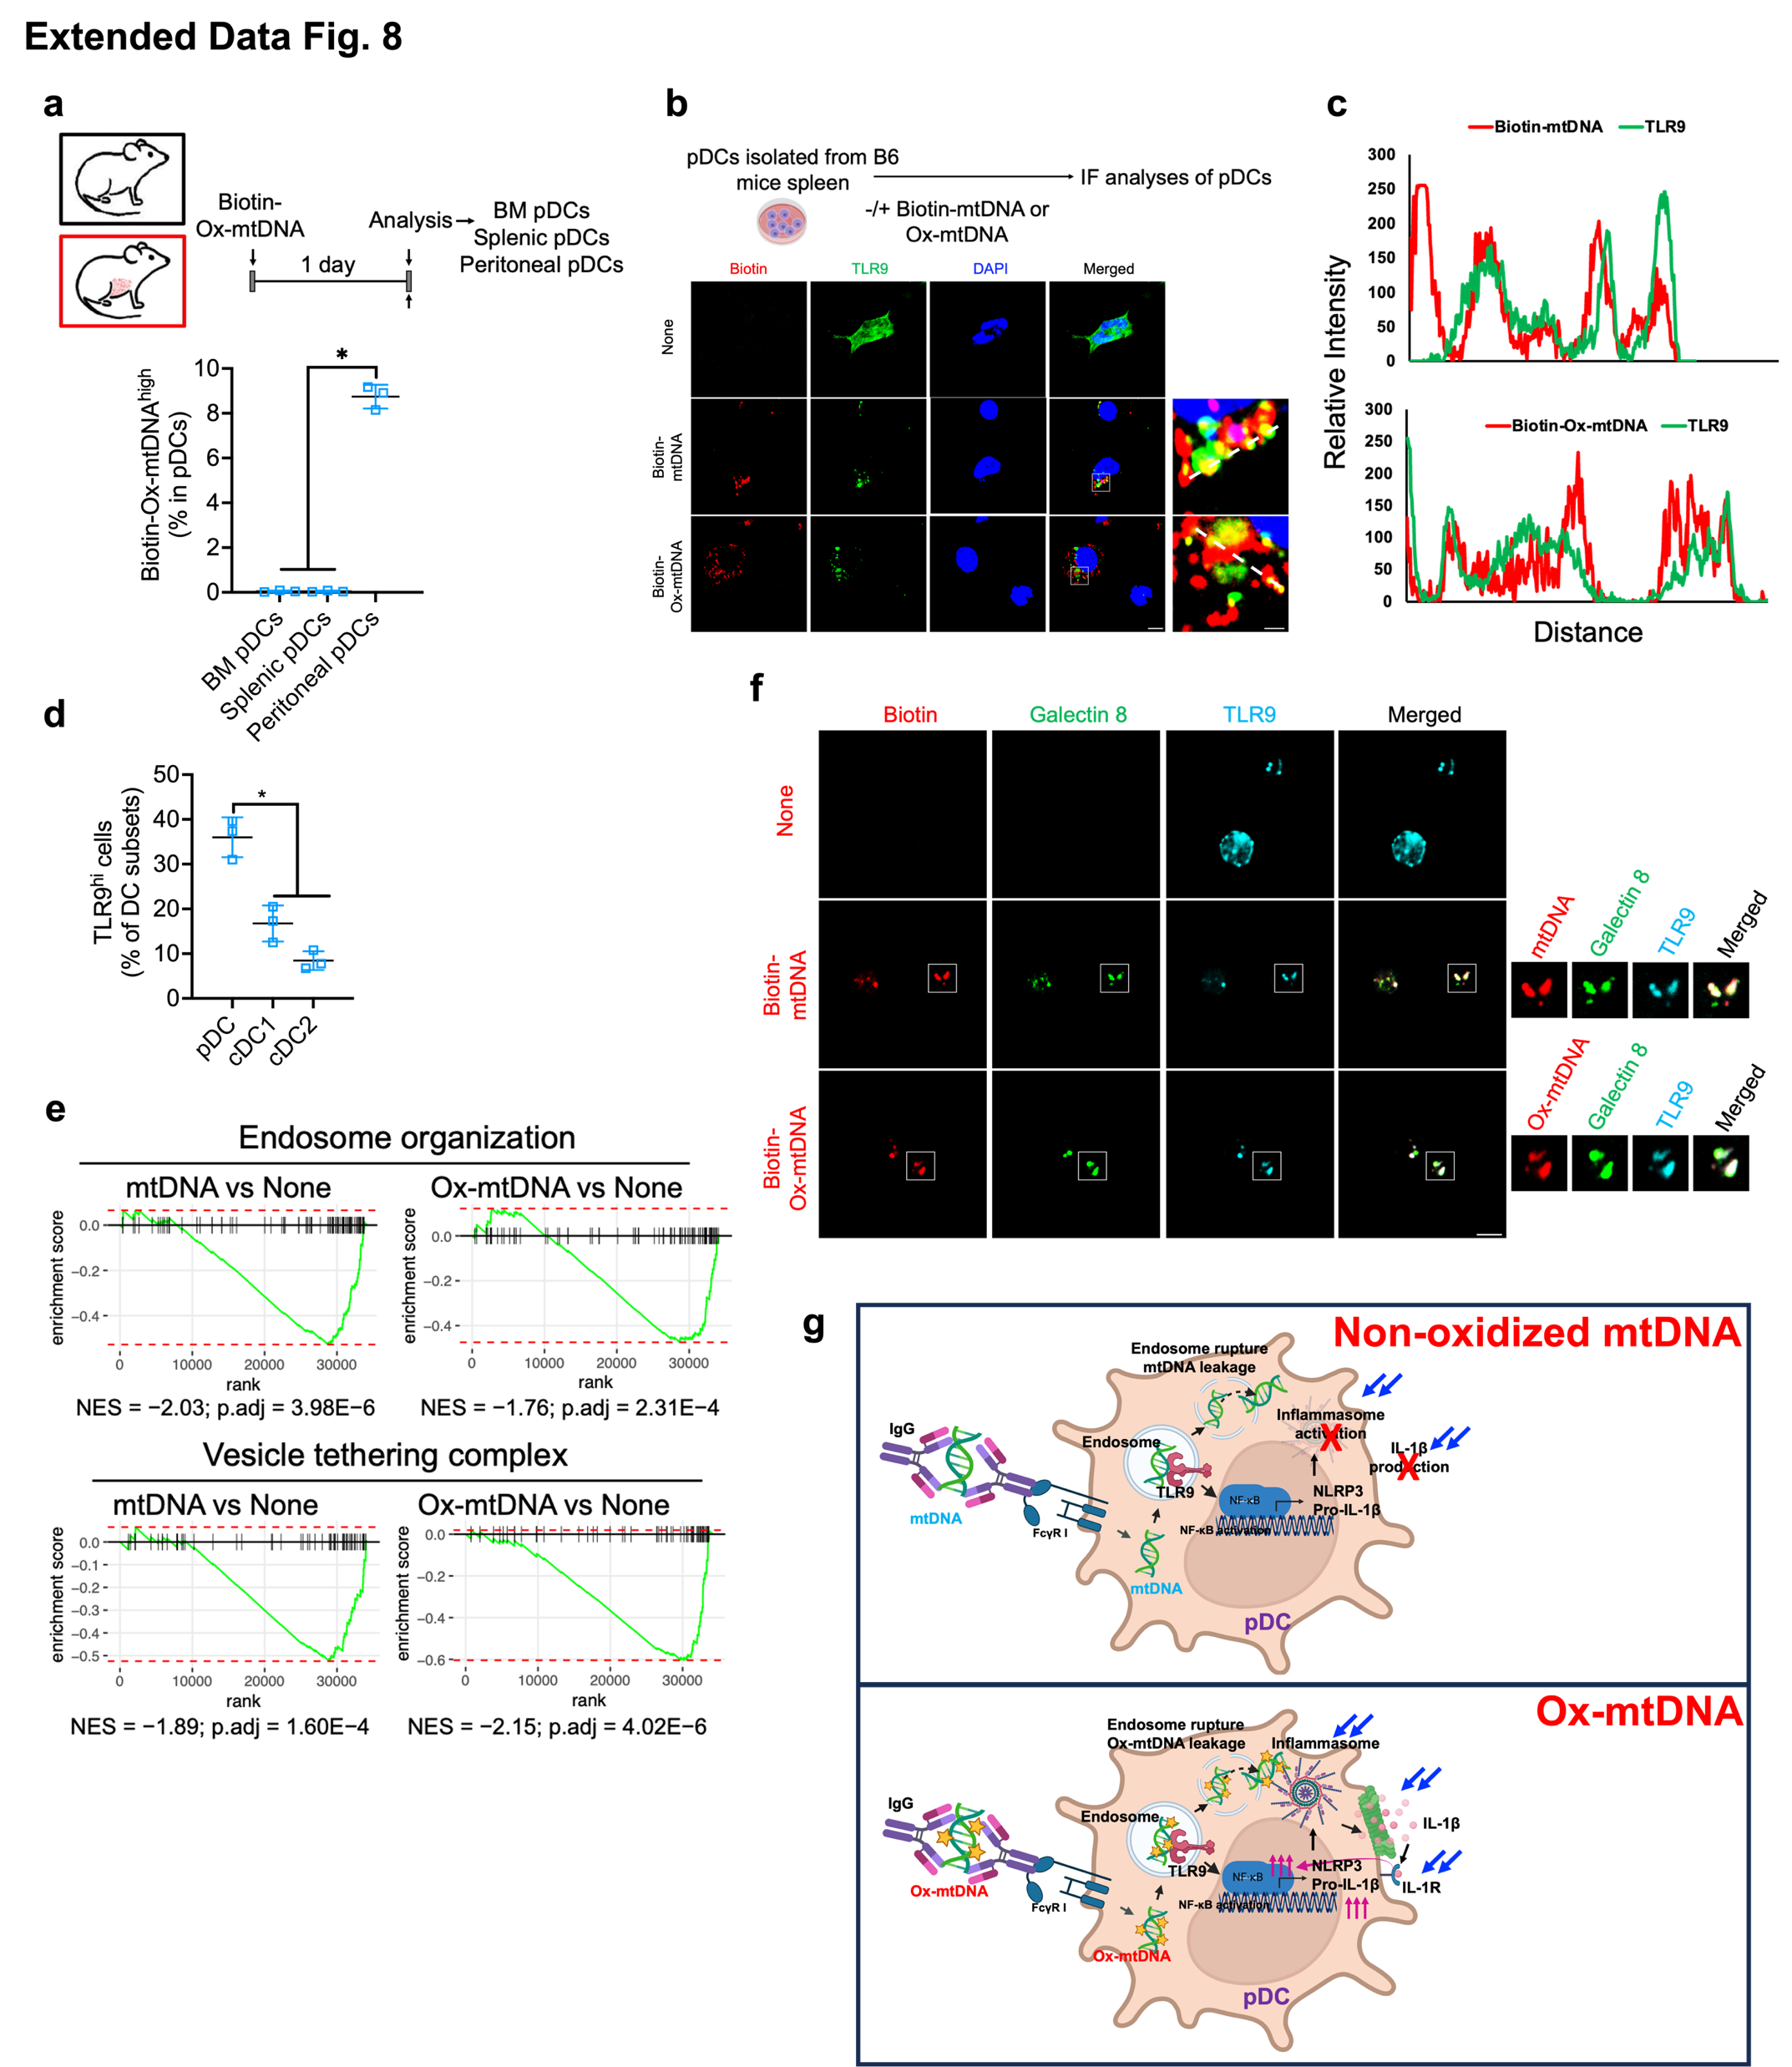
Extended Data Fig. 8: FcγR1 mediates mtDNA uptake followed by delivery to TLR9 and endosomal rupture.
a, Treatment and analysis scheme. 8-week-old B6 males were i.p. injected with 2 μg Biotin-Ox-mtDNA and 24 h later, BM, splenic and peritoneal pDC were purified and FC analyzed for intracellular biotin-Ox-mtDNA uptake (n=3). b, IF analysis of splenic pDC that were incubated ex-vivo with 2 μg Biotin-mtDNA or Biotin-Ox-mtDNA for 1 h and stained for biotin (red) and TLR9 (green). Scale bars, 5 μm and 1 μm (n=3). c, Relative fluorescence intensities of the biotin and TLR9 signals along the broken white lines in b, demonstrating (Ox-)mtDNA-TLR9 co-localization. d, FC analyses of TLR9^{hi} cells in WT and Tlr9^{-/-} Flt3L-induced BMDC cultures (including cDC1, cDC2 and pDC) 4 h after incubation with Ox-mtDNA (n=3). e, GSEA pathway analyses of bulk RNA-seq data (n=3). f, IF analysis of splenic pDC that were incubated with 2 μg biotin-labelled non-oxidized or oxidized mtDNA (red) for 1 h and stained for ruptured endosomes with galectin 8 (green) and TLR9 (cyan) antibodies. Scale bar, 5 μm. g, A working model illustrating how mtDNA and Ox-mtDNA are internalized by pDC and activate TLR9-dependent NF-κB and NLRP3 inflammasome signaling. Although both mtDNA forms activate TLR9 and access the cytoplasm via ruptured endosomes, only Ox-mtDNA binds NLRP3 and triggers inflammasome activation to produce IL-1β that potentiates NF-κB activation via IL-1R.
Results in (a and d) are mean ± SD. ∗ P < 0.05. Kruskal–Wallis test.
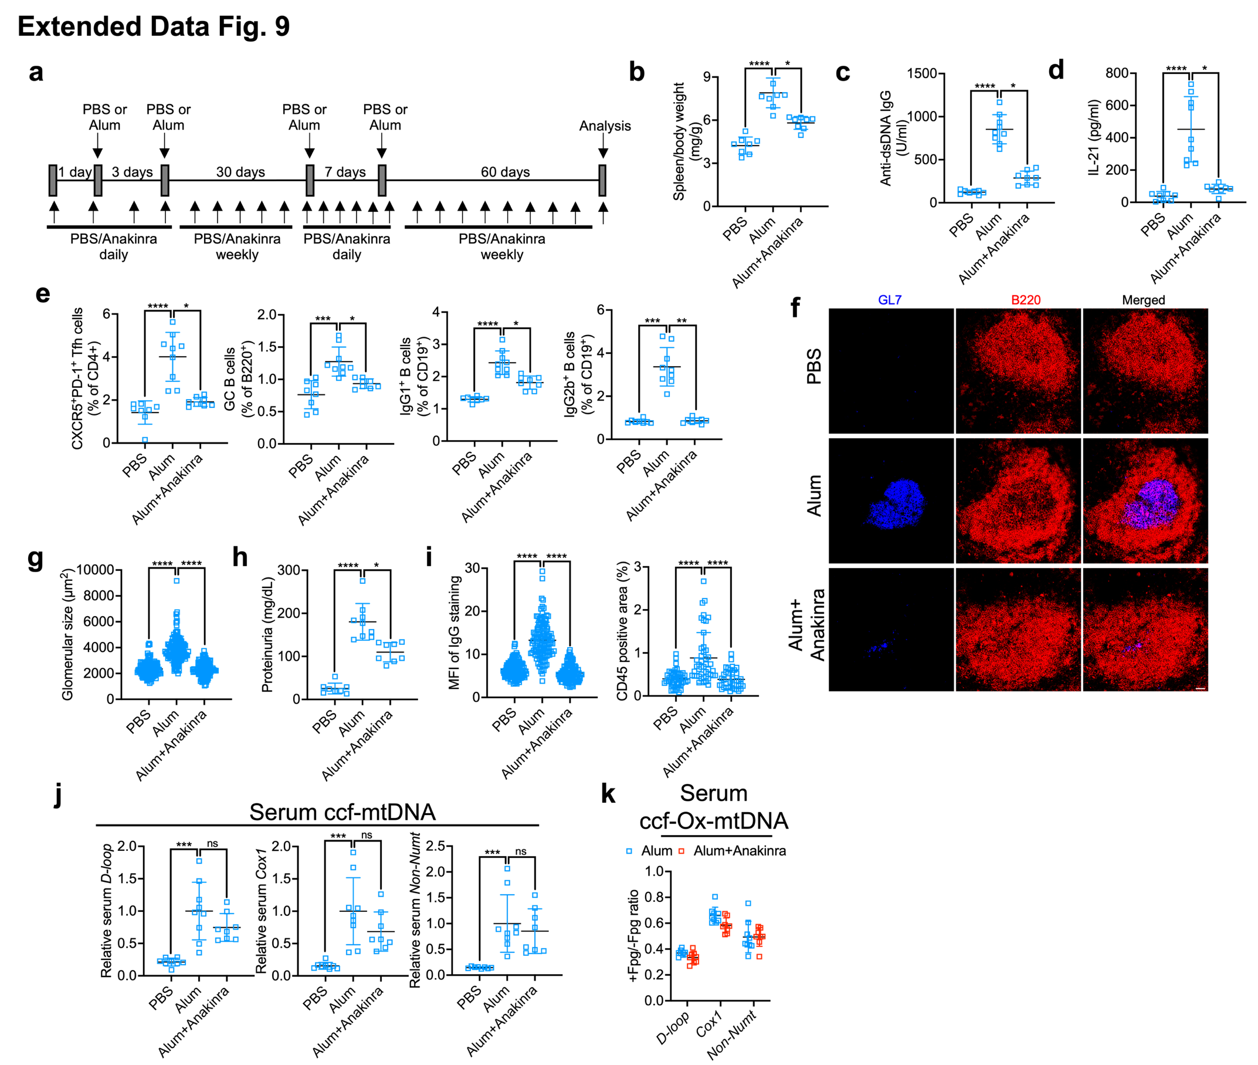
Extended Data Fig. 9: Anakinra blunts alum-induced autoimmunity.
a, Treatment and analysis scheme. B6 females were i.p. injected with PBS or alum -/+ anakinra (25 mg/kg). Autoimmune signs were analyzed at the end of the treatment regimen (n=8/PBS, n=9/alum, n=8/alum+anakinra). b-d, Spleen mass to body weight ratio (b), serum anti-dsDNA IgG (c), serum IL-21 amounts (d), percentages of splenic Tfh, GC B, IgG1⁺IgM⁻CD19⁺ and IgG2b⁺IgM⁻CD19⁺ cells (e), GL7 (blue) and B220 (red) stained spleen sections (Scale bar, 50 μm, f), sizes of glomeruli in kidney sections (n>125, g), urinary protein ELISA (h), MFI quantitation of IgG deposits (n>127) and areas (in %) occupied by CD45⁺ cells (n>37) in kidney sections (i), relative serum ccf-mtDNA (j) and non-Ox-mtDNA (Fpg-resistant) amounts (k).
Results in (b-e and g-k) are mean ± SD. ∗ P<0.05, ∗∗ P<0.01, ∗∗∗ P<0.001, ∗∗∗∗ P<0.0001. ns, not significant. Kruskal–Wallis test.
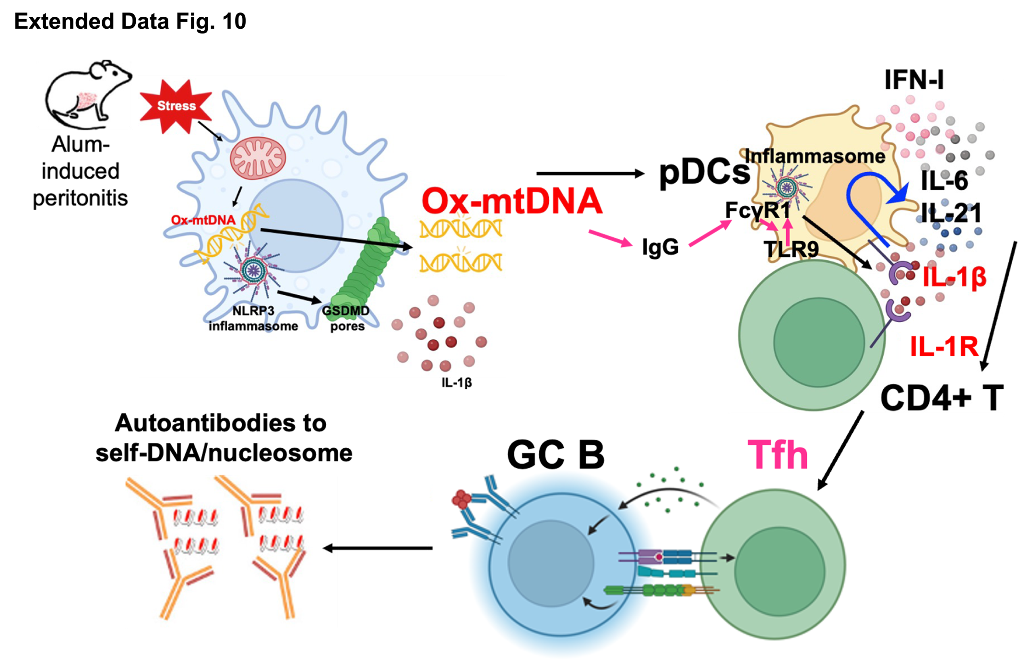
Extended Data Fig. 10: A working model summarizing how Ox-mtDNA induces antibody-mediated autoimmunity.
Ox-mtDNA, an alarmin released by stressed macrophages following NLRP3 inflammasome activation and GSDMD cleavage, is pathogenic after its FcγR1-mediated internalization by pDC and delivery to endosomal TLR9. Through TLR9-mediated NF-κB activation and induction of NLRP3, Ox-mtDNA enables pDC undergo inflammasome activation in response to Ox-mtDNA leakage from ruptured endosomes. NLRP3 inflammasome activation and GSDMD cleavage enable IL-1β secretion. IL-1β-IL1R signaling in pDC and CD4⁺ T cells is crucial for induction of Tfh differentiation, which supports autoantibody production.

