Supplementary Information
Supplementary Figures 1-4
Supplementary Tables 1-2
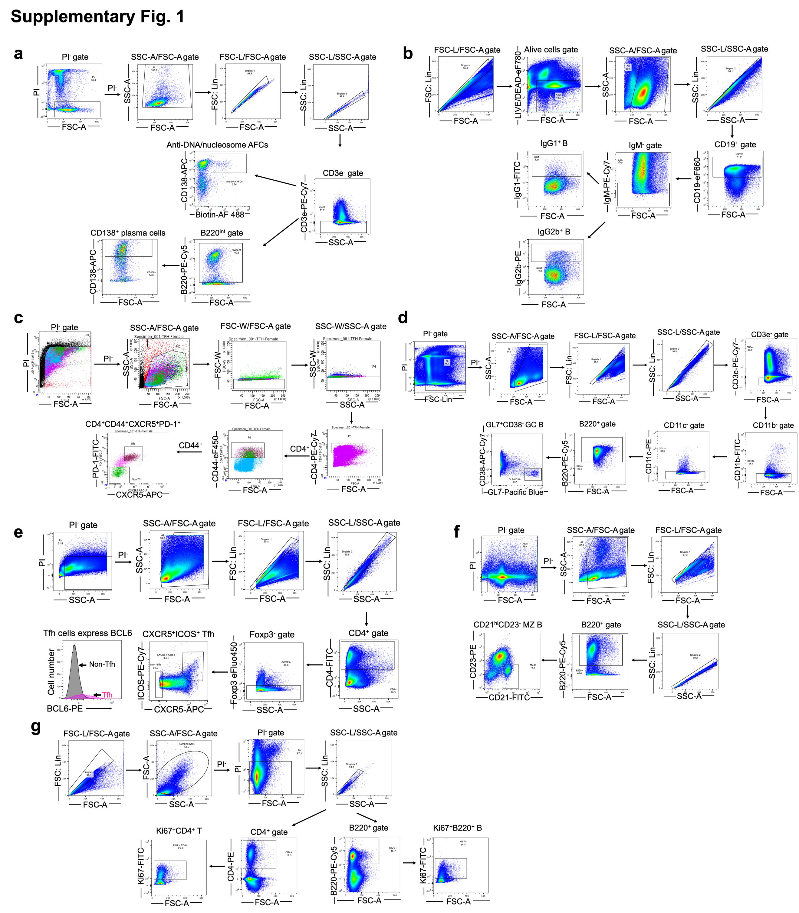
Supplementary Fig. 1: FC gating strategies related to Fig. 1 and Extended Data Fig. 1,2.
a, FC gating strategy of DNA- or nucleosome-reactive AFCs and plasma cells (PC, B220^{int}CD138⁺CD3⁻). b, FC gating strategy of IgM–IgG1⁺CD19⁺ B and IgM–IgG2b⁺CD19⁺ B cells. c, FC gating strategy of Tfh cells (CXCR5⁺PD1⁺CD44⁺CD4⁺). d, FC gating strategy of GC B cells (GL7⁺CD38⁻B220⁺CD3⁻CD11b⁻CD11c⁻). e, FC gating strategy of Tfh cells (CXCR5⁺ICOS⁺Foxp3⁻CD4⁺). The histogram shows Tfh express higher BCL6 levels than non-Tfh (CXCR5⁻Foxp3⁻CD4⁺). f, FC gating strategy of MZ B cells (CD21^{hi}CD23⁻B220⁺). g, FC gating strategy of proliferating Ki67⁺ CD4⁺ T cells and B220⁺ T cells.
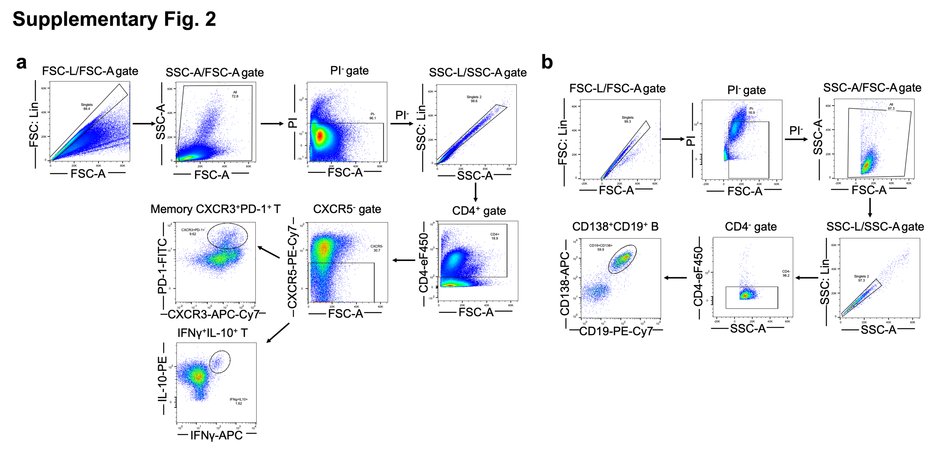
Supplementary Fig. 2: FC gating strategies related to Fig. 2 and Extended Data Fig. 3.
a, FC gating strategy of CXCR3⁺PD1⁺CXCR5⁻CD4⁺ T cells and IFN-γ⁺IL-10⁺CXCR5⁻CD4⁺ T cells. b, FC gating strategy of blood CD138⁺CD19⁺ B cells.
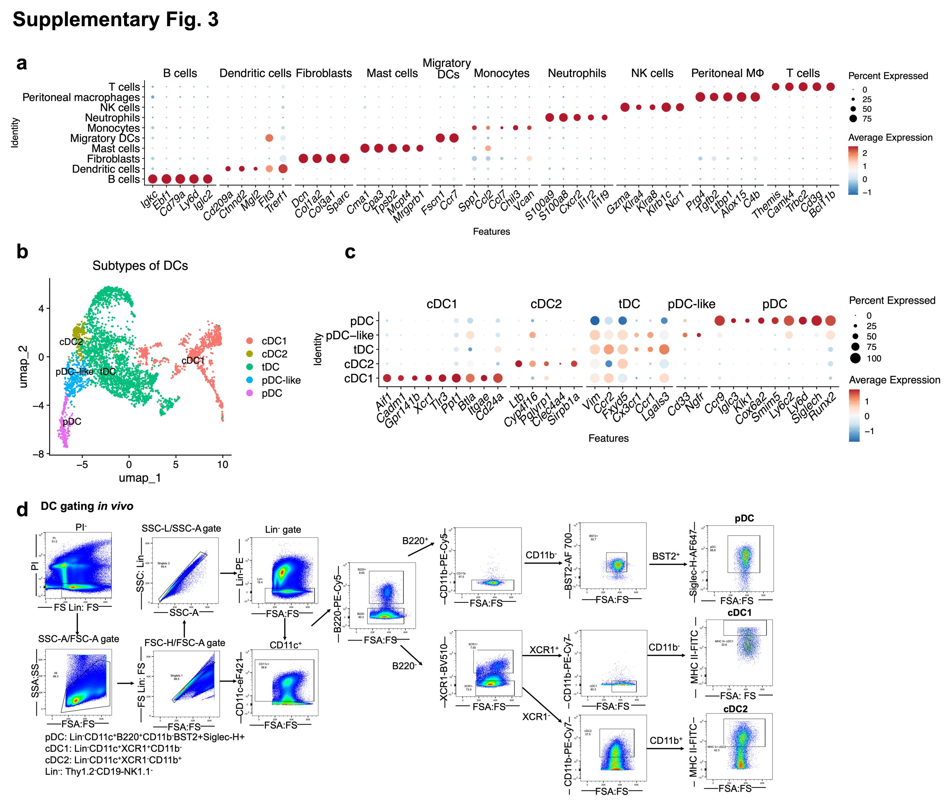
Supplementary Fig. 3: Strategies for defining cell populations, related to Fig. 3 and Extended Data Fig. 4.
a, Markers identifying cell populations shown in Fig. 3a, c. The color scale represents the scaled expression of each gene. Dot size represents the percentage of cells expressing each gene of interest. b,c, UMAP plots (b) and markers (c) identifying DC subclusters in Fig. 3d. d, FC gating strategy of cDC1, cDC2 and pDC.
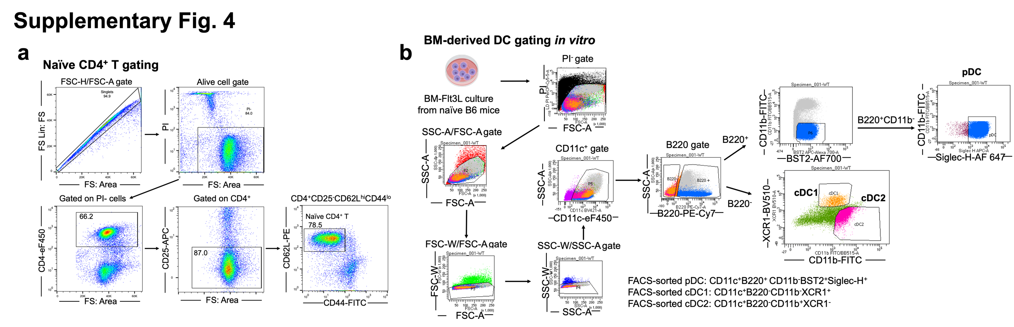
Supplementary Fig. 4: FC gating strategies related to Fig. 4 and Extended Data Fig. 5, 6.
a, FACS sorting strategy of naïve splenic CD4⁺CD25⁻CD62L^{hi}CD44^{lo} T cells. b, FC gating strategy to sort/analyze different DC subsets from BM-Fl3tL cultures.

Supplementary Table 1. Summary of antibodies used in this study.
Antibodies
BD Pharmingen™ PE-Cy™5 Rat Anti-Mouse CD45R/B220 | BD Biosciences | Cat# 553091;  RRID:AB_394621
CD45R (B220) Monoclonal Antibody (RA3-6B2), PE, eBioscience™ | Thermo Fisher Scientific | Cat# 12-0452-82  RRID:AB_465671
CD45R (B220) Monoclonal Antibody (RA3-6B2), FITC, eBioscience™, Invitrogen™ | Thermo Fisher Scientific | Cat# 11045286; RRID:AB_465056
CD45R (B220) Monoclonal Antibody (RA3-6B2), PE-Cyanine7, eBioscience™ | Thermo Fisher Scientific | Cat# 25-0452;  RRID:AB_2341160
CD45R (B220) Monoclonal Antibody (RA3-6B2), eFluor™ 450, eBioscience™ | Thermo Fisher Scientific | Cat# 48-0452  RRID:AB_1548761
CD3e Monoclonal Antibody (145-2C11), PE-Cyanine7, eBioscience™ | Thermo Fisher Scientific | Cat# 25-0031-82; RRID:AB_469572
CD3e Monoclonal Antibody (145-2C11), FITC, eBioscience™ | Thermo Fisher Scientific | Cat# 11-0031-86; RRID:AB_464884
CD3e Monoclonal Antibody (145-2C11), APC, eBioscience™ | Thermo Fisher Scientific | Cat#17-0031-82, RRID:AB_469315
APC anti-mouse CD138 (Syndecan-1) Antibody | BioLegend | Cat# 142506; RRID:AB_10962911
FITC anti-mouse CD169 (Siglec-1) Antibody | BioLegend | Cat# 142405, RRID:AB_2563106
BD Pharmingen™ PE Rat Anti-Mouse CD40 | BD Biosciences | Cat# 553791; RRID:AB_395055
CD4 Monoclonal Antibody (GK1.5), PE, eBioscience™ | Thermo Fisher Scientific | Cat# 12-0041-85; RRID:AB_465508
CD4 Monoclonal Antibody (GK1.5), PE-Cyanine7, eBioscience™ | Thermo Fisher Scientific | Cat# 25-0041-81; RRID:AB_469575
CD4 Monoclonal Antibody (GK1.5), APC, eBioscience™ | Thermo Fisher Scientific | Cat# 17-0041-83; RRID:AB_469321
CD4 Monoclonal Antibody (RM4-5), eFluor™ 450, eBioscience™ | Thermo Fisher Scientific | Cat# 48-0042-80; RRID:AB_1272231
CD4 Monoclonal Antibody (GK1.5), FITC, eBioscience™ | Thermo Fisher Scientific | Cat# 11-0041-86; RRID:AB_464894
CD44 Monoclonal Antibody (IM7), PE-Cyanine5, eBioscience™ | Thermo Fisher Scientific | Cat# 15-0441-83; RRID:AB_468750
BD Pharmingen™ FITC Rat Anti-Mouse CD44 | BD Biosciences | Cat# 553133; RRID:AB_2076224
CD44 Monoclonal Antibody (IM7), FITC, eBioscience™ | Thermo Fisher Scientific | Cat# 11-0441-85; RRID:AB_465046
CD44 Monoclonal Antibody (IM7), eFluor™ 450, eBioscience™ | Thermo Fisher Scientific | Cat# 48-0441-82; RRID:AB_1272246
CD185 (CXCR5) Monoclonal Antibody (SPRCL5), APC, eBioscience™ | Thermo Fisher Scientific | Cat# 17-7185-80; RRID:AB_2573259
CD185 (CXCR5) Monoclonal Antibody (SPRCL5), PE-Cyanine7, eBioscience™ | Thermo Fisher Scientific | Cat# 25-7185-82; N/A
CD279 (PD-1) Monoclonal Antibody (J43), FITC, eBioscience™ | Thermo Fisher Scientific | Catalog# 11-9985-81; N/A
BD Pharmingen™ PE Mouse anti-Bcl-6 | BD Biosciences | Cat# 561522; RRID:AB_10717126
FOXP3 Monoclonal Antibody (FJK-16s), eFluor™ 450, eBioscience™ | Thermo Fisher Scientific | Cat# 48-5773-80; RRID:AB_1518813
PE/Cyanine7 anti-mouse CD278 (ICOS) Antibody | BioLegend | Cat# 117422; RRID:AB_2860637
Biotin anti-mouse CD275 (B7-H2, B7-RP1, ICOS Ligand) Antibody | BioLegend | Cat# 107403; N/A
IL-21 Monoclonal Antibody (FFA21), PE, eBioscience™ | Thermo Fisher Scientific | Catalog# 12-7211-82; N/A
CD11b Monoclonal Antibody (M1/70), PE-Cyanine7, eBioscience™ | Thermo Fisher Scientific | Cat# 25-0112-82, RRID:AB_469588
CD11b Monoclonal Antibody (M1/70), FITC, eBioscience™ | Thermo Fisher Scientific | Cat# 11-0112-86, RRID:AB_464937
CD11b Monoclonal Antibody (M1/70), eFluor™ 660, eBioscience™ | Thermo Fisher Scientific | Cat# 50-0112-82, RRID:AB_11218507
CD11b Monoclonal Antibody (M1/70), PE, eBioscience™ | Thermo Fisher Scientific | Cat# 12-0112-82, RRID:AB_2734869
CD11b Monoclonal Antibody (M1/70), eFluor™ 450, eBioscience™ | Thermo Fisher Scientific | Cat# 48-0112-80, RRID:AB_1582237
CD11c Monoclonal Antibody (N418), PE, eBioscience™ | Thermo Fisher Scientific | Cat# 12-0114-82, RRID:AB_465552
CD11c Monoclonal Antibody (N418), APC, eBioscience™ | Thermo Fisher Scientific | Cat# 17-0114-82, RRID:AB_469346
CD11c Monoclonal Antibody (N418), eFluor™ 450, eBioscience™ | Thermo Fisher Scientific | Cat# 48-0114-82, RRID:AB_1548654
CD11c Monoclonal Antibody (N418), Biotin, eBioscience™ | Thermo Fisher Scientific | Cat# 13-0114-85, RRID:AB_466364
Pacific Blue™ anti-mouse/human GL7 Antigen (T and B cell Activation Marker) Antibody | BioLegend | Cat# 144614, RRID:AB_2563291
CD95 (APO-1/Fas) Monoclonal Antibody (15A7), APC, eBioscience™ | Thermo Fisher Scientific | Cat# 17-0951-82, RRID:AB_10717405
APC/Cyanine7 anti-mouse CD183 (CXCR3) Antibody | BioLegend | Cat# 126552, RRID:AB_2892280
BD Pharmingen™ FITC Rat Anti-Mouse CD21/CD35 | BD Biosciences | Cat# 553818, RRID:AB_395070
BD Pharmingen™ PE Rat Anti-Mouse CD23 | BD Biosciences | Cat# 553139, RRID:AB_394654
Ki-67 Monoclonal Antibody (SolA15), eFluor™ 450, eBioscience™ | Thermo Fisher Scientific | Catalog# 48-5698-82; N/A
IL-10 Monoclonal Antibody (JES5-16E3), PE, eBioscience™ | Thermo Fisher Scientific | Cat# 12-7101-82, RRID:AB_466176
IFN gamma Monoclonal Antibody (XMG1.2), eFluor™ 660, eBioscience™ | Thermo Fisher Scientific | Cat# 50-7311-82, RRID:AB_11217680
Pacific Blue™ anti-mouse IgD Antibody | BioLegend | Cat# 405712, RRID:AB_1937244
PE anti-mouse IgG2b Antibody | BioLegend | Cat# 406708, RRID:AB_2563381
FITC anti-mouse IgG1 Antibody | BioLegend | Cat# 406606, RRID:AB_493293
BD Pharmingen™ PE Rat Anti-Mouse IgM | BD Biosciences | Cat# 553409, RRID:AB_394845
IgM Monoclonal Antibody (II/41), PE-Cyanine7, eBioscience™ | Thermo Fisher Scientific | Cat# 25-5790-82, RRID:AB_469655
Brilliant Violet 421™ anti-mouse CD138 (Syndecan-1) Antibody | BioLegend | Cat# 142523, RRID:AB_2565621
PE anti-mouse CD138 (Syndecan-1) Antibody | BioLegend | Cat# 142504, RRID:AB_10915989
APC anti-mouse CD138 (Syndecan-1) Antibody | BioLegend | Cat# 142506, RRID:AB_10962911
APC/Cyanine7 anti-mouse CD38 Antibody | BioLegend | Cat# 102727, RRID:AB_2616967
CD19 Monoclonal Antibody (eBio1D3 (1D3)), FITC, eBioscience™ | Thermo Fisher Scientific | Cat# 11-0193-86, RRID:AB_657665
CD19 Monoclonal Antibody (eBio1D3 (1D3)), PE, eBioscience™ | Thermo Fisher Scientific | Cat# 12-0193-85, RRID:AB_657662
CD19 Monoclonal Antibody (eBio1D3 (1D3)), eFluor™ 660, eBioscience™ | Thermo Fisher Scientific | Cat# 50-0193-82, RRID:AB_11218286
CD19 Monoclonal Antibody (eBio1D3 (1D3)), eFluor™ 450, eBioscience™ | Thermo Fisher Scientific | Cat# 48-0193-82, RRID:AB_2734905
CD19 Monoclonal Antibody (eBio1D3 (1D3)), PE-Cyanine5, eBioscience™ | Thermo Fisher Scientific | Cat# 15-0193-83, RRID:AB_657673
PE/Cyanine7 anti-mouse CD19 Antibody | BioLegend | Cat# 115520, RRID:AB_313655
MHC Class II (I-A/I-E) Monoclonal Antibody (M5/114.15.2), FITC, eBioscience™ | Thermo Fisher Scientific | Cat# 11-5321-85, RRID:AB_465233
MHC Class II (I-A/I-E) Monoclonal Antibody (M5/114.15.2), PE, eBioscience™ | Thermo Fisher Scientific | Cat# 12-5321-83, RRID:AB_465929
BD Pharmingen™ PE Rat Anti-Mouse CD90.2 | BD Biosciences | Cat# 553005, RRID:AB_394544
BD Pharmingen™ FITC Rat Anti-Mouse CD90.2 | BD Biosciences | Cat# 553004, RRID:AB_394543
NK1.1 Monoclonal Antibody (PK136), APC, eBioscience™ | Thermo Fisher Scientific | Cat# 17-5941-82, RRID:AB_469479
NK1.1 Monoclonal Antibody (PK136), PE, eBioscience™ | Thermo Fisher Scientific | Cat# 12-5941-83, RRID:AB_466051
FITC anti-mouse/rat XCR1 Antibody | BioLegend | Cat# 148210, RRID:AB_2564366
Brilliant Violet 421™ anti-mouse/rat XCR1 Antibody | BioLegend | Cat# 148216, RRID:AB_2565230
Brilliant Violet 510™ anti-mouse/rat XCR1 Antibody | BioLegend | Cat# 148218, RRID:AB_2565231
Alexa Fluor® 700 anti-mouse CD317 (BST2, PDCA-1) Antibody | BioLegend | Cat# 127038, RRID:AB_2832458
FITC anti-mouse CD317 (BST2, PDCA-1) Antibody | BioLegend | Cat# 127008, RRID:AB_2028462
BD Pharmingen™ Alexa Fluor™ 647 Rat Anti-Mouse Siglec-H | BD Biosciences | Cat# 567806, NA
BD Pharmingen™ PE Rat Anti-Mouse CD40 | BD Biosciences | Cat# 553791, RRID:AB_395055
BD Pharmingen™ PE Hamster Anti-Mouse CD80 | BD Biosciences | Cat# 553769, RRID:AB_395039
FITC Conjugated Anti-Mouse IFN-Alpha, Clone RMMA-1 (MAb) | PBL Assay Science | Cat# 22100-3, N/A
Alexa Fluor® 488 anti-IRF7 Antibody | BioLegend | Cat# 656005, RRID:AB_2563528
PE anti-IRF7 Antibody | BioLegend | Cat# 656004, RRID:AB_2563007
IL-6 Monoclonal Antibody (MP5-20F3), PE, eBioscience™ | Thermo Fisher Scientific | Cat# 12-7061-81, RRID:AB_466164
CD25 Monoclonal Antibody (PC61.5), APC, eBioscience™ | Thermo Fisher Scientific | Cat# 17-0251-82, RRID:AB_469366
CD62L (L-Selectin) Monoclonal Antibody (MEL-14), PE, eBioscience™ | Thermo Fisher Scientific | Cat# 12-0621-85, RRID:AB_465723
F4/80 Monoclonal Antibody (BM8), PE, eBioscience™ | Thermo Fisher Scientific | Cat# 12-4801-82, RRID:AB_465923
Ly-6G Monoclonal Antibody (1A8-Ly6g), PerCP-eFluor™ 710, eBioscience™ | Thermo Fisher Scientific | Cat# 46-9668-82, RRID:AB_2573893
Ly-6G Monoclonal Antibody (1A8-Ly6g), APC, eBioscience™ | Thermo Fisher Scientific | Cat# 17-9668-82, RRID:AB_2573307
Ly-6C Monoclonal Antibody (HK1.4), eFluor™ 450, eBioscience™ | Thermo Fisher Scientific | Cat# 48-5932-80, RRID:AB_10805518
Brilliant Violet 510™ anti-mouse CD45 Antibody | BioLegend | Cat# 103138, RRID:AB_2563061
FITC anti-mouse CD289 (TLR9) Antibody | BioLegend | Cat# 159107, RRID:AB_2876554
APC anti-mouse CD289 (TLR9) Antibody | BioLegend | Cat# 159105, RRID:AB_2876553
Phospho-NFKB p65 (Ser281) Polyclonal Antibody, Alexa Fluor™ 488 | Bioss | Catalog # BS-17502R-A488, N/A
Phospho-NF-κB p65 (Ser536) (93H1) Rabbit mAb (Alexa Fluor® 647 Conjugate) | Cell Signaling Technology | Cat# 4887, RRID:AB_561198
Polyclonal Rabbit anti‑Human NALP3 / NLRP3 Antibody | LS Bio | Cat#LS-C334192-20, N/A
TLR9 Polyclonal Antibody | Thermo Fisher Scientific | Cat# PA5-20203, RRID:AB_11152135
Anti-DNA Antibody, clone AC-30-10 | Millipore | Cat# CBL186, RRID:AB_93367
Galectin 8 Polyclonal Antibody | Thermo Fisher Scientific | Cat# PA5-50965, RRID:AB_2636413
ASC | Cell Signaling | Cat# 67824,  N/A
Anti-Ki67 antibody | Abcam | Cat# ab15580, RRID:AB_443209
TLR9 Antibody (F-3) | Santa Cruz Biotechnology | Cat#sc-515921, N/A
TLR9 Antibody (26C593) | Santa Cruz Biotechnology | Cat# sc-52966, RRID:AB_793207
CD45 Monoclonal Antibody (30-F11), eBioscience™ | Thermo Fisher Scientific | Cat# 14-0451-85, RRID:AB_467252
Goat anti-Mouse IgG (H+L) Cross-Adsorbed Secondary Antibody, Alexa Fluor™ 488 | Thermo Fisher Scientific) | Cat# A-11001, RRID:AB_2534069
FITC F(ab')2 Goat Anti-Mouse Complement C3 | MP Bio | Cat# 0855510, RRID:AB_2334516
ASC | Adipogen | Cat#AG-25b-0006-C100; N/A
NLRP3 | Adipogen | Cat#AG-20B-0014-C100; N/A
Mouse IL-1beta /IL-1F2 Antibody | R&D Systems | Ca#MAB401;  RRID:AB_2124620
Mouse IL-1beta /IL-1F2 Biotinylated Antibody | R&D Systems | Ca#BAF401;  RRID: AB_356450
FITC anti-mouse CD11b | eBioscience | Cat#11-0112-82; RRID:AB_464935
PE-Cy7 anti-mouse Gr-1 | eBioscience | Cat#25-5931-82; RRID:AB_469663
eFluor 450 anti-mouse Ly-6C | eBioscience | Cat#48-5932-80;  RRID:AB_10805518
PE anti-mouse F4/80 | eBioscience | Cat#12-4801-82;  RRID:AB_465923
CD16/CD32 | eBioscience | Cat#14-0161-86;  RRID:AB_467135
Donkey anti-rabbit IgG (H+L) secondary antibody, Alexa Fluor 488 | Invitrogen | Cat#A-21206; RRID:AB_2535792
Donkey anti-rabbit IgG (H+L) secondary antibody, Alexa Fluor 594 | Invitrogen | Cat#A-21207; RRID:AB_141637
Donkey anti-mouse IgG (H+L) secondary antibody, Alexa Fluor 488 | Invitrogen | Cat#A-21202; RRID:AB_141607
Donkey anti-mouse IgG (H+L) secondary antibody, Alexa Fluor 594 | Invitrogen | Cat#A-21203; RRID:AB_141633
Donkey anti-rat IgG (H+L) secondary antibody, Alexa Fluor 594 | Invitrogen | Cat#A-21209; RRID:AB_2535795
Donkey anti-Rat IgG (H+L) Highly Cross-Adsorbed Secondary Antibody, Alexa Fluor™ 488 | Invitrogen | Cat# A-21208; RRID:AB_2535794
Mouse IgG1 kappa Isotype Control (P3.6.2.8.1), PE, eBioscience™ | Thermo Fisher Scientific | Cat# 12-4714-82, RRID:AB_470060
Mouse IgG1 kappa Isotype Control (P3.6.2.8.1), FITC, eBioscience™ | Thermo Fisher Scientific | Cat# 11-4714-42, RRID:AB_10596964
Mouse IgG1 Isotype Control (MOPC-21), DyLight™ 488 | Thermo Fisher Scientific | Cat# MA1-191-D488, RRID:AB_2536927
Rat IgG2a kappa Isotype Control (eBR2a), FITC, eBioscience™ | Thermo Fisher Scientific | Cat# 11-4321-42, RRID:AB_10669580
Rat IgG2a kappa Isotype Control (eBR2a), PE, eBioscience™ | Thermo Fisher Scientific | Cat# 12-4321-80, RRID:AB_1834380
Rat IgG2a kappa Isotype Control (eBR2a), APC, eBioscience™ | Thermo Fisher Scientific | Cat# 17-4321-81, RRID:AB_470181
Mouse IgG2a Isotype Control (MOPC-173), DyLight™ 488 | Thermo Fisher Scientific | Cat# MA1-193-D488, RRID:AB_2536960
Mouse IgG2b kappa Isotype Control (eBMG2b), PE, eBioscience™ | Thermo Fisher Scientific | Cat# 12-4732-81, RRID:AB_763659
Mouse IgG2b Isotype Control (MPC-11), DyLight™ 488 | Thermo Fisher Scientific | Cat# MA1-192-D488, RRID:AB_2536950
Mouse IgG3 Isotype Control (PPV-07), DyLight™ 488 | Thermo Fisher Scientific | Cat# MA1-190-D488, RRID:AB_2536894
Mouse IgG3 Isotype Control (PPV-07), DyLight™ 650 | Thermo Fisher Scientific | Cat# MA1-190-D650, RRID:AB_2536895
Rabbit IgG Isotype Control (SP137) | Thermo Fisher Scientific | Cat# MA5-16384, RRID:AB_2537903

Supplementary Table 2. Summary of primers to examine ccf-mtDNA amounts.
Primers for mouse D-loop  Forward: AATCTACCATCCTCCGTGAAACC  Reverse: TCAGTTTAGCTACCCCCAAGTTTAA | Integrated DNA Technologies | N/A
Primers for mouse 18S  Forward: TAGAGGGACAAGTGGCGTTC  Reverse: CGCTGAGCCAGTCAGTGT | Integrated DNA Technologies | N/A
Primers for mouse Tert  Forward: CTAGCTCATGTGTCAAGACCCTCTT  Reverse: GCCAGCACGTTTCTCTCGTT | Integrated DNA Technologies | N/A
Primers for mouse Cox1  Forward: GCCCCAGATATAGCATTCCC  Reverse: GTTCATCCTGTTCCTGCTCC | Integrated DNA Technologies | N/A
Primers for mouse Non-Numt  Forward: CTAGAAACCCCGAAACCAAA  Reverse: CCAGCTATCACCAAGCTCGT | Integrated DNA Technologies^{1, 2} | N/A
Primers for mouse B2m  Forward: ATGGGAAGCCGAACATACTG  Reverse: CAGTCTCAGTGGG GGTGAAT | Integrated DNA Technologies | N/A

References

1. Xian, H. et al. Metformin inhibition of mitochondrial ATP and DNA synthesis abrogates NLRP3 inflammasome activation and pulmonary inflammation. Immunity 54, 1463-1477.e1411 (2021).

2. Xian, H. et al. Oxidized DNA fragments exit mitochondria via mPTP- and VDAC-dependent channels to activate NLRP3 inflammasome and interferon signaling. Immunity 55, 1370-1385.e1378 (2022).

