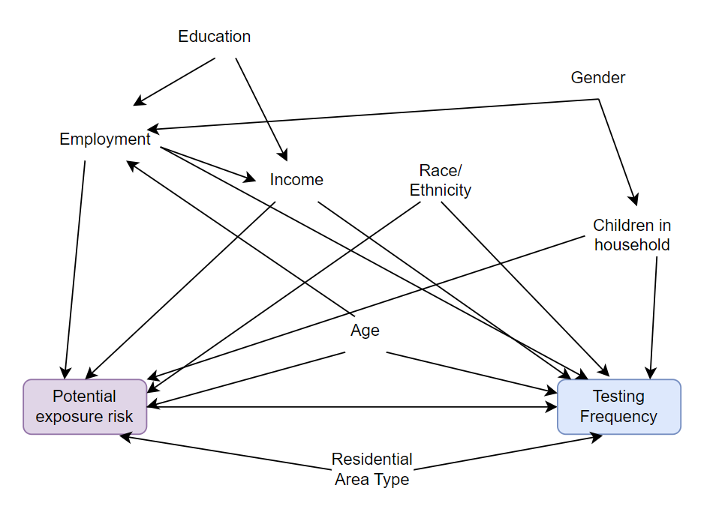
Supplemental Figure 1. Directed Acyclic Graph depicting the relationship between potential exposure risk and testing frequency. Minimum sufficient set includes the following variables: age, race/ethnicity, employment, household income, children in the household, and residential area type

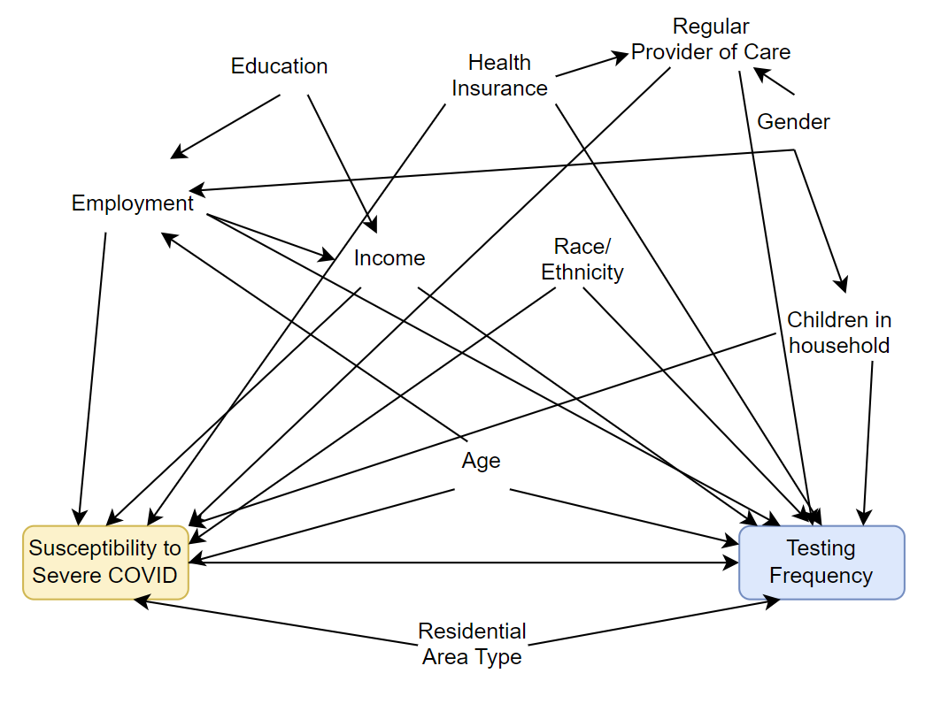
Supplemental Figure 2. Directed Acyclic Graph depicting the relationship between having a condition or exposure increasing susceptibility to severe COVID-19 and testing frequency. Minimum sufficient set includes the following variables: age, employment, income, race/ethnicity, regular provider of care, health insurance, children in the household, and residential area type

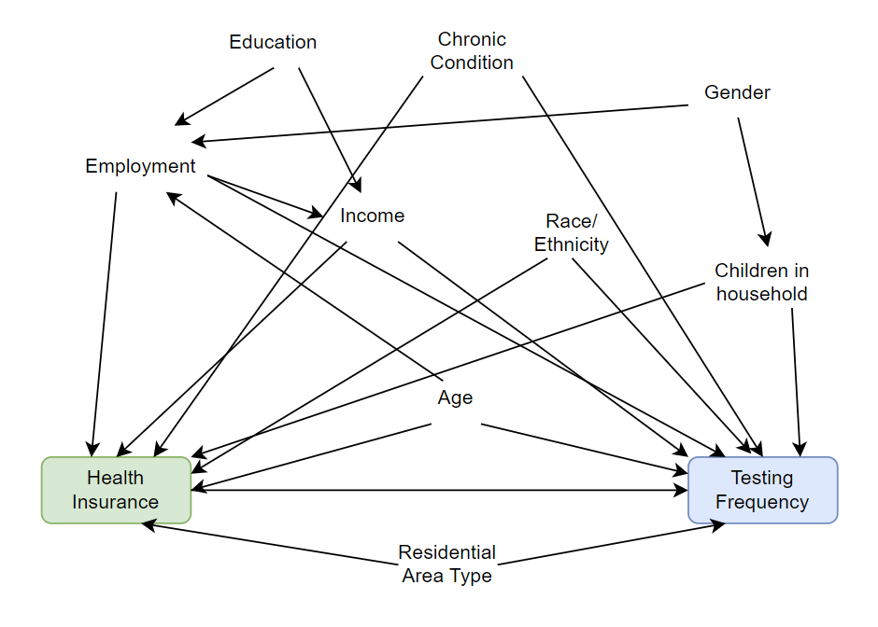

Supplemental Figure 3. Directed Acyclic Graph depicting the relationship between health insurance and testing frequency. Minimum sufficient set includes the following variables: age, chronic condition, employment, household income, race/ethnicity, children in household, and residential area type

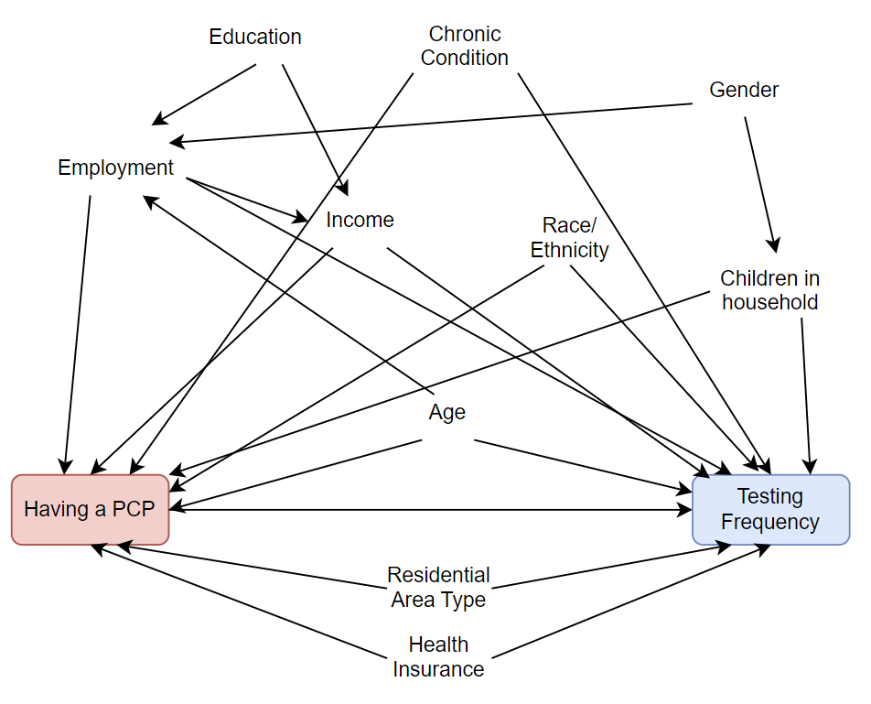
Supplemental Figure 4. Directed Acyclic Graph depicting the relationship between having a primary care provider and testing frequency. Minimum sufficient set includes the following variables: age, chronic condition, employment, household income, race/ethnicity, children in household, residential area type, and health insurance

