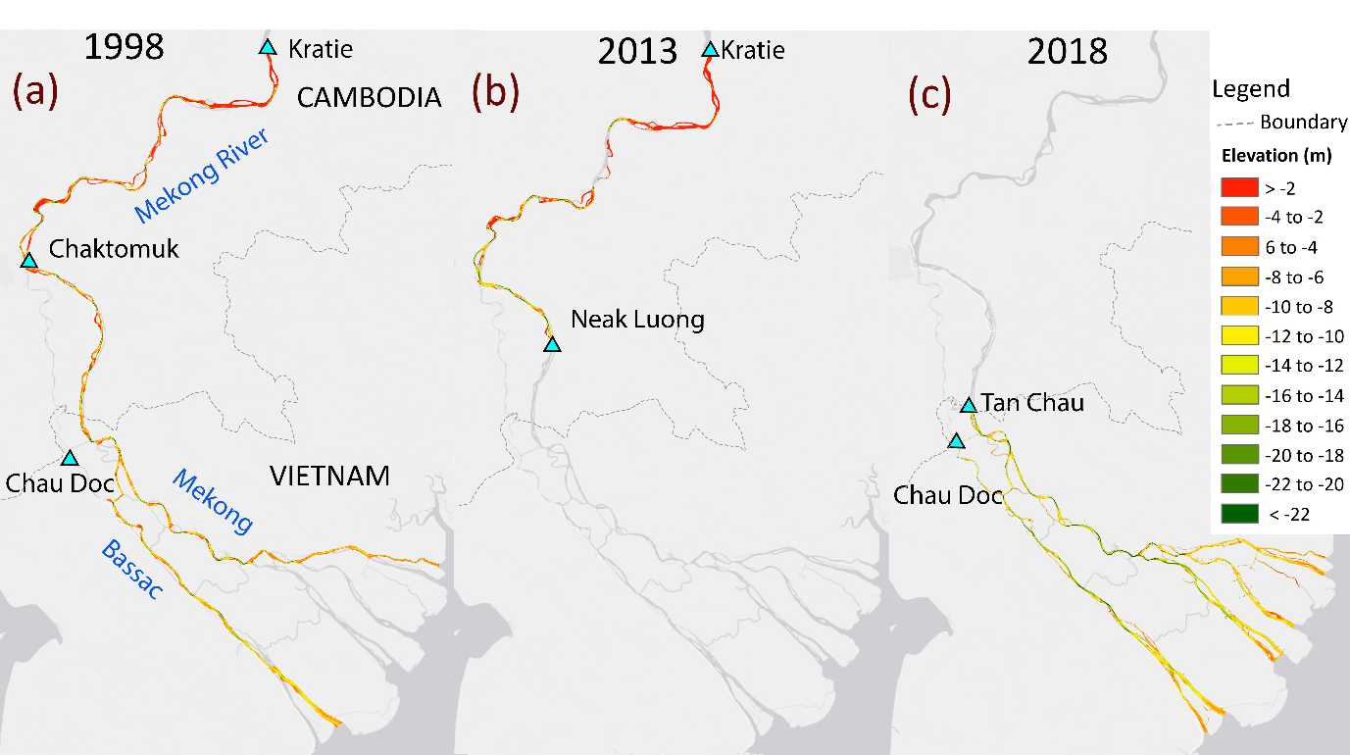
Extended Data Figure 1. (a) The 1998 bathymetric dataset collected for the Mekong Delta during the 1998 original surveyed by the Mekong River Commission (www.mrcmekong.org). This dataset comprises a series of riverbed elevation points that cover a significant portion of the main Mekong channel in the Cambodia region, but they only cover approximately 51% of the principal distributary channels within the Vietnam Mekong delta. These bathymetric records were obtained from Vasilopoulos et al.²⁸; (b) The historical bathymetric data for the year 2013 was collected from Hackney et al.²⁵, with a primary focus on the main Mekong channels from Kratie to Neak Luong in Cambodia; (c) The river bathymetry dataset for 2018 exclusively covers territory in Vietnam, extending from Tan Chau in the Mekong channel and Chau Doc in the Bassac channels to the Mekong coastal zone, and are obtained from Vasilopoulos et al.²⁸. These three bathymetric datasets are referenced to the WGS84 coordinates and Hon Dau vertical datum. Then, these bathymetric datasets are transformed into elevation surface maps (DEMs), using ArcGIS version 10.8 software. This transformation is accomplished through the application of the kriging interpolation toolkit, resulting in an interpolated grid resolution of 50 m.
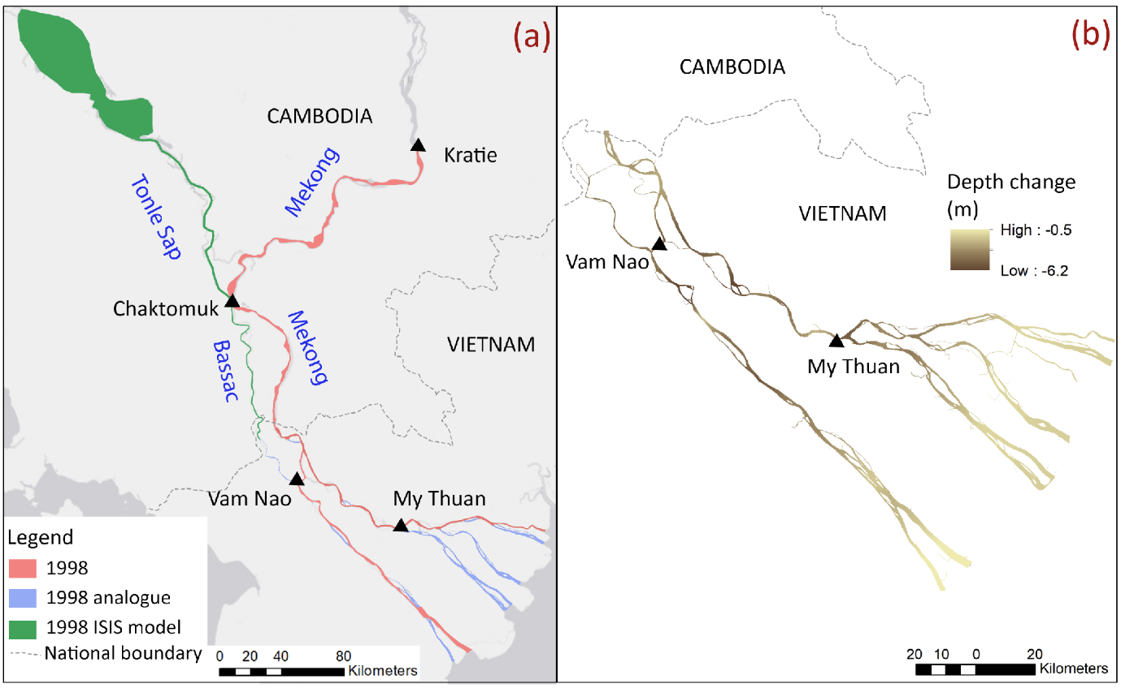
Extended Data Figure 2. (a) The coverage areas of the different mainstream river bathymetry datasets employed in generating a cross-sectional dataset for 1D modelling; (b) The spatial progression of main channels deepening in VMD from 1998 to 2018 as adopted from Vasilopoulos et al.²⁸

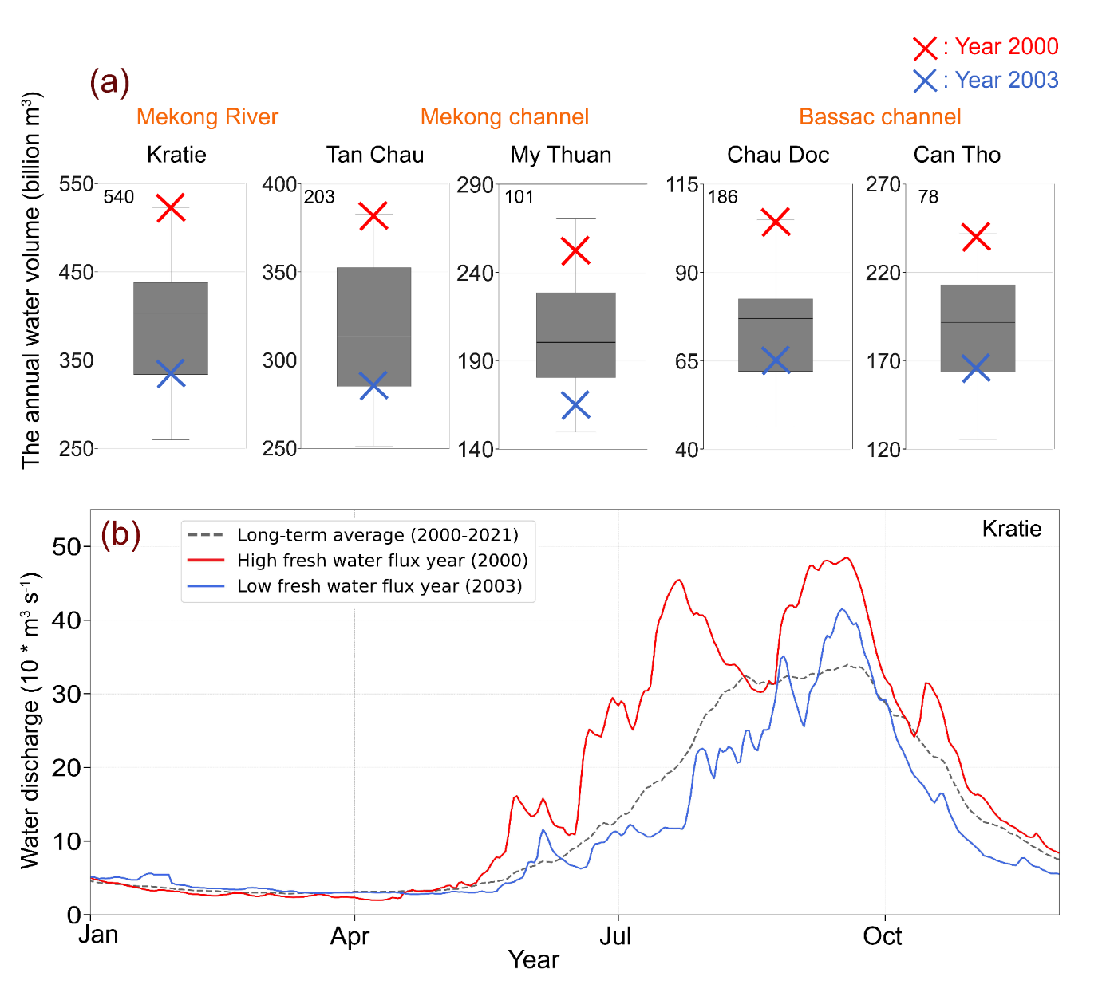
Extended Data Figure 3. (a) Boxplots showing range of annual flow volumes at selected monitoring gauges within the lower Mekong system as measured from MRC and the Southern Regional Hydro-Meteorological Centre, Vietnam (SRHMC) for 2000-2021 highlighting the distinct years chosen to simulate high (2000) and low (2003) flow discharge conditions to calibrate and validate the numerical model. The number stated at the upper left corner of each panel specifies the distance from the gauge to the channel mouth; (b) Observed long-term average hydrograph for Kratie for 2000-2021 (black) also showing hydrographs for 2000 (red) and 2003 (blue) as used in model calibration and validation.

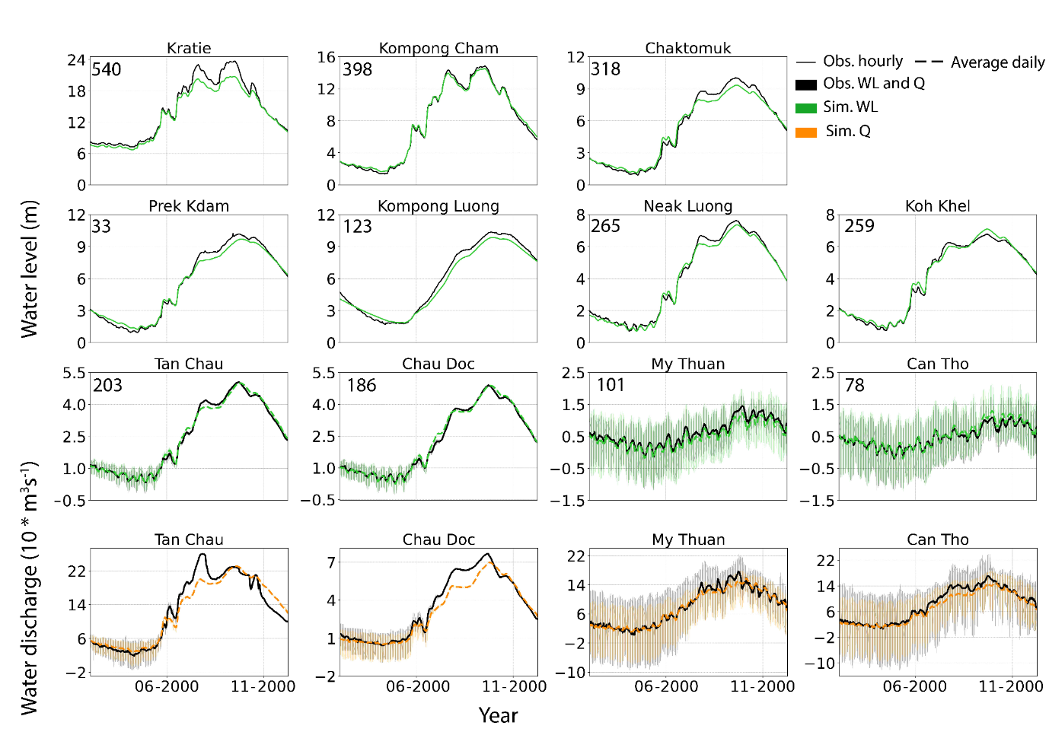
Extended Data Figure 4. Assessing the agreement between the predicted and observed data for water level and water discharge at monitoring stations throughout the lower Mekong system during the calibration run for the high-water flux year of 2000. The number stated at the upper left corner of each panel typically specifies the distance from the gauge to the channel mouth, however for Prek Kdam and Kompong Luong on the TSR and TSL, the stated values represent the distance from the gauges to the Chaktomuk junction. The upstream stations within Cambodia's territory only provide water level data at a daily resolution, therefore, the simulated data in these areas is also organized into daily data for comparison purposes. In contrast, the values in the VMD encompass both water level and water discharge data at hourly intervals. This hourly data allows for the visualization of tidal signal amplitudes through subtle colour variations. Additionally, organizing this data into daily increments, as demonstrated for the upstream gauges, allows for the presentation of the overarching trends in water level or water discharge.
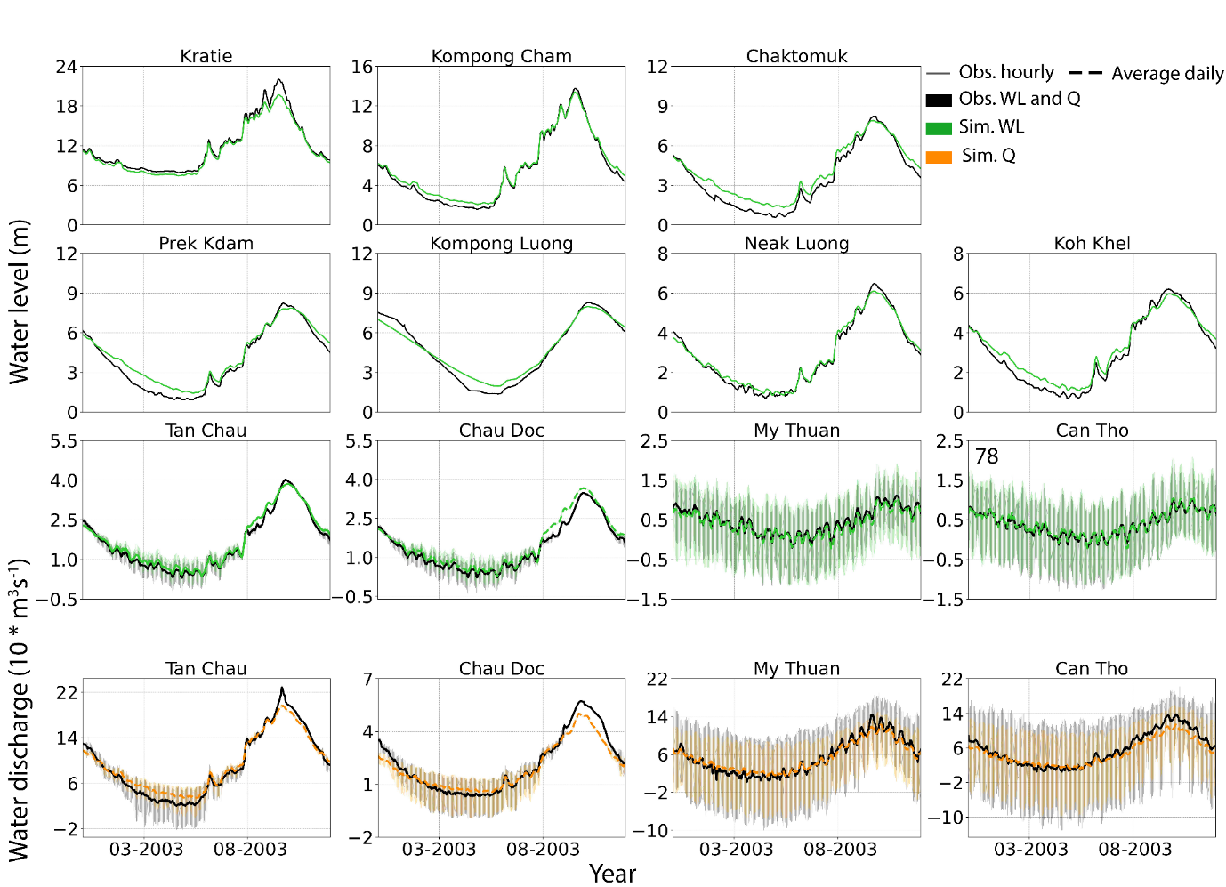
Extended Data Figure 5. Comparison of simulated and observed water levels and water discharges at selected monitoring stations across the lower Mekong system during the validation run for the low-water flux year of 2003.

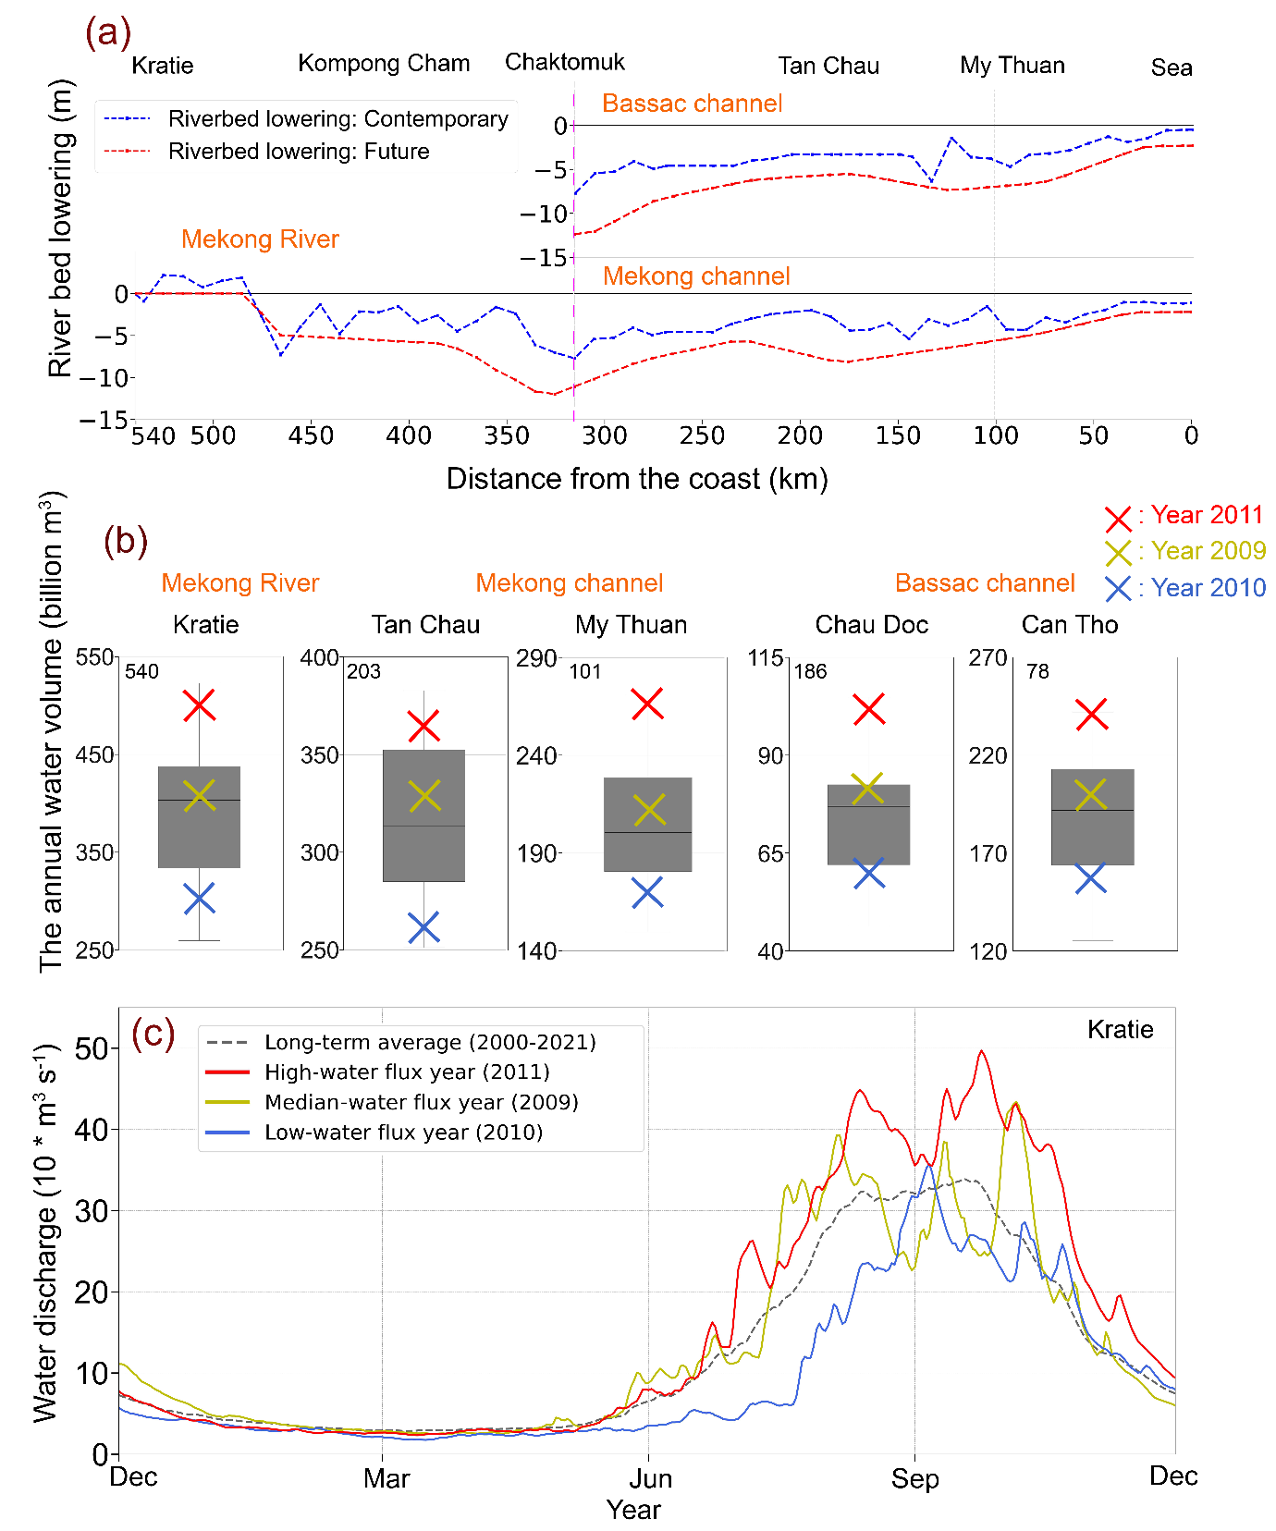
Extended Data Figure 6. (a) Development of two scenarios for the accumulated average riverbed lowering between 1998-2018 and 1998-projected 2038 along the longitudinal axis for the two main Mekong and Bassac channels. The outcomes show an average riverbed lowering of 3.06 m ($σ$ = 2.03 m) from 1998 to 2018 and 5.92 m ($σ$ = 2.84 m) for the 1998 to 2038 scenarios for both channels; (b) Boxplots of total annual water volume recorded at different gauges across the lower Mekong system for the 2000-2021 period highlighting datasets for the high- (2011) median- (2009) and low-(2010) water flux years; (c) Discharge hydrographs as estimated at Kratie for the years 2009 (median flow scenario; yellow), 2010 (low flow scenario; blue) and 2011 (high flow scenario; red) in relation to the long term mean hydrograph for the period 2000-2021.
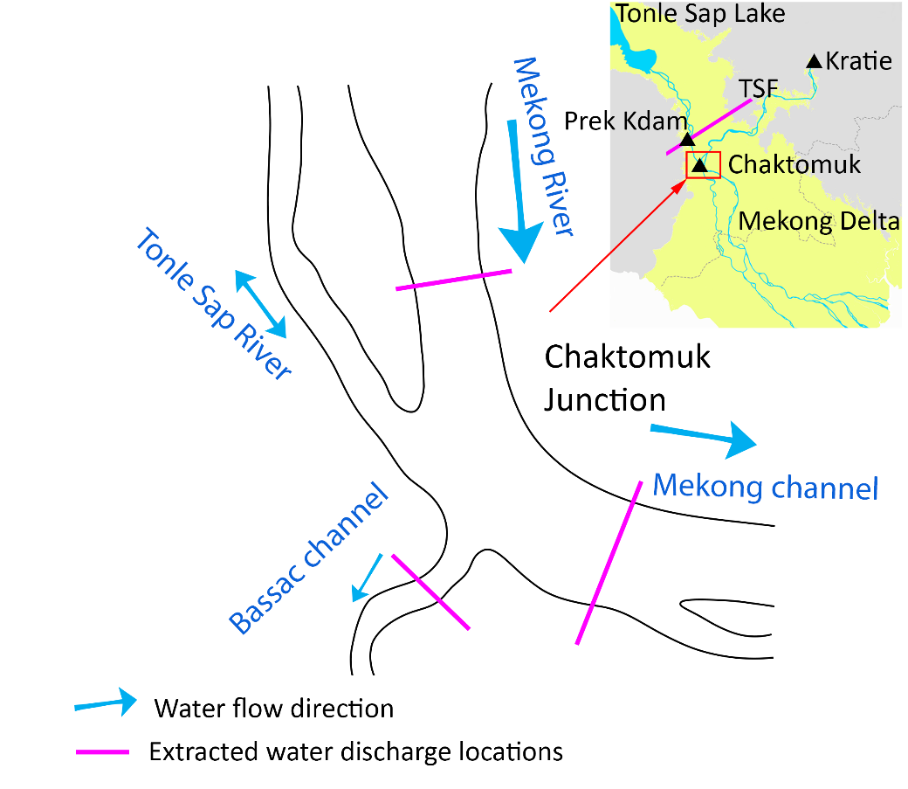
Extended Data Figure 7. Locations of model data extraction.
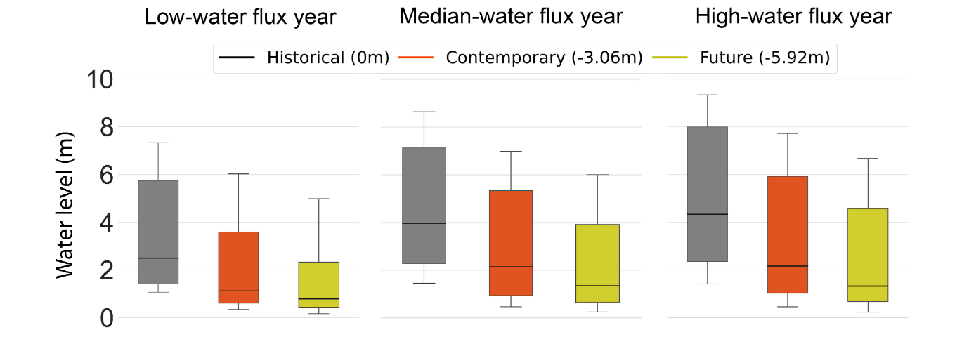
Extended Data Figure 8. Simulated water levels at the Chaktomuk Junction using the Baseline historical, Contemporary and Future bathymetric scenarios and all upstream water flux condition scenarios.
Extended Data Table 1. Existing gauge stations and data availability (source: MRC and Southern Regional Hydro-Meteorological Centre (SRHMC))
No | Gauges (code) | Latitude  (⁰N) | Longitude  (⁰E) | Available data period |  | Resolution | Channel
 |  |  |  | Discharge | Water level
1 | Kratie (KH_014901) | 12.481 | 106.018 | 2000-2021 |  | Daily | Mekong
2 | Kompong Cham  (KH_019802) | 11.909 | 105.338 |  | 1998-2021 | Daily | Mekong
4 | Chaktomuk (KH_033401) | 11.563 | 104.935 |  | 1960-2021 | Daily | Mekong
5 | Prek Kdam (KH_020102) | 11.811 | 104.807 |  | 1960-2021 | Daily | Tonle Sap
6 | Kompong Luong  (KH_020106) | 12.577 | 104.207 |  | 1998-2021 | Daily | Tonle Sap
7 | Neak Luong (KH_019806) | 11.261 | 105.284 |  | 1926-2021 | Daily | Mekong
8 | Koh Khel  (KH_033402) | 11.242 | 105.036 |  | 1990-2021 | Daily | Bassac
9 | Tan Chau (TC) | 10.801 | 105.248 | 1996-2021 | 1996-2021 | Hourly | Mekong
10 | My Thuan (MT) | 10.275 | 105.926 | 2000-2021 | 2000-2021 | Hourly | Mekong
11 | Chau Doc (CD) | 10.705 | 105.134 | 1996-2021 | 1996-2021 | Hourly | Bassac
12 | Can Tho (CT) | 10.053 | 105.787 | 2000-2021 | 2000-2021 | Hourly | Bassac
13 | Vung Tau (VT) | 10.340 | 107.071 |  | 1996-2021 | Hourly | Coastal Mekong
14 | Vam Kenh (VK) | 10.274 | 106.737 |  | 1982-2021 | Hourly | Coastal Mekong
15 | Binh Dai | 10.197 | 106.711 |  | 1996-2021 | Hourly | Coastal Mekong
16 | An Thuan | 09.967 | 106.605 |  | 1996-2021 | Hourly | Coastal Mekong
17 | Ben Trai (BT) | 09.861 | 106.533 |  | 2000-2021 | Hourly | Coastal Mekong
18 | My Thanh (MT) | 09.425 | 106.171 |  | 1991-2021 | Hourly | Coastal Mekong
19 | Ganh Hao | 09.031 | 105.420 |  | 1996-2021 | Hourly | Coastal Mekong
20 | Song Doc | 09.037 | 104.831 |  | 1996-2021 | Hourly | Coastal Mekong
21 | Xeo Ro | 09.887 | 105.083 |  | 1996-2021 | Hourly | Coastal Mekong
22 | Rach Gia | 10.023 | 105.082 |  | 1996-2021 | Hourly | Coastal Mekong

Extended Data Table 2. The Manning roughness coefficient (n) is categorized based on different zones used in the modelling.
Zone | Description | Manning's coefficient (n)  for this model version
1 | Mekong River: Kratie to Phnom Penh | 0.032 to 0.035
2 | Mekong River: Phnom Penh- Tan Chau | 0.031 to 0.032
3 | Mekong River: Tan Chau-My Thuan | 0.025 to 0.032
4 | Mekong River: My Thuan- River months | 0.018 to 0.025
5 | Bassac: Phnom Penh- Chau Doc | 0.031 to 0.032
6 | Bassac: Chau Doc- Can Tho | 0.022 to 0.031
7 | Bassac: Can Tho - River months | 0.017 to 0.022
8 | Side channels | 0.035
9 | Floodplains | 0.037

Extended Data Table 3. The $NSE$ coefficient was calculated across a range of gauge stations spanning the Mekong River, TSL system and Mekong Delta, averaging the values for distinct dry and flood periods during the calibration step for the high-water flux upstream condition (year 2000)
No | Water level (WL) |  | Water discharge (Q)
No | Dry | Flood | Dry | Flood
Kratie | 0.93 | 0.86
Kompong Cham | 0.98 | 0.99
Chaktomuk | 0.86 | 0.93
Prek Kdam | 0.88 | 0.95
Kompong Luong | 0.92 | 0.90
Neak Luong | 0.87 | 0.97
Koh Khel | 0.94 | 0.96
Tan Chau | 0.94 | 0.98 | 0.82 | 0.56
Chau Doc | 0.95 | 0.98 | 0.84 | 0.73
My Thuan | 0.87 | 0.75 | 0.93 | 0.83
Can Tho | 0.96 | 0.93 | 0.73 | 0.76

Extended Data Table 4. The $NSE$ was calculated by taking into account various gauge stations covering the Mekong River, TSL system and Mekong Delta for the validation step. The values were separately averaged for distinct dry and flood periods in the low-water flux upstream condition (year 2003)
No | Water level (WL) |  | Water discharge (Q)
No | Dry | Flood | Dry | Flood
Kratie | 0.90 | 0.88
Kompong Cham | 0.90 | 0.99
Chaktomuk | 0.67 | 0.94
Prek Kdam | 0.80 | 0.98
Kompong Luong | 0.90 | 0.98
Neak Luong | 0.96 | 0.98
Koh Khel | 0.83 | 0.95
Tan Chau | 0.96 | 0.97 | 0.85 | 0.95
Chau Doc | 0.94 | 0.88 | 0.85 | 0.85
My Thuan | 0.89 | 0.82 | 0.94 | 0.85
Can Tho | 0.97 | 0.97 | 0.83 | 0.82

