Supplementary information

Emergent Helical Edge States in a Hybridized Three-Dimensional Topological Insulator
Su Kong Chong¹, Lizhe Liu², Kenji Watanabe³, Takashi Taniguchi³, Taylor D. Sparks², Feng Liu², and Vikram V. Deshpande¹*
¹Department of Physics and Astronomy, University of Utah, Salt Lake City, Utah 84112 USA
²Department of Materials Science and Engineering, University of Utah, Salt Lake City, Utah 84112 USA
³National Institute for Material Science, Tsukuba, Japan
*Corresponding author: vdesh@physics.utah.edu

Table of Contents
I. Gap calculations from density functional theory
II. Layer-dependent hybridization gap
III. Magnetic field response on the zeroth Landau levels
IV. Parallel magnetic field on hybridization gap
V. Electric field modulation of the hybridization gap
VI. Potential topological materials for topological transistors

I. Gap Calculations from Density Functional Theory
To investigate the 2D crossover for BSTS 3D TI, we first perform DFT calculations for our BSTS compound. As shown in Fig. S1a, we recover the 3D bulk gap of ~0.3 eV ^{[1,2]} for the BSTS. The layer-dependent surface states spectra are presented in descending order of thickness from 10 to 1 QL in Fig. S1b-k. The extracted hybridization gaps from the surface bands show an exponential increase of the surface gap size with decreasing number of layers. We also compare the hybridization gap for the BSTS compound at different stoichiometry in Fig. S2. Fittings of the thickness-dependent hybridization gap to the exponential relation $∝e^{-λd}$ yield a characteristic length, λ, of ~0.83 and ~0.56 nm⁻¹ for BiSbTe_{1.5}Se_{1.5} and Bi_{0.7}Sb_{1.3}Te_{1.05}Se_{1.95}, respectively. Our selected Bi_{0.7}Sb_{1.3}Te_{1.05}Se_{1.95} compound shows a larger surface hybridization gap and termination at greater thickness owing to its high intrinsic bulk band compared to other compositions.
Gap parity is an important measure of topological phases. To confirm the topological nature, we followed the proposed analytical method to determine the parity of the hybridization gap. The opposite parity of +1 and -1 denote the normal and inverted gap states, respectively. We first verify the method by checking the parity eigenvalues of the well-known binary TI compounds, including Bi₂Se₃ ^{[3]}, Sb₂Te₃ ^{[4]}, and Sb₂Se₃ ^{[5]}, as summarized in Table S1. Similar to the previously reported works on binary TIs, the hybridization gap parity of BSTS reveal an oscillatory behavior in layer thickness where two inverted regions with odd parity were identified.

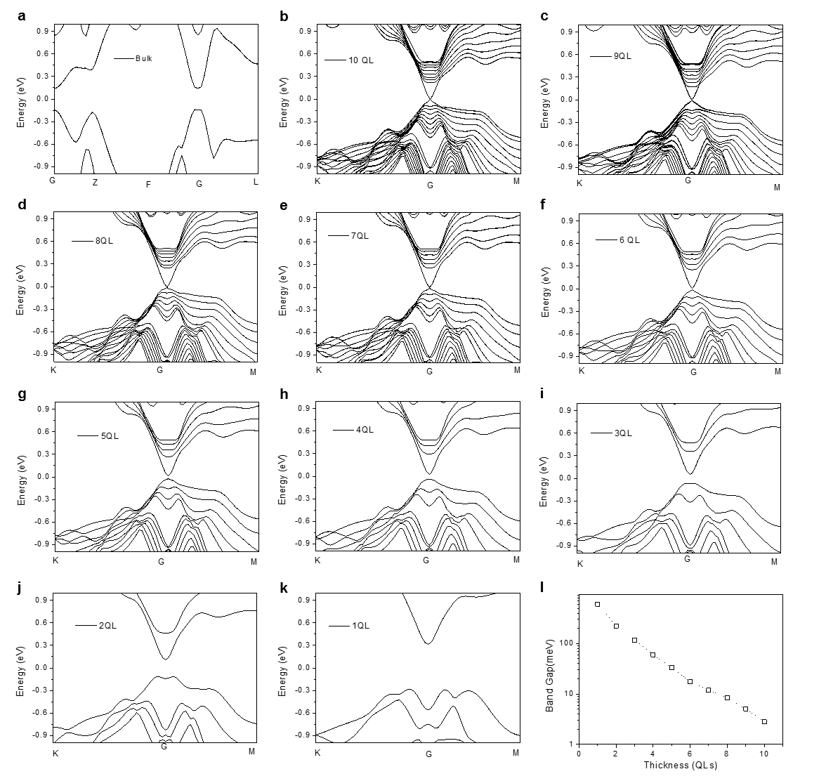
Figure S1. DFT calculations on hybridization gap open at different layer thickness for the Bi_{0.7}Sb_{1.3}Te_{1.05}Se_{1.95} (BSTS). a bulk band, and surface band at b 10 QL down to k 1 QL of the BSTS compound. l Thickness dependence hybridization gap extracted from DFT analyses.

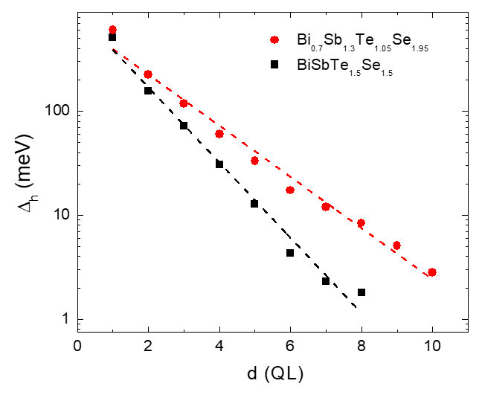
Figure S2. Variation of hybridization gap (∆_{h}) as a function of layer thickness (d) for two different compositions of hBSTS. Dashed lines in the figure are fittings to the ∆_{h} and d relation.

Table S1. Gap parity calculation for different 3D TI compounds. The layer dependence parity for Bi₂Se₃, Sb₂Te₃ and Sb₂Se₃ compounds included in the table are reproduced based on the references ^{[3-5]}.
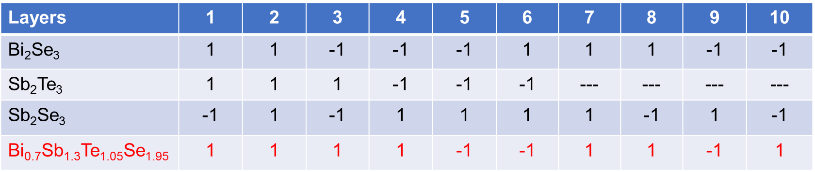

II. Layer-Dependent Hybridization Gap
Table S2 lists the variable thickness hBSTS devices fabricated into a Hall bar geometry for the studies. These devices were fabricated in a dual-gated configuration with top and bottom gates made of hBN and Gr flakes. For monolayer hBSTS, the flakes were too small for the Hall bar structure, therefore were fabricated in a two-terminal contact.
Thermal Activation Energy
Fig. S3 shows the temperature and gate-dependent R_{xx} for the variable thickness hBSTS. The activation behavior at their CNPs is due to the intersurface hybridization gap. While the R_{xx} is greatly suppressed (G greatly enhanced) at high charge density as the chemical potentials are tuned into the electron and hole conduction regimes. This behavior is very similar to a semiconductor, suggesting a trivial insulating state for these samples. Fig. S4 shows the Arrhenius plots for different thickness hBSTS samples. The fittings for G_{xx} versus temperature curves yield the thermal activation energy (E_{A}) for the variable thickness hBSTS as summarized in Fig. 2d.
Differential Conductance
Differential conductance (dI/dV) spectra were measured in a two-terminal probe using the main source-drain contacts. Fig. S5 shows the dI/dV versus V_{b} curves at the CNPs for different thickness BSTS. The hybridization gap sizes were determined from the turn-on voltage typically at conductance in the order ~e²/h, as marked by the red arrows in the figures. To exclude the nonlinear current-voltage signal from the bad contact effect, we also measured the dI/dV in the conduction region by changing the gate voltages for all samples.

Table S2. Device specifications. List of the thickness (d), length (L), width (W), and geometry of the BSTS dual-gated devices fabricated for the studies.
d (nm) | L (±0.1 μm) | W (±0.1 μm) | Geometry
1 | 1.0 | 2.0 | two terminals
3 | 2.8 | 2.3 | four terminals
6 | 5.4 | 3.7 | Hall bar
7 | 3.3 | 2.3 | Hall bar
8 | 4.7 | 2.8 | Hall bar
9 | 5.1 | 3.4 | Hall bar
10 | 3.0 | 3.2 | Hall bar
10 (no gap) | 4.5 | 5.5 | Hall bar

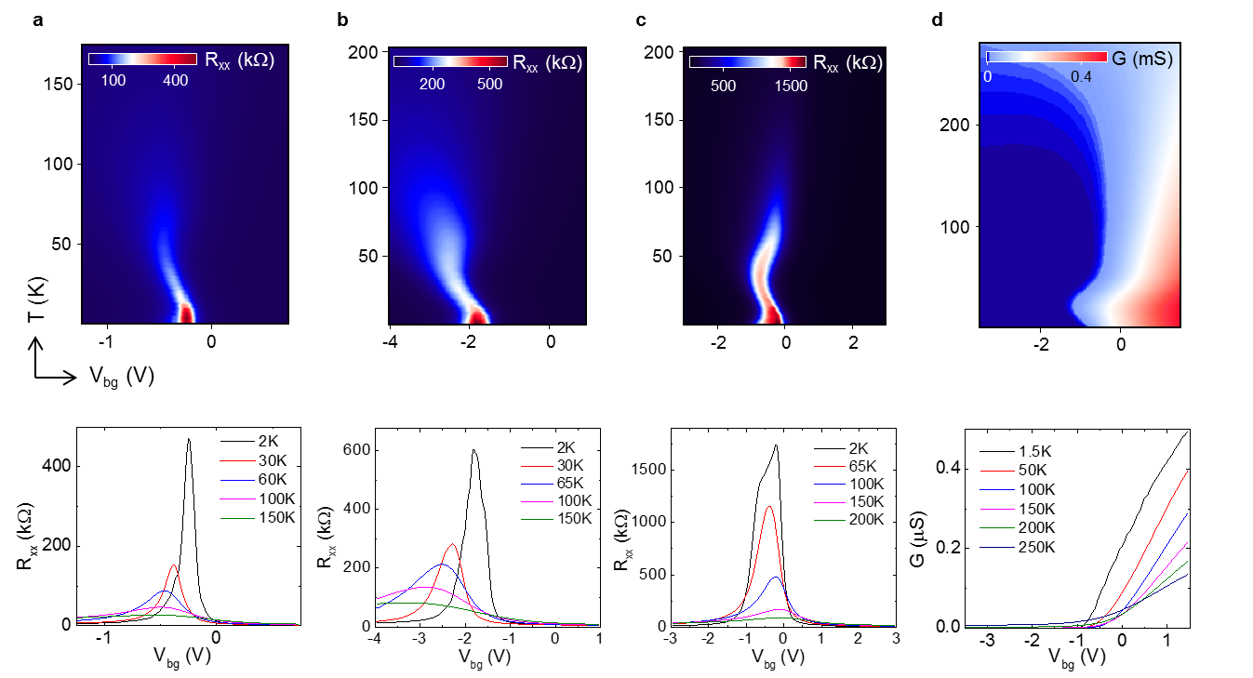
Figure S3. Temperature and gate-dependence transport for the hBSTS. Color maps (top) and line profiles (bottom) of R_{xx} (or G) versus V_{bg} at different temperature for the a 8, b 7, c 6, and d 3 nm hBSTS. Note that the color map of the 3 nm hBSTS is plotted in two-probe conductance (G) as the four-probe resistance measurements are irrelevant due to its extremely large in-gap resistance.

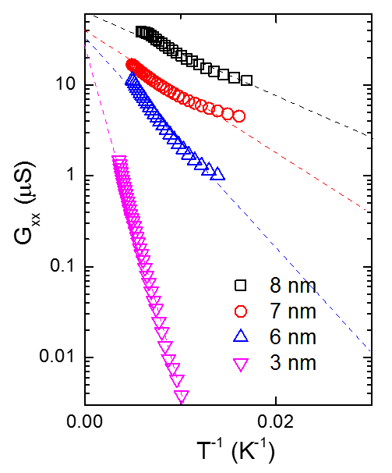
Figure S4. Arrhenius plots. Comparison of G_{xx} versus T⁻¹ curves for the hBSTS at different layer thickness. Dashed lines in the figure are fittings to extract the thermal activation energies (E_{A}) for the respective thickness.

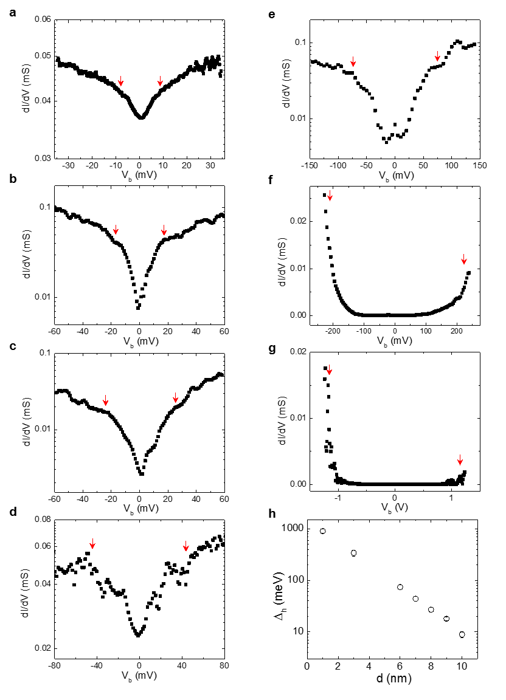
Figure S5. Layer dependence hybridization gap evaluated by differential conductance. Plots of dI/dV versus V_{b} for the hBSTS with thicknesses of a 10, b 9, c 8, d 7, e 6, f 3, and g 1 nm. The red arrows in the figures point to the turn-on voltages. h Plot of ∆_{h} versus flake thickness determined from the dI/dV versus V_{b} spectra.

III. Magnetic Field Response on the Zeroth Landau Levels
A consequence of intersurface hybridization on LLs spectrum is the splitting of zeroth LLs in a perpendicular magnetic field ^{[6,7]}. As the zeroth LLs are pinned to the edges of the highest valence and lowest conduction bands, the zeroth LLs’ energy E₀ can be treated as the hybridization gap Δ_{h} ^{[8]}. Fig. S6a and c show the σ_{xx} versus V_{bg} plots for the 9 and 8 nm hBSTS, respectively. The two N= 0 LL peaks developed at high magnetic field are traced by dashed lines with the change in magnetic field. The developed zeroth quantum Hall plateaus together with the normal integer plateaus at high magnetic field (Fig. S6b and d) further confirms the analyses.
To determine the E₀ change in magnetic field, we measured the quantum capacitance using a capacitance bridge method ^{[9]}. Fig. S7a shows the mapping of total capacitance (C) as functions of V_{bg} and magnetic field for the 9 nm hBSTS. The C dip at the CNP is corresponding to the lowest density of state resulting from the hybridization gap. The dip size develops with magnetic field. For further analysis on the C dip, we extracted the chemical potential (μ) versus density (n) relation (Fig. S7b) by integrating the quantum capacitance over the charge density. The step height in μ determines the E₀. Fig. S7c plots the E₀ as a function of magnetic field for the 9 and 8 nm hBSTS. The E₀ is plotted at high magnetic field (> 8T) where the N= 0 LLs are fully developed. The development of E₀ in magnetic field indicates a gap widening at ~1.2 and ~1.6 meV/T for the 9 and 8 nm hBSTS, respectively.

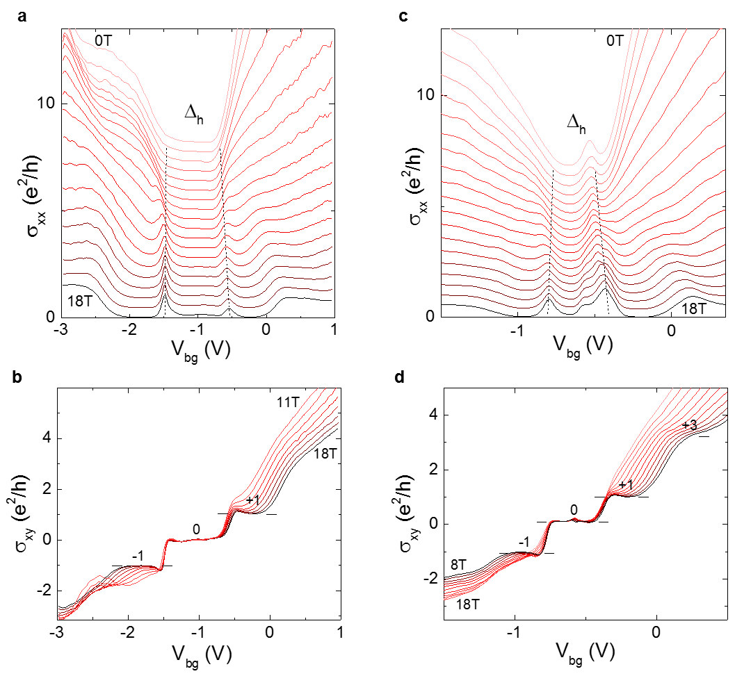
Figure S6. Magneto-transport. Line profiles of a, c σ_{xx} and b, d σ_{xy} as a function of V_{bg} at different magnetic field for the 9 nm and 8 nm hBSTS, respectively. Dashed lines in a and c trace the developments of N= 0 sublevels with magnetic field. The filling factors of the respective LLs are labeled in b and d.

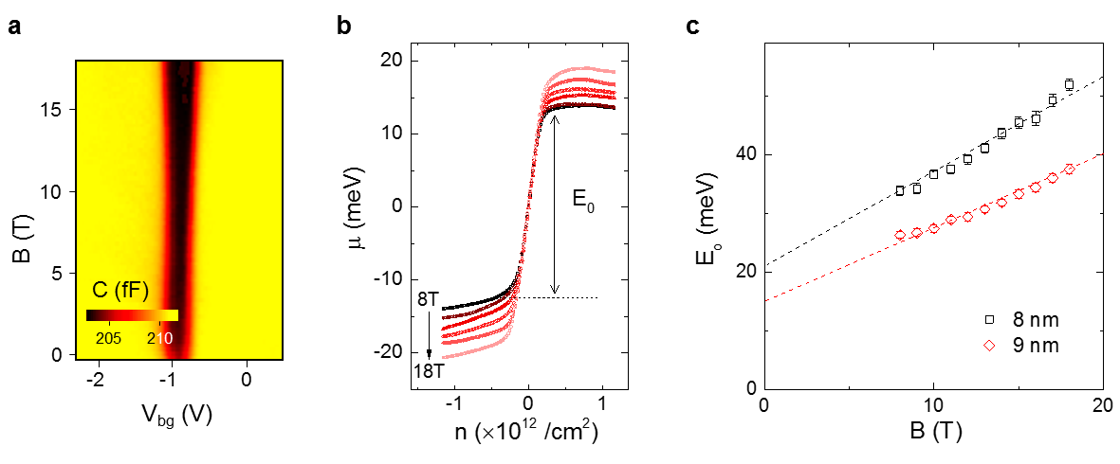
Figure S7. Zeroth LL’s energy. a Color map of the C as functions of V_{bg} swept across the zeroth LLs at different magnetic fields for the 9 nm hBSTS. b Plots of μ(n) versus n across the zeroth LL regime at different magnetic fields. The E₀ is extracted from the step height of the μ(n) at n= 0 cm⁻², as indicated by the arrow line. c Plots of E₀ as a function of magnetic field for the 8 and 9 nm hBSTS. Dashed lines in c are fittings to the E₀ versus B relation.

IV. Angular Magnetic Field on Hybridization Gap
Besides, we performed transport measurements in a parallel magnetic field. Fig. S8 compares the ρ_{xx} as a function of V_{bg} at different magnetic field applied in parallel to the sample for the 9 and 10 nm hBSTS. The G_{xx} versus parallel magnetic field taken at their charge neutralities are inserted in the figures. Similar to the perpendicular magnetic field, the G_{xx} curve for the 9 nm hBSTS remains low and unchanged with the increase of the parallel magnetic field. Whereas for the 10 nm hBSTS, the G_{xx} curve at low field follows a similar trend as in the perpendicular magnetic field. The G_{xx} slowly decreases from ~e²/2h at a small magnetic field as a result of time-reversal symmetry breaking. The dG_{xx}/dB of ~0.01-0.02 e²/h/T (B= 0-2T) is more than one order of magnitude smaller compared to the slope in perpendicular magnetic field. While at higher magnetic field the dG_{xx}/dB changes sign and G_{xx} curve continues increasing with further increment in magnetic field. Different from the perpendicular magnetic field response which develops into QH gapped state, the parallel magnetic field can shift the surface bands’ energy according to their spin states and turns into a semimetal state when the magnetic energy exceeding the hybridization gap ^{[10,11]}.
This different response in parallel and perpendicular directions at high magnetic field suggests an angular magnetic field dependence transition between the two limits. To further study this transition, we plotted ρ_{xx} color map as functions of V_{bg} and magnetic field direction (θ) at 18 T in Fig. S9 (top). The color map clearly shows suppression of QH effect as the θ < 20º. The line profile of ρ_{xx} versus θ taken at charge neutrality is plotted in Fig. S9 (bottom). As shown in the figure, the angular magnetic field dependence ρ_{xx} curve starts to deviate from the oscillatory function of cos θ at -12º ≤ θ ≤ 12º. At smaller θ, the ρ_{xx} curve reduces almost linearly with a decrease in θ. This interesting linear dependency in angular magnetic field deserves further theoretical investigations.

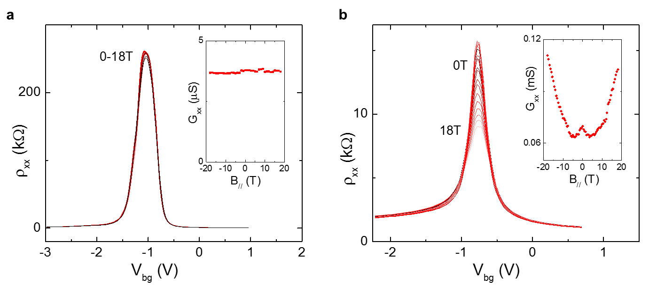
Figure S8. In-plane magnetic field effect. Plot ρ_{xx} as a function of V_{bg} measured at different in-plane magnetic fields from 0 to 18 T for the a 9, and b 10 nm hBSTS. Insets in a and b are plots of ρ_{xx} maxima as a function of the in-plane magnetic field. The decreasing of ρ_{xx} at strong in-plane magnetic field indicates a hybridization gap-closing feature as a resultant of the shifting in surface bands.

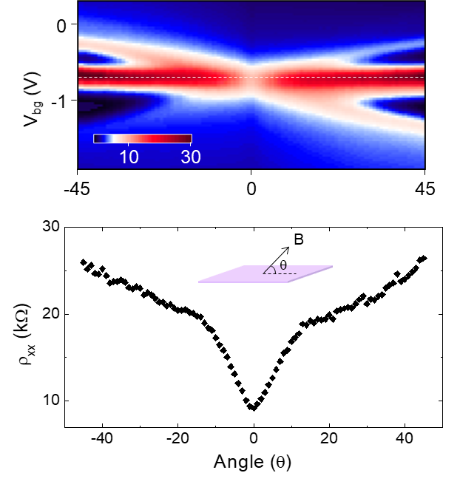
Figure S9. Angular dependence magnetic field effect. (Top) Color map of ρ_{xx} as functions of V_{bg} and direction of magnetic field (θ) measured at magnetic field of 18 T for the 10 nm hBSTS. (Bottom) Line profile of ρ_{xx} as a function of θ taken at chemical potential aligned to the surface gap. Schematic diagram illustrates the direction of magnetic field applied to the hBSTS sample.

V. Electric Field Modulation of the Hybridization Gap
DFT Calculations
Theoretical calculations proposed that an external electric field can induce topological phase transition by closing and reopening of the surface hybridization gap ^{[12-14]}. To investigate this effect, we first perform DFT calculations for our BSTS compound. Fig. S10 shows the surface band structure of a 3 QL hBSTS (Δ_{h}~120 meV) under different external electric fields. We observe a gap-closing at a critical electric field of ~0.06 V/Å, where the Rashba-split surface bands cross at their band edges. When exceeding the critical electric field, surface band edges further separate and result in a gap-opening. We further analyze the gap parity in electric field as shown in Fig. S11b. The 3 QL hBSTS has an even parity gap, which belongs to a normal gap state. The gap parity changes sign at the crossing point and remains inverted with further increase in electric field. The gap size extracted from the calculations (Fig. S11b) shows a slower gap-reopening rate compared to its closing rate. Furthermore, we analyze the gap parity change in electric field for 4 and 5 QL hBSTS with normal and inverted gaps, respectively, as shown in Fig. S11a. For both cases, the gap parity flips its sign at the critical electric field, suggesting an interchange of the normal and inverted surface gap.
Dual-Gating Effect
To analyze the effect of electric field on the hybridization gap, we performed dual-gating measurement for the variable thickness BSTS samples. The results are presented in color maps of R_{xx} as functions of dual-gate voltages in Fig. S12a-f. The diagonal feature in dual-gating maps justifies the strong coupling between the top and bottom surfaces ^{[15]}. The line profiles of R_{xx} versus V_{bg} taken at different V_{tg} for the respective thicknesses are shown in Fig. S12g-l. The substantial change in R_{xx} when tuned away from charge neutrality by V_{tg} for thinner samples indicates that they are very responsive to electric field modulation. To verify this, we convert the dual-gate voltages into displacement field (D) and further investigate the change in conduction and gap size with D.
Thermal Activation Energy
To analyze the thermal activation in electric field, we extracted the temperature-dependent ρ_{xx} at different D as plotted in Fig. S13a, for the 9 nm hBSTS. The activation behavior slowly suppressed as D increases. At large D, ρ_{xx} curve tends to flatten at low temperature. The D-dependent hybridization gap can be evaluated from the thermal activation energy calculated at different D. Fig. S13b shows Arrhenius plots of G_{xx} at different D, where the dashed lines are the fittings to the Arrhenius equation. The insignificant change in G_{xx} with the temperature at large D indicates again a suppression in hybridization gap by D. The activation energy E_{A} at different D is summarized in Fig. 4f in the text.
Differential Conductance
The D-dependent hybridization gap can also be probed by differential conductance measurement. Fig. S14a shows the color maps of dI/dV as a function of V_{b} and V_{bg} at different V_{tg} for the 9 nm hBSTS. Shifting of the dI/dV minimum towards negative polarity V_{bg} with increasing of positive V_{tg} verifies the probed hybridization gap state along the direction of the increasing D as pointed in dual-gate map in Fig. S12a. The vanishing dI/dV minimum at high V_{tg} as indicated by the color contrast supports the thermal activation results, where the gap size diminishes at large D. Line profiles of dI/dV versus V_{b} taken at CNPs for different Vtg are plotted in Fig. S14b. The gap size determined from the dI/dV dips at different D is included in Fig. 4f in the text.

Quantum Capacitance
As the thermally-activated gap can be affected by the smearing effect ^{[16]}, we further implement capacitance measurement to probe the thermodynamics density of states for D dependent hybridization gap. Fig. S15 shows the color maps of total capacitance as functions of dual-gate voltages for different thickness hBSTS. The substantial reduction in C_{Q} dip intensity again supports the suppression of the hybridization gap at large D. The quantum capacitances C_{Q} at n= 0 cm⁻² along D were extracted using the analyses discussed in our previous work ^{[9]}. The chemical potential curves were obtained by integrating C_{Q}⁻¹ over the charge density at different D, as shown in Fig. S16. Likewise, the hybridization gap sizes at different D are assessed quantitatively from the step heights of the μ(n) curves, as summarized in Fig. 4f in the text.

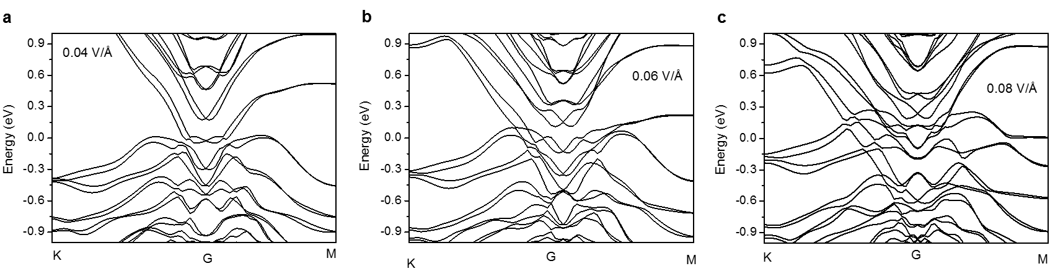
Figure S10. Surface band evolution and hybridization gap modulation by external perpendicular electric field. Band structure of a 3 QL hBSTS simulated at electric fields of a 0.04 V/Å, b 0.06 V/Å, and c 0.08 V/Å.

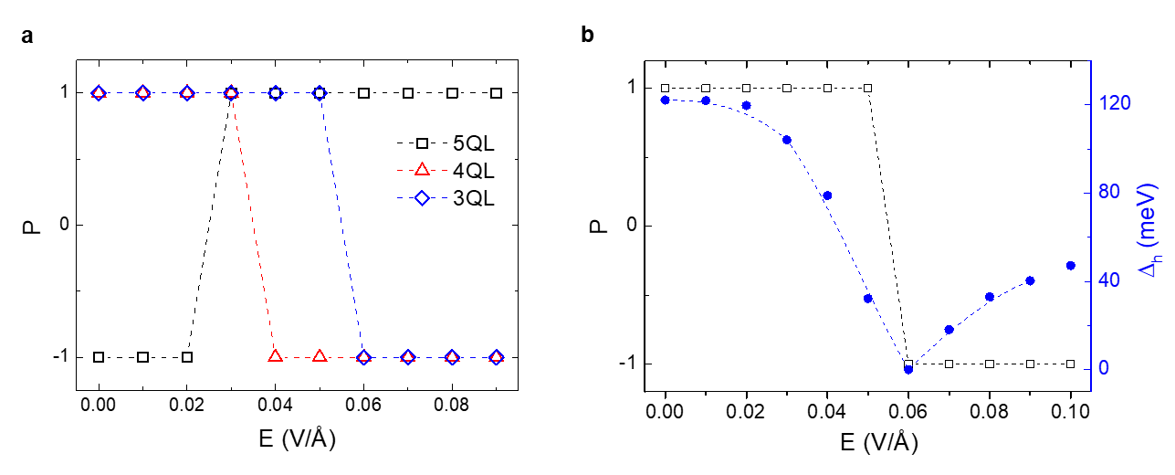
Figure S11. Size and parity of the hybridization gap modulated by external electric field. a Surface gap parity as a function of electric field for different thickness hBSTS. b Variation of the hybridization gap size and the corresponding parity as a function of electric field for the 3 QL hBSTS.

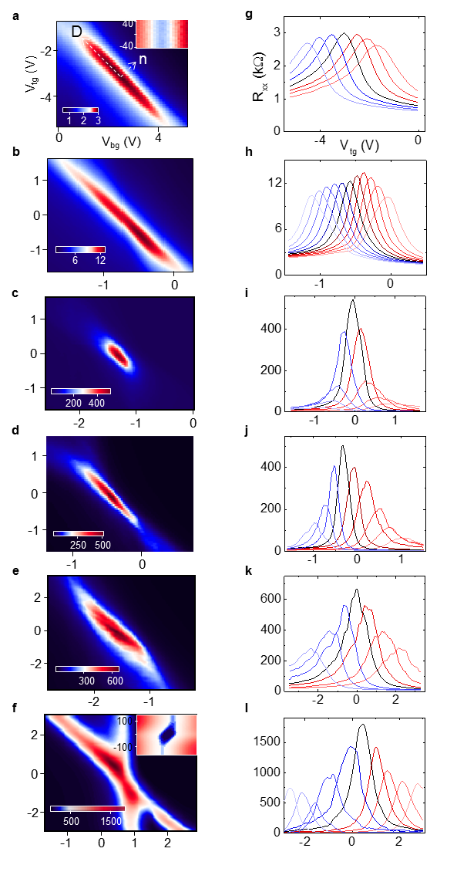
Figure S12. Dual-gating effect. Color maps of R_{xx} as a function of dual-gate voltages at the temperature of 1.6 K for the variable thickness BSTS a 10 (no gap), b 10, c 9, d 8, e 7, f 6 nm. g-l R_{xx} versus V_{tg} plots taken at different V_{bg} for the respective thickness samples. Insets in a and f are dI/dV maps as functions of V_{b} and V_{bg} for the 10 (no gap) and 6 nm BSTS, respectively.

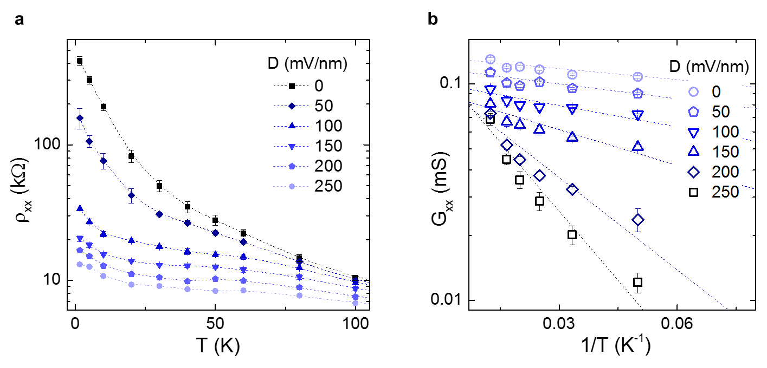
Figure S13. Temperature dependence transport and thermal activation in displacement field. Plots of a ρ_{xx} versus T, and b G_{xx} versus T⁻¹ for the 9 nm hBSTS at different D. Dashed lines in b are fittings of the G_{xx} to the Arrhenius equation.

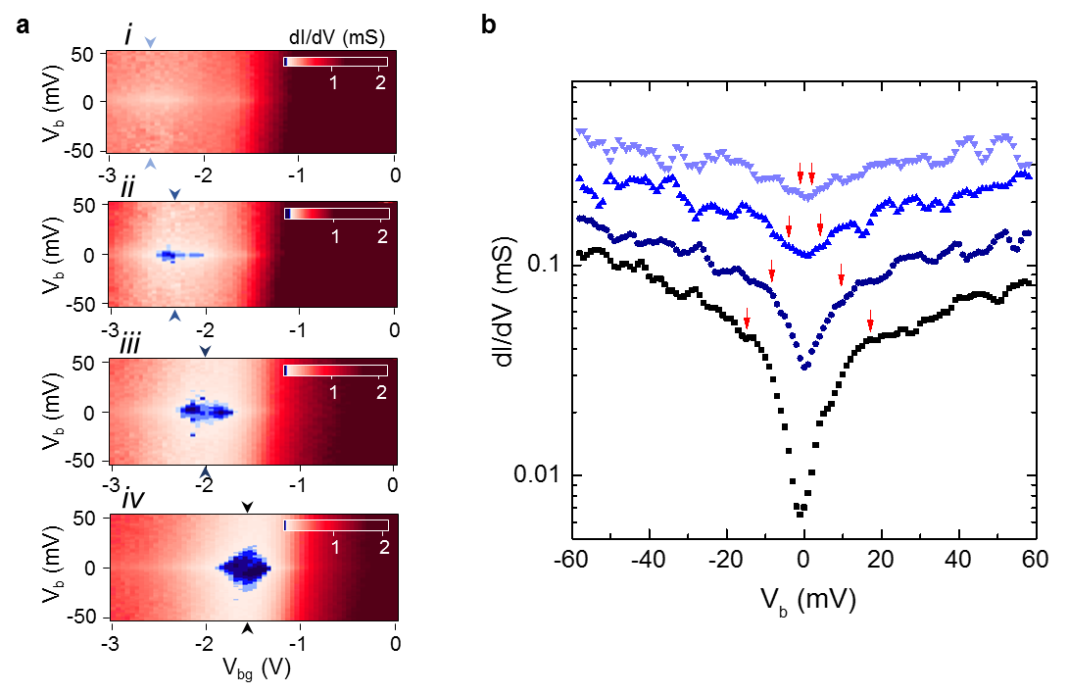
Figure S14. Differential conductance in displacement field. a Color maps of dI/dV as functions of V_{b} and V_{bg} for the 9 nm hBSTS at different V_{tg} of (i) 1.5 V, (ii) 1 V, (iii) 0.5 V, and (iv) 0 V. b dI/dV line profiles at charge neutrality point taken from the respective color maps, as indicated by the blue arrows in a. Red arrows in b point to the turn-on voltages at the respective D.

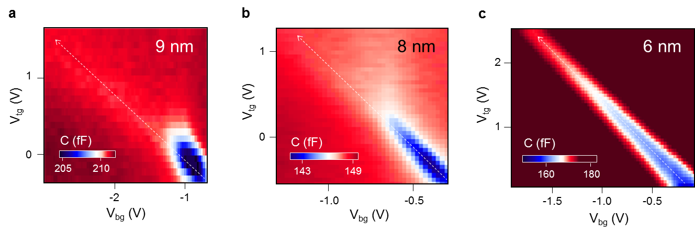
Figure S15. Thermodynamic density of states in displacement field. Color maps of total capacitance (C) as functions of dual-gate voltages for the a 9, b 8, and c 6 nm hBSTS. The dashed line arrows in the figures point to the direction of the D applied at zero charge density.

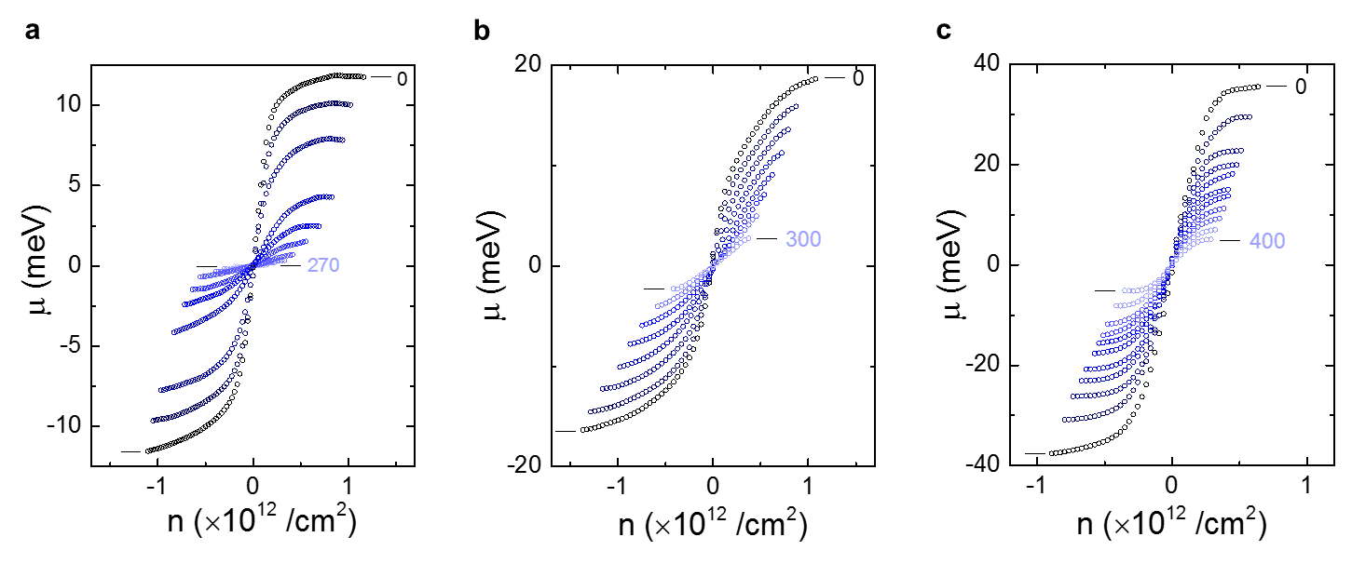
Figure S16. Chemical potentials of the surface hybridization gap in displacement field. Plots of μ(n) versus n calculated from C_{Q} at different D for the a 9, b 8, and c 6 nm hBSTS. The surface hybridization gaps at different D were determined from the step height of the μ(n) plots.

VI Potential Topological Materials for Topological Transistors
Realization of electric field mediated topological quantum phase transitions offers great potential towards practical applications of topological quantum devices, such as topological transistors ^{[17]}. Switching topological phases for controllable on/off edge channels by electric field is desirable due to its high reversibility as compared to doping modulations, and lattice distortions by applying strain or pressure. As the proposed topological transistors rely on electric field-effect, a few criteria need to be satisfied. Firstly, the critical field E_{c} should not exceed the breakdown field for dielectrics, and more sufficiently smaller E_{c} for durability. Secondly, the difference of conductance response in trivial and topological states should be large enough to distinguish both states, which means the large on/off ratio. For the topological transistor, the “on” state conductance is fixed to the quantized value at e²/2h. Therefore, the “off” insulating state determines the on/off ratio. Another important parameter is the size of this bulk surface gap, which determines the temperature limit of the topological edge states. From the electric field response of our hBSTS, we demonstrated a relatively small displacement field of ~0.25-0.8 V/nm with a surface hybridization gap of ~20-80 meV for 9-6 nm hBSTS. Also, the more than one order of magnitude change in ρ_{xx} between “on” and “off” states is highly promising for the proposed application. Table S3 summarizes the theoretical and experimental parameters for electric field mediated topological phase transition in different types of topological systems reported in the literature ^{[17-28]}.

Table S3. Comparison of electric field mediated topological phase transition for different topological materials. The theoretical/experimental parameters, such as bulk surface gap (∆), disorder strength (W), and gap-closing field (E_{c}) are included in the table.
Materials | Topology | ∆ (meV) | W (meV) | E_{C} (V/nm) | Refs
HgTe/CdTe | 2D TI | ~40 | ~50 | >0.003* | ^{[18,19]}
InAs/GaSb | 2D TI | 3-9 | <10 | ~0.1 | ^{[20]}
Strained InAs/InGaSb | 3D TI | 5-35 | - | - | ^{[21]}
WTe₂ | Weyl semimetal | 45-55 | - | - | ^{[22]}
Na₃Bi | 2D TI | ~300 | - | 1.12 | ^{[23]}
ZrTe₅ | Dirac semimetal | 10-80 | - | ~0.07 | ^{[24]}
Bi(111) | 2D TI | ~320 | - | 21* | ^{[25]}
Graphene/WSe₂ | 2D TI | ~0.25 | - | 0.02 | ^{[26]}
1T’-TMDs | Semimetal | ~80 | - | 1.42* | ^{[17]}
Phosphorene | semiconductor | 50-300 | - | ~1.1-3.0* | ^{[27]}
hBSTS | 3D TI | ~18-80 | <5 | ~0.25-0.8 | This work
*Based on theoretical calculations

References
- Frantzeskakis, E. et al. Dirac states with knobs on: Interplay of external parameters and the surface electronic properties of three-dimensional topological insulators. Phys. Rev B 91, 2045134 (2015).
- Arakane, T. et al. Tunable Dirac cone in the topological insulator Bi_{2-x}Sb_{x}Te_{3-y}Se_{y}. Nat. Comm. 3, 636 (2012).
- Liu, C. X. et al. Oscillatory crossover from two-dimensional to three-dimensional topological insulators. Phys. Rev B 81, 041307(R) (2010).
- Cao, G. et al. Rhombohedral Sb₂Se₃ as an intrinsic topological insulator due to strong van der Waals interlayer coupling. Phys. Rev B 97, 075147 (2018).
- Li, Z. et al. High thermoelectric performance of few-quintuple Sb₂Te₃ nanofilms. Nano Energy 43, 285-290 (2018).
- Yang, Z. & Han, J. H. Landau level states on a topological insulator thin film. Phys. Rev B 83, 045415 (2011).
- Zyuzin, A. A. & Burkov, A. A. Thin topological insulator film in a perpendicular magnetic field. Phys. Rev B 83, 195413 (2011).
- Pertsova, A., Canali, C. M. & MacDonald, A. H. Thin films of a three-dimensional topological insulator in a strong magnetic field: microscopic study. Phys. Rev. B 91, 075430 (2015).
- Chong, S. K., Tsuchikawa, R., Harmer, J., Sparks, T. D. & Deshpande, V. V. Landau levels of topologically-protected surface states probed by dual-gated quantum capacitance. ACS Nano 14, 1158-1165 (2020).
- Zyuzin, A. A., Hook, M. D. & Burkov, A. A. Parallel magnetic field driven quantum phase transition in a thin topological insulator film. Phys. Rev. B 83, 245428 (2011).
- Zhou, B. Lu, H.-Z., Chu, R.-L., Shen, S.-Q. & Niu, Q. Finite size effects on helical edge states in a quantum spin-Hall system. Phys. Rev. Lett. 101, 246807 (2008).
- Liu, G., Zhou, G. & Chen, Y.-H. Modulation of external electric field on surface states of topological insulator Bi₂Se₃ thin films. Appl. Phys. Lett. 101, 223109 (2012).
- Kim, M., Kim, C. H., Kim, H.-S. & Ihm, J. Topological quantum phase transitions driven by external electric fields in Sb₂Te₃ thin films. Proc. Natl. Acad. Sci. U.S.A. 109, 671-674 (2012).
- Wang, J., Lian, B. & Zhang, S.-C. Electrically tunable magnetism in magnetic topological insulators. Phys. Rev. Lett. 115, 036805 (2015).
- Chong, S. K., Han, K. B., Sparks, T. D. & Deshpande, V. V. Tunable coupling between surface states of a three-dimensional topological insulator in the quantum Hall regime. Phys. Rev. Lett. 123, 036804 (2019).
- Breunig, O., Wang, Z., Taskin, A. A., Lux, J., Rosch, A. & Ando, Y. Gigantic negative magnetoresistance in the bulk of a disordered topological insulator. Nat. Comm. 8, 15545 (2017).
- Qian, X., Liu, J., Fu, L., Li, J. Quantum spin Hall effect in two-dimensional transition metal dichalcogenides. Science 346, 1344-1347 (2014).
- Yang, W., Chang, K. & Zhang, S.-C. Intrinsic spin Hall effect induced by quantum phase transition in HgCdTe quantum wells. Phys. Rev. Lett. 100, 056602 (2008).
- Maciejko J., Qi, X.-L. & Zhang, S.-C. Magnetoconductance of the quantum spin Hall state. Phys. Rev. B 82, 155310 (2010).
- Qu, F. et al. Electric and magnetic tuning between the trivial and topological phases in InAs/GaSb double quantum wells. Phys. Rev. Lett. 115, 036803 (2015).
- Irie, H., Akiho, T., Couedo, F., Suzuki, K., Onomitsu, K. & Muraki, K. Energy gap tuning and gate-controlled topological phase transition in InAs/In_{x}Ga_{1−x}Sb composite quantum wells. Phys. Rev. Mater. In press.
- Tang, S. et al. Quantum spin Hall state in monolayer 1T’-WTe₂. Nat. Phys. 13, 683-687 (2017).
- Collins, J. L. et al. Electric-field-tuned topological phase transition in ultrathin Na₃Bi. Nature 564, 390-394 (2018).
- Vaswani, C. et al. Light-driven Raman coherence as a nonthermal route to ultrafast topology switching in a Dirac semimetal. Phys. Rev. X 10, 021013 (2020).
- Sawahata, H., Yamaguchi, N., Kotaka, H. & Ishii, F. Electric field dependence of topological edge states in one-bilayer Bi(111): A first-principles study. e-J. Surf. Sci. Nanotechnol. 16, 427-430 (2018).
- Island, J. O. et al. Spin-orbit-driven band inversion in bilayer graphene by the van der Waals proximity effect. Nature 571, 85-89 (2019).
- Liu, Q., Zhang, X., Abdalla, L. B., Fazzio, A., Zunger, A. Switching a normal insulator into a topological insulator via electric field with application to phosphorene. Nano Lett. 15, 1222-1228 (2015).

