Graphical Abstract
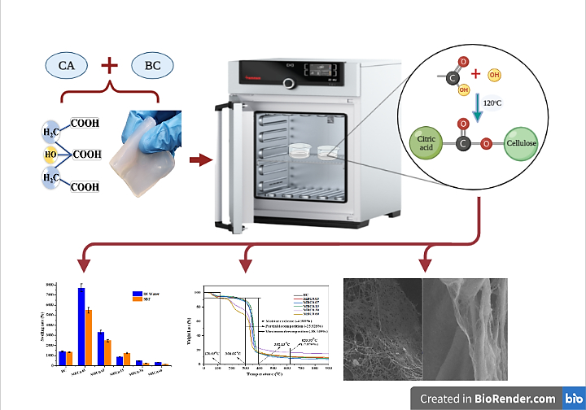
Created with BioRender.com

