Supporting Information for

Highly efficient photocatalytic degradation of tetracycline by in-situ constructed bismuth oxyiodide/zeolitic imidazolate framework-8 heterojunction catalysts

Rongfei Jiang^{a, #}, Weiqi Luo^{a, #}, Jinyang Pengª, Jijun Tang^{a,} *, Xinyue Wang^{b}, Adel Qlayel Alkhedaide^{c}, Yihui Teng^{b}, Yi Heª, Qiuyang Daiª, Guicheng Gaoª, Jiaoxia Zhang^{f,*}, Zeinhom M. El-Bahy^{e}, Mohammed A. Amin^{f}, Yonglin Ye^{a,*}

ª School of Materials Science and Engineering, Jiangsu University of Science and Technology, Zhenjiang, 212003, China.
^{b} School of Naval Architecture and Ocean engineering, Jiangsu University of Science and Technology, Zhenjiang, 212003, China
^{c} Department of Clinical Laboratory Sciences, Turabah University College, Taif University, P.O. Box 11099, Taif 21944, Saudi Arabia
^{d} School of Materials and Chemical Engineering, Ningbo University of Technology, Ningbo, 315211, China
^{e} Department of Chemistry, Turabah University College, Taif University, P.O. Box 11099, Taif 21944, Saudi Arabia
^{f} Department of Chemistry, Faculty of Arts and Science, Northern Border University, Rafha, Saudi Arabia

1. Experimental
1.1Materials
Bismuth nitrate pentahydrate (Bi (NO₃)₃⋅5H₂O, AR, ≥ 99%), potassium iodide (KI, AR, ≥ 99%), zinc acetate (Zn (CH3COO)₂⋅2H₂O, AR, ≥ 99%), 2-methylimidazole (C₄H₆N₂, AR, ≥ 99%), and methanol (CH₃OH, analytical reagent) were purchased from China National Pharmaceutical Chemical Reagent Co. Ltd. Tetracycline (C₂₂H₂₄N₂O₈, TC, AR, ≥ 99%) was purchased from Shanghai McLean Company, and ethylene glycol ((CH₂OH)₂, analytical reagent) was from Shanghai Myriad Company.
1.2 Preparation of BiOI
BiOI was prepared by a hydrothermal method. Briefly, 2.4 g Bi (NO₃)₃⋅5H₂O and 1.2 g KI were dissolved in 50 mg ethylene glycol under sonication. The obtained clear orange solution was placed in 100 mL of PTFE liner and held under reaction at 180°C in a blast drying oven for 2 hours. Centrifugation at 8000 r/min was used to separate the resultant solid, which was then washed three times with ethanol and water. An overnight drying at 80°C caused the form of a brick-red solid BiOI.
1.3 Preparation of Bi₅O₇I
The prepared BiOI powder was ground and placed in a ceramic crucible calcined at 600°C for 5 hours in a muffle furnace, and pure Bi₅O₇I was obtained after natural cooling.
1.4 Preparation of Bi₅O₇I/ZIF-8
Bi₅O₇I/ZIF-8 was prepared via an in-situ growth method. Briefly, at room temperature 0.40 g Bi₅O₇I was dissolved in 40 mL methanol under 5-minute sonication, and then 1.65 g Zn (CH₃COO)₂⋅2H₂O and 2.463 g 2-dimethylimidazole (molar ratio 1:4) were added and stirred at 1000 r/min for 24 h. The resulting turbid solution was washed with anhydrous ethanol and separated three times by centrifugation (8000 r/min). The material obtained after drying in an oven at 80°C overnight was named as 1.0BZ, whereas 0.5BZ refers to the material obtained by the reaction of 0.40 g of Bi₅O₇I with 0.825 Zn (CH₃COO)₂⋅2H₂O and 1.23 g 2-dimethylimidazole, 0.75BZ, 1.25BZ, 1.5BZ, 2.0BZ, and 2.5BZ were 0.4 g of Bi₅O₇I and the corresponding proportion of ZIF-8 reactants were prepared to give. The synthetic schematic diagram is shown in the supporting information

1.5 Characterizations
X-ray diffraction (XRD) data were collected with Cu-Ka radiation (λ = 1.54 Å) on a Shimadzu XRD-6000 instrument (voltage: 40 KV, current: 30 mA, scan angle: 5°~ 80°, scan speed: 5°/min). Scanning electron microscopy (SEM) was performed on a Japan Electronics JSM-6480 microscope. High-resolution transmission electron microscopy (HRTEM) and scanning TEM elemental mapping were achieved by an FEI Tecnai G2 F30 microscope (accelerating voltage = 300 kV). X-ray Spectroscopy (XPS) was used to study the binding energies of composite material and all the elements (VG ESCALAB 250Xi, Thermo Fisher Scientific, Waltham, Massachusetts). Fourier transform infrared (FT-IR) spectra were obtained using an Agilent spectrometer in a frequency range of 4000–400 cm⁻¹. The UV-vis diffuse reflection spectroscopy (DRS) absorption spectra were recorded on a Hitachi U4100 UV spectrometer. Fluorescent spectra were obtained on a FS5 spectrofluorometer. The transient photo-current measurements were performed using a DH-7000 Electrochemical Workstation (Jiangsu Dong Hua Analysis Instruments Co., Ltd, China).
1.6 Photocatalytic reaction test
The photocatalytic activity of the created materials was assessed through the breakdown of TC while subjected to a 250 W visible light source from a xenon lamp (λ > 420 nm). To achieve the adsorption-degradation equilibrium, the photocatalyst (20 mg) was dissolved in 100 mL aqueous TC solution (30 mg/L) and stirred for 30 minutes while shielded from light. To determine the rate of TC degradation, the absorbance of TC was calculated at 357 nm using a UV-visible photometer (Persee TU -1901, China).
1.7 Computational details
Vienna Ab initio Simulation Package (VASP) was utilized for all spin-polarized first-principles numbers . For structure optimization, the Perdew–Burke–Ernzerhof (PBE) functional was utilized along with the generalized gradient approximation (GGA) [1]. The wave function of the core region was described by the projector augmented wave (PAW) approach [2], while the valence wave function was extended to a linear combination of plane waves with an energy cut-off of 400 eV [3] . The dispersion correction PBE + D3 describes the weak Van der Waals communication [4] . The overall energy in geometric optimization approached 10⁻⁵ eV, whereas the Hellmann-Feynman force given to each relaxed atom was less than 0.03 eV/Å. The Gamma point was used for performing the integration of the Brillouin zone. The VASPKIT code was executed for the postprocessing of the VASP calculated data [5].

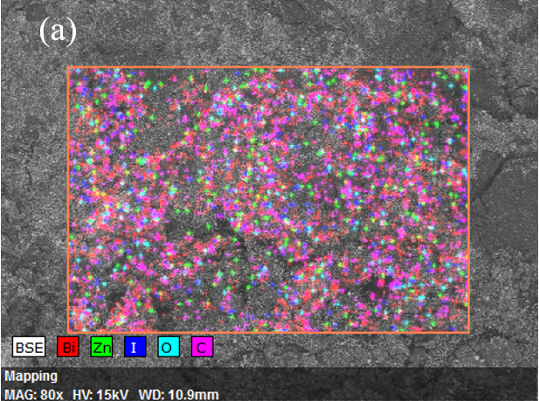
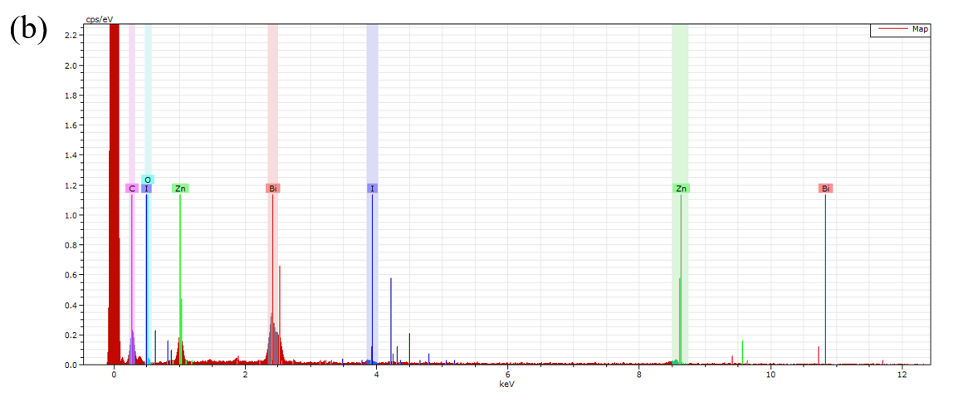
Fig. S 1 2.0BZ EDX sample scan area (a), X-ray spectra (b).

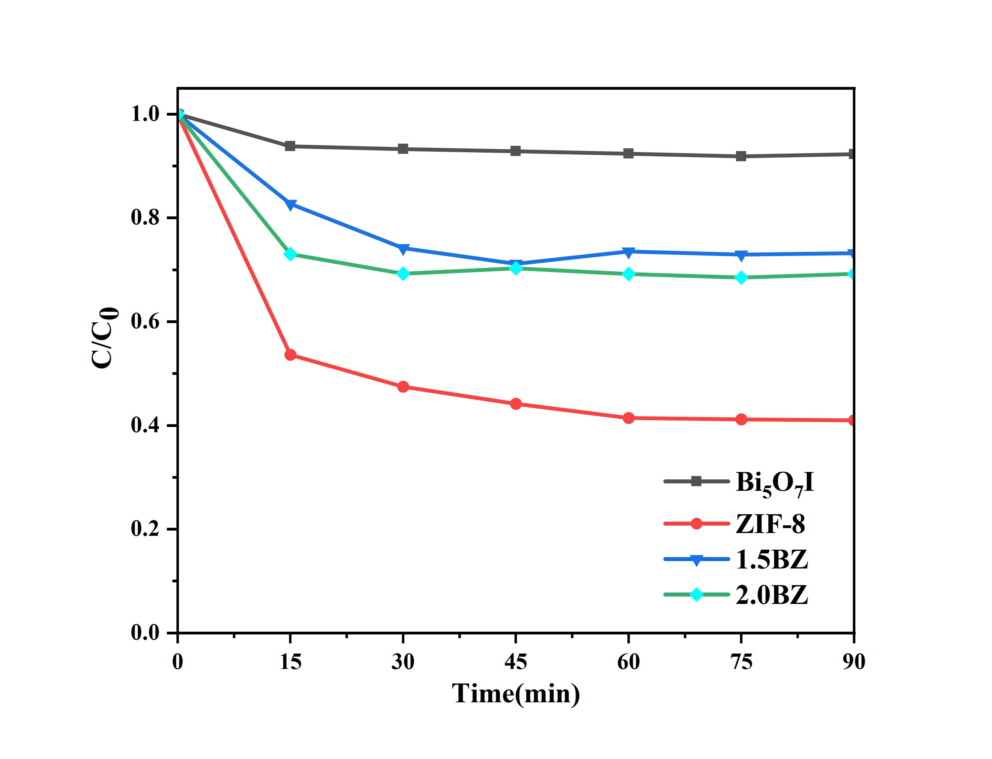
Fig. S 2 The effect of dark reaction adsorption of TC in each sample

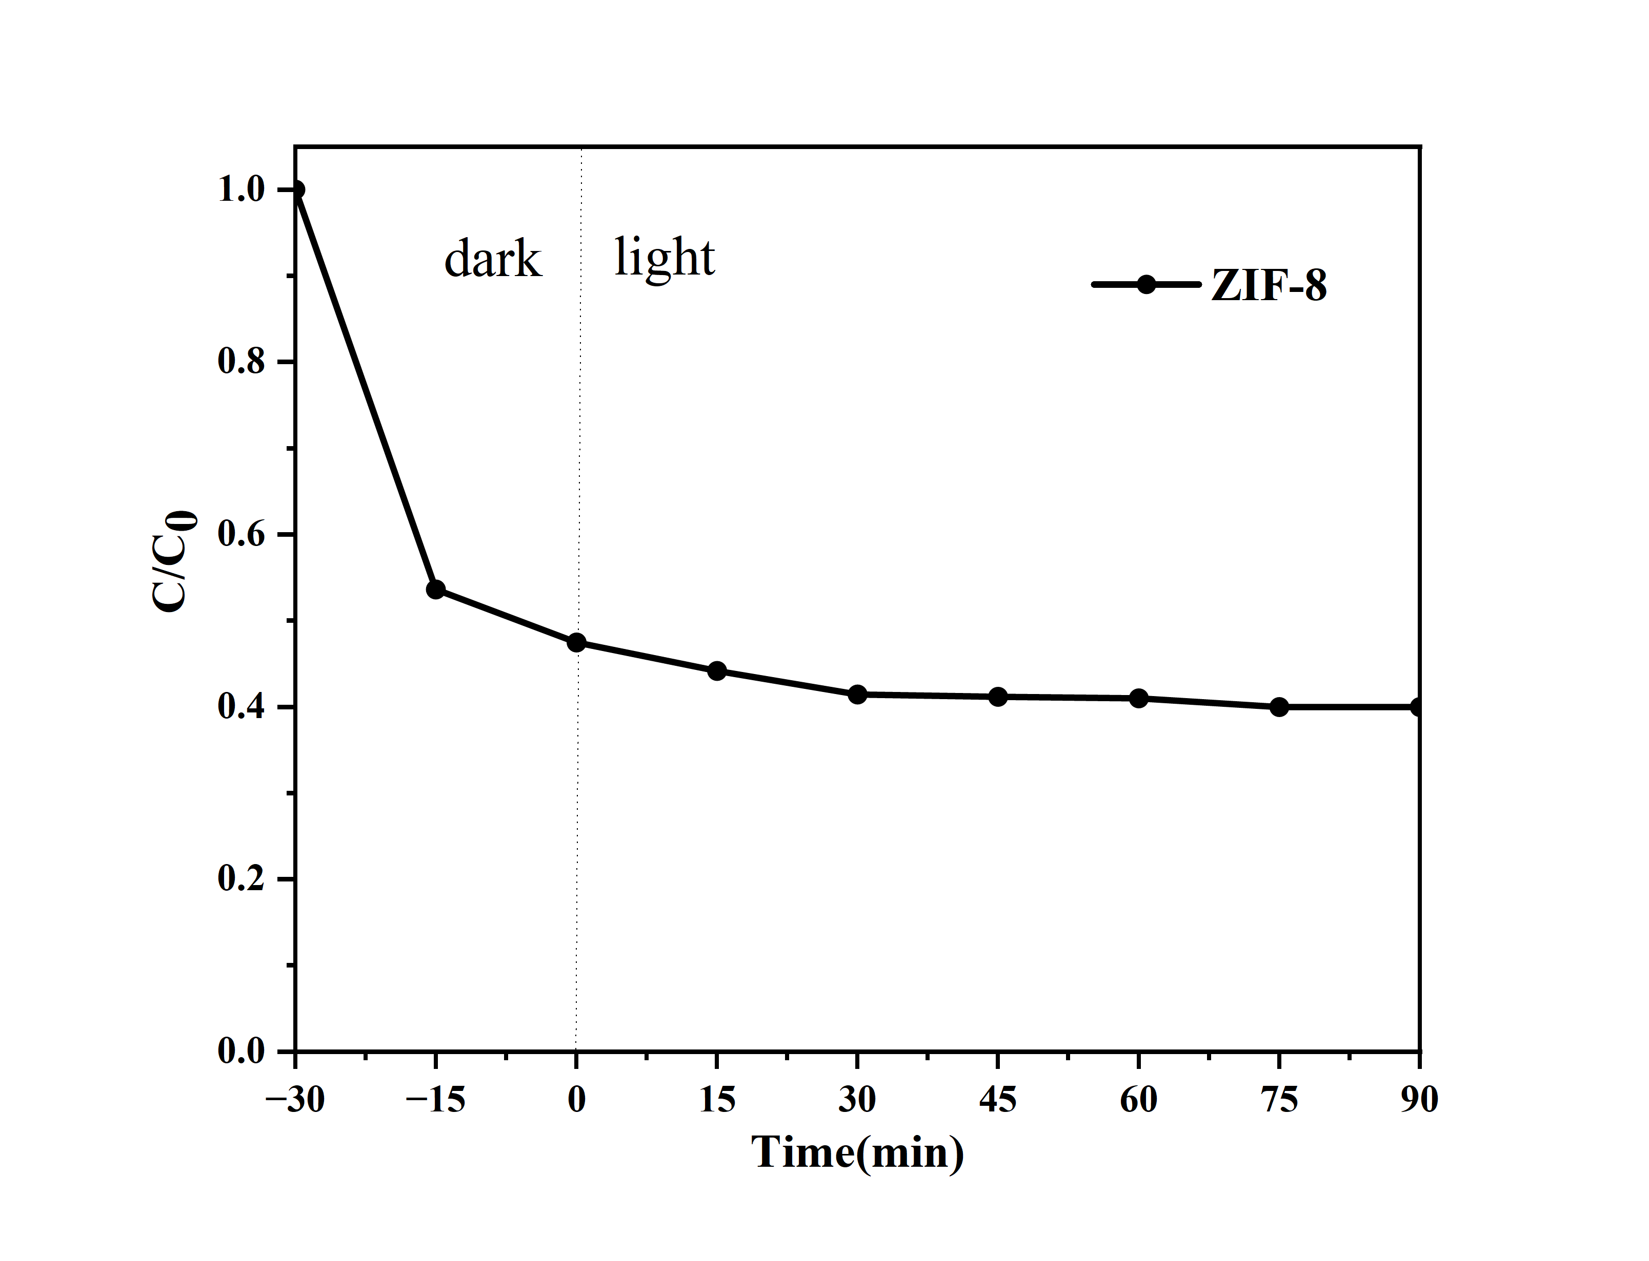
Fig. S 3 ZIF -8 Photocatalytic performance

References

- Guo, Z. (2005). Fabrication of Core-Shell Nanoparticles: Louisiana State University and Agricultural & Mechanical College.
- Zhuravlev, M. Y., Schepper, W., Heitmann, S., Vinzelberg, H., Zahn, P., Mertig, I. et al (2002). Reliable prediction of giant magnetoresistance characteristics. Physical Review B, 65(14), 144428. doi:10.1103/PhysRevB.65.144428
- Grimme, S., Antony, J., Ehrlich, S., Krieg, H. (2010). A consistent and accurate ab initio parametrization of density functional dispersion correction (DFT-D) for the 94 elements H-Pu. The Journal of chemical physics, 132(15). doi:10.1063/1.3382344
- Kopač, D., Jurković, D. L. i., Likozar, B., Huš, M. (2020). First-principles-based multiscale modelling of nonoxidative butane dehydrogenation on Cr2O3 (0001). ACS catalysis, 10(24), 14732-14746. doi:10.1021/acscatal.0c03197
- Garcıa-Otero, J., Garcıa-Bastida, A., Rivas, J. (1998). Influence of temperature on the coercive field of non-interacting fine magnetic particles. Journal of magnetism and magnetic materials, 189(3), 377-383. doi:10.1016/s0304-8853(98)00243-1

