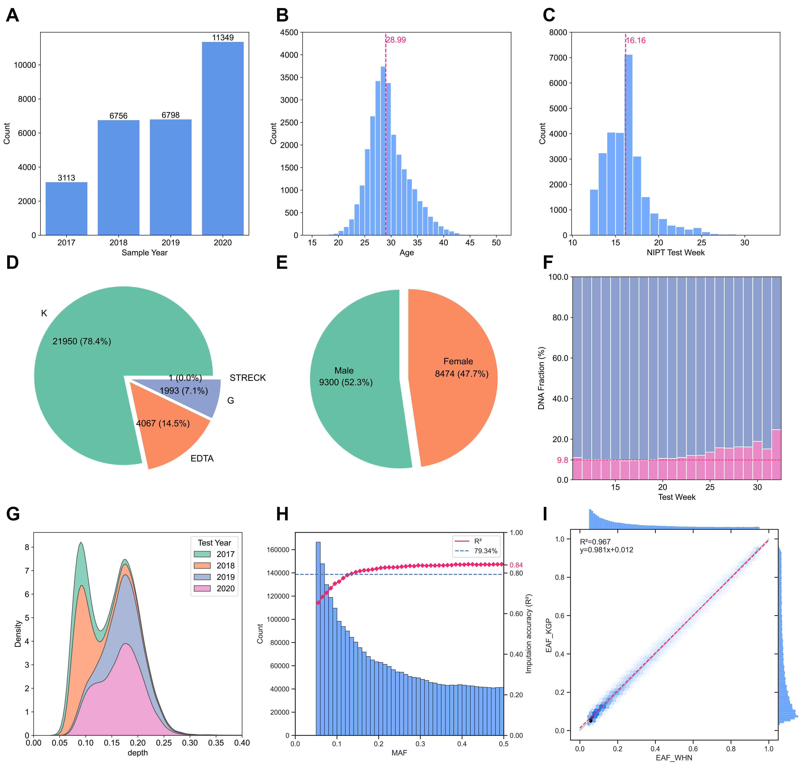
Figure S1. The information of samples and variants in the discovery study
A) number of participants by sampling year, B) age distribution of participants, C) gestational weeks at the time of NIPT testing, D) types of blood collection tubes used, E) gender distribution of newborns, F) maternal and fetal DNA fractions by NIPT test week, G) sequencing depth by sampling year, H) imputation performance of imputed variants, and I) comparison of alternate allele frequencies between the discovery study and the 1000 Genomes Project East Asian population.

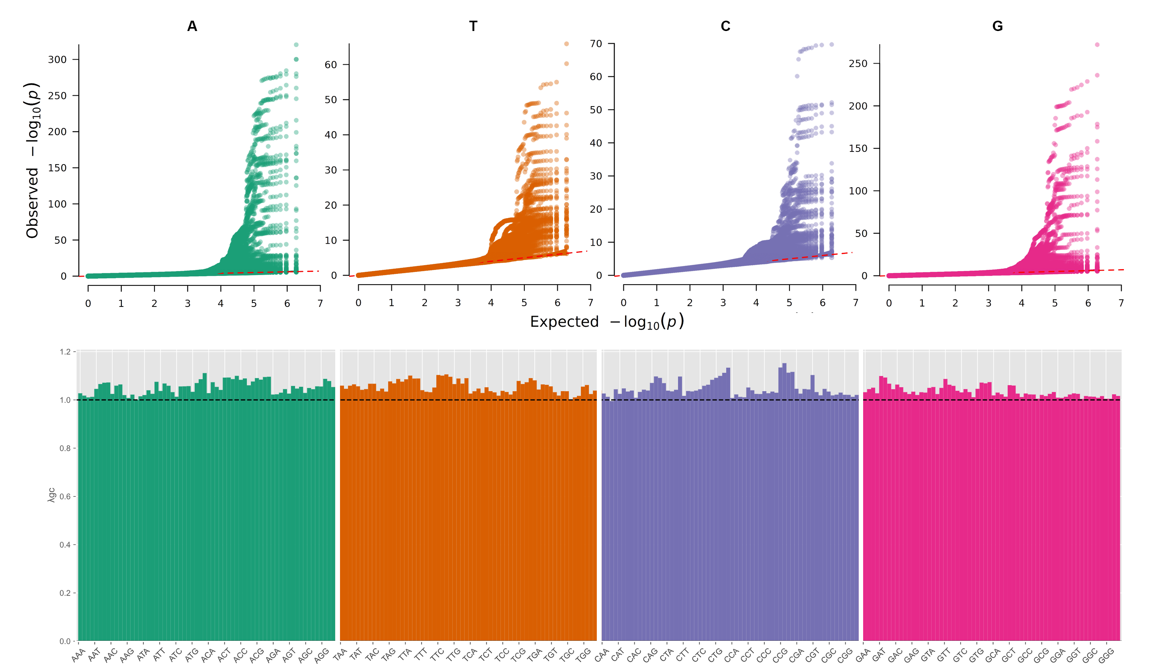
Figure S2. The QQ-plots and genomic inflation factors of GWAS results for 256 cfDNA motif frequencies

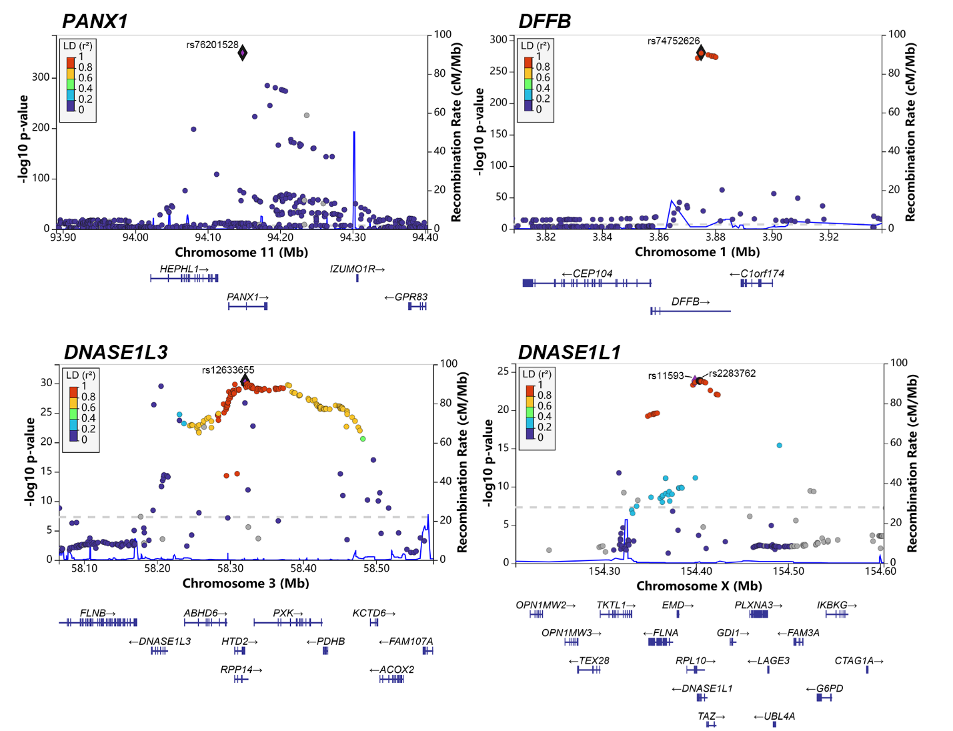
Figure S3. The regional plots of the top 4 GWAS signals

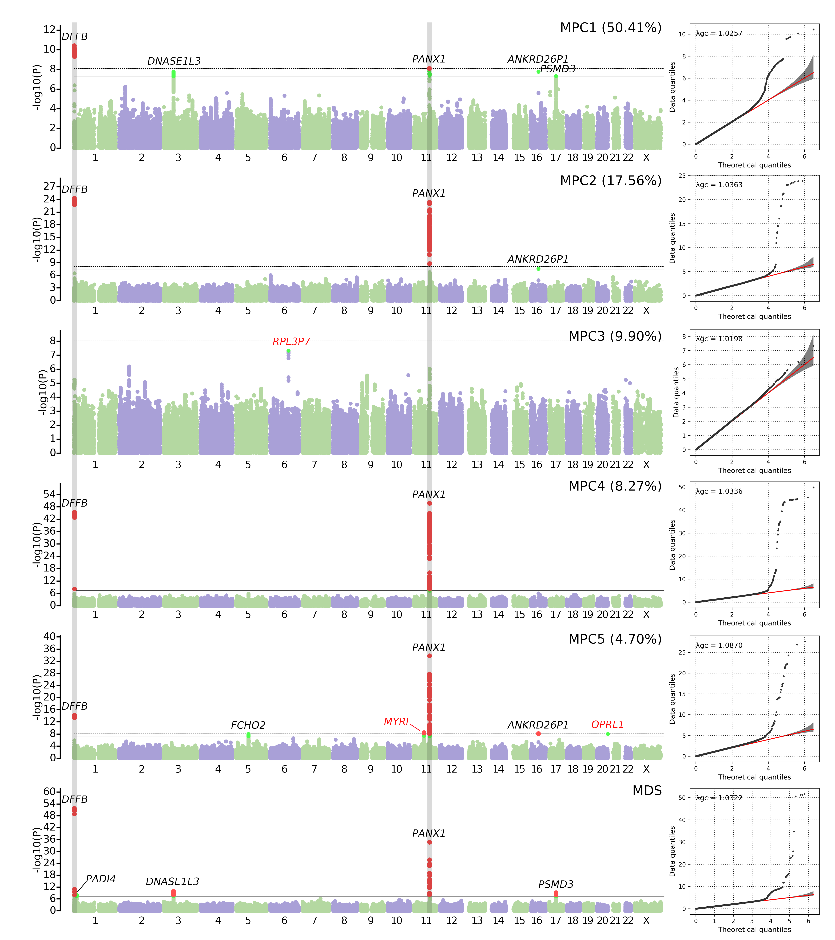
Figure S4. The Manhattan plot and QQ-plots of six secondary phenotypes
Notes: MPC represents the principal components of cfDNA motifs, and MDS represents the motif diversity score. Genes shown in black have passed the study-wide significance threshold of 1.95e-10, while genes in red have not reached this threshold. The percentage in parentheses represents the proportion of variance in cfDNA motif frequencies explained by each MPC.
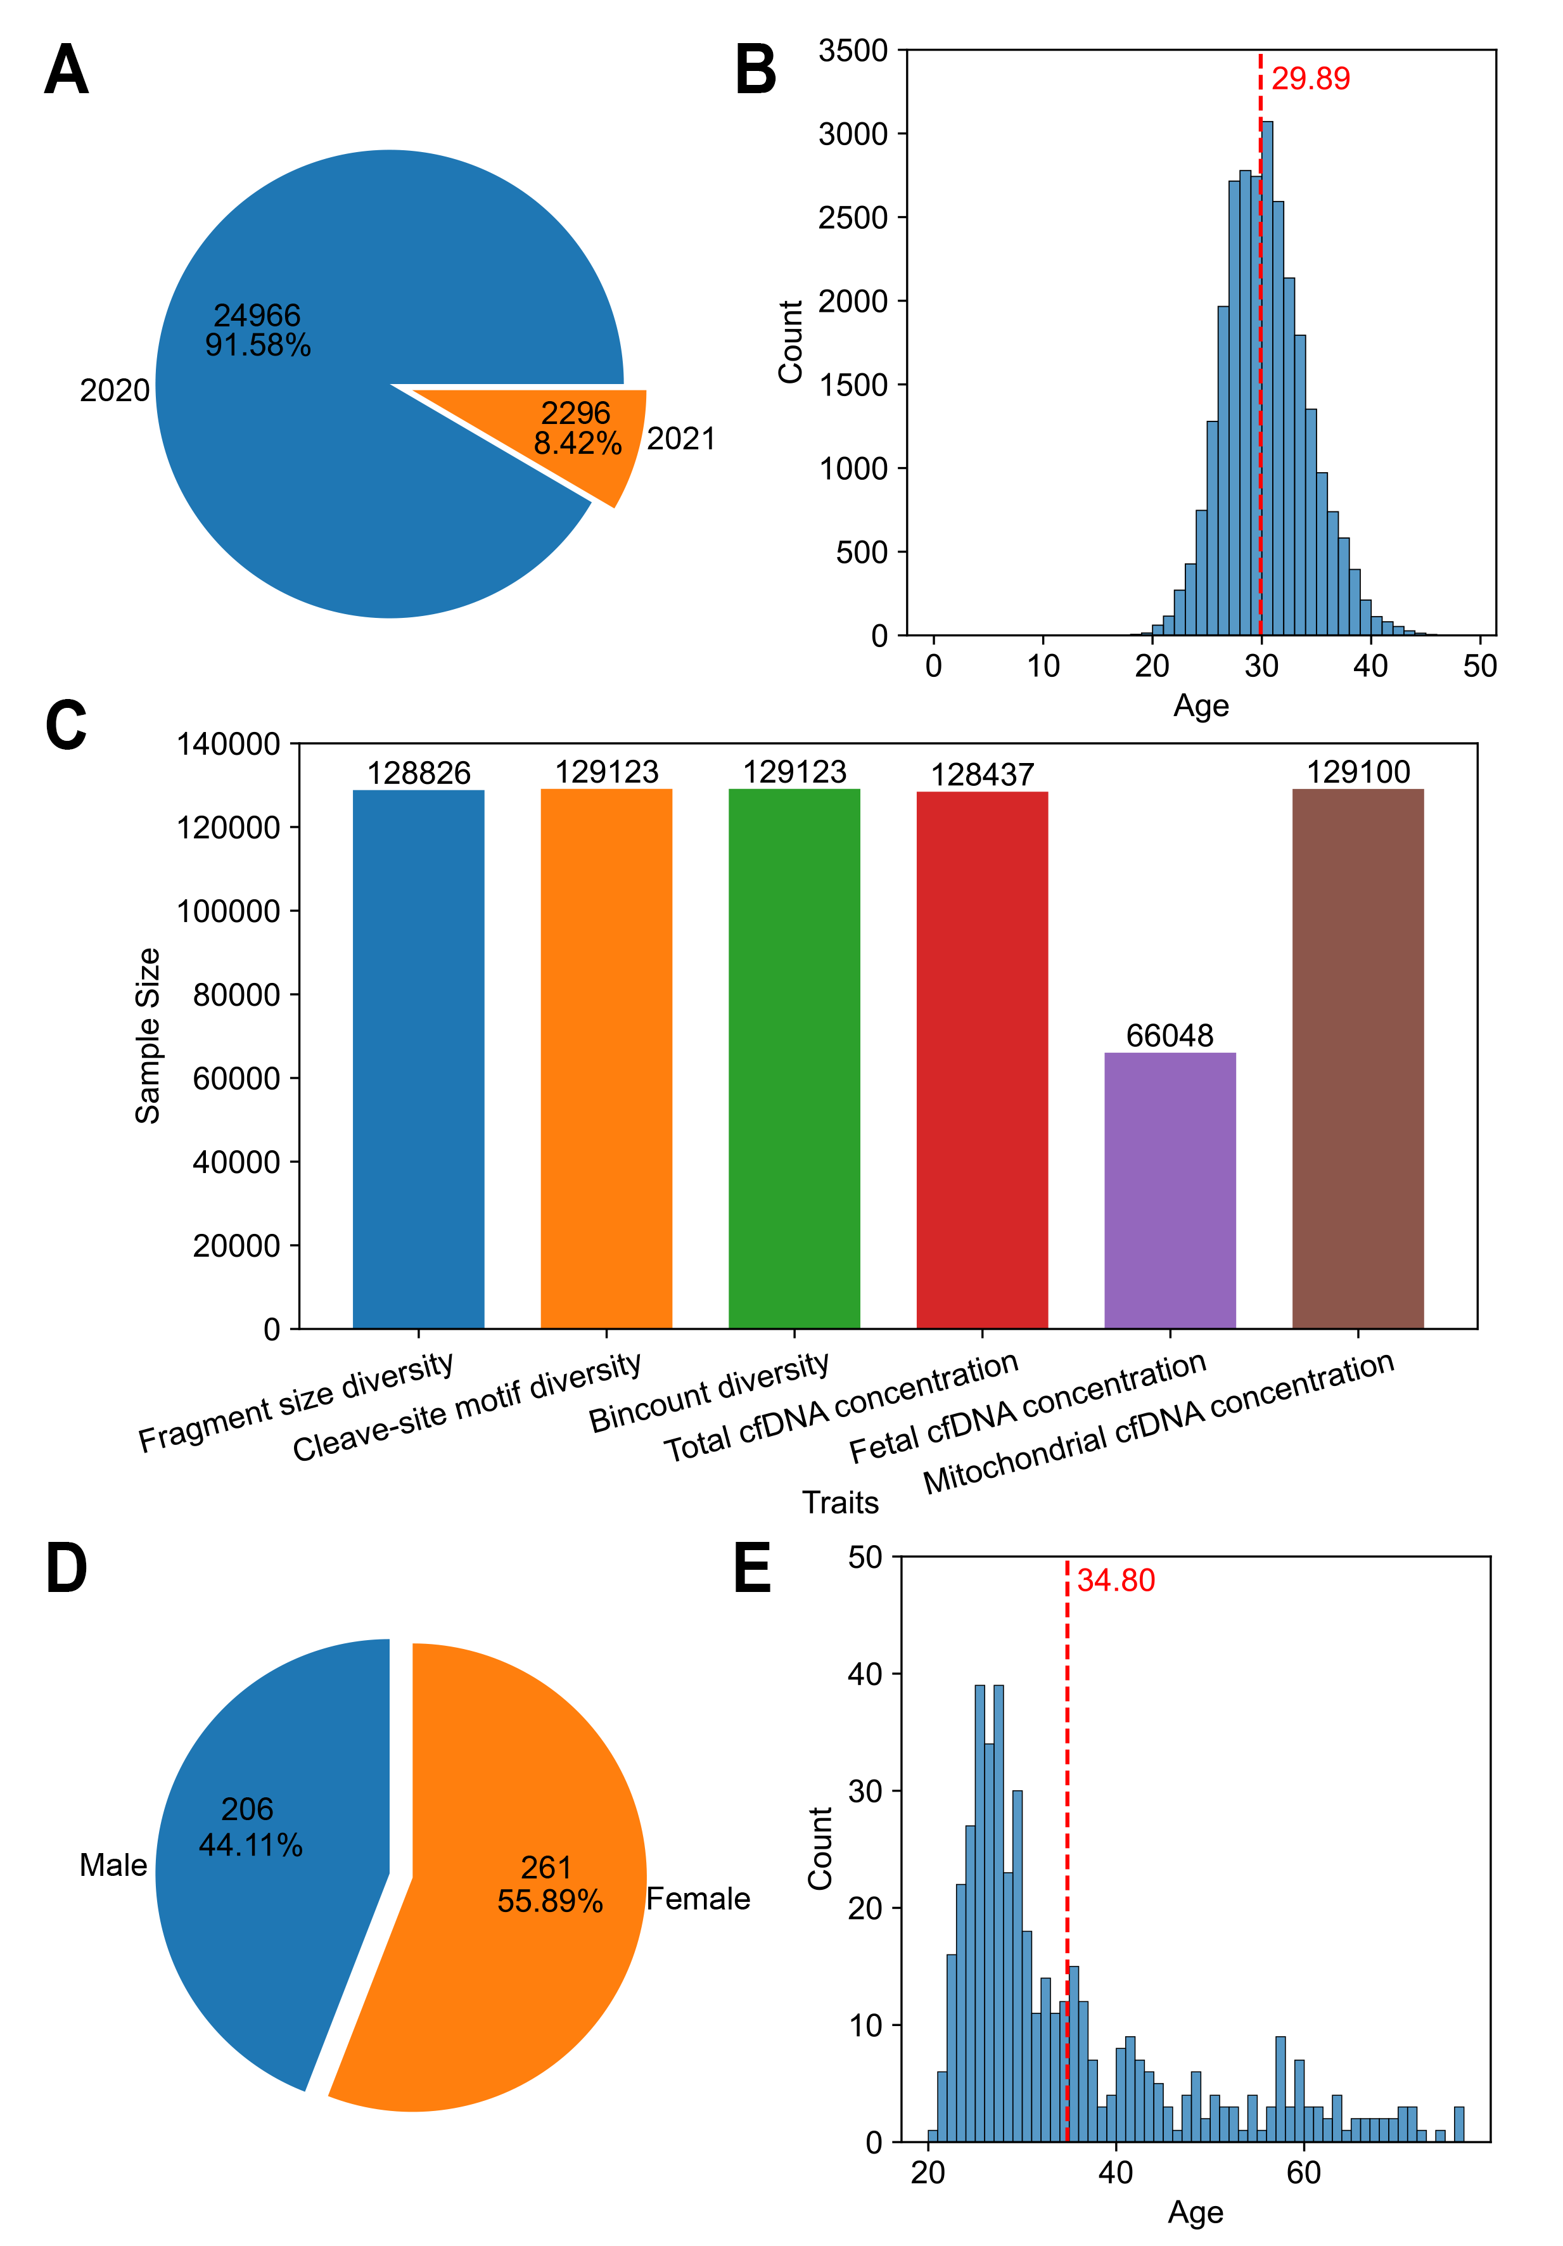
Figure S5. The sample information in the three replication studies
A-B) number of samples collected in 2020 and 2021, and age distributions of participants in the first replication study, based on approximately 25,000 Chinese NIPT samples; C) sample sizes used for GWAS analysis of six cfDNA features in the second replication study, based on Dutch NIPT samples; D-E) gender and age distributions of participants in the third replication study, based on approximately 400 healthy individuals from the general population.
Figure S6. Regional plots of 23 study-wide significant loci in the discovery study and three replication studies

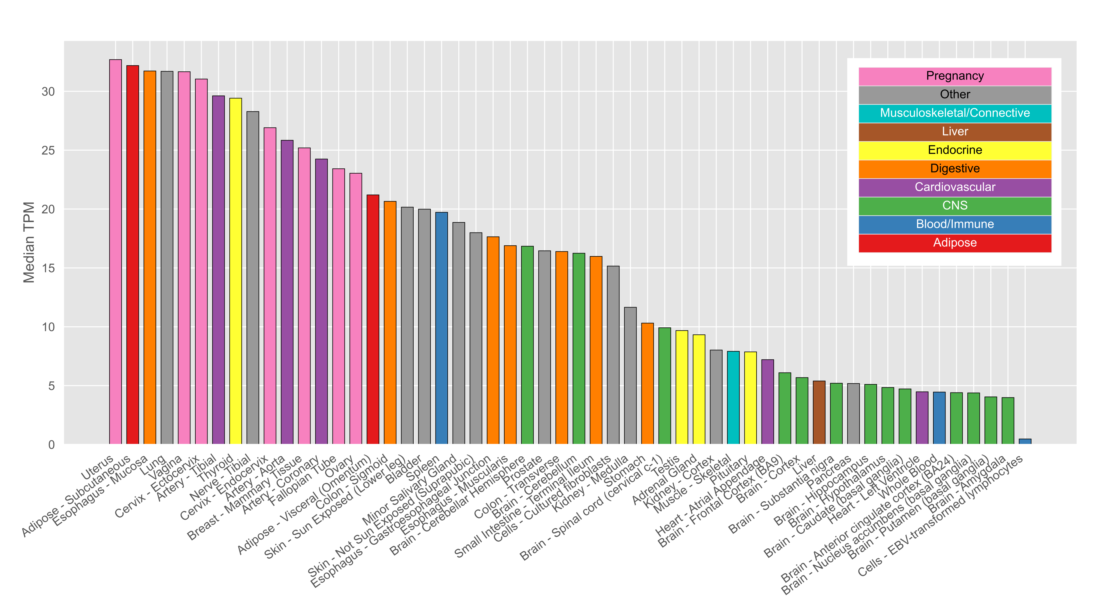
Figure S7. The median value of transcripts per million (TPM) of gene FCHO2 from the GTEx database

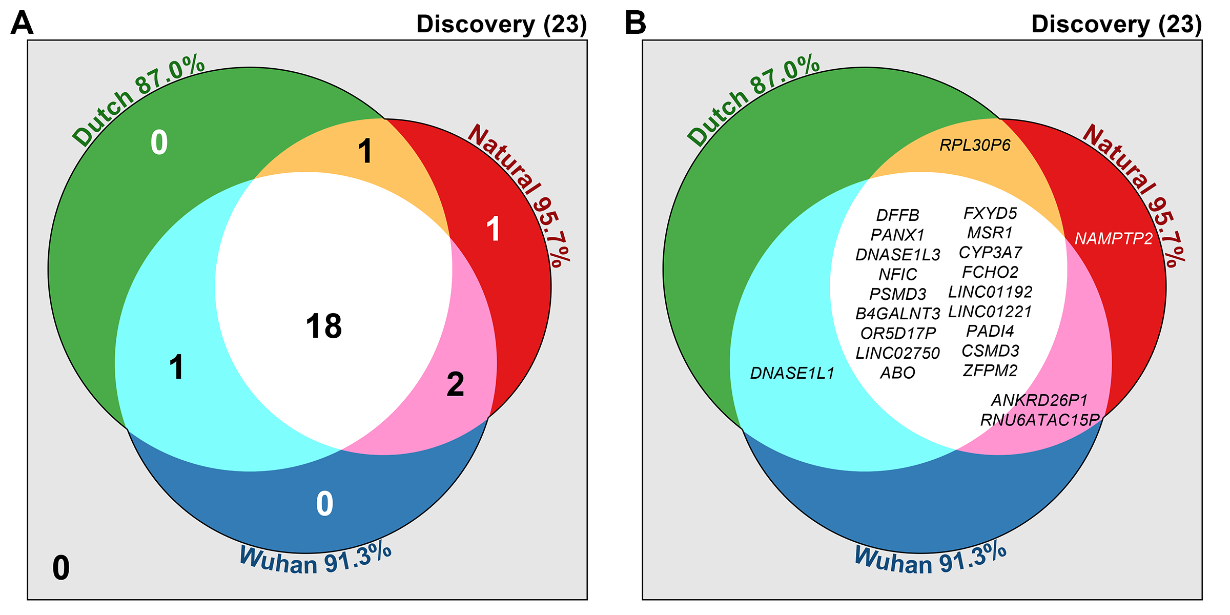
Figure S8. Replication performance of the three studies at the 1e-4 threshold
A) number of replicated genes in each replication study, B) names of replicated genes in each replication study

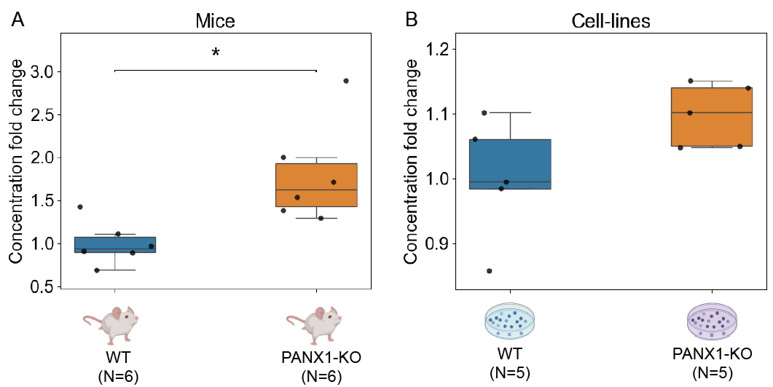
Figure S9. The fold change of cfDNA concentration in mouse and cell line experiments

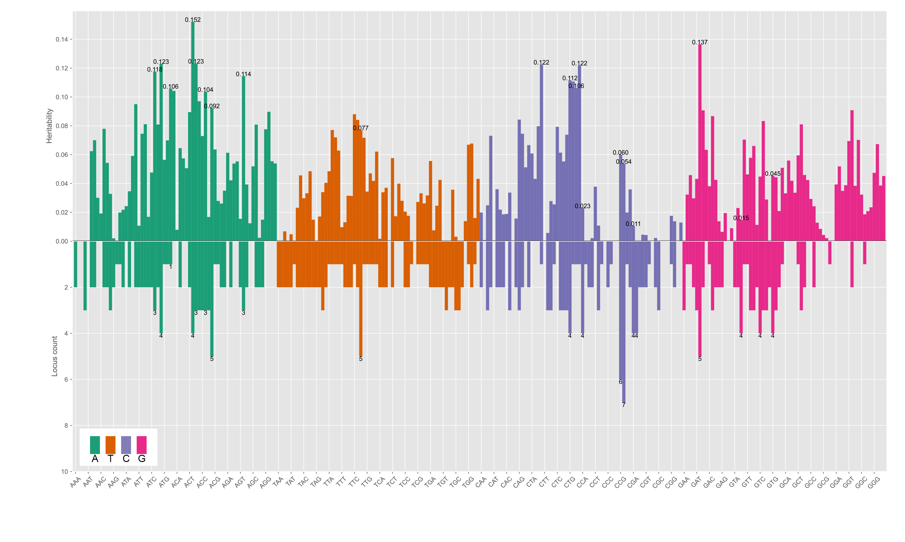
Figure S10. The heritability and number of study-wide significant loci of 256 motifs

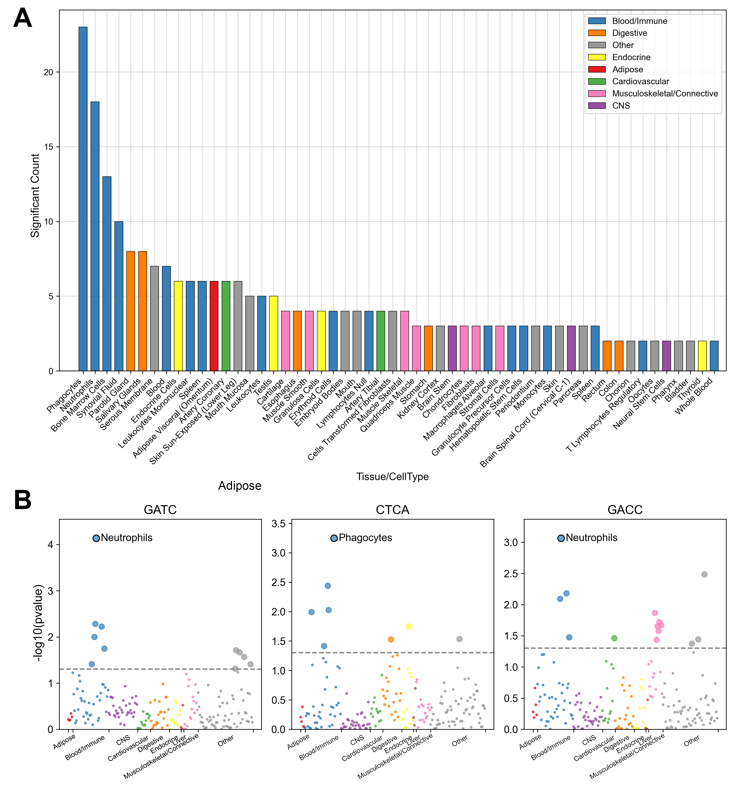
Figure S11. Results of partition heritability analysis
A) number of associated cfDNA motifs for tissues/cell types with significant associations, B) heritability partition results for three cfDNA motifs, with the most significantly associated cell types labeled.

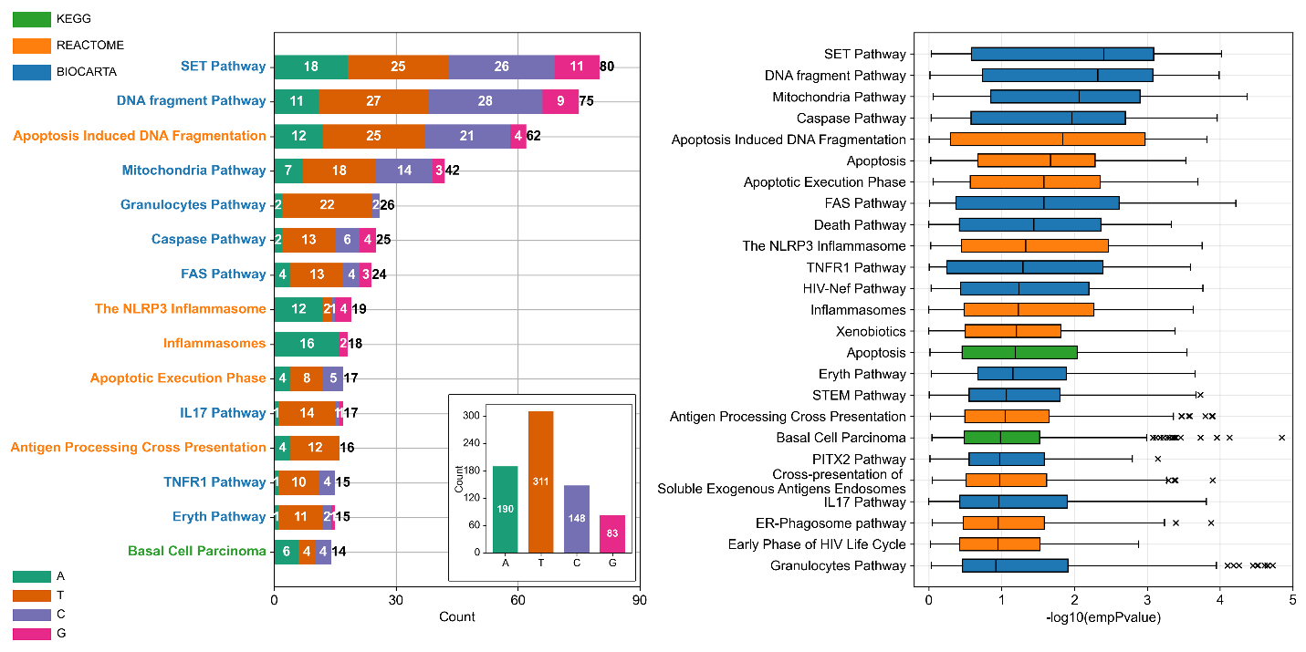
Figure S12. Significant count and p-value distribution in pathway-based analysis

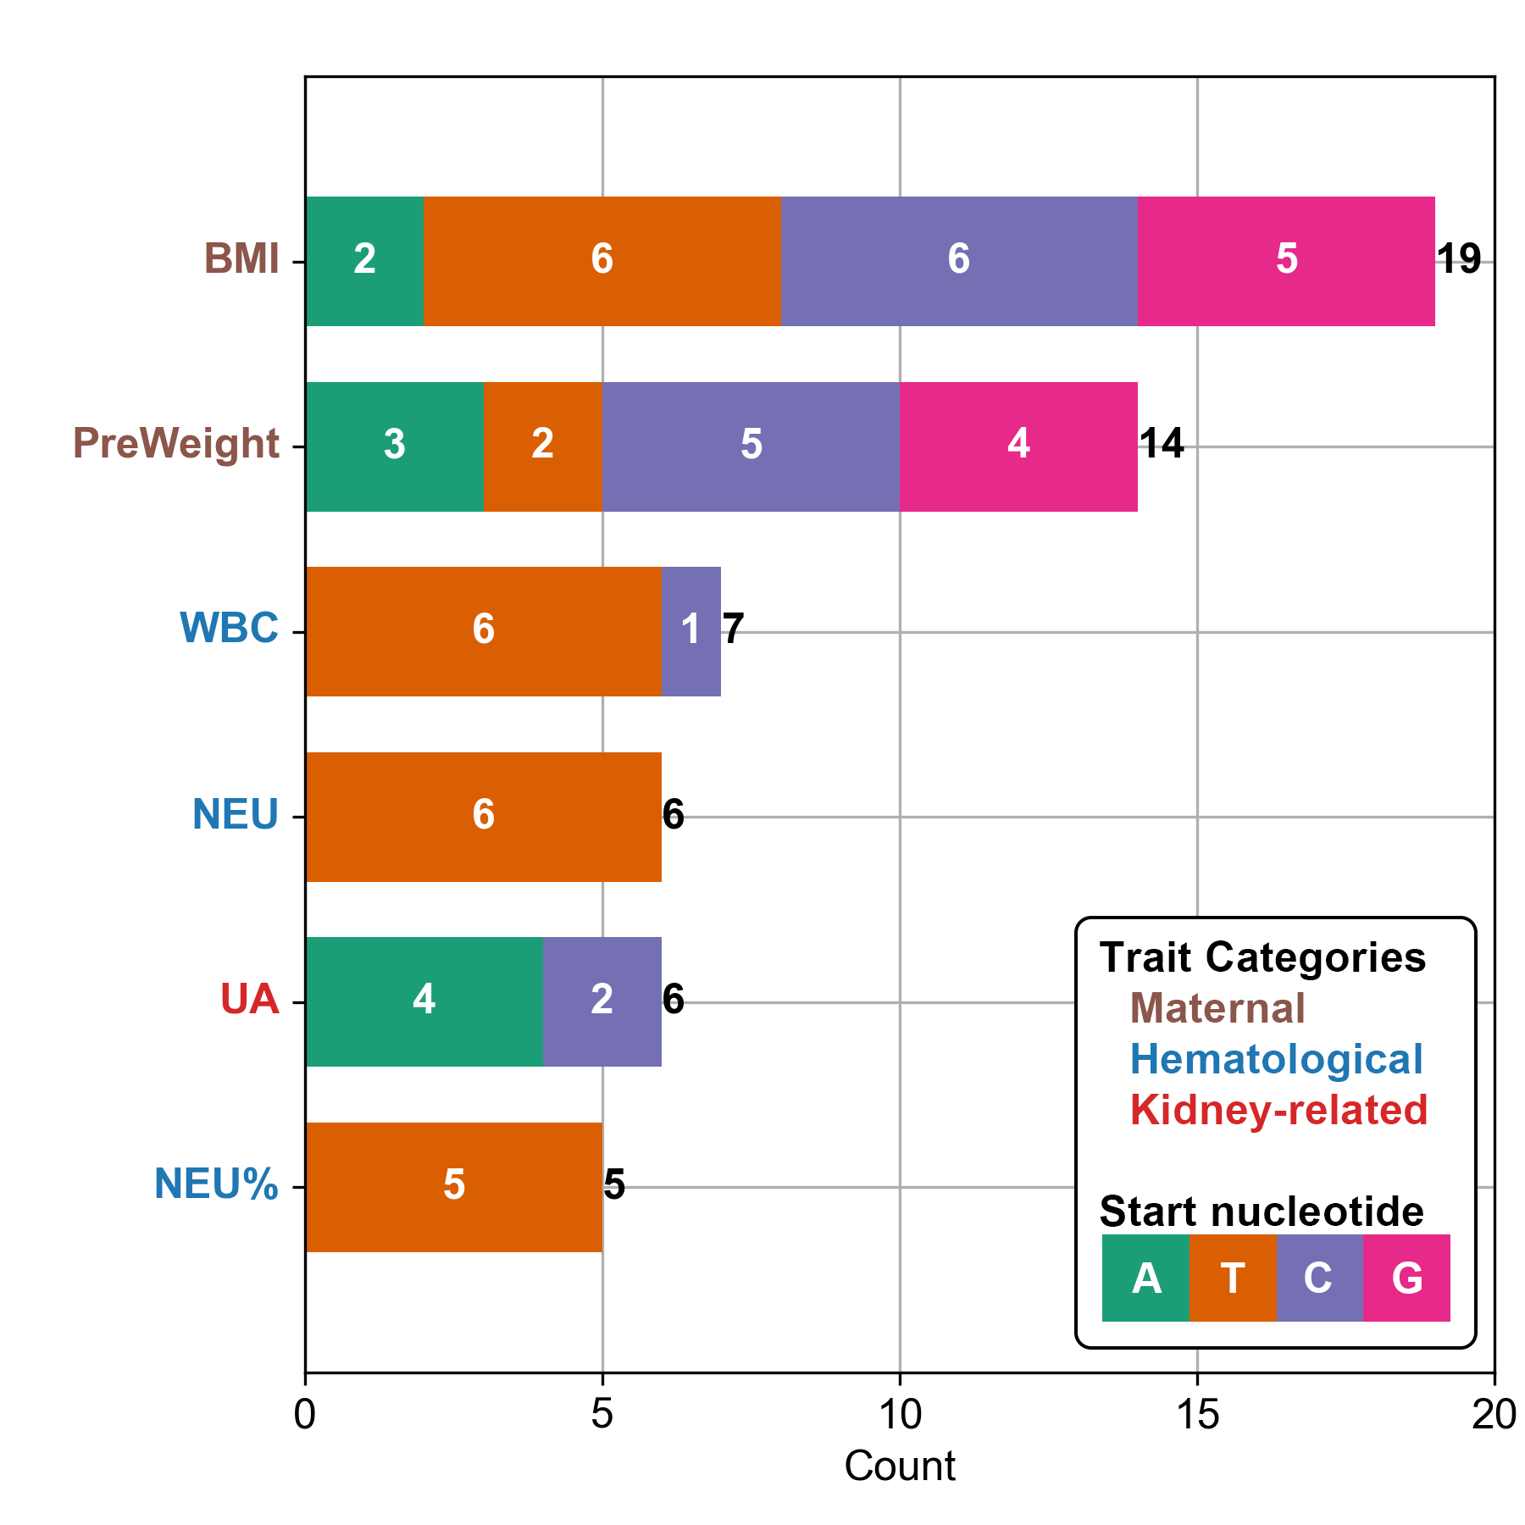
Figure S13. Count of significantly genetic-correlated motifs for each phenotype
Notes: BMI represents maternal body mass index, PreWeight represents maternal pre-pregnancy weight, WBC represents white blood cell counts, NEU represents neutrophil count, UA indicates uric acid, and NEU% represents the percentage of neutrophils.

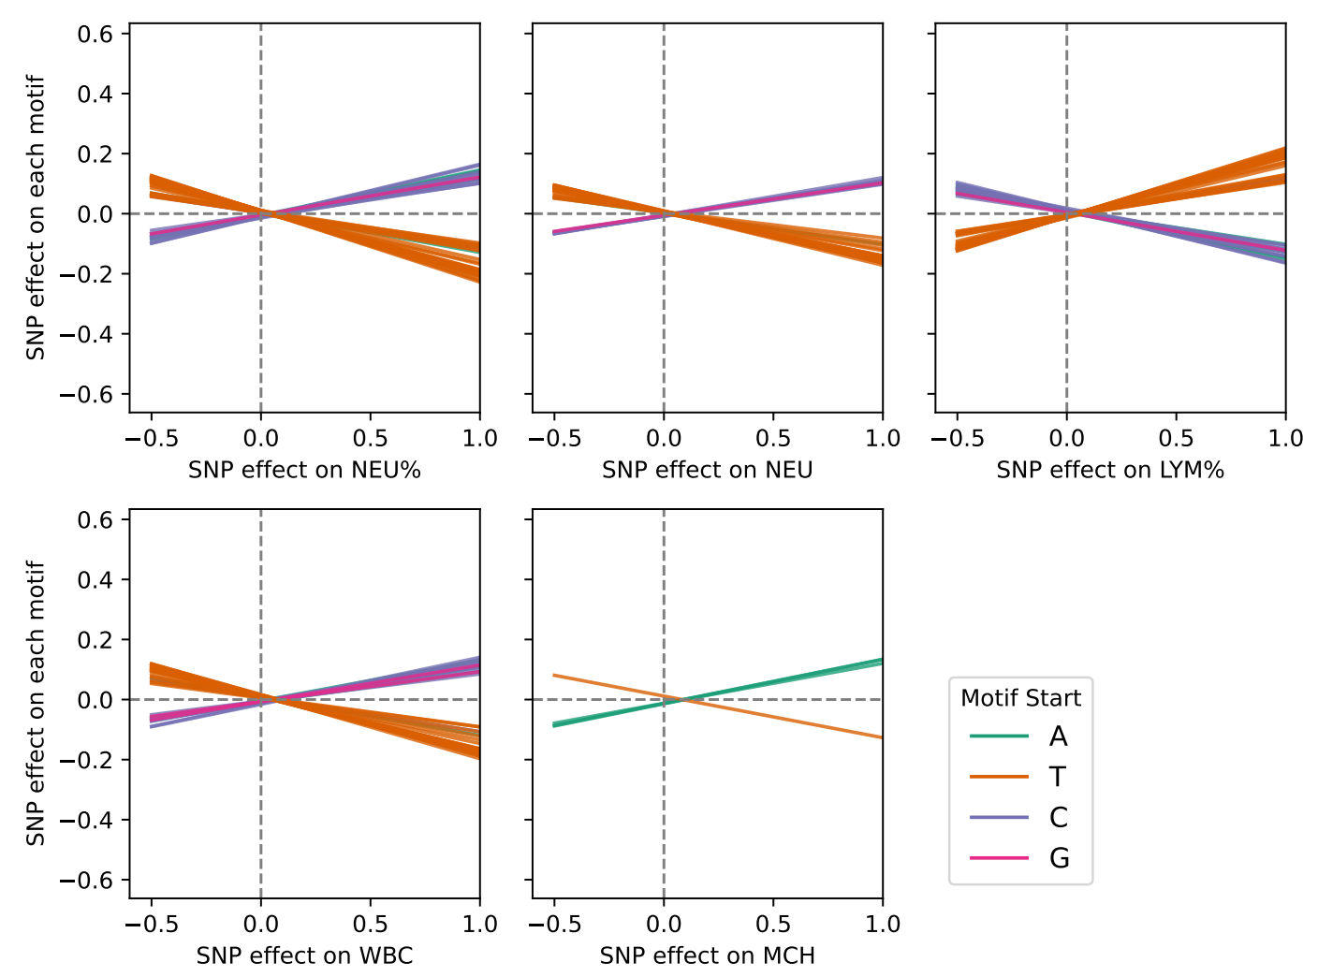
Figure S14. The Mendelian randomization regression lines of the 5 casually related phenotype
Notes: NEU% represents percentage of neutrophils, NEU presents neutrophil counts, LYM% presents percentage of lymphocytes, WBC represents white blood cell count, and MCH represents mean corpuscular hemoglobin.

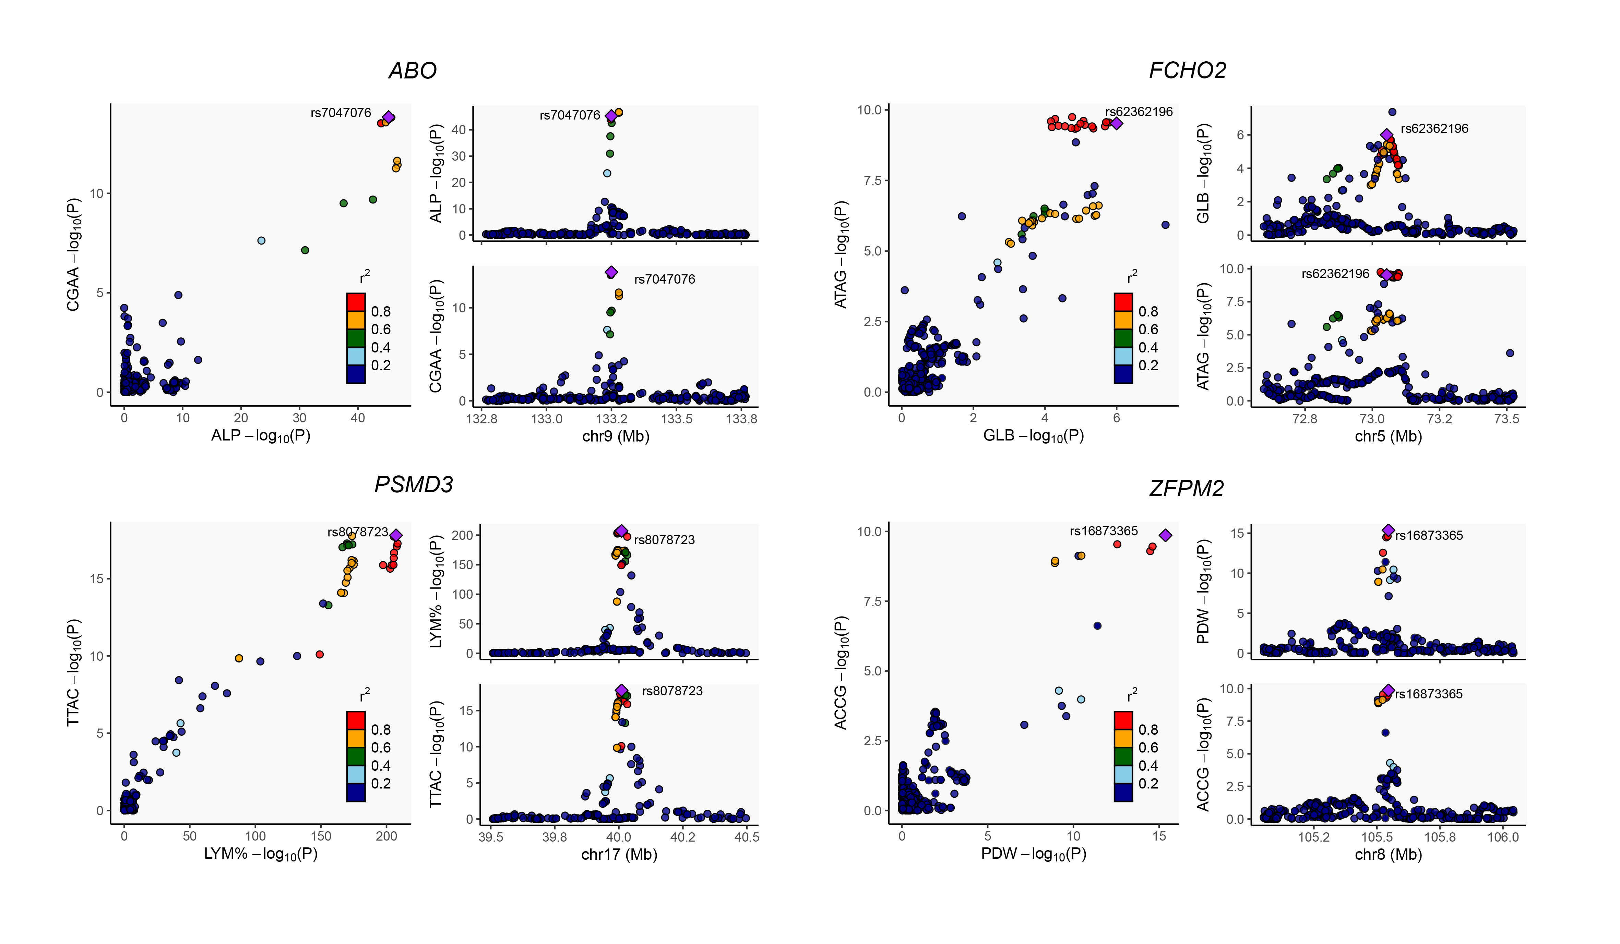
Figure S15. Colocalization regional plot for four loci between cfDNA motifs and pregnancy phenotypes
Notes: ALP represents alkaline phosphatase, GLB represents globulin, LYM% presents percentage of lymphocytes, and PDW represents platelet distribution width.

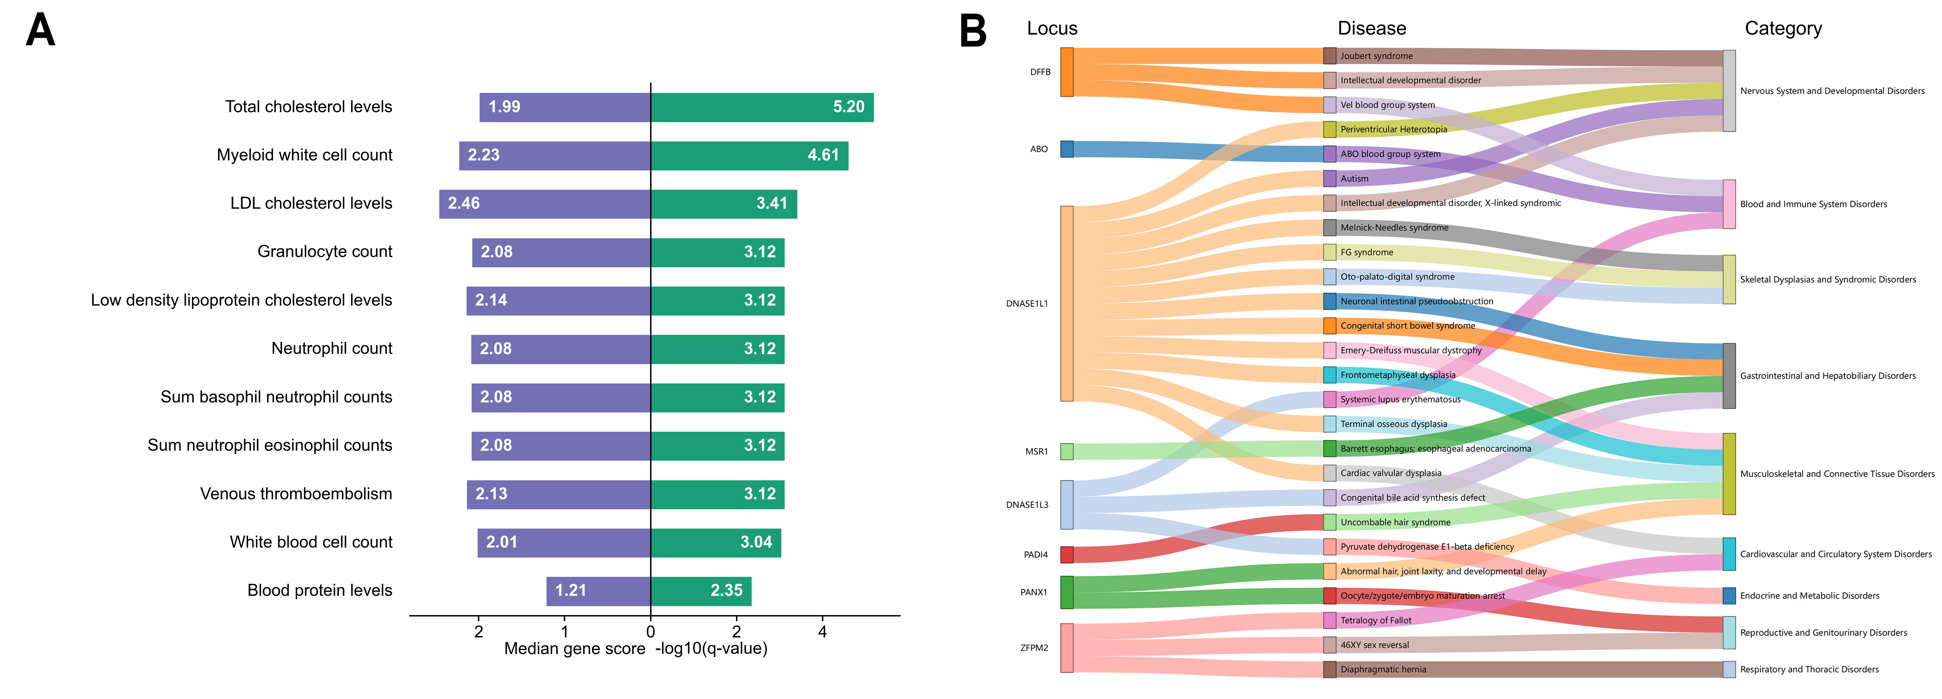
Figure 16. The pleiotropy analysis results with GWAS catalog and OMIM database
A) the enriched phenotypes from the GWAS catalog that are associated with study-wide significant SNPs linked to cfDNA motif frequencies; B) the Sankey diagram, from left to right, sequentially displays the study-wide significant loci associated with cfDNA motif frequencies, the associated disease in OMIM database, and the disease categories.

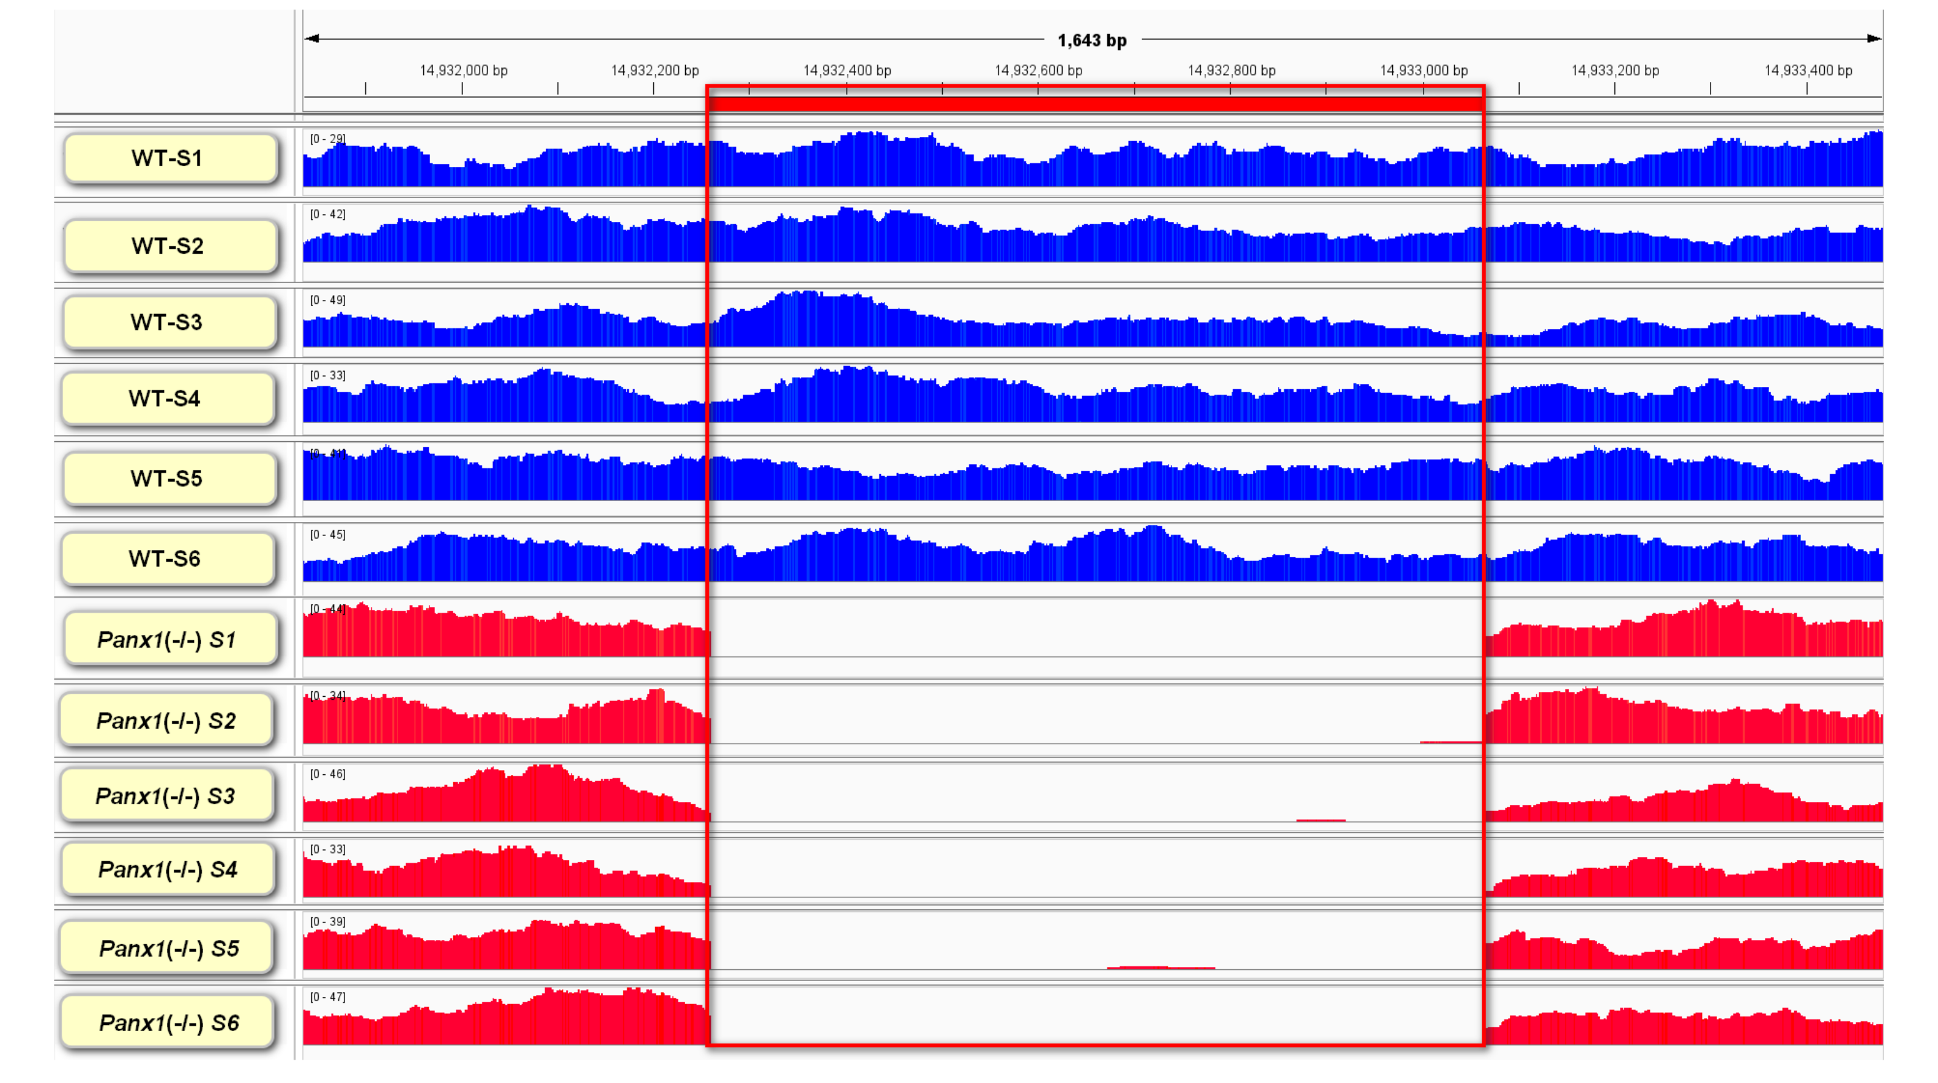
Figure S17. The plasma cfDNA sequencing and alignment results verified the Panx1-deficient mice model
Table S1. 84 Genome-wide significant loci associated with cfDNA motif frequencies in GWAS analysis
Table S2. 23 Study-wide significant loci associated with cfDNA motif frequencies in GWAS analysis
Table S3. Heritability and number of significant loci for each cfDNA motif
Table S4. P-values of heritability partition analysis
Table S5. Number of associated motifs for tissues/cell types with significant associations in heritability partition analysis
Table S6. P-values for pathway-based analysis
Table S7. Number of associated cfDNA motifs for each pathway in the pathway-based analysis
Table S8. Results for genetic correlation analysis
Table S9. Number of associated motifs for six pregnancy phenotypes in genetic correlation analysis
Table S10. Results for P->M Mendelian Randomization analysis
Table S11. Results of sensitivity tests for 156 causal associations in Mendelian randomization
Table S12. Colocalization results between cfDNA motifs and pregnancy phenotypes
Table S13. Genes associated with both cfDNA motif frequencies and diseases from OMIM database

