Supplementary Information

Synthesis, Characterization and Catalytic Activity of Polyethylene Glycol (PEG) Functionalized MXene (Ti₃C₂T_{x}) for Methylene Blue Dye Degradation Under UV Light Irradiation

Maisha Rahman¹, Muhammad Shamim Al Mamun^{1*}, Tsuyoshi Takaoka², Tadahiro Komeda², Mohamed Aly Saad Aly³, Md Nasiruddin⁴, Waleed Alahmad⁵

¹Chemistry Discipline, School of Science, Engineering and Technology, Khulna University, Khulna-9208, Bangladesh.
²Institute of Multidisciplinary Research for Advanced Materials, Tohoku University, 2-1-1, Katahira, Aoba-ku, Sendai 980-8577
³Department of Electrical and Computer Engineering at Georgia Tech Shenzhen Institute (GTSI), Shenzhen, Guangdong 518052, China
⁴Department of Chemistry Bangabandhu Sheikh Mujibur Rahman Science and Technology University, Gopalganj.
⁵Department of chemistry, Faculty of science at Chulalongkorn University, Bangkok 10330, Thailand

Table of Content
- Synthesis Process of MXene
- Reproducible data of MB+NaBH₄+ MXene+UV
- Reproducible data of MB+NaBH₄+ MXene-PEG+UV

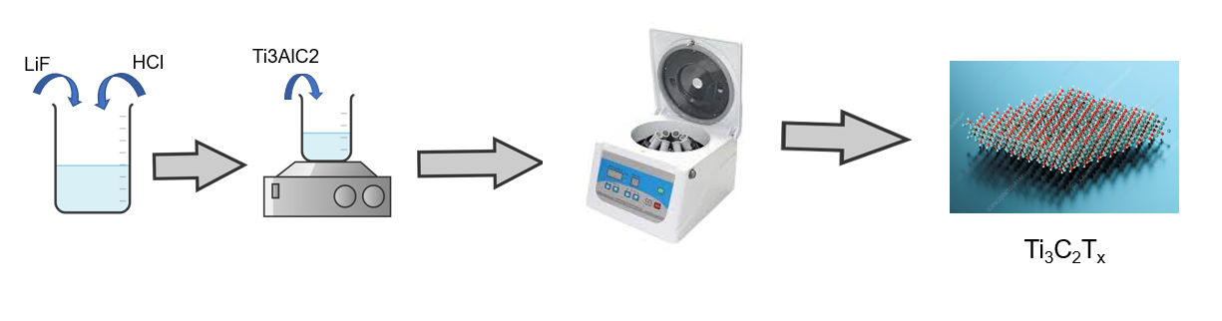

Figure S1. Synthesis process of MXene.

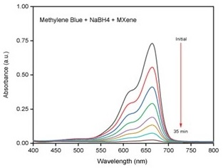

Figure S2. Reproducible data of MB+NaBH₄+ MXene+UV.

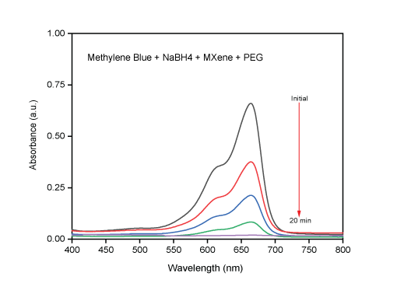

Figure S3. Reproducible data of MB+NaBH₄+ MXene-PEG + UV.

