Supplementary information
Amplifying persistent luminescence in heavily doped nanopearls for bioimaging and solar-to-chemical synthesis
Bing Qi^{†,+}, Wenjing Dai^{†,+}, Bibo Lou‡, Bin Song†, Ziyun Miao†, Yurong Wei†, Chong-Geng Ma‡,*, Jie Wang†,*
†The Key Lab of Health Chemistry & Molecular Diagnosis of Suzhou, College of Chemistry, Chemical Engineering & Materials Science, Laboratory of Nanoscale Biochemical Analysis, Institute of Functional Nano and Soft Materials (FUNSOM), Soochow University, Suzhou 215123, China.
‡CQUPT-BUL Innovation Institute, School of Optoelectronic Engineering, Chongqing University of Posts and Telecommunications, Chongqing, China.
Corresponding author: cgma.ustc@gmail.com, jiewang@suda.edu.cn.

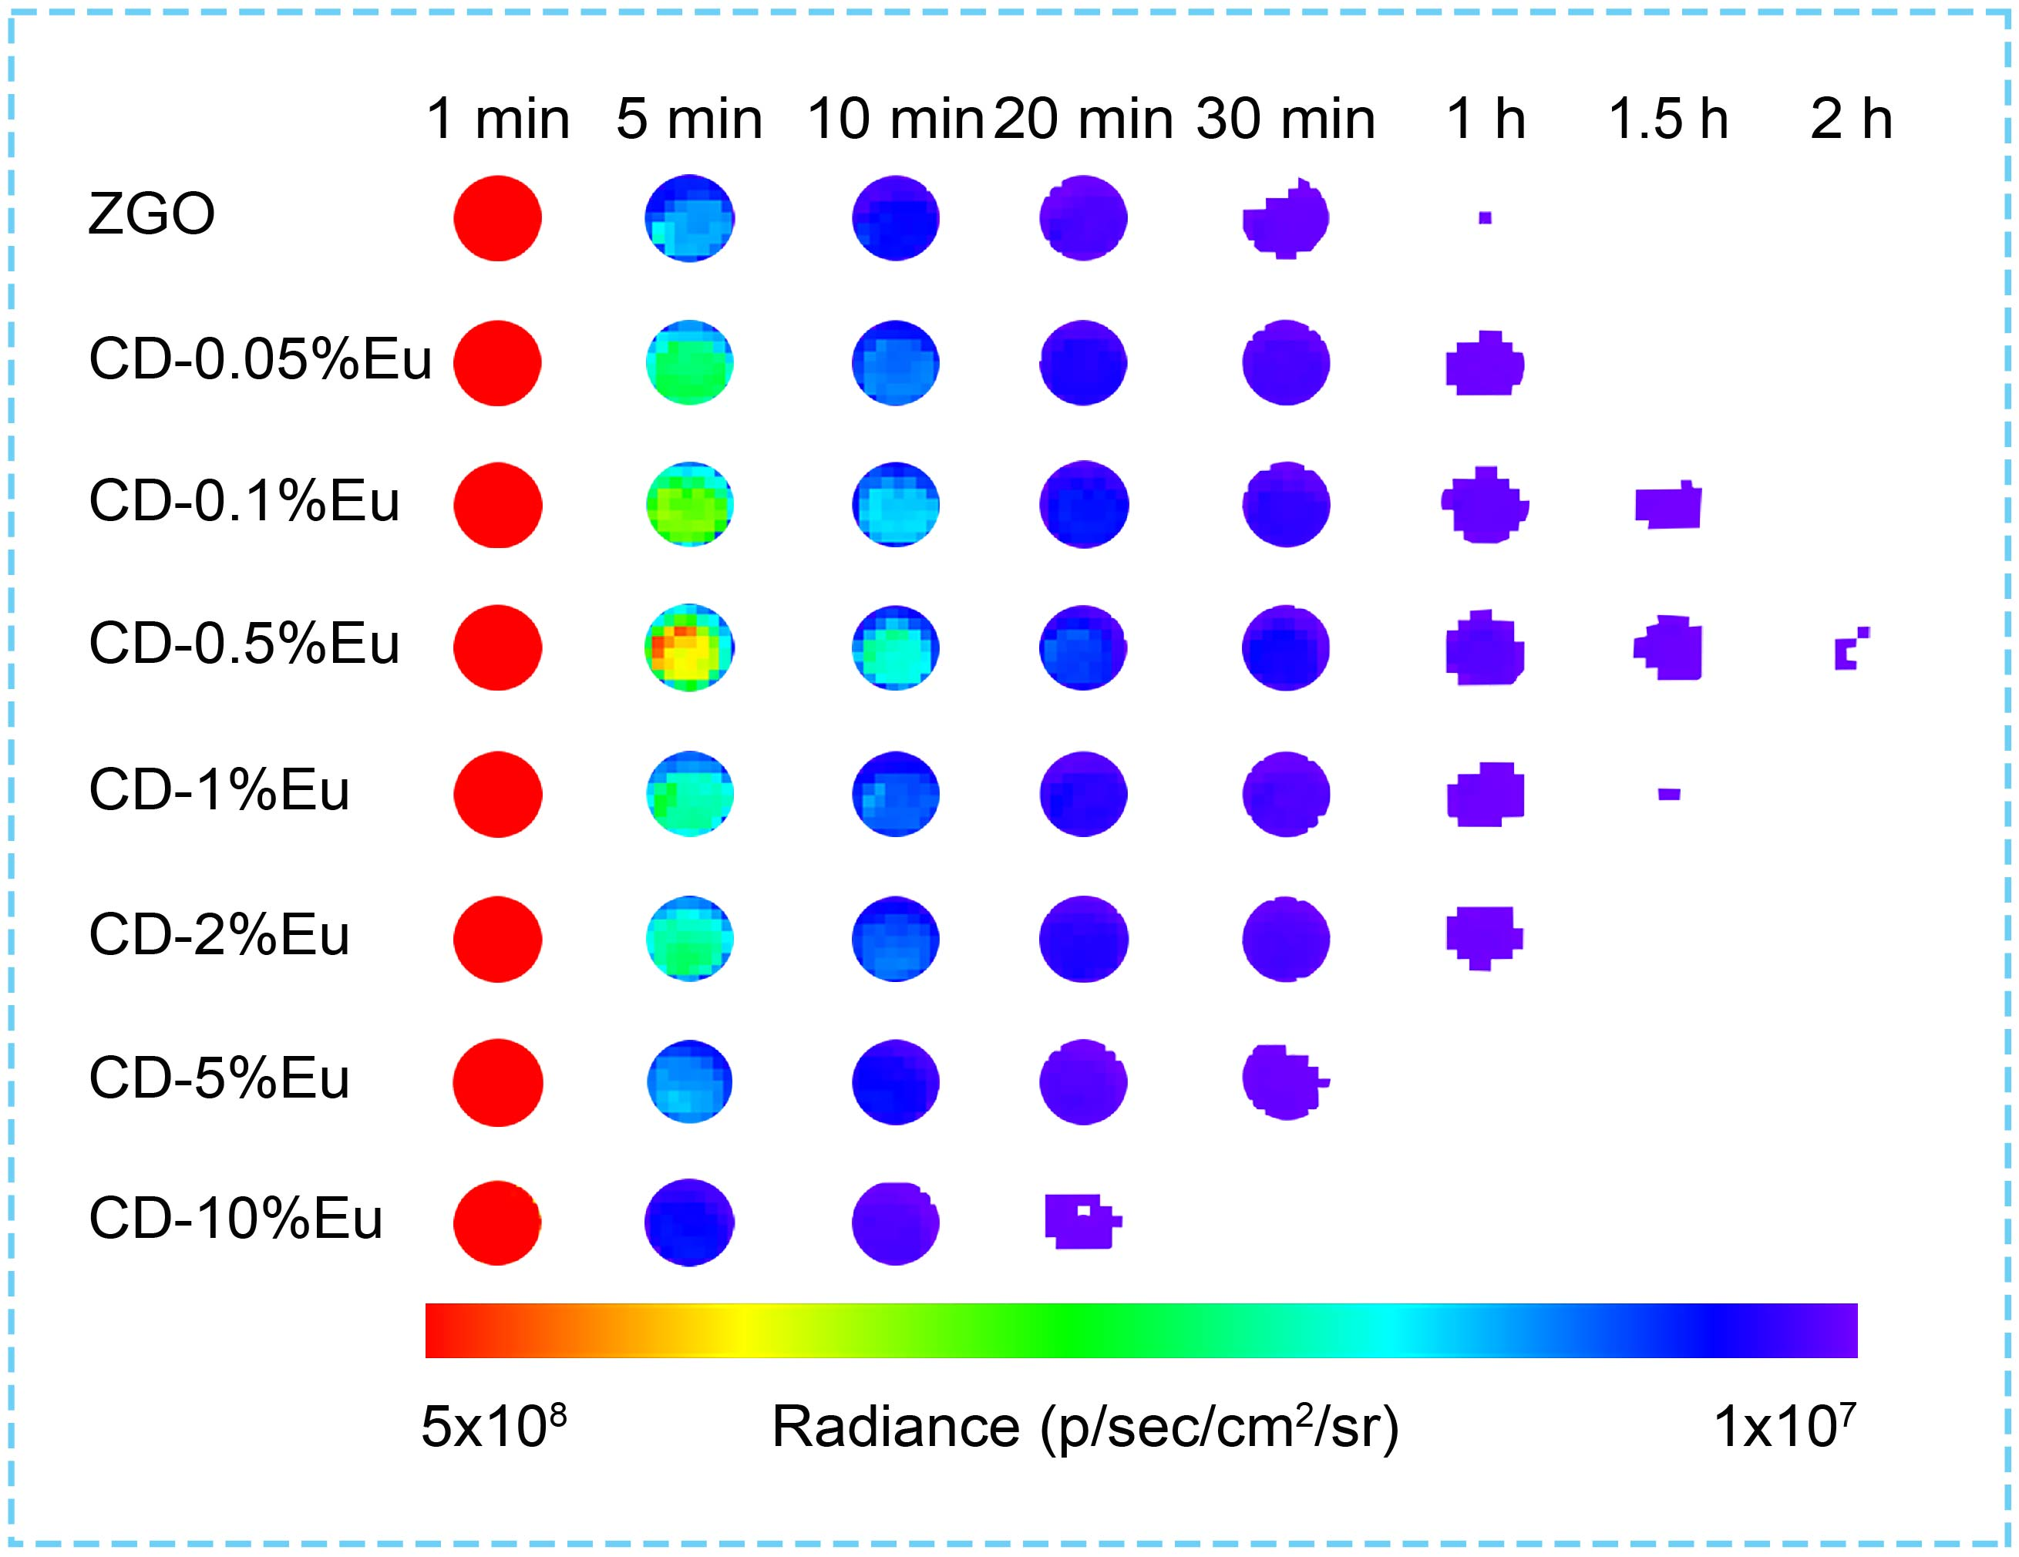
Figure S1 | Persistent luminescence decay images of CD-Eu PLNPs pre-charged by UV light. The PLNPs were illuminated by a commercial LED (254 nm) for 3 min and the persistent luminescence images were taken by an IVIS optical imaging system in bioluminescence mode.

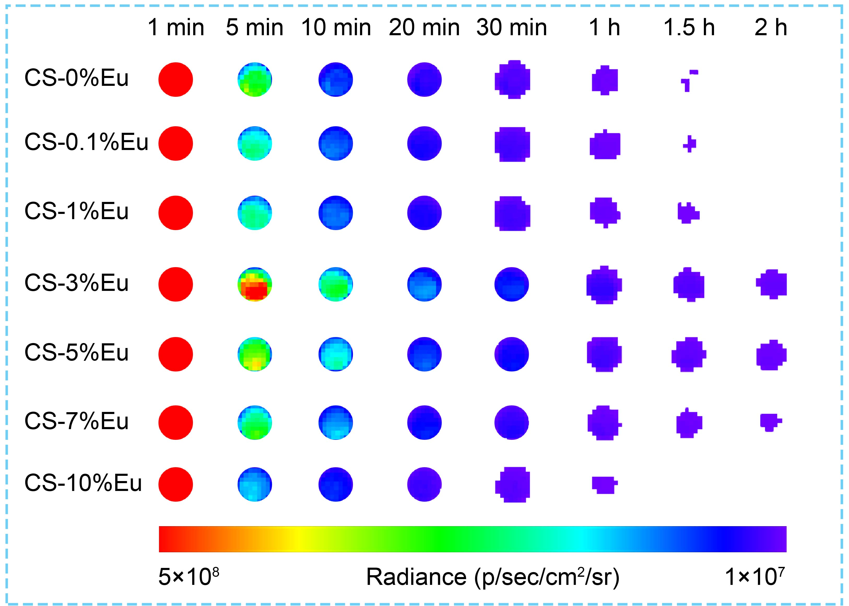
Figure S2 | Persistent luminescence decay images of CS-Eu pre-charged by UV light. The PLNPs were illuminated by a commercial LED (254 nm) for 3 min and the persistent luminescence images were taken by an IVIS optical imaging system in bioluminescence mode.

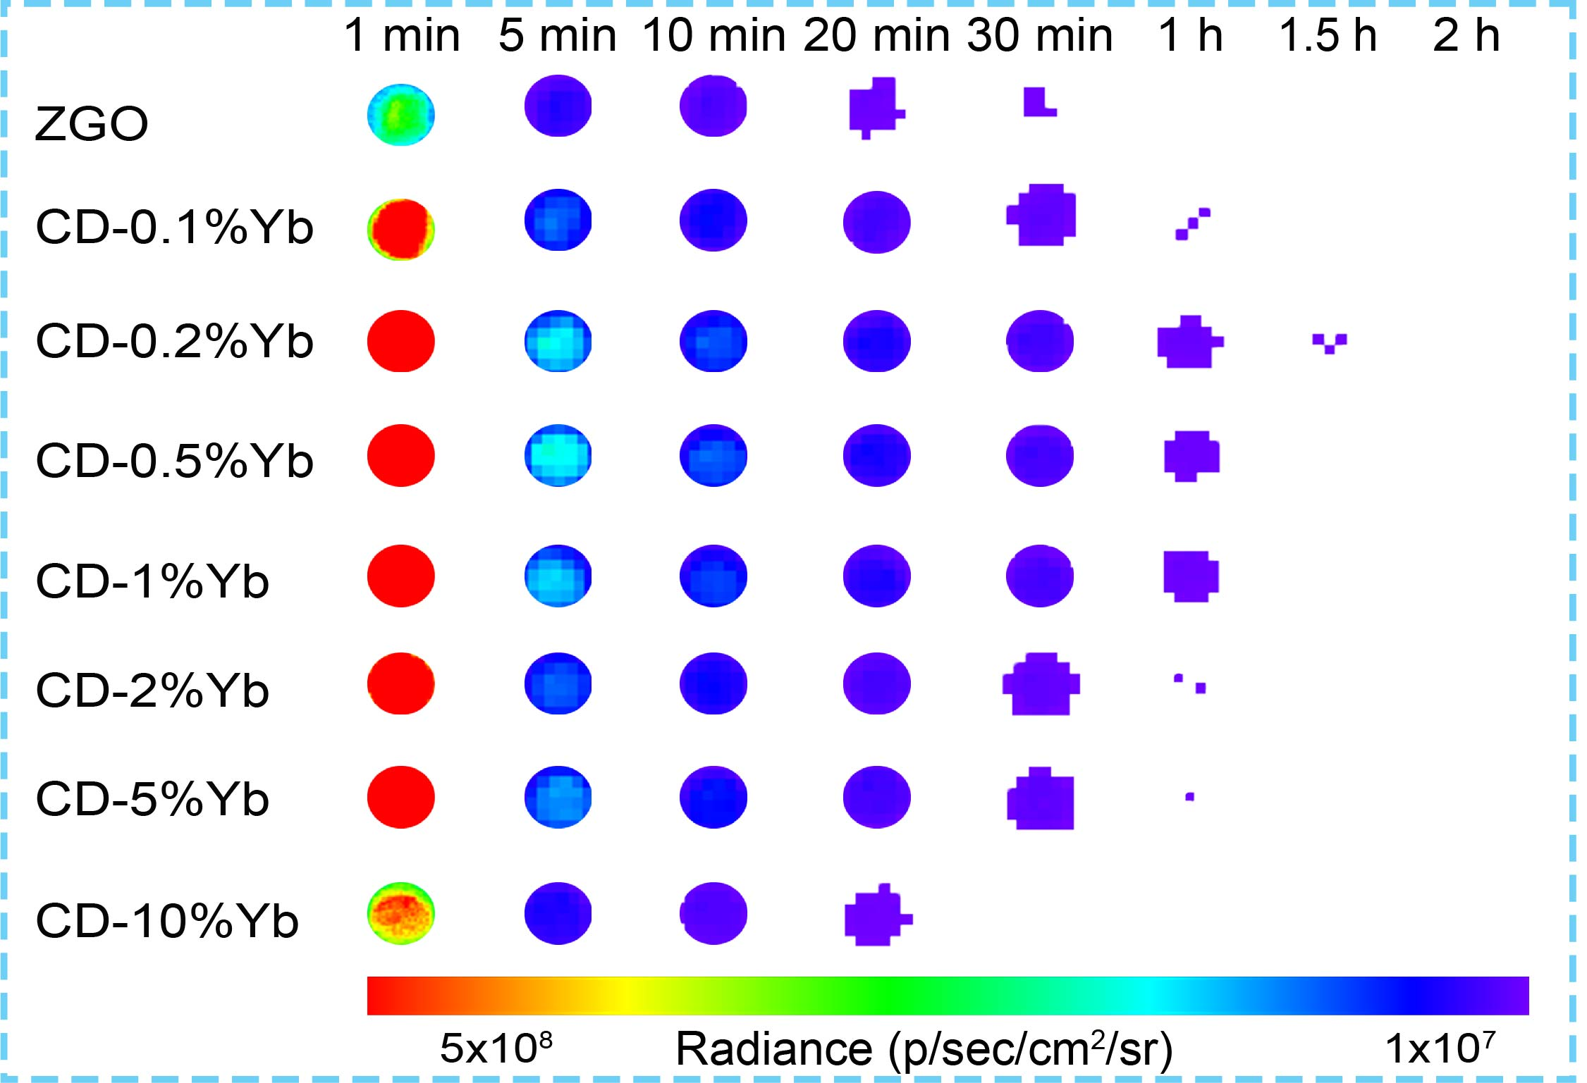
Figure S3 | Persistent luminescence decay images of CD-Yb PLNPs pre-charged by UV light. The PLNPs were illuminated by a commercial LED (254 nm) for 3 min and the persistent luminescence images were taken by an IVIS optical imaging system in bioluminescence mode.

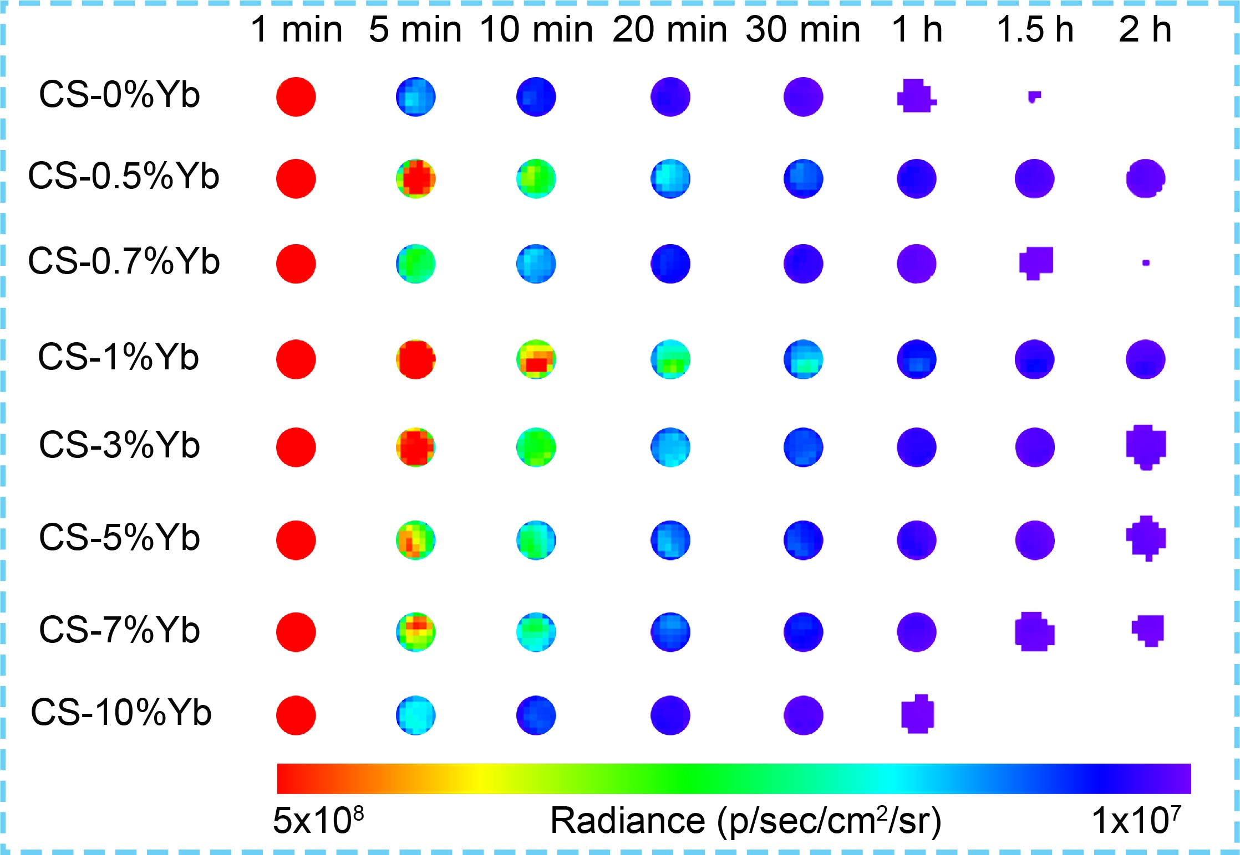
Figure S4 | Persistent luminescence decay images of CS-Yb pre-charged by UV light. The PLNPs were illuminated by a commercial LED (254 nm) for 3 min and the persistent luminescence images were taken by an IVIS optical imaging system in bioluminescence mode.

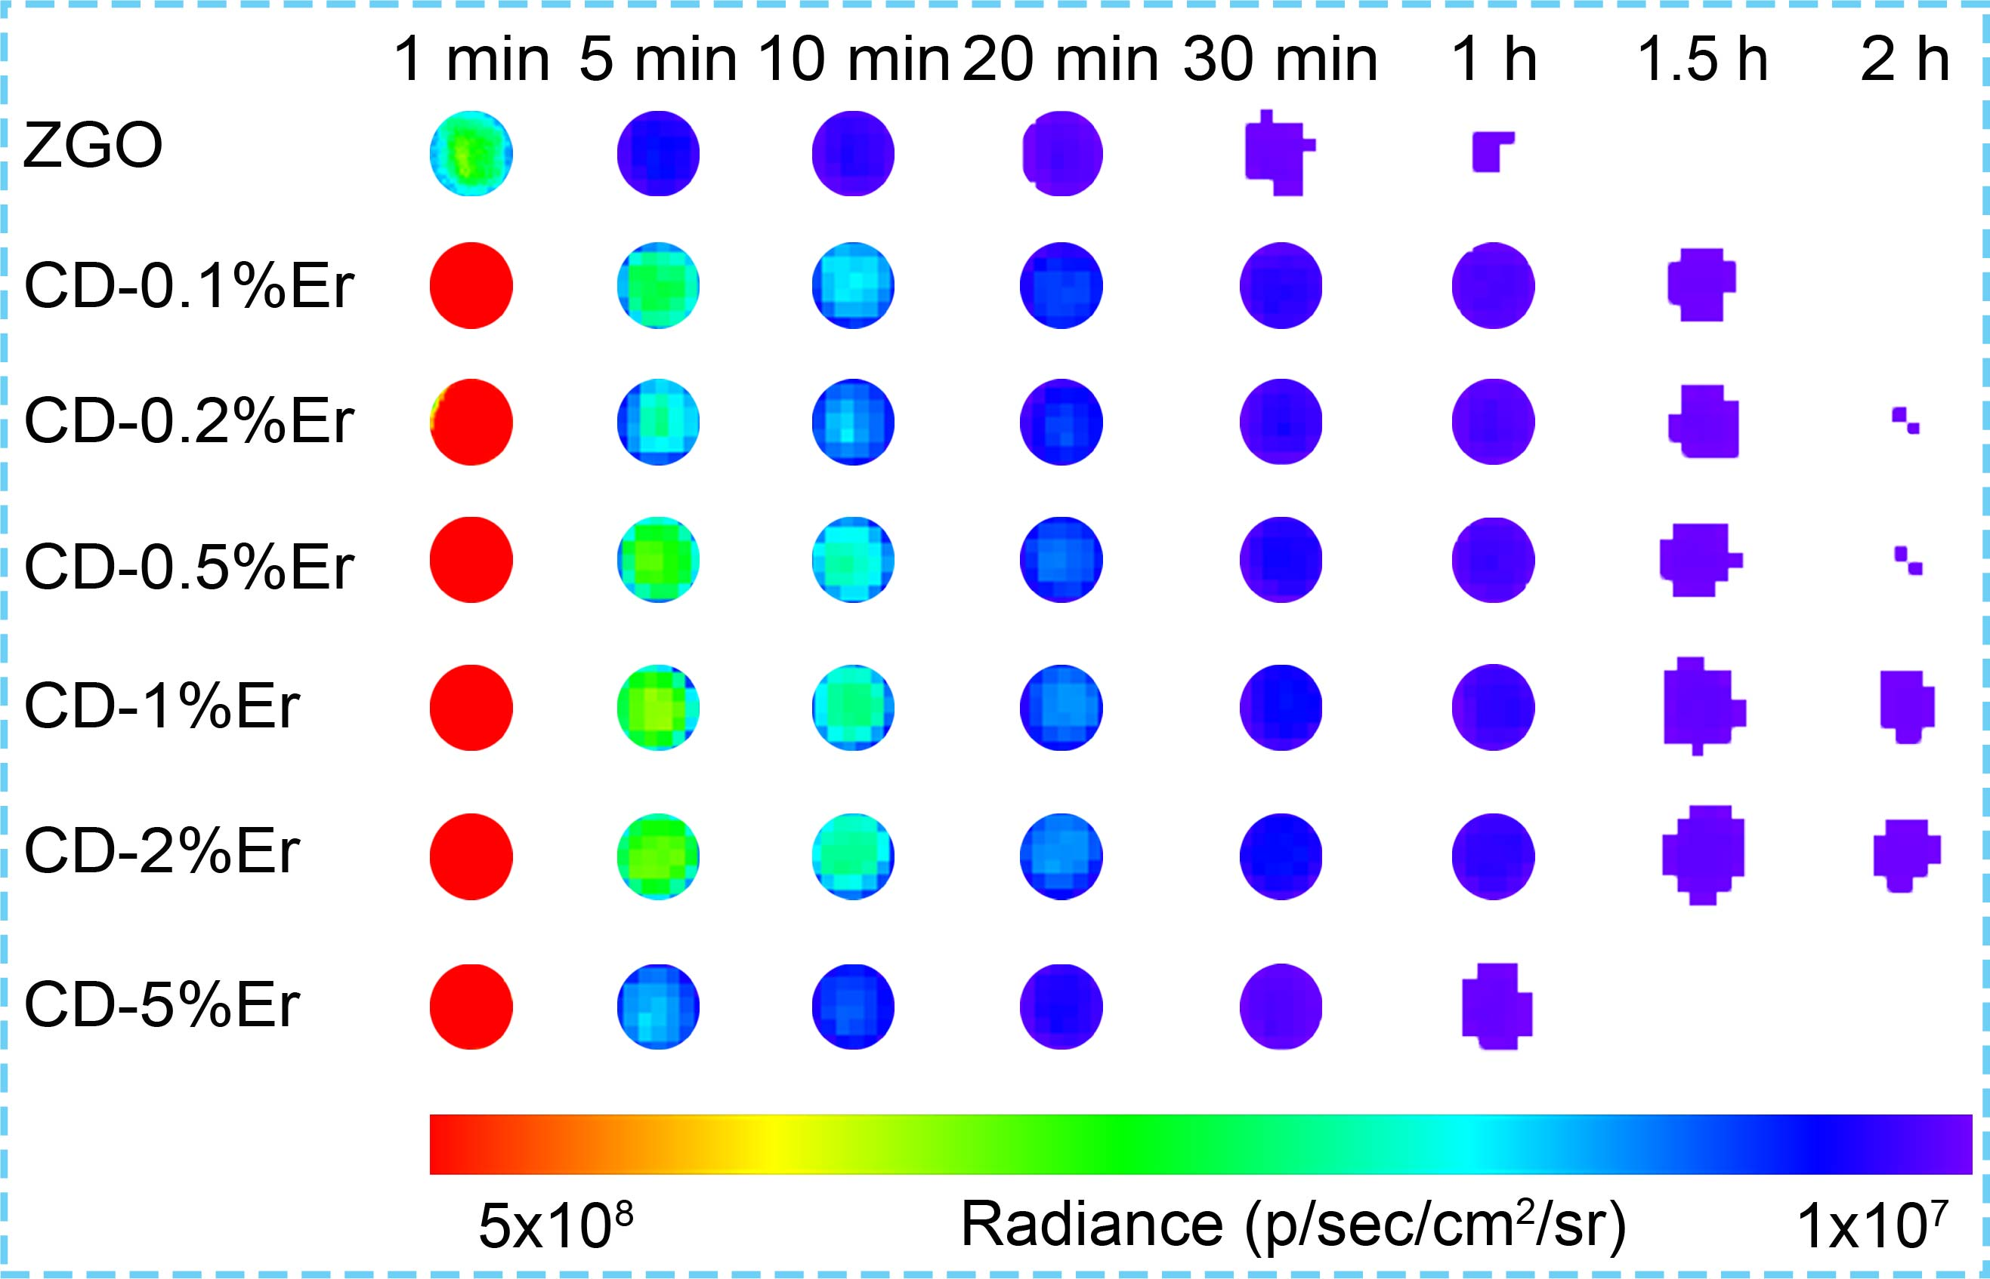
Figure S5 | Persistent luminescence decay images of CD-Er PLNPs pre-charged by UV light. The PLNPs were illuminated by a commercial LED (254 nm) for 3 min and the persistent luminescence images were taken by an IVIS optical imaging system in bioluminescence mode.

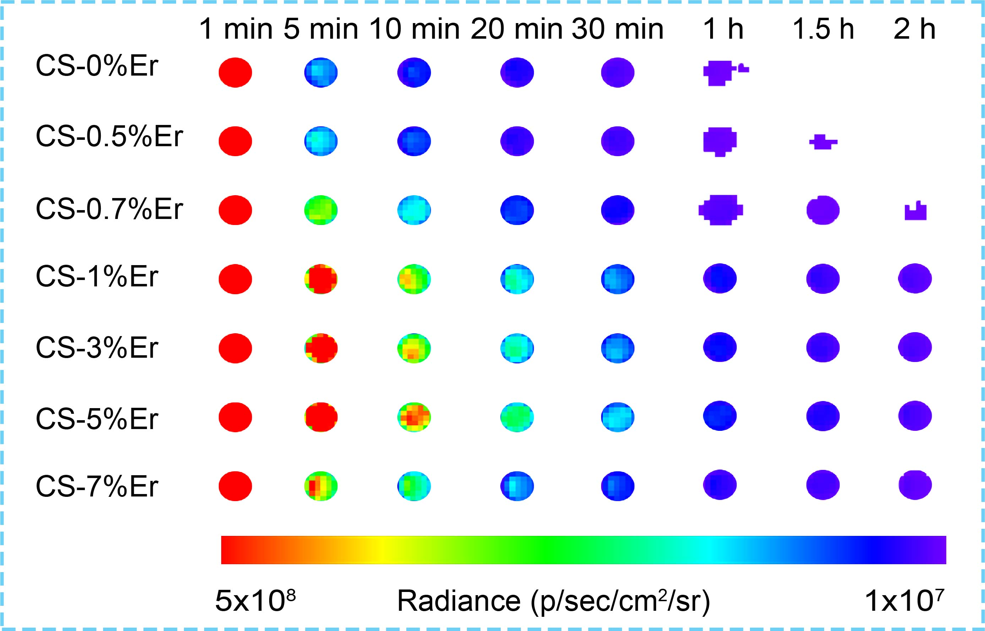
Figure S6 | Persistent luminescence decay images of CS-Er pre-charged by UV light. The PLNPs were pre-illuminated by a commercial LED (254 nm) for 3 min and the persistent luminescence images were taken by an IVIS optical imaging system in bioluminescence mode.

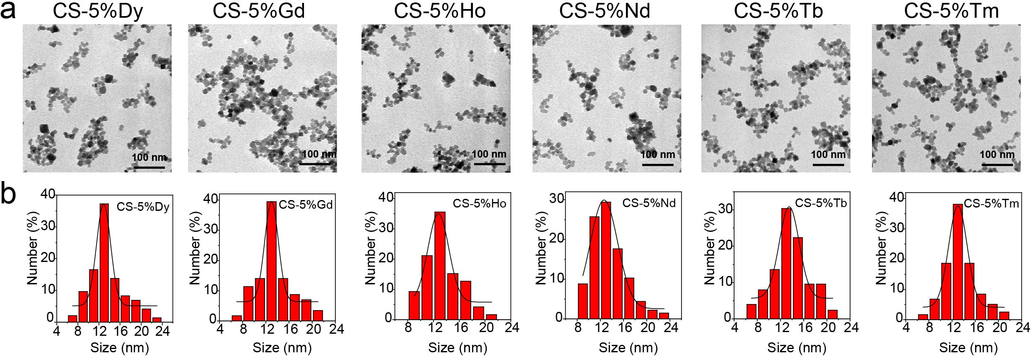
Figure S7 | Characterization of the morphology and size of the CS-5%Ln (Ln: Ho, Gd, Dy, Nd, Tb, Tm) PLNPs. TEM images (a) and the corresponding size distributions (b) of CS-5%Ln nanoparticles. The CS-5%Ln PLNPs show good uniformity and dispersibility. The average size of CS-5%Ln PLNPs is about 13 nm, 4 nm larger than that of ZGO, suggesting that a 4 nm of Ln-doped shell is coated on the surface of the ZGO nanoparticles.

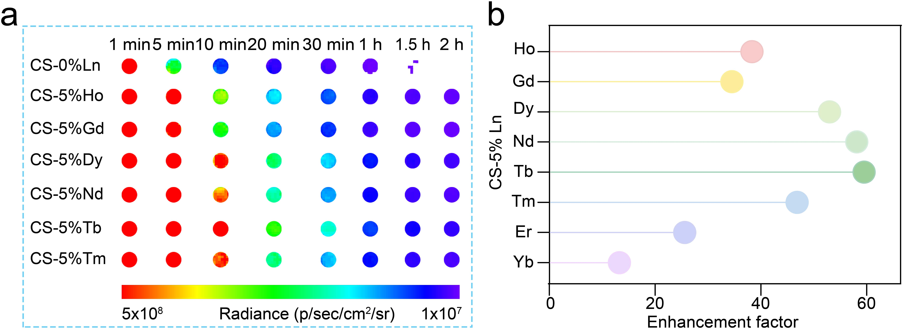
Figure S8 | Persistent luminescence properties of CS-5%Ln PLNPs pre-charged by UV light. a, Persistent luminescence decay images of the CS-0%Ln and CS-5%Ln (Ln: Ho, Gd, Dy, Nd, Tb, Tm) PLNPs (weight, 30 mg). b, Persistent luminescence enhancement factors of the CS-0%Ln and CS-5%Ln compared to ZGO PLNPs. The PLNPs were pre-illuminated by a commercial LED (254 nm) for 3 min. The persistent luminescence decay images were taken by an IVIS optical imaging system in bioluminescence mode. All the CS-5%Ln PLNPs exhibit much stronger persistent luminescence intensity than ZGO PLNPs, with persistent luminescence enhancement factors over 10 even after 2 h of decay. Moreover, the persistent luminescence enhancement factor of CS-5%Tb to ZGO reaches 60 at 1 min post-excitation, showing the robust ability of core-shell engineering in enhancing the persistent luminescence efficiency.

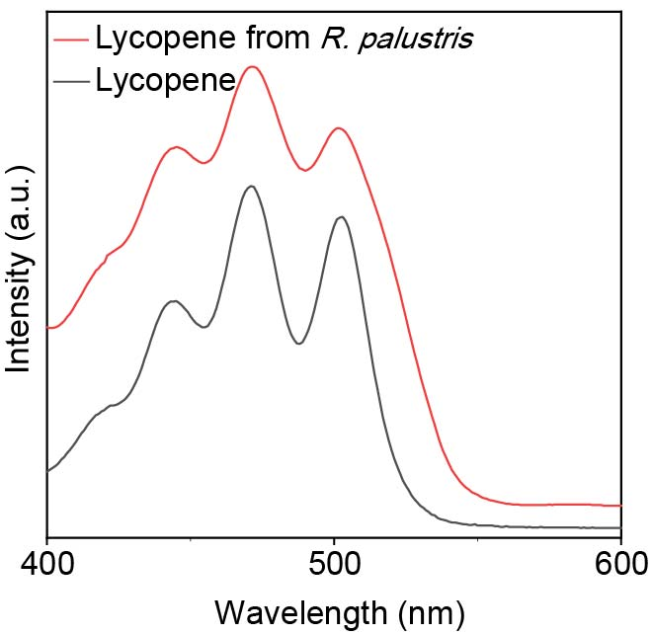
Figure S9 | Absorption spectra of the lycopene standard and lycopene extracted from R. palustris.

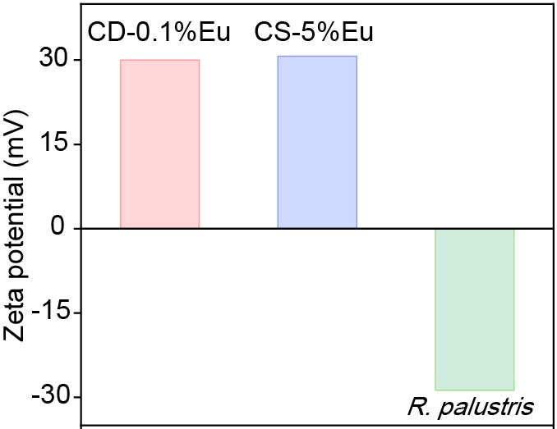
Figure S10 | Zeta potential of CD-0.1%Eu, CS-5%Eu and R. palustris.

