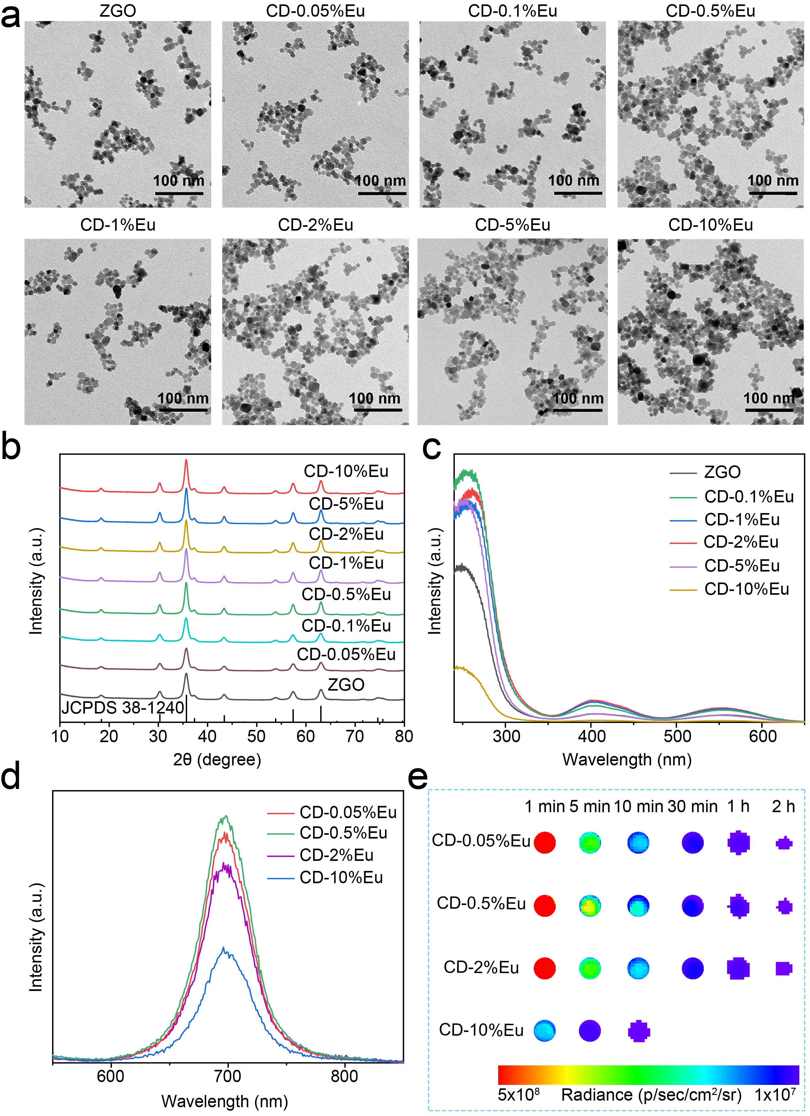
Extended Data Fig. 1 | a, Transmission electron microscope (TEM) images of CD-Eu nanoparticles. b, X-ray diffraction (XRD) patterns of CD-Eu nanoparticles. c, Excitation spectrum of the CD-X%Eu nanoparticles (x = 0, 0.1, 1, 2, 5, 10 ). Phosphorescence (d) and persistent luminescence decay images (e) of CD-Eu nanoparticles.
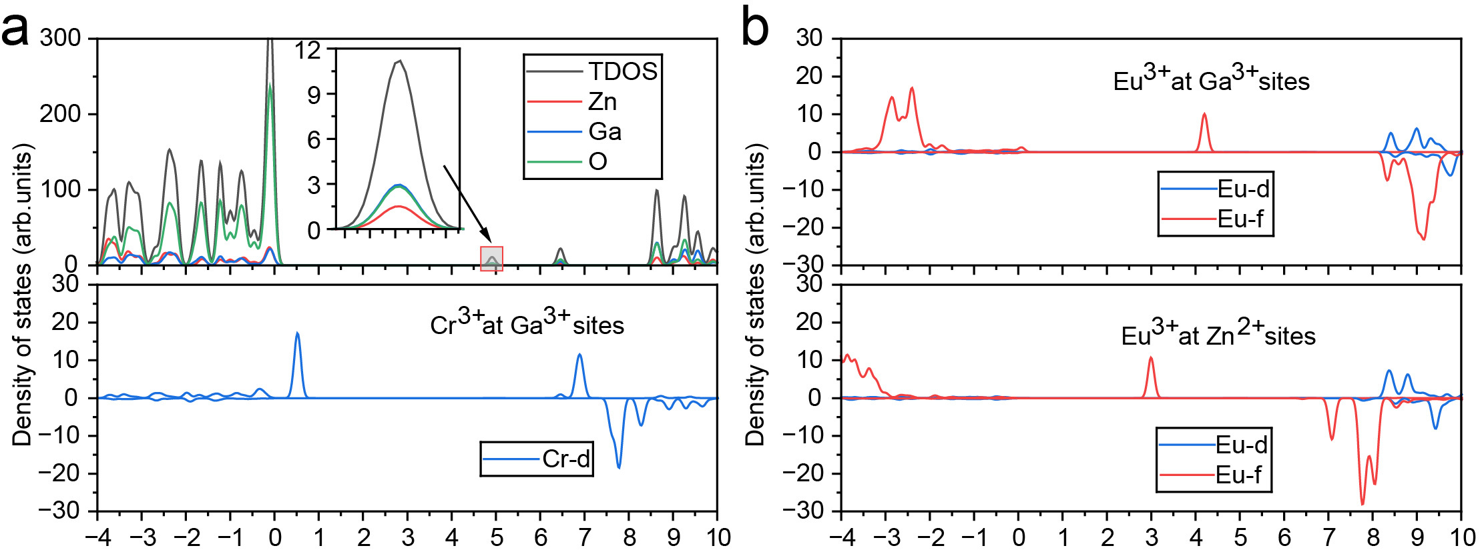
Extended Data Fig. 2 | Calculated total and partial density of states diagrams of pure and Cr³⁺- (a) and Eu³⁺-doped (b) ZnGa₂O₄. The VBM energy is referenced to zero.

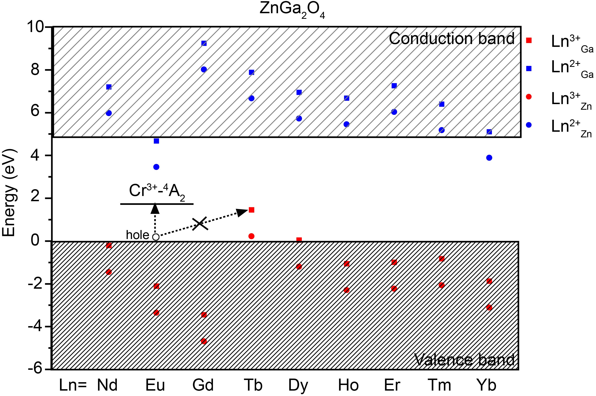
Extended Data Fig. 3 | Calculated HRBE diagrams of Ln³⁺- and Ln²⁺-doped ZnGa₂O₄ (Ln = Nd, Eu, Gd, Tb, Dy, Ho, Er, Tm, and Yb). The VBM energy is referenced to zero. Square and circular data points indicate the energy positions of the 4f ground states of Ln³⁺ and Ln²⁺ ions, respectively, derived from first-principle calculations for Eu ions and Dorenbos’s zigzag model for lanthanides. The horizontal bar represents the ground state level of Cr³⁺ dopants, as obtained from CTL calculations.

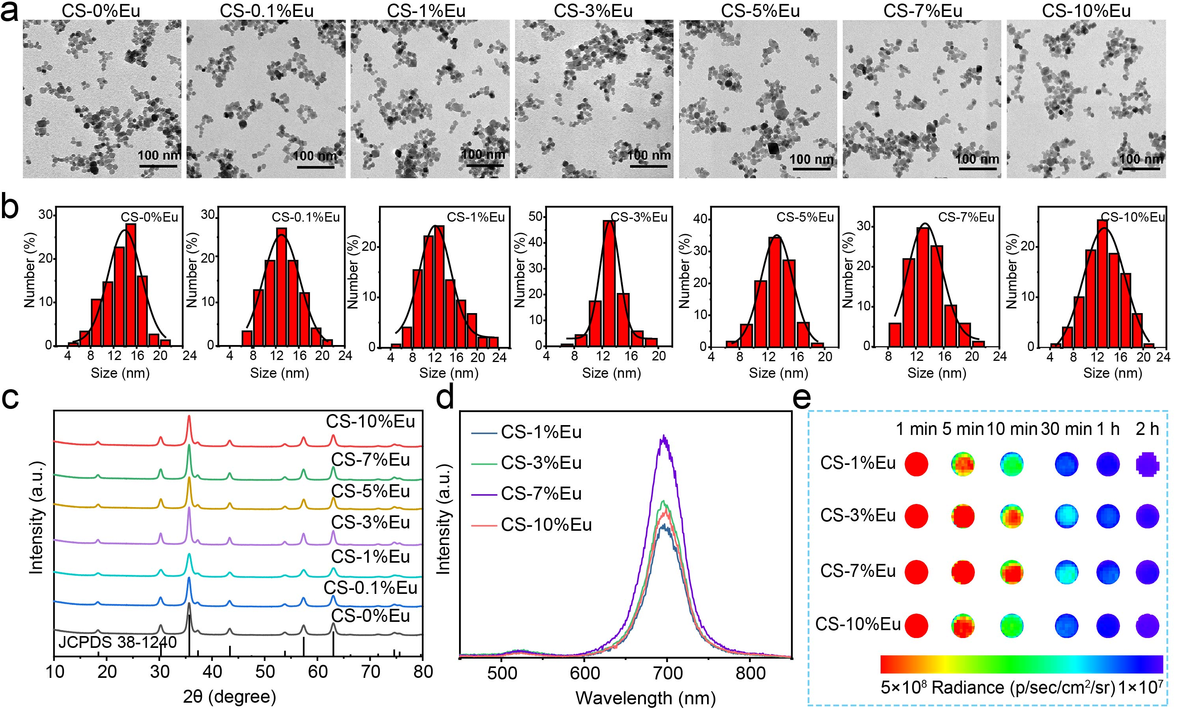
Extended Data Fig. 4 | TEM images (a) and the corresponding size distributions (b) of CS-Eu nanoparticles. c, XRD patterns of CS-Eu PLNPs. d, Phosphorescence spectrum of CS-Eu nanoparticles. e, Persistent luminescence decay images of CS-Eu nanoparticles.

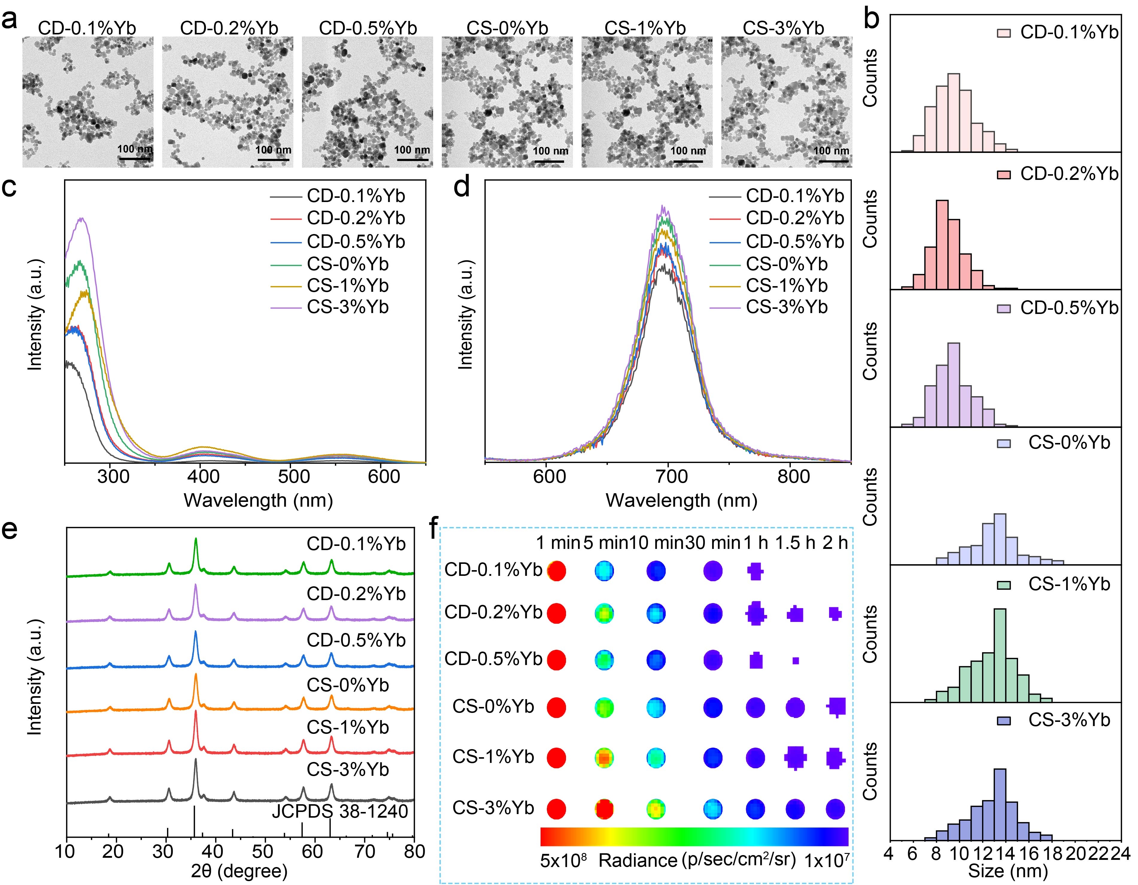
Extended Data Fig. 5 | TEM images (a) and the size distributions (b) of CD-Yb and CS-Yb nanoparticles. Excitation (c) and phosphorescence (d) spectrum of CD-Yb and CS-Yb nanoparticles. e, XRD patterns of CD-Yb and CS-Yb nanoparticles. f, Persistent luminescence decay images of CD-Yb and CS-Yb nanoparticles.

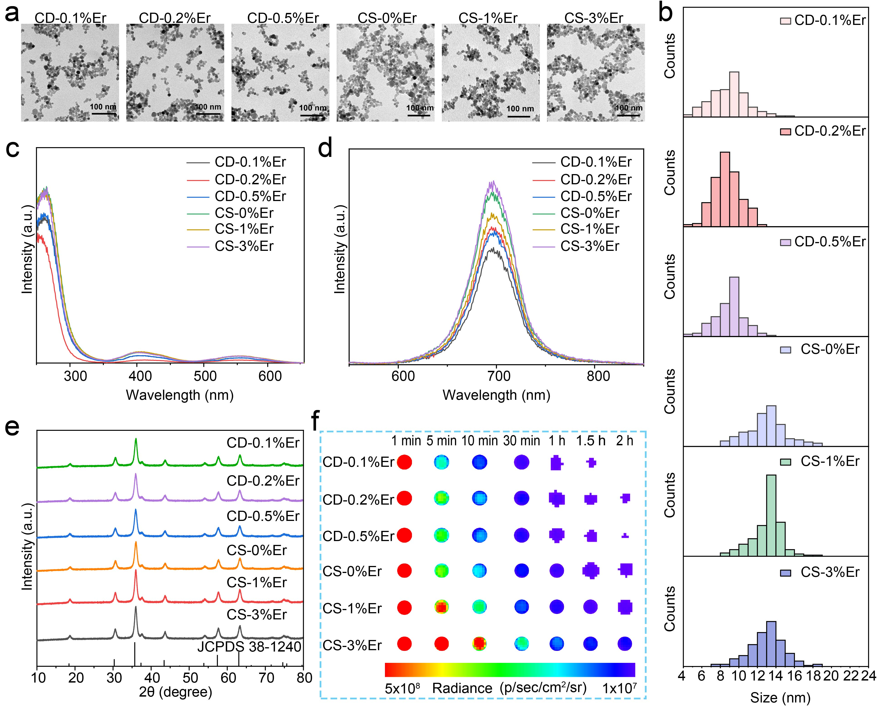
Extended Data Fig. 6 | TEM images (a) and size distributions (b) of CD-Er and CS-Er nanoparticles. Excitation (c) and phosphorescence (d) spectrum of CD-Er and CS-Er nanoparticles. e, XRD patterns of CD-Er and CS-Er nanoparticles. f, Persistent luminescence decay images of CD-Er and CS-Er nanoparticles.

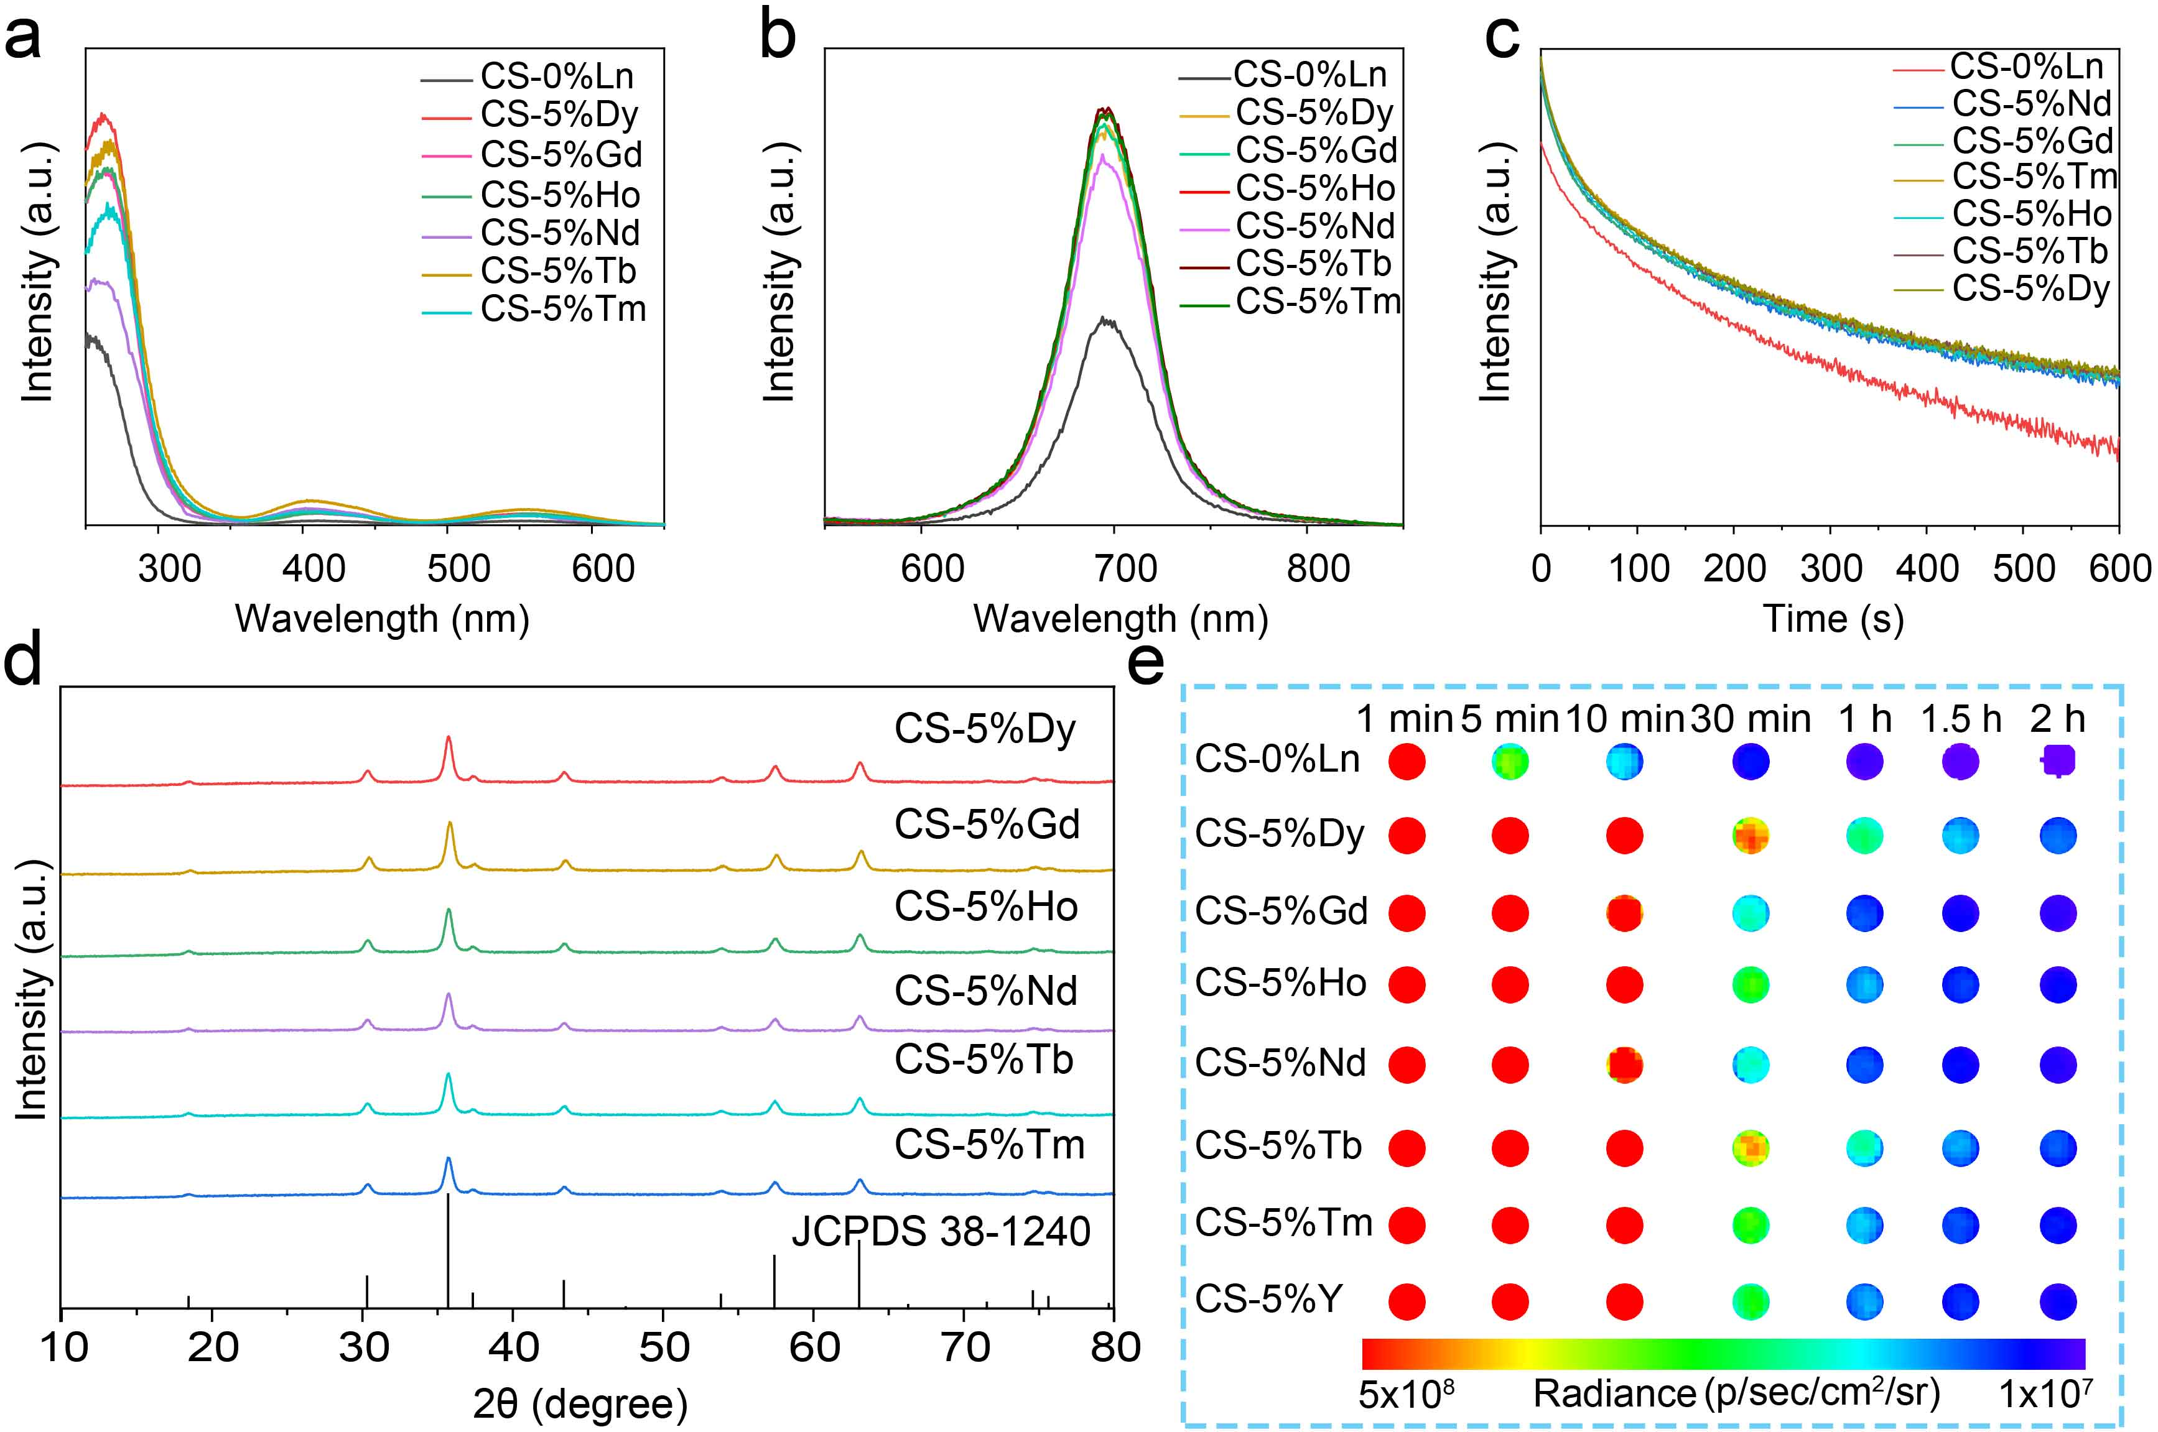
Extended Data Fig. 7 | Excitation (a) and phosphorescence (b) spectrum of CS-5%Ln (Ln = Dy, Gd, Ho, Nd, Tb, Tm) nanoparticles. c, Persistent luminescence decay curves of CS-5%Ln nanoparticles. d, X-ray diffraction (XRD) patterns of CS-5%Ln nanoparticles. e, Persistent luminescence decay images of CS-5%Ln nanoparticles.

