Dear Editors and Reviewers:
We would like to thank Plant Cell Reports for giving us the opportunity to revise our manuscript entitled “Overexpression of SlMBP22 in tomato affects flower morphology, fruit set and development” - PCRE-D-21-00228. We greatly appreciate the constructive criticism and thank the reviewers for their valuable comments. We have carefully addressed all the issues raised by the reviewers in the revised manuscript and have provided to the point response. The main corrections in the previous manuscript are marked in red in revised manuscript.

Editor: The manuscript was reviewed by two experts in the field. While Rev 2 was satisfied with the ms as-is, Rev 2 pointed out what the associate editor and I see as major limitations of submission: lack of novelty, very limited new information, lengthy Introduction and Discussion, and the lack of using a down-regulation approach. Especially, if the author would employ down-regulation approach, the results could even show certain improved plant traits that would be of agronomical value which could add to the merit to the manuscript. Therefore, the current ms is rejected, but encouraged for resubmission if the authors choose to perform additional experiments and analyses, as well as taking care of the writing problems.
Response: Thank you for your insightful suggestion. B_{s} genes make a valuable contribution to the regulation of reproductive development in seed plants (Mol Genet Genomics 266:942-950). However, few members of this subfamily involved in plant development have been characterized in different angiosperm species. Previous report demonstrated that petunia B_{s} FBP24 gene fails to replace Arabidopsis ABS/TT16 gene by a mutant complementation experiment, suggesting that there are functional conservation and divergence of the supposed orthologous genes in different angiosperm species (Plant J 47:934-946). At present, there is no research on B_{s} gene in tomato reproductive development. Therefore, we considered that it is meaningful to investigate the possible functions of B_{s} genes in tomato reproductive development. Actually, in order to reveal the possible functions of SlMBP22 gene, we employed both up-regulation and down-regulation approaches. We did not observe obvious phenotypes related to vegetative growth and reproductive development in SlMBP22-RNAi plants (Fig. 1), however, overexpression of SlMBP22 dramatically produced a series of defects compared to WT. A loss-of-function mutation does not generate visible phenotypes, but gain-of-function produces a lot of phenotypes. For example, Sl-AGL11 down-regulated tomato lines failed to show obvious phenotypes except a slight reduction in seed size. In contrast, Sl-AGL11 overexpression triggered dramatic modifications of flower and fruit structure (J Exp Bot 68:4869-4884). Therefore, we focused on studying the SlMBP22 overexpression lines, to reveal how SlMBP22 affected tomato reproductive development in this study. Our findings further advance our knowledge of physiological effects of B_{s} MADS-box transcription factors and provide valuable information for modern breeding biotechnologies.
In addition, we have simplified the introduction and discussion, and made some modifications, which were marked in red in our revised manuscript.
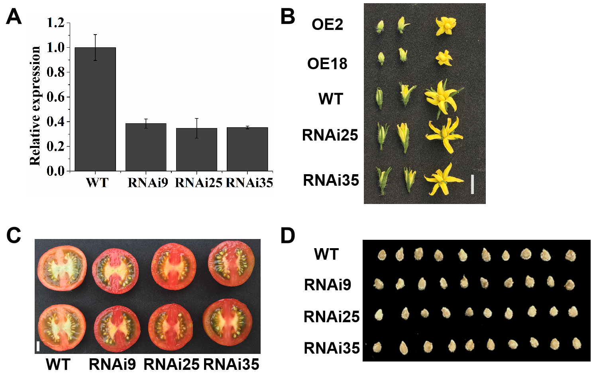
Fig. 1 Phenotype of tomato lines with RNAi-mediated down-regulation of SlMBP22. (A) Relative expression levels of SlMBP22 monitored by qPCR on flowers at anthesis stage.（B）The flowers at different developmental stages: 2 d ahead of anthesis (left), anthesis (middle) and 2 d after anthesis (right) in SlMBP22-OE lines, SlMBP22-RNAi lines and the wild type. (C) Representative fruits from the wild-type and silenced transgenic lines. Bar = 1 cm. (D) A comparison of the wild-type and SlMBP22-RNAi transgenic seeds.
COMMENTS TO THE AUTHOR:

Reviewer #1: This manuscript contains interesting information on the overexpression of B_{sister} tomato MADS-box gene SlMBP22, which resulted in considerable alterations in floral morphology, and affected the expression levels of several floral homeotic genes in the tomato transgenic plants generated. The aim of the authors was the functional characterization of this gene, revealing the role of SlMBP22 in tomato reproductive development. In general the manuscript is well written, but the introduction and discussion are largely exhaustive and more suitable for a review than for a research article. Both sections should be considerably reduced, sticking to the information related to the subject of study and the results obtained.
The authors show in this manuscript that the overexpression of SlMBP22 in transgenic tomato plants exhibited defects in reproductive growth and development, such as morphological alterations of flowers, reduced fruit set and growth, abnormal seed color, proanthocyanidin accumulation, altered seed dormancy, etc. In a previous publication (Li et al., 2020) these same authors conclude that the overexpression of SlMBP22 in tomato also affects plant growth, participating in the control of agronomical traits, tolerance to abiotic stress, and regulation of auxin and gibberellin signalling. Too many roles/functions for a single gene! In my opinion, the overexpression of a gene usually produces pleiotropic effects in the transgenic plants generated, and it is not a valuable tool to elucidate the real role or function of a gene in a plant. Gene silencing, by gene editing or other similar approaches, can provide more reliable and valuable information about the function of a gene than its mere overexpression in the plant. From this point of view, the main objective of the authors -to get information on the real gene function- has not been accomplished. So that the wide impact and novelty of the obtained results are seriously compromised and there is not a clear biological message beyond the state-of-the art, which is prerequisite for publication in Plant Cell Reports.
Response: Thank you for your insightful comments. We agree with the reviewer’s suggestions. It is better to study a gene functions via loss-of-function and gain-of-function. Actually, to reveal the possible functions of SlMBP22 gene in tomato, we employed both up-regulation and down-regulation approaches. Unfortunately, we did not observe obvious phenotypes related to vegetative growth and reproductive development in SlMBP22-RNAi plants (Fig. 1), which maybe due to functional redundancy or species difference. However, overexpression of SlMBP22 dramatically produced a series of defects compared to WT. It is possible that a loss-of-function mutation does not generate visible phenotypes, but gain-of-function produces a lot of phenotypes. For example, Sl-AGL11 down-regulated tomato lines failed to show obvious phenotypes except a slight reduction in seed size. In contrast, Sl-AGL11 overexpression triggered dramatic modifications of flower and fruit structure (J Exp Bot 68:4869-4884). Therefore, we focused on studying the SlMBP22 overexpression lines, to reveal how SlMBP22 affected tomato reproductive development in this study. Overexpression of SlMBP22 not only results in morphological alterations of flowers but also affects fruit set, fruit size and seed pigmentation. At present, there is no research on B_{s} gene in tomato reproductive development. We preliminarily elucidate the causes related with the SlMBP22 overexpressing transgenic plants defects. What's more, our findings further advance our knowledge of physiological effects of B_{s} MADS-box transcription factors and provide valuable information for modern breeding biotechnologies. Thus, we hope that our manuscript could be published in plant cell reports.
According to the reviewer’s suggestions, we have simplified the introduction and discussion, and made some modifications, which were marked in red in our revised manuscript.
Fig. 1 Phenotype of tomato lines with RNAi-mediated down-regulation of SlMBP22. (A) Relative expression levels of SlMBP22 monitored by qPCR on flowers at anthesis stage.（B）The flowers at different developmental stages: 2 d ahead of anthesis (left), anthesis (middle) and 2 d after anthesis (right) in SlMBP22-OE lines, SlMBP22-RNAi lines and the wild type. (C) Representative fruits from the wild-type and silenced transgenic lines. Bar = 1 cm. (D) A comparison of the wild-type and SlMBP22-RNAi transgenic seeds.

Reviewer #2: The manuscript "Overexpression of SlMBP22 in tomato affects flower morphology, fruit set and Development" is clearly written, the experimental design is adequate and the conclusions are robust demonstrating that the overexpression of SlMBP22 results in morphological 635 alterations, and affects fruit set, fruit size and seed pigmentation.
Response: Thank you for your insightful comments.

We are thankful for highlighting the deficiencies of our manuscript. We tried our best to improve the manuscript by making some changes. These changes will not influence the content and framework of the paper. We hope that this revision would make the manuscript more acceptable and suitable for publication. If there are any further questions about this manuscript, please don’t hesitate to contact us by phone at the following number (+86-139-96265017) or send an email to huzongli@cqu.edu.cn. Once again, we would like to express our great appreciation to you and reviewers for comments and suggestions on our paper. Looking forward to hearing from you.
Thank you and best regards.

Sincerely,
Prof. Dr. Zongli Hu
Email: huzongli@cqu.edu.cn

