SUPPLEMENTAL MATERIAL
A
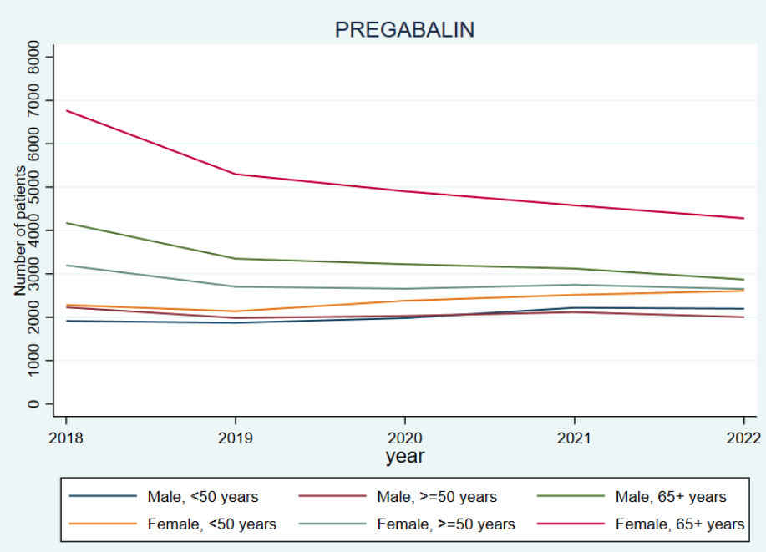
B
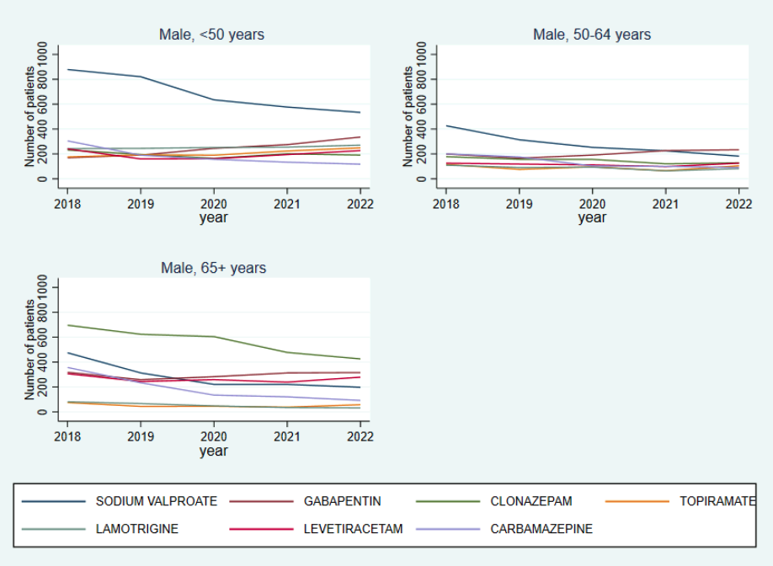

C
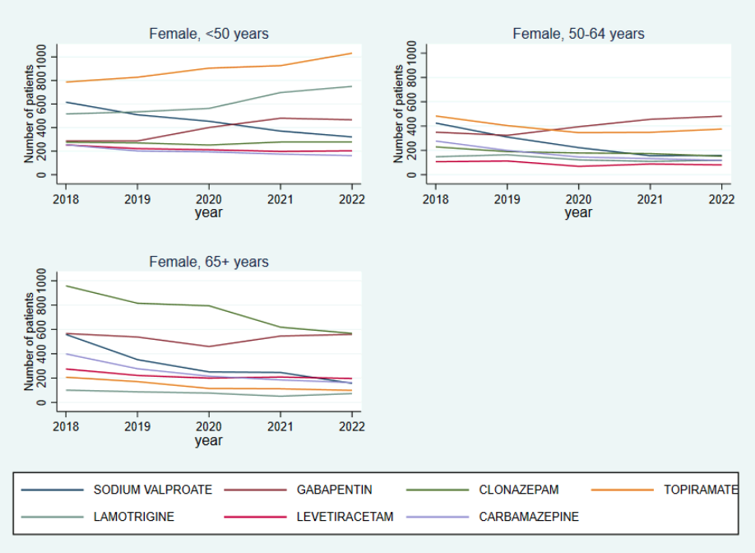
Figure S1 The year trend of antiseizure medications type at initiation by age and gender. A: Trend of Pregabalin by age and gender; B: Trend of sodium valproate, gabapentin, clonazepam, topiramate, lamotrigine, levetiracetam and carbamazepine among male patients; C: Trend of sodium valproate, gabapentin, clonazepam, topiramate, lamotrigine, levetiracetam and carbamazepine among female patients

