Supplement Figures and Table
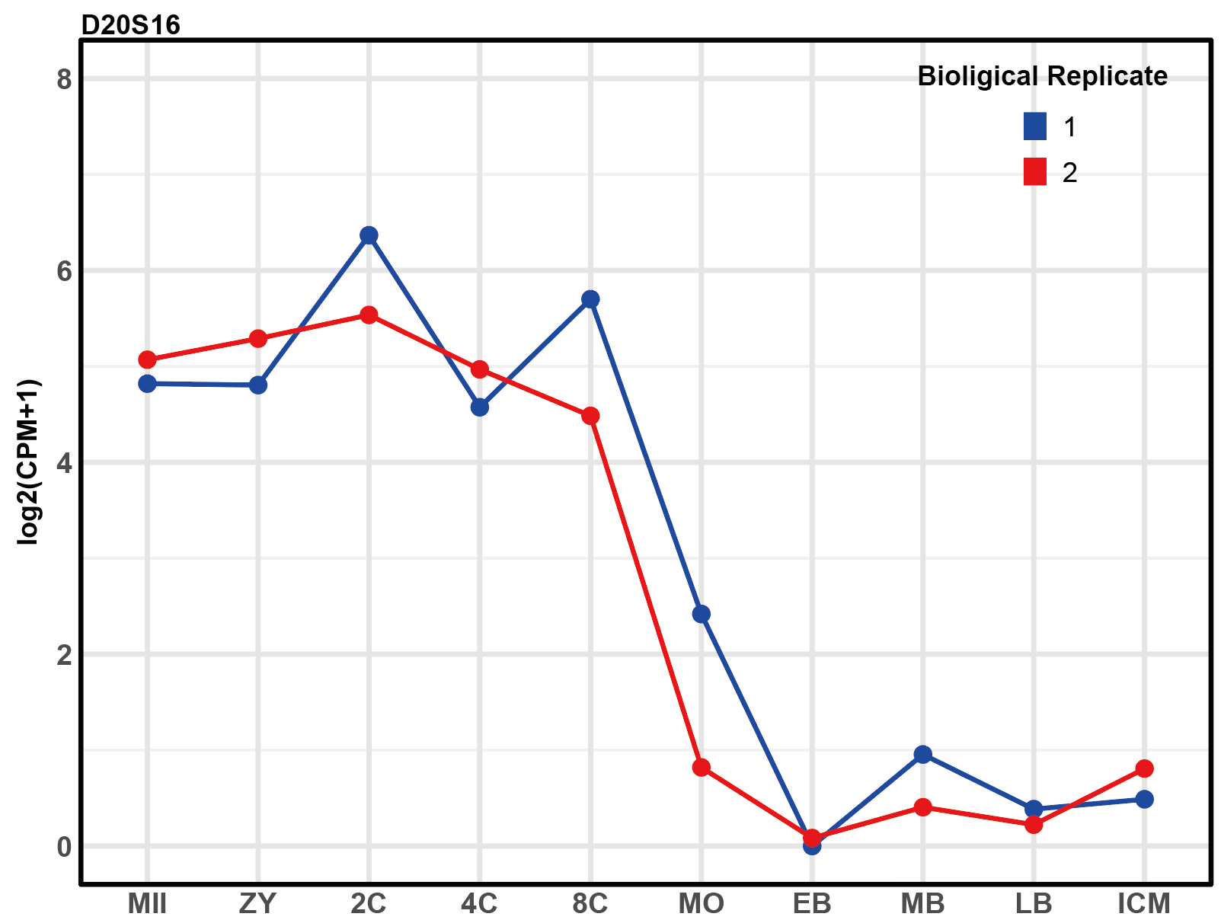
Figure S1 Expression pattern of D20S16 across various developmental stages: MII oocyte (MII), zygote (ZY), 2-cell (2C), 4-cell (4C), 8-cell (8C), morula (MO), early blastocyst (EB), middle blastocyst (MB), late blastocyst (LB), to ICM (Inner Cell Mass) with 2 biological replicates.
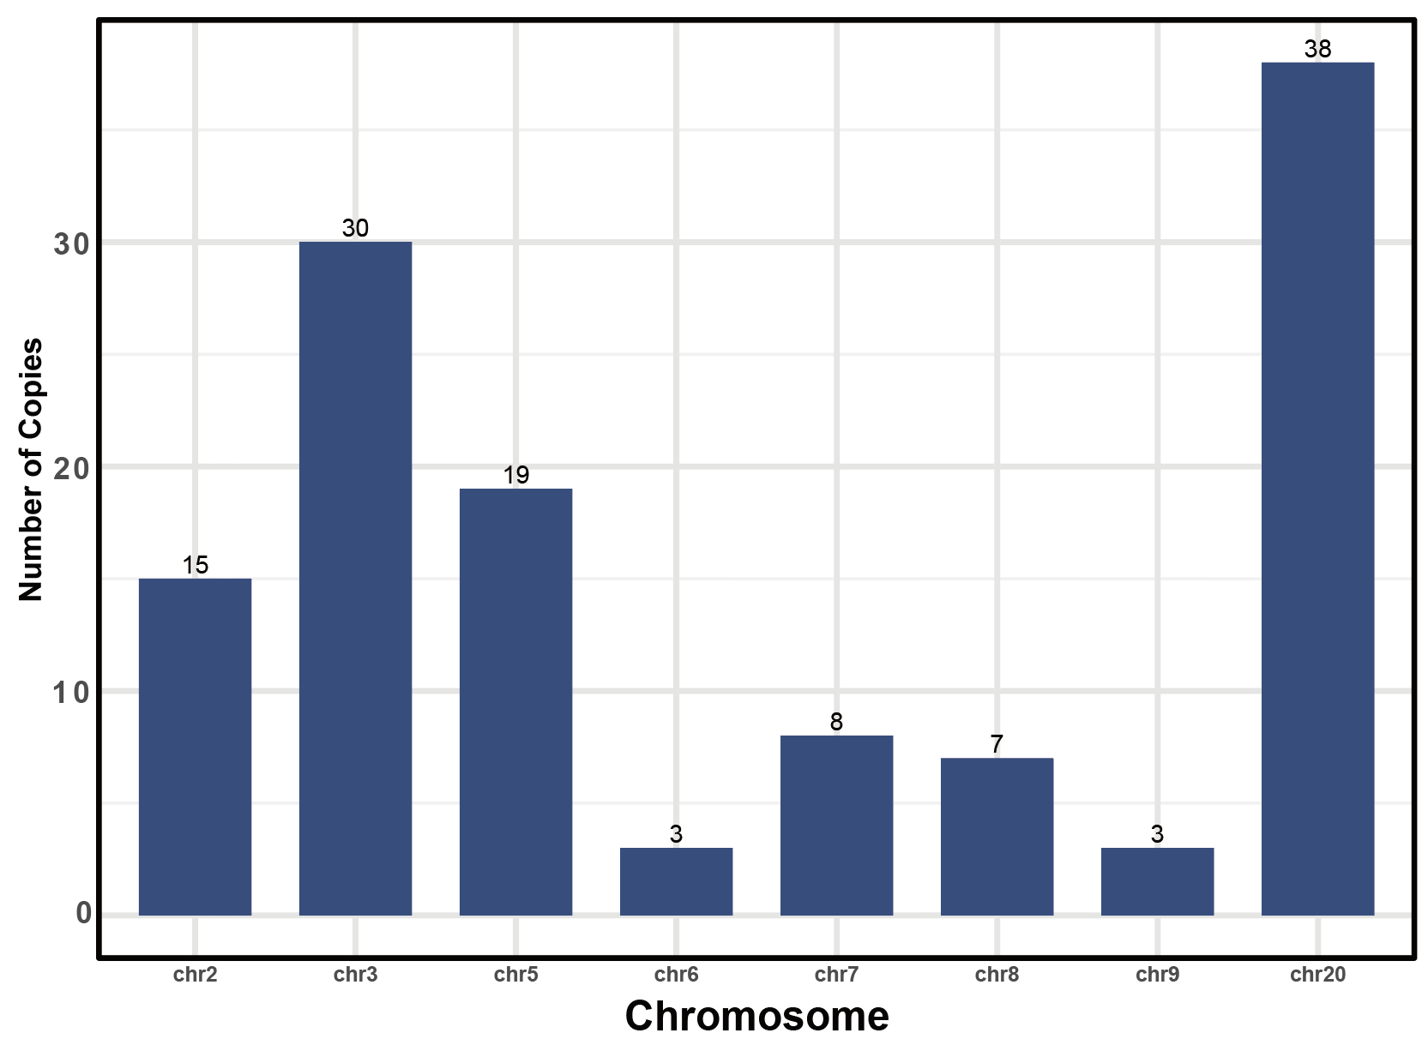
Figure S2 Bar graph showing the count of D20S16 copies distributed across different chromosomes. There are 38 copies on chr. 20 and 30 on chr. 3.
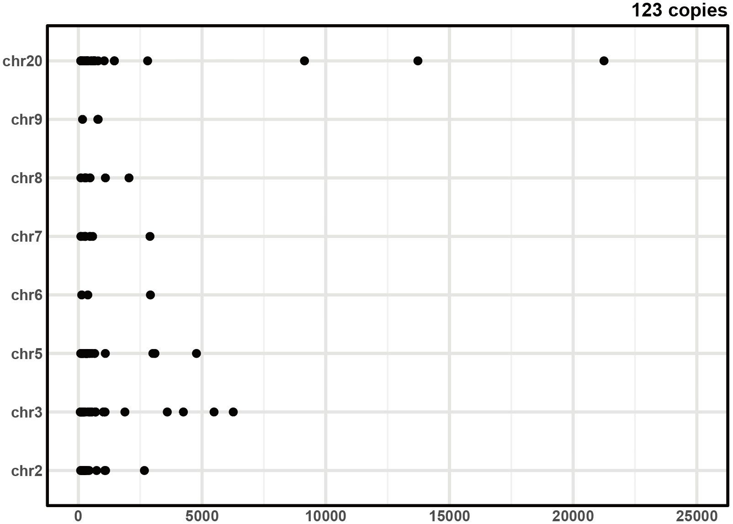
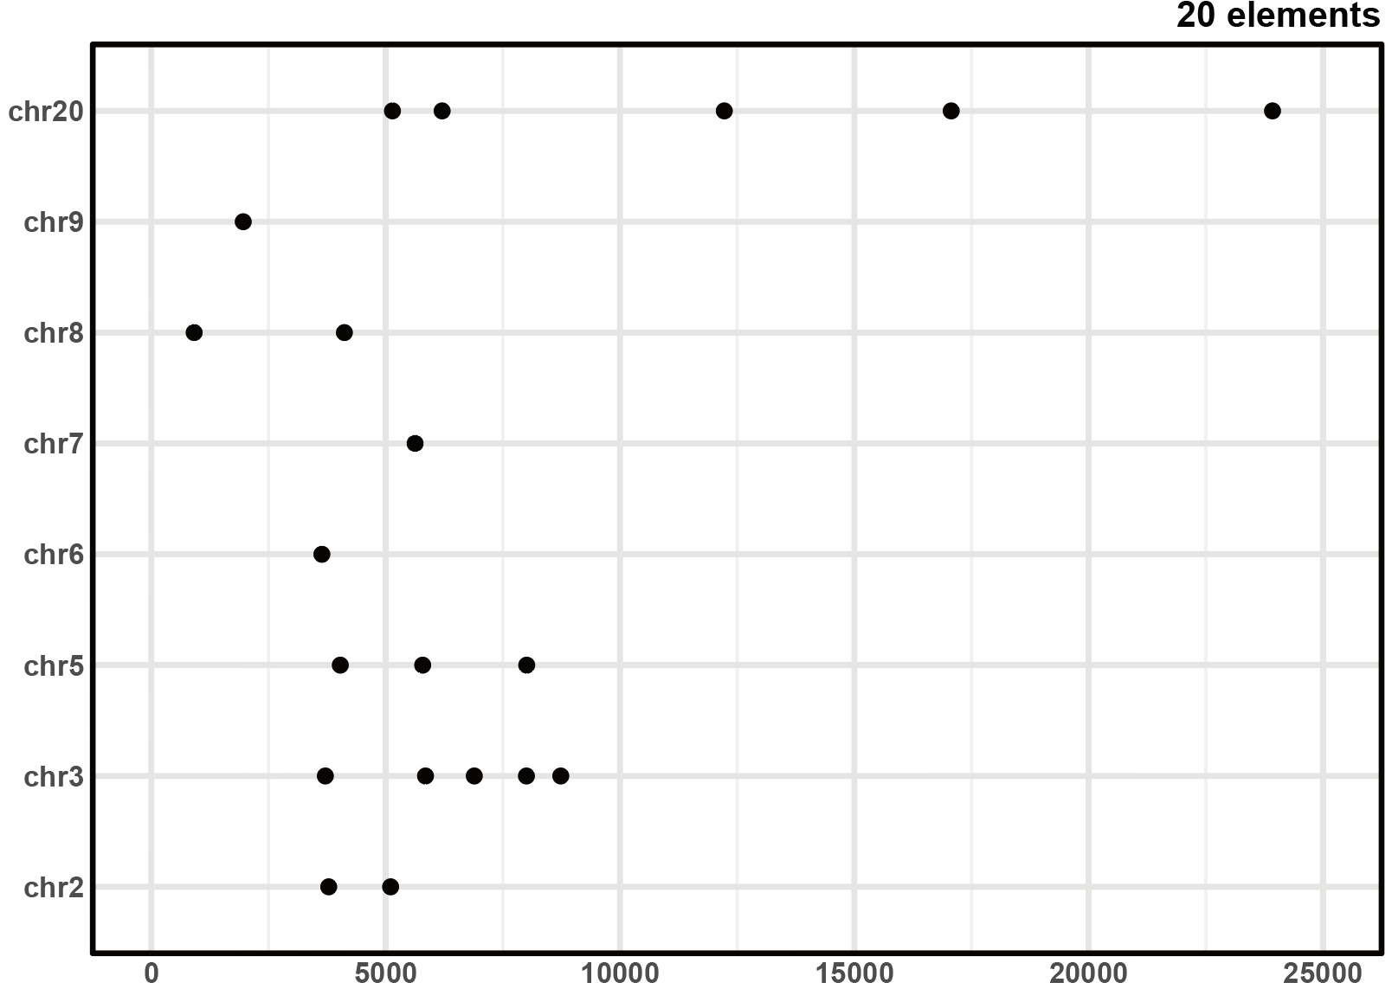
Figure S3 Comparison between length of D20S16 copies and merged elements across the genome. Each dot represents the length of a copy (element). The numerous short copies before merging become larger elements after merging.
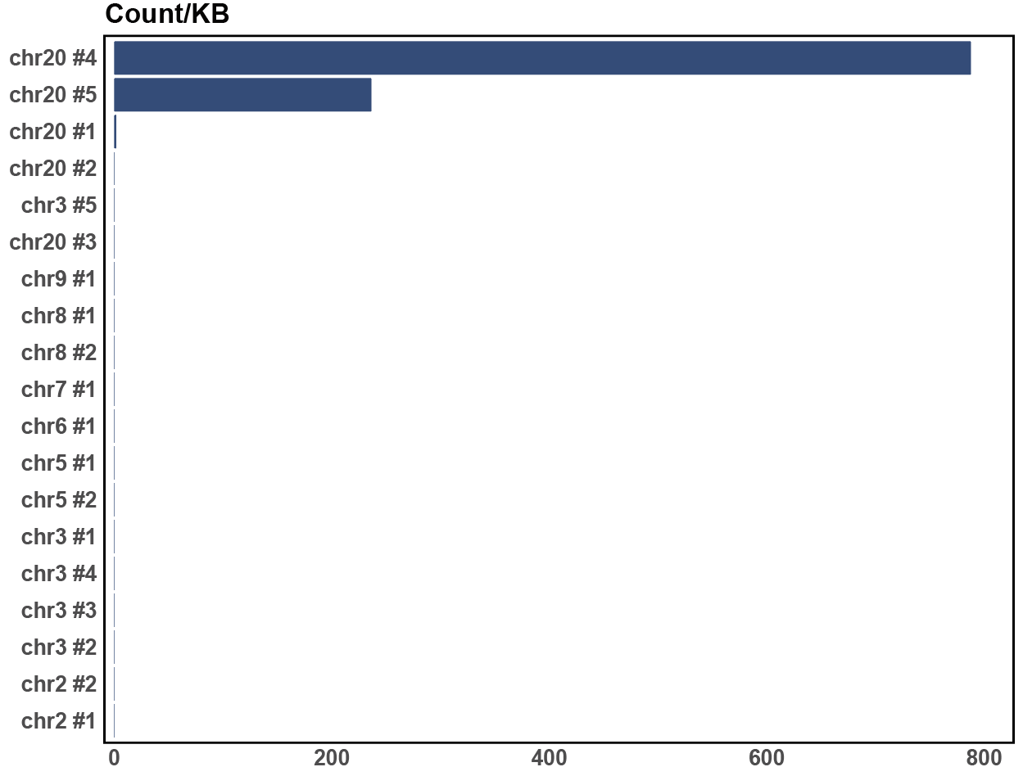
Figure S4 Relative expression levels of D20S16 elements across different chromosomes in the extended dataset. Expression is much higher from chr20#4 and #5 than from the other elements.
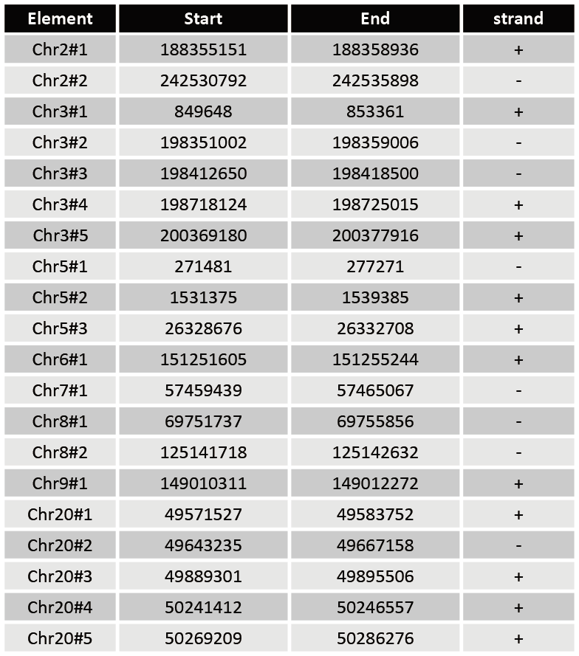
Table. S1 Names, starting points, ending points, and strands of the 20 elements from D20S16.
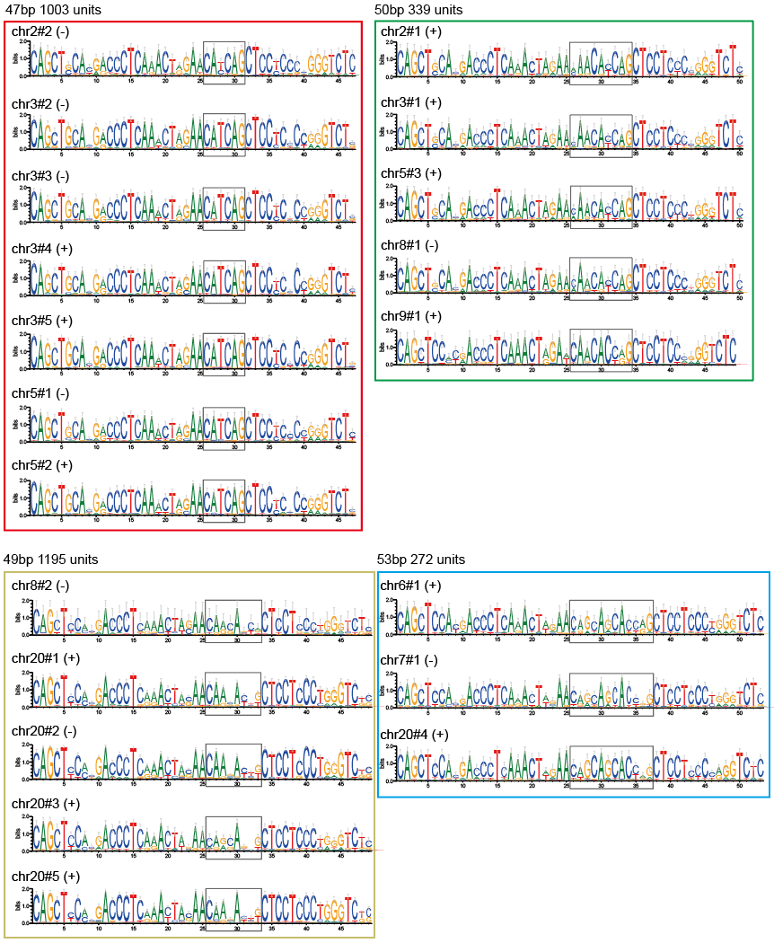
Figure S5 Consensus sequences and variable regions of 4 types of D20S16 (47, 49, 50, 53 bp). Sequence logos are used to highlight the nucleotide diversity at each position. The 47-bp type (CATCAG) has 1003 units, found on chrs. 2, 3, and 5. The 49-bp type (CAA-A--G) has 1195 units, found mainly on chrs. 8 and 20. The 50-bp type (CAACACCAG) is more dispersed, with 339 units found on chrs. 2, 3, 5, 8, and 9. The 53-bp (CAGCAGCACC-G) group has 272 units, including chr20#4.
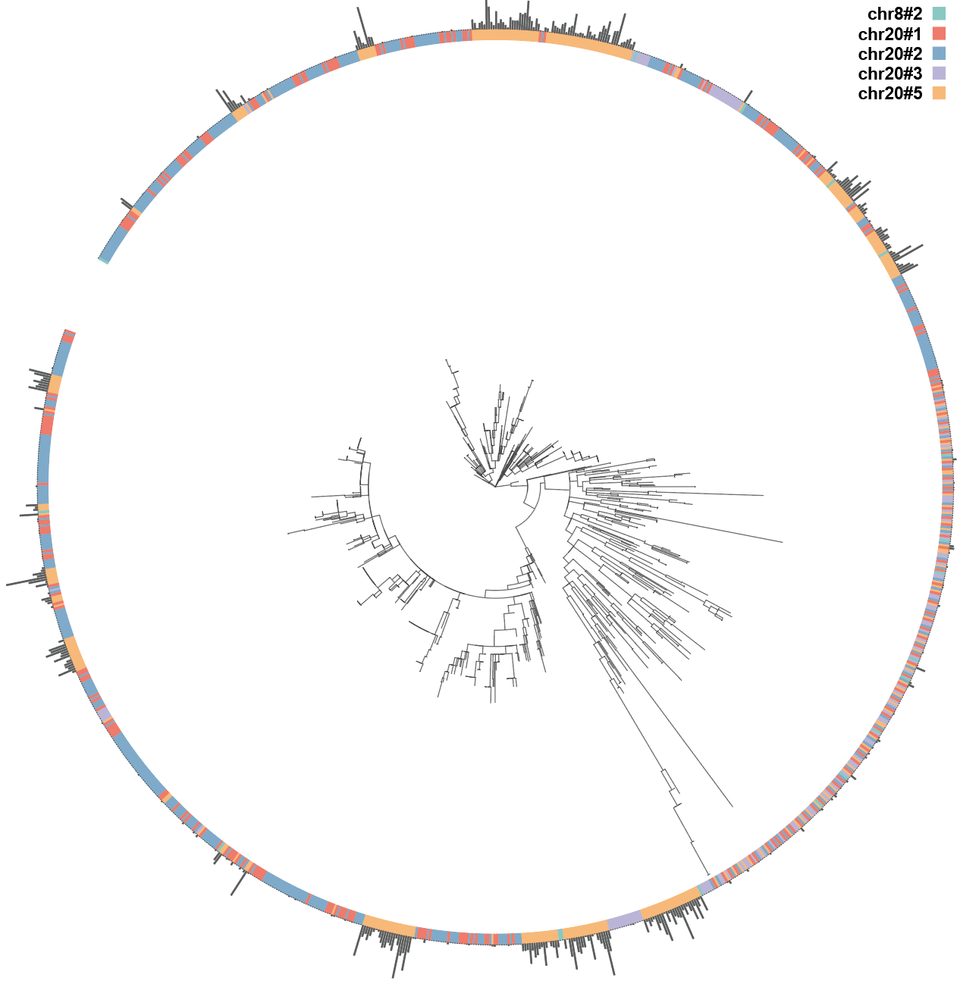
Figure. S6 Phylogenetic tree consisting of 5 elements (chr8#2, chr20#1, chr20#2, chr20#3, chr20#5) of the 49-bp group, with gray bars showing expression level.

