Targeting Hydrophobic Residues in Alpha-Synuclein NAC Domain Disrupts Aggregation and Seed-Competent Fibril Formation
Viswanath Das,^{[a], [b] +,}* Sayed Mostafa Modarres Mousavi,^{[c]+} Narendran Annadurai,^{[a]+} Sajad Moradi,^{[d]} Lukáš Malina,^{[a], [e]} Markéta Kolaříková,^{[e]} Vaclav Ranc,^{[a]} Ivo Frydrch,^{[a]} Roman Kouřil,^{[f]} Saman Hosseinkhani,^{[g]} Marián Hajdúch,^{[a], [b]} and Maryam Nikkhah^{[c]}*
[a] Institute of Molecular and Translational Medicine, Faculty of Medicine and Dentistry, Palacký University and University Hospital Olomouc, Hněvotínská 1333/5, 779 00 Olomouc (Czech Republic)
[b] Institute of Molecular and Translational Medicine, Czech Advanced Technologies and Research Institute, Palacký University Olomouc, Křížkovského 511/8, 779 00, Olomouc (Czech Republic)
[c] Department of Nanobiotechnology, Faculty of Biological Sciences, Tarbiat Modares University, Tehran, 14115-154 (Iran)
[d] Nano Drug Delivery Research Center, Health Technology Institute, Kermanshah University of Medical Sciences, Kermanshah (Iran)
[e] Department of Medical Biophysics, Faculty of Medicine and Dentistry, Palacký University Olomouc, Hněvotínská 3, 775 15 Olomouc (Czech Republic)
[f] Department of Biophysics, Faculty of Science, Palacký University Olomouc, Šlechtitelů 27, 783 71 Olomouc (Czech Republic)
[g] Department of Biochemistry, Faculty of Biological Sciences, Tarbiat Modares University, Tehran, 14115-154 (Iran)
+ These authors contributed equally to this work.
* Corresponding authors: V. Das (E-mail: viswanath.das@upol.cz); M. Nikkhah (E-mail: m_nikkhah@modares.ac.ir)

SUPPLEMENTARY FIGURES
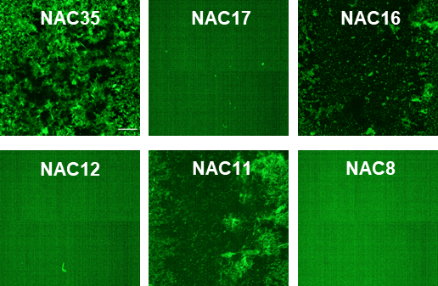
Figure S1. Fluorescence images of ThT-stained NAC aggregates after 48 h of aggregation. Scale bar: 200 µm. NAC peptides (100 µM) were aggregated for 48 h with ThT. After the assay, wells were embedded in 0.05% low-melting agarose, solidified at room temperature, and imaged with a 4x objective on a Cell Voyager CV7000S microscope (Yokogawa) using a 488 nm laser (Ex = 460-490 nm, Em = 500-550 nm).

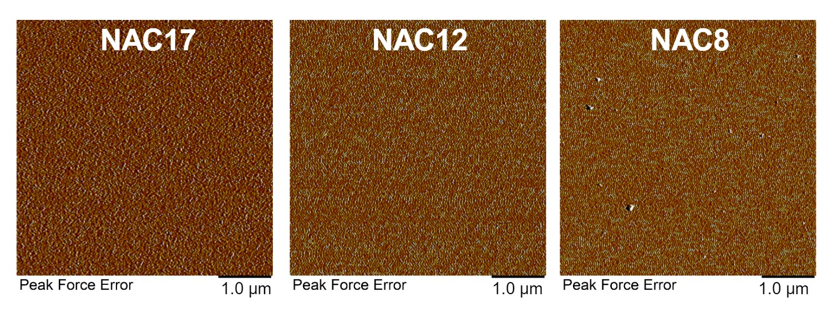
Figure S2. AFM images of NAC17, NAC12, and NAC8 samples collected from assay wells after 48 h of aggregation show the absence of aggregates.

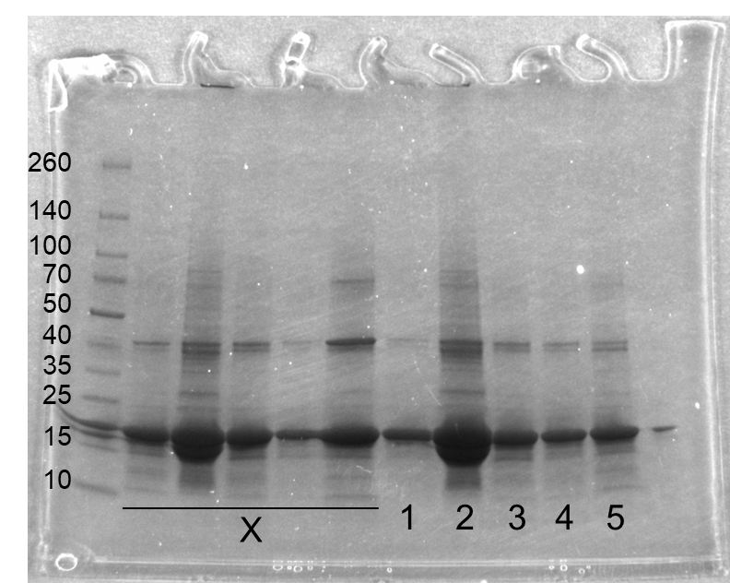
Figure S3. Uncropped full-sized Coomassie-stained gels for Figure 4e. 1: αSyn, 2: αSyn + αSyn fibril, 3: αSyn + NAC35 fibril, 4: αSyn + NAC16 fibril, and 5: αSyn + NAC11 fibril.

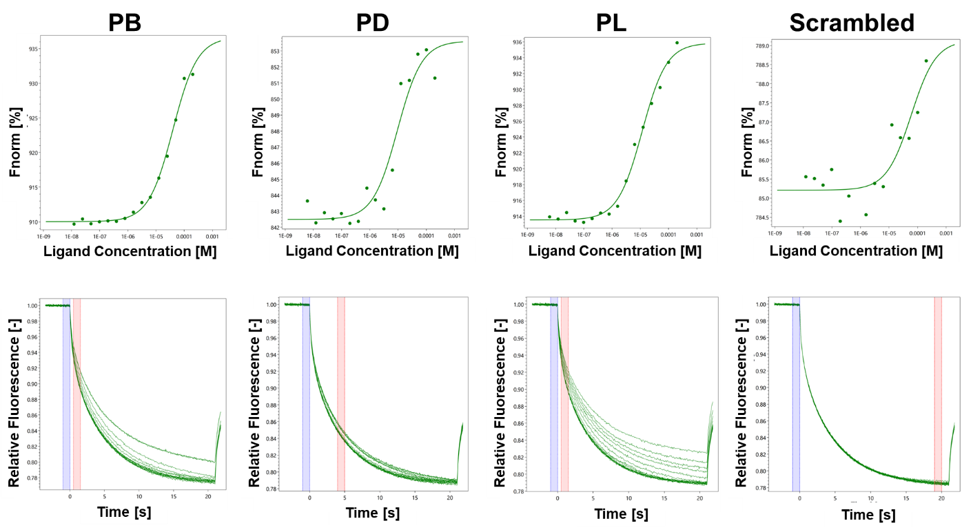
Figure S4. MST traces (top) and dose-response curves (bottom) for labeled His₆-tagged αSyn with RED-tris-NTA against PD, PB, PL, and scrambled peptides. The resulting dose-response curves were fitted to a one-site binding model for K_{d} determination. All measurements were done in triplicates.

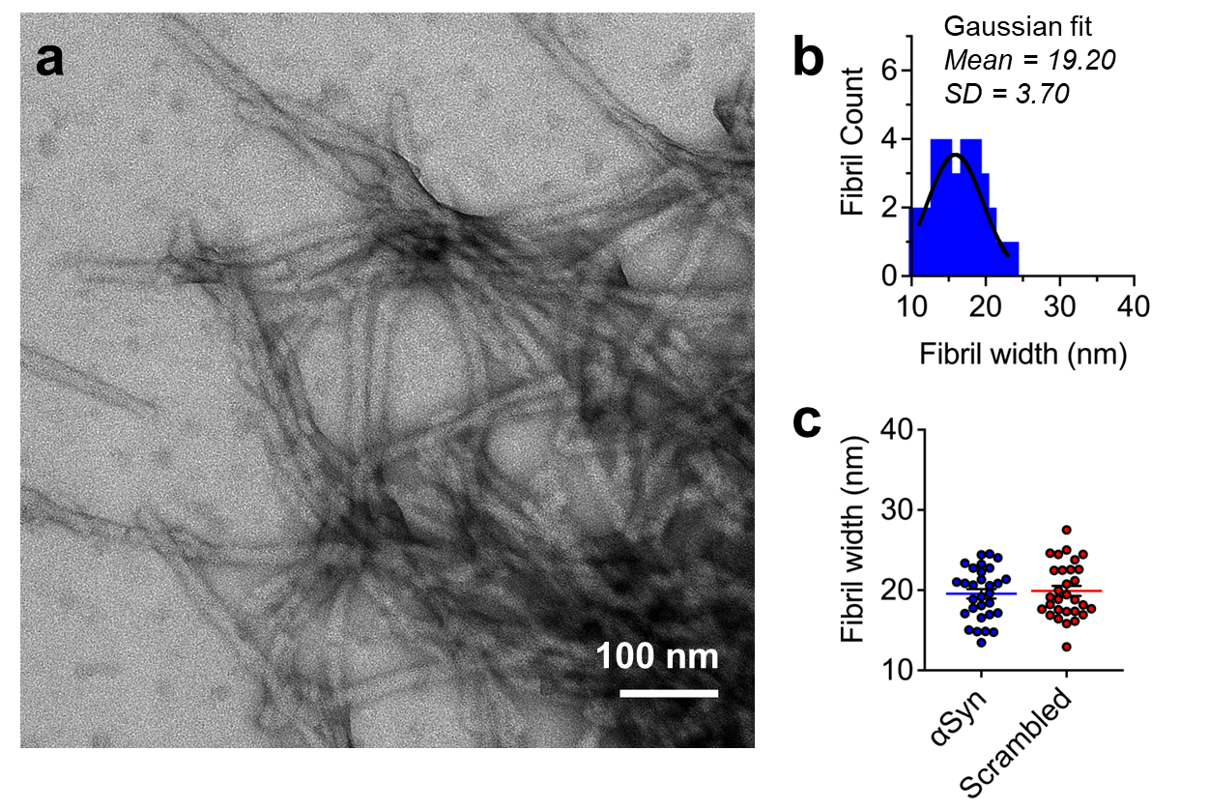
Figure S5. (a) TEM images of αSyn fibrils formed in the presence of scrambled peptides show no anti-inhibitory activity against αSyn aggregation. (b) Histograms displaying the distribution of fibril widths for αSyn fibrils formed in the presence of scrambled peptides. Gaussian fits with mean and standard deviation are shown. N = 30 measurements from 3 representative images. (c) The width of αSyn fibrils formed in the absence or presence of scrambled peptides shows no effect. Mean ± SEM (n = 30 measurements from 3 representative images).

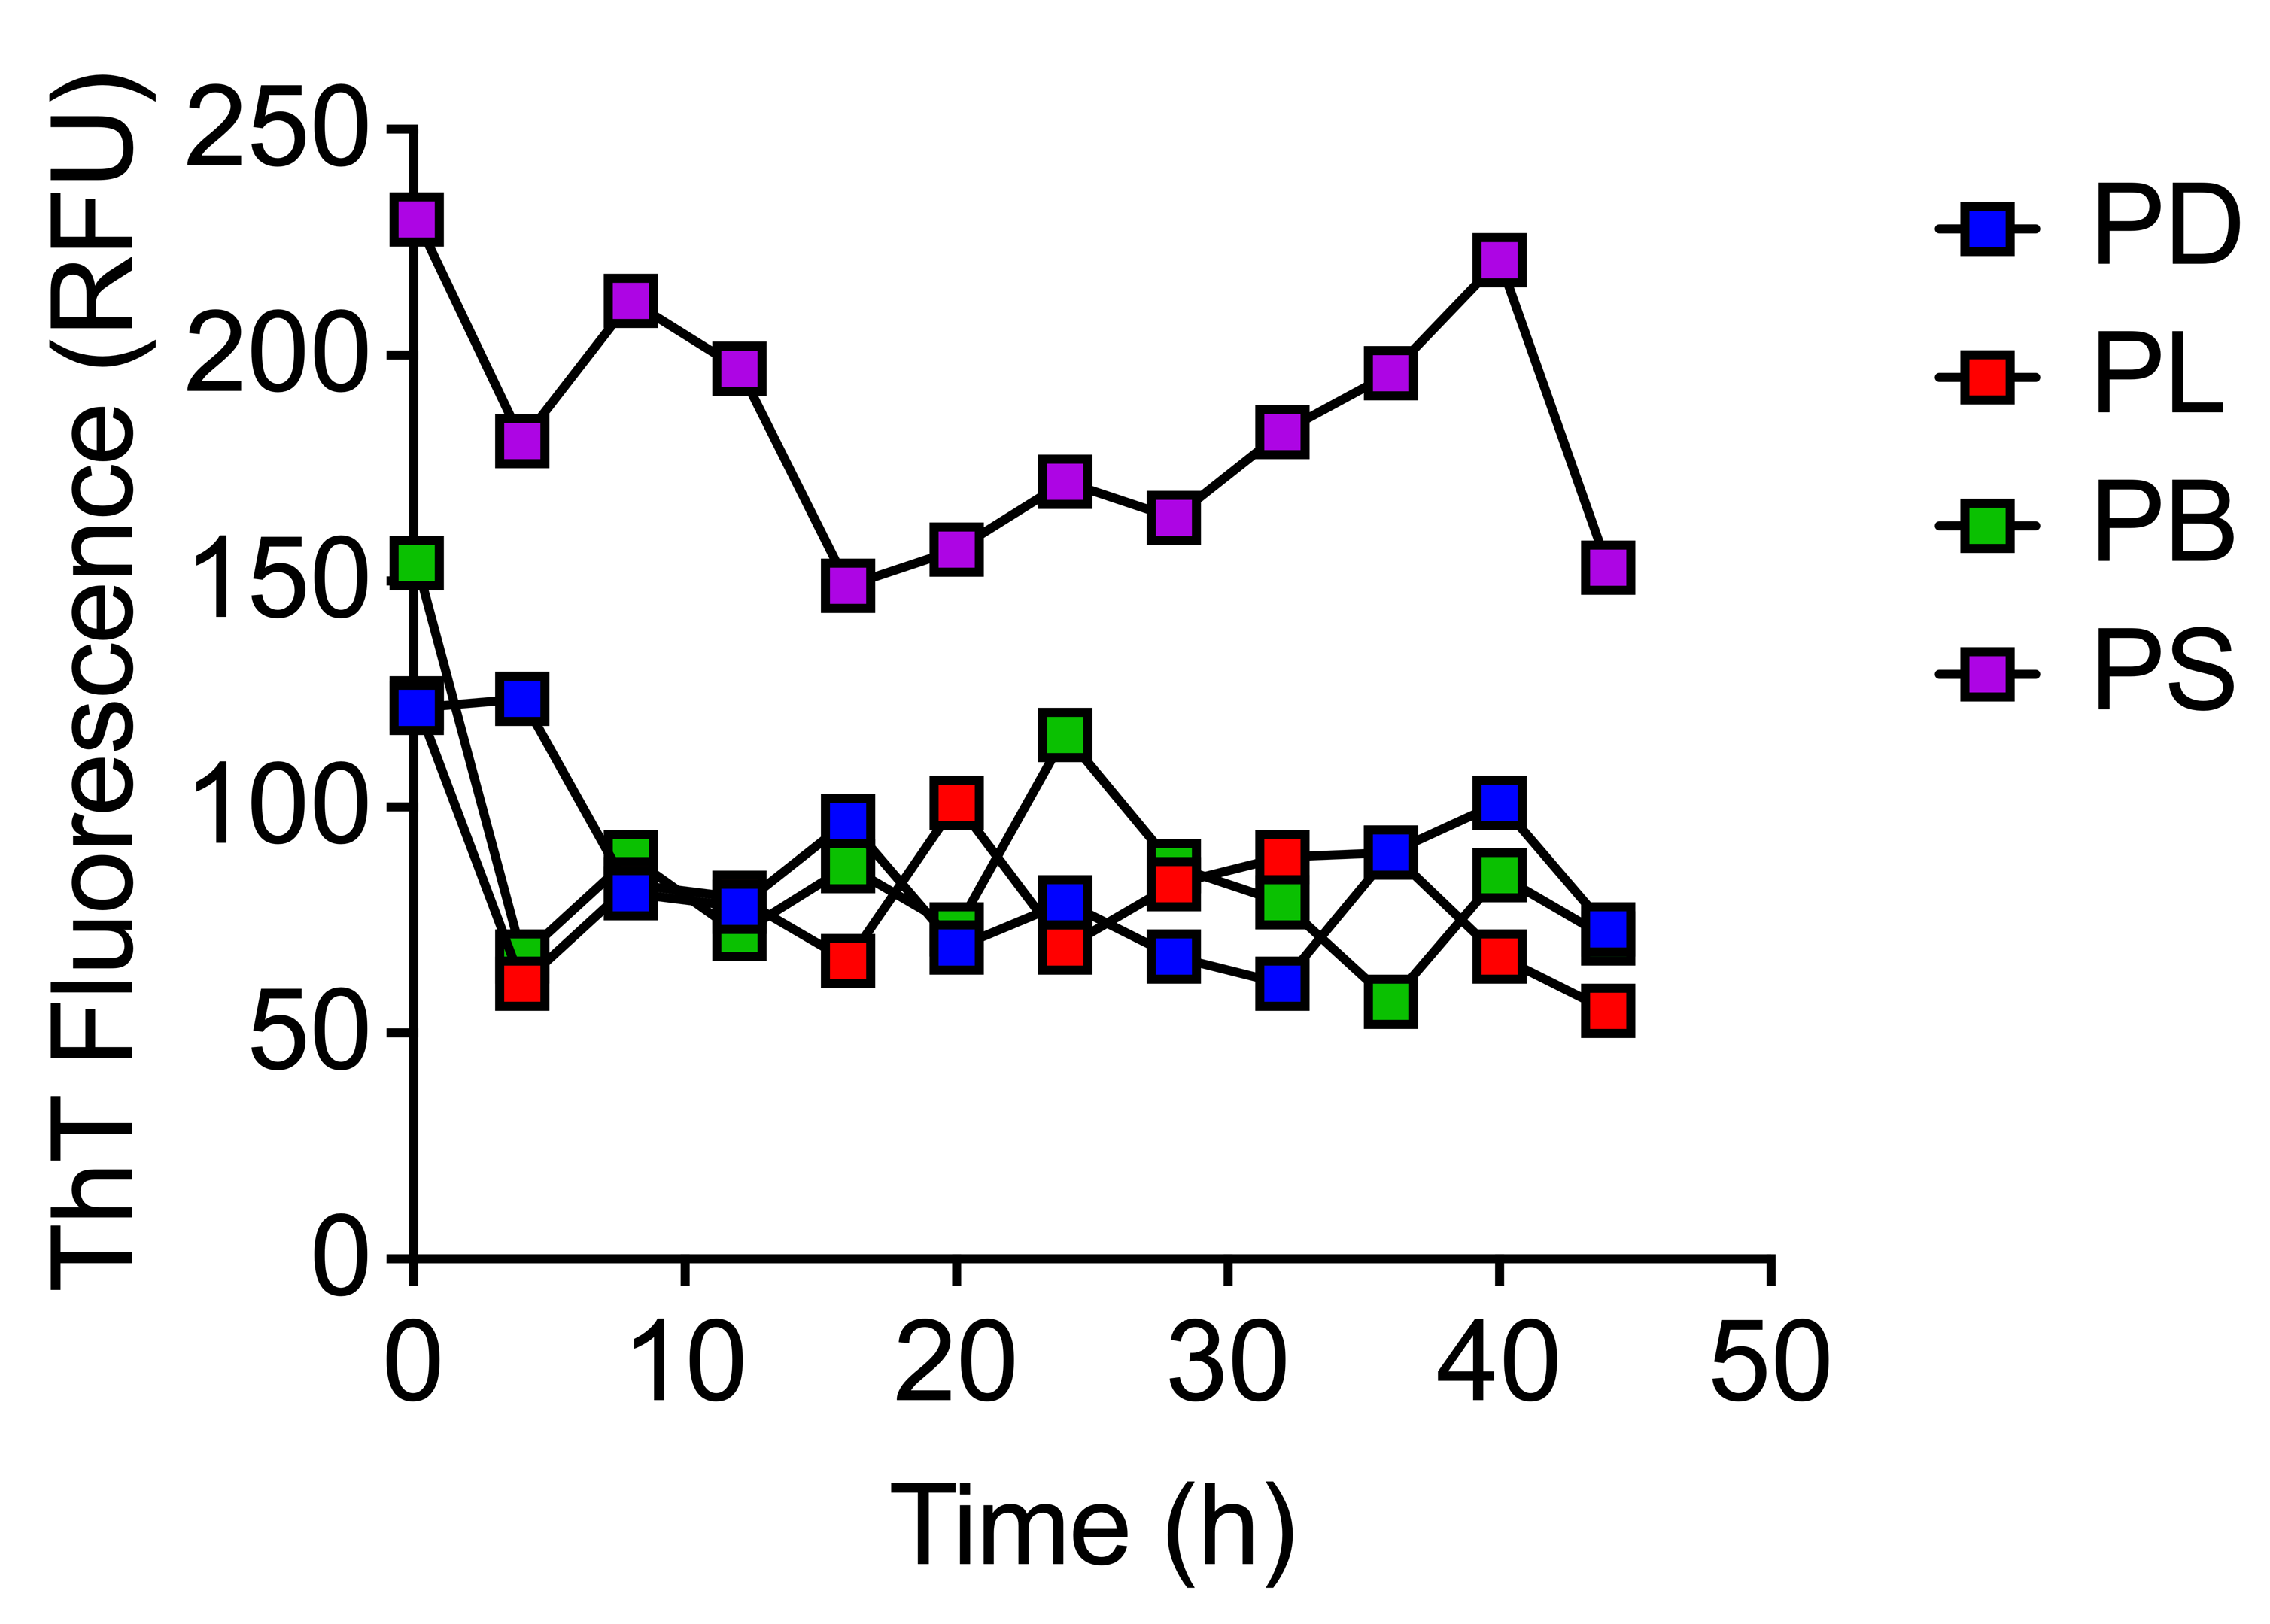
Figure S6. ThT kinetics data for PD, PL, PB, and PS peptides alone showed no signs of aggregation. PD, PL, PB, and PS peptides at 200 μM concentration were aggregated with 50 μΜ ThT. N = 1.

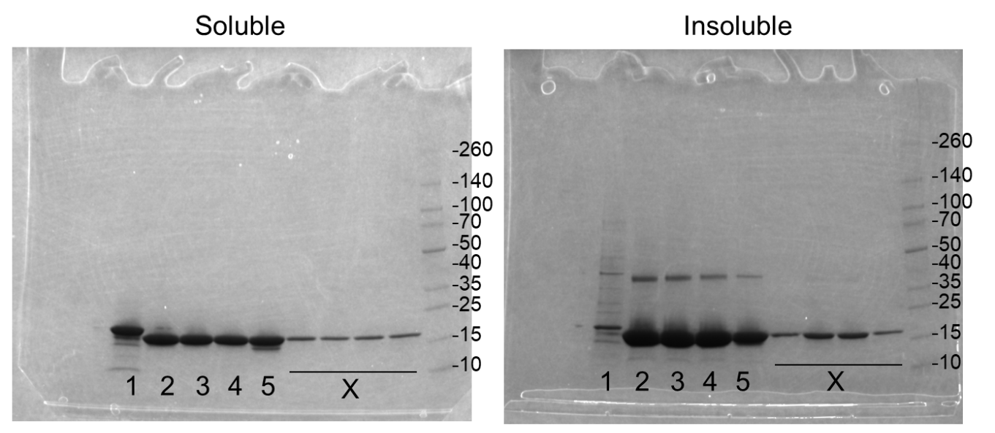
Figure S7. Uncropped full-sized Coomassie-stained gels for Figure 5p. 1: Monomer, 2: αSyn, 3: αSyn + PD, 4: αSyn + PL, and 5: αSyn + PB.

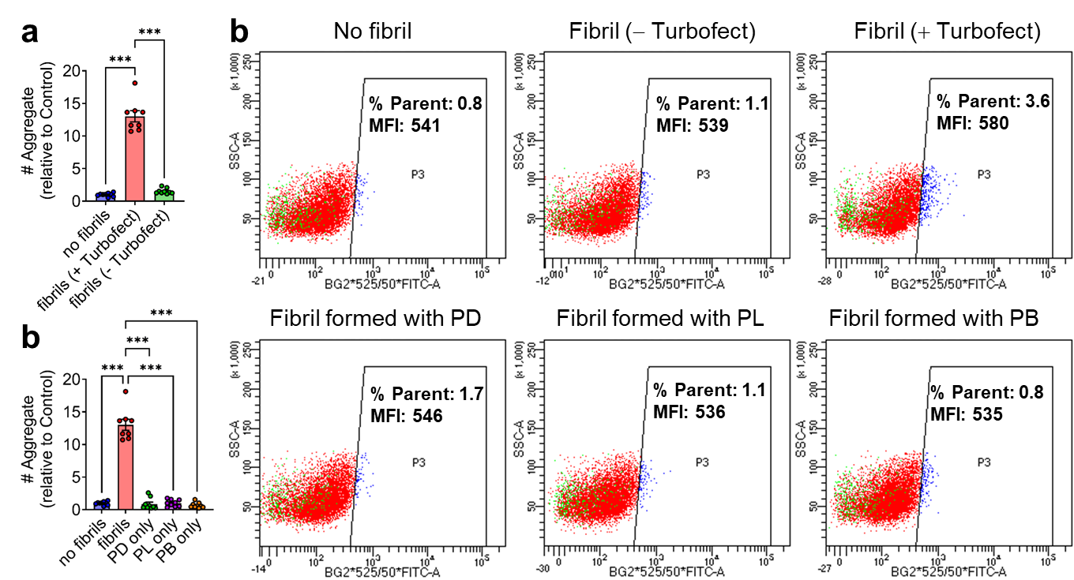
Figure S8. Quantification of CFP/YFP inclusions in biosensor cells transduced with αSyn fibrils from the total fraction with (+) or without (-) Turbofect transfection reagents (a) or αSyn fibrils and only PD, PL, and PB inhibitor peptides (b). Mean ± SEM (n = 3 independent experiments). ***P ≤ 0.001, One-way ANOVA with Tukey's posthoc test. (c) Cells were treated with fibrils formed under various conditions (No fibril, Fibril - TurboFect, Fibril + TurboFect, Fibril formed with PD, PL, or PB). Cells were analyzed for side scatter (SSC-A) and fluorescence in both the CFP (excited at 445 nm) and YFP (excited at 488 nm) channels to detect intracellular seeding and the formation of aggregates. The P3 gate represents cells positive for both CFP and YFP fluorescence, indicating the presence of inclusions. The percentage of the parent population (% Parent) and the median fluorescence intensity (MFI) within the P3 gate are displayed. Fibril transduction with TurboFect resulted in the highest % Parent (3.6%) and MFI (580), suggesting increased intracellular seeding and aggregate formation compared to other conditions.
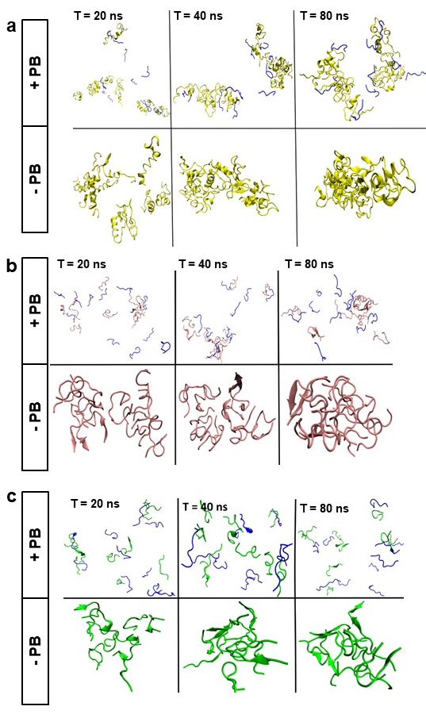
Figure S9. Molecular dynamics frames of NAC35 (a), NAC16 (b), and NAC11 (c) peptides in the presence (+PB) or absence (-PB) of the PB inhibitor at intermediate time steps (20 ns, 40 ns, and 80 ns). The blue structures represent PB interactions with NAC peptides.

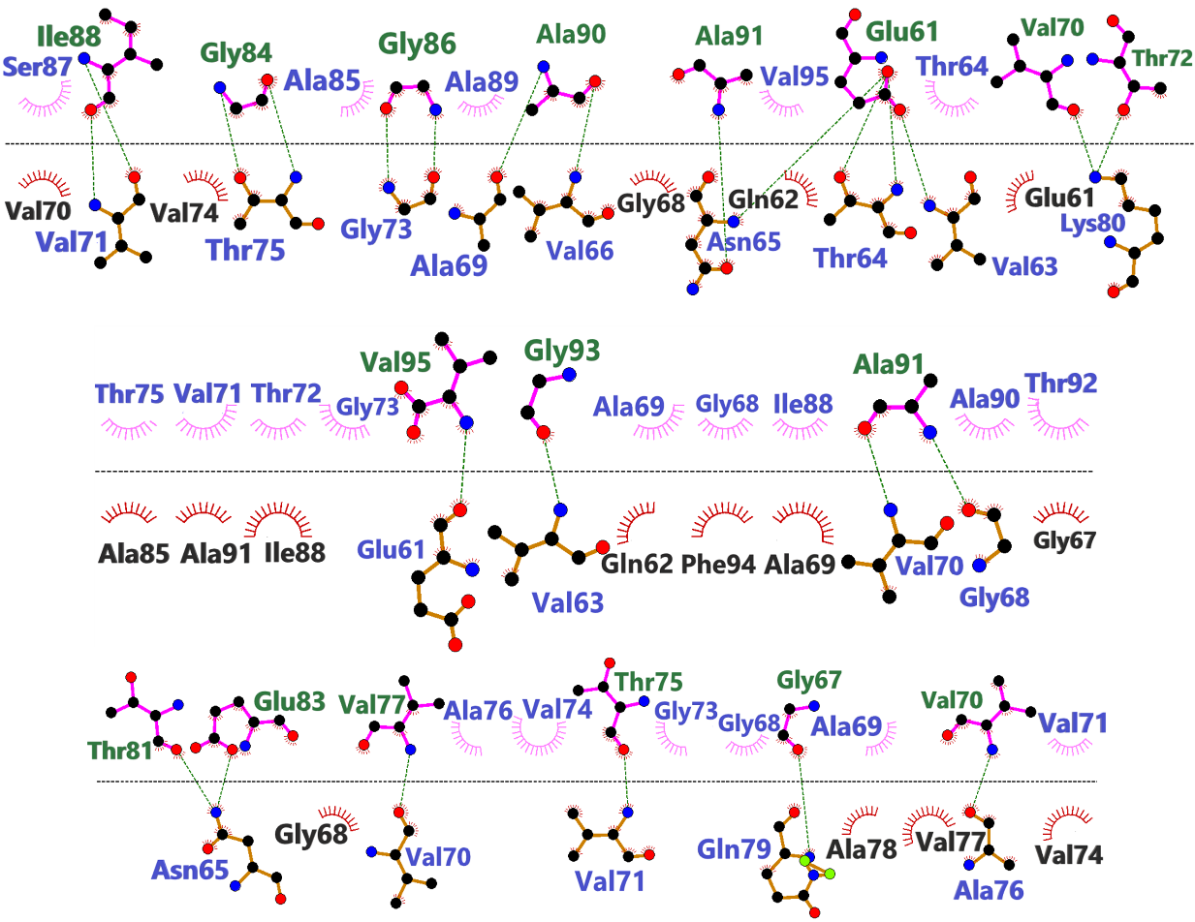
Figure S10. The interacting residues in the aggregation of NAC35 at 100 ns of MD simulation.

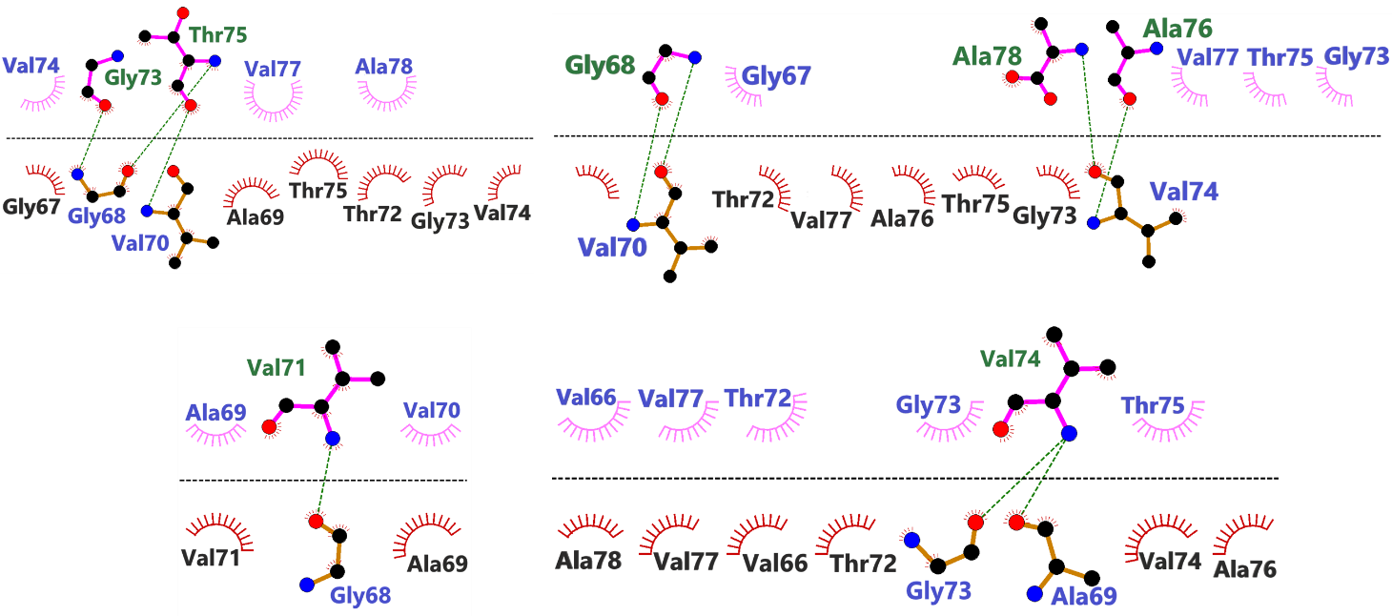
Figure S11. The interacting residues in the aggregation of NAC16 at 100 ns of MD simulation.

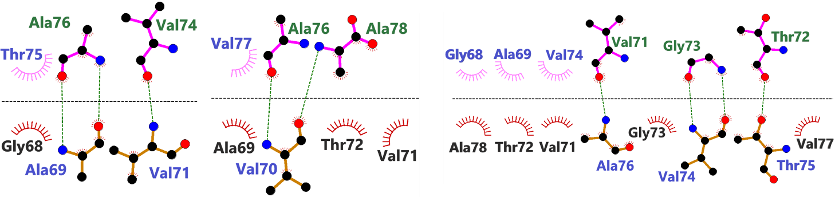
Figure S12. The interacting residues in the aggregation of NAC11 at 100 ns of MD simulation.

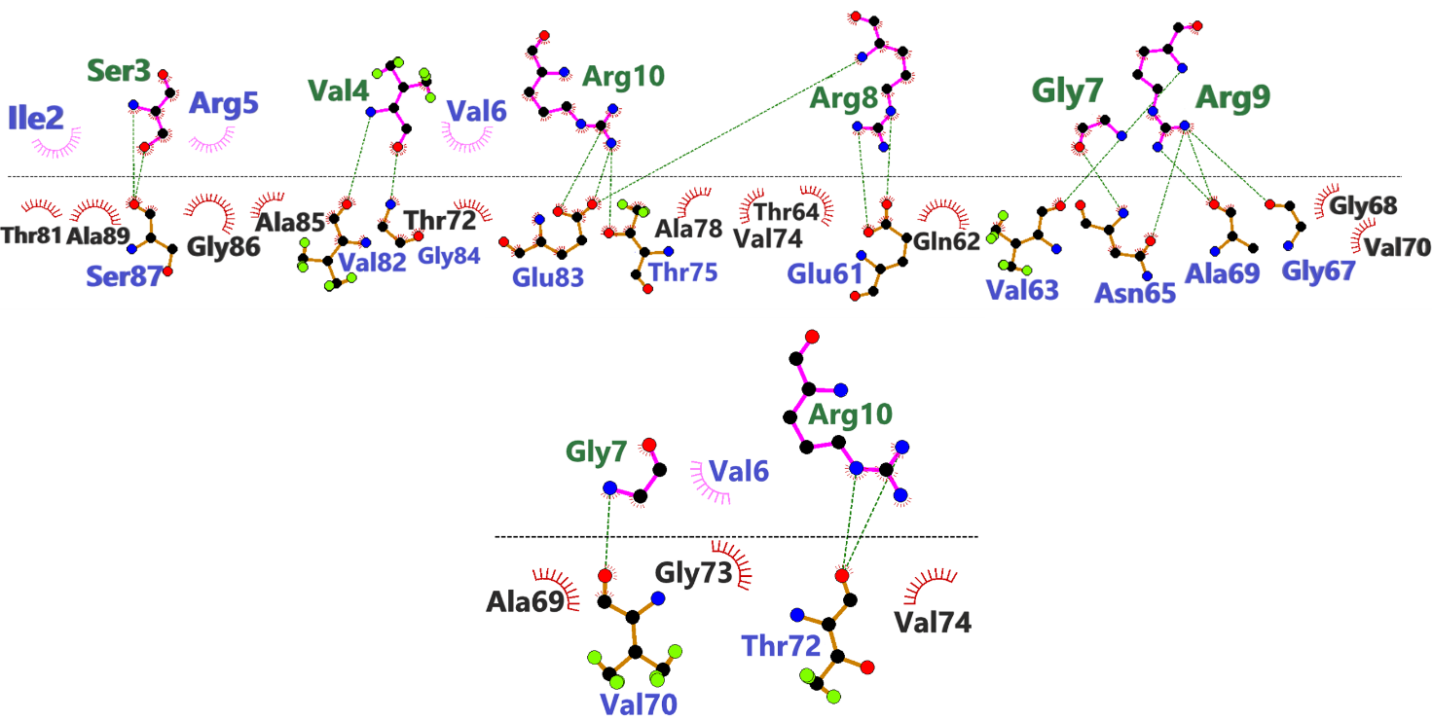Figure S13. Molecular interactions between PB (above the line) and NAC35 (below the line) as observed at 100 ns of MD simulation.

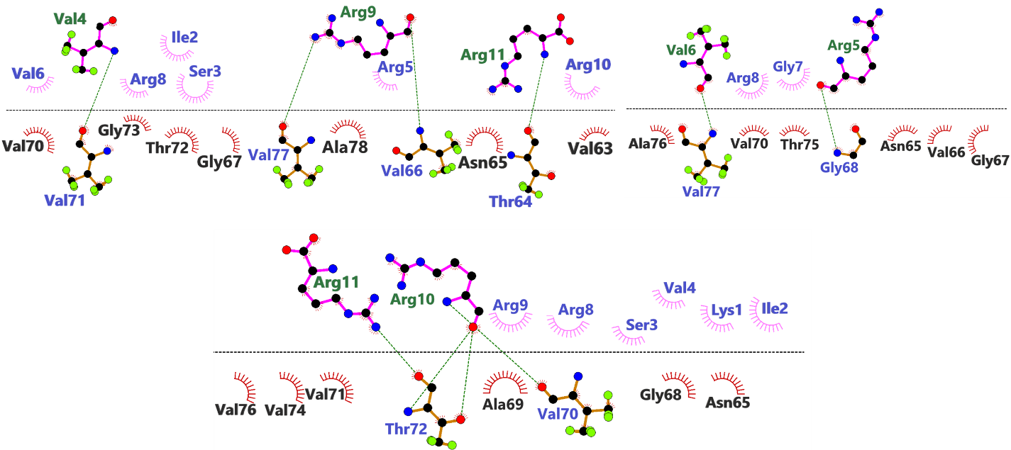
Figure S14. Molecular interactions between PB (above the line) and NAC16 (below the line) as observed at 100 ns of MD simulation.

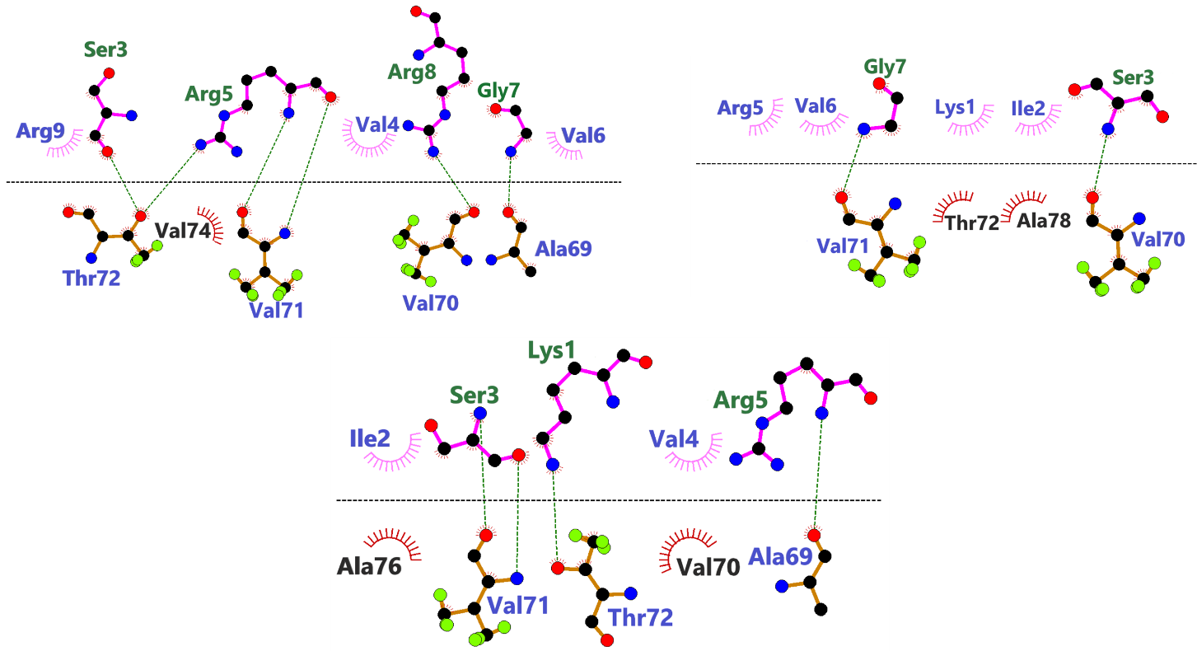
Figure S15. Molecular interactions between PB (above the line) and NAC11 (below the line) as observed at 100 ns of MD simulation.
SUPPLEMENTARY TABLES
Table S1. F values and degrees of freedom for one-way ANOVA performed in Fig. 1c, h-j.
Fig. 1c
 | SS | DF | MS | F (DFn | DFd) | P value
Treatment (between columns) | 28 | 2 | 14 | F (2 | 6) = 149 | P<0.001
Residual (within columns) | 0.55 | 6 | 0.092
Total | 28 | 8
Number of treatments (columns) | 3
Number of values (total) | 9

Fig. 1h
 | SS | DF | MS | F (DFn | DFd) | P value
Treatment (between columns) | 44 | 2 | 22 | F (2 | 6) = 251 | P<0.001
Residual (within columns) | 0.52 | 6 | 0.087
Total | 44 | 8
Number of treatments (columns) | 3
Number of values (total) | 9

Fig. 1i
 | SS | DF | MS | F (DFn | DFd) | P value
Treatment (between columns) | 0.12 | 2 | 0.062 | F (2 | 6) = 15 | P=0.004
Residual (within columns) | 0.024 | 6 | 0.0041
Total | 0.15 | 8
Number of treatments (columns) | 3
Number of values (total) | 9

Fig. 1j
 | SS | DF | MS | F (DFn | DFd) | P value
Treatment (between columns) | 0.25 | 2 | 0.13 | F (2 | 6) = 12 | P=0.008
Residual (within columns) | 0.062 | 6 | 0.01
Total | 0.31 | 8
Number of treatments (columns) | 3
Number of values (total) | 9

Table S2. F values and degrees of freedom of one-way ANOVA performed in Fig. 4b and d.
Fig. 4b
 | SS | DF | MS | F (DFn, DFd) | P value
Treatment (between columns) | 2.14 | 4 | 0.54 | F (4, 25) = 7.52 | P<0.001
Residual (within columns) | 1.78 | 25 | 0.07
Total | 3.92 | 29
Data summary
Number of treatments (columns) | 5
Number of values (total) | 30

Fig. 4d
 | SS | DF | MS | F (DFn, DFd) | P value
Treatment (between columns) | 2.68 | 4 | 0.67 | F (4, 15) = 14.08 | P<0.001
Residual (within columns) | 0.71 | 15 | 0.05
Total | 3.39 | 19
Data summary
Number of treatments (columns) | 5
Number of values (total) | 20
Table S3. F values and degrees of freedom of one-way ANOVA performed in Fig. 5b, d, i, o, and q.
Fig. 5b
 | SS | DF | MS | F (DFn | DFd) | P value
Treatment (between columns) | 3500 | 3 | 1167 | F (1.0 | 1.0) = 5972 | P=0.008
Individual (between rows) | 13 | 1 | 13 | F (1 | 3) = 64 | P=0.004
Residual (random) | 0.59 | 3 | 0.2
Total | 3514 | 7
Number of treatments (columns) | 4
Number of subjects (rows) | 2

Fig. 5d
 | SS | DF | MS | F (DFn | DFd) | P value
Treatment (between columns) | 3.5 | 4 | 0.87 | F (4 | 9) = 135 | P<0.001
Residual (within columns) | 0.058 | 9 | 0.0065
Total | 3.5 | 13
Number of treatments (columns) | 5
Number of values (total) | 14

Fig. 5i
 | SS | DF | MS | F (DFn, DFd) | P value
Treatment (between columns) | 255.4 | 3 | 85.12 | F (3, 116) = 6.08 | P<0.001
Residual (within columns) | 1624 | 116 | 14.00
Total | 1879 | 119
Data summary
Number of treatments (columns) | 4
Number of values (total) | 120

Fig. 5o
 | SS | DF | MS | F (DFn | DFd) | P value
Treatment (between columns) | 0.557 | 3 | 0.1857 | F (3 | 8) = 14.17 | P=0.001
Residual (within columns) | 0.1049 | 8 | 0.01311
Total | 0.6619 | 11
Number of treatments (columns) | 4
Number of values (total) | 12

Fig. 5q
 | SS | DF | MS | F (DFn | DFd) | P value
Treatment (between columns) | 0.6381 | 3 | 0.2127 | F (3 | 12) = 9.325 | P=0.002
Residual (within columns) | 0.2737 | 12 | 0.02281
Total | 0.9118 | 15
Number of treatments (columns) | 4
Number of values (total) | 16

Table S4. F values and degrees of freedom of one-way ANOVA performed in Fig. 6c-e.
Fig. 6c
 | SS | DF | MS | F (DFn, DFd) | P value
Treatment (between columns) | 630,1 | 4 | 157,5 | F (4, 25) = 87.85 | P<0.001
Residual (within columns) | 44,82 | 25 | 1,793
Total | 674,9 | 29
Number of treatments (columns) | 5
Number of values (total) | 30

Fig. 6d
 | SS | DF | MS | F (DFn, DFd) | P value
Treatment (between columns) | 1,253 | 3 | 0,4176 | F (3, 20) = 50.38 | P<0.001
Residual (within columns) | 0,1658 | 20 | 0,008289
Total | 1,419 | 23
Number of treatments (columns) | 4
Number of values (total) | 24

Fig. 6e
 | SS | DF | MS | F (DFn, DFd) | P value
Treatment (between columns) | 5,401 | 4 | 1,35 | F (4, 10) = 15.26 | P<0.001
Residual (within columns) | 0,8849 | 10 | 0,08849
Total | 6,286 | 14
Number of treatments (columns) | 5
Number of values (total) | 15

Table S5. F values, degrees of freedom, and other details of one-way ANOVA performed in Fig. 7d-g.
Fig. 7d
 | SS | DF | MS | F (DFn, DFd) | P value
Treatment (between columns) | 86,22 | 3 | 28,74 | F (3, 12) = 569.9 | P<0.001
Residual (within columns) | 0,6052 | 12 | 0,05043
Total | 86,82 | 15
Number of treatments (columns) | 4
Number of values (total) | 16

Fig. 7e
 | SS | DF | MS | F (DFn, DFd) | P value
Treatment (between columns) | 95,57 | 3 | 31,86 | F (3, 12) = 81.14 | P<0.001
Residual (within columns) | 4,711 | 12 | 0,3926
Total | 100,3 | 15
Number of treatments (columns) | 4
Number of values (total) | 16

Fig. 7f
 | SS | DF | MS | F (DFn, DFd)
Treatment (between columns) | 34,76 | 3 | 11,59 | F (3, 16) = 99.81
Residual (within columns) | 1,857 | 16 | 0,1161
Total | 36,61 | 19
Number of treatments (columns) | 4
Number of values (total) | 20

Fig. 7g
 | SS | DF | MS | F (DFn, DFd)
Treatment (between columns) | 0,913 | 3 | 0,3043 | F (3, 12) = 20.12
Residual (within columns) | 0,1815 | 12 | 0,01513
Total | 1,094 | 15
Number of treatments (columns) | 4
Number of values (total) | 16

APPENDIX
Appendix S1. Image Analysis Script to quantify CFP/YFP inclusions and cell confluence. This appendix illustrates the step-by-step procedure for applying the Image Analysis Script to quantify intracellular CFP/YFP inclusions and cell confluence. The steps are demonstrated using example images of control cells (fibril untransduced) and cells transduced with 1 µM αSyn fibrils after 72 hours of the seeding experiment. In control (untransduced) cells, only basal levels of CFP/YFP inclusions are detected, reflecting the natural background signal. In contrast, cells transduced with αSyn fibrils exhibit higher CFP/YFP inclusion levels, confirming successful seeding. Each step is detailed with visual screenshots from the software for both control and transduced cells.
Step 1: Input Image
- Example images of control and αSyn fibril-transduced cells are loaded into the software.
Step 2: Find Nuclei/Channel 445/45 (Method M)
- The script identifies the nuclei in both control and transduced cells. Nuclei detection is visualized and highlighted in both sets of cells.
Step 3: Find Spots/Channel BP525/50 (Method C)
- In this step, the script detects CFP/YFP inclusions (spots) in the cells, differentiating between control and transduced conditions.

