Entry for the Table of Contents
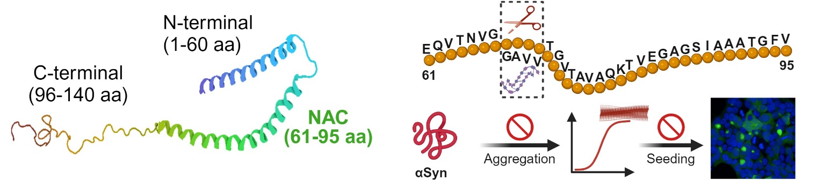

Truncation of the 68GAVV71 hydrophobic stretch within the NAC region of α-synuclein (αSyn) disrupts β-sheet-rich fibril formation and prion-like seeding activity. This work highlights the importance of targeting this sequence for inhibiting aggregation, providing insights into potential therapeutic approaches for synucleinopathies.

