Additional Figures

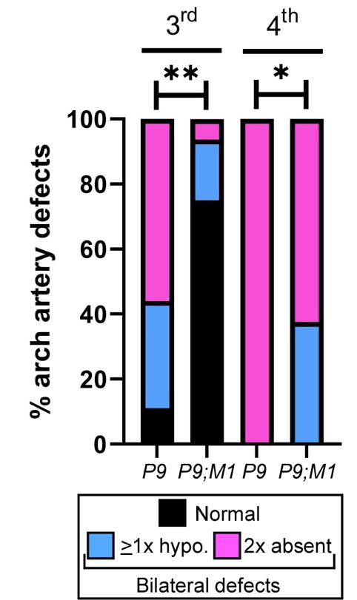

Additional file 1. Caudal PAA defects in CD1-Pax9–/– and CD1-Pax9–/–;Msx1^{+/–} embryos
The phenotype of the 3rd and 4th PAAs were recorded in E10.5 embryos following intracardiac ink injection. Data is reproduced from Table 3 and the incidence expressed as a percentage. The PAAs are defined as normal when both left and right PAAs are patent to ink and of normal size, hypoplastic (hypo.) if thinner than normal, and absent when not patent to ink. There is a significant increase in normal 3rd and hypoplastic 4th PAAs in CD1-Pax9–/–;Msx1^{+/–} embryos (P9;M1) compared to CD1-Pax9–/– embryos (P9). Fisher’s exact test for associations, **p<0.005, **p<0.01.

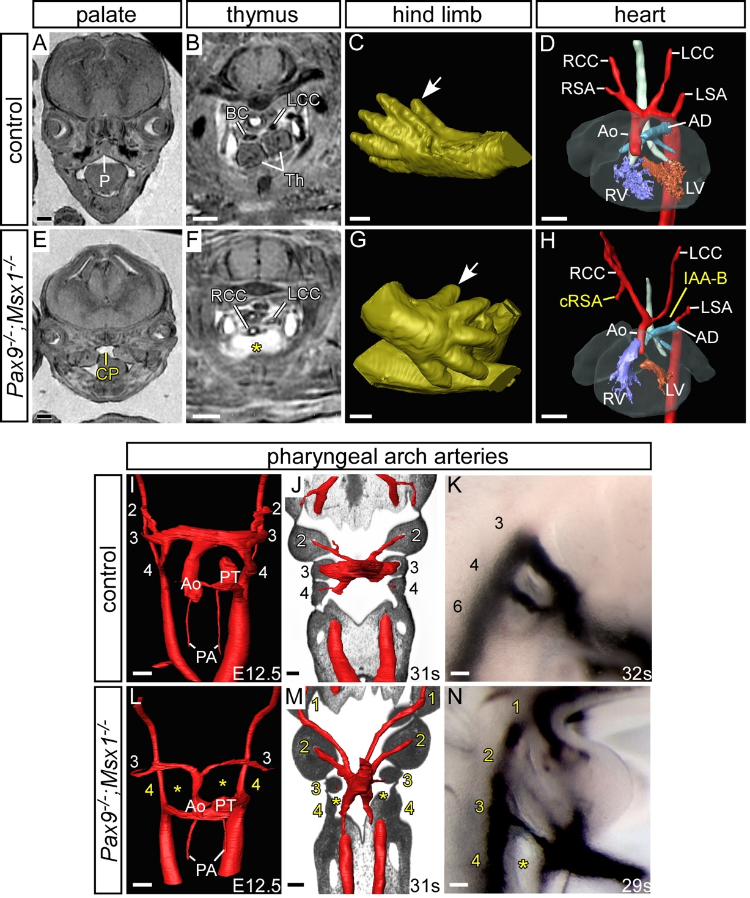

Additional file 2. Defects in Pax9–/–;Msx1–/– embryos on a congenic CD1 genetic background.
Embryos at E15.5 were imaged by MRI (A-H), at E12.5 (I, L) and E10.5 (J, M) by HREM, and at E10.5 following intracardiac ink injection (K, N). Panels A-D are taken from Figure 1 for comparison. (A-D) Control embryos have a normal palate (A), thymus (B), hind limb digit (white arrow; C), heart and arch arteries (D). (E-H) Pax9–/–;Msx1–/– embryos display cleft palate (CP; E), absent thymus (asterisk; F) but do not have pre-axial digit duplication (white arrow; G) as seen in Pax9–/– and Pax9–/–;Msx1^{+/–} embryos (see Figs 1H, 5D and 6B,C). (H) Some Pax9–/–;Msx1–/– embryos have cardiovascular defects such as cervical origin of the right subclavian artery (cRSA) and interrupted aortic arch type B (IAA-B). (I-K) Control embryos showing normal pharyngeal arch artery (PAA) development. (I) Embryo at E12.5 with a septated outflow tract and symmetric 3rd and 4th PAAs. (J) Embryo at E10.0 with symmetric 2nd and 3rd PAAs. The 4th PAA is forming. (K) Embryo at E10.0 with symmetrical 3rd, 4th and 6th PAAs patent to ink. (L-N) Pax9–/–;Msx1–/– embryos have aberrant PAA morphogenesis. (L) E12.5 embryo with hypoplastic 3rd and absent 4th PAAs. The outflow tract is not fully septated. (M, N) E10.0 embryos with aberrantly persisting 1st and 2nd, hypoplastic 3rd and absent 4th PAAs.
Abbreviations: AD, arterial duct; Ao, aorta: LCC/RCC, left/right common carotid artery; LSA/RSA, left/right subclavian artery; LV/RV, left/right ventricle; P, palate; PA, pulmonary artery; PT, pulmonary trunk; Th, thymus. Scale bars: 500µm in A-H, 100µm in I-N.
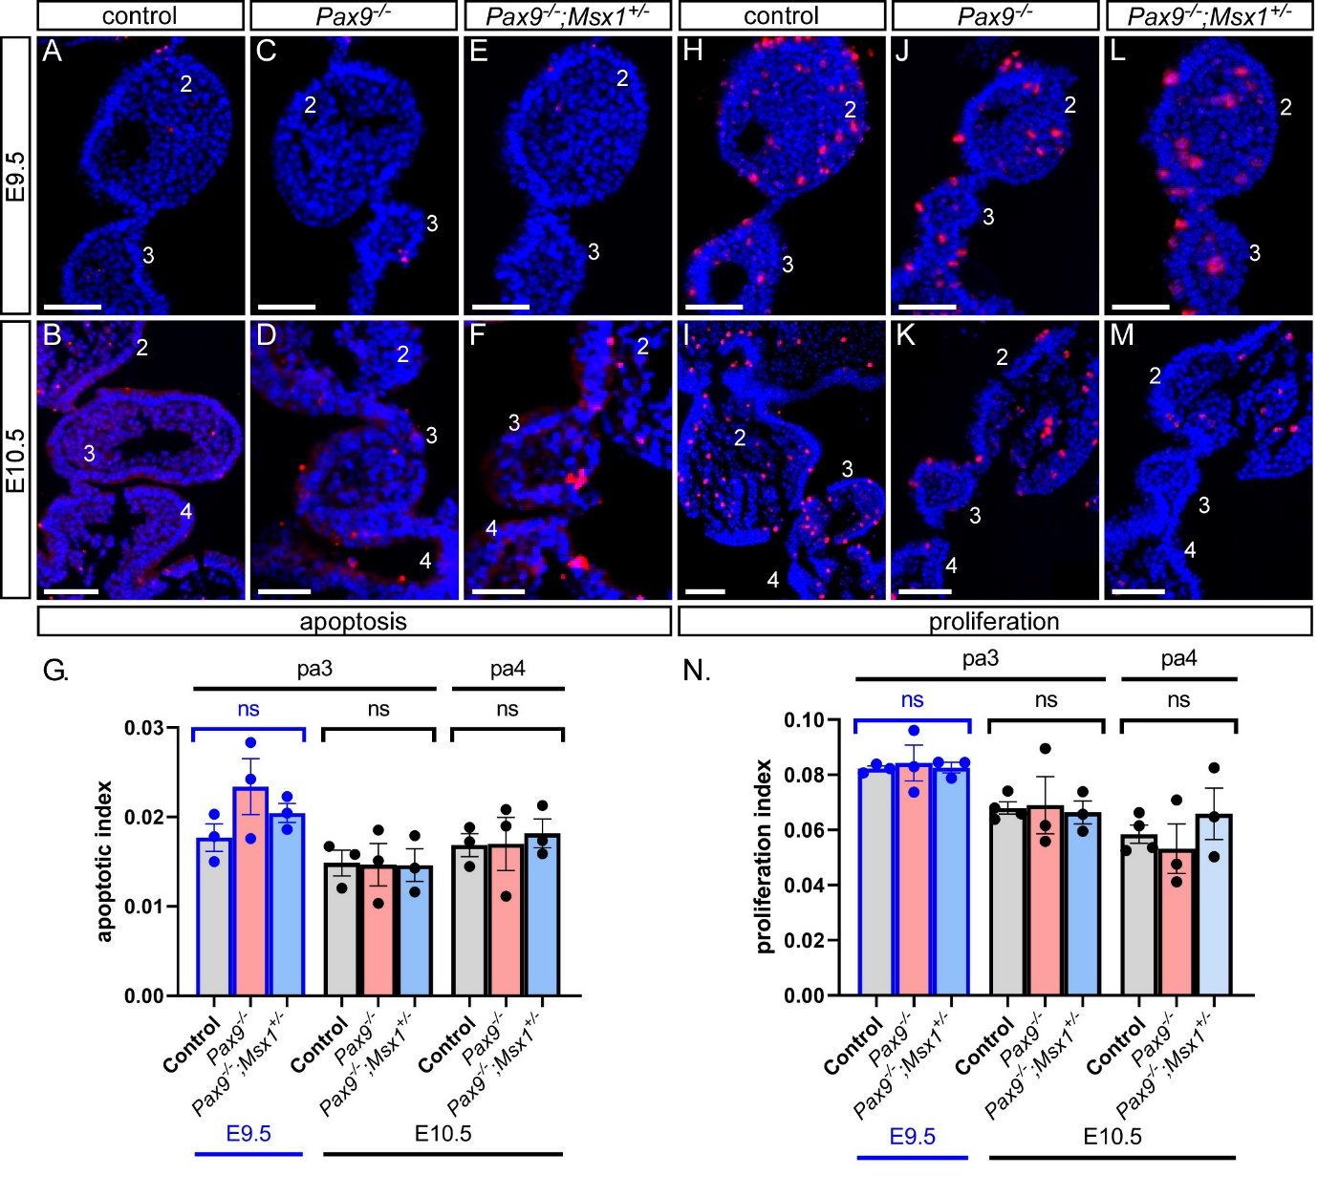
Additional file 3. Apoptosis and cell proliferation are not affected in Pax9–/– and Pax9–/–;Msx1^{+/–} mutant embryos on a congenic CD1 background.
(A-F) Embryo sections were immunostained using an anti-caspase-3 antibody to detect apoptosis in the caudal pharyngeal arches of control (A, B), Pax9–/– (C, D) and Pax9–/–;Msx1^{+/–} (E, F) embryos at E9.5 and E10.5. (G) No significant difference in the rate of apoptosis was found between control, CD1-Pax9–/– and CD1-Pax9–/–;Msx1^{+/–} embryos at E9.5 and E10.5 (n=3 per genotype and stage). (H-M) Embryo sections were immunostained using an anti-phospho-histone H3 antibody to detect proliferation in the caudal pharyngeal arches of control (H, I), Pax9–/– (J, K) and Pax9–/–;Msx1^{+/–} (L, M) embryos at E9.5 and E10.5. (N) No significant difference in the rate of proliferation was found between control, CD1-Pax9–/– and CD1-Pax9–/–;Msx1^{+/–} embryos at E9.5 and E10.5 (n=3 per genotype and stage). One-way ANOVA with Tukey’s multiple comparisons test. ns, not significant; pa, pharyngeal arch. Scale bars: 50μm.

Additional Tables

Additional Table 1. Developmental defects in Msx1–/– and Pax9^{+/–}:Msx1–/– mutant mice

 |  |  | Defects
Genotype | Stage | n | Palate | Thymus | Limb | Cardio
Msx1–/– | Neonate | 6 | 7  (100%) | 0 | 0 | 0
Msx1–/– | E15.5 | 1
Pax9^{+/–};Msx1–/– | Neonate | 8 | 14  (100%) | 0 | 0 | 0
Pax9^{+/–};Msx1–/– | E15.5 | 6
Pax9^{+/–};Msx1–/– | E10.5 | 7 | - | - | - | 0

Defects were assessed in neonates by direct observation, E15.5 embryos by μCT and MRI analysis, and the pharyngeal arch arteries in E10.5 embryos by intra-cardiac ink injection. Abbreviation: Cardio, cardiovascular.

Additional Table 2. PCR primers for genotyping

Mouse line | Primer name | Primer sequence | Product (bp)
Pax9 | P9-gen2-F1 | ACTCACCGGCCTGCACCAATTAC | 196 (wild-type) 450 (mutant)
Pax9 | P9-gen2-R1 | TTGTTCTCACTGAGCCGGCCTGT | 196 (wild-type) 450 (mutant)
Pax9 | P9-gen2-R2 | GGATGTGCTGCAAGGCGATTAAG | 196 (wild-type) 450 (mutant)
Pax9^{Flox} | P9-lox1-F | AGCGGAGACAAGGATGAAACCAC | 305 (wild-type) 351 (mutant)
Pax9^{Flox} | P9-lox1-R | AGAGGAATCCCGATGTTCACCAG | 305 (wild-type) 351 (mutant)
Msx1 | M1-F1b | CCTACGCAAGCACAAGACCAAC | 202 (wild-type) 410 (mutant)
Msx1 | M1-R1b | CTCCTGCAGTCTCTTGGCCTTA | 202 (wild-type) 410 (mutant)
Msx1 | M1-R2b | GGCCACACGCGTCACCTTAATA | 202 (wild-type) 410 (mutant)
Isl1Cre | S1X-A | GCATAACCAGTGAAACAGCATTGCTG | 280
Isl1Cre | S1X-B | GGACATGTTCAGGGATCGCCAGGCG | 280

Additional Table 3. Antibodies used for immunostaining

Target | Catalogue number | Species and type | Supplier | Dilution
Primary antibodies
AP-2α | 3B5 | Rat monoclonal | Santa Cruz | 1:50
aSMA | a2547 | Mouse monoclonal | Sigma | 1:500
Cleaved caspase-3 | 9661 | Rabbit polyclonal | Cell Signalling | 1:100
ERG | ab92513 | Rabbit monoclonal | Abcam | 1:200
Phospho-histone H3 | 06-570 | Rabbit polyclonal | Millipore | 1:300
Secondary antibodies
Donkey anti-mouse IgG Alexa Fluor 594 | A-21203 | - | Thermo Fisher Scientific | 1:200
Donkey anti-rabbit IgG Alexa Fluor 594 | A-21207 | - | Thermo Fisher Scientific | 1:200
Donkey anti-rat IgG Alexa Fluor 594 | A-21209 | - | Thermo Fisher Scientific | 1:200
Donkey anti-rabbit IgG Alexa Fluor 488 | A-21206 | - | Thermo Fisher Scientific | 1:200
Nuclear stain
DAPI | H-1200 | - | Vector Laboratories | -

