Supporting Information

Synthesis of isomers of Brussonol, Przewalskine E and Euolutchuol E
Wenjing Zong,† Jing Zhang*,†
†Jiangxi University of Chinese Medicine, Jiangxi 330004, P. R. China.
Email: m827027934@163.com

Table of Contents
I Experimental Procedures and Spectroscopic Data of Compounds …………..2
II References ………………………………………………………….…….....7
III ¹H and ¹³C NMR Spectra of Compounds ………..…………………….…...8
Ⅳ X-Ray Crystallographic Data…………………..……………………….…17

I Experimental Procedures and Spectroscopic Data of Compounds General Procedures. All reactions involving air or moisture sensitive reagents or intermediates were carried out under an argon atmosphere with dry solvents under anhydrous conditions, unless otherwise noted. Reagents were purchased at the highest commercial quality and used without further purification, unless otherwise stated. Solvents purification was conducted according to Purification of Laboratory Chemicals, 8th Edition (W. L. F. Armarego). Tetrahydrofuran and toluene were distilled from sodium/ benzophenone. Dichloromethane was distilled from calcium hydride. Yields refer to isolated compounds, unless otherwise stated. Reactions were monitored by using thin-layer chromatography (TLC) carried out on 0.25 mm Tsingdao silica gel plates (60F-254) using Tsingdao silica gel (60, particle size 0.040–0.063 mm). The silica gel from the same company was also used for flash column chromatography. NMR spectra were recorded on a Brüker AVANCE 400 (¹H: 400 MHz) or a Brüker AVANCE 500 (¹H: 500 MHz, ¹³C: 126 MHz) instrument. Chemical shifts were reported in parts per million (ppm) with respect to the residual solvent signal CDCl₃ (¹H NMR: δ = 7.26; ¹³C NMR: δ = 77.16). Peak multiplicities were reported as follows: s = singlet, d = doublet, t = triplet, q = quartet, dd = doublet of doublets, td = triplet of doublets, dt = doublet of triplets, ddd = doublet of doublet of doublets, m = multiplet, br = broad signal. High resolution mass spectra (HRMS) were recorded on an Agilent Mass spectrometer using ESI-TOF (electrospray ionization-time of flight).

Synthesis of compound (7a, 7b)
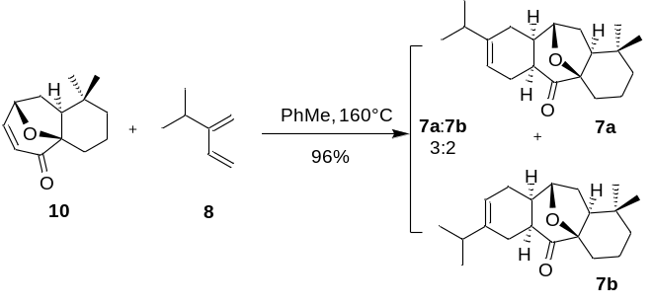
Route 1: The solution of dienophile 10 (1.21 g, 5.87 mmol) and diene 8 (1.41 g, 14.66 mmol) in PhMe (30 mL, 0.2 M) was stirred at 160°C with oil bath in a sealed tube. Upon completion of the reaction, the mixture was concentrated in vacuo and purified by using column chromatography (PE/EA, 30:1) to give product 7a and 7b (1.71g, 96%, 7a: 7b= 3: 2) as a pale yellow oil.
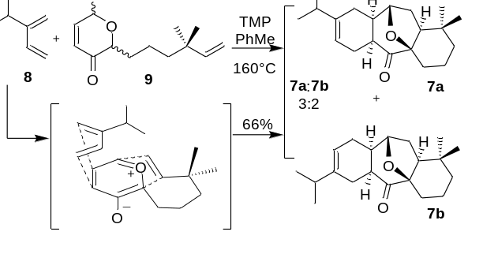
Route 2: To a solution of precursor 9 (110 mg, 0.41 mmol) and diene 8 (118 mg, 1.23 mmol) in PhMe (8 mL, 0.05 M) was added TMP (105 µL, 0.62 mmol) dropwise at room temperature, and the mixture was stirred at 160°C with oil bath in a sealed tube for 40 h. The reaction mixture was cooled to room temperature, and quenched by the addition of water (1.0 mL), and the aqueous layer was extracted with EtOAc (3 × 5 mL). The combined organic layers were washed with brine (5 mL), and then dried over with Na2SO4. The solvents were removed under vacuum, and the residue was purified by using flash column chromatography on silica gel (PE/EA, 30:1) to give the product 7a and 7b (83 mg, 66%, 7a: 7b= 3: 2) as a pale yellow oil.
¹H NMR (500 MHz, CDCl₃) δ 5.52 – 5.37 (m, 1H), 4.25 – 4.11 (m, 1H), 2.73 – 2.58 (m, 1H), 2.53 – 2.36 (m, 1H), 2.32 – 2.13 (m, 4H), 2.13 – 1.95 (m, 3H), 1.90 (m, 1H), 1.77 – 1.68 (m, 2H), 1.63 (m, 1H), 1.46 (m, 2H), 1.16 (m, 1H), 0.98 (m, 6H), 0.93 (d, J = 3.7 Hz, 3H), 0.87 (s, 3H).
¹³C NMR (126 MHz, CDCl₃) δ 212.2, 211.9, 144.4, 143.1, 118.0, 116.5, 88.7, 88.7, 78.0, 77.9, 49.8, 49.8, 42.3, 42.1, 41.6, 41.4, 37.9, 37.8, 35.0, 34.8, 32.3, 32.3, 31.8, 31.8, 31.7, 31.7, 28.3, 26.9, 25.9, 25.3, 25.3, 24.3, 24.0, 24.0, 21.3, 21.3, 21.2, 21.0, 16.8, 16.8.
HRMS (ESI) m/z: [M + H]⁺ Calcd for C₂₀H₃₁O₂ 303.2319; Found 303.2325.

Synthesis of compound (10a, 10b)
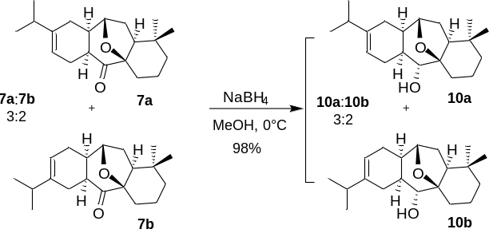
To a stirred solution of the ketone 7a and 7b (1.32 g, 4.36 mmol) in methanol (44 mL) was slowly added sodium borohydride (198 mg, 5.24 mmol) at 0℃. After stirring for 5 minutes, the resulting mixture was quenched with saturated aqueous NH4Cl solution (5 mL) at 0°C. The mixture was concentrated under reduced pressure and the aqueous layer was extracted with EtOAc (3 × 15 mL). The combined organic layers were dried over Na2SO4, filtered and concentrated under reduced pressure. The residue was purified by using flash chromatography on silica gel (PE/EA, 20:1) to provide product 10a and 10b (1.30 g, 98%, 10a: 10b=3: 2) as white solid.
¹H NMR (400 MHz, CDCl₃) δ 5.46 – 5.24 (m, 1H), 3.98 (dd, J = 15.4, 7.7 Hz, 1H), 3.06 (m, 1H), 2.40 – 2.26 (m, 1H), 2.20 (dt, J = 25.0, 5.9 Hz, 2H), 2.05 (m, 2H), 1.99 – 1.75 (m, 5H), 1.75 – 1.61 (m, 3H), 1.47 (m, 3H), 1.08 (m, 1H), 0.99 (dd, J = 6.9, 2.0 Hz, 6H), 0.93 (s, 3H), 0.89 (d, J = 2.5 Hz, 3H).
¹³C NMR (126 MHz, CDCl₃) δ 142.5, 139.9, 117.3, 115.0, 84.3, 84.2, 73.7, 73.7, 44.3, 44.3, 38.8, 38.0, 36.4, 36.3, 35.2, 35.1, 33.7, 33.0, 32.0, 32.0, 31.2, 29.8, 27.7, 27.7, 26.1, 25.9, 25.5, 25.4, 25.3, 21.7, 21.7, 21.4, 21.3, 16.9.
HRMS (ESI) m/z: [M - H]⁻ Calcd for C₂₀H₃₁O₂ 303.2330; Found 303.2329.

Synthesis of compound (11a, 11b)
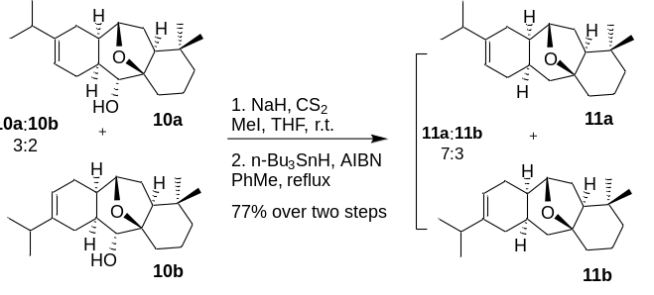
To a solution of 10a and 10b (500 mg, 1.64 mmol) in dry THF (16 mL, 0.1 M) was added NaH (60% in mineral oil, 118 mg, 4.93 mmol). After the mixture was stirred at rt for about 30 min, CS2 (0.6 mL, 9.85 mmol) was added and the stirring was continued for 1 h. MeI (1.23 mL, 19.70 mmol) was then added. The resultant mixture was stirred at rt overnight, quenched with saturated NaHCO3 solution (5.0 mL), and extracted with EtOAc (2 × 15 mL). The combined organic layers were washed with brine (15 mL), dried over Na2SO4, filtered, and concentrated. The crude product was directly used for the next step without purification. The crude xantate was dissolved in dry toluene (41 mL) and heated to 80°C. A solution of nBu3SnH (2.2 mL, 8.21 mmol) and AIBN (59 mg, 0.36 mmol) in toluene (41 mL) was added dropwise. The mixture was stirred at 80°C with oil bath for 4h, cooled to rt, and then concentrated under reduced pressure. The residue was purified by using flash chromatography (PE/EA, 150:1) to give product 11a and 11b (365 mg, 77% over two steps, 11a: 11b=7: 3) as a a pale yellow oil.
¹H NMR (500 MHz, CDCl₃) δ 5.39 – 5.23 (m, 1H), 4.04 (dd, J = 18.0, 7.8 Hz, 1H), 2.44 – 2.32 (m, 1H), 2.27 (t, J = 16.9 Hz, 1H), 2.17 (m, 2H), 2.00 (m, 1H), 1.93 (m, 1H), 1.80 (m, 2H), 1.65 (m, 5H), 1.52 (dd, J = 7.7, 3.7 Hz, 2H), 1.47 – 1.33 (m, 9H), 1.29 (dd, J = 18.1, 9.7 Hz, 5H), 1.08 (m, 2H), 1.01 – 0.95 (m, 7H), 0.92 (t, J = 7.4 Hz, 5H), 0.88 (s, 7H).
¹³C NMR (126 MHz, CDCl₃) δ 142.0, 139.8, 117.0, 115.0, 81.5, 81.4, 77.9, 77.6, 49.6, 49.6, 42.9, 42.7, 37.7, 37.6, 37.1, 36.2, 35.3, 35.1, 33.0, 33.0, 32.3, 31.9, 31.9, 31.8, 30.8, 30.4, 28.0, 27.0, 25.5, 25.1, 24.8, 24.2, 21.7, 21.6, 21.4, 21.3, 17.7, 17.5, 13.8, 13.7.
HRMS (ESI) m/z: [M - H]⁻ Calcd for C₂₀H₃₁O 287.2380; Found 287.2365.

Synthesis of compound (6a, 6b)
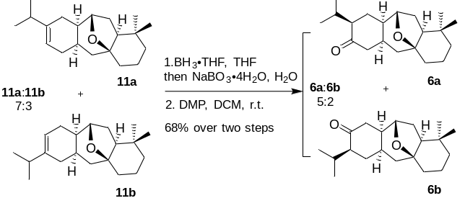
To a solution of 11a and 11b (236 mg, 0.82 mmol) in dry THF (8 mL, 0.1 M) was added BH3·THF (1.0 M in THF, 2.0 mL, 2.04 mmol) at 0°C. After the mixture was stirred at 0°C for about 10 min, the reaction mixture was heated to 35°C with oil bath and stirred for 1.5 h. The reaction mixture was cooled to 0°C and quenched by the addition of water (6 mL). NaBO3·4H2O (252 mg, 1.64 mmol) was then added. The resultant mixture was stirred at rt for 4 h, diluted with water (10 mL), and extracted with EtOAc (2 × 15 mL). The combined organic layers were washed with brine (15 mL), and dried over Na2SO4, filtered, and concentrated.
To a solution of the crude intermediate from above reaction in DCM (14 mL, 0.06 M) was slowly added DMP (411 mg, 0.97 mmol) at room temperature. After stirring for 30 minutes, the resulting mixture was quenched with saturated aqueous Na2SO3 solution (2 mL) and water (10 mL), and extracted with DCM (2 × 15 mL). The combined organic layers were washed with brine (15 mL), and dried over by Na2SO4, filtered, and concentrated. The residue was purified by using flash chromatography (PE/EA, 20:1) to give product 6a (122 mg, 49%) and 6b (47 mg, 19%) as a a pale yellow oil.
6a: ¹H NMR (400 MHz, CDCl₃) δ 4.11 (d, J = 7.9 Hz, 1H), 2.65 – 2.46 (m, 2H), 2.23 – 2.14 (m, 1H), 2.11 – 1.83 (m, 7H), 1.83 – 1.74 (m, 2H), 1.65 – 1.60 (m, 2H), 1.42 – 1.32 (m, 5H), 0.90 (d, J = 6.7 Hz, 3H), 0.88 – 0.85 (m, 9H).
¹³C NMR (126 MHz, CDCl₃) δ 213.0, 81.6, 76.9, 54.9, 49.1, 46.9, 41.7, 40.3, 37.7, 32.9, 32.3, 32.3, 31.7, 31.5, 28.7, 26.3, 24.8, 21.5, 18.8, 17.4.
HRMS (ESI) m/z: [M + H]⁺ Calcd for C₂₀H₃₃O₂ 305.2475; Found 305.2482.
6b: ¹H NMR (500 MHz, Chloroform-d) δ 4.05 (d, J = 8.1 Hz, 1H), 2.66 (dd, J = 16.5, 14.2 Hz, 1H), 2.42 – 2.26 (m, 2H), 2.15 (dd, J = 16.6, 3.2 Hz, 1H), 2.11 – 1.98 (m, 3H), 1.98 – 1.90 (m, 1H), 1.80 (m, 1H), 1.74 – 1.69 (m, 1H), 1.66 (d, J = 3.5 Hz, 1H), 1.63 (d, J = 9.7 Hz, 1H), 1.55 (dd, J = 13.7, 6.7 Hz, 1H), 1.47 – 1.39 (m, 4H), 1.27 – 1.21 (m, 1H), 1.15 – 1.05 (m, 1H), 0.89 (d, J = 7.0 Hz, 3H), 0.87 (d, J = 6.5 Hz, 6H), 0.80 (d, J = 6.9 Hz, 3H).
¹³C NMR (126 MHz, CDCl₃) δ 215.4, 81.0, 76.9, 52.3, 49.2, 45.2, 40.6, 38.3, 37.8, 33.4, 32.4, 32.3, 31.7, 28.6, 26.7, 25.1, 24.5, 21.1, 18.5, 17.4.
HRMS (ESI) m/z: [M + Na]⁺ Calcd for C₂₀H₃₂O₂Na 327.2295; Found 327.2291.

Synthesis of compound(12)
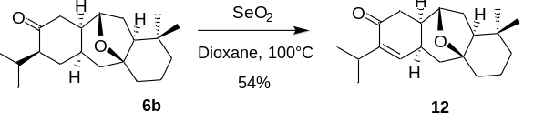
To a solution of 6b (22 mg, 0.07 mmol) in dioxane (1 mL, 0.07 M) was added SeO₂ (16mg, 0.14mmol), and the mixture was stirred at 100°C with oil bath in a sealed tube for 5.5 h. The reaction mixture was cooled to room temperature, followed by filtering, and concentrating. The residue was purified by using flash column chromatography on silica gel (PE/EA, 20:1) to give the product 12 (12 mg, 54%) as white solid.
¹H NMR (400 MHz, CDCl₃) δ 6.45 (d, J = 5.6 Hz, 1H), 4.06 (d, J = 8.0 Hz, 1H), 2.92 – 2.80 (m, 1H), 2.80 – 2.65 (m, 2H), 2.29 (dd, J = 16.4, 4.3 Hz, 1H), 2.06 (m, 1H), 2.00 – 1.91 (m, 1H), 1.90 – 1.77 (m, 2H), 1.74 – 1.62 (m, 2H), 1.54 – 1.40 (m, 4H), 1.34 (t, J = 13.0 Hz, 1H), 1.12 (dm, 1H), 0.99 (dd, J = 12.1, 6.9 Hz, 6H), 0.89 (d, J = 5.5 Hz, 6H).
¹³C NMR (126 MHz, CDCl₃) δ 200.0, 144.7, 143.7, 80.4, 76.9, 49.3, 41.3, 38.5, 38.2, 37.6, 33.0, 32.4, 31.7, 31.6, 29.3, 26.4, 24.7, 22.3, 22.0, 17.4.
HRMS (ESI) m/z: [M + H]⁺ Calcd for C₂₀H₃₁O₂ 303.2319; Found 303.2315.

Synthesis of compound(13)
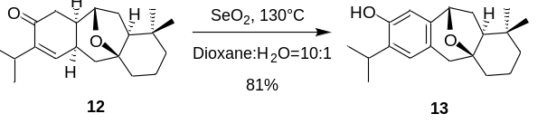
To a solution of 12 (12 mg, 0.04 mmol) in dioxane and H₂O (1 mL, 10:1) was added SeO₂ (9mg, 0.08mmol), and the mixture was stirred at 130°C with oil bath in a sealed tube for 6 h. The reaction mixture was cooled to room temperature, followed by filtering, and concentrating. The residue was purified by using flash column chromatography on silica gel (PE/EA, 10:1) to give the product 13 (9.7 mg, 81%) as white solid.
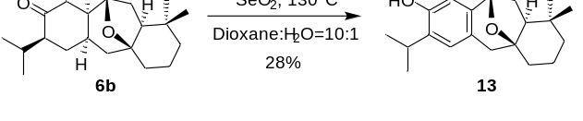
Or: To a solution of 6b (43 mg, 0.14 mmol) in dioxane (3.5 mL, 0.04M) was added SeO₂ (78mg, 0.70mmol), and the mixture was stirred at 130°C with oil bath in a sealed tube for 6.5 h. The reaction mixture was cooled to room temperature, followed by filtering, and concentrating. The residue was purified by using flash column chromatography on silica gel (PE/EA, 10:1) to give the product 13 (12.0 mg, 28%) as white solid.
¹H NMR (500 MHz, CDCl₃) δ 6.85 (s, 1H), 6.39 (s, 1H), 4.97 – 4.82 (m, 1H), 4.79 (d, J = 6.7 Hz, 1H), 3.15 (p, J = 6.9 Hz, 1H), 2.88 (d, J = 16.1 Hz, 1H), 2.45 (d, J = 16.1 Hz, 1H), 2.14 – 2.04 (m, 1H), 2.03 – 1.94 (m, 1H), 1.90 (dd, J = 12.1, 8.4 Hz, 1H), 1.85 – 1.72 (m, 3H), 1.67 – 1.61 (m, 1H), 1.57 (d, J = 7.4 Hz, 1H), 1.51 (m, 1H), 1.22 (dd, J = 13.9, 6.9 Hz, 6H), 0.96 (s, 3H), 0.83 (s, 3H).
¹³C NMR (126 MHz, CDCl₃) δ 150.6, 139.9, 133.1, 127.0, 124.8, 110.7, 81.0, 75.9, 50.8, 43.7, 39.8, 32.2, 32.0, 30.7, 30.6, 27.0, 27.0, 22.9, 22.7, 16.3.
HRMS (ESI) m/z: [M - H]⁻ Calcd for C₂₀H₂₇O₂ 299.2017; Found 299.2022.

Synthesis of compound(14)
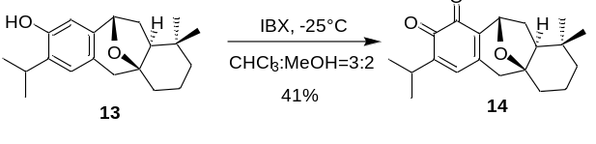
To a solution of 13 (12 mg, 0.04 mmol) in CHCl₃/MeOH (2 mL, 3:2) was added IBX (28mg, 0.10mmol) at -25°C. After the mixture was stirred at -25°C for about 24 h, the reaction mixture was quenched with saturated aqueous Na2SO3 solution (1 mL) and saturated aqueous NaHCO₃ solution (1 mL). The resultant mixture was extracted with EtOAc (2 × 5 mL). The combined organic layers were washed with brine (4 mL), and dried over Na2SO4, filtered, and concentrated. The residue was purified by using flash chromatography (PE/EA, 10:1) to give product 14 (5.1 mg, 41%) as a dark yellow oil.
¹H NMR (400 MHz, CDCl₃) δ 6.36 (s, 1H), 4.98 (d, J = 6.6 Hz, 1H), 3.00 – 2.87 (m, 1H), 2.60 (d, J = 19.8 Hz, 1H), 2.13 (d, J = 19.7 Hz, 1H), 2.08 – 1.99 (m, 1H), 1.99 – 1.90 (m, 2H), 1.83 – 1.73 (m, 3H), 1.53 – 1.45 (m, 2H), 1.18 – 1.14 (m, 1H), 1.09 (dd, J = 6.9, 3.2 Hz, 6H), 0.98 (s, 3H), 0.83 (s, 3H).
¹³C NMR (126 MHz, CDCl₃) δ 180.9, 177.1, 147.8, 146.4, 138.8, 134.4, 80.1, 69.8, 51.8, 46.0, 38.8, 32.1, 31.4, 30.6, 29.8, 27.3, 27.1, 21.7, 21.6, 15.9.
HRMS (ESI) m/z: [M - H]⁻ Calcd for C₂₀H₂₅O₃ 313.1809; Found 313.1801.

Synthesis of compound(15)
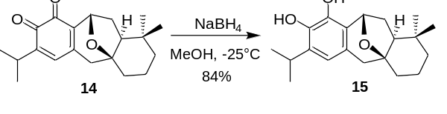

Compound 14 (5 mg, 0.016 mmol)was dissolved in MeOH (1 mL) and cooled to -25°C. A solution of NaBH₄ (3.0 mg) in MeOH (0.5 mL) was added dropwise. After the mixture was stirred at -25°C for about 5 min, the reaction mixture was quenched with saturated aqueous NH₄Cl solution (1 mL) and diluted with EtOAc (10 mL). The resultant mixture was washed with water (2 mL) and brine (2 mL). The combined organic layers were dried over Na2SO4, filtered, and concentrated. The residue was purified by using flash chromatography (PE/EA, 3:1) to give product 15 (4.2 mg, 84%) as a yellow oil.
¹H NMR (500 MHz, CDCl₃) δ 6.45 (s, 1H), 5.29(s, 1H), 5.24 (d, J = 6.5 Hz, 1H), 4.83(s, 1H), 3.04 (p, J = 6.9 Hz, 1H), 2.88 (d, J = 16.2 Hz, 1H), 2.43 (d, J = 16.2 Hz, 1H), 2.09 (m, 1H), 1.95 (dd, J = 12.8, 7.4 Hz, 2H), 1.81 (q, J = 7.7 Hz, 3H), 1.55 – 1.49 (m, 2H), 1.24 – 1.20 (m, 6H), 1.15 (d, J = 12.3 Hz, 1H), 0.97 (s, 3H), 0.83 (s, 3H).
¹³C NMR (126 MHz, CDCl₃) δ 138.9, 138.3, 133.1, 126.1, 125.8, 117.8, 80.5, 70.9, 50.6, 43.8, 39.0, 32.0, 31.4, 30.7, 30.2, 29.8, 27.4, 23.0, 22.7, 16.1.
HRMS (ESI) m/z: [M - 2H]²⁻ Calcd for C₂₀H₂₆O₃ 314.1893; Found 314.1887.

II References
[1] Xu, B.; Wang, B.-Y.; Xun, W.; Qiu, F. G. Angew. Chem. Int. Ed. 2019, 58, 5754-5757.
[2] Jia, Z.; Hu, X.; Zhao, Y.; Qiu, F. G.; Chan, A. S. C.; Zhao, J. Org. Lett. 2019, 21, 9584-9588.
[3] Jiao, Z.-W.; Tu, Y.-Q.; Zhang, Q.; Liu, W.-X.; Zhang, S.-Y.; Wang, S.-H.; Zhang, F.-M.; Jiang, S. Nat. Commun. 2015, 6, 7332-7338.
[4] Ahmad, A.; Burtoloso, A. C. B. Org. Lett. 2019, 21, 6079-6083.

III ¹H and ¹³C NMR Spectra of Compounds
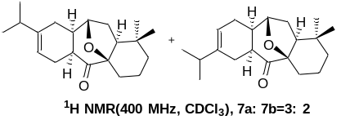
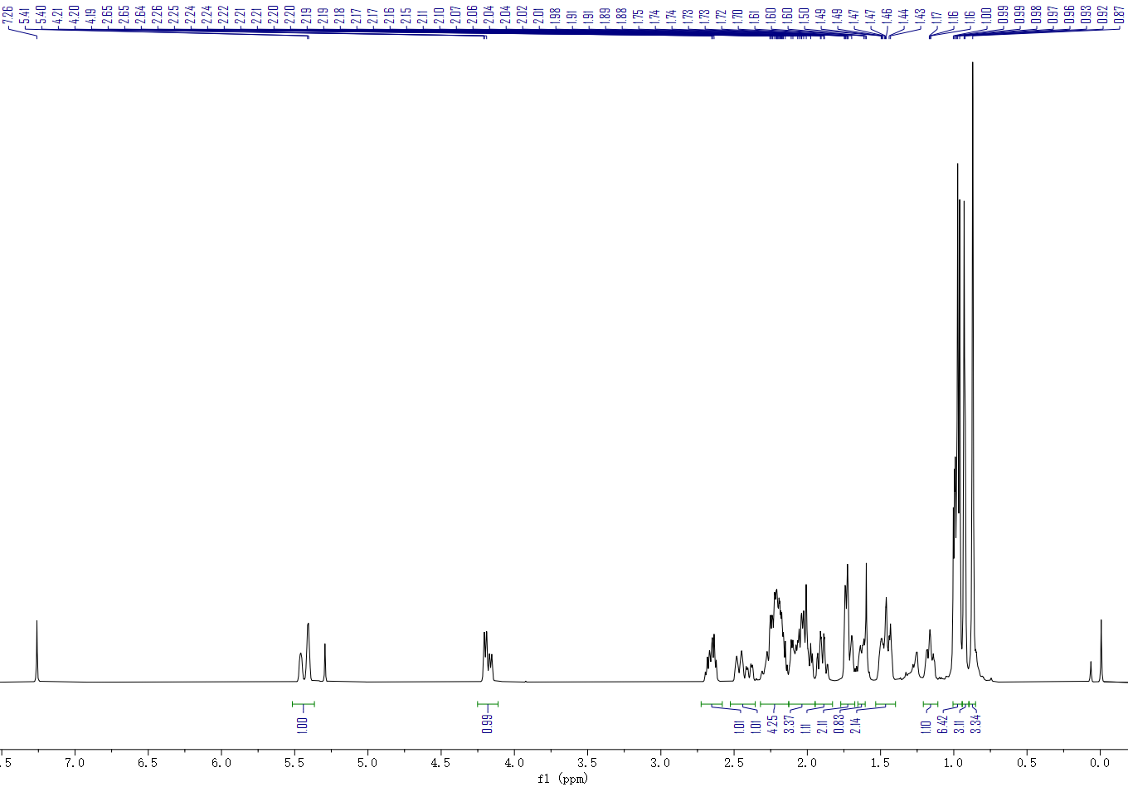

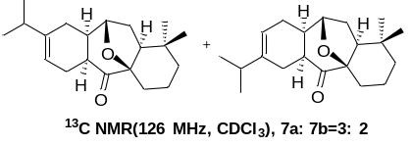
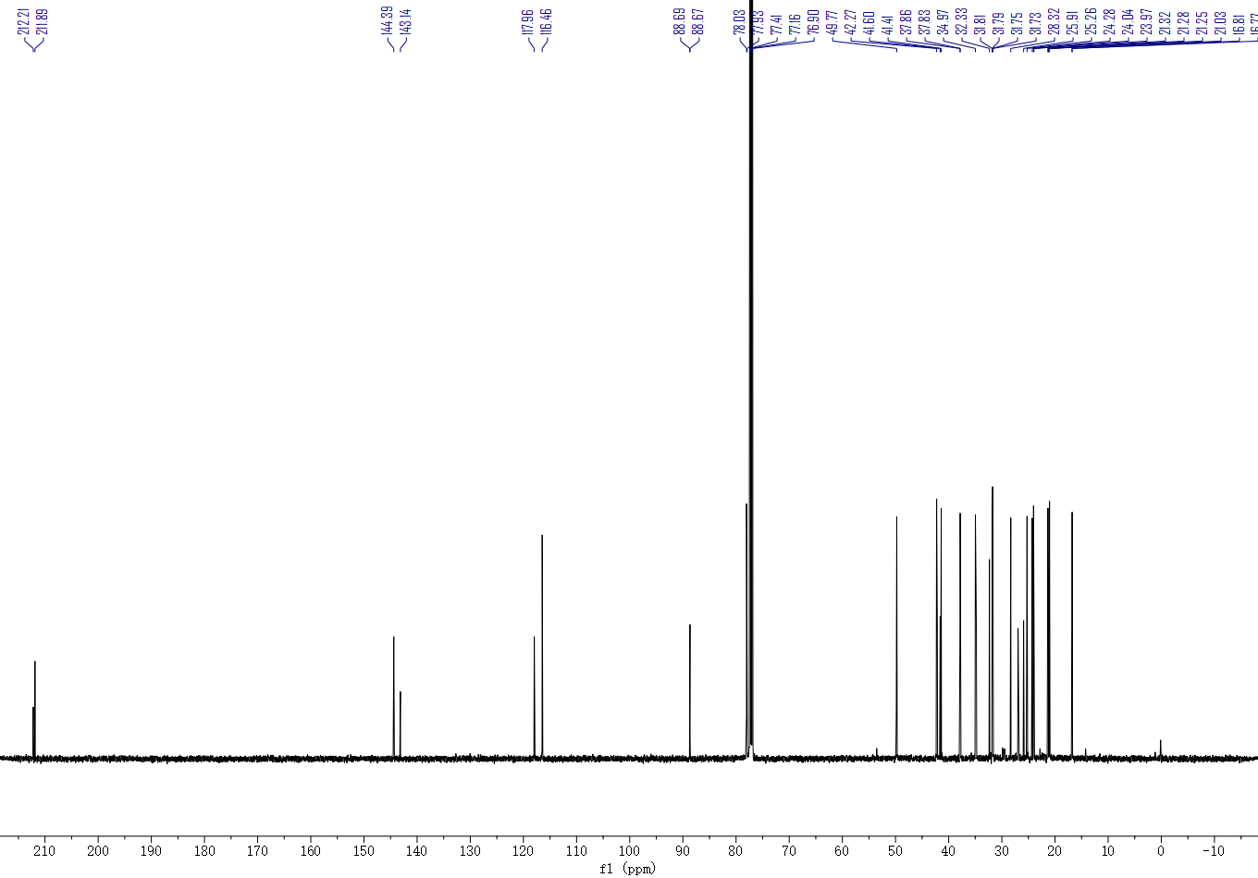
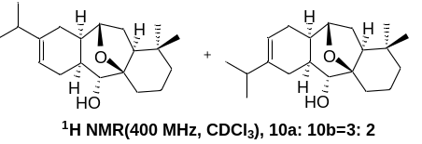
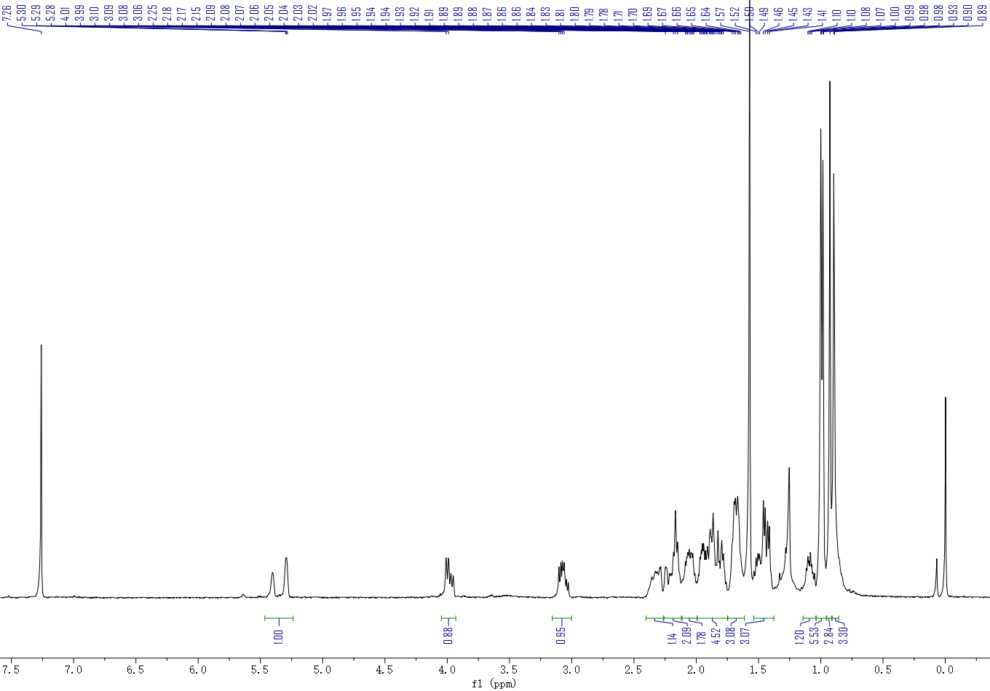

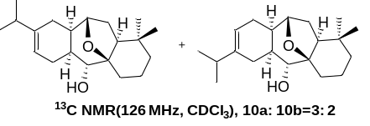
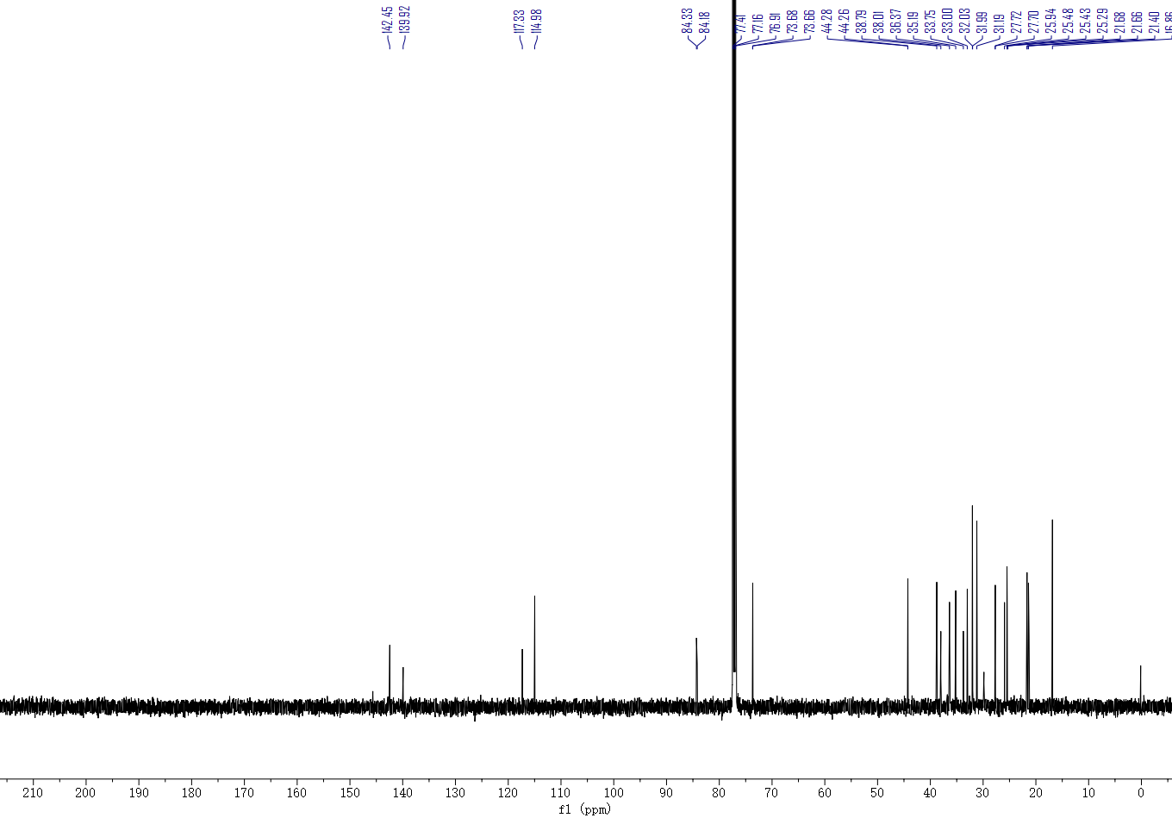
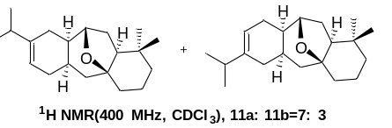
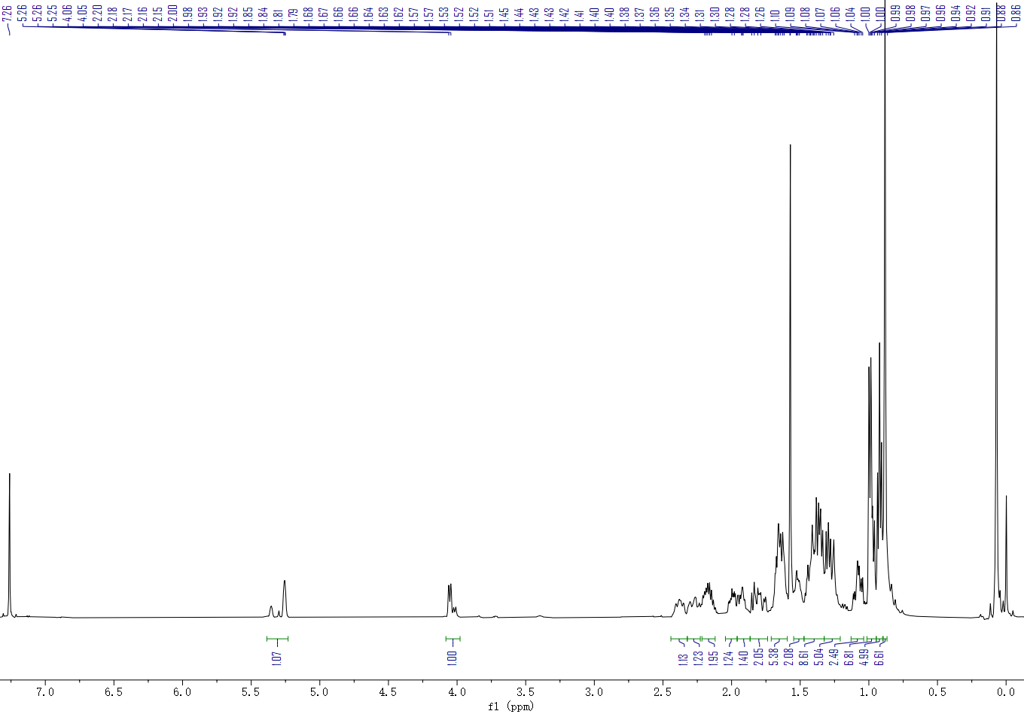

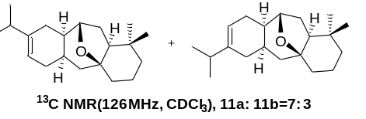
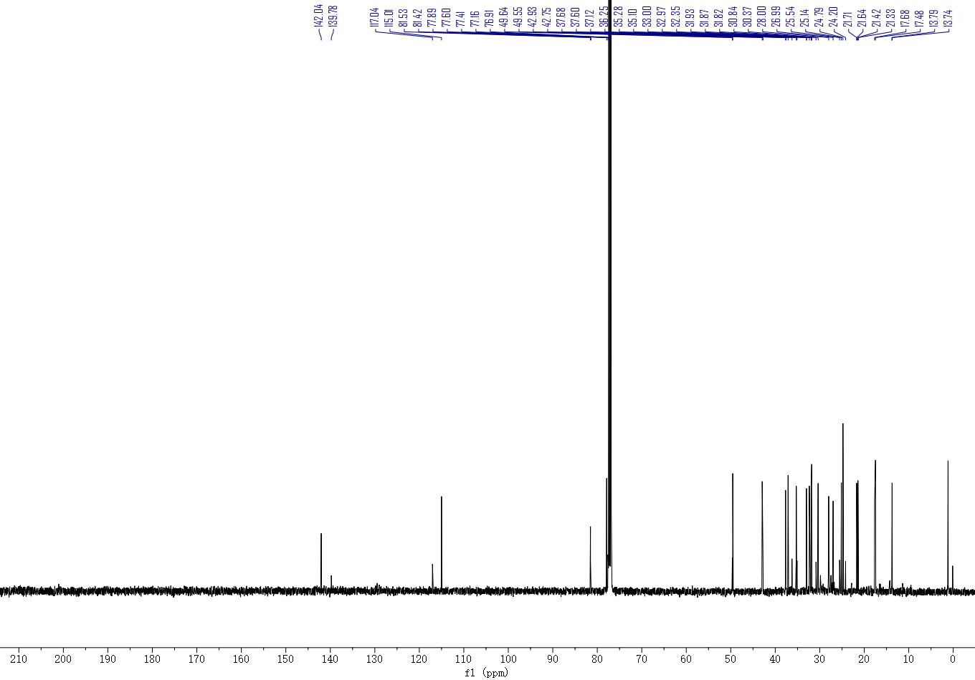
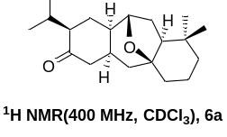
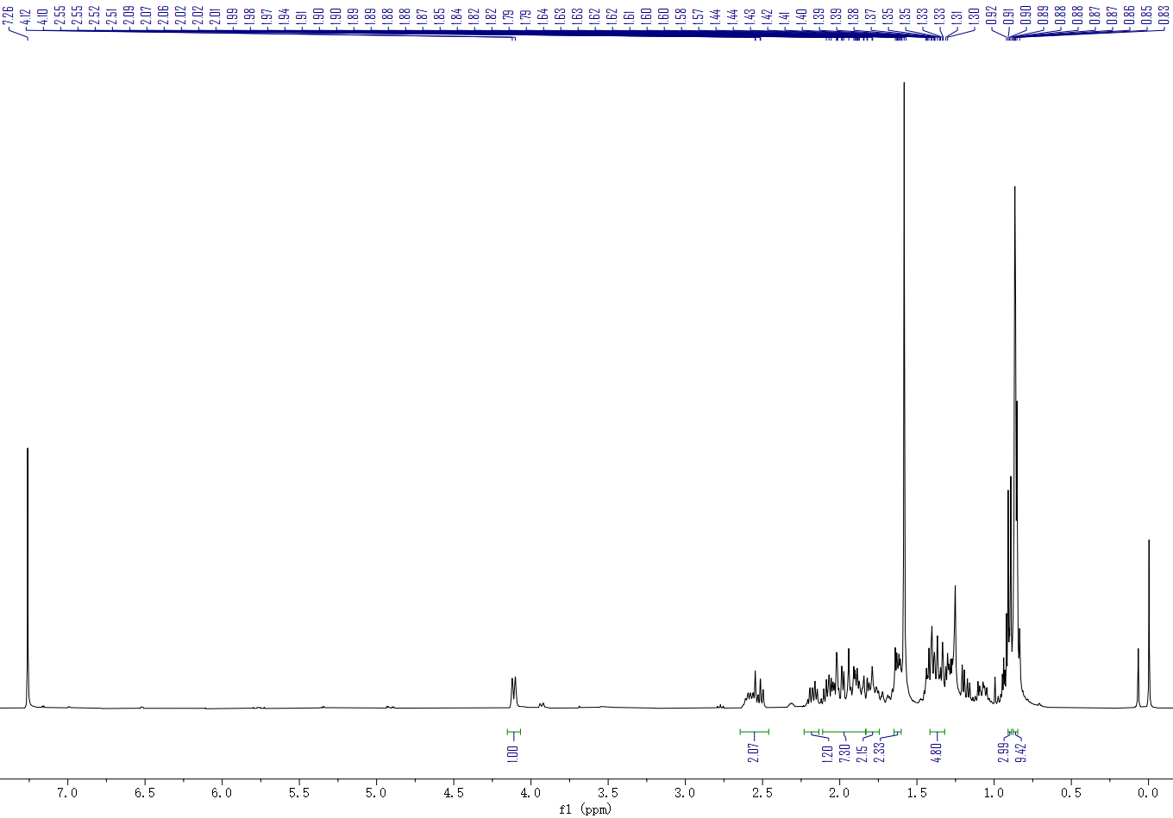

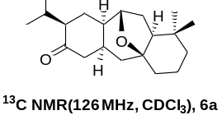
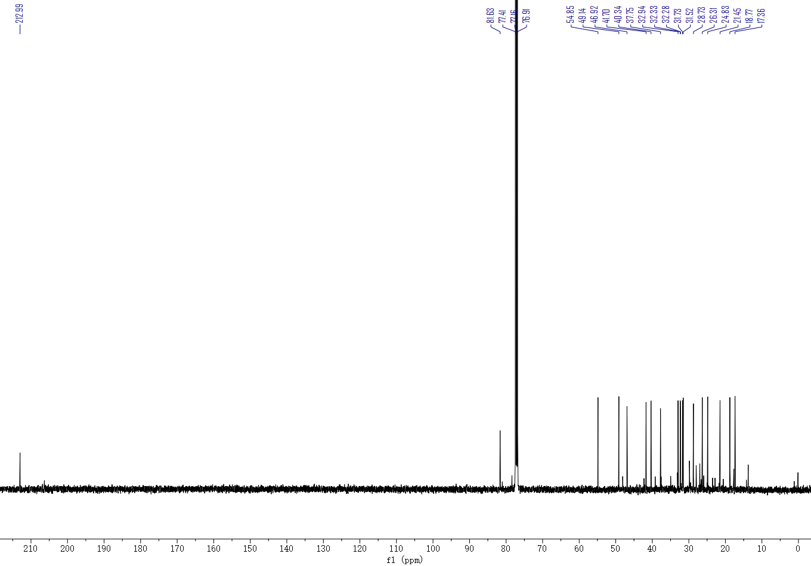
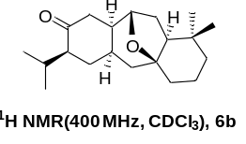
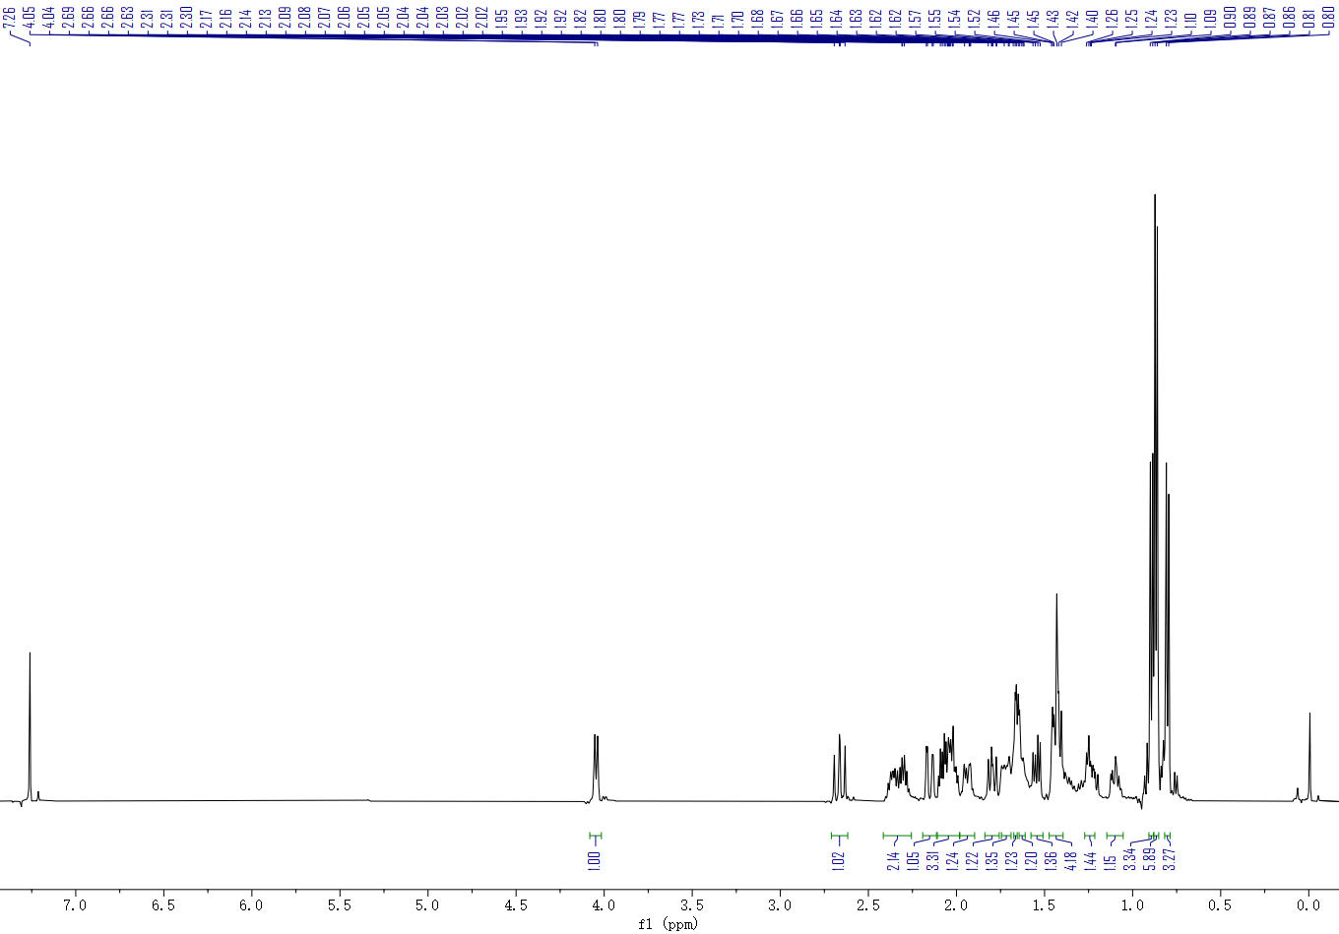

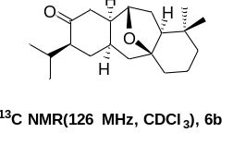
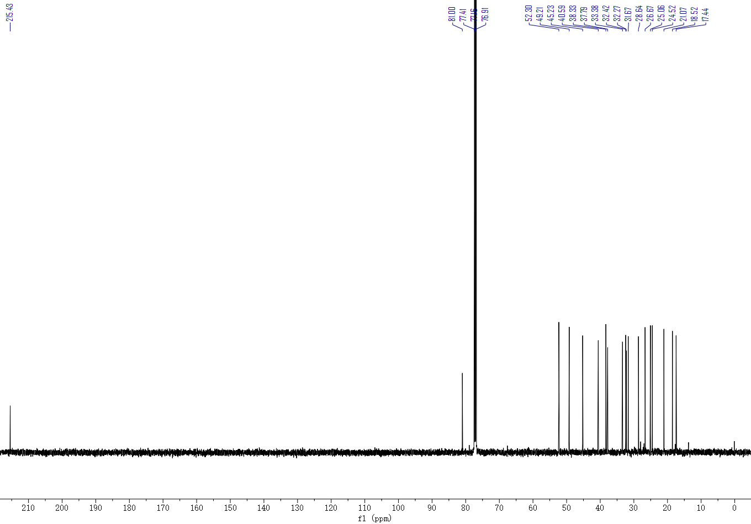
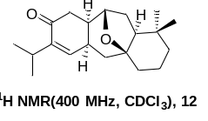
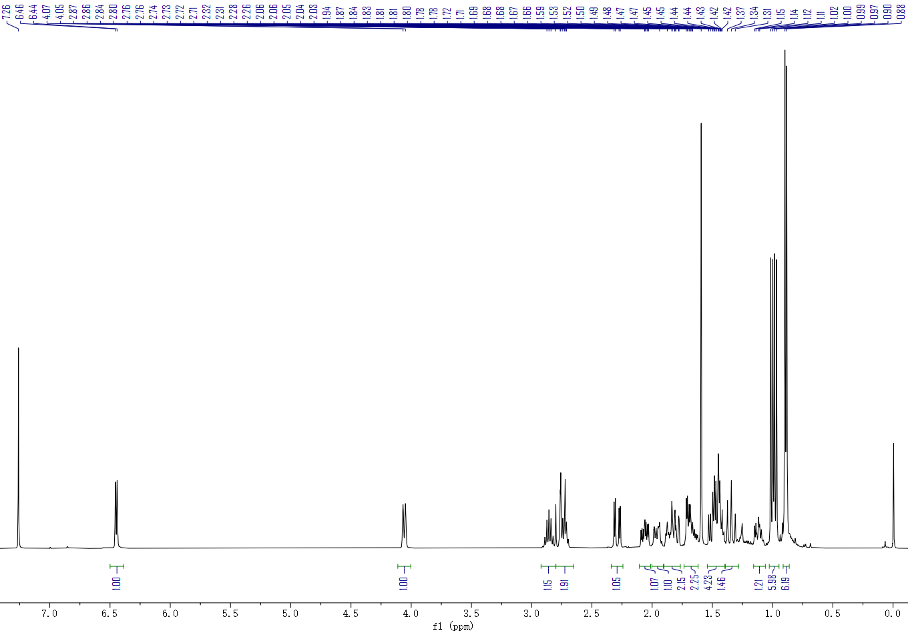

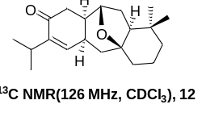
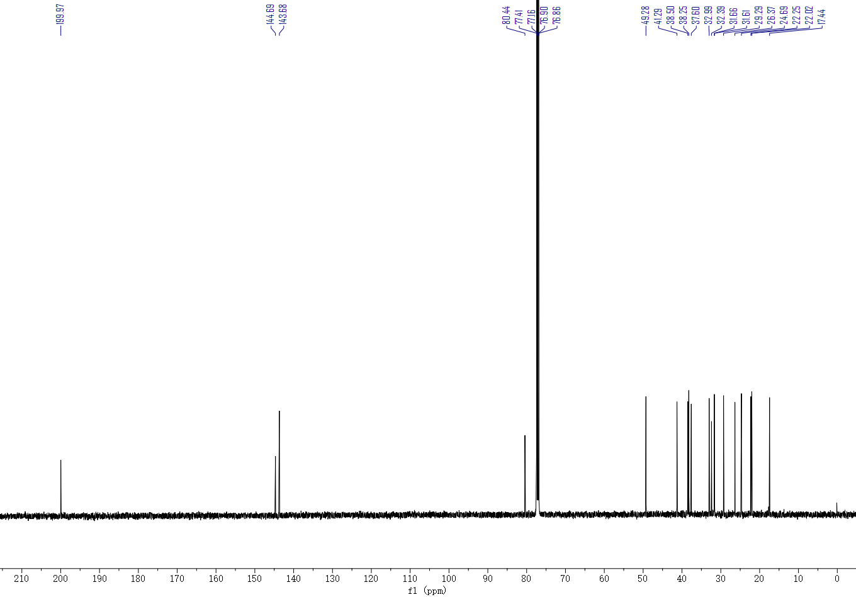
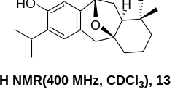
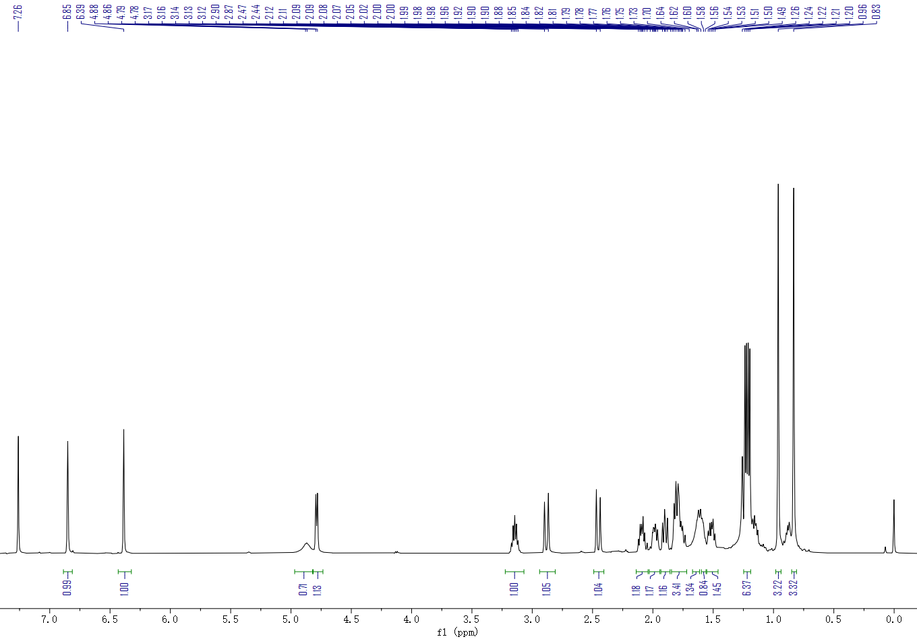

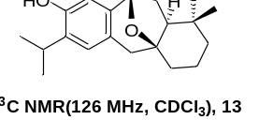
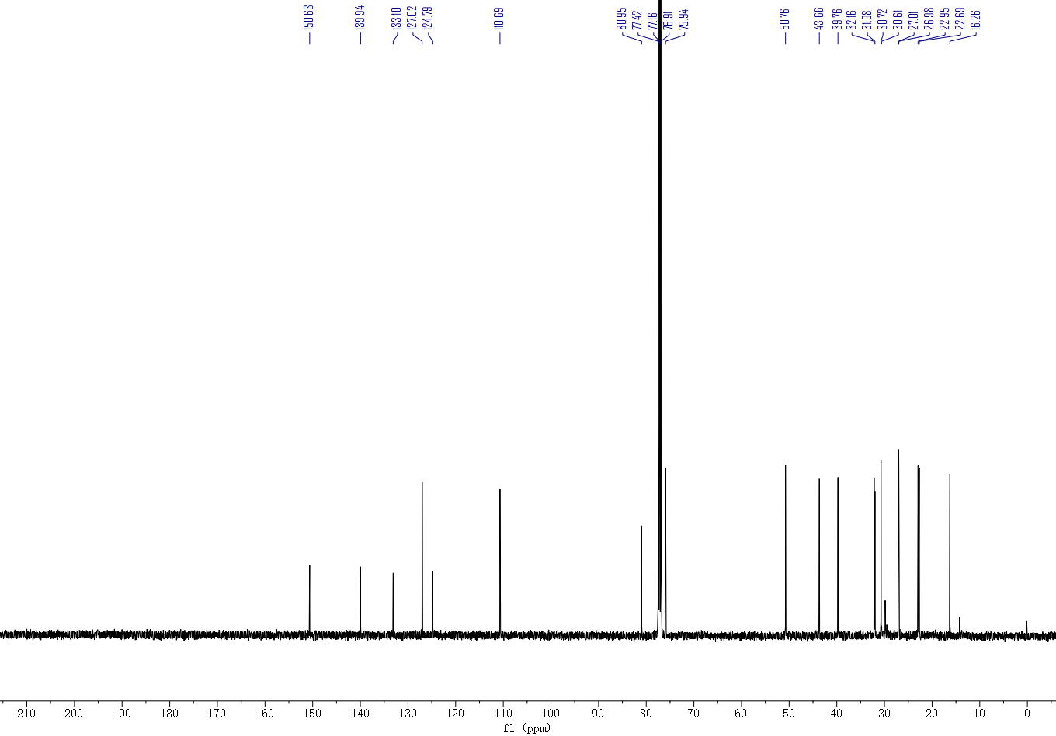
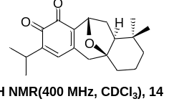
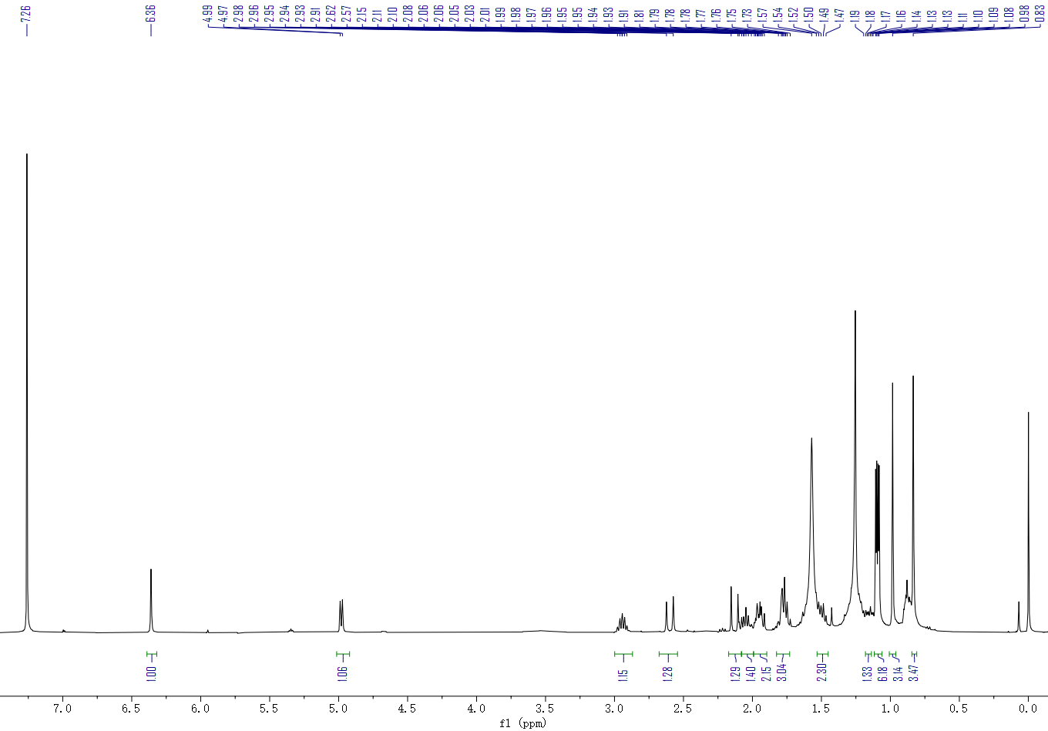

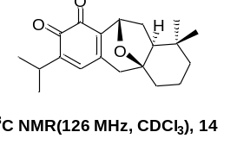
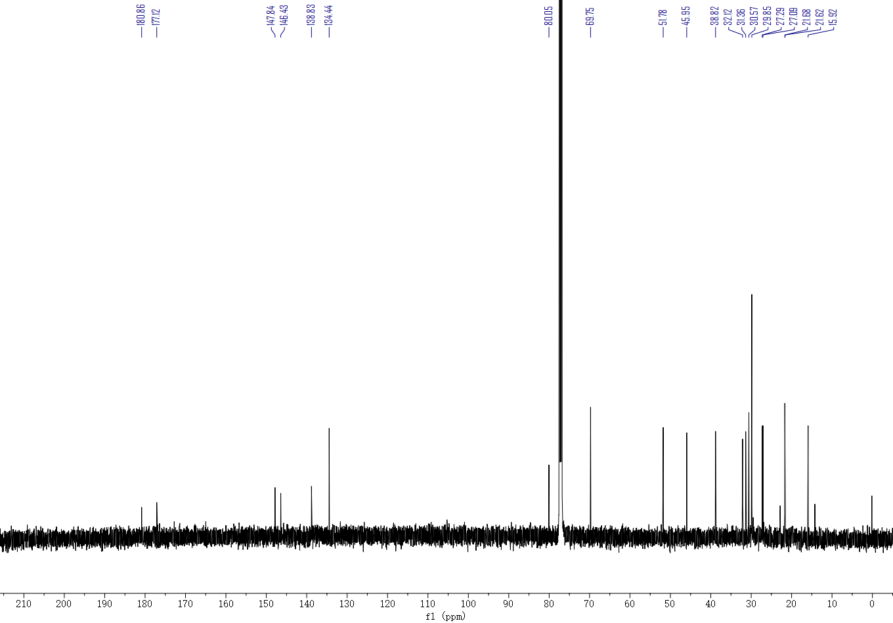
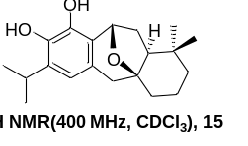
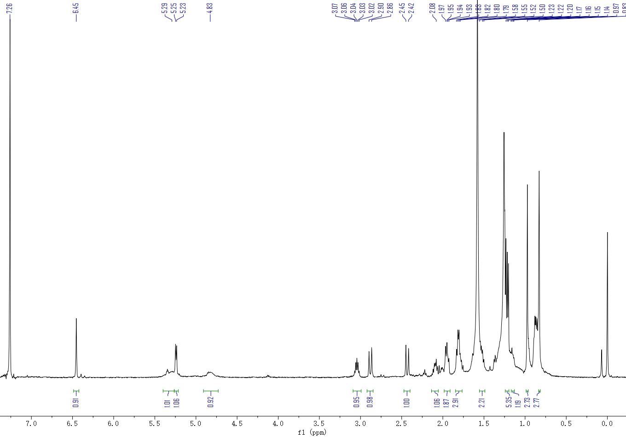

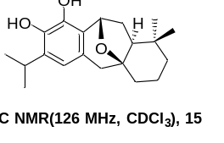
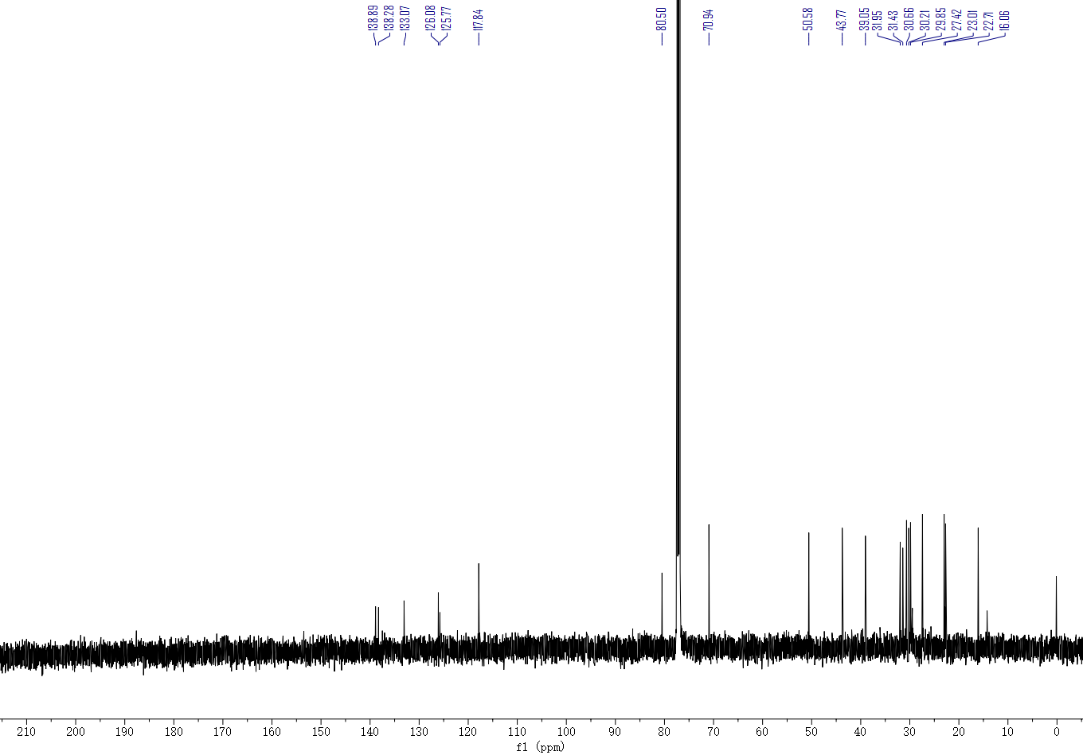

X-Ray Crystallographic Data

Phenol 13
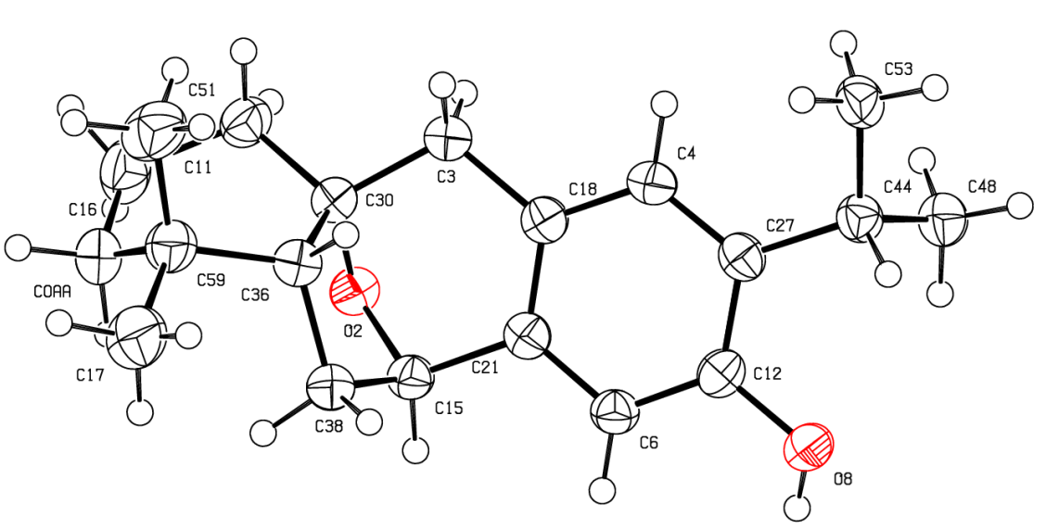
CCDC | 2041445
Empirical formula | C₂₀H₂₈O₂
Formula weight | 300.42
Temperature/K | 150.0
Crystal system | orthorhombic
Space group | P2₁ 2₁ 2₁
Hall group | P2ac2ab
Bond precision | C-C = 0.0032 A
Wavelength | 0.71073
a/Å | 6.9621(3)
b/Å | 11.6172(7)
c/Å | 21.0398(12)
α/° | 90
β/° | 90
γ/° | 90
Volume/ Å³ | 1701.70(16)
Z | 4
Dx, g/cm³ | 1.173
Mu/mm⁻¹ | 0.073
F(000) | 656.0
h, k, l_{max} | 8, 14, 26
Nref | 3481
T_{min}, T_{max} | 0.012, 0.028
Data completeness | 1.72/1.00
Theta(max) | 26.377
R(reflections) | 0.0383(3012)
wR2(reflections) | 0.0991(3481)
S | 1.024
Npar | 204

