Supplementary Figures

Activation of EGFR signaling by Tc-Vein and Tc-Spitz regulates the metamorphic transition in the red flour beetle Tribolium castaneum

Sílvia Chafino, David Martín* and Xavier Franch-Marro*

Institute of Evolutionary Biology (IBE, CSIC-Universitat Pompeu Fabra), Passeig de la Barceloneta 37, 08003 Barcelona, Catalonia, Spain.

* Authors for correspondence: xavier.franch@ibe.upf-csic.es and david.martin@ibe.upf-csic.es

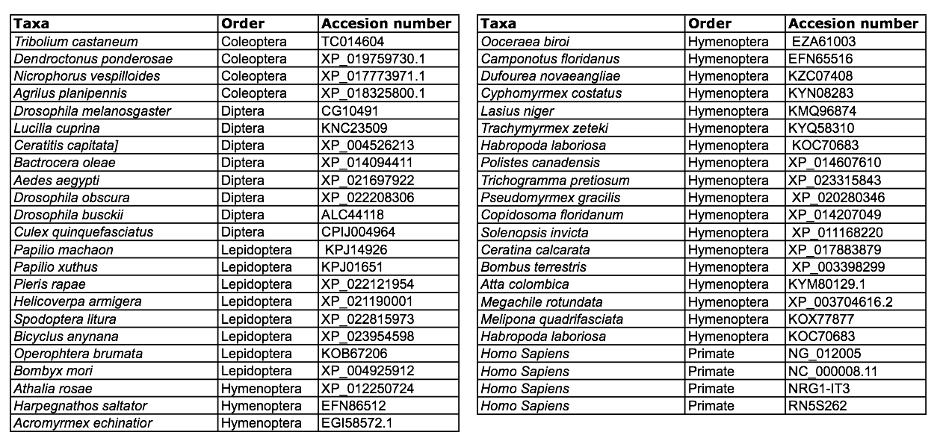

Supplementary Table 1. Accession numbers of Vein sequences used for alignments.

Supplementary Figure 1. Amino acid sequence of Tribolium Tc-Vn. The signal peptide is underlined. The Ig-like domain is shown in bold blue and the Egfr-like domain is represented in bold green. The PEST region is marked in bold black between conserved protein domains. The highly-conserved cysteines are represented in bold red.

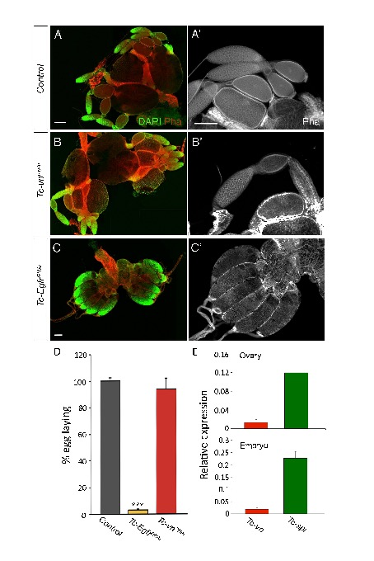Supplementary Figure 4. Roles of Tc-Egfr and Tc-Vn in oogenesis of Tribolium. Comparison of ovaries from females treated with (A-A’) dsMock (control), (B-B’) dsTc-Egfr (dsTc-Egfr^{RNAi}) and (C-C’) dsTc-vn (dsTc-vn^{RNAi}). The ovaries are stained with Phalloidin (in red) and DAPI (in green) to visualize the structure of the tissue and the nuclei of the cells respectively. Scale bar represents 150 μm. (G) Percentage of egg laying in Tc-Egfr^{RNAi} and Tc-vn^{RNAi} female adults compared with Control. Error bars indicate the SEM (n=3). (E) Tc-vn and Tc-spi mRNA levels measured by qRT-PCR in ovary and embryo. Transcript abundance values are normalized against the Tc-Rpl32 transcript.

