Supplemental Figures
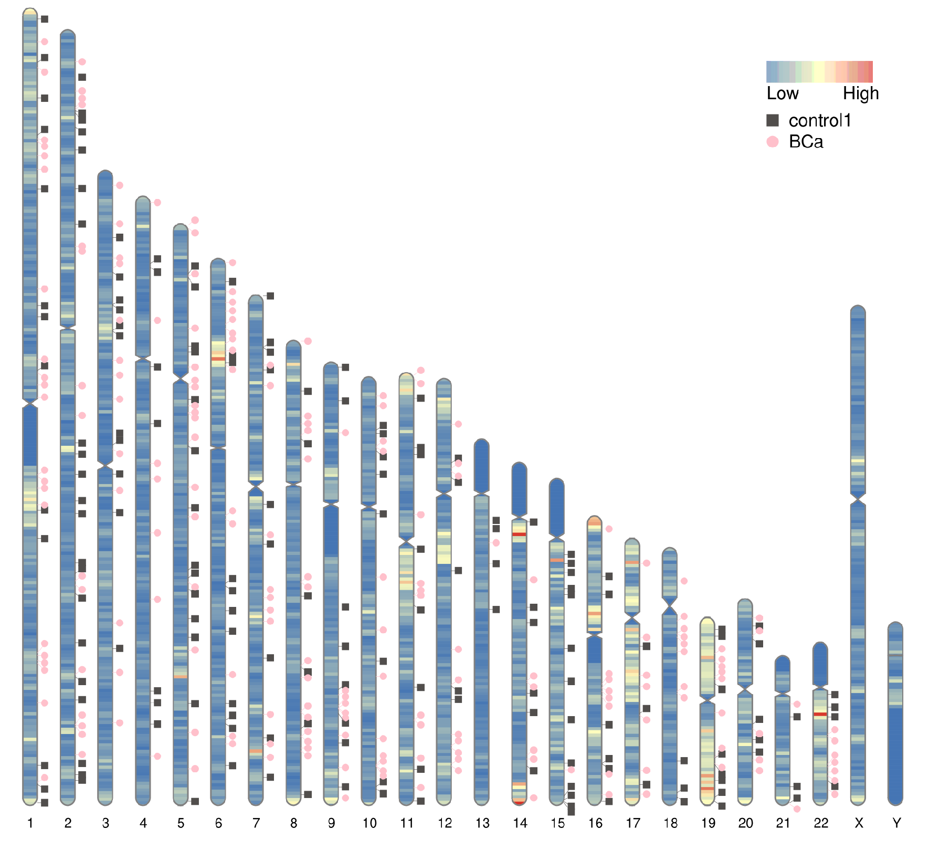
Supplemental Figure 1: Idiogram of BCa and control 1. Chromosome mapping represents gene density. The remaining nine controls are not shown.

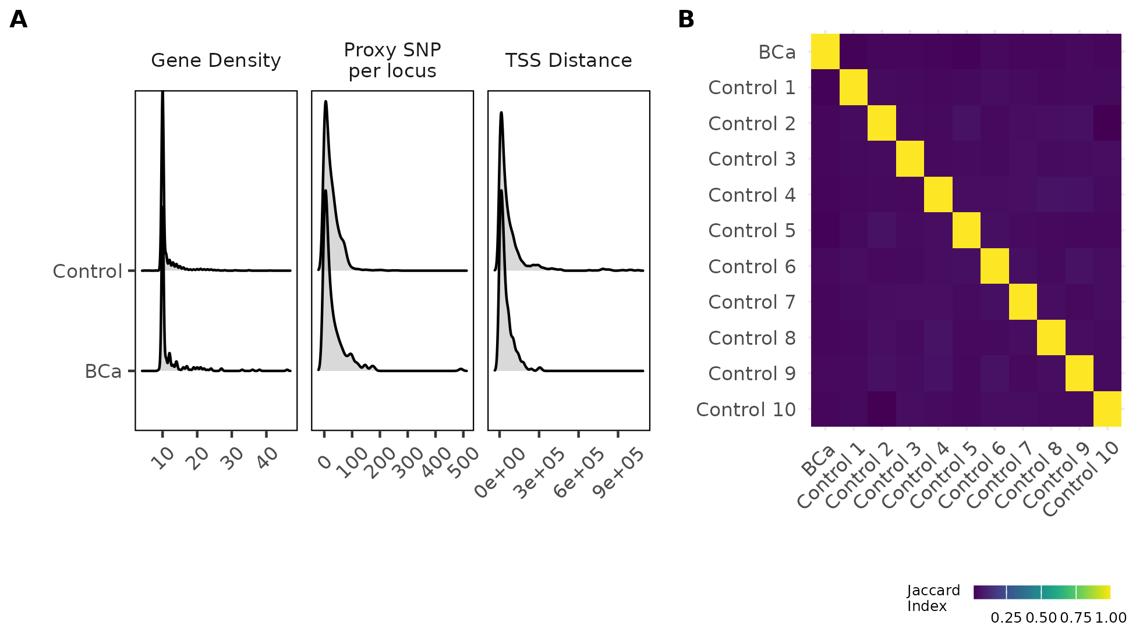
Supplemental Figure 2: Curation of control set. (A) Distribution of gene density, proxy SNP per locus, and distance from transcription start site for BCa and control SNPs. (B) Jaccard index heatmap comparing candidate gene sets in BCa and all control sets.

