Supplementary Information

Machine learning and high-throughput computational guided development of high temperature oxidation-resisting Ni-Co-Cr-Al-Fe based high-entropy alloys
Xingru Tan¹, William Trehern², Aditya Sundar², Yi Wang^{2,3}, Saro San^{2,3}, Tianwei Lu¹, Fan Zhou⁴, Ting Sun¹, Youyuan Zhang¹, Yuying Wen¹, Zhichao Liu⁴, Michael Gao² and Shanshan Hu^{1*}
¹Mechanical & Aerospace Engineering Department, Benjamin M. Statler College of Engineering and Mineral Resources, West Virginia University, Morgantown, WV 26505, USA
²National Energy Technology Laboratory, 1450 Queen Avenue SW, Albany, OR 97321, USA
³NETL Support Contractor, 1450 Queen Avenue SW, Albany, OR 97321, USA
⁴Industrial & Management Systems Engineering Department, West Virginia University, Morgantown, WV 26505, USA

* Correspondence should be addressed to: Shanshan Hu (shanshan.hu@mail.wvu.edu)

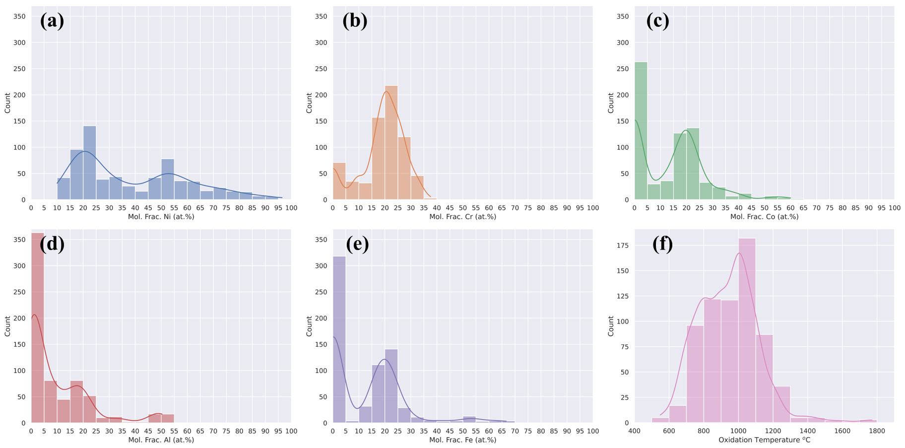
Supplementary Figure 1 Histogram of literature collected dataset with marginal distributions. The frequency distribution of (a) Ni, (b) Cr, (c) Co, (d)Al, (e) Fe, (f) oxidation temperature containing entries count within the dataset used in regression model training and testing.

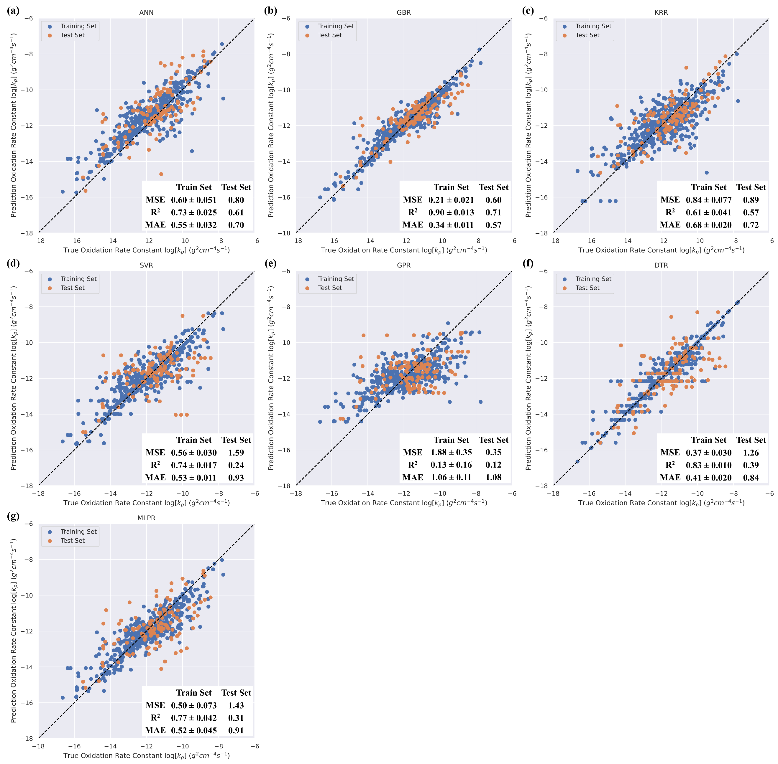
Supplementary Figure 2 Parity plot of the predictive k_{p} value versus the literature reported k_{p} values. Predicted k_{p} values plots against literature reported k_{p} values of 7 machine learning approaches: (a) artiﬁcial neural network (ANN), (b) gradient boosting regression (GBR), (c) kernel ridge regression (KRR), (d) support vector regression (SVR), (e) gaussian process regression (GPR), (f) decision trees regression (DTR) and (g) multilayer perceptron regression (MLPR) machine learning algorithm. Blue and red plots represent train, and test set, respectively. Mean squared error (MSE), coefﬁcient of determination (R²) and mean absolute error (MAE) are computed to estimate the prediction errors. Black dashed line is the ideal fitting line.

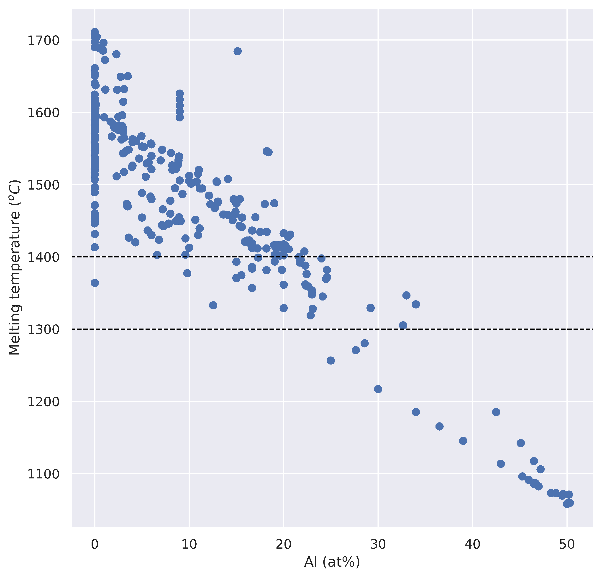
Supplementary Figure 3 Alloy melting temperature vs Al content. The melting temperature of known alloy in ML database vs Al content in the alloys. The melting temperature is approximated by the weight sum of the element melting point.

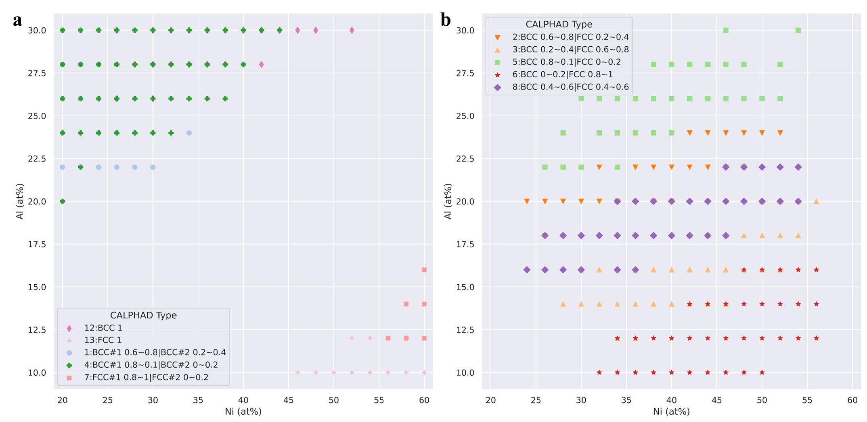
Supplementary Figure 4 Phase diagram type vs Ni and Al content. The phase diagram type of (a) single BCC or FCC (type 1, 4, 7, 12, 13) and (b) dual BCC plus FCC (type 2, 3, 5, 6, 8) within temperature range 1100 °C to 1250 °C plotted against Ni and Al content.

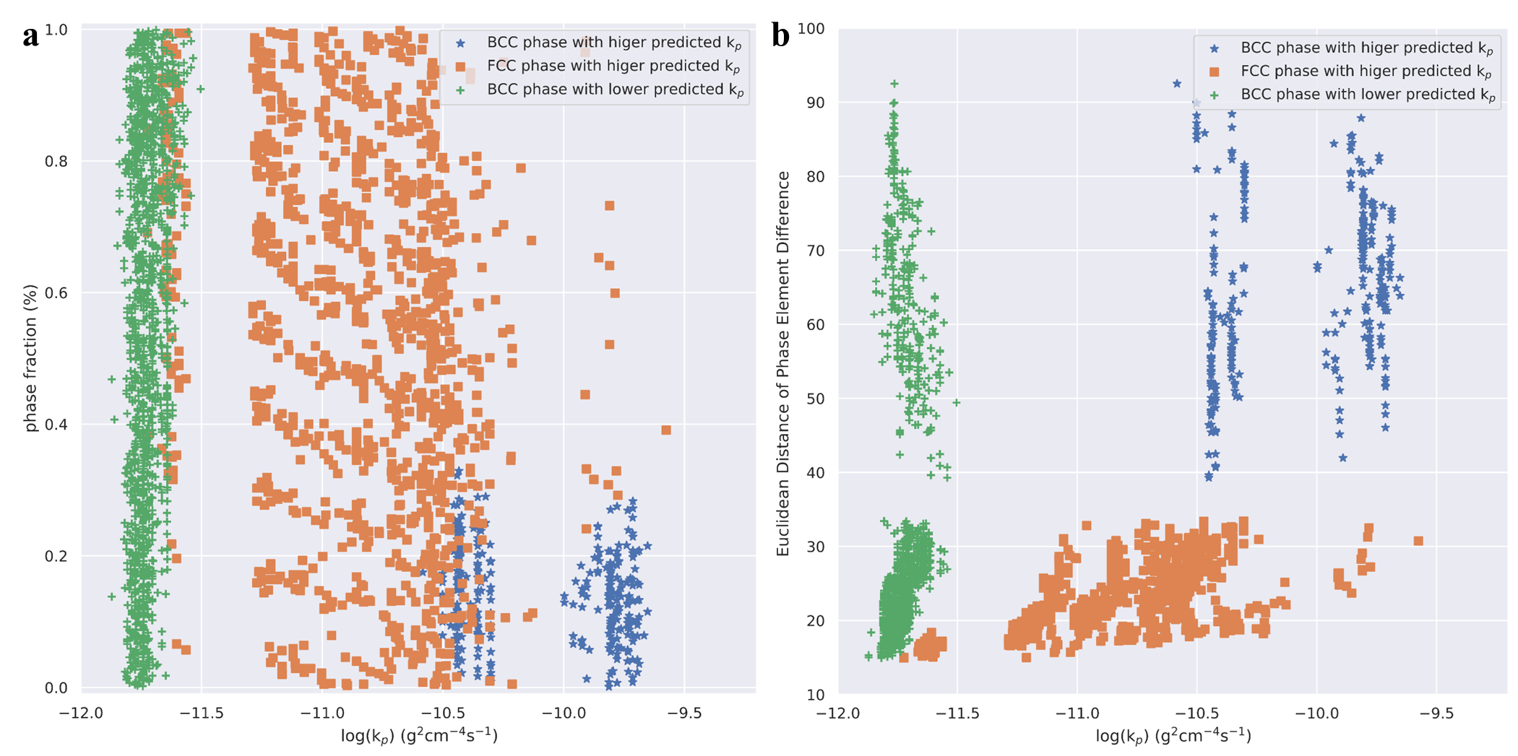
Supplementary Figure 5 Thermodynamic information vs ML predicted k_{p}. Thermodynamic information of (a) the phase fraction and (b) Euclidean Distance of phase element difference in the dual-phase alloys vs ML predicted k_{p} at 1150 °C. + stands for the phase with lower predicted k_{p} in each dual phase alloys which are all BCC structure. and ■ stand for the phase with higher predicted k_{p} in each dual phase alloys with BCC and FCC structure, respectively.

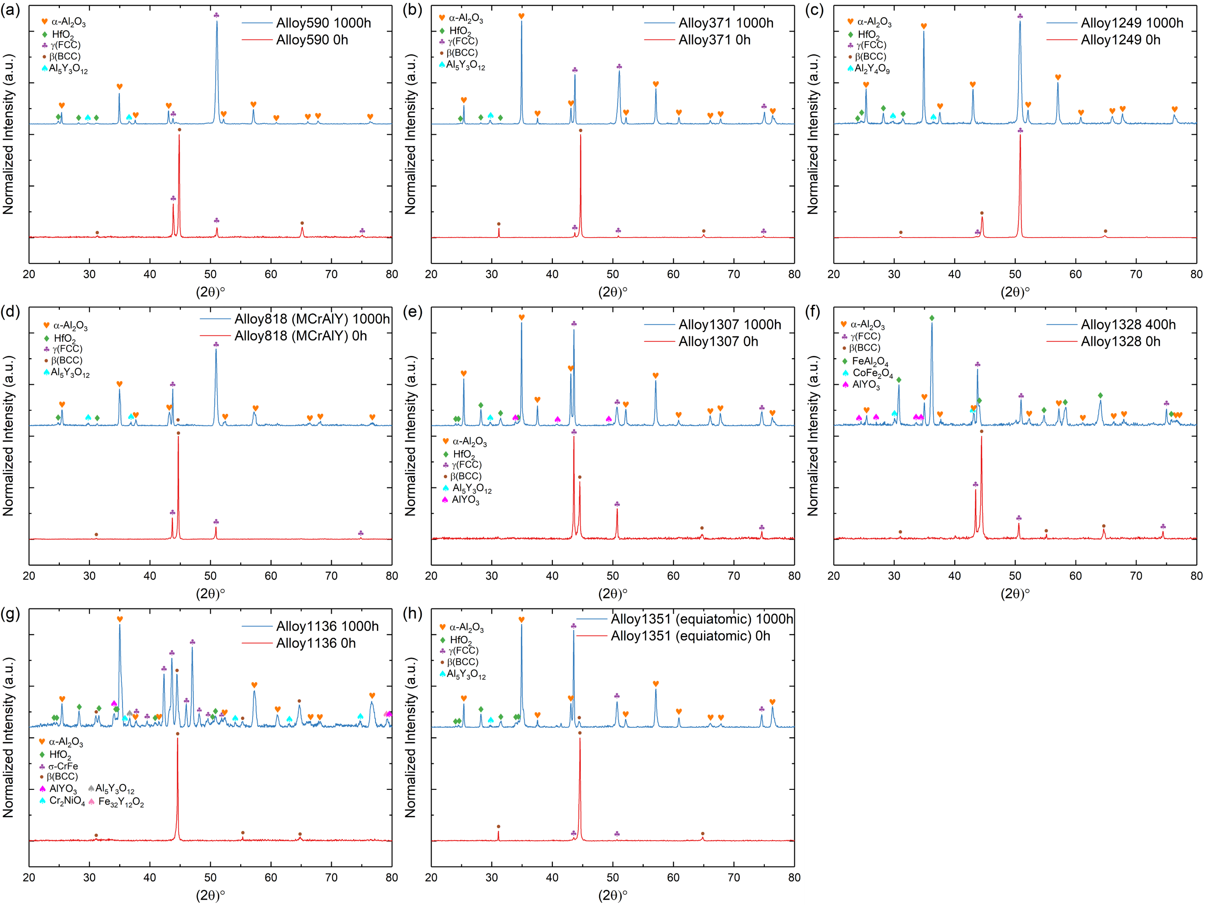
Supplementary Figure 6 XRD result of experimental validation alloy. XRD pattern of alloy (a) 590, (b) 371, (c) 1249, (d) 818, (e) 1307, (f) 1328, (g) 1136 and (h) 1351 before and after oxidation at 1150 °C under ambient air for 1000h and 400 hours (alloy 1328).
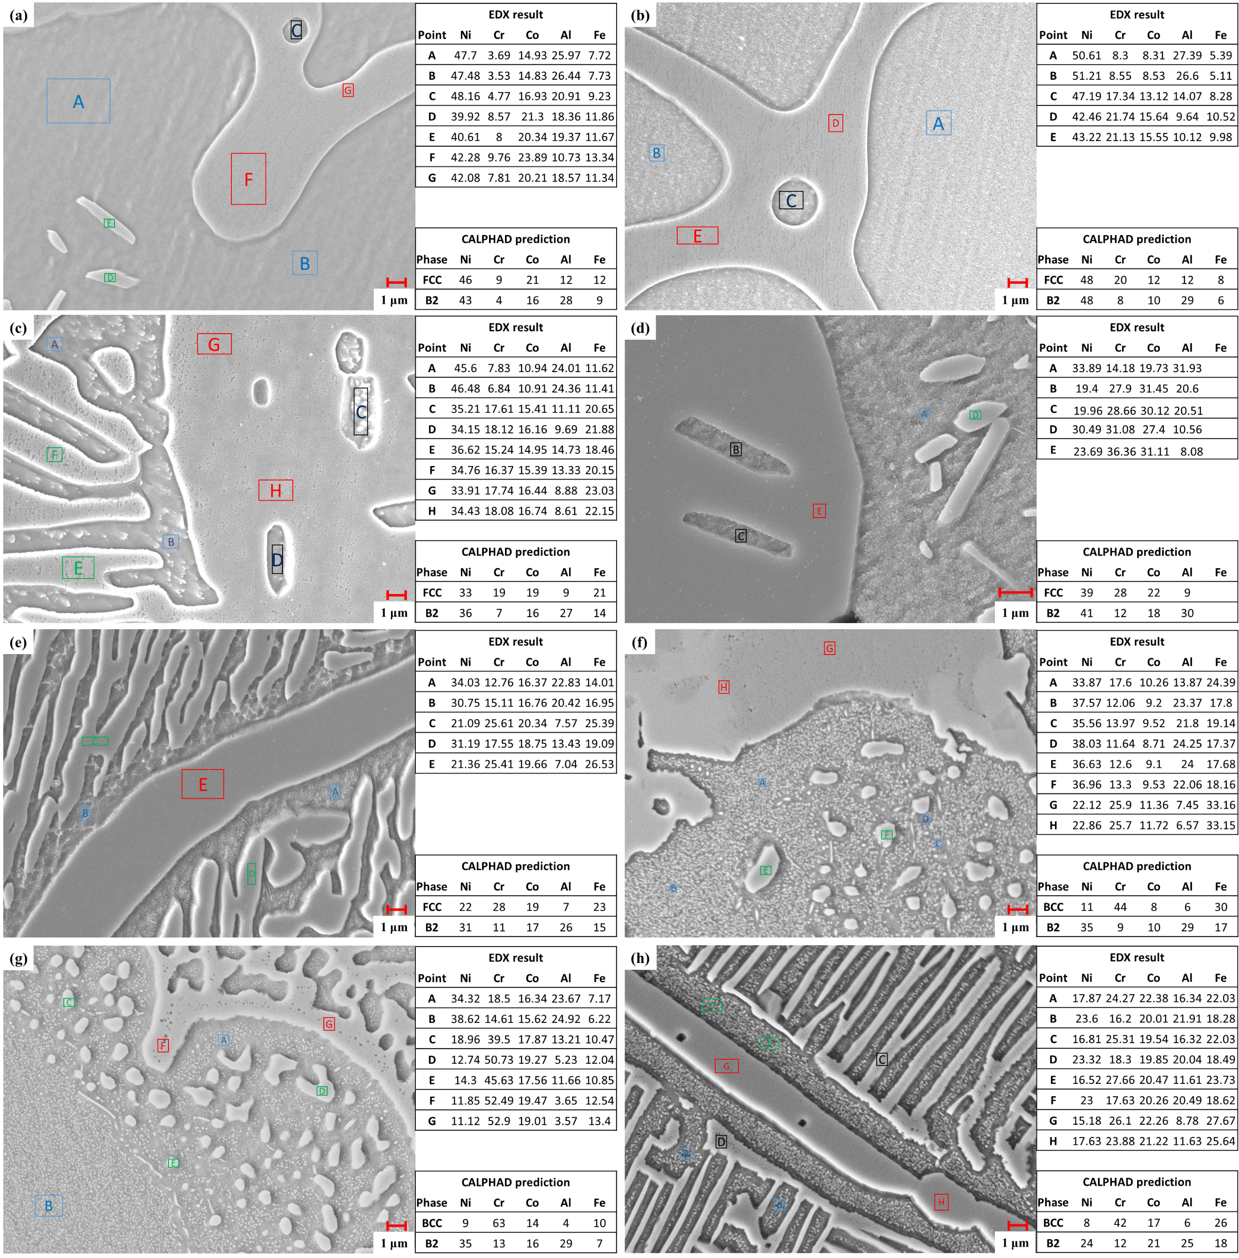
Supplementary Figure 7 SEM and elemental analysis of phase in experimental validation alloy. SEM and EDX elemental analysis of phases in alloy (a) 590, (b) 371, (c) 1249, (d) 818, (e) 1307, (f) 1328, (g) 1136 and (h) 1351.

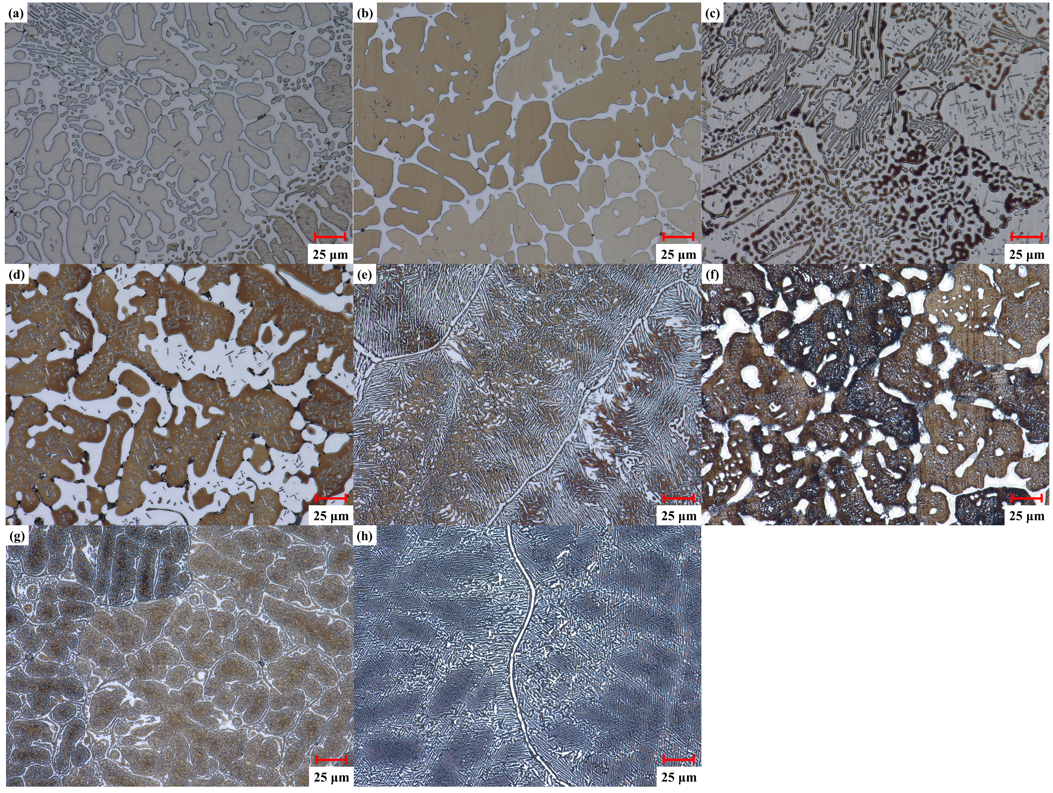
Supplementary Figure 8 Microstucture result of experimental validation alloy. XRD pattern of alloy (a) 590, (b) 371, (c) 1249, (d) 818, (e) 1307, (f) 1328, (g) 1136 and (h) 1351 before and after oxidation at 1150 °C under ambient air for 1000h and 400 hours (alloy 1328).

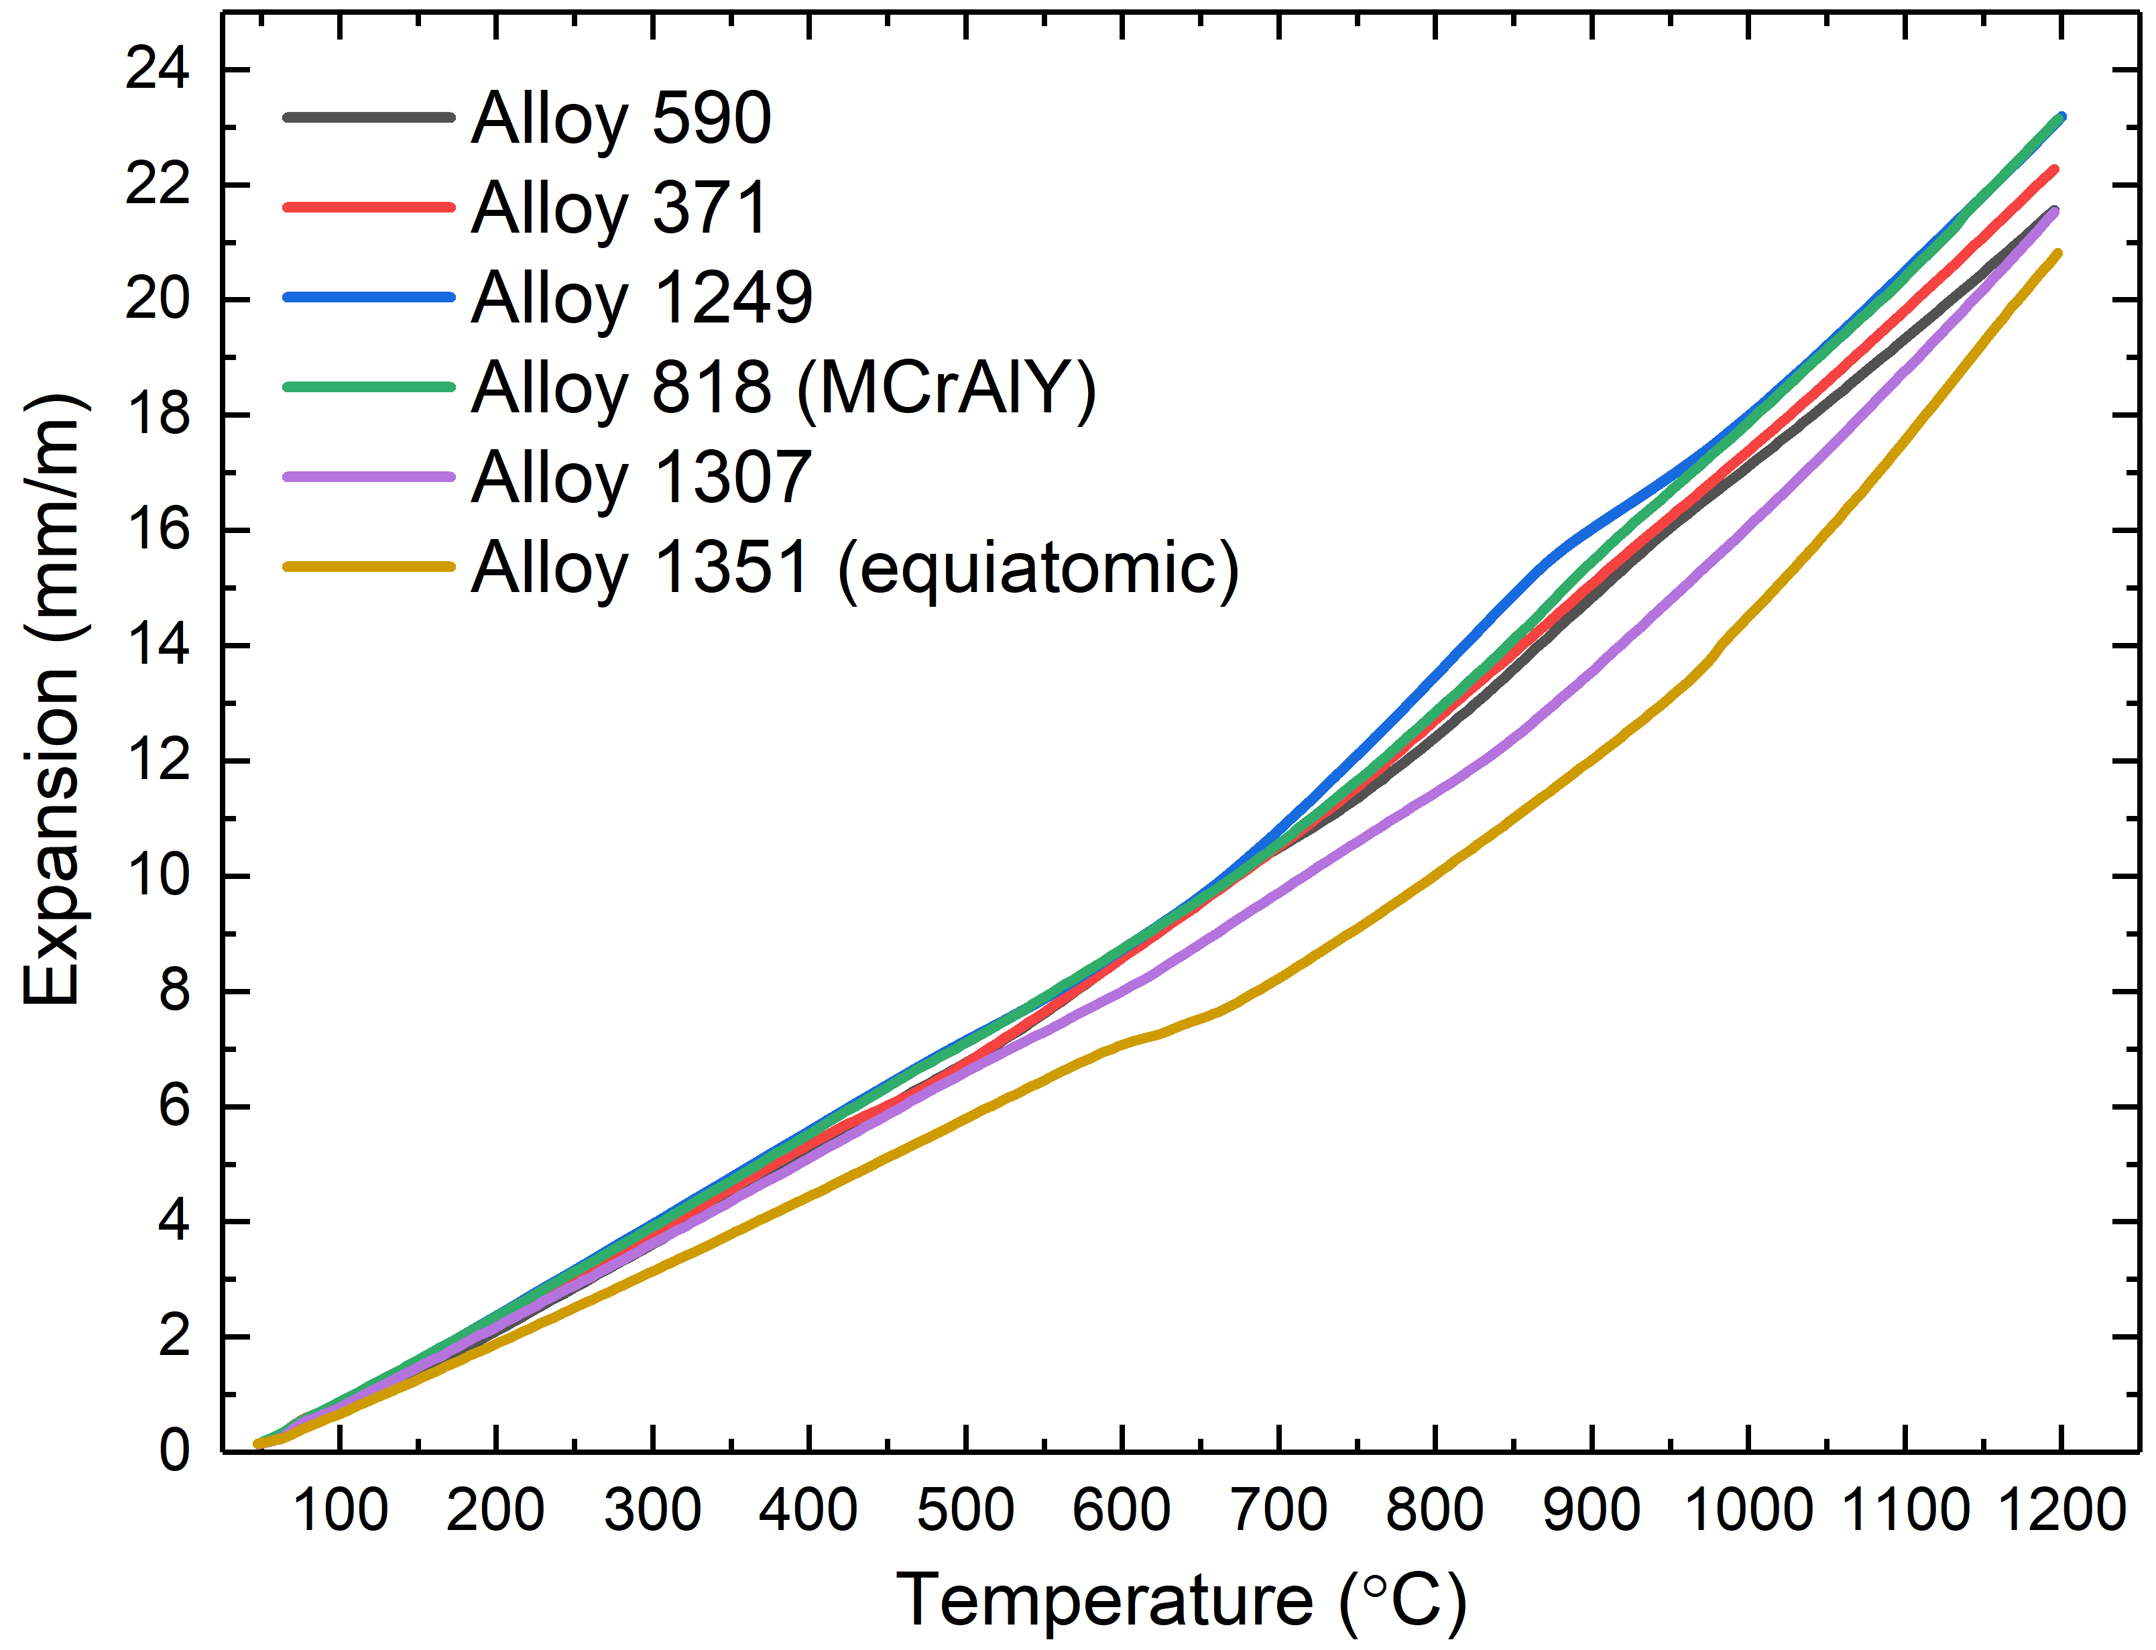
Supplementary Figure 9 Thermal expansion behavior of experimental validation alloy. Thermal expansion of Alloy 590, 371 ,1249, 818 (MCrAlY), 1307 and 1351 (equiatomic).

Supplementary Table 1. 44 Initial input features for ML models, corresponding descriptions and calculation formula.
Feature | Description | Formula | Feature | Description | Formula
Ni | Atomic percentage of Ni |  | Cr | Atomic percentage of Cr
Co | Atomic percentage of Co |  | Al | Atomic percentage of Al
Fe | Atomic percentage of Fe |  | Y | Atomic percentage of Y
Hf | Atomic percentage of Hf |  | Ti | Atomic percentage of Ti
Mo | Atomic percentage of Mo |  | Mn | Atomic percentage of Mn
Ta | Atomic percentage of Ta |  | Si | Atomic percentage of Si
C | Atomic percentage of C |  | Nb | Atomic percentage of Nb
B | Atomic percentage of B |  | V | Atomic percentage of V
P | Atomic percentage of P |  | Zr | Atomic percentage of Zr
Cu | Atomic percentage of Cu |  | Pd | Atomic percentage of Pd
W | Atomic percentage of W |  | Sc | Atomic percentage of Sc
Mg | Atomic percentage of Mg |  | Sm | Atomic percentage of Sm
Ca | Atomic percentage of Ca |  | Nd | Atomic percentage of Nd
Ce | Atomic percentage of Ce |  | La | Atomic percentage of La
Tb | Atomic percentage of Tb |  | Pt | Atomic percentage of Pt
Gd | Atomic percentage of Gd |  | Re | Atomic percentage of Re
Sn | Atomic percentage of Sn |  | N | Atomic percentage of N
S | Atomic percentage of S |  | invT | Inverse of oxidation temperature | invT=1000/T
VEC | Valence electron concentration | $$VEC=\sum_{i=1}^{n}{C_{i}{VEC}_{i}}$$ | ΔH_{mix} | Mixing enthalpy | ${∆H}_{mix}=\sum_{i=1, i≠j}^{n}{Ω_{ij}C_{i}C_{j}}$ $Ω_{ij}=4∆H_{AB}^{mix}$
ΔS_{mix} | Mixing entropy | $${∆S}_{mix}=-R\sqrt{\sum_{i=1}^{n}{C_{i}ln⁡(C_{i})}}$$ | Ω | Parameter for predicting the solid-solution formation | $$Ω=\frac{T_{m}{∆S}_{mix}}{\left|{∆H}_{mix}\right|}$$
δ | Atomic size mismatch | $δ=\sqrt{\sum_{i=1}^{n}{C_{i}(1-r_{i}/\overline{r})}}$ $\overline{r}= \sum_{i=1}^{n}{C_{i}r_{i}}$ | Al+Cr | Sum of Al and Cr | $$Al+Cr$$
Δx | Electronegativity mismatch | $∆x=\sqrt{\sum_{i=1}^{n}{C_{i}{(x_{i}-\overline{x})}^{2}}}$ $\overline{x}= \sum_{i=1}^{n}{C_{i}x_{i}}$ | Cr/Al | Ratio of Al and Cr | $$\frac{Cr}{Al}$$

Supplementary Table 2. Phase diagram as predicted by ThermalCal. The phase diagram is categorized based on the predict phase fraction of BCC or FCC phases within the temperature range of 1000 °C to 1250 °C. Exemplary phase diagrams for each category are provided for reference.
Phase Diagram Category | #1 FCC | #2 FCC | #1 BCC | #2 BCC | Exp.
1 | / | / | 0.6~0.8 | 0.2~0.4 | 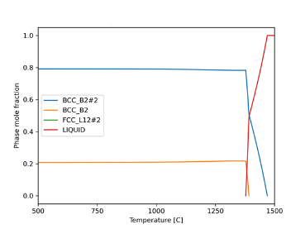
2 | 0.2~0.4 | / | 0.6~0.8 | / | 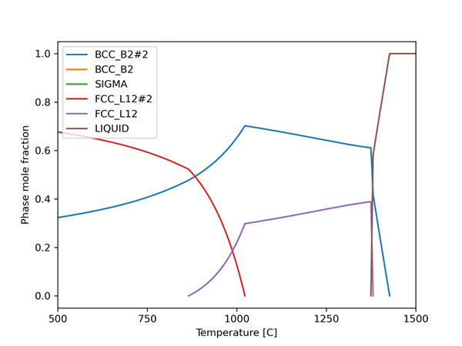
3 | 0.6~0.8 | / | 0.2~0.4 | / | 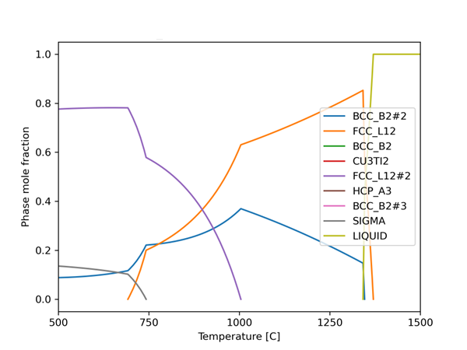
4 | / | / | 0.8~1 | 0~0.2 | 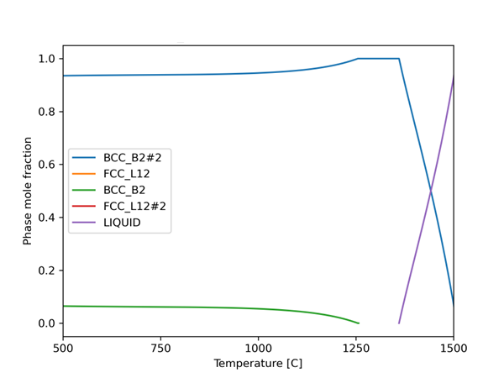
5 | 0~0.2 | / | 0.8~1 | / | 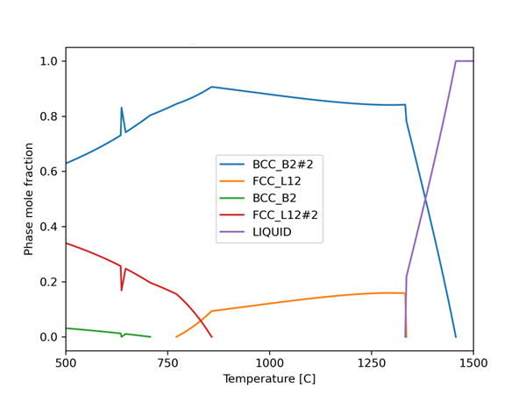
6 | 0.8~1 | / | 0~0.2 | / | 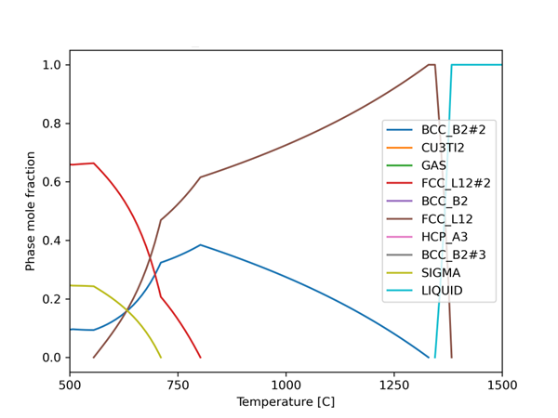
7 | 0.8~1 | 0~0.2 | / | / | 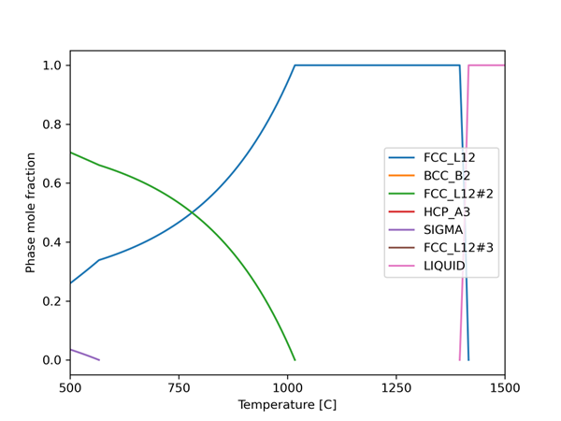
8 | 0.4~0.6 | / | 0.4~0.6 | / | 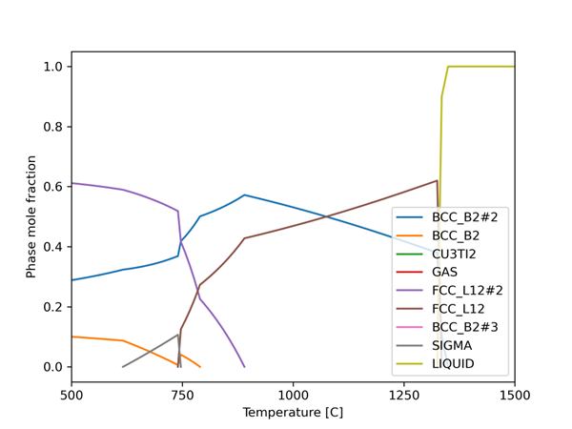
9 | dominated | minor | minor | / | 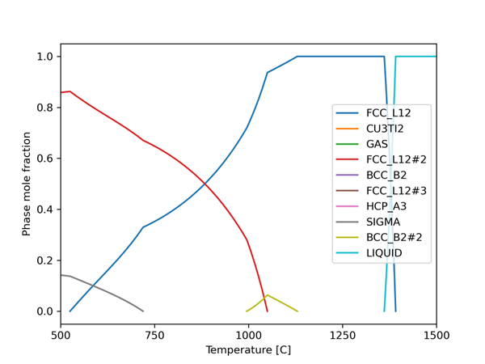
10 | dominated | minor | dominated | / | 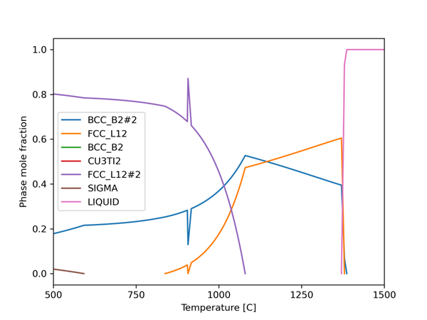
11 | minor | / | dominated | minor | 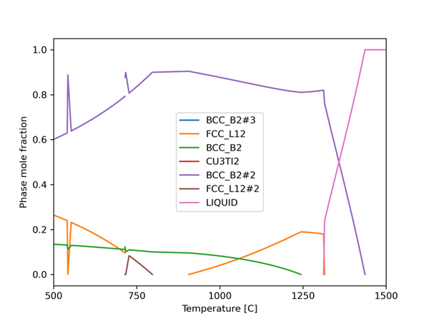
12 | / | / | 1 | / | 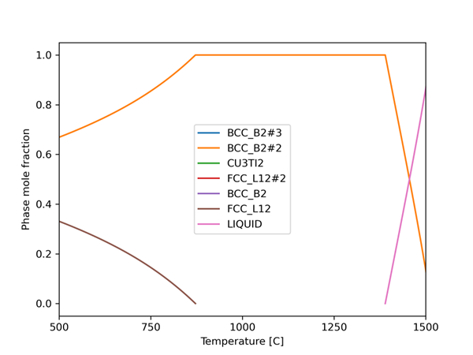
13 | 1 | / | / | / | 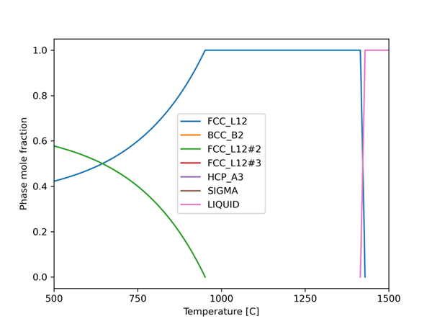

Supplementary Table 3. Eight alloys used for experimental validation. Cr/Al and Cr+Al of each phase are included.
Alloy No. | Alloy Composition (at%) | Phase Composition (at%) | Phase Fraction (%) | Cr/Al | Cr+Al
590 | Ni₄₄Cr₆Co₁₈Al₂₂Fe₁₀ | Ni_{43.1}Cr_{4.0}Co_{16.2}Al_{27.7}Fe_{8.9} | 63.4 | 0.1 | 31.7
590 | Ni₄₄Cr₆Co₁₈Al₂₂Fe₁₀ | Ni_{45.6}Cr_{9.5}Co_{21.0}Al_{12.1}Fe_{11.8} | 36.6 | 0.8 | 21.6
371 | Ni₄₈Cr₁₀Co₁₀Al₂₆Fe₆ | Ni_{48.0} Cr_{7.9}Co_{9.6}Al₂₉Fe_{5.5} | 82.9 | 1.8 | 31.8
371 | Ni₄₈Cr₁₀Co₁₀Al₂₆Fe₆ | Ni_{47.9}Cr_{20.3}Co_{12.0}Al_{11.5}Fe_{8.3} | 17.1 | 0.3 | 36.9
1249 | Ni₃₄Cr₁₄Co₁₈Al₁₆Fe₁₈ | Ni_{32.5}Cr_{18.8}Co_{19.2}Al_{8.7}Fe_{20.7} | 59.8 | 0.3 | 33.7
1249 | Ni₃₄Cr₁₄Co₁₈Al₁₆Fe₁₈ | Ni_{36.2}Cr_{6.9}Co_{16.2}Al_{26.8}Fe_{13.9} | 40.2 | 2.2 | 27.5
818 (MCrAlY) | Ni₄₀Cr₁₈Co₁₈Al₂₄ | Ni_{41.4}Cr_{13.3}Co_{16.5}Al_{28.8} | 75.3 | 0.5 | 42.1
818 (MCrAlY) | Ni₄₀Cr₁₈Co₁₈Al₂₄ | Ni_{35.7}Cr_{32.4}Co_{22.5}Al_{9.4} | 24.7 | 3.4 | 41.8
1307 | Ni₂₈Cr₁₆Co₁₈Al₂₀Fe₁₈ | Ni_{30.8}Cr_{10.1}Co_{17.4}Al_{26.4}Fe_{15.3} | 66.6 | 3.9 | 35
1307 | Ni₂₈Cr₁₆Co₁₈Al₂₀Fe₁₈ | Ni_{22.4}Cr_{27.8}Co_{19.3}Al_{7.2}Fe_{23.4} | 33.4 | 0.4 | 36.5
1328 | Ni₃₀Cr₁₆Co₁₀Al₂₄Fe₂₀ | Ni_{34.8}Cr_{8.8}Co_{10.4}Al_{28.6}Fe_{17.4} | 79.5 | 7.1 | 50.3
1328 | Ni₃₀Cr₁₆Co₁₀Al₂₄Fe₂₀ | Ni_{11.3}Cr_{44.1}Co_{8.3}Al_{6.2}Fe_{30.1} | 20.5 | 0.3 | 37.4
1136 | Ni₃₀Cr₂₂Co₁₆Al₂₄Fe₈ | Ni_{34.8}Cr_{12.7}Co_{16.4}Al_{28.7}Fe_{7.5} | 81.4 | 17.4 | 66.4
1136 | Ni₃₀Cr₂₂Co₁₆Al₂₄Fe₈ | Ni_{8.9}Cr_{62.8}Co_{14.4}Al_{3.6}Fe_{10.3} | 18.6 | 0.4 | 41.4
1351(Equiatomic) | Ni₂₀Cr₂₀Co₂₀Al₂₀Fe₂₀ | Ni₂₄Cr_{12.5}Co_{20.9}Al_{24.7}Fe_{18.0} | 74.7 | 0.5 | 37.2
1351(Equiatomic) | Ni₂₀Cr₂₀Co₂₀Al₂₀Fe₂₀ | Ni_{8.3}Cr_{42.1}Co_{17.4}Al_{6.2}Fe_{26.1} | 25.3 | 6.8 | 48.3

