Preparation and performance of a biological dust suppressant based on the synergistic effect of enzyme-induced carbonate precipitation and surfactant
Mingyue Wu¹, Xiangming Hu^{1,2}, Qian Zhang¹, Yanyun Zhao¹, Weimin Cheng¹, Di Xue¹
¹Key Lab of Mine Disaster Prevention and Control, College of Safety and Environmental Engineering, Shandong University of Science and Technology, No. 579, Qianwangang Road, Xin'an Street, Huangdao District, Qingdao, Shandong, China.
²Department of Chemical Engineering and Safety, Binzhou University, Yellow River 5 Road, Pengli Street, Bincheng District, Binzhou City, Shandong, China.
Corresponding author: Yanyun Zhao (E-mail: skd995627@sdust.edu.cn, Tel: +86 13864265956, Fax: +86 531 86057013)

Table S1 Industrial analysis of coal sample
Item | A_{ad} /% | V_{ad} /% | M_{ad} /% | FC_{ad} /%
Proportion | 5.48 | 50.41 | 2.47 | 41.64
Note: A_{ad}—ash content; V_{ad}—volatile content; M_{ad}—moisture; FC_{ad}—content of fixed carbon.
Fig. S1. Particle size distribution of coal sample
Extraction of urease
The soybeans washed with distilled water were placed in the drying oven. In order to prevent the inactivation of urease in the soybeans, the temperature of the drying oven was set to 30 ℃. The dried soybeans were crushed with a wall breaker and placed in conical bottles according to the ratio of soybean powder to anhydrous ethanol at 1:10. Then the 30 min is oscillated at 30 ℃, 180 rpm in a constant temperature oscillator. After the end of the oscillation, it was stored in a refrigerator with a temperature of 4 ℃ for 12 h. Finally, the supernatant was obtained by centrifuging with 8000 rpm for 15 min in a centrifuge, and the supernatant was crude enzyme solution.
Determination of urease activity
First, prepare a urea solution with a concentration of 0.6 mol/L. Then, take 10 mL of surfactant-containing urease and urea solutions and place them in a beaker. After mixing, the concentration of surfactant in the solution are 0, 0.02, 0.04, 0.06, 0.08, 0.10, 0.20, 0.30, 0.40, and 0.50 %. Before mixing, the urease solution containing cationic and anionic surfactant was allowed to stand for 12 h to prevent the ionization of the surfactant from affecting the conductivity value. The sensor probe of the conductivity meter (FE38-Standard, METTLER TOLEDO Instruments, Shanghai Co., Ltd., China) was quickly inserted into the mixture. Data was recorded from 1st min to 10th min at an interval of 1 min. It should be noted that the sensor probe was completely immersed in the solution at 25 ℃ and pH = 7.5.
Fig. S2 Schematic diagram of settlement test
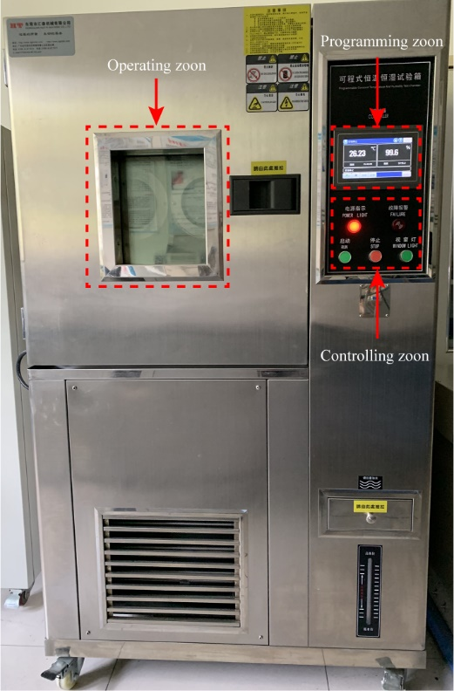
Fig. S3 The constant temperature and humidity oven

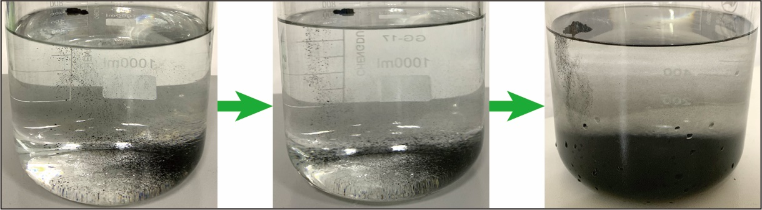
Fig. S4 Process of coal dust settling

