
B
A
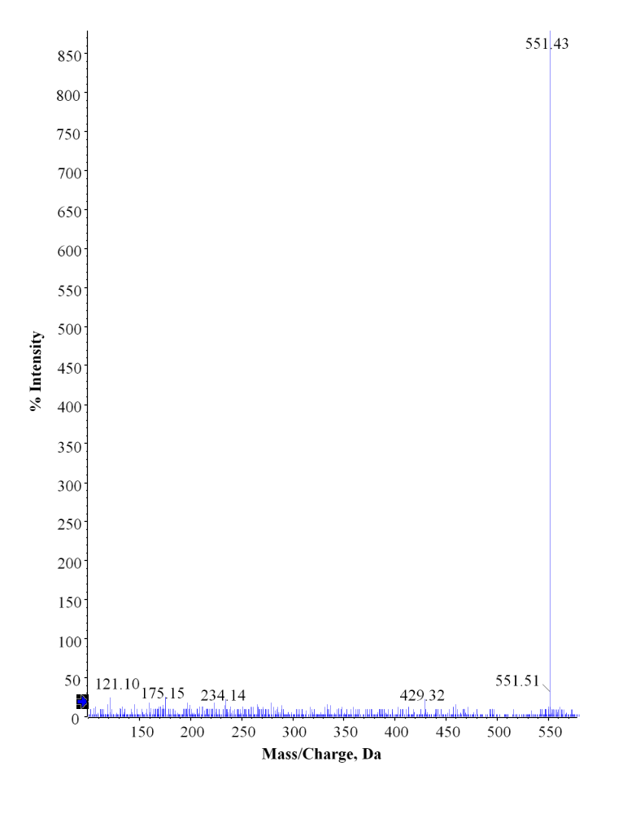 Supplementary Fig. 1. (A) Purified lutein HPLC chromatogram extracted from marigold petals (B) LC-MS profile of lutein extracted demonstrating purity.
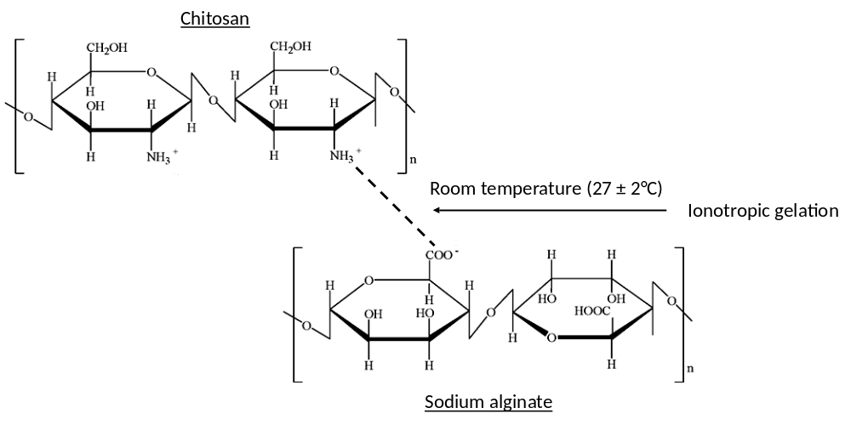
Supplementary Fig. 2. Chitosan-sodium alginate interaction scaffold.

