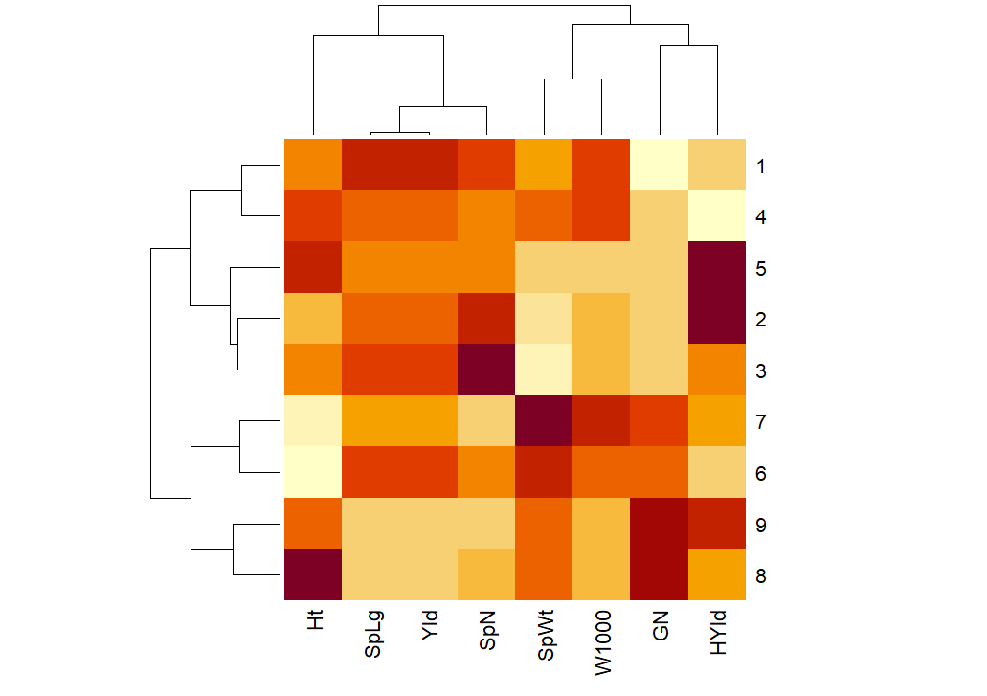
Supplementary 1. Heatmap of triticale genotypes and yield related traits in first year under normal irrigation condition

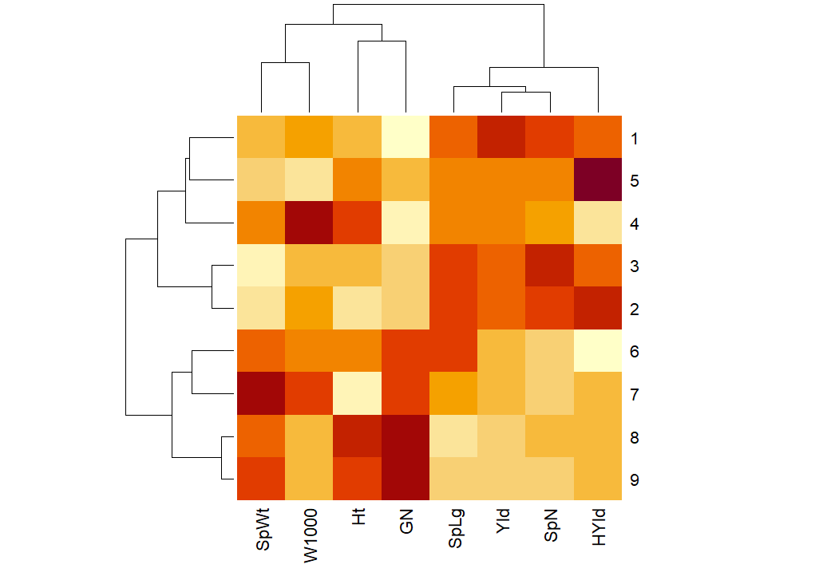
Supplementary 2. Heatmap of triticale genotypes and yield related traits in first year under water deficit condition

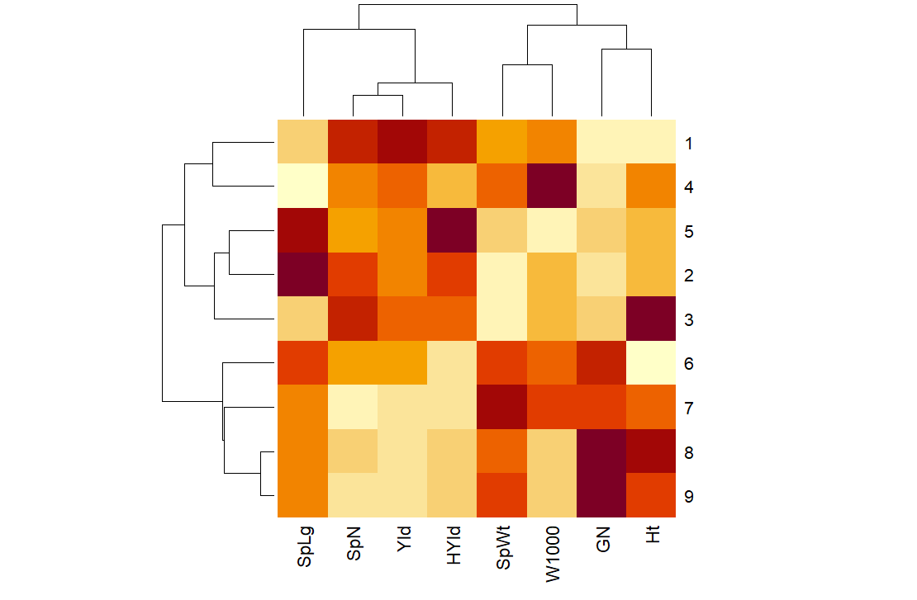
Supplementary 3. Heatmap of triticale genotypes and yield related traits in second year under normal irrigation condition

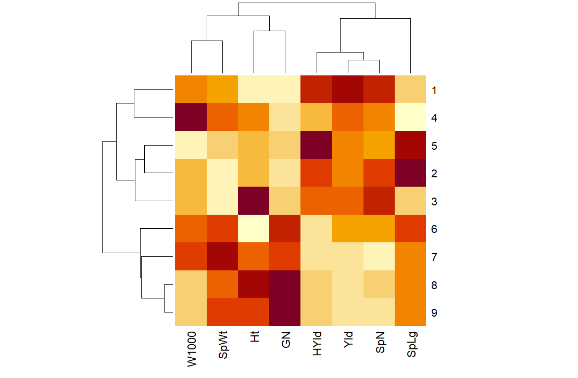
Supplementary 4. Heatmap of triticale genotypes and yield related traits in second year under water deficit condition

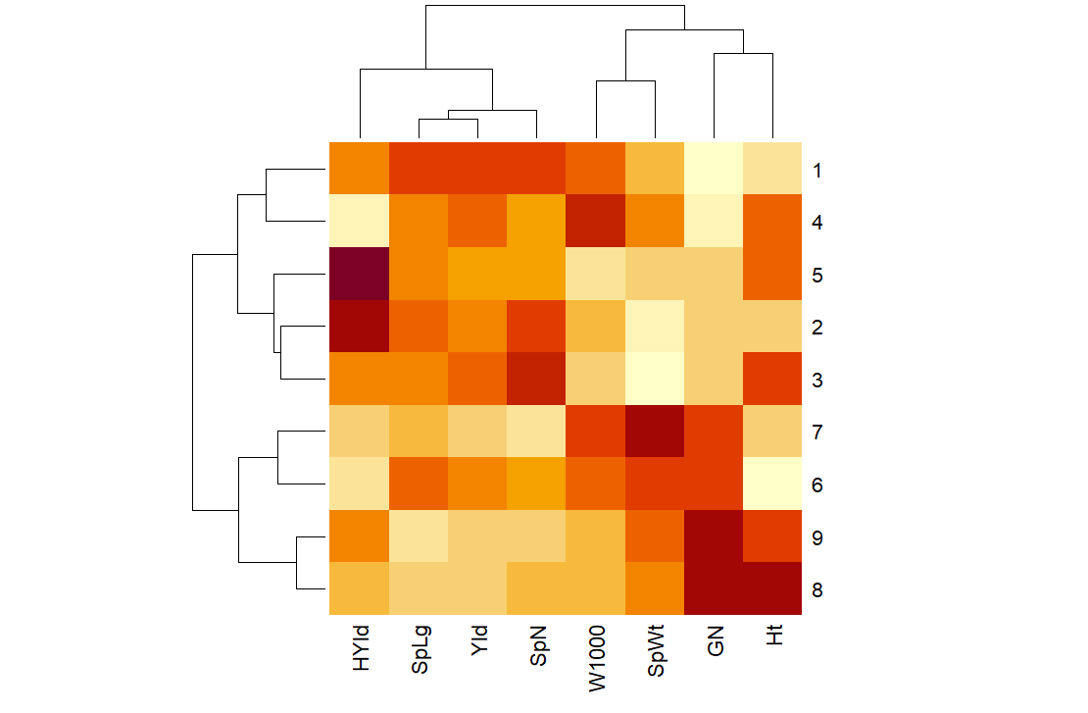
Supplementary 5. Heatmap of triticale genotypes and yield related traits in both years under normal irrigation condition

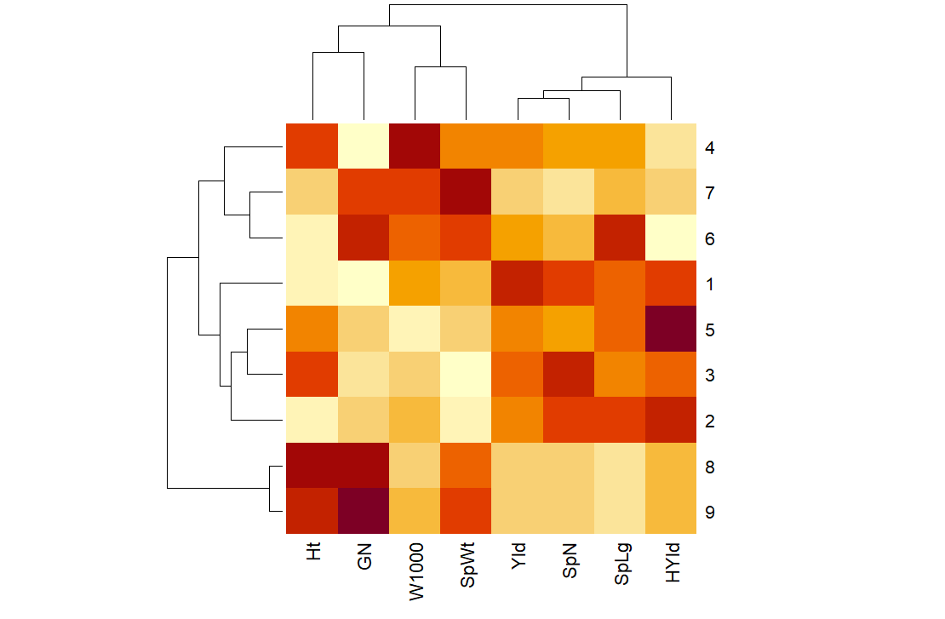
Supplementary 6. Heatmap of triticale genotypes and yield related traits in both years under water deficit condition

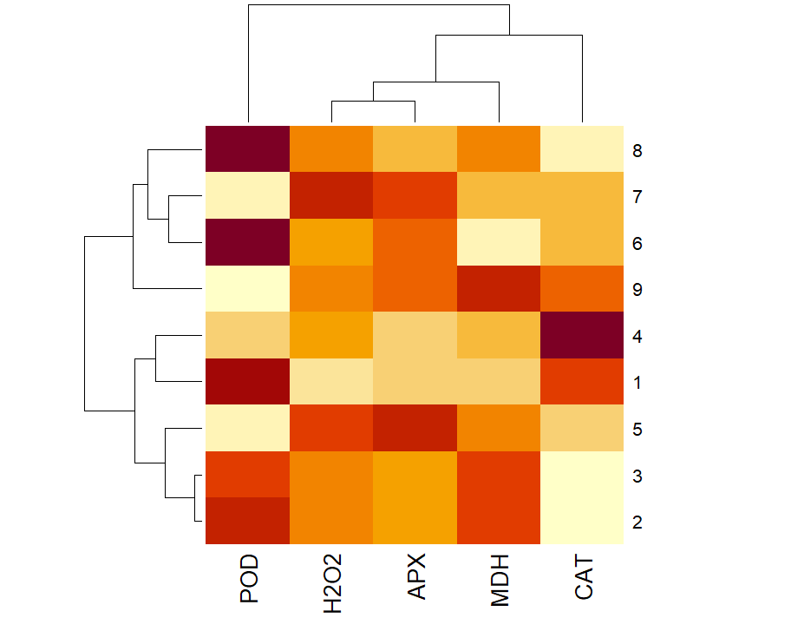
Supplementary 7. Heatmap of triticale genotypes and biochemical traits in first year under normal irrigation condition

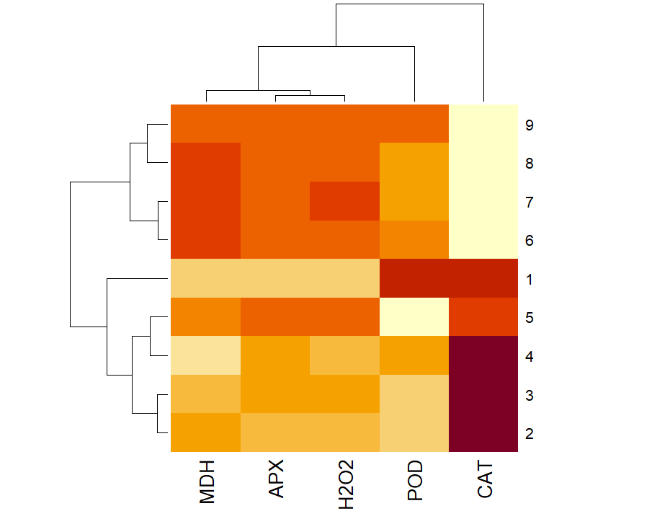
Supplementary 8. Heatmap of triticale genotypes and biochemical traits in first year under water deficit condition

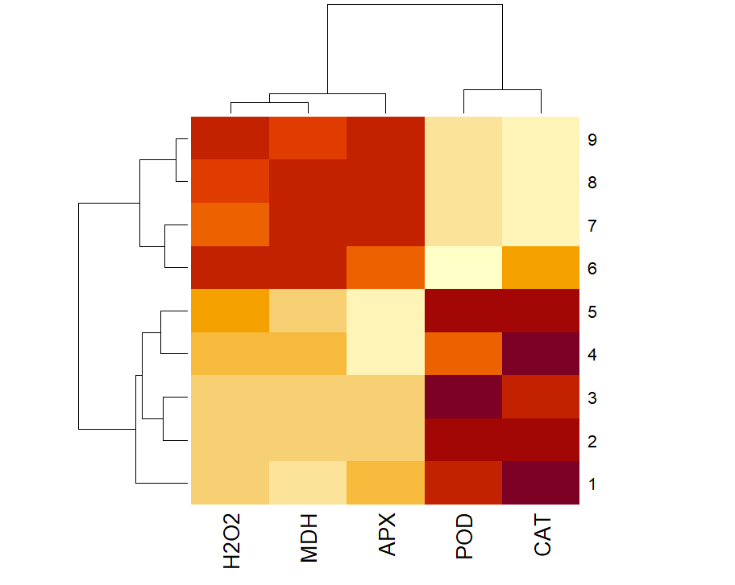
Supplementary 9. Heatmap of triticale genotypes and biochemical traits in second year under normal irrigation condition

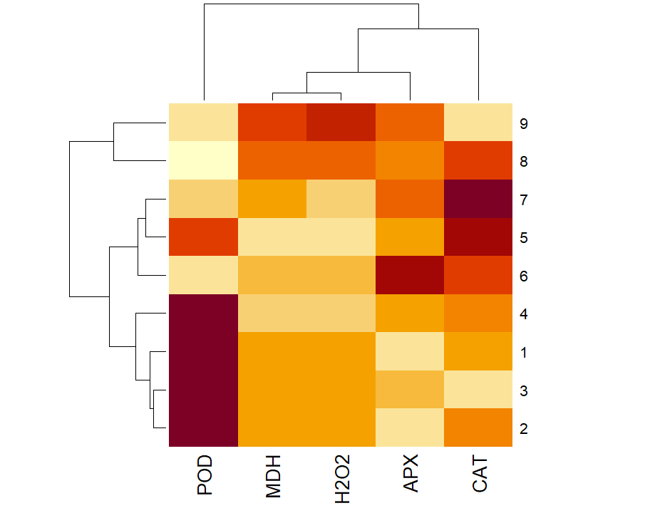
Supplementary 10. Heatmap of triticale genotypes and biochemical traits in second year under water deficit condition

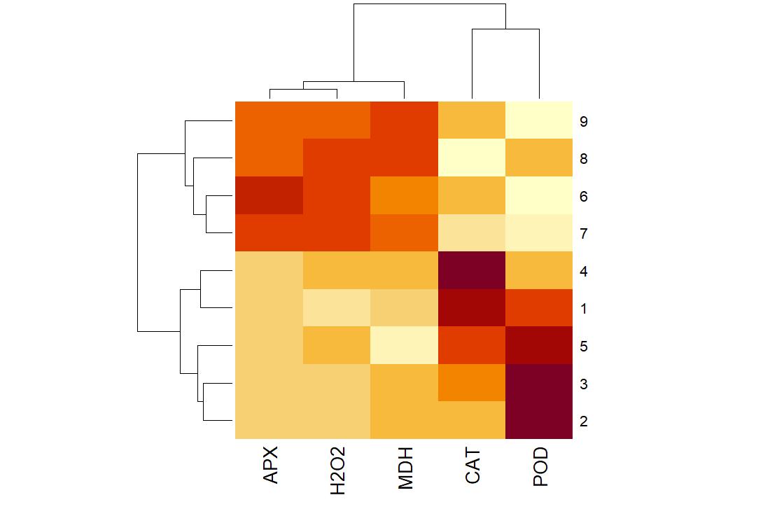
Supplementary 11. Heatmap of triticale genotypes and biochemical traits in both years under normal irrigation condition

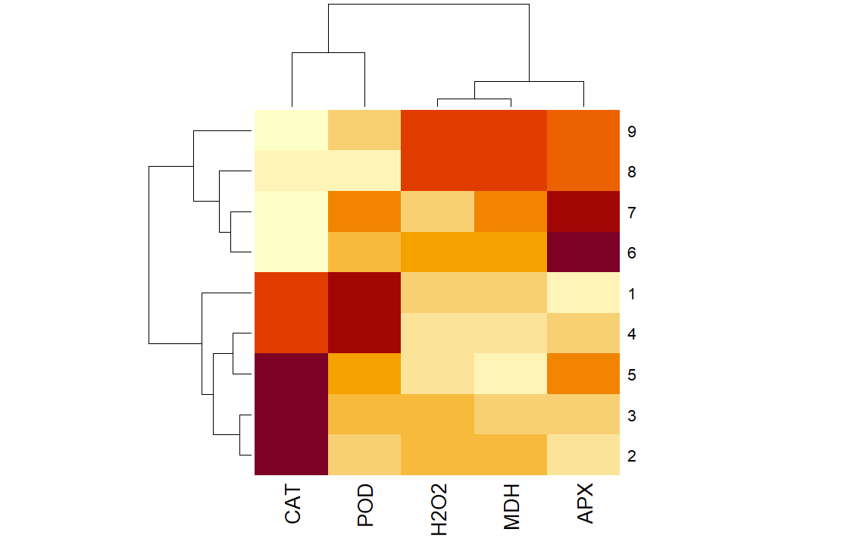
Supplementary 12. Heatmap of triticale genotypes and biochemical traits in both years under water deficit condition

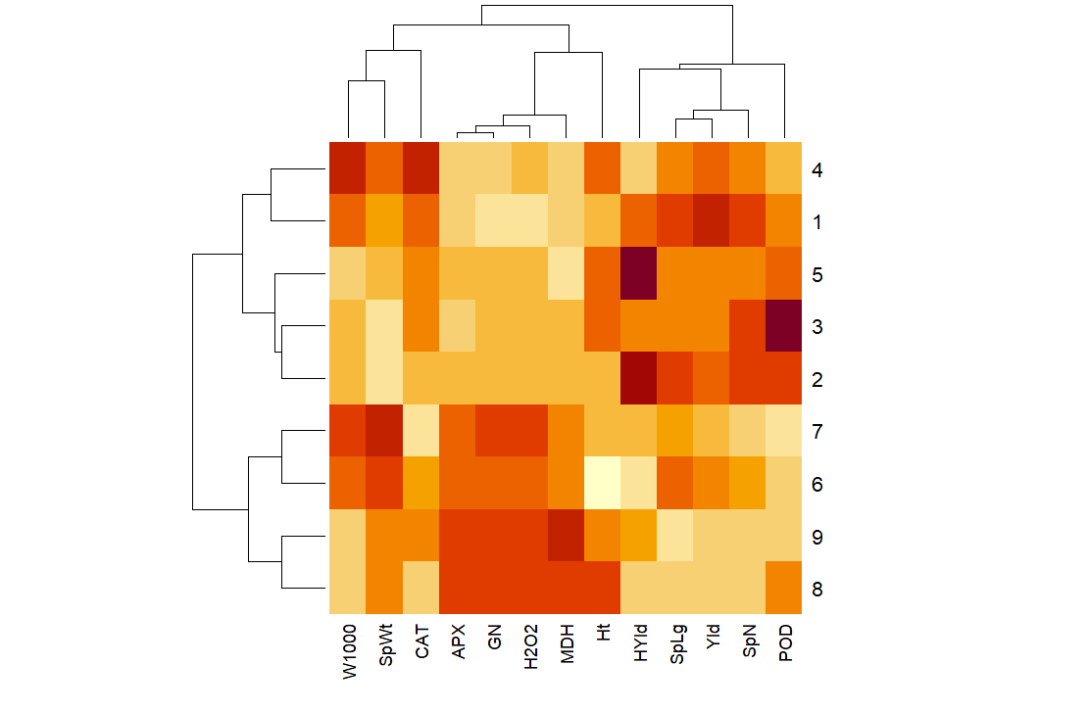
Supplementary 13. Heatmap of triticale genotypes and yield related traits along with biochemical traits in both years under normal irrigation condition

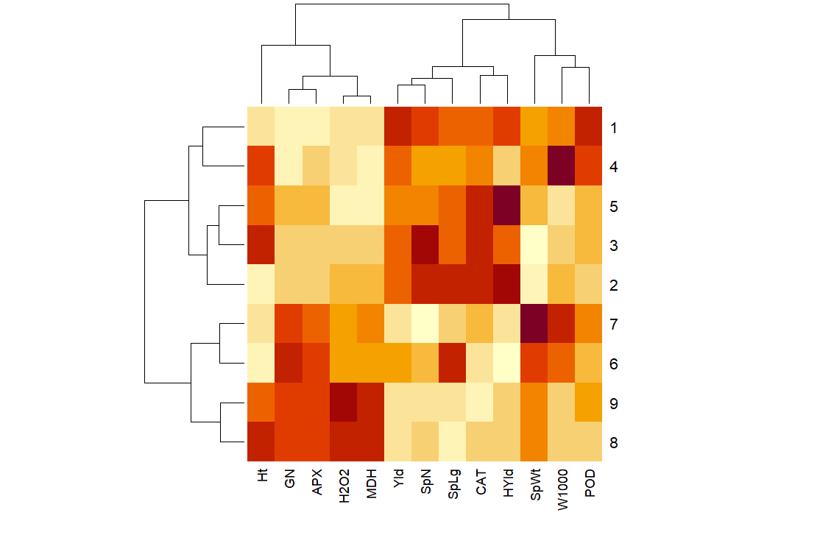
Supplementary 14. Heatmap of triticale genotypes and yield related traits along with biochemical traits in both years across both normal irrigation and water deficit condition

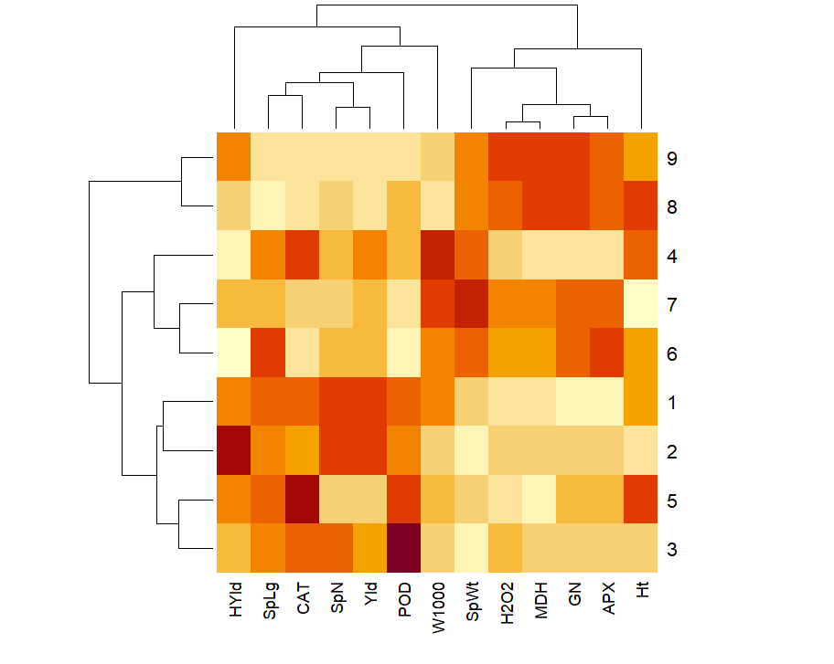Supplementary 15. Heatmap of triticale genotypes and yield related traits along with biochemical traits in both years under water deficit condition

