Supplementary Information

Figures
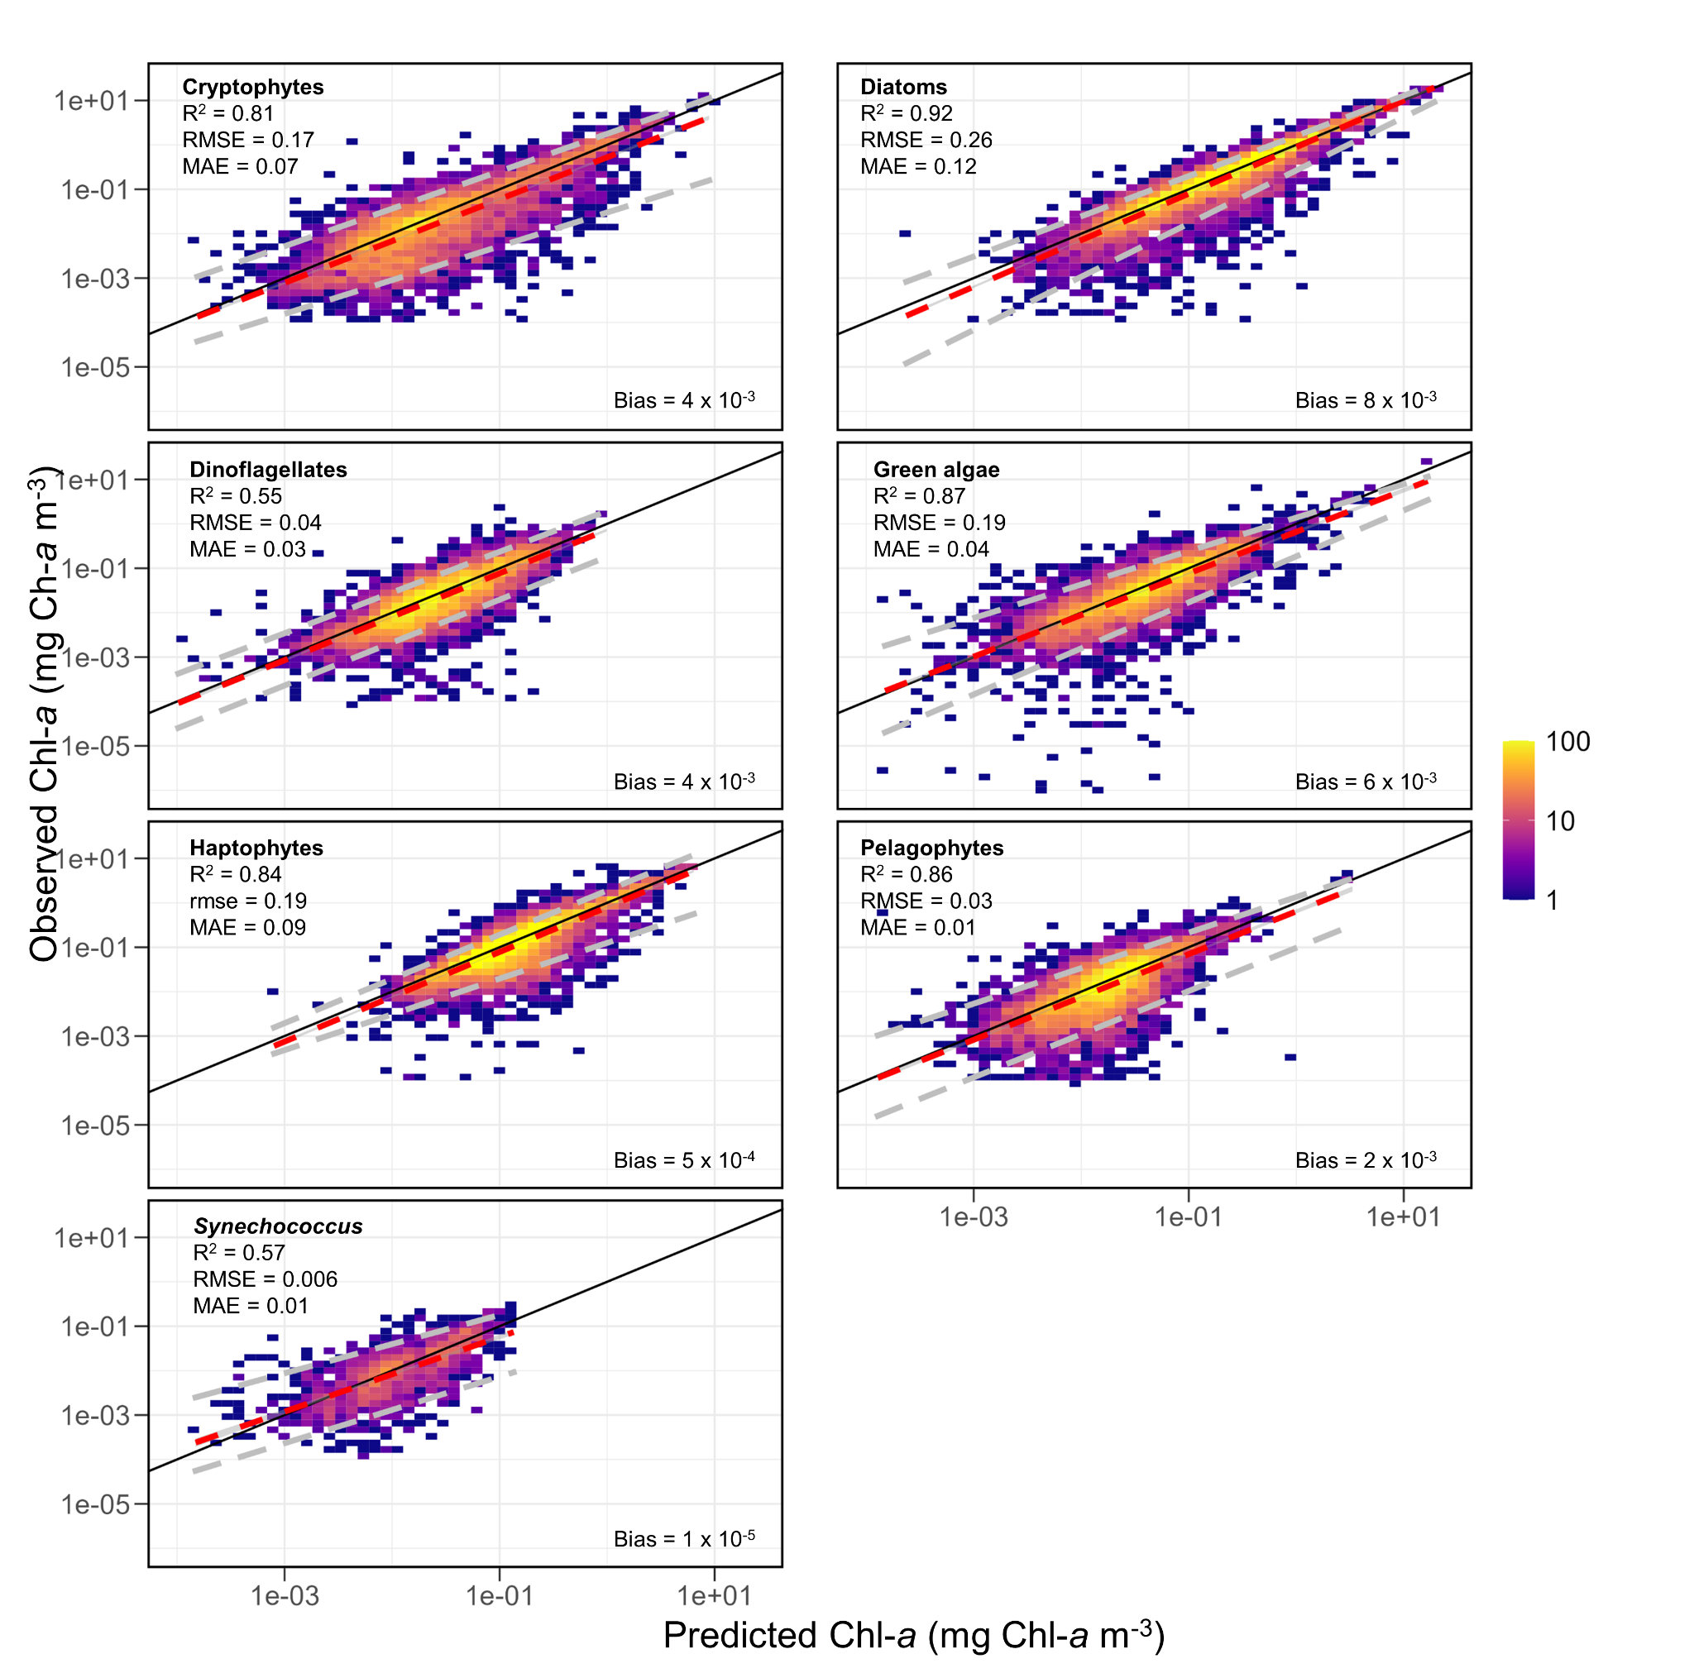
Supplementary Figure 1: Relationships between measured Chl-a and predicted Chl-a, where the R² is the variance explained, RMSE is the root-mean-square error, and MAE is the mean absolute error. The red dashed line indicates the slope of the regression, the dashed grey lines indicate the boundary where 90% of the data is contained, and the solid black line indicates the line of unity between predicted and measured data. The colour of the scatter plot represents the sample density in log space.
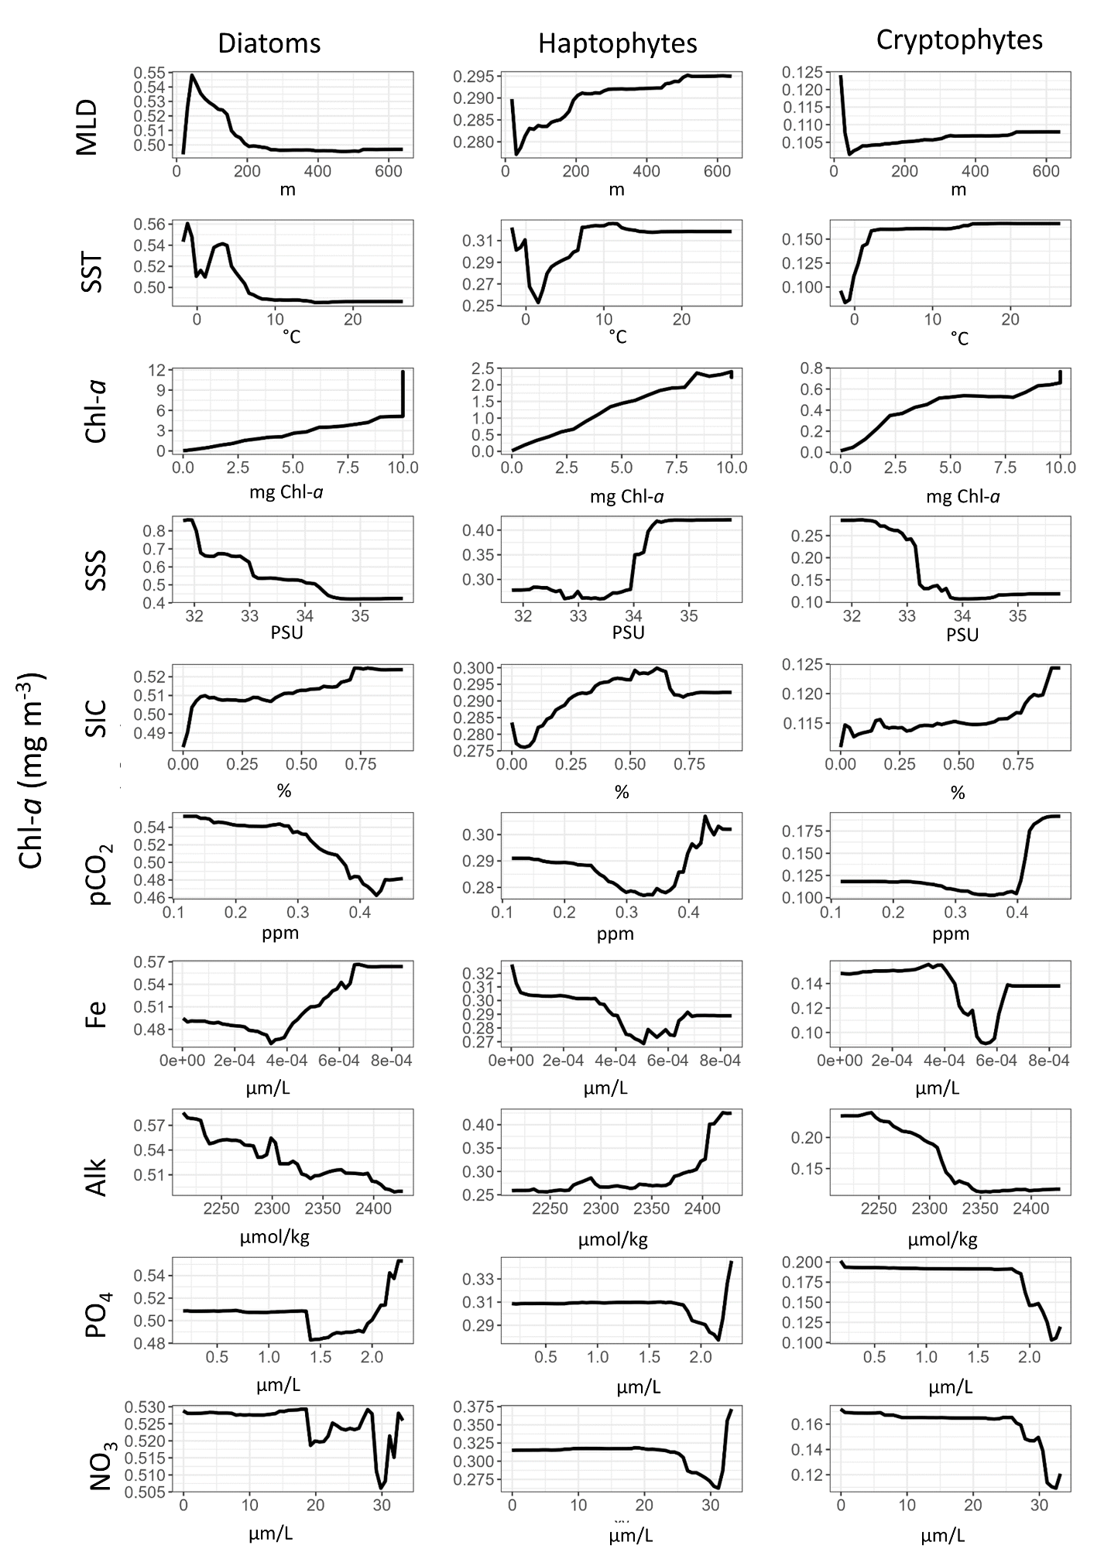
Supplementary Figure 2: Partial dependence plots showing the relationship between group- specific Chl-a concentrations with different environmental variables.
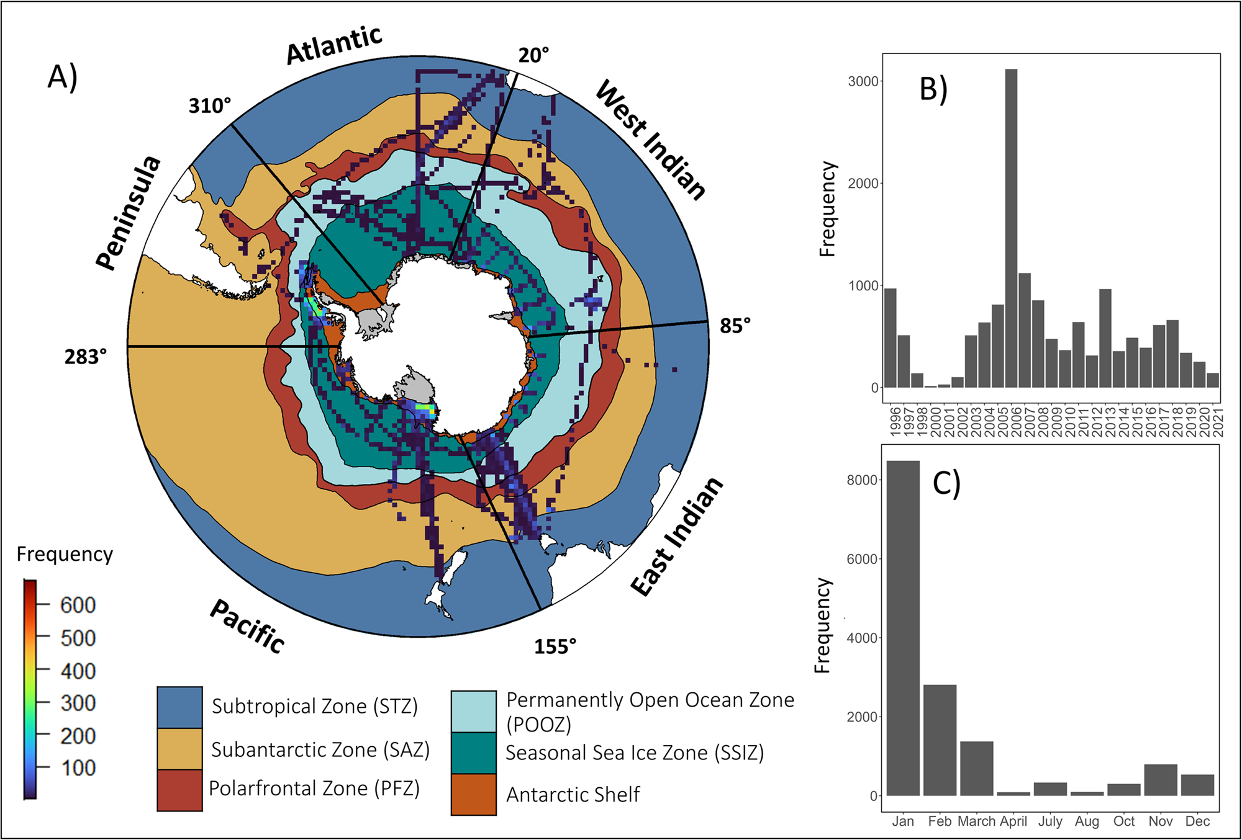
Supplementary Figure 3: Taken from Hayward et al., 2024; The circumpolar distribution of pigment sampling locations. Pigment distributions across the six oceanographic zones (Subtropical Zone, Subantarctic Zone, Polar Frontal Zone, Permanently Open Ocean Zone, Seasonal Sea Ice Zone, and the Antarctic Shelf; A) and sampling frequency in respective years B) and months C).
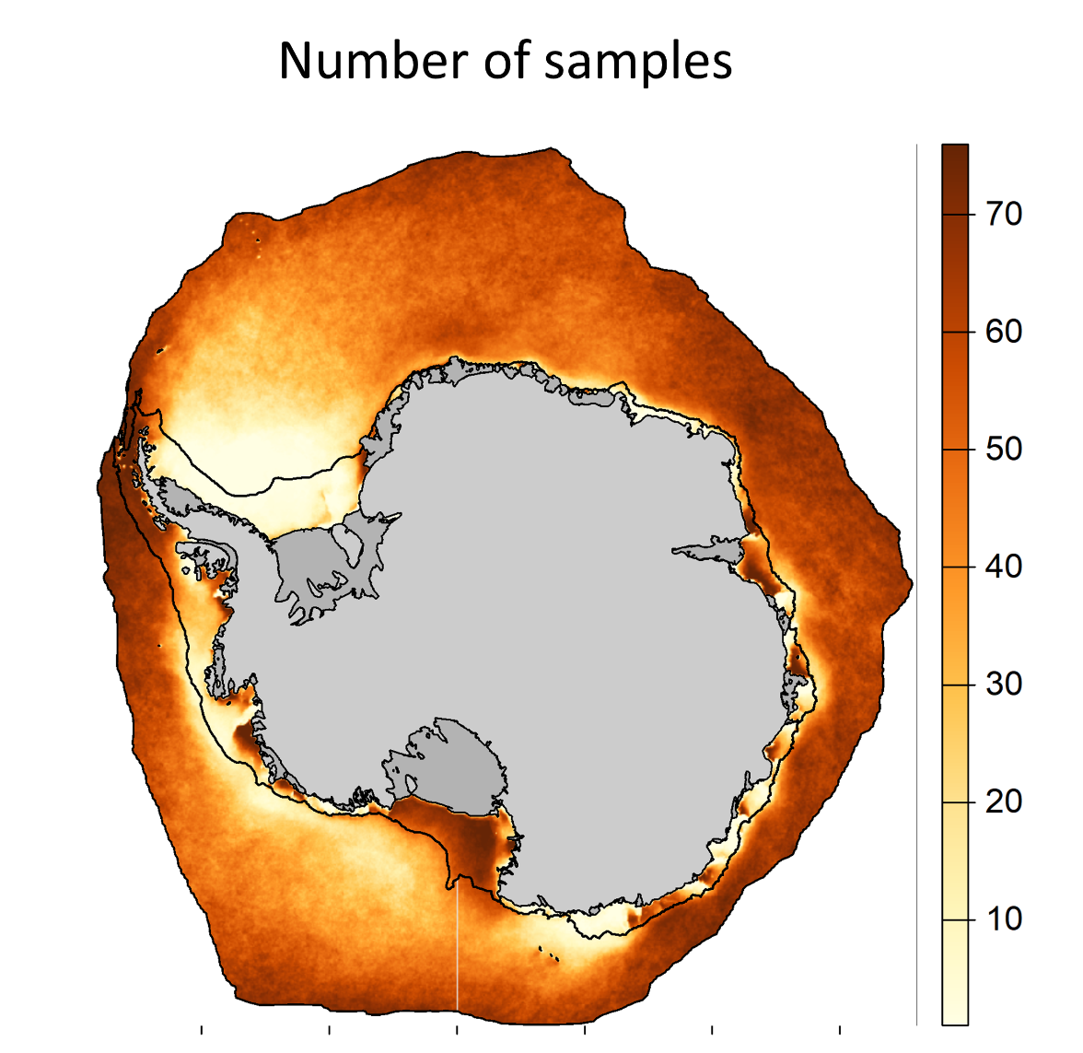
Supplementary Figure 4: Number of samples present within the study region during summer months between September 1997 to September 2023.

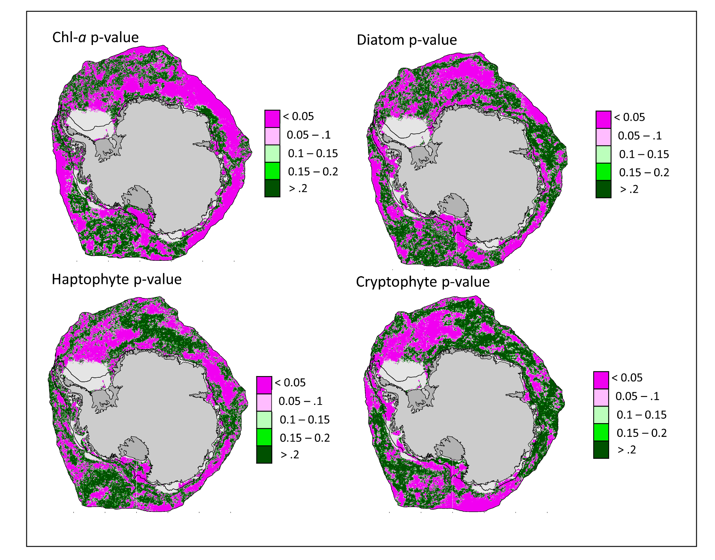
Supplementary Figure 5: Statistical significance ‘p-value’ determined from autocorrelation-corrected (Yue and Wang, 2004) Mann-Kendall tests for Chl-a, Diatoms, Haptophytes, and Cryptophytes.

