2D single-faceted IrO₂(101) monolayer enabling high-performing proton exchange membrane water electrolysis beyond 8,000 h stability at 1.5 A cm⁻²

Deren Yang¹*, Chunyang Zhang¹, Yufeng Qin¹, Xiaoyun Shi¹, Kang Hua¹, Xuemin An¹, Yubo Liu¹, Yang Yue¹, Louyu Jin¹, Yipeng Zhang¹, Shouwei Zuo²*, Aidong Tan¹* and Jianguo Liu¹*
¹Institute of Energy Power Innovation, North China Electric Power University, 2 Beinong Road, Beijing 102206, P. R. China. ²Beijing Synchrotron Radiation Facility, Institute of High Energy Physics, Chinese Academy of Sciences, Beijing 100049, P. R. China.
Deren Yang and Chunyang Zhang contributed equally to this work.
*E-mail: jianguoliu@ncepu.edu.cn; yangderen@ncepu.edu.cn

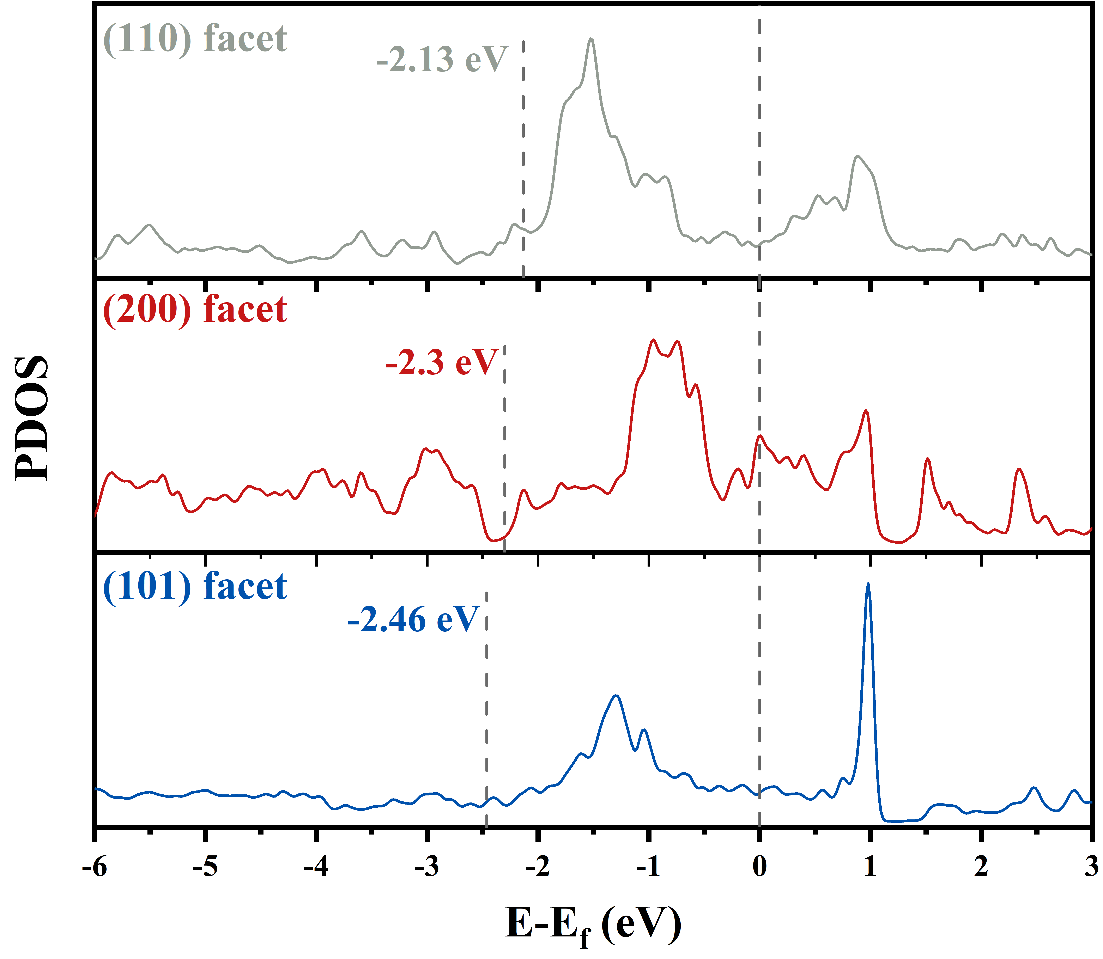
Supplementary Fig. 1 The PDOS plots of the exposed Ir atoms in the (110), (200) and (101) facets, respectively.

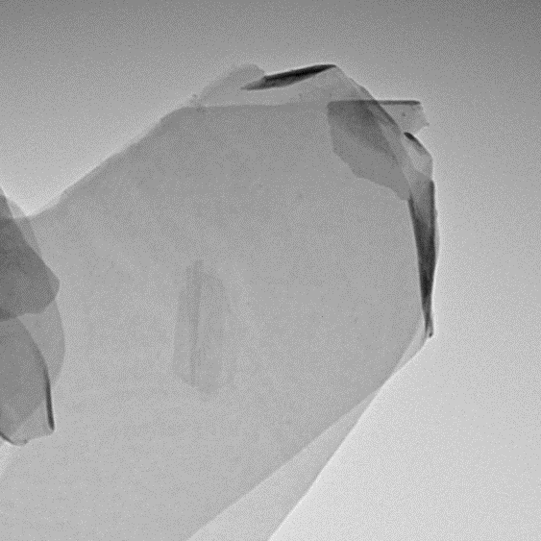
50 nm
200 nm
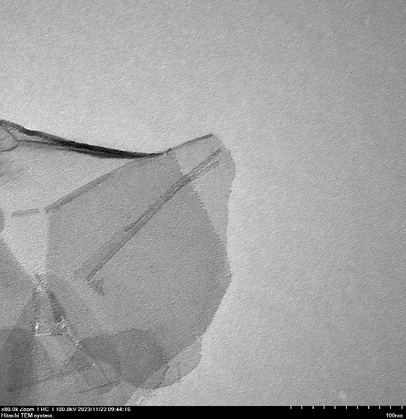 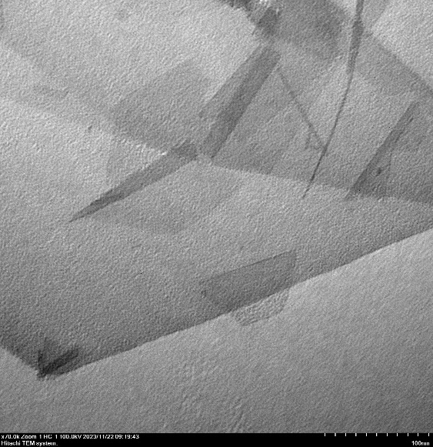 Supplementary Fig. 2 TEM images of 2D IrO₂(101) monolayer
100 nm
100 nm

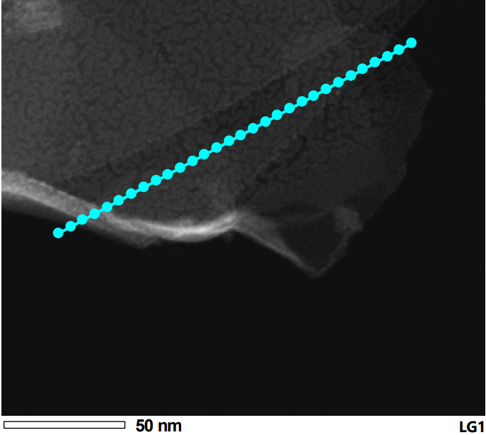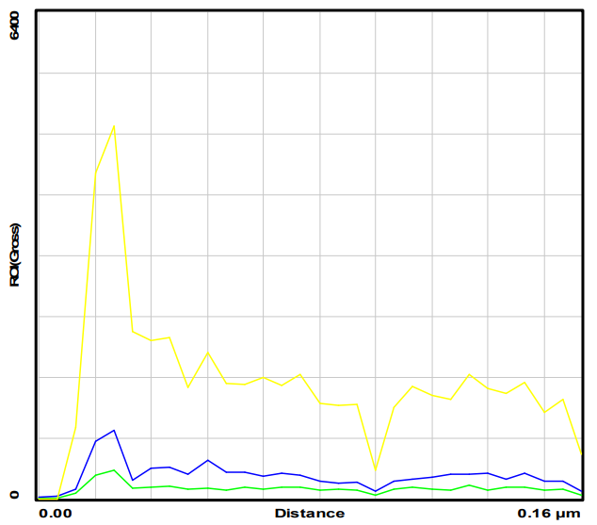
N
O
Ir
a
b
Supplementary Fig. 3 (a) STEM image of IrO₂(101) monolayer, (b) distribution of Ir, O and N along the blue line in (a).

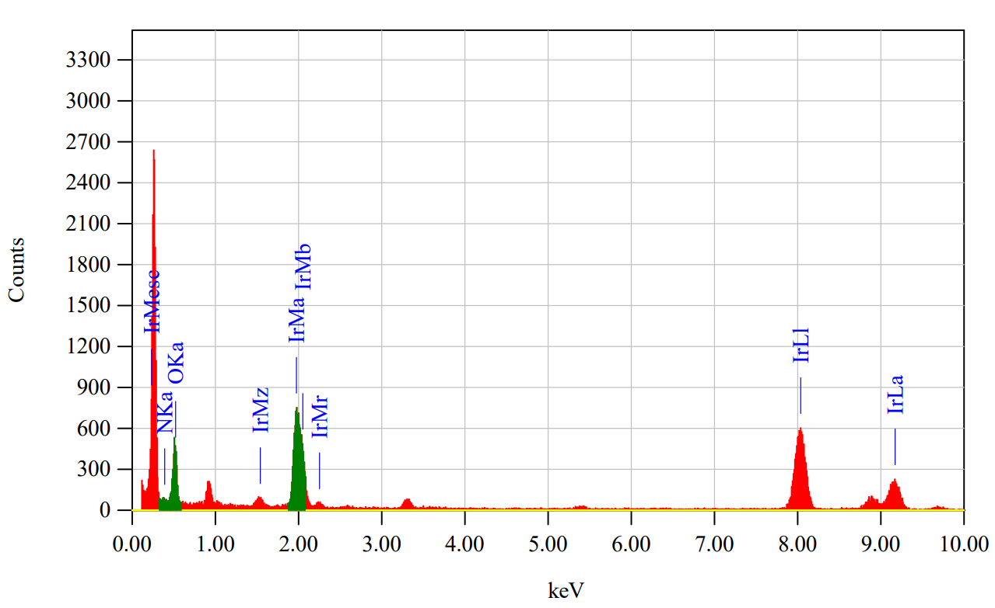 Supplementary Fig. 4 EDX spectrum of IrO₂(101) monolayer.

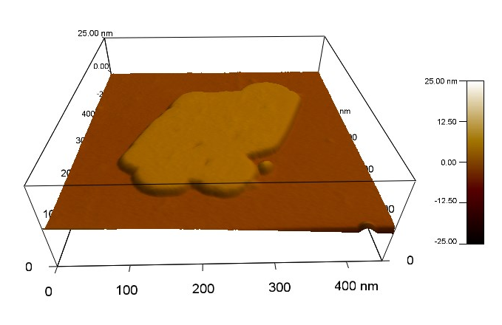
Supplementary Fig. 5 AFM image in 3D form of IrO₂(101) monolayer.

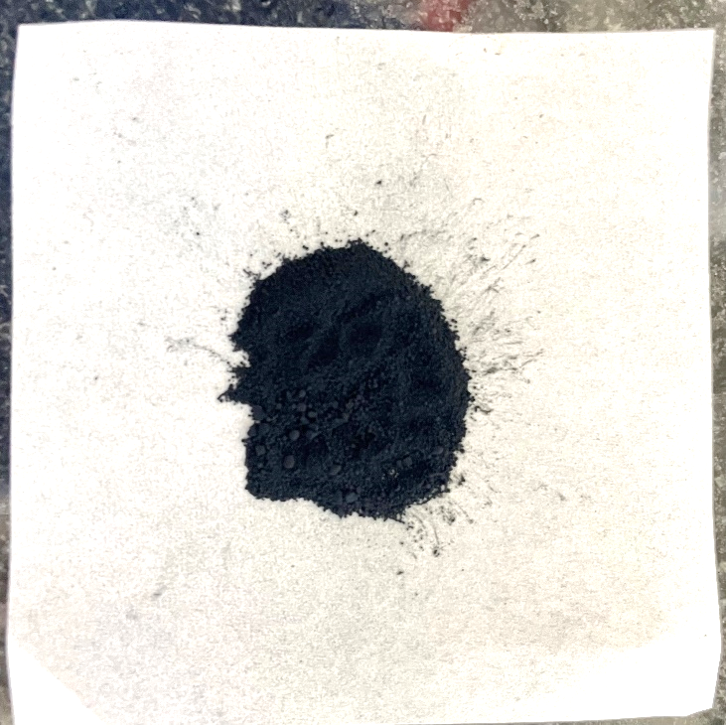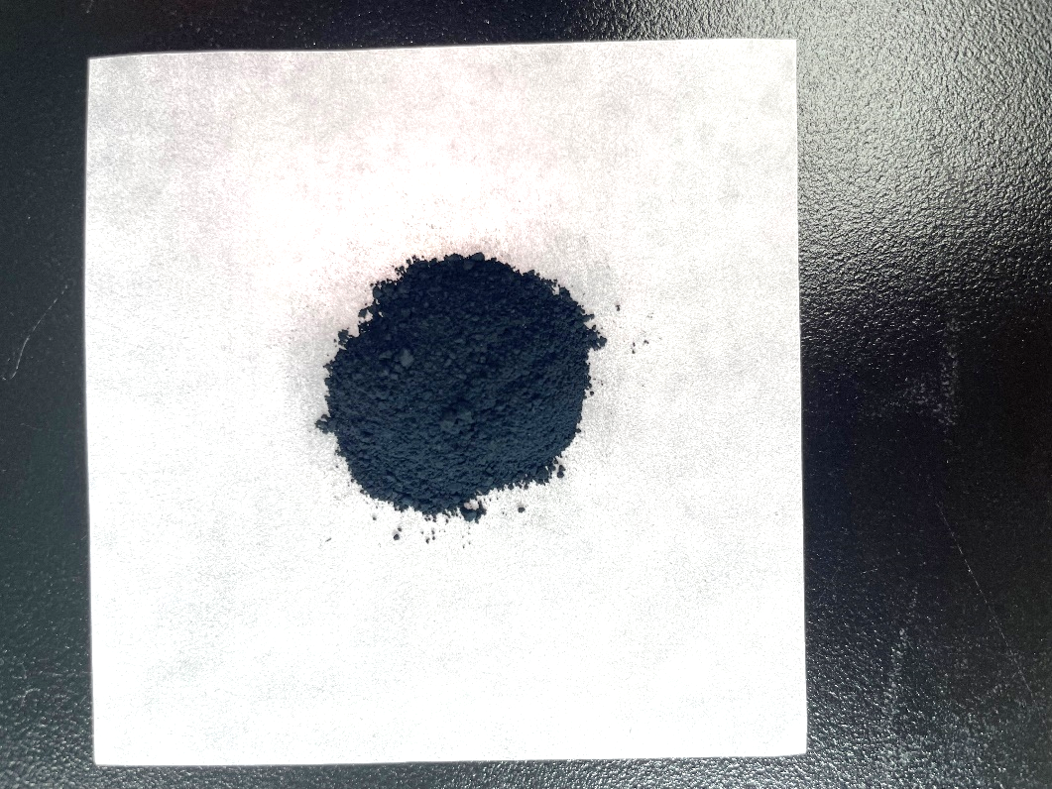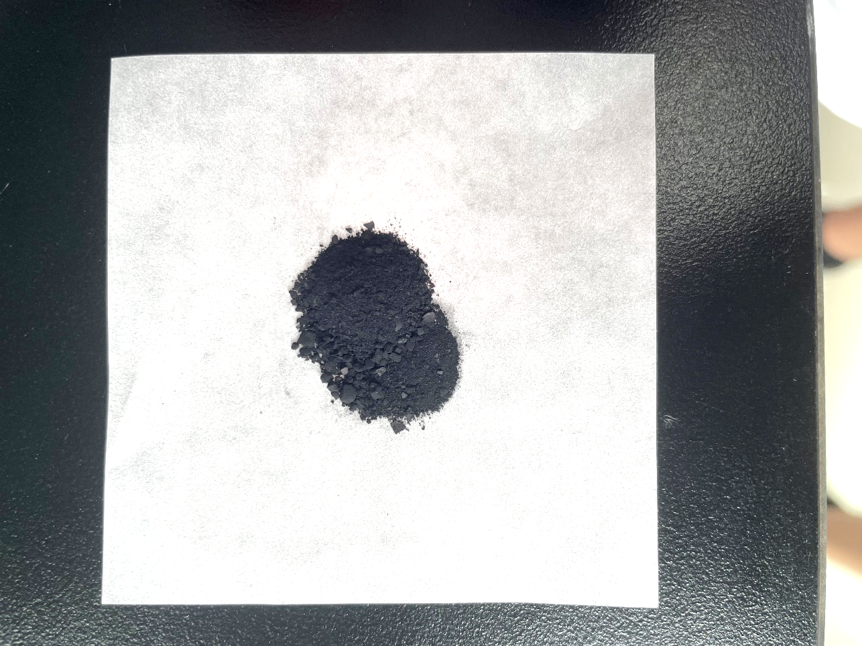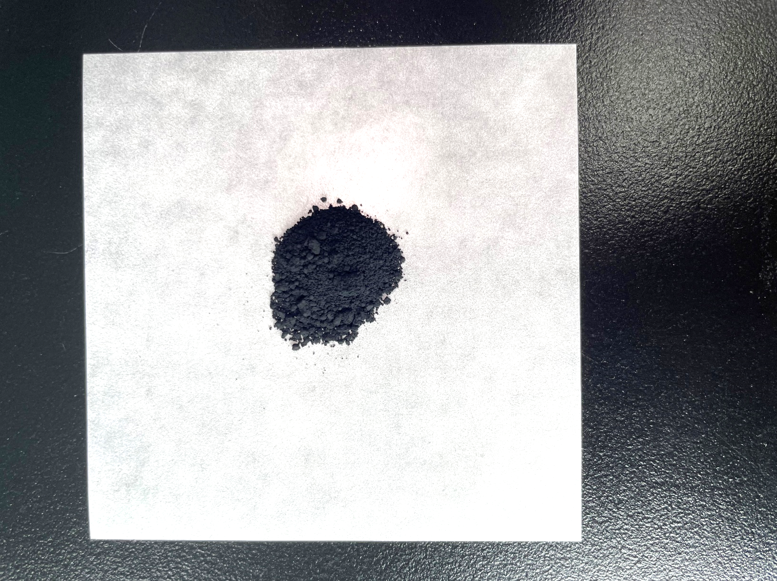
IrO₂(101) monolayer
IrO₂ NP
C-IrO₂ (Alfa Aesar)
C-IrO₂ (Umicore)
Supplementary Fig. 6 Photos taken by IrO₂(101) monolayer, IrO₂ NP, C-IrO₂ (Alfa Aesar) and C-IrO₂ (Umicore) on weighing paper.

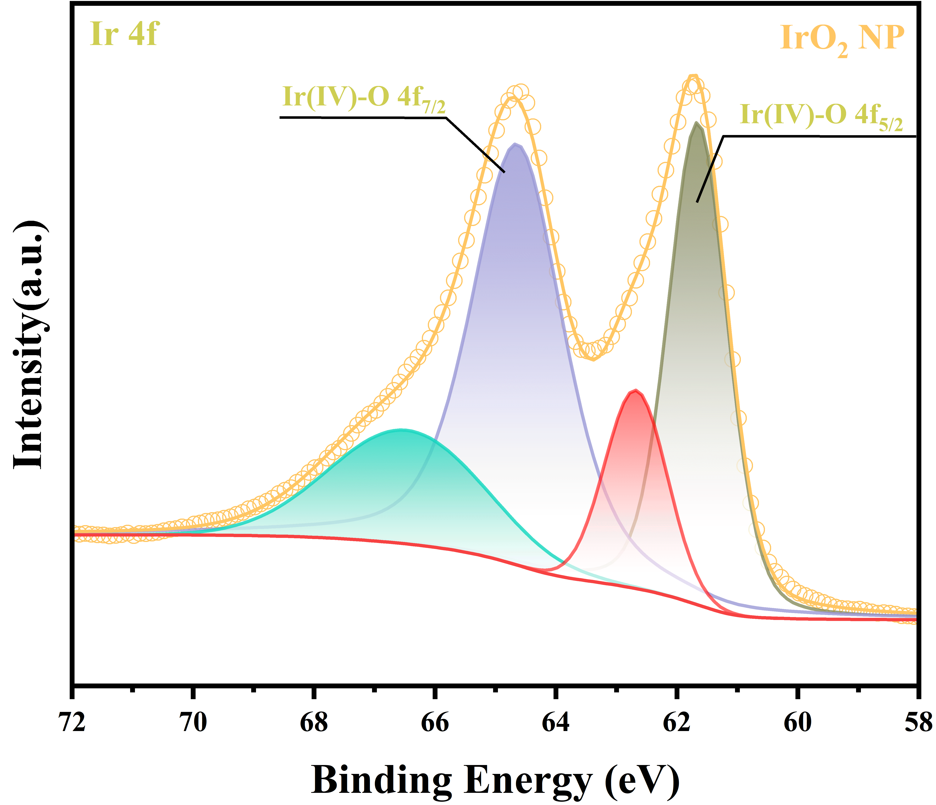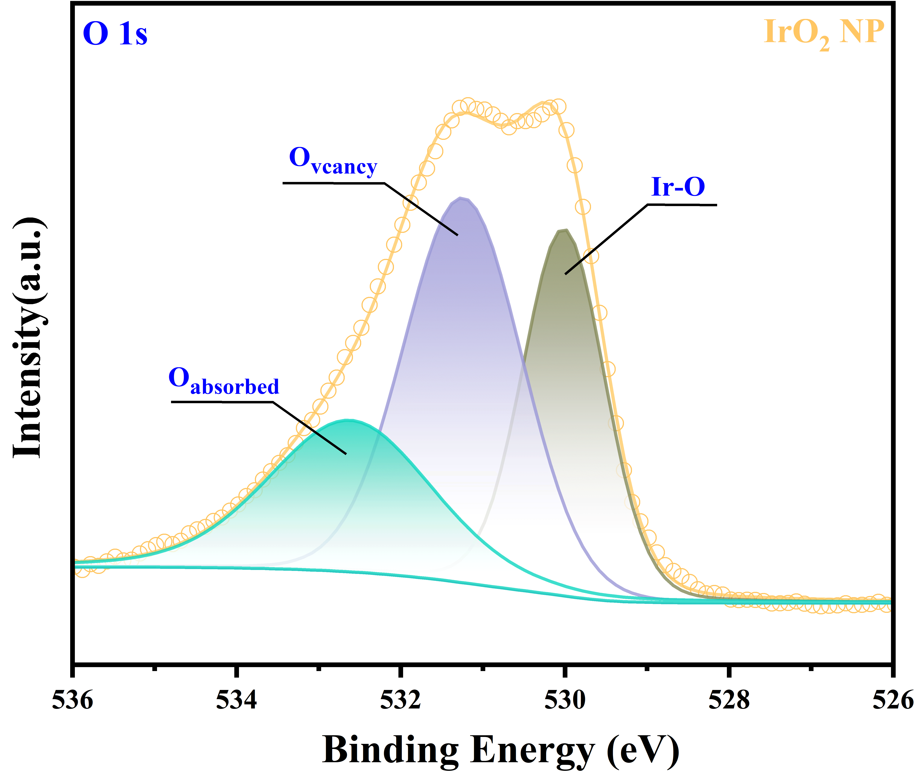
b
a

Supplementary Fig. 7 (a) Ir 4f, (b) O 1s XPS spectra of IrO₂ NP.

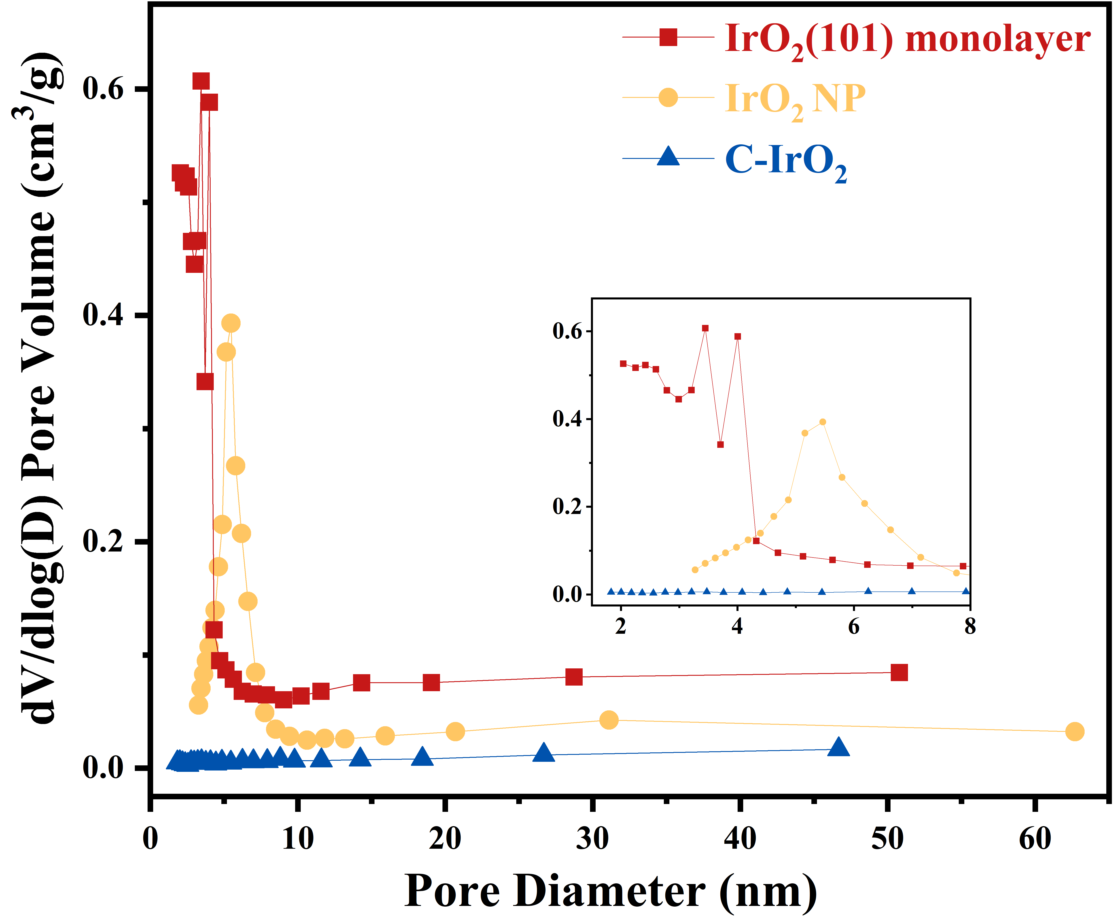
Supplementary Fig. 8 Pore diameter distribution of IrO₂(101) monolayer, IrO₂ NP and C-IrO₂. Inset shows the pore diameter distribution from 2 to 8 nanometers.

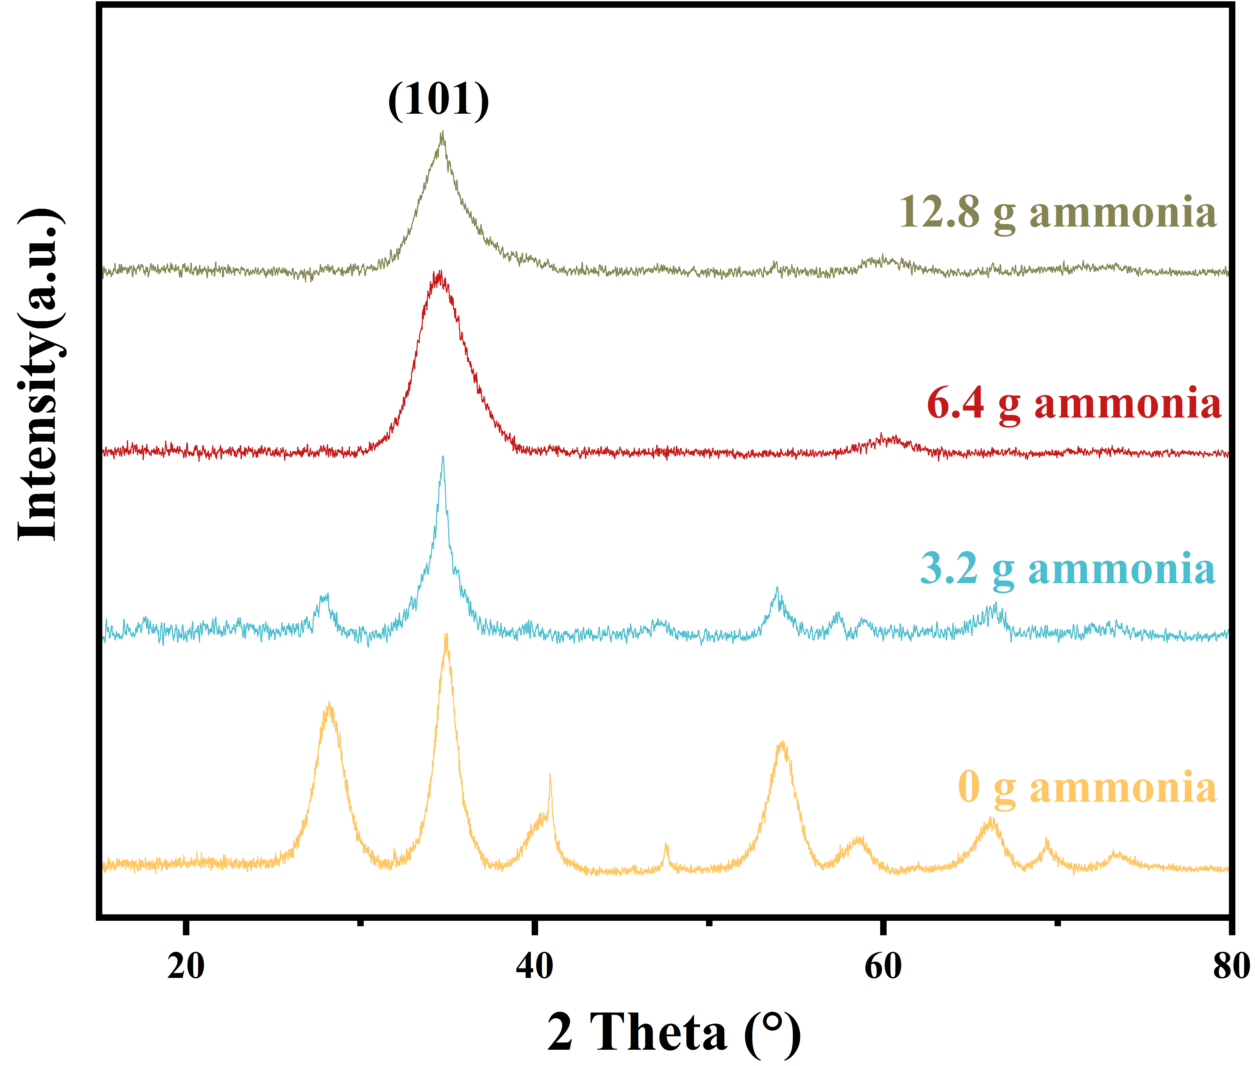
Supplementary Fig. 9 XRD patterns of IrO₂ synthesized with 0 g, 3.2 g, 6.4 g and 12.8 g ammonia, respectively.

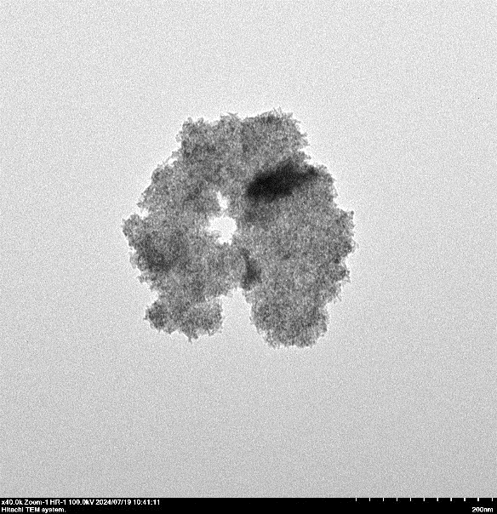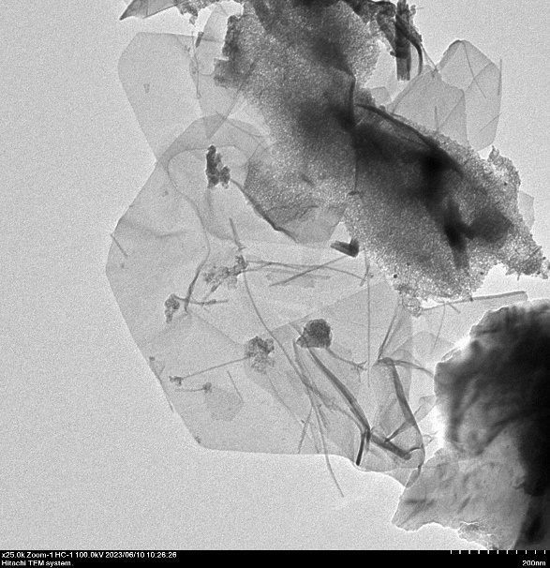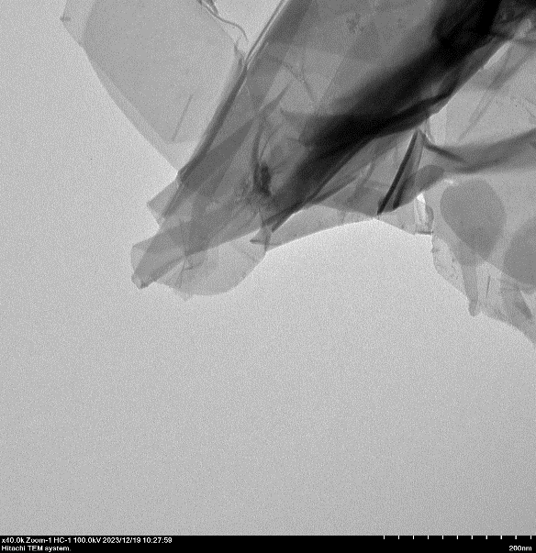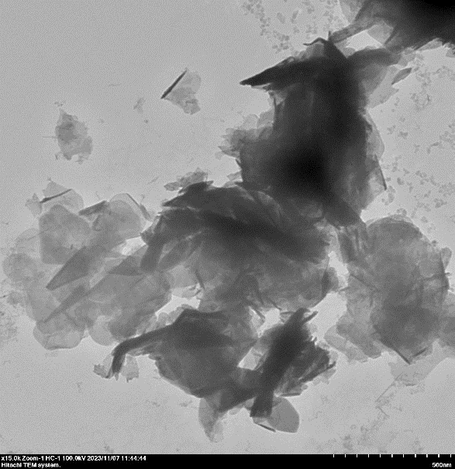
b
a
200 nm
c
d
500 nm
200 nm
200 nm
Supplementary Fig. 10 TEM images of IrO₂ synthesized with (a) 0 g, (b) 3.2 g, (c) 6.4 g and (d) 12.8 g ammonia, respectively.

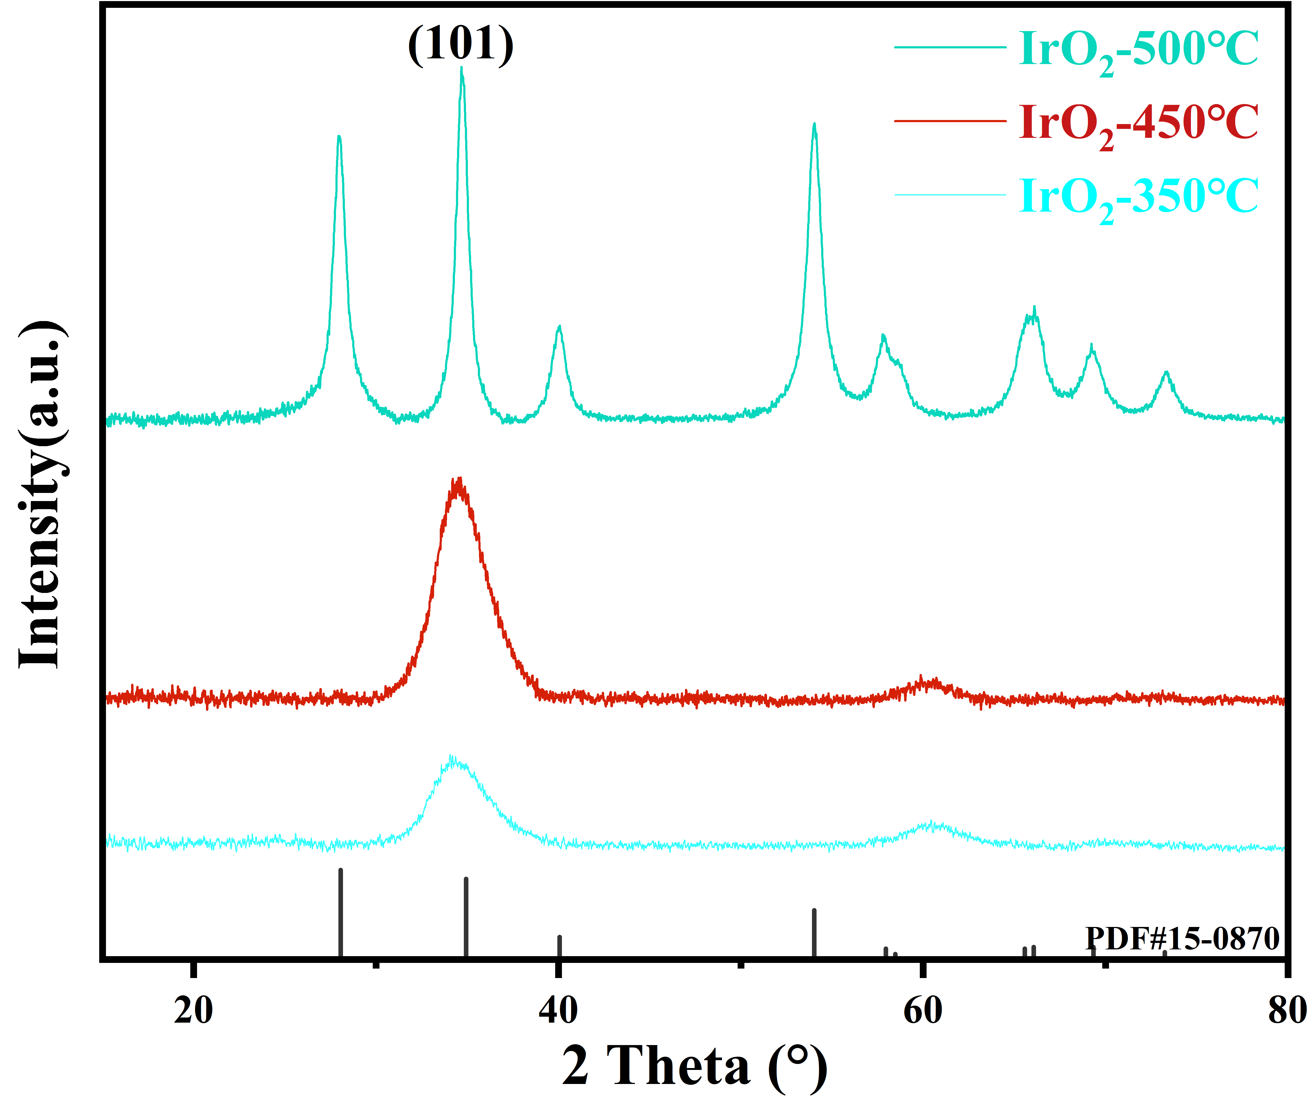
Supplementary Fig. 11 XRD patterns of IrO₂ synthesized at different calcination temperatures.

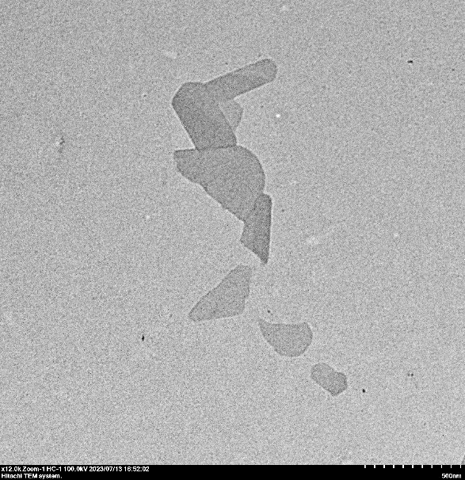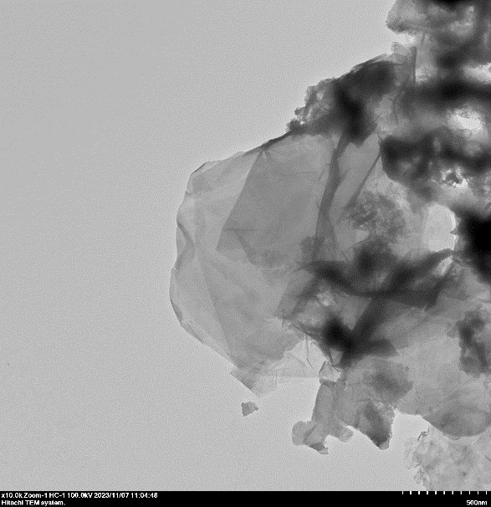
Supplementary Fig. 12 TEM images of IrO₂ synthesized at (a) 350 ℃ and (b) 550 ℃.
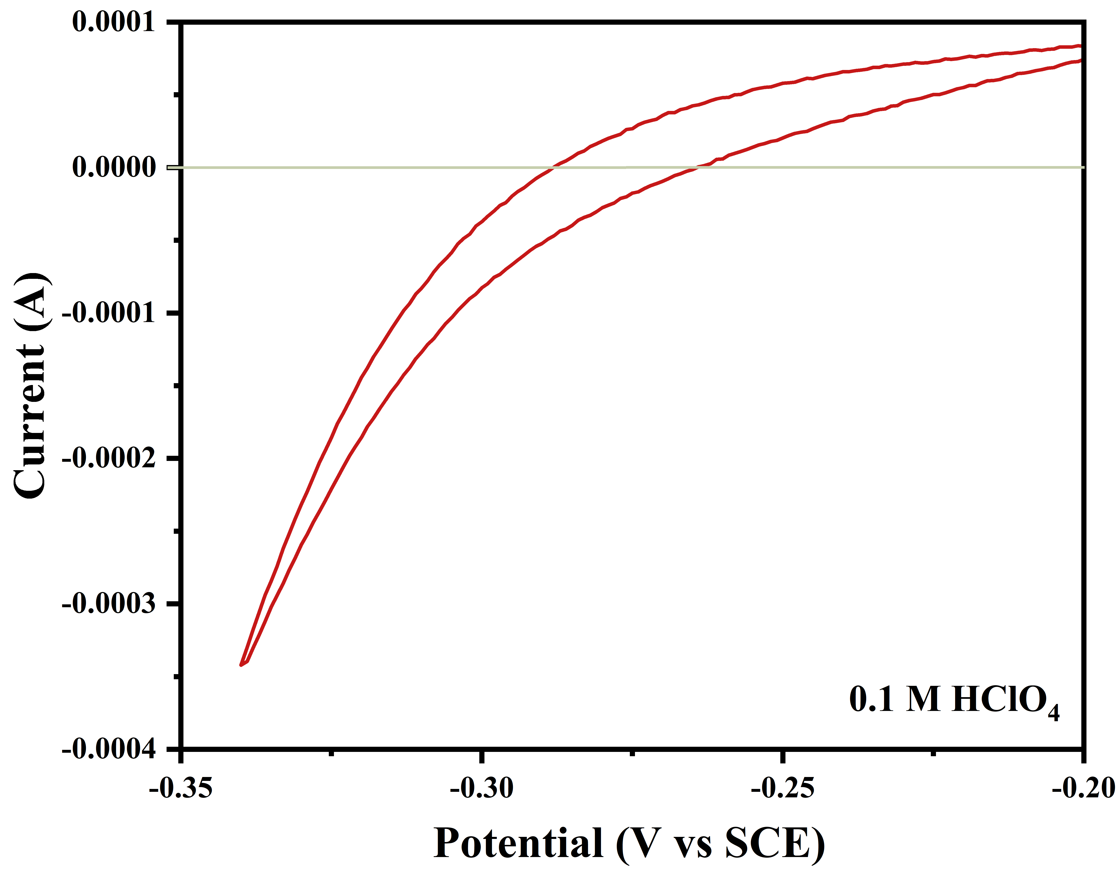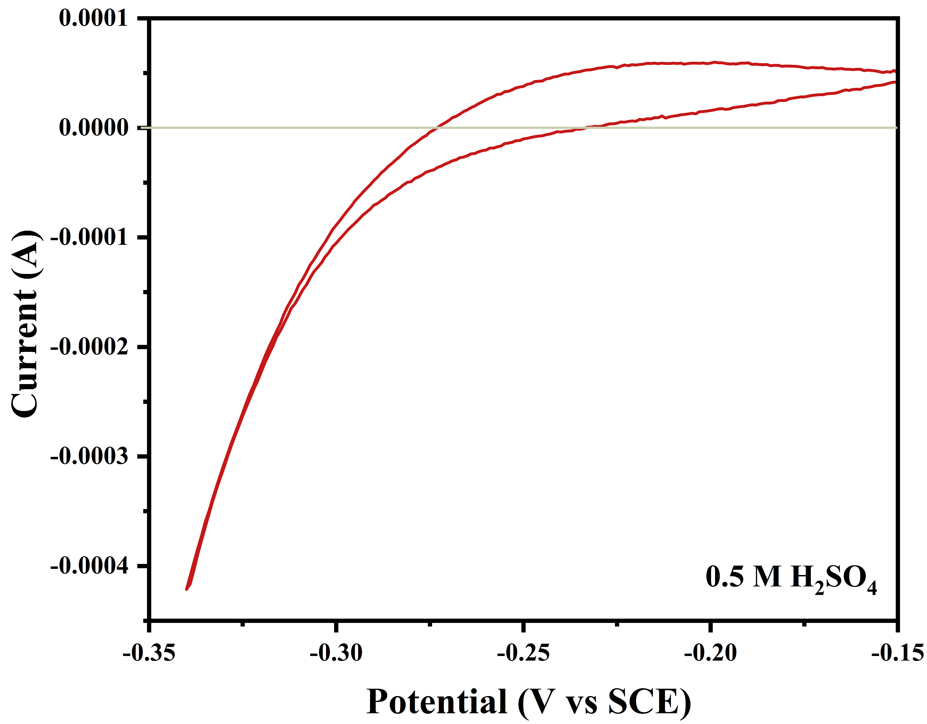
b
a
Supplementary Fig. 13 Calibration of the saturated calomel electrode (SCE) electrode with respect to reversible hydrogen electrode (RHE) in a) 0.1 M HClO₄ and b) 0.5 M H₂SO₄ aqueous electrolytes bubbled with pure hydrogen gas at room temperature. Scan rate: 1 mV s⁻¹.

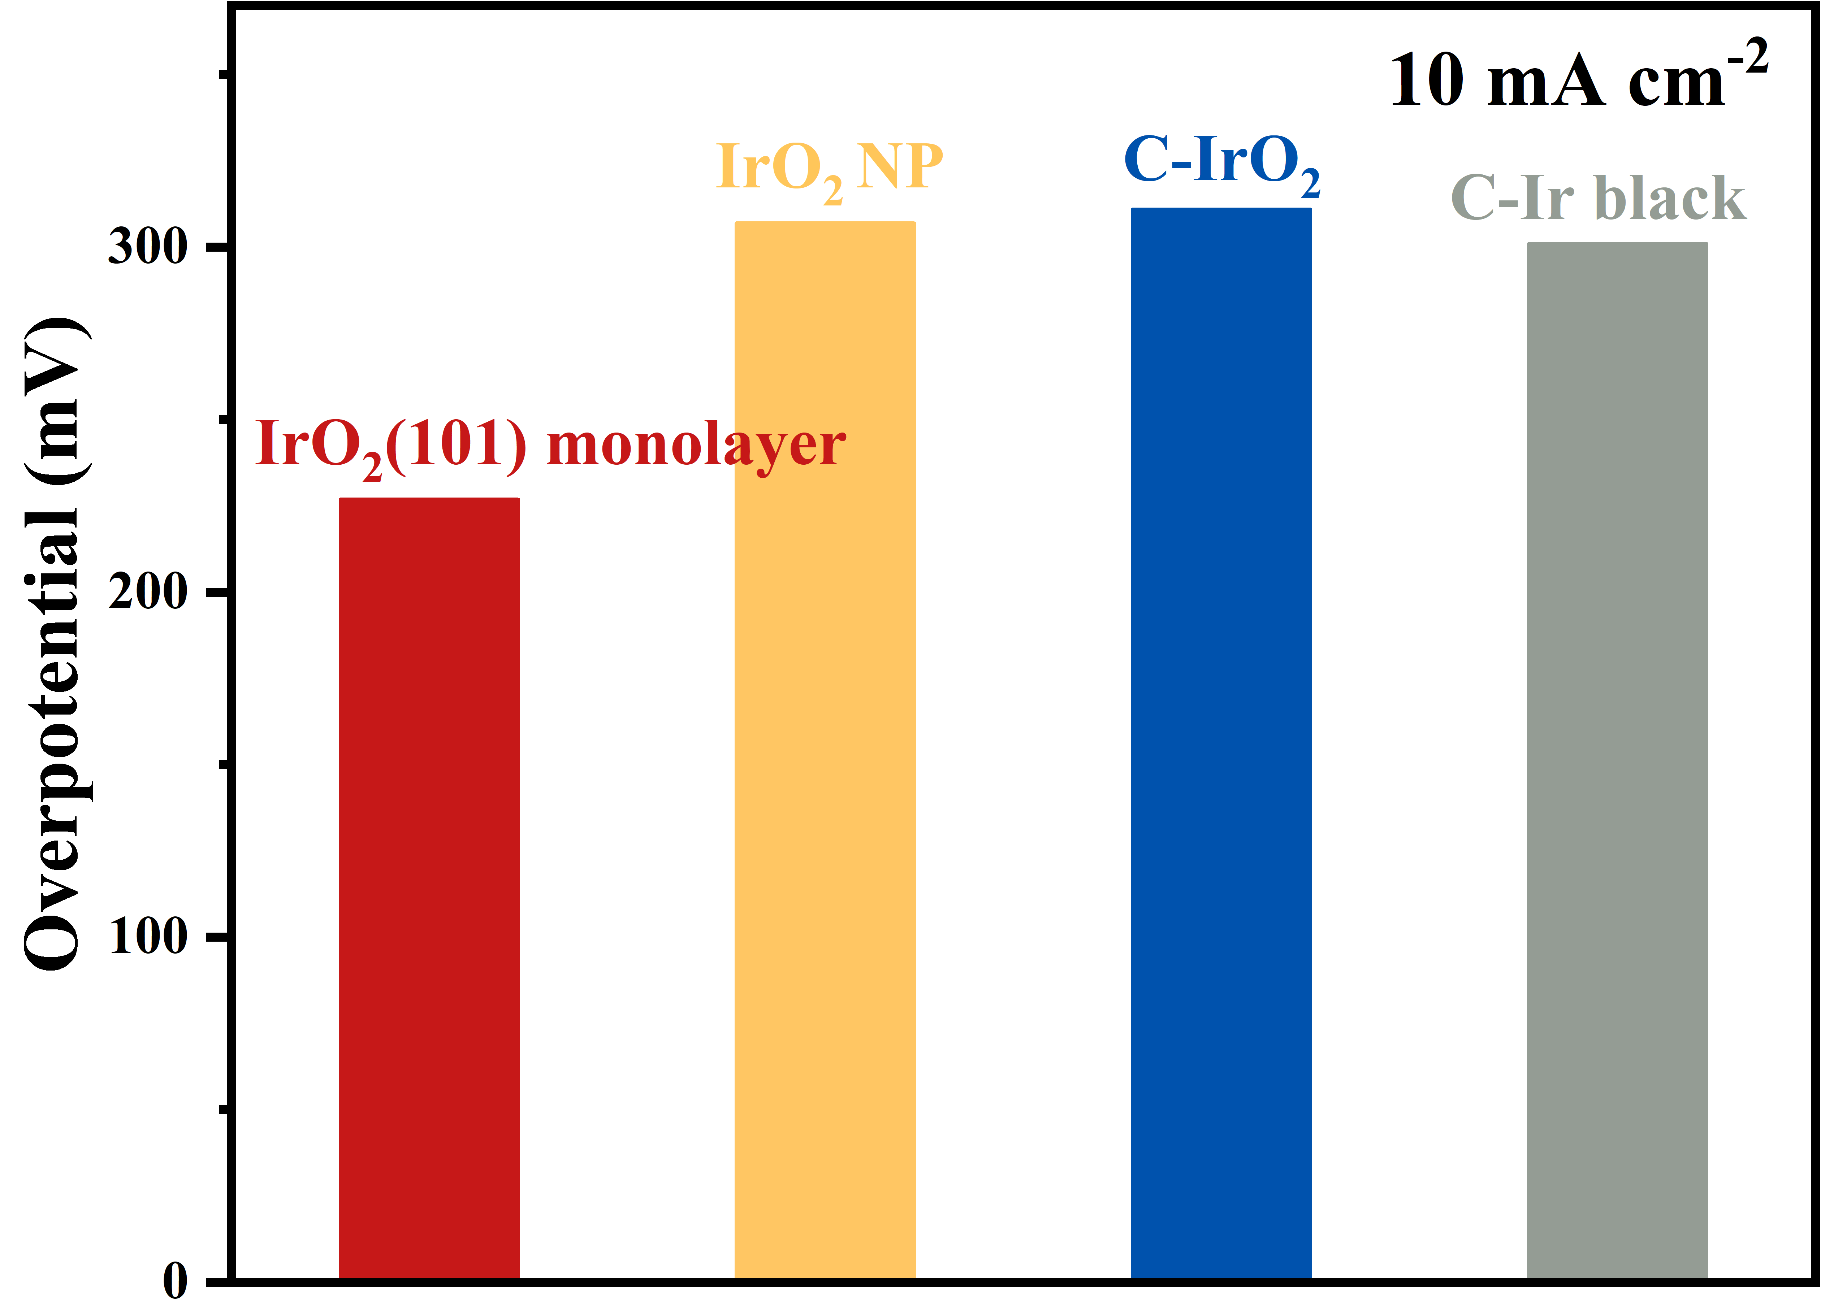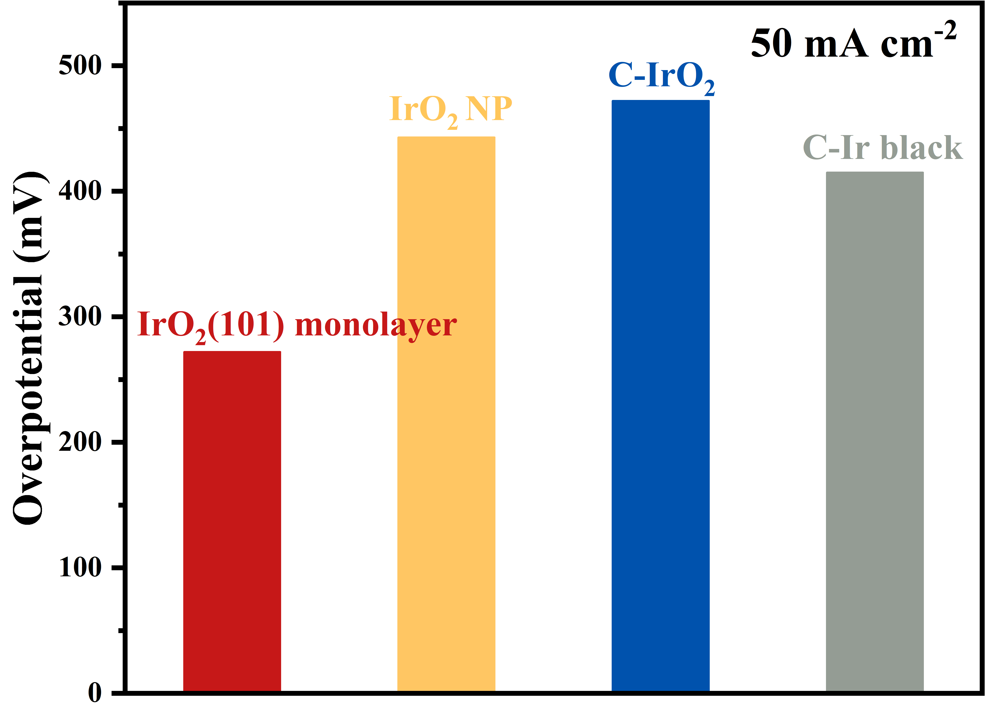
a
b
Supplementary Fig. 14 Comparison of overpotential at (a) 10 mA cm⁻² and (b) 50 mA cm⁻² for IrO₂(101) monolayer, IrO₂ NP, C-IrO₂, and C-Ir black.

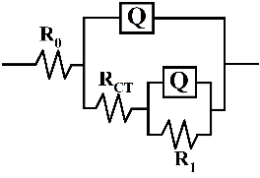
Supplementary Fig. 15 EIS curves of IrO₂(101) monolayer, IrO₂ NP, C-IrO₂, and C-Ir black in O₂-saturated 0.1 M HClO₄ electrolyte.

b
a
Supplementary Fig. 16 Adhesion test of membrane electrodes to bubbles with (a) IrO₂(101) monolayer, (b) IrO₂ NP and C-IrO₂, bubbles contact membrane electrode at position 1, are compressed to maximum extent at position 2, and are detached from membrane electrode at position 3.

b
a
Supplementary Fig. 17 Comparison of (a) geometric activities, (b) ECSA-based activities at 1.50 V vs. RHE for IrO₂(101) monolayer, IrO₂ NP, C-IrO₂, and C-Ir black.

a
b
c
d
Supplementary Fig. 18 CV curves at different sweep speeds of (a) IrO₂(101) monolayer and (c) Clean GC, C_{DL} fitting curves of (b) IrO₂(101) monolayer and (d) Clean GC in O₂-saturated 0.5 M H₂SO₄ electrolyte.
f
e
d
c
b
a

Supplementary Fig. 19 CV curves at different sweep speeds of (a) IrO₂ NP, (c) C-IrO₂ and (e) C-Ir black, C_{DL} fitting curves of (b) IrO₂ NP, (d) C-IrO₂ and (f) C-Ir black in O₂-saturated 0.5 M H₂SO₄ electrolyte.

c
d
a
b
Supplementary Fig. 20 (a) Polarization curves, (b) Tafel plots, (c) Mass activisities at 1.5 V vs RHE and (d) EIS curves of IrO₂(101) monolayer, IrO₂ NP, C-IrO₂, and C-Ir black in O₂-saturated 0.5 M H₂SO₄ electrolyte.

a
d
Supplementary Fig. 21 (a) Polarization curves, (b) Tafel plots of IrO₂ synthesized with 0 g 3.2 g, 6.4 g and 12.8 g ammonia in O₂-saturated 0.1 M HClO₄ electrolyte with iR-correction.
b
a
Supplementary Fig. 22 (a) Polarization curves, (b) Tafel plots of IrO₂ synthesized at 350 ℃, 450 ℃ and 550 ℃ in O₂-saturated 0.1 M HClO₄ electrolyte with iR-correction.

Supplementary Fig. 23 Durability test of IrO₂(101) monolayer at 200 mA cm⁻² in O₂-saturated 0.1 M HClO₄ electrolyte.

Supplementary Fig. 24 Cyclic voltammetry of IrO₂(101) monolayer. CV curves of the first and 10000th CV cycles in O₂-saturated 0.1 M HClO₄ electrolyte.

b
a
Supplementary Fig. 25 (a) Polarization curves before the first, after the 2,000th and 10,000th CV cycle. (b) Overpotential at 10 and 50 mA cm⁻² before the first, after the 2,000th and 10,000th CV cycle in O₂-saturated 0.1 M HClO₄ electrolyte.

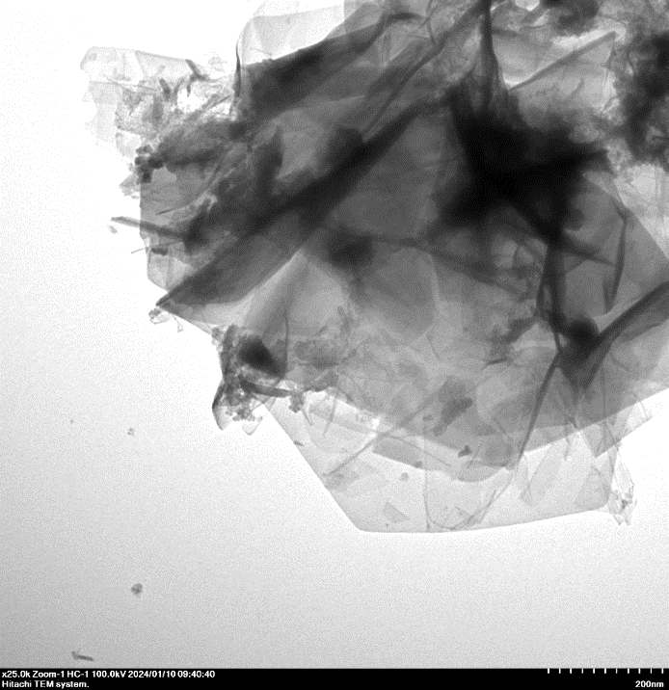
200 nm
Supplementary Fig. 26 TEM image of IrO₂(101) monolayer after durability test at 50 mA cm⁻² in O₂-saturated 0.1 M HClO₄ electrolyte.

Supplementary Fig. 27 Comparison of XRD before and after durability test at 50 mA cm⁻² in O₂-saturated 0.1 M HClO₄ electrolyte for IrO₂(101) monolayer.

Supplementary Fig. 28 Comparison of XPS spectra before and after durability test at 50 mA cm⁻² in O₂-saturated 0.1 M HClO₄ electrolyte for IrO₂(101) monolayer.


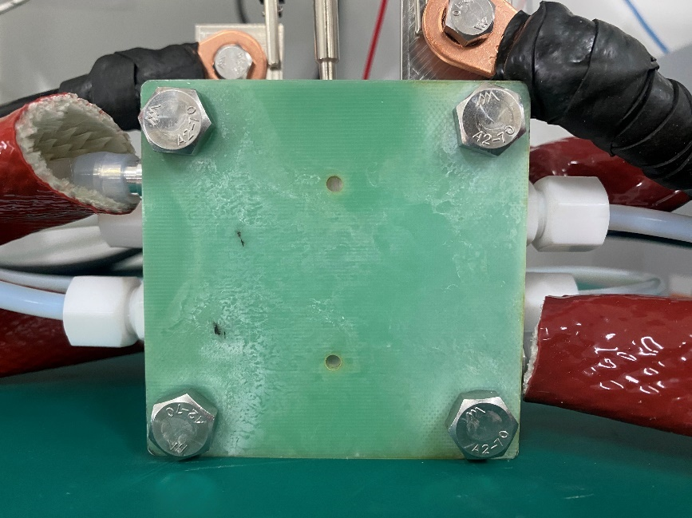
Supplementary Fig. 29 Photo of the PEM electrolyzer.

Supplementary Table 1 EDX result of IrO₂(101) monolayer.
Element | (keV) | Mass% | Counts | Sigma | Atom% | K
N K | 0.392 | 2.58 | 322.21 | 0.16 | 12.15 | 0.6898
O K | 0.525 | 14.38 | 2493.78 | 0.36 | 59.33 | 0.4971
Ir M | 1.977 | 83.05 | 7161.16 | 1.48 | 28.52 | 1.0000
Total |  | 100.00 |  |  | 100.00

Supplementary Table 2 Binding energy of signal peak in XPS spectra.
Catalyst | Ir(IV)-O 4f_{5/2} | Ir(IV)-O 4f_{7/2} | Ir-O | O_{vancy} | O_{absorbed}
IrO₂(101) monolayer | 64.92 | 61.87 | 530.08 | 531.6 | 533.42
IrO₂ NP | 64.67 | 61.67 | 530.03 | 531.26 | 532.65
C-IrO₂ | 64.87 | 61.95 | 530.08 | 531.41 | 533.05

Supplementary Table 3 Frequency of signal peaks in Raman spectra.
Catalyst | E_{g} | A_{1g}
IrO₂(101) monolayer | 540.09 | ——
IrO₂ NP | 543.55 | 714.50
C-IrO₂ | 547.71 | 712.47

Supplementary Table 4 Average pore diameter of IrO₂(101) monolayer, IrO₂ NP and C-IrO₂.
Catalyst | Average pore diameter (nm)
IrO₂(101) monolayer | 3.29
IrO₂ NP | 4.90
C-IrO₂ | 9.19

Supplementary Table 5 EXAFS parameters

Catalyst | Shell | N | σ² | R | R factor (%)
IrO₂(101) monolayer | Ir-O | 5.9 | 0.003 | 2.00 | 0.14
C-IrO₂ | Ir-O | 6.0 | 0.002 | 2.00 | 0.07
Ir foil | Ir- Ir | 12.0 | 0.003 | 2.71 | 0.63

Supplementary Table 6 Charge transfer resistance (R_{CT}) calculated by fitting EIS of IrO₂(101) monolayer, IrO₂ NP, C-IrO₂ and C-Ir black.

Catalyst | R_{CT} (ohm)
IrO₂(101) monolayer | 10.32
IrO₂ NP | 109.60
C-IrO₂ | 88.49
C-Ir black | 18.06

Supplementary Table 7 Inductively coupled plasma test of iridium dissolved in HClO₄ electrolyte after durability test at 50 mA cm⁻².
Catalyst | Label | 193 (KED) [ppb]
IrO₂(101) monolayer | 1 | 387.492
IrO₂(101) monolayer | 2 | 398.953
IrO₂(101) monolayer | 3 | 398.459
IrO₂(101) monolayer | Mean: | 394.968
IrO₂(101) monolayer | RSD [%]: | 1.6
IrO₂(101) monolayer | SD: | 6.5
IrO₂ NP | 1 | 446.569
IrO₂ NP | 2 | 391.611
IrO₂ NP | 3 | 452.126
IrO₂ NP | Mean: | 430.102
IrO₂ NP | RSD [%]: | 7.8
IrO₂ NP | SD: | 33.5
C- IrO₂ | 1 | 1244.936
C- IrO₂ | 2 | 1248.965
C- IrO₂ | 3 | 1123.690
C- IrO₂ | Mean: | 1205.846
C- IrO₂ | RSD [%]: | 5.9
C- IrO₂ | SD: | 71.2

Supplementary Table 8 S-number of IrO₂(101) monolayer, IrO₂ NP and and C- IrO₂
Catalyst | $n_{O_{2}}$(mol) | $n_{Ir}$(mol) | S-number
IrO₂(101) monolayer | 0.41976 | 9.05+e⁻⁸ | 4.64+e⁶
IrO₂ NP | 0.04741 | 9.86+e⁻⁸ | 4.18+ e⁵
C- IrO₂ | 0.03158 | 2.76+e⁻⁷ | 1.14+ e⁵

