rear lidar) at a given time, with accurate metadata for future reference.
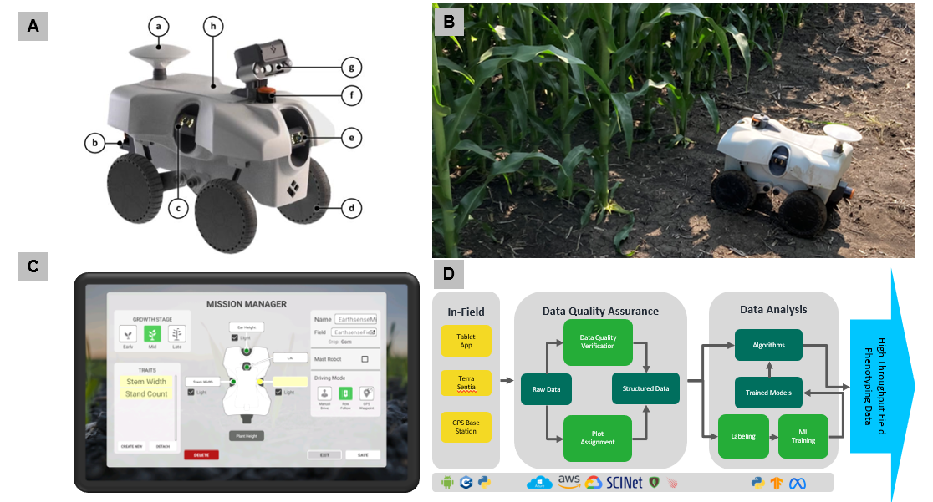
Figure S1. TerraSentia robots were used between 2019 and 2023 at 418 unique field locations x time combinations. Panel A documents key components of the robots: a) GPS antenna with RTK capabilities, b) 2D LiDAR (not shown) for trait measurements, c) right-side-facing gimbal stabilized high-definition RGB camera, d) 4-wheel independent drive with electric hub motors and independent suspensions, e) front-facing gimbal stabilized high-definition RGB camera, f) 2D LiDAR for autonomous navigation and trait measurement, g) stereo (RGB-D) cameras, swappable with Leaf Area Index camera or other sensors, h) battery bay for hot-swappable 22,000 mAh lithium batteries. Panel B demonstrates operation in a maize field, beginning outside of the first range and driving autonomously between rows through the column. Panel C displays one screen of the tablet app user interface, indicating ability to assign traits for each sensor. Panel D diagrams the components and data flow from the field, to cloud, to delivering high-throughput field phenotyping data to various end-users, such as crop scientists, crop breeders, and agronomists.
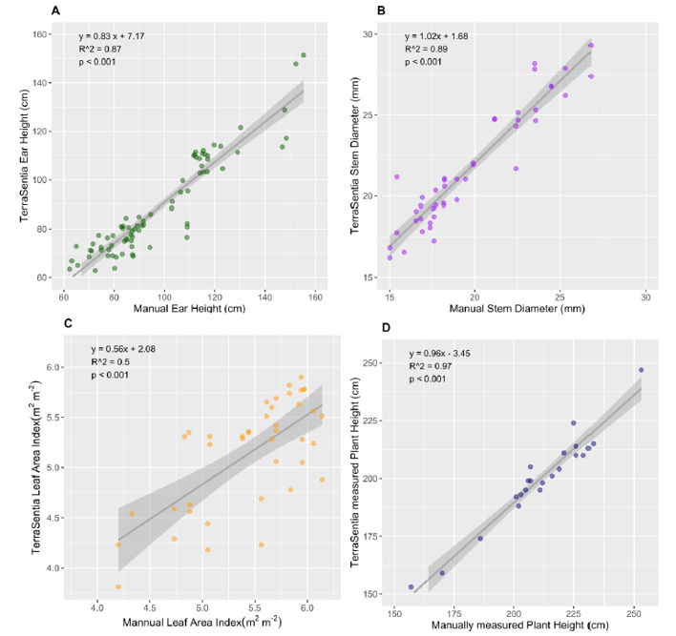
Figure S2. Validation of maize phenotypic traits collected by TerraSentia compared to manual measurements from the same experimental plots (A) Ear Height, (B) Stem Diameter, (C) Leaf Area Index and (D) Plant Height traits.

