Title: Gα15 signaling facilitates the initial phases of pancreas cell transformation and is associated with the basal-like/squamous subtype

Running title: The potential of GNA15 signature to trace elusive PDAC.

.

Supplementary Figures

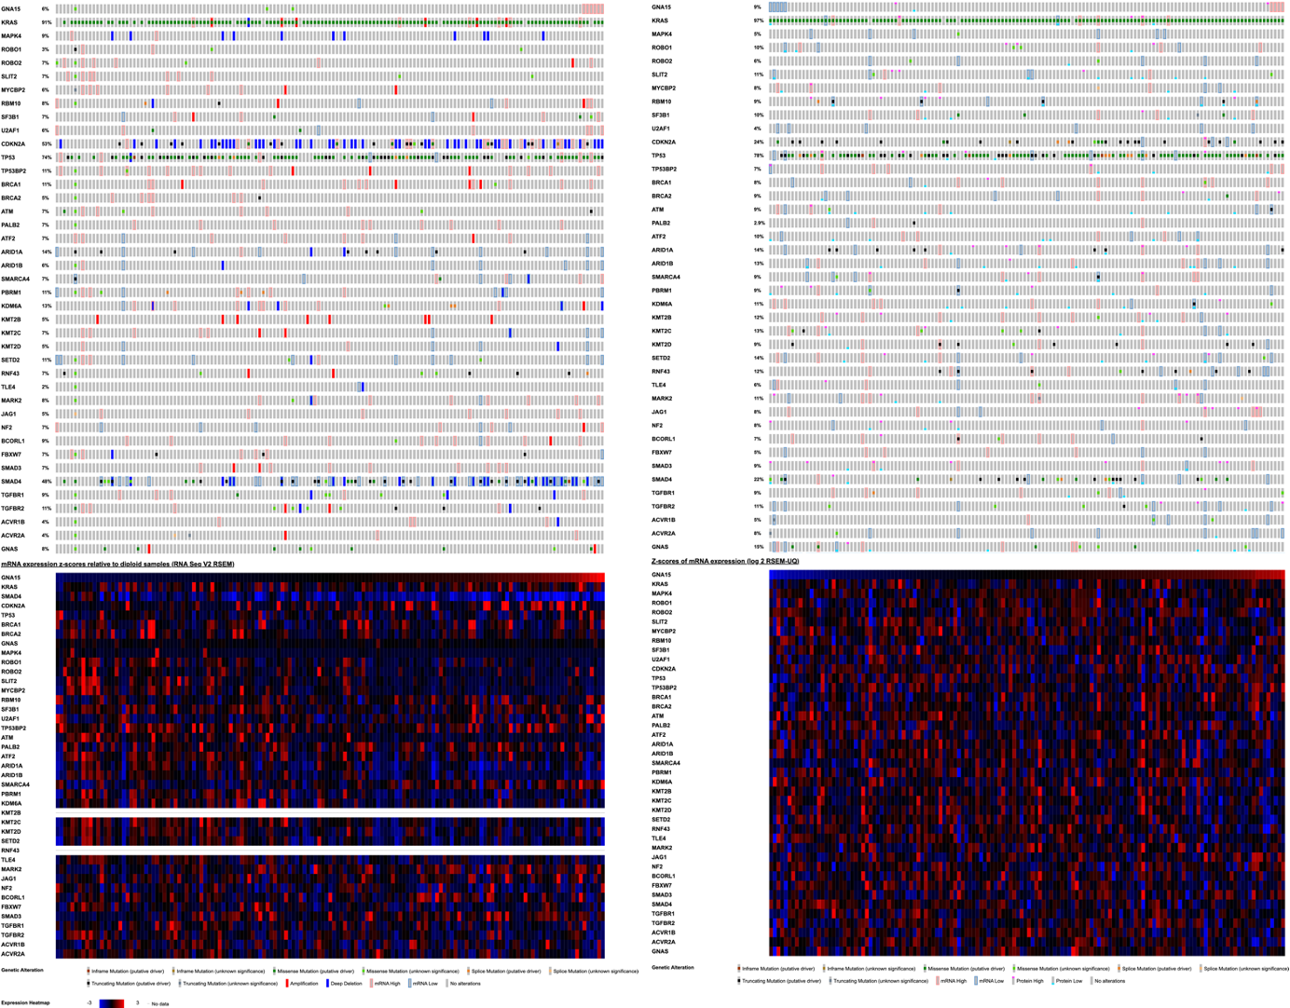
Supplementary Figure 1 – GNA15 expression and genomic aberrations characteristic of PDAC. Genes reported to carry mutations with over 5% prevalence were compared for expression and genetic aberrations with GNA15 expression level in TCGA-PAAD and TCGA-CPTC cohorts.

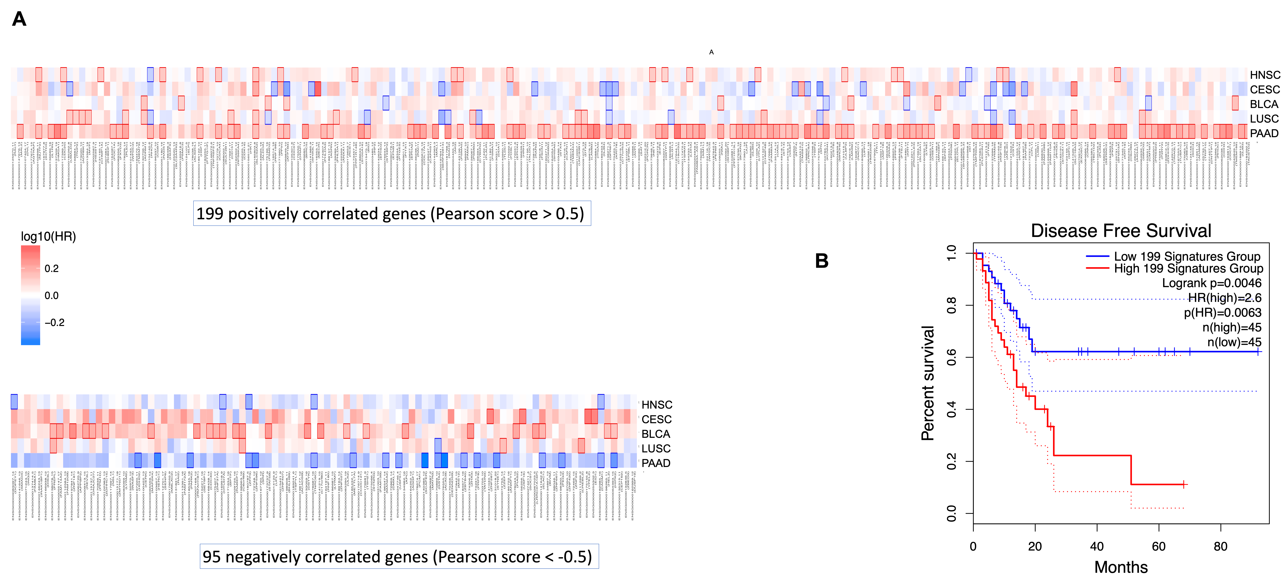 Supplementary Figure 2 – GEPIA2 analysis [1, 2] of the genes positively or negatively correlated with GNA15 expression in TCGA. A) In the upper panel, 200 genes were co-expressed with GNA15 reporting a Pearson score above 0.5, Mantel-Cox test was applied to estimate their prognostic value in predicting shorter disease-free survival among squamous cancer forms available (HNSC Head and Neck Squamous Carcinoma, CESC Cervical Squamous Cells Carcinoma, BLCA Bladder Cancer, LUSC Lung Squamous Cells Carcinoma). The same analysis performed with 95 genes that anti-correlated with Pearson score below -0.5 predicted longer disease-free survival. B) Disease free survival calculating the HR using 200 .co-expressed genes. Dotted lines represent the 95% confidence interval. HR is the hazards ratio based on Cox PH Model. Group cut-off by quartile.

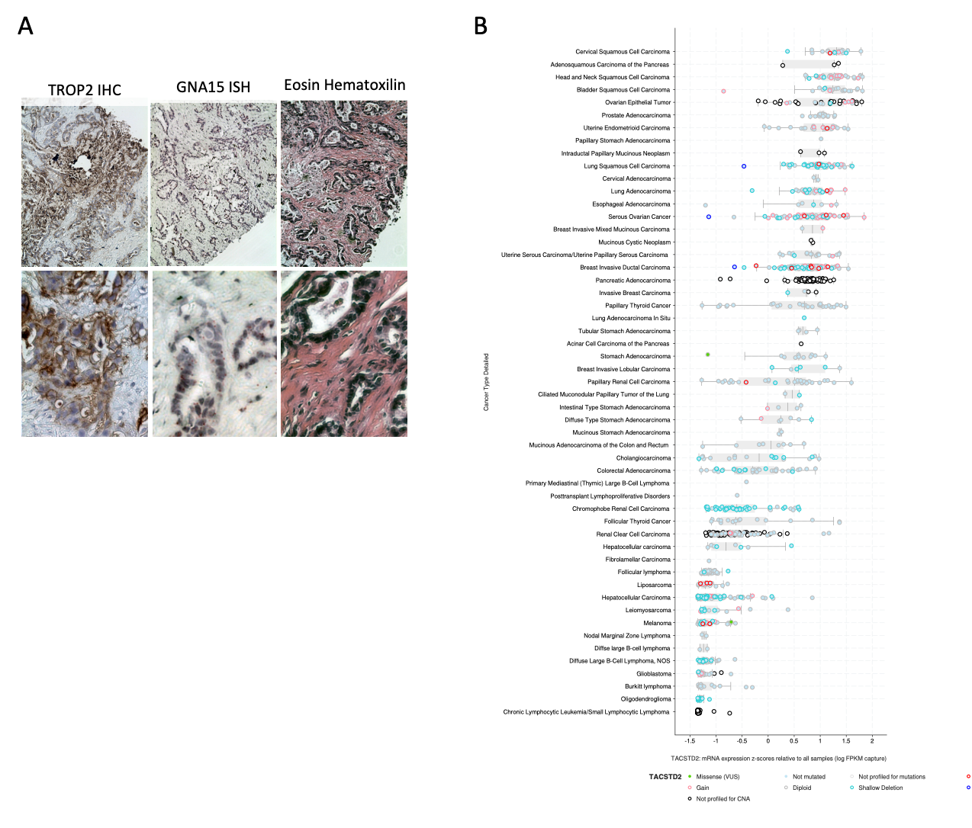
Supplementary Figure 3 – TACSTD2 distribution A) Serial sections of PDAC cases analyzing TACSTD2 by Immunohistochemistry and GNA15 by ISH. B) TACSTD2 mRNA expression in PANCAN.
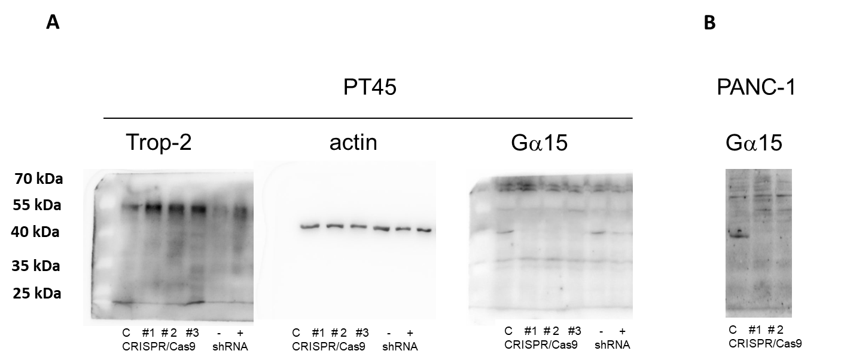

Supplementary Figure 4 – Western blot analysis of Gα15 and Trop-2 expression. A) Full length blot membranes of the panels in Figure 3A. B) Validation of Gα15 loss of expression in PANC-1 cells CRISPR/Cas9 KO clones.

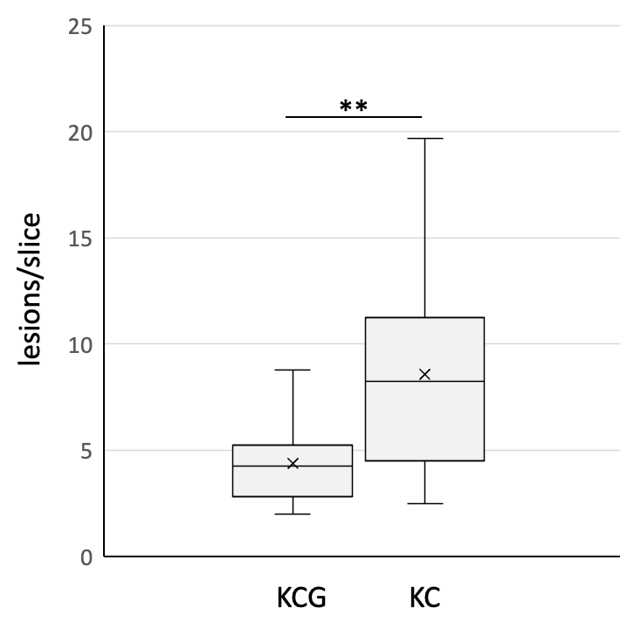
Supplementary Figure 5 –Lesion density of in KC vs KCG mice. Lesion density measured in serial sections prepared from the same mice described in Fig. 6. (** Unpaired T test 2 tails p value ** <0.005).

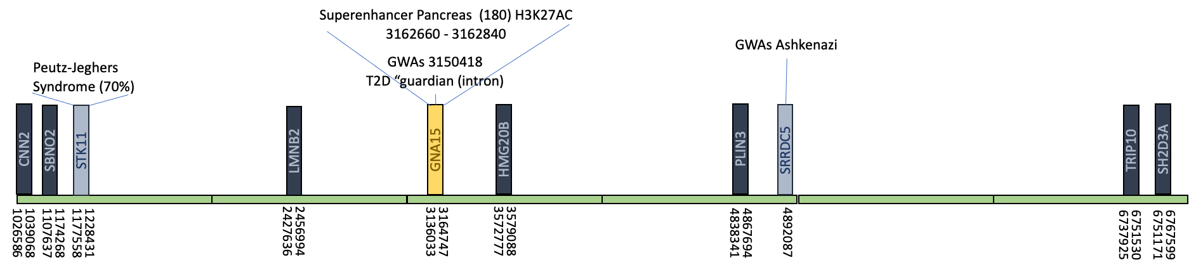
Supplementary Figure 6 - Scheme of the19p13.3 locus surrounding GNA15. In blue genes in the top 70 co-expression list in PDAC. Hoglund et al. [3] reported a structural rearrangement of chromosome 19 in 8 out 9 cases of PDAC. 6 cases displayed a gain of function of 19q with 19q13.1-13.2 (PLAUR is 19q13.3) being the commonly overexpressed segment. 7 displayed 19 p losses always including 19p13.3. This same region was reported as a susceptibility locus by a pooled genome-wide association (GWAS) study that analyzed a population of American Jewish, largely Ashkenazi, that have higher risk to develop PDAC [4]. Additional hints point to this locus for predisposing factors for PDAC development. The GUARDIAN GWAS study associated a SNP in the third intron of GNA15 to type 2 diabetes. The GWAS catalogue (https://www.ebi.ac.uk/gwas/genes/GNA15) reports associations with obesity-related traits simultaneously present with asthma [5] and immunity and respiratory clinical traits [6-8], heart failure [9], myocarditis [10] mean cell hemoglobin [11]. Ch19p.13.3 is also associated to Peutz-Jagher syndrome a predisposing factor for PDAC. However, the phenotype is due to the loss of an oncosuppressor, STK1, rather than a gain in expression of the signature genes. Neighboring this locus, CDKN2D is encoded in ch. 19p13.2, CDNK2D, was co-expressed with GNA15 and reported to influence the adhesive properties of mesenchymal amniotic fluid cell [12]. CDNK2D was involved in PDAC cell proliferation and angiogenesis [13]. A search for superenhancers (http://sea.edbc.org/) up to 50 kb upstream GNA15 produced 12 hits. A 180 bp long region is marked as an active enhancer by h3k27ac that was previously suggested to play a role in controlling the expression of PDAC oncogenes [14] and to be under KRAS control [15]. Changes in H3K27ac during PDAC progression have been claimed to links anabolic glucose metabolism to distant metastasis [16]

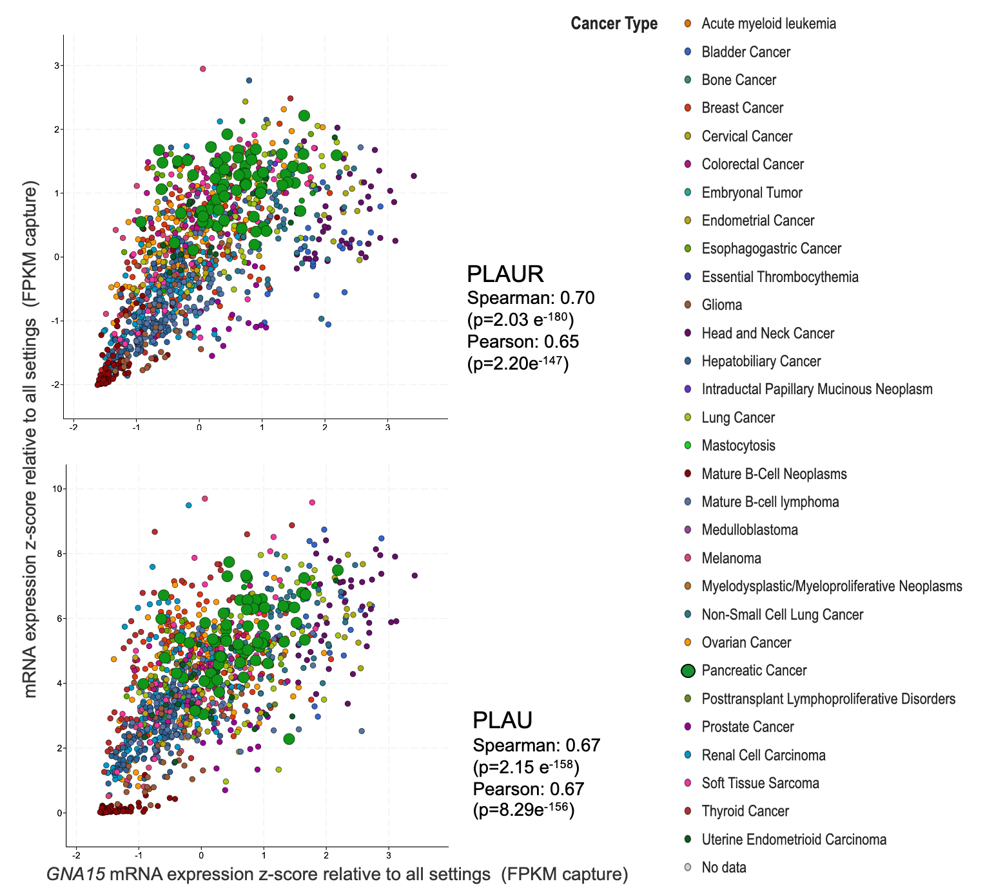
Supplementary Figure 7 – Correlation between GNA15 expression and the top two genes in the TCGA-ICGC data in neoplasia arisen in various tissues.

Supplementary Tables
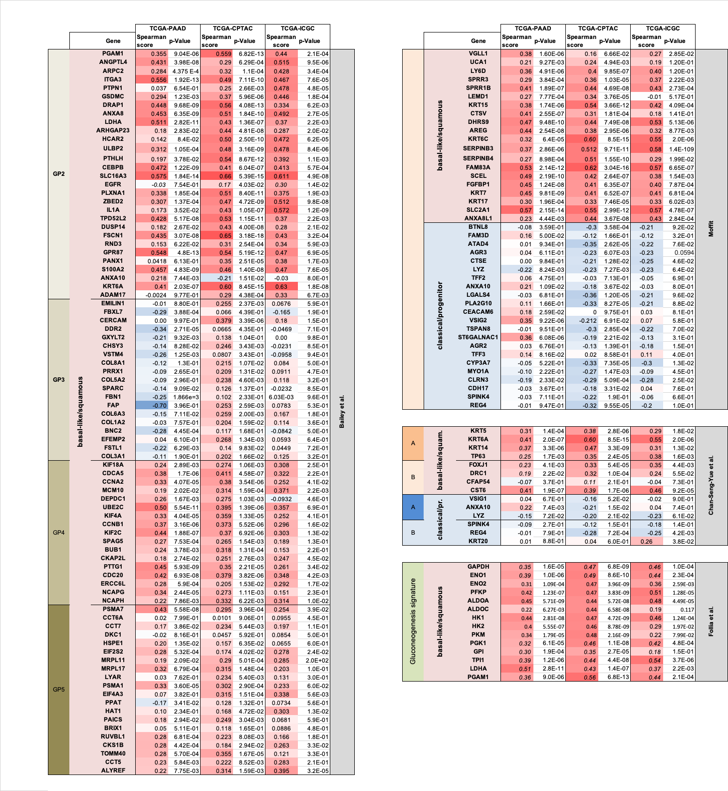
Supplementary Table 1 - GNA15 associated genes in PDAC TCGA cohorts. The table analyzes biomarkers of the different molecular subtypes and relative subgroups identified by different authors (Bailey et al.[17], Moffit et al. [18], Chan-Seng-Yue [19] et al., Follia et al. [20]) for positively (red background) or negatively (blue background) correlated with GNA15 expression according to Pearson’s scores in TCGA-PAAD, CPTAC and PDAC cases in TCGA-ICGC.

Gene name | Chromosomal position | Previous involvement with GNA15 in PDAC signature | Previous involvement with invasive trophoblast | TCGA-PAAD |  |  | TCGA-IGCG |  |  | CPTAC
 | Chromosomal position | Previous involvement with GNA15 in PDAC signature | Previous involvement with invasive trophoblast | Spearman’s correlation | p-Value | q-Value | Spearman’s correlation | p-Value | q-Value | Spearman’s correlation | p-Value | q-Value
GNA15 | 19p13.3 | [2, 21-29]
TACSTD2 | 1p32.1 | [22-24] | [30] | 0.72 | 1.5E-28 | 2.9E-24 | 0.57 | 1.1E-105 | 8.8E-103 | 0.42 | 8.4E-8 | 8.2E-6
GJB3 | 1p34.3 | [21, 22] | [31] | 0.67 | 2.6E-23 | 2.6E-19 | 0.56 | 1.2E-102 | 8.5E-100 | 0.51 | 1.4E-10 | 8.5E-8
TRIP10 | 19p13.3 | [29] |  | 0.67 | 6.0E-23 | 3.9E-19 | 0.39 | 1.7E-45 | 4.9E-44 | 0.51 | 1.0E-10 | 5.4E-8
LY6E | 8q24.3 | [2] | [32] | 0.66 | 4.1E-22 | 2.0E-18 | 0.38 | 5.9E-44 | 1.6E-42 | 0.34 | 3.4E-5 | 7.1E-4
ING3 | 7q31.31 |  |  | -0.65 | 2.2E-21 | 7.2E-18 | -0.29 | 1.2E-25 | 1.1E-24 | -0.33 | 7.4E-5 | 1.3E-3
RHOC | 1p13. |  | [33] | 0.65 | 1.6E-21 | 6.2E-18 | 0.31 | 1.6E-27 | 1.7E-26 | 0.40 | 8.9E-7 | 4.6E-5
CDH3 | 16q22.1 | [22, 24, 29] | [34] | 0.64 | 5.3E-21 | 1.2E-17 | 0.54 | 3.2E-92 | 1.2E-89 | 0.66 | 3.4E-19 | 4.9E-15
DNTTIP1 | 20q13.12 |  |  | 0.64 | 4.2E-21 | 1.0E-17 | 0.37 | 1.9E-39 | 4.0E-38 | 0.35 | 2.2E-5 | 5.3E-4
PEDS1 | 20q13.13 |  |  | 0.63 | 6.5E-20 | 8.0E-17 | 0.45 | 1.5E-61 | 1.1E-59 | 0.50 | 4.9E-10 | 1.8E-7
SLC2A1 | 1p34.2 | [29] | [35] | 0.63 | 4.4E-20 | 6.2E-17 | 0.45 | 4.0E-60 | 2.6E-58 | 0.54 | 8.0E-12 | 8.6E-9
CDCP1 | 3p21.31 | [22, 29] | [36] | 0.62 | 4.3E-19 | 3.0E-16 | 0.54 | 8.8E-94 | 3.4E-91 | 0.43 | 1.4E-7 | 1.4E-5
P2RY2 | 11q13.4 | [2, 29] | [37] | 0.62 | 5.8E-19 | 3.5E-16 | 0.45 | 3.1E-60 | 2.1E-58 | 0.52 | 4.4E-11 | 3.0E-8
NMU | 4q12 | [25] |  | 0.62 | 2.8E-19 | 2.2E-16 | 0.47 | 2.4E-66 | 2.3E-64 | 0.26 | 2.4E-3 | 0.016
SH2D3A | 19p13.3 | [22, 24] |  | 0.62 | 5.8E-19 | 3.5E-16 | 0.25 | 4.6E-19 | 3.0E-18 | 0.31 | 2.2E-4 | 2.9E-3
KRT19 | 17q21.2 | [22, 26, 29] |  | 0.61 | 1.2E-18 | 6.3E-16 | 0.52 | 4.1E-85 | 1.0E-82 | 0.57 | 2.6E-13 | 5.6E-10
GPR87 | 3q25.1 | [22, 29] |  | 0.60 | 9.4E-18 | 3.3E-15 | 0.55 | 3.5E-97 | 1.7E-94 | 0.54 | 5.2E-12 | 6.1E-9
SMAD4 | 18q21.2 |  |  | -0.59 | 6.6E-17 | 1.7E-14 | -0.37 | 6.2E-40 | 1.3E-38 | -0.38 | 4.1E-6 | 1.5E-4
SBNO2 | 19p13.3 |  |  | 0.58 | 1.9E-16 | 3.9E-14 | 0.45 | 1.8E-60 | 1.2E-58 | 0.52 | 3.8E-11 | 2.6E-8
PLIN3 | 19p13.3 | [29] | [38] | 0.57 | 6.7E-16 | 1.2E-13 | 0.55 | 1.2E-98 | 6.4E-96 | 0.69 | 1.2E-20 | 2.9E-16
PLAUR | 19q13.31 | [27, 28] | [39] | 0.55 | 1.6E-14 | 1.7E-12 | 0.70 | 2.0E-180 | 6.8E-176 | 0.43 | 8.8E-8 | 8.4E-6
UBE2C | 20q13.12 |  |  | 0.55 | 6.8E-15 | 8.0E-13 | 0.39 | 7.1E-46 | 2.1E-44 | 0.40 | 1.4E-6 | 6.6E-5
CNN2 | 19p13.3 |  |  | 0.51 | 2.9E-12 | 1.4E-10 | 0.44 | 3.7E-58 | 2.2E-56 | 0.36 | 1.1E-5 | 3.1E-4
HMG20B | 19p13.3 |  |  | 0.52 | 3.5E-13 | 2.4E-11 | 0.13 | 4.0E-06 | 9.9E-06 | 0.46 | 1.6E-7 | 1.24E-5
LMNB2 | 19p13.3 |  |  | 0.48 | 3.8E-11 | 1.2E-09 | 0.43 | 5.6E-55 | 2.8E-53 | 0.47 | 5.0E-9 | 8.7E-7
PLAU | 10q22.2 | [29] | [40] | 0.47 | 1.5E-10 | 3.8E-09 | 0.67 | 2.1E-158 | 3.6E-154 | 0.53 | 1.0E-11 | 9.1E-9

Supplementary Table 2 - GNA15 associated genes and the “squamous”, motile cell phenotype. The names of the 10 genes that best correlated according to Spearman’s score are highlighted in bold in the first column. Selected genes are listed among the following hundred, including those located in ch 19p13.3 (in bold), genes previously listed with GNA15 in PDAC biomarkers signatures, GPCR or GPCR ligands and best correlating in TCGA-IGCG.
Most genes in the GNA15 signature encode for molecular structures that mediate extracellular interactions regulated by Ca²⁺ and downstream Ca²⁺ dependent effectors [41]. Gα15 could be diverting GPCR signaling towards PLCβ and Ca²⁺. Within the genes most tightly co-expressed with GNA15 in TCGA and RNAseq are present GPCR agonists (i.e. PLAUR [42] and NMU [43]) and GPCR (GPR87 [44, 45], ATP receptor P2RY2) previously described to support PDAC spreading and metabolic reprograming towards glycolysis[46]. The invasive component of the early placenta presents a remarkable analogy with cancer and trophoblastic-transdifferentiation has been suggested for decades as a rational explanation for these similarities[30]. In the villi of the cytotrophoblasts during the early first trimester, two distinct subpopulations of cells were described within the columns, that likely maintains pools of actively dividing progenitor cells giving rise to the developing placenta villous tree based on the expression of either EpCAM (CD326/Trop-1) or CDCP1 (CD318)[36]. IGFBP1 promotes extravillous cell migration via RhoC and, like fibronectin, contains an RGD sequence to bind α₅β₁ [33]. Based on our results, GNA15 and its signature could link GPCR mediated cues to invasive propensity.
Several other genes of the signature or induced by GNA15 in PANC-1 (e.g. IGFBP1) affect the adhesive behavior and invasiveness of the cytotrophoblasts villi invading the mucosa[30]. Studies in PDAC cell lines showed that KRAS itself affects the function of membrane proteins to reduce adhesion and promote invasiveness [47].

 | KCG |  | KC
Male | 7 |  | 5
Female | 10 |  | 7
Age | 39-44 day |  | 39-43 day
 | # | % | # | % | P
Fields | 373 |  | 287
0 Lesion/field | 319 | 85.5 % | 175 | 61.0 % | ****
1 Lesion/field | 49 (49 Lesion) | 13.1 % | 80 (80 Lesion) | 27.9 % | ***
2 Lesions/field* | 4 (8 Lesion) | 1.1 % | 23 (46 Lesion) | 8.0 % | **
3 Lesions/field* | 1 (3 Lesion) | 0.3 % | 7 (21 Lesion) | 2.4 % | ns
4 Lesions/field | 0 | 0 | 2 (8 Lesion) | 0.7 % | ns
Total Fields  with Lesions | 54 | 14.5 % | 112 | 39 %
Total Lesions | 60 |  | 155
Contiguous Fields
with Lesions*
2 | 8 (8/319) | 2.5 % | 21 (21/112) | 18.8 %
3 | 0 | 0 | 5 (5/112) | 4.5 %
4 | 0 | 0 | 3 (3/112) | 2.7 %
5 | 0 | 0 | 1 (1/112) | 0.9 %
6 | 0 | 0 | 1 (1/112) | 0.9 %
2-6 | 8 (8/319) | 2.5 % | 31 (31/112) | 27.7 % | ****
Empty Fields Neighboring Field with Lesion (total empty fields) | 83 (83/319) | 26.0 %  Avg/Panc  26.0 % | 96 (96/175) | 54.9 %  Avg/Panc  54.9 % | nd
Empty Fields Neighboring Field with >2 Lesion (total empty fields)* | 4 (4/319) | 1.3%  Avg/Panc  1.9 % | 28 (28/175) | 16.0 %  Avg/Panc  17.6 % | ***

Supplementary Table 3. Lesion burden and distribution in KCG and KC pancreata in Figure 6
* KC appears about 8- to 10-fold more active than KCG judging from fields with multiple lesions and clusters of adjacent fields with lesions.
P, Unpaired t-test, **** p<0.0001, *** p<0.001, ** p<0.005.
ns, KCG had only one field with 3 lesions and none with 4, precluding statistical comparison to KC.
nd, not done.
Panc, pancreas.
Avg/panc, the average of the % empty fields in each pancreas neighboring a field with >2 lesions.

References:

[1] Z. Tang, B. Kang, C. Li, T. Chen, Z. Zhang, GEPIA2: an enhanced web server for large-scale expression profiling and interactive analysis, Nucleic Acids Res, 47 (2019) W556-W560.
[2] F. Xie, X. Huang, C. He, R. Wang, S. Li, An Inflammatory Response-Related Gene Signature Reveals Distinct Survival Outcome and Tumor Microenvironment Characterization in Pancreatic Cancer, Front Mol Biosci, 9 (2022) 876607.
[3] M. Hoglund, L. Gorunova, A. Andren-Sandberg, S. Dawiskiba, F. Mitelman, B. Johansson, Cytogenetic and fluorescence in situ hybridization analyses of chromosome 19 aberrations in pancreatic carcinomas: frequent loss of 19p13.3 and gain of 19q13.1-13.2, Genes Chromosomes Cancer, 21 (1998) 8-16.
[4] S.A. Streicher, A.P. Klein, S.H. Olson, R.C. Kurtz, L.T. Amundadottir, A.T. DeWan, H. Zhao, H.A. Risch, A pooled genome-wide association study identifies pancreatic cancer susceptibility loci on chromosome 19p12 and 19p13.3 in the full-Jewish population, Hum Genet, (2020).
[5] Z. Zhu, Y. Guo, H. Shi, C.L. Liu, R.A. Panganiban, W. Chung, L.J. O'Connor, B.E. Himes, S. Gazal, K. Hasegawa, C.A. Camargo, Jr., L. Qi, M.F. Moffatt, F.B. Hu, Q. Lu, W.O.C. Cookson, L. Liang, Shared genetic and experimental links between obesity-related traits and asthma subtypes in UK Biobank, J Allergy Clin Immunol, 145 (2020) 537-549.
[6] Y. Han, Q. Jia, P.S. Jahani, B.P. Hurrell, C. Pan, P. Huang, J. Gukasyan, N.C. Woodward, E. Eskin, F.D. Gilliland, O. Akbari, J.A. Hartiala, H. Allayee, Genome-wide analysis highlights contribution of immune system pathways to the genetic architecture of asthma, Nat Commun, 11 (2020) 1776.
[7] T.A. Olafsdottir, F. Theodors, K. Bjarnadottir, U.S. Bjornsdottir, A.B. Agustsdottir, O.A. Stefansson, E.V. Ivarsdottir, J.K. Sigurdsson, S. Benonisdottir, G.I. Eyjolfsson, D. Gislason, T. Gislason, S. Guethmundsdottir, A. Gylfason, B.V. Halldorsson, G.H. Halldorsson, T. Juliusdottir, A.M. Kristinsdottir, D. Ludviksdottir, B.R. Ludviksson, G. Masson, K. Norland, P.T. Onundarson, I. Olafsson, O. Sigurdardottir, L. Stefansdottir, G. Sveinbjornsson, V. Tragante, D.F. Gudbjartsson, G. Thorleifsson, P. Sulem, U. Thorsteinsdottir, G.L. Norddahl, I. Jonsdottir, K. Stefansson, Eighty-eight variants highlight the role of T cell regulation and airway remodeling in asthma pathogenesis, Nat Commun, 11 (2020) 393.
[8] G. Kichaev, G. Bhatia, P.R. Loh, S. Gazal, K. Burch, M.K. Freund, A. Schoech, B. Pasaniuc, A.L. Price, Leveraging Polygenic Functional Enrichment to Improve GWAS Power, Am J Hum Genet, 104 (2019) 65-75.
[9] N.L. Smith, J.F. Felix, A.C. Morrison, S. Demissie, N.L. Glazer, L.R. Loehr, L.A. Cupples, A. Dehghan, T. Lumley, W.D. Rosamond, W. Lieb, F. Rivadeneira, J.C. Bis, A.R. Folsom, E. Benjamin, Y.S. Aulchenko, T. Haritunians, D. Couper, J. Murabito, Y.A. Wang, B.H. Stricker, J.S. Gottdiener, P.P. Chang, T.J. Wang, K.M. Rice, A. Hofman, S.R. Heckbert, E.R. Fox, C.J. O'Donnell, A.G. Uitterlinden, J.I. Rotter, J.T. Willerson, D. Levy, C.M. van Duijn, B.M. Psaty, J.C. Witteman, E. Boerwinkle, R.S. Vasan, Association of genome-wide variation with the risk of incident heart failure in adults of European and African ancestry: a prospective meta-analysis from the cohorts for heart and aging research in genomic epidemiology (CHARGE) consortium, Circ Cardiovasc Genet, 3 (2010) 256-266.
[10] P. Lacaze, K.J. Ronaldson, E.J. Zhang, A. Alfirevic, H. Shah, L. Newman, M. Strahl, M. Smith, C. Bousman, B. Francis, A.P. Morris, T. Wilson, F. Rossello, D. Powell, V. Vasic, R. Sebra, J.J. McNeil, M. Pirmohamed, Genetic associations with clozapine-induced myocarditis in patients with schizophrenia, Transl Psychiatry, 10 (2020) 37.
[11] M.H. Chen, L.M. Raffield, A. Mousas, S. Sakaue, J.E. Huffman, A. Moscati, B. Trivedi, T. Jiang, P. Akbari, D. Vuckovic, E.L. Bao, X. Zhong, R. Manansala, V. Laplante, M. Chen, K.S. Lo, H. Qian, C.A. Lareau, M. Beaudoin, K.A. Hunt, M. Akiyama, T.M. Bartz, Y. Ben-Shlomo, A. Beswick, J. Bork-Jensen, E.P. Bottinger, J.A. Brody, F.J.A. van Rooij, K. Chitrala, K. Cho, H. Choquet, A. Correa, J. Danesh, E. Di Angelantonio, N. Dimou, J. Ding, P. Elliott, T. Esko, M.K. Evans, J.S. Floyd, L. Broer, N. Grarup, M.H. Guo, A. Greinacher, J. Haessler, T. Hansen, J.M.M. Howson, Q.Q. Huang, W. Huang, E. Jorgenson, T. Kacprowski, M. Kahonen, Y. Kamatani, M. Kanai, S. Karthikeyan, F. Koskeridis, L.A. Lange, T. Lehtimaki, M.M. Lerch, A. Linneberg, Y. Liu, L.P. Lyytikainen, A. Manichaikul, H.C. Martin, K. Matsuda, K.L. Mohlke, N. Mononen, Y. Murakami, G.N. Nadkarni, M. Nauck, K. Nikus, W.H. Ouwehand, N. Pankratz, O. Pedersen, M. Preuss, B.M. Psaty, O.T. Raitakari, D.J. Roberts, S.S. Rich, B.A.T. Rodriguez, J.D. Rosen, J.I. Rotter, P. Schubert, C.N. Spracklen, P. Surendran, H. Tang, J.C. Tardif, R.C. Trembath, M. Ghanbari, U. Volker, H. Volzke, N.A. Watkins, A.B. Zonderman, V.A.M.V. Program, P.W.F. Wilson, Y. Li, A.S. Butterworth, J.F. Gauchat, C.W.K. Chiang, B. Li, R.J.F. Loos, W.J. Astle, E. Evangelou, D.A. van Heel, V.G. Sankaran, Y. Okada, N. Soranzo, A.D. Johnson, A.P. Reiner, P.L. Auer, G. Lettre, Trans-ethnic and Ancestry-Specific Blood-Cell Genetics in 746,667 Individuals from 5 Global Populations, Cell, 182 (2020) 1198-1213 e1114.
[12] J.M. Miranda-Sayago, N. Fernandez-Arcas, A. Reyes-Engel, C. Benito, I. Narbona, A. Alonso, Changes in CDKN2D , TP53, and miR125a expression: potential role in the evaluation of human amniotic fluid-derived mesenchymal stromal cell fitness, Genes Cells, 17 (2012) 673-687.
[13] H.Y. Zhu, Y.J. Gao, Y. Wang, C. Liang, Z.X. Zhang, Y. Chen, LncRNA CRNDE promotes the progression and angiogenesis of pancreatic cancer via miR-451a/CDKN2D axis, Transl Oncol, 14 (2021) 101088.
[14] C. Ghosh, S. Paul, P. Dandawate, S.S. Gunewardena, D. Subramaniam, C. West, S. Anant, A. Dhar, Super-enhancers: novel target for pancreatic ductal adenocarcinoma, Oncotarget, 10 (2019) 1554-1571.
[15] A.J. Mathison, R. Kerketta, T.M. de Assuncao, E. Leverence, A. Zeighami, G. Urrutia, T.J. Stodola, M.P. di Magliano, J.L. Iovanna, M.T. Zimmermann, G. Lomberk, R. Urrutia, Kras(G12D) induces changes in chromatin territories that differentially impact early nuclear reprogramming in pancreatic cells, Genome Biol, 22 (2021) 289.
[16] O.G. McDonald, X. Li, T. Saunders, R. Tryggvadottir, S.J. Mentch, M.O. Warmoes, A.E. Word, A. Carrer, T.H. Salz, S. Natsume, K.M. Stauffer, A. Makohon-Moore, Y. Zhong, H. Wu, K.E. Wellen, J.W. Locasale, C.A. Iacobuzio-Donahue, A.P. Feinberg, Epigenomic reprogramming during pancreatic cancer progression links anabolic glucose metabolism to distant metastasis, Nat Genet, 49 (2017) 367-376.
[17] P. Bailey, D.K. Chang, K. Nones, A.L. Johns, A.-M. Patch, M.-C. Gingras, D.K. Miller, A.N. Christ, T.J.C. Bruxner, M.C. Quinn, C. Nourse, L.C. Murtaugh, I. Harliwong, S. Idrisoglu, S. Manning, E. Nourbakhsh, S. Wani, L. Fink, O. Holmes, V. Chin, M.J. Anderson, S. Kazakoff, C. Leonard, F. Newell, N. Waddell, S. Wood, Q. Xu, P.J. Wilson, N. Cloonan, K.S. Kassahn, D. Taylor, K. Quek, A. Robertson, L. Pantano, L. Mincarelli, L.N. Sanchez, L. Evers, J. Wu, M. Pinese, M.J. Cowley, M.D. Jones, E.K. Colvin, A.M. Nagrial, E.S. Humphrey, L.A. Chantrill, A. Mawson, J. Humphris, A. Chou, M. Pajic, C.J. Scarlett, A.V. Pinho, M. Giry-Laterriere, I. Rooman, J.S. Samra, J.G. Kench, J.A. Lovell, N.D. Merrett, C.W. Toon, K. Epari, N.Q. Nguyen, A. Barbour, N. Zeps, K. Moran-Jones, N.B. Jamieson, J.S. Graham, F. Duthie, K. Oien, J. Hair, R. Grutzmann, A. Maitra, C.A. Iacobuzio-Donahue, C.L. Wolfgang, R.A. Morgan, R.T. Lawlor, V. Corbo, C. Bassi, B. Rusev, P. Capelli, R. Salvia, G. Tortora, D. Mukhopadhyay, G.M. Petersen, I. Australian Pancreatic Cancer Genome, D.M. Munzy, W.E. Fisher, S.A. Karim, J.R. Eshleman, R.H. Hruban, C. Pilarsky, J.P. Morton, O.J. Sansom, A. Scarpa, E.A. Musgrove, U.-M.H. Bailey, O. Hofmann, R.L. Sutherland, D.A. Wheeler, A.J. Gill, R.A. Gibbs, J.V. Pearson, N. Waddell, A.V. Biankin, S.M. Grimmond, A.V. Biankin, A.L. Johns, C.J. Axford, A. Mawson, D.K. Chang, C.J. Scarlett, M.-A.L. Brancato, S.H. Simpson, M. Martyn-Smith, L.A. Chantrill, V.T. Chin, A. Chou, M.J. Cowley, J.L. Humphris, R.S. Mead, A.M. Nagrial, M. Pajic, J. Pettit, M. Pinese, I. Rooman, J. Wu, C. Watson, A. Steinmann, H.C. Lee, R. Wong, A.V. Pinho, M. Giry-Laterriere, R.J. Daly, E.A. Musgrove, R.L. Sutherland, S.M. Grimmond, N. Waddell, K.S. Kassahn, D.K. Miller, P.J. Wilson, A.-M. Patch, S. Song, I. Harliwong, S. Idrisoglu, C. Nourse, E. Nourbakhsh, S. Manning, S. Wani, M. Gongora, M. Anderson, O. Holmes, C. Leonard, D. Taylor, S. Wood, C. Xu, K. Nones, J.L. Fink, A. Christ, T. Bruxner, N. Cloonan, F. Newell, J.V. Pearson, P. Bailey, M. Quinn, S. Nagaraj, S. Kazakoff, N. Waddell, K. Krisnan, K. Quek, D. Wood, J.S. Samra, A.J. Gill, N. Pavlakis, A. Guminski, C. Toon, R. Asghari, N.D. Merrett, D. Pavey, A. Das, P.H. Cosman, K. Ismail, C. O'Connnor, V.W. Lam, D. McLeod, H.C. Pleass, A. Richardson, V. James, J.G. Kench, C.L. Cooper, D. Joseph, C. Sandroussi, M. Crawford, J. Gallagher, M. Texler, C. Forest, A. Laycock, K.P. Epari, M. Ballal, D.R. Fletcher, S. Mukhedkar, C. Gairdner, N.A. Spry, B. DeBoer, M. Chai, N. Zeps, M. Beilin, K. Feeney, N.Q. Nguyen, A.R. Ruszkiewicz, C. Worthley, C.P. Tan, J. Chen, M.E. Brooke-Smith, V. Papangelis, H. Tang, A.P. Barbour, A.D. Clouston, P. Martin, T.J. O'Rourke, J.W. Fawcett, K. Slater, S. Yeung, M. Hatzifotis, P. Hodgkinson, C. Christophi, M. Nikfarjam, A. Mountain, A. Scarpa, R.T. Lawlor, N. Sperandio, G. Bonizzato, S. Grimaldi, C. Canto, P. Merlini, G. Turri, A. Pea, C. Pedrazzani, A. Ruzzenente, S. Gobbo, G. Martignoni, R. Girelli, A.V. Biankin, S.M. Grimmond, D.K. Chang, E.A. Musgrove, M.D. Jones, C. Nourse, N.B. Jamieson, J.S. Graham, A.V. Biankin, D.K. Chang, M.D. Jones, N.B. Jamieson, J.S. Graham, Genomic analyses identify molecular subtypes of pancreatic cancer, Nature, 531 (2016) 47-52.
[18] R.A. Moffitt, R. Marayati, E.L. Flate, K.E. Volmar, S.G. Loeza, K.A. Hoadley, N.U. Rashid, L.A. Williams, S.C. Eaton, A.H. Chung, J.K. Smyla, J.M. Anderson, H.J. Kim, D.J. Bentrem, M.S. Talamonti, C.A. Iacobuzio-Donahue, M.A. Hollingsworth, J.J. Yeh, Virtual microdissection identifies distinct tumor- and stroma-specific subtypes of pancreatic ductal adenocarcinoma, Nat Genet, 47 (2015) 1168-1178.
[19] M. Chan-Seng-Yue, J.C. Kim, G.W. Wilson, K. Ng, E.F. Figueroa, G.M. O'Kane, A.A. Connor, R.E. Denroche, R.C. Grant, J. McLeod, J.M. Wilson, G.H. Jang, A. Zhang, A. Dodd, S.B. Liang, A. Borgida, D. Chadwick, S. Kalimuthu, I. Lungu, J.M.S. Bartlett, P.M. Krzyzanowski, V. Sandhu, H. Tiriac, F.E.M. Froeling, J.M. Karasinska, J.T. Topham, D.J. Renouf, D.F. Schaeffer, S.J.M. Jones, M.A. Marra, J. Laskin, R. Chetty, L.D. Stein, G. Zogopoulos, B. Haibe-Kains, P.J. Campbell, D.A. Tuveson, J.J. Knox, S.E. Fischer, S. Gallinger, F. Notta, Transcription phenotypes of pancreatic cancer are driven by genomic events during tumor evolution, Nat Genet, 52 (2020) 231-240.
[20] L. Follia, G. Ferrero, G. Mandili, M. Beccuti, D. Giordano, R. Spadi, M.A. Satolli, A. Evangelista, H. Katayama, W. Hong, A.A. Momin, M. Capello, S.M. Hanash, F. Novelli, F. Cordero, Integrative Analysis of Novel Metabolic Subtypes in Pancreatic Cancer Fosters New Prognostic Biomarkers, Front Oncol, 9 (2019) 115.
[21] Y. Huo, Y. Zhou, J. Zheng, G. Jin, L. Tao, H. Yao, J. Zhang, Y. Sun, Y. Liu, L.P. Hu, GJB3 promotes pancreatic cancer liver metastasis by enhancing the polarization and survival of neutrophil, Front Immunol, 13 (2022) 983116.
[22] N. Jonckheere, I. Van Seuningen, Integrative analysis of the cancer genome atlas and cancer cell lines encyclopedia large-scale genomic databases: MUC4/MUC16/MUC20 signature is associated with poor survival in human carcinomas, J Transl Med, 16 (2018) 259.
[23] C.A. Iacobuzio-Donahue, A. Maitra, G.L. Shen-Ong, T. van Heek, R. Ashfaq, R. Meyer, K. Walter, K. Berg, M.A. Hollingsworth, J.L. Cameron, C.J. Yeo, S.E. Kern, M. Goggins, R.H. Hruban, Discovery of novel tumor markers of pancreatic cancer using global gene expression technology, Am J Pathol, 160 (2002) 1239-1249.
[24] A. Singh, P. Greninger, D. Rhodes, L. Koopman, S. Violette, N. Bardeesy, J. Settleman, A gene expression signature associated with "K-Ras addiction" reveals regulators of EMT and tumor cell survival, Cancer Cell, 15 (2009) 489-500.
[25] Y. Gu, Q. Feng, H. Liu, Q. Zhou, A. Hu, T. Yamaguchi, S. Xia, H. Kobayashi, Bioinformatic evidences and analysis of putative biomarkers in pancreatic ductal adenocarcinoma, Heliyon, 5 (2019) e02378.
[26] Q. Song, Y. Yang, D. Jiang, Z. Qin, C. Xu, H. Wang, J. Huang, L. Chen, R. Luo, X. Zhang, Y. Huang, L. Xu, Z. Yu, S. Tan, M. Deng, R. Xue, J. Qie, K. Li, Y. Yin, X. Yue, X. Sun, J. Su, F. He, C. Ding, Y. Hou, Proteomic analysis reveals key differences between squamous cell carcinomas and adenocarcinomas across multiple tissues, Nat Commun, 13 (2022) 4167.
[27] M. Li, W. Ding, Y. Wang, Y. Ma, F. Du, Development and validation of a gene signature for pancreatic cancer: based on inflammatory response-related genes, Environ Sci Pollut Res Int, (2022).
[28] T. Idichi, N. Seki, H. Kurahara, K. Yonemori, Y. Osako, T. Arai, A. Okato, Y. Kita, T. Arigami, Y. Mataki, Y. Kijima, K. Maemura, S. Natsugoe, Regulation of actin-binding protein ANLN by antitumor miR-217 inhibits cancer cell aggressiveness in pancreatic ductal adenocarcinoma, Oncotarget, 8 (2017) 53180-53193.
[29] F. Puleo, R. Nicolle, Y. Blum, J. Cros, L. Marisa, P. Demetter, E. Quertinmont, M. Svrcek, N. Elarouci, J. Iovanna, D. Franchimont, L. Verset, M.G. Galdon, J. Deviere, A. de Reynies, P. Laurent-Puig, J.L. Van Laethem, J.B. Bachet, R. Marechal, Stratification of Pancreatic Ductal Adenocarcinomas Based on Tumor and Microenvironment Features, Gastroenterology, 155 (2018) 1999-2013 e1993.
[30] J. Piechowski, Plausibility of trophoblastic-like regulation of cancer tissue, Cancer Manag Res, 11 (2019) 5033-5046.
[31] Y. Koch, B. van Furden, S. Kaiser, D. Klein, M. Kibschull, H. Schorle, A. Carpinteiro, A. Gellhaus, E. Winterhager, Connexin 31 (GJB3) deficiency in mouse trophoblast stem cells alters giant cell differentiation and leads to loss of oxygen sensing, Biol Reprod, 87 (2012) 37.
[32] M.B. Langford, J.E. Outhwaite, M. Hughes, D.R.C. Natale, D.G. Simmons, Deletion of the Syncytin A receptor Ly6e impairs syncytiotrophoblast fusion and placental morphogenesis causing embryonic lethality in mice, Sci Rep, 8 (2018) 3961.
[33] J. Saso, S.K. Shields, Y. Zuo, C. Chakraborty, Role of Rho GTPases in human trophoblast migration induced by IGFBP1, Biol Reprod, 86 (2012) 1-9.
[34] H. Sahin, Y.K. Akpak, U. Berber, I. Gun, D. Demirel, A.R. Ergur, Expression of P-cadherin (cadherin-3) and E-selectin in the villous trophoblast of first trimester human placenta, J Turk Ger Gynecol Assoc, 15 (2014) 13-17.
[35] S. Basak, S. Vilasagaram, K. Naidu, A.K. Duttaroy, Insulin-dependent, glucose transporter 1 mediated glucose uptake and tube formation in the human placental first trimester trophoblast cells, Mol Cell Biochem, 451 (2019) 91-106.
[36] F.T.M. Wong, C. Lin, B.J. Cox, Cellular systems biology identifies dynamic trophoblast populations in early human placentas, Placenta, 76 (2019) 10-18.
[37] A. Kittel, Z.S. Csapo, E. Csizmadia, S.W. Jackson, S.C. Robson, Co-localization of P2Y1 receptor and NTPDase1/CD39 within caveolae in human placenta, Eur J Histochem, 48 (2004) 253-259.
[38] G.N. Than, T. Turoczy, B. Sumegi, N.G. Than, S. Bellyei, H. Bohn, G. Szekeres, Overexpression of placental tissue protein 17b/TIP47 in cervical dysplasias and cervical carcinoma, Anticancer Res, 21 (2001) 639-642.
[39] S. Liu, Q. Zheng, X.Y. Cui, K.X. Dai, X.S. Yang, F.S. Li, Q. Yan, Expression of uPAR in human trophoblast and its role in trophoblast invasion, Int J Clin Exp Pathol, 8 (2015) 14325-14334.
[40] G.E. Lash, H.A. Otun, B.A. Innes, J.N. Bulmer, R.F. Searle, S.C. Robson, Low oxygen concentrations inhibit trophoblast cell invasion from early gestation placental explants via alterations in levels of the urokinase plasminogen activator system, Biol Reprod, 74 (2006) 403-409.
[41] G. Innamorati, T.M. Wilkie, G. Malpeli, S. Paiella, S. Grasso, B. Rusev, B.E. Leone, M.T. Valenti, L.D. Carbonare, S. Cheri, A. Giacomazzi, M. Zanotto, V. Guardini, M. Deiana, D. Zipeto, M. Serena, M. Parenti, F. Guzzi, R.T. Lawlor, G. Malerba, A. Mori, G. Malleo, L. Giacomello, R. Salvia, C. Bassi, Galpha15 in early onset of pancreatic ductal adenocarcinoma, Sci Rep, 11 (2021) 14922.
[42] T.W. Bauer, W. Liu, F. Fan, E.R. Camp, A. Yang, R.J. Somcio, C.D. Bucana, J. Callahan, G.C. Parry, D.B. Evans, D.D. Boyd, A.P. Mazar, L.M. Ellis, Targeting of urokinase plasminogen activator receptor in human pancreatic carcinoma cells inhibits c-Met- and insulin-like growth factor-I receptor-mediated migration and invasion and orthotopic tumor growth in mice, Cancer Res, 65 (2005) 7775-7781.
[43] K. Ketterer, B. Kong, D. Frank, N.A. Giese, A. Bauer, J. Hoheisel, M. Korc, J. Kleeff, C.W. Michalski, H. Friess, Neuromedin U is overexpressed in pancreatic cancer and increases invasiveness via the hepatocyte growth factor c-Met pathway, Cancer Lett, 277 (2009) 72-81.
[44] Y. Dong, J. Tian, B. Yan, K. Lv, J. Li, D. Fu, Liver-Metastasis-Related Genes are Potential Biomarkers for Predicting the Clinical Outcomes of Patients with Pancreatic Adenocarcinoma, Pathol Oncol Res, 27 (2021) 1609822.
[45] L. Wang, W. Zhou, Y. Zhong, Y. Huo, P. Fan, S. Zhan, J. Xiao, X. Jin, S. Gou, T. Yin, H. Wu, T. Liu, Overexpression of G protein-coupled receptor GPR87 promotes pancreatic cancer aggressiveness and activates NF-kappaB signaling pathway, Mol Cancer, 16 (2017) 61.
[46] L.P. Hu, X.X. Zhang, S.H. Jiang, L.Y. Tao, Q. Li, L.L. Zhu, M.W. Yang, Y.M. Huo, Y.S. Jiang, G.A. Tian, X.Y. Cao, Y.L. Zhang, Q. Yang, X.M. Yang, Y.H. Wang, J. Li, G.G. Xiao, Y.W. Sun, Z.G. Zhang, Targeting Purinergic Receptor P2Y2 Prevents the Growth of Pancreatic Ductal Adenocarcinoma by Inhibiting Cancer Cell Glycolysis, Clin Cancer Res, 25 (2019) 1318-1330.
[47] A.J. Martinko, C. Truillet, O. Julien, J.E. Diaz, M.A. Horlbeck, G. Whiteley, J. Blonder, J.S. Weissman, S. Bandyopadhyay, M.J. Evans, J.A. Wells, Targeting RAS-driven human cancer cells with antibodies to upregulated and essential cell-surface proteins, Elife, 7 (2018).

