Supplementary Information
Ultrahigh through-plane thermal conductivity of graphite by reducing inter-plane twist
Lu Zhao^{1,*}, Zitao Chen^{2,*}, Song Hu^{3,*}, Aomiao Zhi³, Junqiao Wu^{5,6}, Feiyu Kang^{1,4}, Xuezeng Tian^{2,†}, Xiaokun Gu^{3,†} and Bo Sun^{1,4,†}

¹Tsinghua-Berkeley Shenzhen Institute, Tsinghua University, Shenzhen 518055, China.

²Institite of Physics, Chinese Academy of Sciences, Beijing 100190, China.

³Institute of Engineering Thermophysics, School of Mechanical Engineering, Shanghai Jiao Tong University, Shanghai 200240, China.

⁴Tsinghua Shenzhen International Graduate School and Guangdong Provincial Key Laboratory of Thermal Management Engineering and Materials, Shenzhen 518055, China.

⁵Department of Materials Science and Engineering, University of California, Berkeley, CA 94720, USA.

⁶Materials Sciences Division, Lawrence Berkeley National Laboratory, Berkeley, CA 94720, USA.

*These authors contributed equally.

†To whom correspondence should be addressed: sun.bo@sz.tsinghua.edu.cn, xiaokun.gu@sjtu.edu.cn, tianxuezeng@iphy.ac.cn.

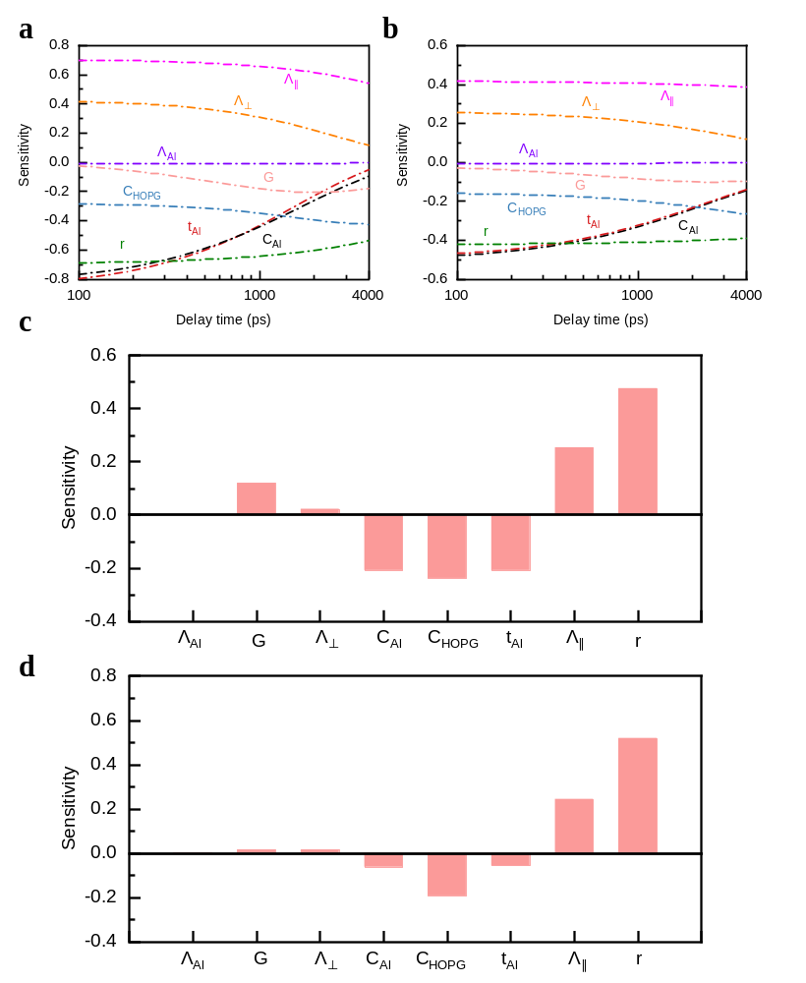
Fig. S1. Sensitivity to different parameters for conventional TDTR at (a) 100K and (b) 300K. Sensitivity of FWHM to different parameters in the beam-offset TDTR at (c) 100K and (d) 300K. For both conventional and beam-offset TDTR measurements, the laser spot size is 30 μm and modulation frequency is 0.5 MHz.

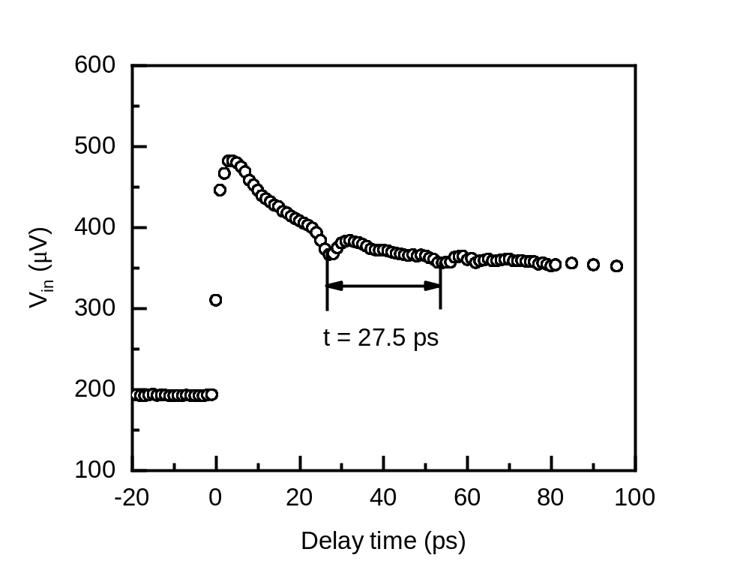
Fig. S2. Transducer thickness calculated by pico-acoustics. Using the longitudinal speed of sound v_{L} of 6.42 nm ps⁻¹ in Al, the thickness of Al film is calculated to be 88.3 nm.

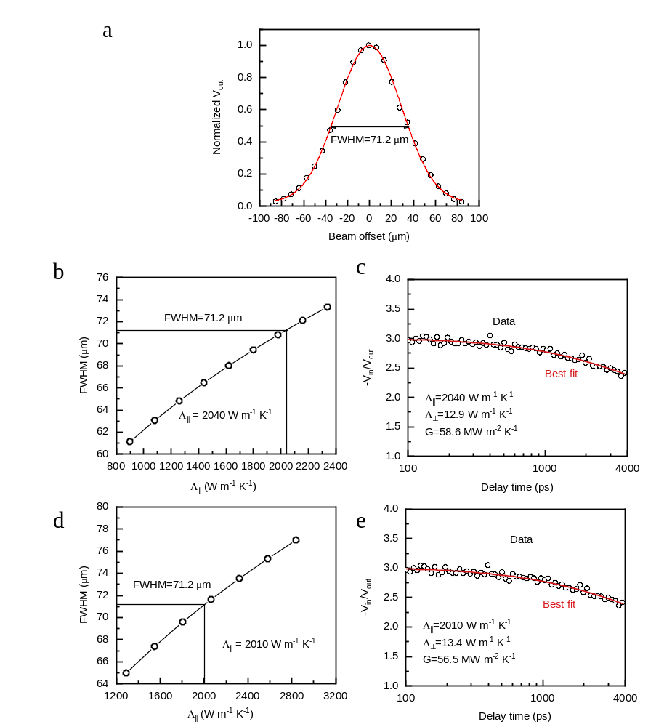
Fig. S3. Iteration process to determine Λ⊥, Λ∥ and G at 300 K. (a) Beam-offset TDTR measurement at 300 K, where we obtain a FWHM of 71.2 µm. (b) and (c) The first round of iteration. In (b), Λ∥ is determined to be 2040 W m⁻¹ K⁻¹ using the FWHM from beam-offset TDTR, while we assume a Λ⊥ of 9 W m⁻¹ K⁻¹ from literature value. We then put the obtained Λ∥ in conventional TDTR measurement, as in (c), and we obtain Λ⊥ of 12.9 W m⁻¹ K⁻¹. (d) and (e) The second round of iteration, where we repeat the process as in (b) and (c). In (d), we put Λ⊥ of 12.9 W m⁻¹ K⁻¹ determined from (c) in the thermal model, and Λ∥ is determined to be 2010 W m⁻¹ K⁻¹. We then put Λ∥ of 2010 W m⁻¹ K⁻¹ in (e), and Λ⊥ of 13.4 W m⁻¹ K⁻¹ is determined. No further repeat of such process is needed as the values of Λ⊥ and Λ∥ will not change any more.

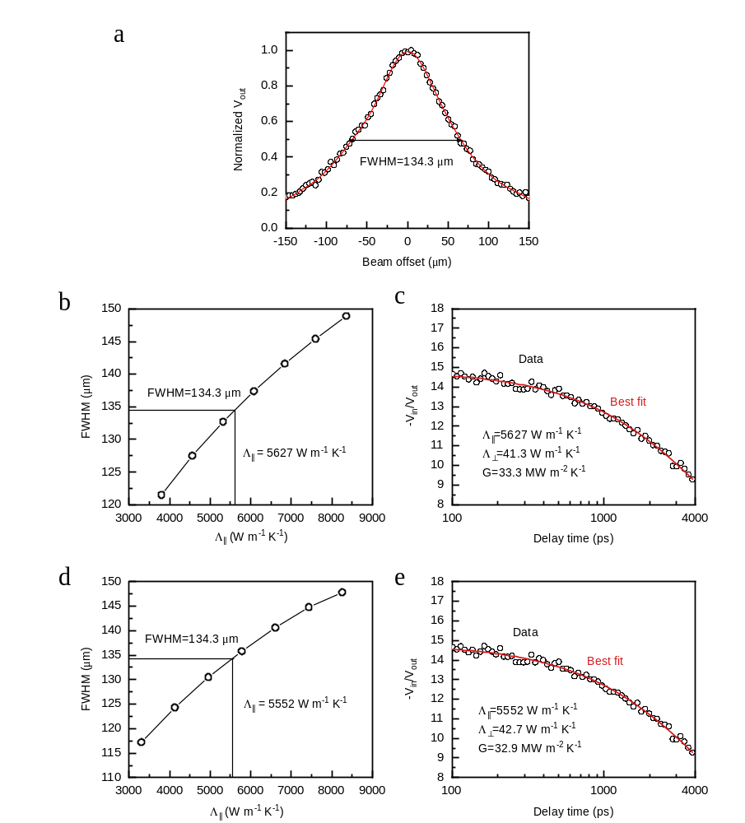
Fig. S4. Iteration for Λ⊥, Λ∥ and G at 100K. (a) Beam offset TDTR measurement at 100K. (b) and (c) The first round of iteration. (d) and (e) The second round of iteration.

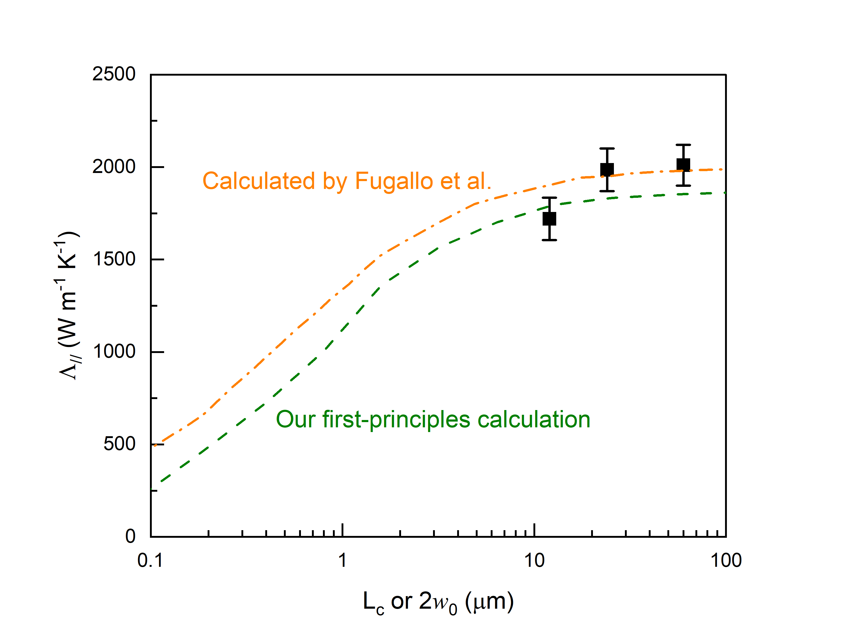
Fig. S5. In-plane thermal conductivity of G1 as a function of heat diameter or characteristic length (L_{c}). Spot-size dependent TDTR measurement of Λ∥ at 300 K (black squares), our first-principles calculations (olive dashed line) and by Fugallo et al.¹ (orange dashed dot lines) are presented.

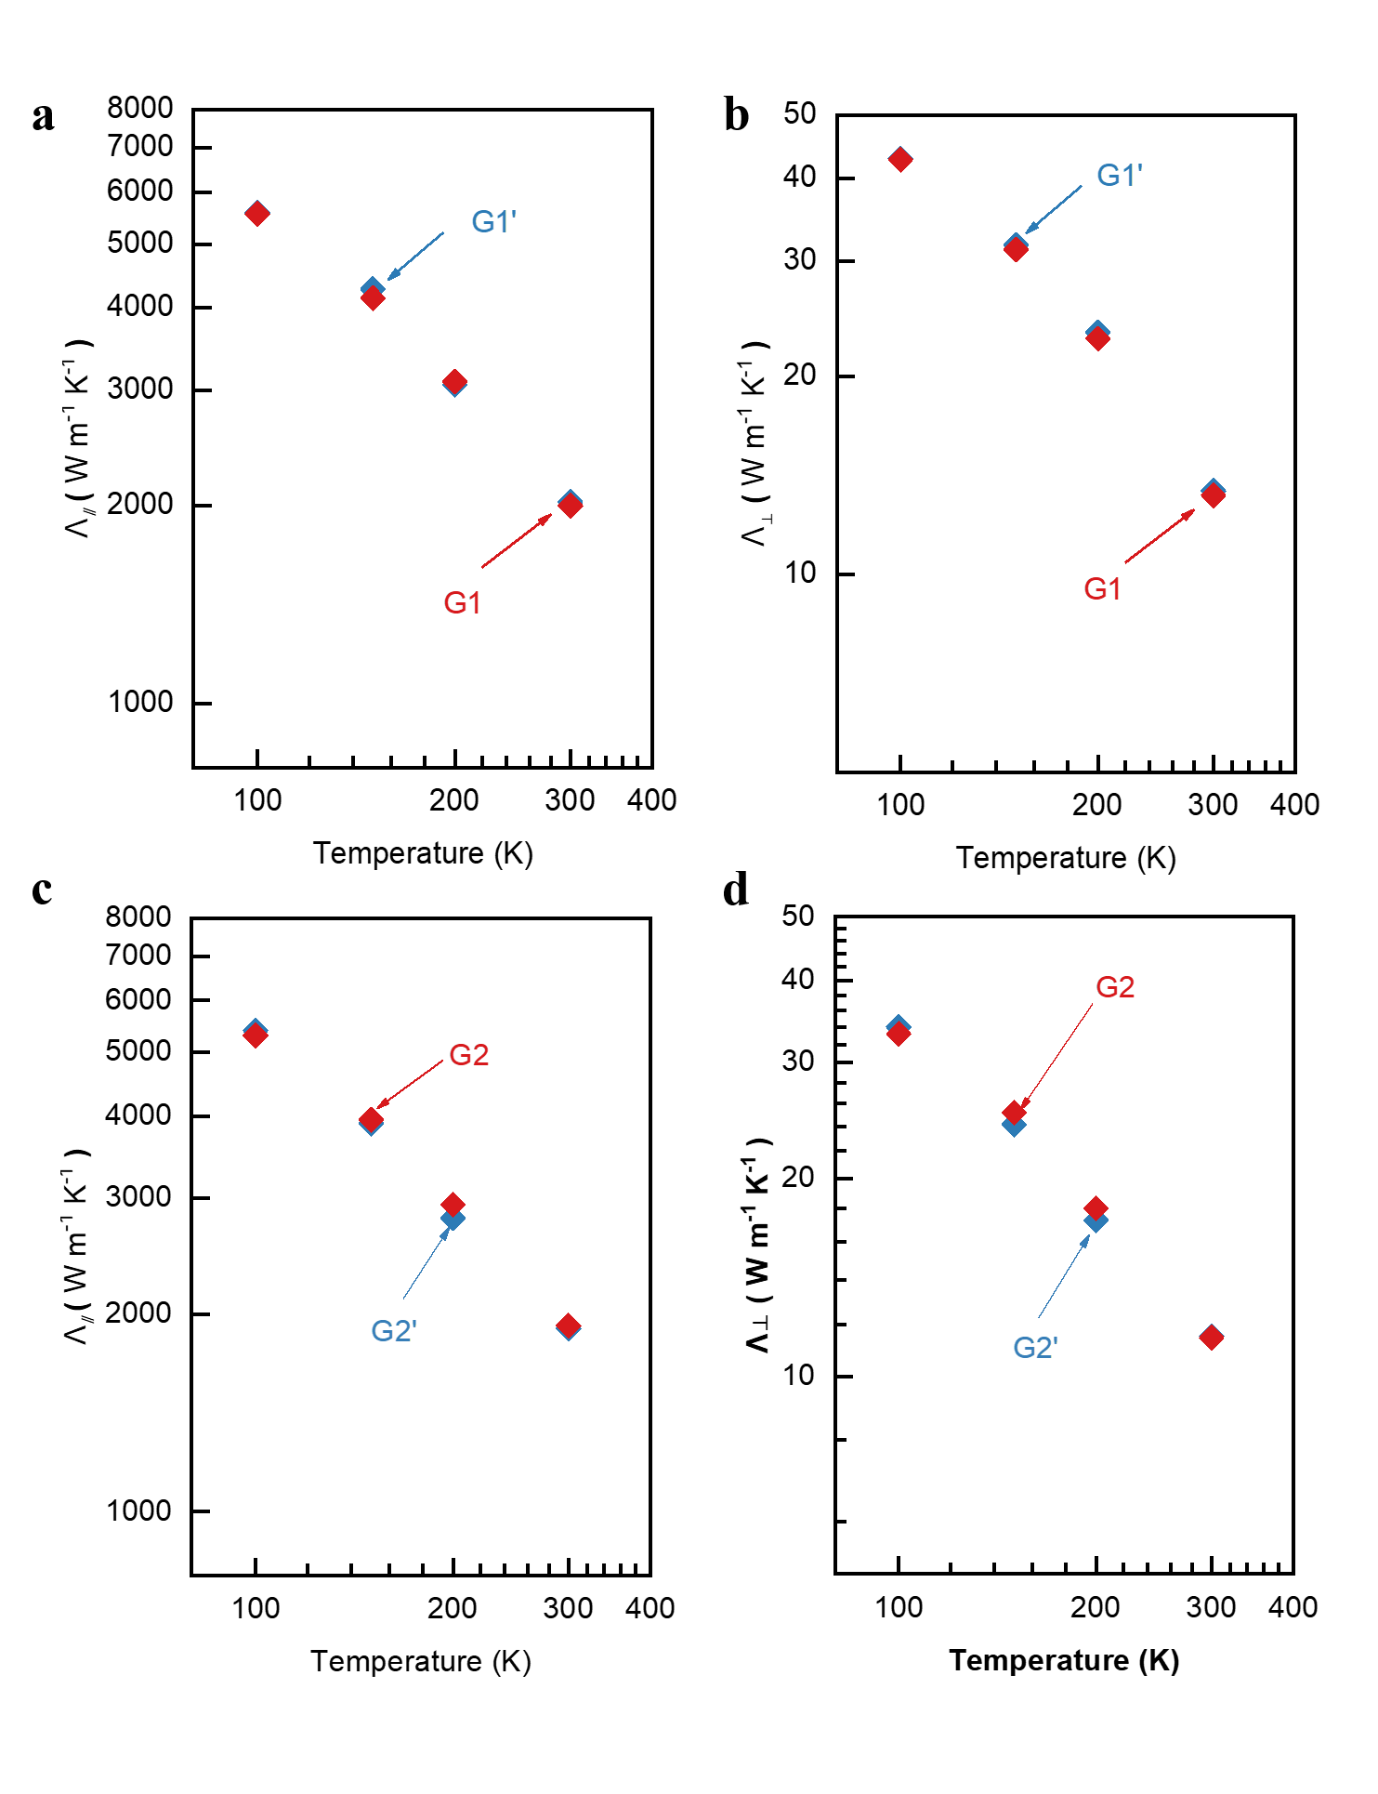
Fig. S6. The comparison of thermal conductivity for ZYA (a, b) and ZYB (c, d) grades HOPG from SPI supplies (G1 and G2) and HQ Graphene (G1’ and G2’). We purchased two different HOPG samples in ZYA, ZYB grades from SPI supplies and HQ Graphene for cross validation, and then performed same measurements for samples from the two companies, and we find that all Λ⊥ and Λ∥ are consistent with each other within the whole temperature range.

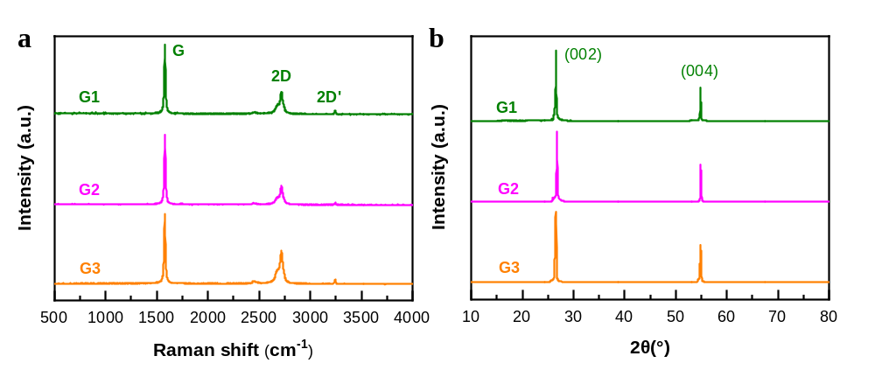
Fig. S7. (a) Raman spectroscopy of HOPG. (b) XRD measurement of HOPG. All three samples do not display D peaks (1350 cm⁻¹) caused by defects, and the absence of D peaks in our case indicate that absolute disorders are not probed in three HOPG samples within the detection of Raman spectroscopy. Additionally, all samples exhibit noticeable G peak at 1580 cm⁻¹ and 2D peak at 2700 cm⁻¹, the former is contributed from sp² carbon networks and the doublet of later 2D is a reflection of well stacked graphene sheets along c axis, which again proved the dominant of almost perfect 2D layered structure^{2,3}. As expected, the XRD patterns clearly indicate the preferential orientation in [002] direction, and no appearance of other diffraction peaks, which shows all samples are in excellent crystallinity.

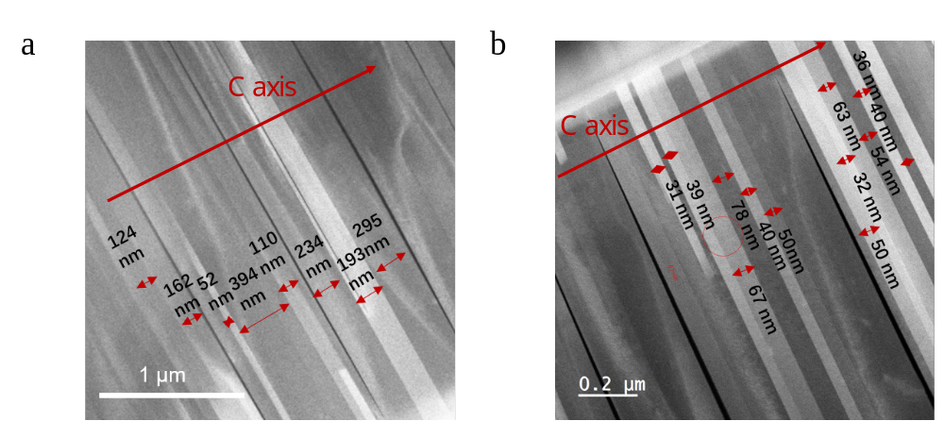
Fig. S8. Cross-sectional TEM images of G1 (a) and G3 (b). The average period of twist is 196 nm for G1 and 48nm for G3.

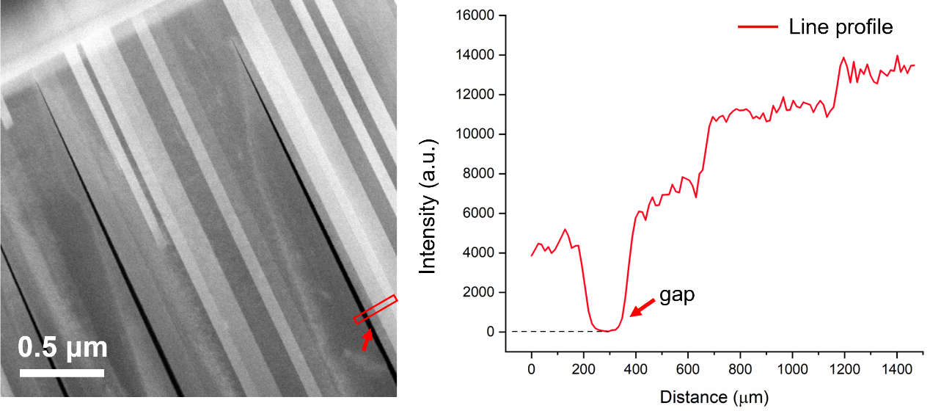
Fig. S9. Characterization of wedge-shaped gap.

Supplementary Note Ⅰ: Sensitivity and uncertainty analysis of TDTR measurement
The sensitivity (S_{α}) to parameter in conventional TDTR is defined as⁴:
 | $$S_{α}=\frac{∂\ln{R}}{∂\ln{α}}$$ | (1)
Where α is the parameter which is sensitive to TDTR measurements (such as thermal conductivity, laser spot size, heat capacity and so on), and R is the value of ratio R=-V_{in}/V_{out} (V_{in} and V_{out} are the in-phase and out-of-phase signal processed by lock-in amplifier).
For beam-offset TDTR, the sensitivity parameter for FWHM of V_{out} is defined as⁵:
 | $$S_{α}^{FWHM}=\frac{∂\ln{FWHM}}{∂\ln{α}}$$ | (2)
Where α is defined as the same with above. In sensitivity analysis of Fig. S1, volume heat capacity of Al and graphite is 2.42 J cm⁻³ K⁻¹ ⁶ and 1.62 J cm⁻³ K⁻¹⁷, respectively. And thermal conductivity of Al film is 200 W m⁻¹ K⁻¹, which is determined from the Wiedemann-Franz law. Laser spot size in this calculation is 30 μm and modulation frequency is 0.5 MHz.
The measurement uncertainty of Λ⊥ and Λ∥ can be evaluated by:
 | $${\left(\frac{∆Λ_{⊥}}{Λ_{⊥}}\right)}^{2}=\sum{{\left(\frac{S_{α}}{S_{⊥}}\frac{∆α}{α}\right)}^{2}}$$ | (3)

 | $${\left(\frac{∆Λ_{∥}}{Λ_{∥}}\right)}^{2}=\sum{{\left(\frac{S_{α}^{FWHM}}{S_{∥}^{FWHM}}\right)}^{2}}$$ | (4)
Where the Δα/α is the uncertainty of parameter α. And total uncertainty for in-plane thermal conductivity is 10% and for through-plane thermal conductivity is 6% at 300 K.

Supplementary Note Ⅱ: Iteration process to determine both in-plane and through-plane thermal conductivity of graphite from TDTR and beam-offset TDTR
FWHM of V_{out} obtained by beam-offset TDTR and ratio of V_{in}/V_{out} measured by conventional TDTR are iteratively used to accurately calculate Λ⊥, Λ∥ and G using the multilayer anisotropic heat transfer model.
The iteration process for in-plane thermal conductivity, through-plane thermal conductivity, and thermal conductance at 300 K is shown as Figure S2. The FWHM of normalized V_{out} is calculated as 71.2 μm by fitting the offset curve, then this experimental FWHM is used to extract the corresponding in-plane thermal conductivity in anisotropic thermal model⁵. In the first iteration (Fig. S2 (b) and (c)), in order to extract the in-plane thermal conductivity, firstly, through-plane thermal conductivity for bulk HOPG and thermal conductance are fixed to be about 9 W m⁻¹ K⁻¹ for Λ⊥ from TPRC data⁸, and 50 MW m⁻² K⁻¹ for G⁹, then the Λ⊥ and G are put into the anisotropic thermal model to calculate the simulated FWHM plot as a function of Λ∥, and the value of 2040 W m⁻¹ K⁻¹ for Λ∥ is obtained. We then use Λ∥ of 2040 W m⁻¹ K⁻¹ as input to the conventional TDTR thermal model, by fitting the ratio of Λ∥ and Λ⊥ to the multilayer thermal model, the values of 12.9 W m⁻¹ K⁻¹ for Λ⊥ and 58.6 MW m⁻² K⁻¹ for G are obtained¹⁰. Then the second iteration is conducted (Fig. S2 (d) and (e)), the Λ⊥ of 12.9 W m⁻¹ K⁻¹ and G of 58.6 MW m⁻² K⁻¹ are put into the anisotropic thermal model to calculate the simulated FWHM plot as a function of Λ∥, and the value of 2010 W m⁻¹ K⁻¹ for Λ∥ is obtained. Λ∥of 2010 W m⁻¹ K⁻¹ is put into the conventional TDTR thermal model, and then the values of 13.4 W m⁻¹ K⁻¹ for Λ⊥ and 56.5MW m⁻¹ K⁻¹ for G are obtained. At least 2-3 iterations are needed to get constant Λ⊥, G and Λ∥ within the deviation of 0.5%.
The FWHM of normalized V_{out} at 100 K is calculated as 134.3 μm (Fig. S3(a)) by fitting the offset curve, and similar iteration is conducted. In the first iteration (Fig. S3 (b) and (c)), value of cross-plane thermal conductivity for bulk HOPG is about 38 W m⁻¹ K⁻¹ in TPRC data, and G is about 30 MW m⁻² K⁻¹, then the Λ⊥ and G are put into the anisotropic thermal model to calculate the simulated FWHM map as a function of Λ∥, and the value of 5627 W m⁻¹ K⁻¹ for Λ∥ is obtained, which is put into the conventional TDTR thermal model, and the values of 41.3 W m⁻¹ K⁻¹ for Λ⊥ and 33.3 MW m⁻² K⁻¹ for G are obtained. In the second iteration (Fig. S3 (d) and (e)), values of through-plane thermal conductivity and interface thermal conductivity are fixed as 41.3 W m⁻¹ K⁻¹ and 33.3 MW m⁻² K⁻¹, and they are put into the anisotropic thermal model to calculate the simulated FWHM map as a function of Λ∥, and the value of 5552W m⁻¹ K⁻¹ for Λ∥ is obtained. And then, Λ∥ of 5552 W m⁻¹ K⁻¹ is put into the conventional TDTR thermal model, the values of 42.7 W m⁻¹ K⁻¹ for Λ⊥ and 32.9 MW m⁻² K⁻¹ for G are obtained by fitting the ratio of Λ∥ and Λ⊥ to the multilayer thermal model.

Supplementary Note Ⅲ: Calculations on thermal transport properties of graphite

First-Principles Calculations for Perfect Sample
We perform first-principles-based Boltzmann transport equation (BTE) calculations on the perfectly AB stacking graphite. The first-principles calculations are carried out using the Quantum-Espresso package^{11,12}. The exchange-correlation functional r²SCAN-rVV10 is adopted¹³, as the short-range interatomic interaction is well described by the “strongly constrained and appropriately normed” (SCAN) meta-GGA and the long-range non-local van der Waals interaction is captured by the rVV10 functional.
To obtain the temperature effects on lattice constants and vibrational properties, the free energy should be computed and minimized first. Here, we adopt the quasi-harmonic approximation to estimate the free energy, which is expressed as
$F=E_{0}+\sum_{q}{\sum_{s}{\frac{ℏω_{qs}}{2}}}+\sum_{q}{\sum_{s}{k_{B}Tln\left(1-\exp\left(-ℏω_{qs}/k_{B}T\right)\right)}}$ (1)
where $E_{0}$ is the ground state energy, $λ≡(q,s)$ represents the s-th phonon mode with the wavevector of $q$, $ω$ is the phonon frequency, $k_{B}$ and $ℏ$ are the Boltzmann constant and reduced Planck constant, respectively.
The ground state energy is computed through self-consistent calculation with a 24×24×12 k-point mesh and the kinetic energy cutoff for the plane-wave basis set is set to 100 Ry. These parameters ensure the energy converged within 1 meV/atom. The optimized lattice constants, $a_{0}^{E}$ = 2.4524 Å and $c_{0}^{E}$ = 6.6412 Å, are obtained by minimizing the potential energy. The ground state energies of other lattice constants combinations are also computed.
To calculate the phonon dispersion and phonon scattering rates, the second-order harmonic force constants as well as higher-order anharmonic force constants are extracted by fitting the displacement-force relation from DFT calculations of graphite supercells made up of 5×3×2 conventional supercells (240 atoms in total) with 2×2×2 k-grids. For each lattice with distinct lattice parameters, 200 different configurations that are generated by the stochastic temperature dependent effective potential method¹⁴ are used. With the calculated harmonic force constants, the phonon dispersion is obtained, which is used to compute the free energy of each set of lattice parameters according to Eq. (1).
To determine the minimum free energy corresponding to different temperatures, we evaluate the free energy on a grid with $a$ ranging from $1.000a_{0}^{E}$ $to$ $1.006a_{0}^{E}$ and $c/a$ ranging from $1.00c_{0}^{E}/a_{0}^{E}$ to $1.04c_{0}^{E}/a_{0}^{E}$. The free energy surface with $a$ and $c/a$ as variables is approximated by a two-dimensional quadratic function, whose coefficients are determined by fitting the free-energy data. With the coefficients of the quadratic function, the minimum free energy is determined analytically. Fig. S10 shows the obtained lattice constants of graphite along the a-axis and c-axis directions, along with the experimental data. By numerically differentiating the temperature dependent lattice constants, the coefficients of thermal expansion of graphite are determined and shown in Fig. S11. The coefficients of thermal expansion along both directions are consistent with the experimental data, reflecting that the r²SCAN-rVV10 density functional performs well on graphite.
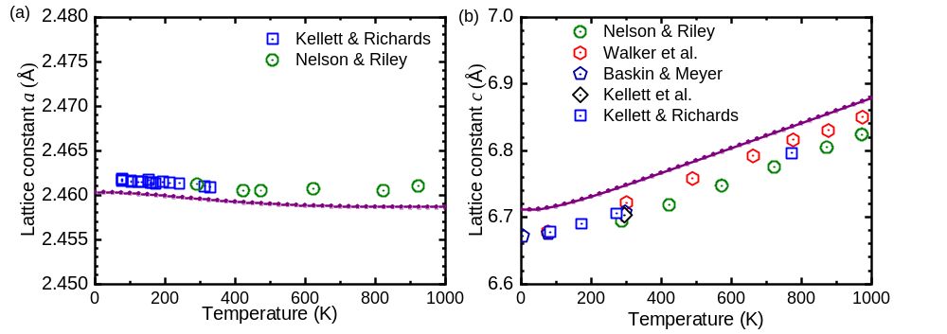
Fig. S10. Temperature dependent lattice constants of graphite along the a-axis (a) and c-axis (b) directions. The curves are calculated from first-principles calculations, while the symbols are experimental data^{15–19}.

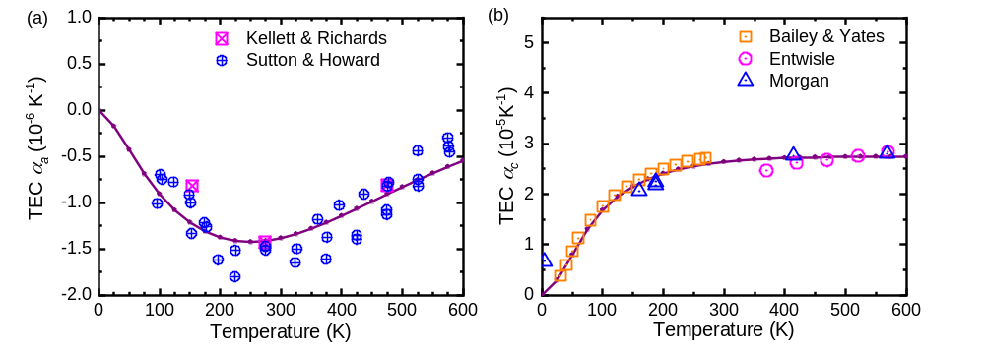
Fig. S11. Temperature dependent coefficient of thermal expansion (CTE) of graphite along the a-axis (a) and c-axis (b) directions. The curves are calculated from first-principles calculations, while the symbols are experimental data^{15,20,21}.

The phonon dispersion of graphite at 300 K along the high-symmetry directions is shown in Fig. S12. The temperature effects are fully taken into account, as the harmonic force constants are extracted from the first-principles displacement-force data of the supercell, whose size are determined by the lattice constants at 300 K and the atomic displacements are generated by the stochastic temperature dependent effective potential method at 300 K. The obtained phonon dispersion matches experimental data well.
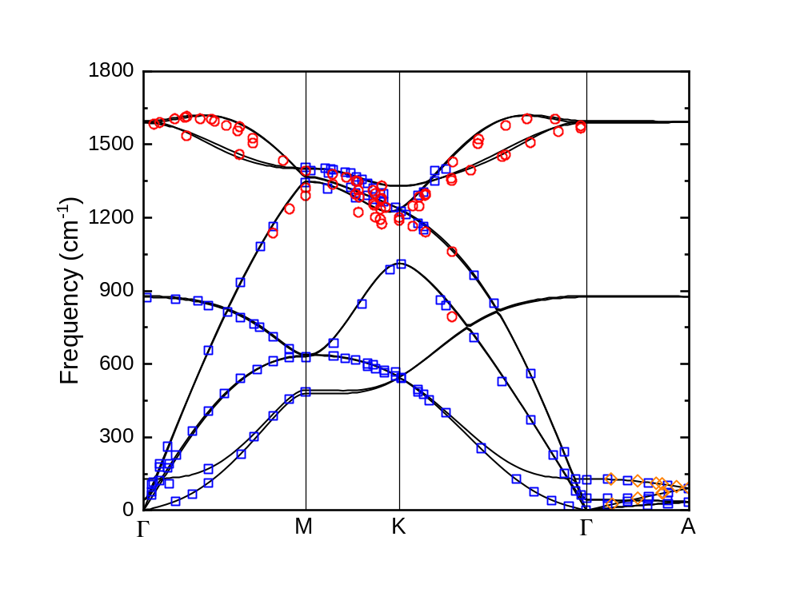
Fig. S12. Phonon dispersion relation of graphite along the path of high symmetry points at 300K, yellow, red triangle and circle are both experimental data. Red circles are from Ref. 22; blue squares are Ref. 23; yellow diamonds are from Ref. 24.
Phonon BTE has proven predicting lattice thermal conductivity (k) and phonon properties accurately and predictively, including 2D and van der Waals layered materials ²¹. The lattice thermal conductivity is expressed as:
 | $$k=\frac{1}{Ω}\sum_{λ}{ ℏ}ω_{λ}v_{λ}n_{λ}^{0}\left(n_{λ}^{0}+1\right)F_{λ}$$ | (2)
where $v_{λ}$ is the group velocity, $n_{λ}^{0}$ is equilibrium phonon population, $n_{λ}^{0}\left(n_{λ}^{0}+1\right)F_{λ}$ is the deviation of the non-equilibrium phonon population from the equilibrium one, $F_{λ}$ is the deviation function of the phonon mode, Ω is the volume of the system, $ω_{λ}$is the frequency of vibration and ħ is Planck's constant. The deviation functions of phonon modes are determined by solving the BTE, where the three-phonon, four-phonon and phonon-isotope scatterings are considered as the mechanisms of phonon scattering. The phonon-boundary scattering is also included in the scattering term if the size effect of thermal conductivity is investigated. The BTE is expressed as
$∇T⋅v_{λ}^{α}\frac{∂F_{λ}}{∂T}=W_{λ}^{3ph}+W_{λ}^{4ph}+W_{λ}^{isotope}+W_{λ}^{boundary}$ (3)
The three-phonon and four-phonon scattering terms are derived from the Fermi’s golden rule and written as
$W_{λ}^{3ph}=\sum_{λ'}{\sum_{λ''}{\frac{2π}{ħ}{\left|\left\langle f\left|Φ_{3}\right|i\right\rangle \right|}^{2}δ\left(E_{f}-E_{i}\right)}}$ (4)
$W_{λ}^{4ph}=\sum_{λ'}{\sum_{λ''}{\sum_{λ'''}{\frac{2π}{ħ}{\left|\left\langle f\left|Φ_{4}\right|i\right\rangle \right|}^{2}δ\left(E_{f}-E_{i}\right)}}}$ (5)
where $f$ and $i$ denote the final and initial states, the δ function ensures energy conservation, $Φ_{3}$ and $Φ_{4}$ is the third- and fourth-order anharmonic terms of the potential energy under the normal mode representation, which require the information of third- and four-order force constants as inputs. To integrate the Brillouin zone, dense q-point grid are used. To find out the grid that results in converged thermal conductivity, we first calculate the in-plane thermal conductivity of perfect graphite sample using 15×15×7 and 19×19×9 q-grids. In this set of calculation, three-phonon, four-phonon and phonon-isotope scatterings are included in the scattering terms. The difference of in-plane thermal conductivity is less than 1 W/mK, thus we report the in-plane results from the 15×15×7 grid as the converged values. The converged through-plane thermal conductivity requires much a denser grid, and we check the results using a series of N×N×N grids. Due to the severe computational cost, in the convergence test, four-phonon scattering is absent in Eq. (3). Fig. S13 shows the q-point grid dependence of the predicted thermal conductivity of graphite at 300 K. The through-plane thermal conductivity does not converge until N is larger than 21.
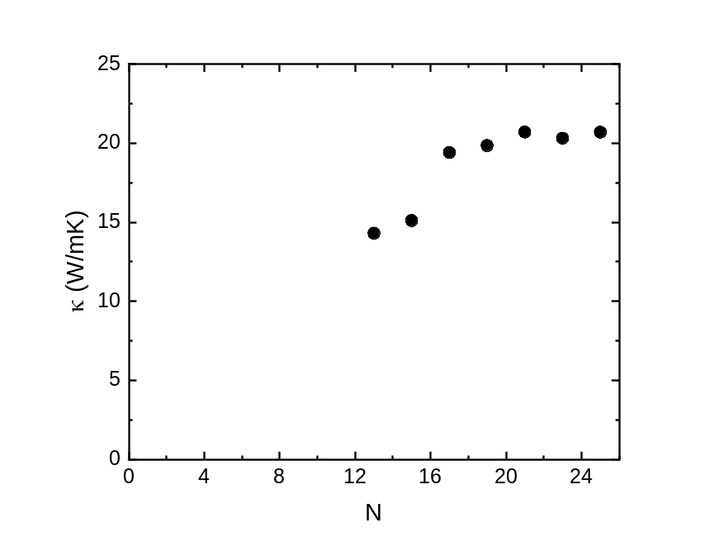
Figure S13. Through-plane thermal conductivity of graphite at 300 K as a function of N. The Brillouin zone is sample by a q-grid N×N×N. Four-phonon scattering is absent in the calculation.

To consider the effect of four-phonon scattering on the in-plane thermal conductivity, we utilize the relaxation time approximation to handle the four-phonon scattering, that is, Eq. (5) is written as
$W_{λ}^{4ph}=\frac{n_{λ}^{0}\left(n_{λ}^{0}+1\right)}{τ_{λ}^{4ph}}$ (6)
where $τ_{λ}^{4ph}$ is the relaxation time for mode $λ$ due to four-phonon scatterings. The inverse of $τ_{λ}^{4ph}$ is the four-phonon scattering rate, and are explicitly computed via²⁵
$\frac{1}{τ_{λ}^{4ph}}=2π\sum_{λ^{'}}{\sum_{λ^{''}}{\sum_{λ^{'''}}{{\left|V_{4}\left(λ,λ^{'},λ^{''},λ^{'''}\right)\right|}^{2}\left[\frac{1}{2}\frac{n_{λ^{'}}^{0}n_{λ^{''}}^{0}\left(n_{λ^{'''}}^{0}+1\right)}{\left(n_{λ}^{0}+1\right)}δ\left(ω_{λ}+ω_{λ^{'}}+ω_{λ^{''}}-ω_{λ^{'''}}\right)+\frac{1}{2}\frac{\left(n_{λ^{'}}^{0}+1\right)n_{λ^{''}}^{0}n_{λ^{'''}}^{0}}{n_{λ}^{0}}δ\left(ω_{λ}+ω_{λ^{'}}-ω_{λ^{''}}-ω_{λ^{'''}}\right)+\frac{1}{6}\frac{n_{λ^{'}}^{0}n_{λ^{''}}^{0}n_{λ^{'''}}^{0}}{n_{λ}^{0}}δ\left(ω_{λ}-ω_{λ^{'}}-ω_{λ^{''}}-ω_{λ^{'''}}\right)\right]}}}$ (7)
where $V_{3}$ and $V_{4}$ are the three-phonon and four-phonon scattering matrix elements, which quantify the strength of the scattering events. To make the computation affordable, we do not calculate the four-phonon lifetime of each phonon mode in the 21×21×21 q-mesh, but estimate the mode-specific four-phonon lifetime from an interpolation process based on the results from a 11×11×11 q-meshes. The difference between Eq. (6) and Eq. (5) lies in that the four-phonon scattering term on mode $λ$ only depends on the equilibrium population of other phonon modes when Eq. (6) but on the non-equilibrium population in Eq. (5). Eq. (6) assumes that the four-phonon scattering terms included in the scattering term of PBTE as a purely resistive term, but actually a portion of four-phonon scatterings are the normal processes assisting phonons to redistribute to other states, which is beneficial to heat conduction. Hence, the use of Eq. (6) in replace of Eq. (5) lead to an underestimation of the through-plane thermal conductivity, and the reported data should be treated as the lower bound of the intrinsic thermal conductivity of graphite.
By solving the PBTE iteratively, the predicted through-plane thermal conductivity of graphite is 42.2, 20.7 and 14.7 W m⁻¹ K⁻¹ at 100, 200 and 300 K, and the simulation data agrees with the measurement soundly. Based on our results calculated from r²SCAN-rVV10, we also compute the thermal accumulative thermal conductivity as a function phonon mean free path. The simulation confirms that the phonon mean free path of graphite is relatively long, i.e., the through-plane thermal conductivity of a sample with a thickness of 500 nm is less than 60% of that of an infinitely thick sample.

Calculations for twisted samples
To explore the influence of interlayer twisting on heat conduction of graphite along the cross-plane, we adopt molecular dynamics (MD) simulation to compute the interfacial thermal conductance of twisted interface with different twisted angles and model the thermal conductivity through thermal resistance circuit analysis.
- Interfacial thermal resistance
Non-equilibrium molecular dynamics (NEMD) simulations are used to study the impact of twisted interfaces on the thermal resistance of graphite. The interatomic interaction between carbon atoms in the same layer is modelled by the optimized Tersoff potential²⁶, while the interlayer interaction is described by an anisotropic interlayer potential (ILP)²⁷ with a parameter set reproducing the measured interlayer distance and sound of speed. To better describe the phonon properties, we adjust the parameter S in the original parameter set from 1.0 to 1.2, making the phonon dispersion curve along the $Γ-A$ direction closer to measured phonon dispersion data.
In our NEMD simulations, two graphite thin films with different in-plane orientation are connected to form a twisted angle. The length of the graphite structure is 13.4 nm which contains 44 graphene layers in our simulation systems. The timestep is set as 1fs, and the structure is relaxed in NVT ensemble at 300K for 1 ns, after which the temperature difference is generated by maintaining various temperatures with a difference of 60 K at the two ends of the structure with Langevin thermostat for at least 2 ns to ensure the system achieving steady state. By recording the temperatures of each graphitic layer, the interfacial thermal resistance (ITR) of the twisted interface as a function of angle at 300K is computed by the ratio between temperature difference of two neighboring layer and the heat flux.

- Spectral heat current (SHC) and phonon transmission
The spectral heat current (SHC) through the graphite interface is used to explore the effect of twisted layer on phonon transport along cross-plane. The SHC is defined as:
 | $$Q\left(ω\right)=2Re\sum_{i∈A}{\sum_{j∈B}{\int_{-∞}^{∞}{dτe^{iωτ}\left\langle F_{ji}(τ)∙\left.v_{j}(0)\right\rangle \right.}}}$$ | (8)
Where $F_{ji}$ is the inter-atomic force between atom i and j, and $v_{j}$ denotes the velocity of atom j. A and B are groups of atoms in adjacent layers. And based on the SHC, the phonon transmission is defined as：
 | $$T_{r}\left(ω\right)=\frac{Q_{θ}(ω)}{Q_{0}(ω)}$$ | (9)
Where $Q_{θ}(ω)$ and $Q_{0}\left(ω\right)$ represent the SHC with twisted angle $θ$and 0, respectively. The phonon transmission is greatly reduced in twisted sample.
- Total resistance
The total resistance of N AB-stacking layers graphite with a twisted interface is calculated through the series thermal resistance model (STRM) based on the ITR:
 | $$R_{tot}=R_{int}+(N-1)R_{0}$$ | (10)
Where N is the number of AB stacking layers (it contains two graphene layer in graphite). As the total thickness is Nd, d is the distance of two adjacent layers (0.68nm), we then obtain the $Λ_{⊥}$:
 | $$Λ_{⊥}=\frac{Nd}{\left(N-1\right)R_{0}+R_{int}}$$ | (11)
Defining the twisted interface density (TWID) as 1/Nd (nm⁻¹), we obtain the $Λ_{⊥}$as the function of twisted interface density (TWID).

C. One-dimensional spring-mass model
Considering the large difference between the interlayer and intralayer of the graphite species, there is a strong covalent bond in single-layer graphene, while the interlayer is weak van der Waals force. So we take the multilayer stacked graphene as a one-dimensional rigid atomic layer model as shown in Fig. S14. The force constants along different directions between torsional layers are calculated by finite displacement method:
$\begin{aligned}K_{i,α}=\frac{F_{i,α}-F_{i,-α}}{2Δ}\#\left(12\right)\end{aligned}$where $F_{i,α}$ and $F_{i,-α}$ represent the force when moving the ith layer atoms in α direction and -α direction, $Δ$ is the small displacement.
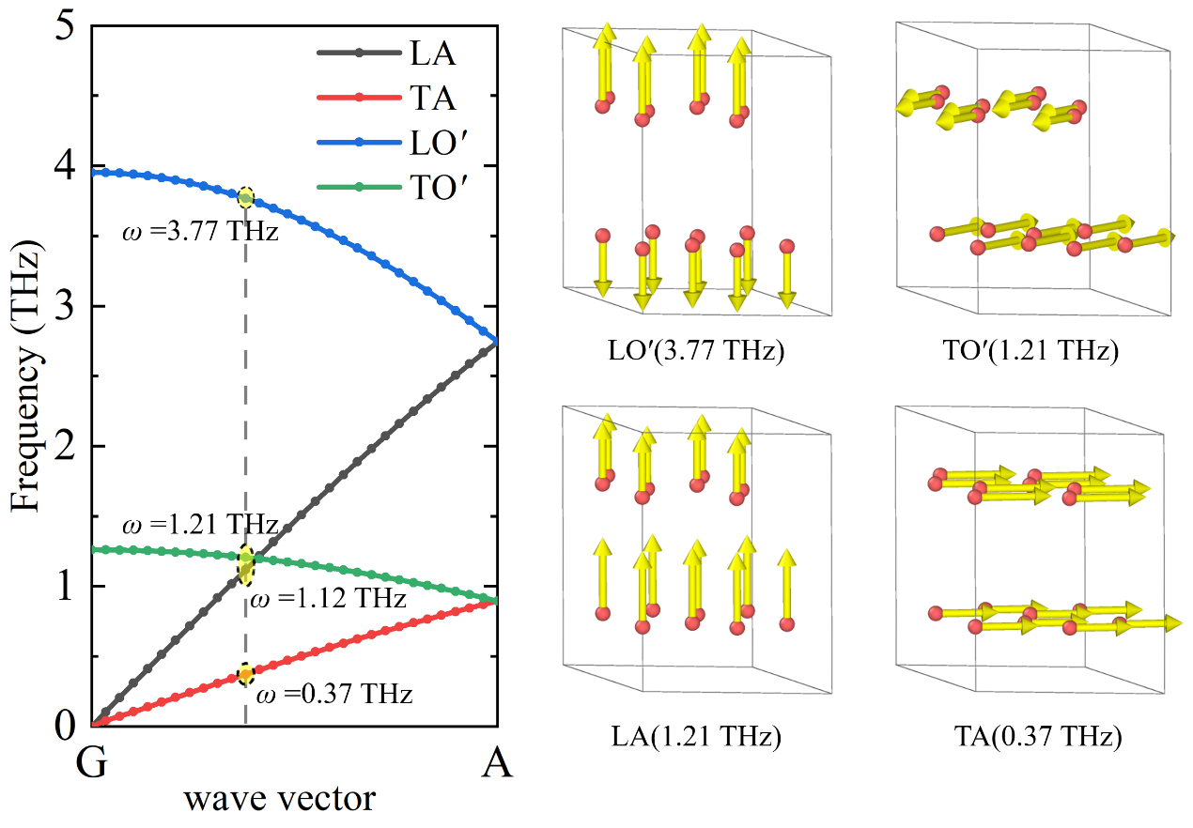
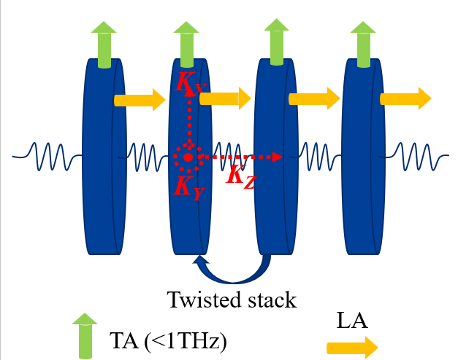
Fig. S14. Simplified one-dimensional rigid graphene layer model. LA is the vibration mode perpendicular to the graphene layer, TA is the vibration mode parallel to the layer.

References:
1. Fugallo, G. et al. Thermal Conductivity of Graphene and Graphite: Collective Excitations and Mean Free Paths. Nano Lett. 14, 6109–6114 (2014).
2. Cançado, L. G. et al. Measuring the degree of stacking order in graphite by Raman spectroscopy. Carbon 46, 272–275 (2008).
3. Miao, X., Tongay, S. & Hebard, A. F. Extinction of ferromagnetism in highly ordered pyrolytic graphite by annealing. Carbon 50, 1614–1618 (2012).
4. Koh, Y. K. et al. Comparison of the 3ω method and time-domain thermoreflectance for measurements of the cross-plane thermal conductivity of epitaxial semiconductors. Journal of Applied Physics 105, 054303 (2009).
5. Feser, J. P., Liu, J. & Cahill, D. G. Pump-probe measurements of the thermal conductivity tensor for materials lacking in-plane symmetry. Review of Scientific Instruments 85, 104903 (2014).
6. Thermophysical Properties of Matter - The TPRC Data Series. Volume 4. Specific Heat - Metallic Elements and Alloys. https://apps.dtic.mil/sti/citations/ADA951938.
7. Thermophysical Properties of Matter - the TPRC Data Series. Volume 5. Specific Heat - Nonmetallic Solids. https://apps.dtic.mil/sti/citations/ADA951939.
8. Touloukian, Y. S., Powell, R., Ho, C. & Klemens, P. Thermophysical Properties of Matter - The TPRC Data Series. Volume 2. Thermal Conductivity - Nonmetallic Solids. (Defense Technical Information Center, 1971).
9. Schmidt, A. J., Collins, K. C., Minnich, A. J. & Chen, G. Thermal conductance and phonon transmissivity of metal–graphite interfaces. Journal of Applied Physics 107, 104907 (2010).
10. Cahill, D. G. Analysis of heat flow in layered structures for time-domain thermoreflectance. Review of Scientific Instruments 75, 5119–5122 (2004).
11. Giannozzi, P. et al. QUANTUM ESPRESSO: a modular and open-source software project for quantum simulations of materials. J. Phys.: Condens. Matter 21, 395502 (2009).
12. Giannozzi, P. et al. Advanced capabilities for materials modelling with Quantum ESPRESSO. J. Phys.: Condens. Matter 29, 465901 (2017).
13. Ning, J. et al. Workhorse minimally empirical dispersion-corrected density functional with tests for weakly bound systems: ${\mathrm{r}}^{2}\mathrm{SCAN}+\mathrm{rVV}10$. Phys. Rev. B 106, 075422 (2022).
14. Shulumba, N., Hellman, O. & Minnich, A. J. Intrinsic localized mode and low thermal conductivity of PbSe. Phys. Rev. B 95, 014302 (2017).
15. Kellett, E. A. & Richards, B. P. The thermal expansion of graphite within the layer planes. Journal of Nuclear Materials 12, 184–192 (1964).
16. Kellett, E. A. & Richards, B. P. The c-axis thermal expansion of carbons and graphites. J Appl Cryst 4, 1–8 (1971).
17. Nelson, J. B. & Riley, D. P. The thermal expansion of graphite from 15°c. to 800°c.: part I. Experimental. Proc. Phys. Soc. 57, 477 (1945).
18. Walker, P. L., McKinstry, H. A. & Wright, C. C. X-Ray Diffraction Studies of a Graphitized Carbon - Changes in Interlayer Spacing and Binding Energy with Temperature. ACS Publications https://pubs.acs.org/doi/abs/10.1021/ie50524a033 (2002) doi:10.1021/ie50524a033.
19. Baskin, Y. & Meyer, L. Lattice Constants of Graphite at Low Temperatures. Phys. Rev. 100, 544–544 (1955).
20. Sutton, A. L. & Howard, V. C. The role of porosity in the accommodation of thermal expansion in graphite. Journal of Nuclear Materials 7, 58–71 (1962).
21. Entwisle, M. F. Thermal expansion of pyrolytic graphite. Physics Letters 2, 236–238 (1962).
22. Maultzsch, J., Reich, S., Thomsen, C., Requardt, H. & Ordejón, P. Phonon Dispersion in Graphite. Phys. Rev. Lett. 92, 075501 (2004).
23. Mohr, M. et al. Phonon dispersion of graphite by inelastic x-ray scattering. Phys. Rev. B 76, 035439 (2007).
24. Nicklow, R., Wakabayashi, N. & Smith, H. G. Lattice Dynamics of Pyrolytic Graphite. Phys. Rev. B 5, 4951–4962 (1972).
25. Gu, X. & Zhao, C. Y. Thermal conductivity of hexagonal Si, Ge, and Si1-xGex alloys from first-principles. Journal of Applied Physics 123, 185104 (2018).
26. Lindsay, L. & Broido, D. A. Optimized Tersoff and Brenner empirical potential parameters for lattice dynamics and phonon thermal transport in carbon nanotubes and graphene. Phys. Rev. B 81, 205441 (2010).
27. Ouyang, W., Mandelli, D., Urbakh, M. & Hod, O. Nanoserpents: Graphene Nanoribbon Motion on Two-Dimensional Hexagonal Materials. Nano Lett. 18, 6009–6016 (2018).

