Supplementary Materials of
Global Estimation of River Bankfull Discharge Reveals Distinct Flood Recurrences Across Different Climate Zones
Yinxue Liu^{1,2}*, Michel Wortmann^{1,3}*, Laurence Hawker⁴, Jeffrey Neal⁴, Jiabo Yin^{1,5}, Marcus Suassuna Santos⁶, Bailey Anderson^{7,8}, Richard Boothroyd⁹, Andrew Nicholas¹⁰, Greg Sambrook Smith¹¹, Philp J Ashworth¹², Hannah Cloke^{13,14}, Solomon Gebrechorkos^{1,15}, Julian Leyland¹⁵, Boen Zhang¹, Ellie Vahidi¹⁰, Helen Griffith¹³, Pauline Delorme¹⁶, Stuart James McLelland¹⁶, Daniel R Parsons^{2,17}, Stephen E. Darby¹⁵, Louise Slater¹

¹School of Geography and the Environment, University of Oxford, South Parks Road, Oxford, OX1 3QY, UK,
²Geography and Environment, Loughborough University, Loughborough, UK
³European Centre for Medium-Range Weather Forecasts (ECMWF), Shinfield Park, Reading, RG2 9AX, UK,
⁴School of Geographical Sciences, University of Bristol, University Road, Bristol BS8 1SS, UK,
⁵State Key Laboratory of Water Resources Engineering and Management, Wuhan University, Wuhan, China,
⁶Department of Hydrology, Brazilian Geological Survey – CPRM, Brasilia, Brazil,
⁷WSL Institute for Snow and Avalanche Research SLF, Davos Dorf, Switzerland,
⁸Institute for Atmospheric and Climate Science, ETH Zurich, Zurich, Switzerland,
⁹Department of Geography and Planning, School of Environmental Sciences, University of Liverpool, Liverpool, UK
¹⁰Geography, Faculty of Environment, Science and Economy, University of Exeter, Exeter, UK
¹¹School of Geography, Earth and Environmental Sciences, University of Birmingham, Birmingham, B15 2TT, UK
¹²School of Applied Sciences, University of Brighton, Sussex, BN2 4AT, UK
¹³Department of Meteorology, University of Reading, Reading, UK
¹⁴Department of Geography & Environmental Science, University of Reading, Reading, UK
¹⁵School of Geography and Environmental Sciences, University of Southampton, Southampton, UK
¹⁶Energy and Environment Institute, University of Hull, Hull, UK
¹⁷Vice Chancellor's Office, Loughborough University, Loughborough, UK
Correspondence to: Yinxue Liu (Yinxue.liu@ouce.ox.ac.uk); Michel Wortmann (michel.wortmann@ecmwf.int) [both authors contributed equally to the work]

Contents of this file
This file contains 8 supplementary figures, 2 supplementary tables, and Text S1, S2.
- Fig. S1 shows an example of deriving bankfull discharge from the USGS gauging records.
- Fig. S2 shows the spatial distribution of the observed bankfull discharge from 9 different sources.
- Fig. S3 shows the cross-validation results of the RF model and the importance ranking of the predictors.
- Fig. S4 shows the training and testing results of the random forest model in four climate regions.
- Fig. S5 shows the error density distribution together with the magnitude of the estimated bankfull discharge.
- Fig. S6 presents the comparison between the Wetted River Width (WRWs) at 1% occurrence and the GRWL width for all the GRIT rivers with WRW at 1% occurrence >0.
- Fig. S7 shows the relationship between the estimated return period variation of the Q_{BFobs} and the number of exceedance events for 1,818 gauging stations.
- Fig. S8 shows the relationship between the estimated return period variation of the Q_{BFest} and the number of exceedance events for 9,058 gauging stations.
- Table S1 describes details of the predictors used in the RF model.
- Table S2 shows the error metrics of the Q_{BFest} and multiple bankfull discharge proxies, relative to the Q_{BFobs} with outliers of Q_{BFest} excluded.
- Text S1 describes the sources of (and methods used to generate) the bankfull discharge observation dataset.
- Text S2 presents the equations of the error metrics used to assess the Random Forest model performance.

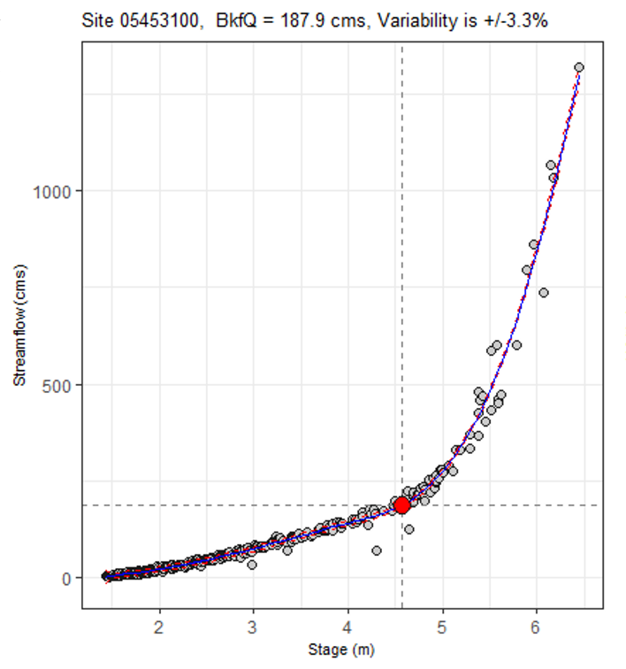
Fig. S1. Example of bankfull discharge computed at one gauge in the USA (site 05453100) which has a National Weather Service flood stage of 4.57 m (vertical dash line) and an estimated bankfull discharge of 187.87 m³/s (horizontal dash line). The red circle indicates estimated bankfull discharge (y-axis) at the bankfull stage (x-axis). The blue line indicates a smooth Locally-weighted scatterplot smoothing (LOESS) curve fitted to the stage-discharge measurements over the full historical record (grey circles), with the red dashed lines showing the upper and lower bounds of the 95% confidence interval derived from the LOESS curve.

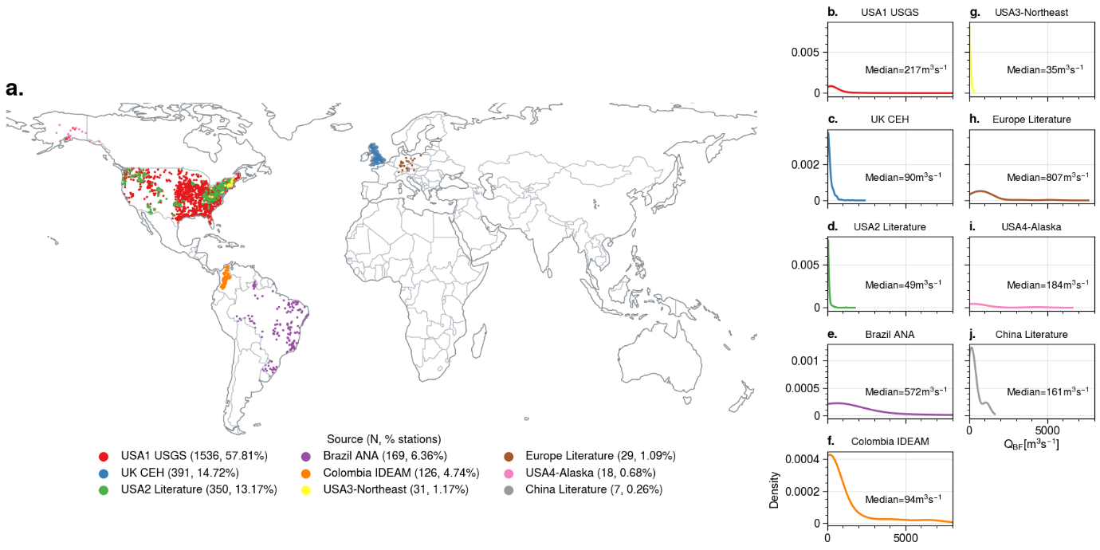
Fig. S1. Location of observed bankfull discharge at 2,657 stations (panel a) and the density distribution of the bankfull discharge from each source (panels b-f). Colour is assigned to differentiate the data sources. In panel a, numbers in brackets indicate the number of stations from each source. In panel b-f, the median value for each source is annotated.
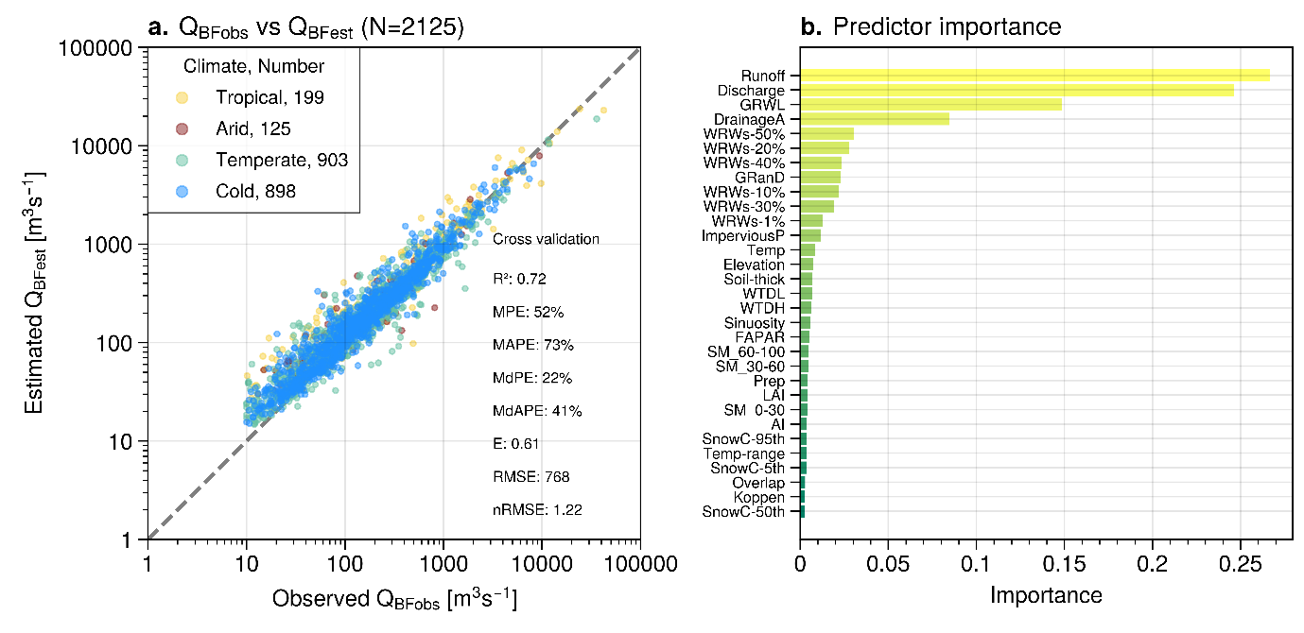
Fig. S3. Cross-validated RF model. a, Scatter plot (log scale) of Q_{BFobs} versus Q_{BFest} at 2,125 training Q_{BFobs} locations with 5-fold cross-validation metric values annotated. Both axes are log scaled. Legend (upper left) indicates the number of samples in each climate. Colours indicate the four main Koppen climate regions. b, Importance ranking of predictors in decreasing order. The horizontal axis indicates the relative contribution of each predictor to the model performance (their sum equals 1).
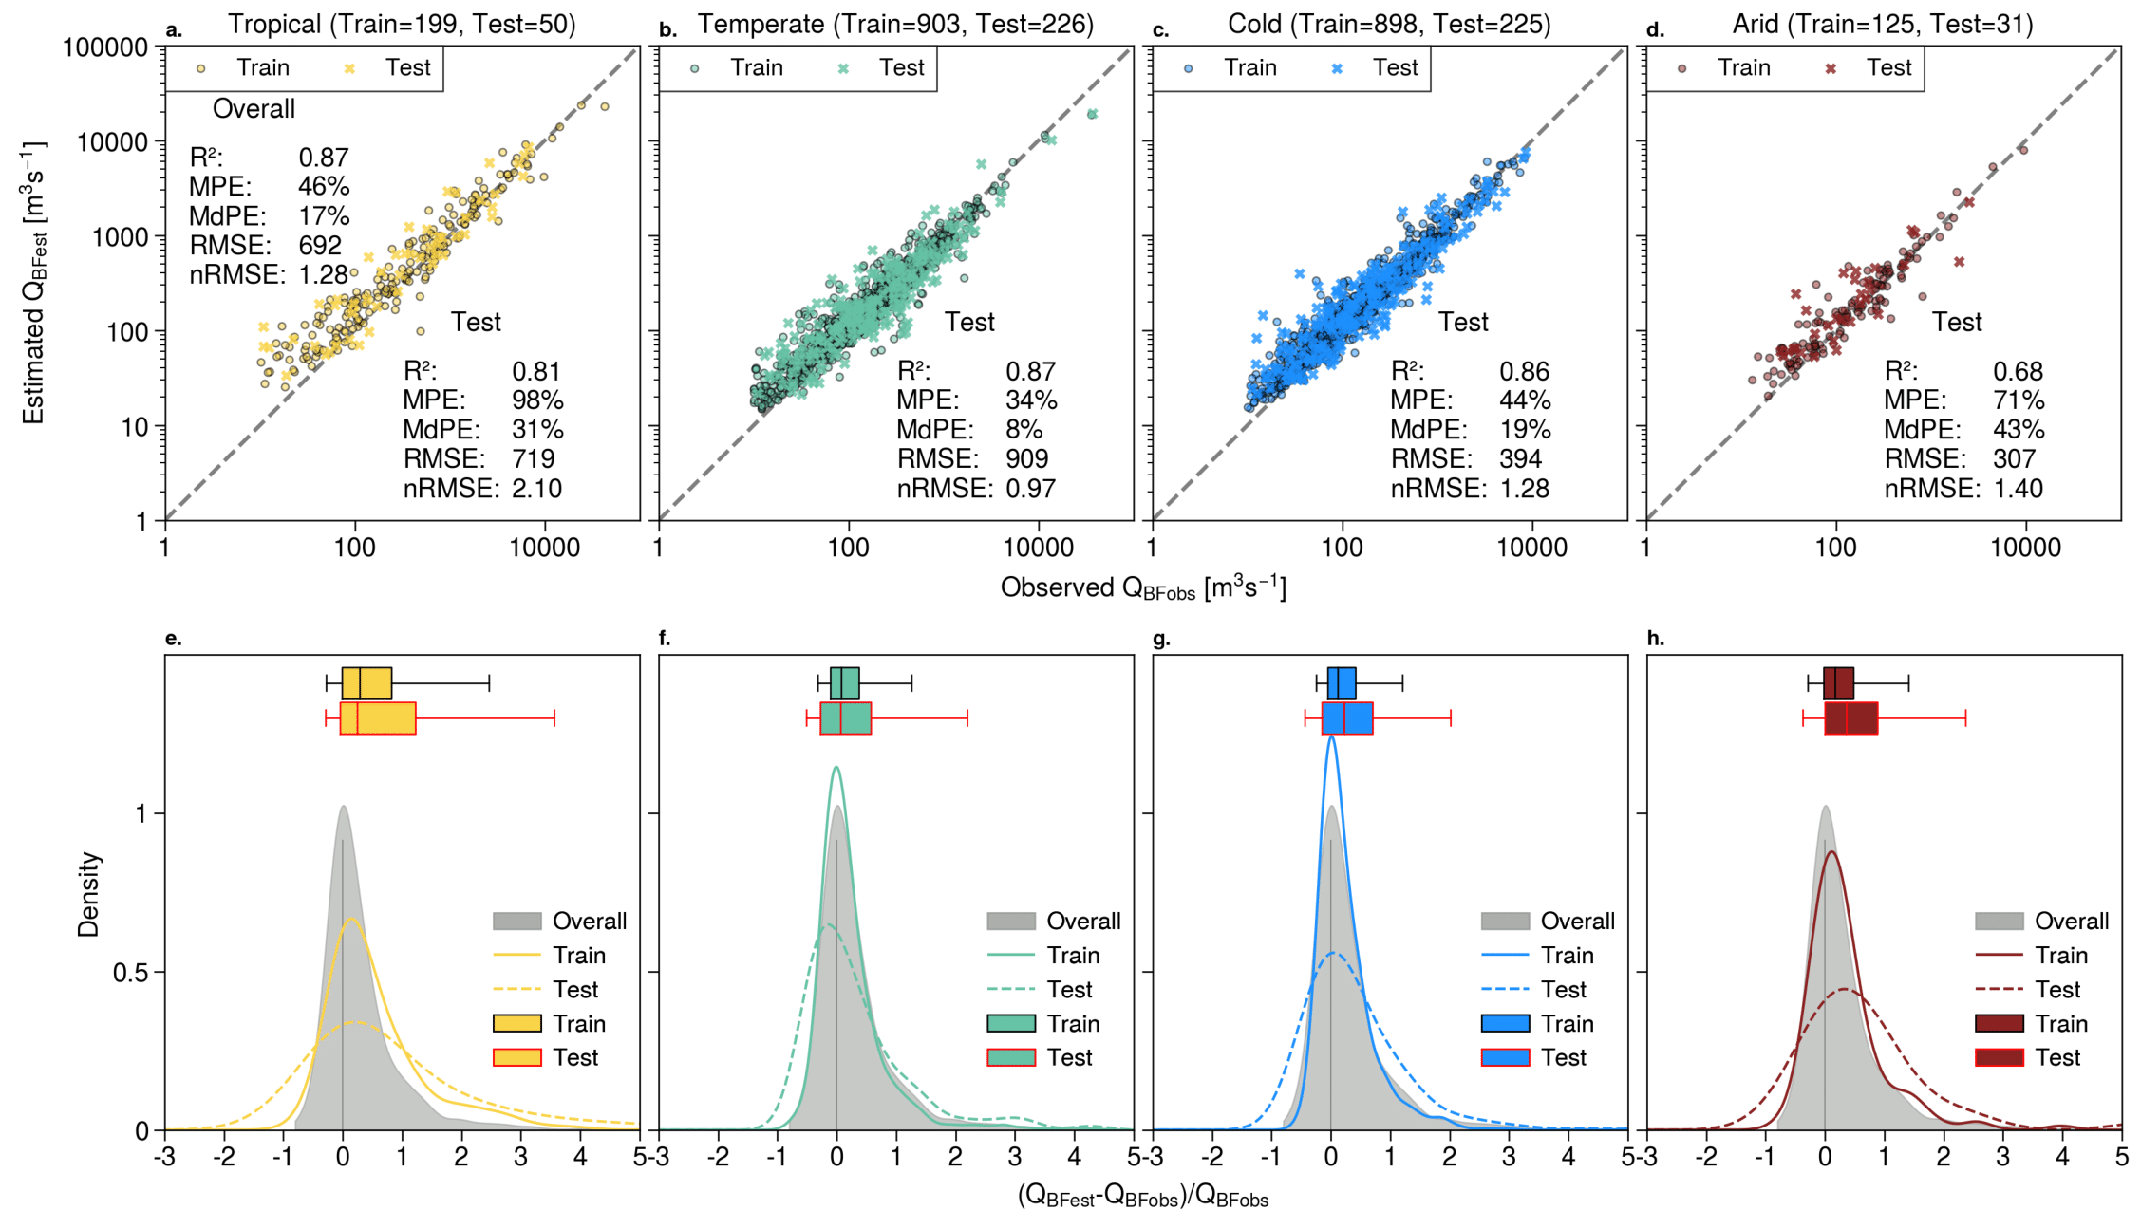
Fig. S4. Performance of the global RF model in the training and testing datasets in four climate regions. a-d, Comparison between Q_{BFobs} and Q_{BFest} in the tropical, arid, temperate, and cold regions, respectively (log scale). Error metrics (R², Mean Percentage Error: MPE, Median Percentage Error: MdPE, Root Mean Square Error: RMSE, normalized RMSE, equations of these metrics are in Supplementary Text S2) of the overall testing are annotated in the upper left on panel a, while error metrics of individual climate are annotated on the lower right of each panel. Panel captions show the number of training and testing data points in each climate region. e-h, Q_{BFest} error (horizontal axis) distribution (density and boxplot) in the four climate regions, differentiating by training and testing data. Grey shaded area is the overall density distribution (training + testing in all climate regions). Grey vertical line marks the horizontal axis origin. The boxplots share the same horizontal axis as the density plot. The boxplot lines, from left to right, mark the 95th, 75th, 50th, 25th, and 5th percentiles, respectively. Colour indicates the climate region, consistent with panels a-d.
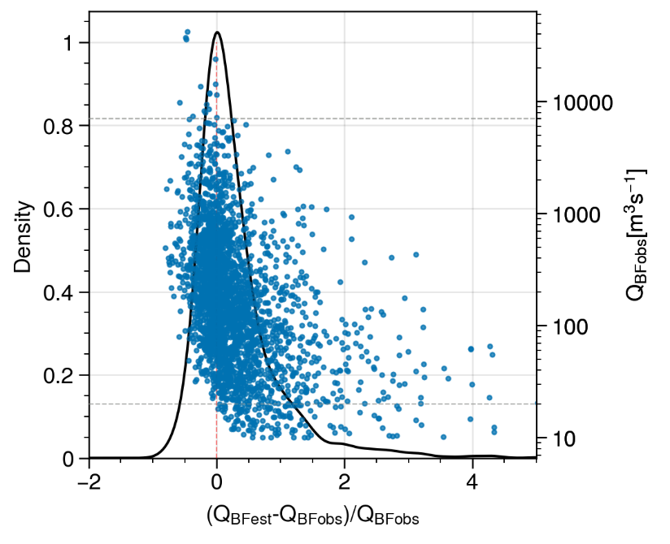
Fig. S5. Distribution of error in Q_{BFest} at 2,657 gauging stations. Black line is the error density distribution, with the x-axis showing the magnitude of the Q_{BFest} error, and the y-axis (left) showing the density value. Blue scatter points show the error distribution associated with the magnitude of Q_{BFest} (right y-axis in log scale). Horizontal dashed grey lines mark the overestimation and underestimation thresholds (right y-axis). Q_{BFest} values smaller than 20 m³s⁻¹ (lower horizontal dashed grey line) were all overestimated in the model (scatters all locate on the right of x=0 line), while Q_{BFest} values greater than 7,000 m³s⁻¹ (upper horizontal dashed grey line) were all underestimated in the model (scatters all locate on the left of x=0).

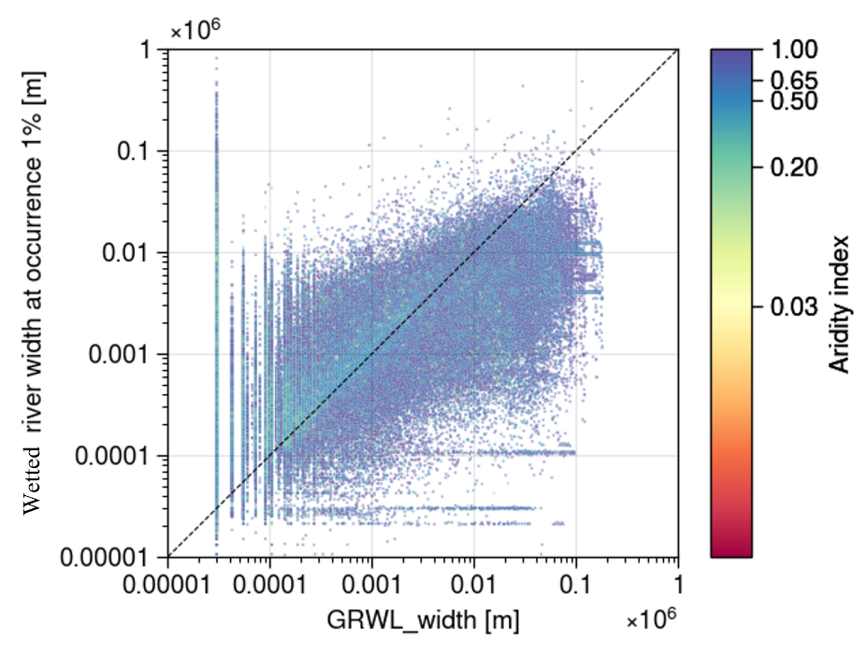
Fig. S6. Comparison between Wetted River Width at 1% occurrence (y-axis) with GRWL river width (x-axis), coloured by Aridity index with higher value indicating more humid climate, lower value indicating dryer climate. Both axes are in log scale.
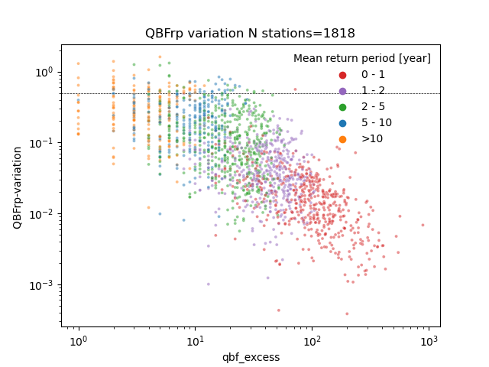
Fig. S7. The relationship between the variation in the Q_{BFobs-RP} (y axis) and the number of events exceeding Q_{BF} (x-axis) at 1,818 Q_{BFobs} sites (log scale). Variation in the Q_{BF-RP} is introduced by applying 10%, 25%, 50%, 75% of the Q_{BFobs} as the threshold to select flood events. The return period is estimated by extracting the flood probability from its relationship with the select flood events using the loess function in R. These sites exclude those without high-quality daily discharge records. Colour (legend) indicates the mean Q_{BFobs-RP}. The variation is defined by the maximum Q_{BFobs-RP} minus the minimum Q_{BFobs-RP} divided by the mean Q_{BFobs-RP}.
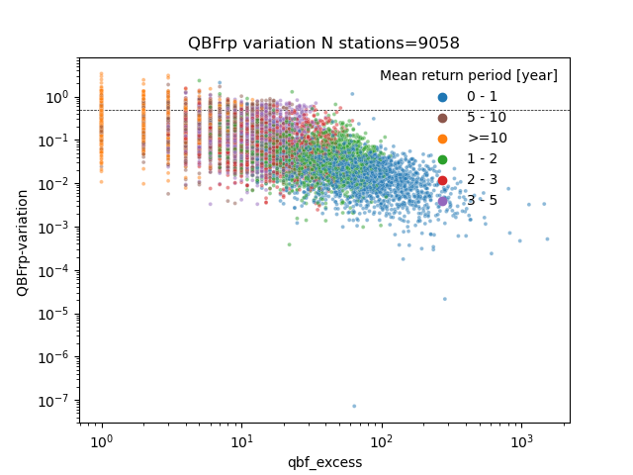
Fig. S8. The relationship between the variation in the Q_{BFest-RP} (y axis) and the number of events exceeding Q_{BFest} (x-axis) at 9,058 Q_{BFest} sites (log scale). Variation in the Q_{BFest-RP} is introduced by applying 10%, 25%, 50%, 75% of the Q_{BFest} as the threshold to select flood event. The return period is estimated by extracting the flood probability from its relationship with the select flood events using the loess function in R. These sites exclude those without high-quality daily discharge records. Colour (legend) indicates the mean Q_{BFest-RP}. The variation is defined by the maximum Q_{BFest-RP} minus the minimum Q_{BF-RP} divided by the mean Q_{BFest-RP}.

Table S1. Predictors used for bankfull discharge estimation. CS: Catchment Sum (total value accumulated in the upstream catchment). CA: Catchment Average (mean of all raster values within the catchment), CM: Catchment Majority (the majority of all raster values within the catchment), RM: Reach Median, RA: Reach Average (median/mean, respectively, of all raster values within the river).
Symbol | Data source and processing | Calculation | Unit | Reference
DrainageA | FABDEM with a spatial resolution of ~30 m, computed based on topography, minimum 50 km² | CS | km² | Wortmann et al.^{25,35}
Discharge | GLOFAS v4.0 reanalysis daily discharge data from 1993 to 2022, gridded data at 0.05°. Average value over the time period was used. | RM | cum/s | Zoster et al.⁴¹
Runoff | GLOFAS v4.0 reanalysis annual total runoff data from 1993 to 2022, gridded data at 0.05°. Average value over the time period was used. | RM | mm | Zoster et al.⁴¹
GRWL, grwl_overlap | Global River Width from Landsat (GRWL). Landsat-based river width at transects, minimum width 30 m. The overlap ratio between the GRWL river mask and the GRIT river network. | RM | M, / | Allen & Pavelsky et al.²⁶, Wortmann et al.²⁵
WRW-1%, WRW-10%, WRW-20%, WRW-30%, WRW-40%, WRW-50% | Wetted River Width at 1%, 10%, 20%, 30%, 40%, 50% Landsat-based water occurrence (occurrence range 0-100), width=wet areas/wet length | RA | m | Pekel et al.⁴²
Sinuosity | River topology sinuosity, obtained from GRIT river attribute | RA | / | Wortmann et al.^{25, 35}
GRanD | Global Reservoir and Dam database version 1.3. Vector data with location and capacity of reservoir | CS | m³ | Lehner et al.⁴⁵
Elevation | FABDEM Elevation with a spatial resolution ~30 m | CA | m | Hawker et al.²⁴
Slope | Slope of each GRIT catchment | CA | / | Wortmann et al.^{25,35}
Prep | Mean annual precipitation from MSWX between 1979 and 2022, gridded data at 0.1°, average value over the above time period was used. | CA | mm | Beck et al.⁴⁶
Temp | Monthly average temperature from MSWX between 1979-2022, gridded data at 0.1°. Average value over time period was used. | CA | °C | Beck et al.⁴⁶
Temp-range | Monthly minimal and maximum temperature range from MSWX between 1979-2022, gridded data at 0.1°. Monthly temperature range was calculated using maximum minus minimum temperature. Average value over months of the time period was used. | CA | °C | Beck et al.⁴⁶
WTDH, WTDL,  SM_0-30, SM_30-60, SM_60-100 | Water table depth-high and low. Gridded data at 0.25° annual data between 1970-2014. Soil Moisture at 0-30, 30-60, 60-100 cm Average value over time period was used. | CA | cm | Guglielmo et al.⁶³
WTDH, WTDL,  SM_0-30, SM_30-60, SM_60-100 |  | CA | cm | Guglielmo et al.⁶³
WTDH, WTDL,  SM_0-30, SM_30-60, SM_60-100 |  | CA | / | Guglielmo et al.⁶³
Soil-thick | Average soil and sedimentary deposit thickness (value range 0-50), gridded data at ~1 km | CA | m | Pelletier et al.⁴⁷
AI | Gridded Aridity Index data at ~1 km | CA | / | Zomer et al.⁴⁸
Koppen | The koppen climate category | CM | / | Beck et al.²⁹
SnowC-50th, SnowC-95th | MODIS snow cover fraction, gridded data at ~1 km (value range 0-100), 5th, 50th, 95th percentile values of averaged annual maximum value over 2000-2019 | CA | / | Hengl et al.⁴⁹
LAI,  FAPAR | Gridded Leaf area index data at 0.05°, daily data between 1979 and 2022, averaged value is used.  Fraction of Absorbed Photosynthetically Active Radiation Daily mean 1979-2022 | CA | / | Vermote et al.⁵²
LAI,  FAPAR |  | CA | / | Vermote et al.⁵²
ImperviousP | Impervious percentage was calculated as urban areas divided by the pixel size 0.25° (value range 0-1), urban area is extracted from the land cover classification map at 2010. | CA | / | Copernicus Climate Change Service⁵³

Text S1
The bankfull discharge observations are a compilation of nine different datasets (Fig. S1 above). The observations are of two types: five existing bankfull discharge datasets (sourced primarily from the literature) and three computed bankfull discharge datasets (computed from cross-sectional river measurements).
The six existing bankfull discharge datasets include: UK CEH, USA2 Literature, Europe Literature, USA3-Northeast, USA4-Alaska, China Literature (shown in the legend of Fig. S1). All the literature references are included in the reference list of the main manuscript.
The UK CEH data was obtained by personal communication from the UK National River Flow Archive – UK Centre for Ecology and Hydrology, https://nrfa.ceh.ac.uk/.
The USA2 Literature data was sourced from the paper Bieger et al., 2015. We obtained the data from http://swat.tamu.edu/publications/. Data description of the bankfull discharge data can be found in the paper available at https://doi.org/10.1111/jawr.12282.
The Europe Literature data was sourced from Schneider et al., 2011, available at https://doi.org/10.1016/j.jhydrol.2011.08.004, Table 5 (column Q_{bf} obs). It reports observed bankfull discharge at 67 locations in Europe. We kept the 30 stations whose station id match with the longitude and latitude information recorded the Global Runoff Data Centre (GRDC) database (downloaded from https://portal.grdc.bafg.de/applications/public.html?publicuser=PublicUser#dataDownload/Home).
The USA3-Northeast source is a compilation of values curated by Gardner Bent, based on a series of reports listed in https://pubs.usgs.gov/sir/2013/5155/. We retained 48 sites which match with the station id obtained from the United States Geological Survey-USGS (available at https://waterdata.usgs.gov/nwis/inventory).
The USA4-Alaska data was compiled by Anderson, 2023, and can be downloaded from https://doi.org/10.5281/zenodo.7920063. It reports the bankfull discharge for 45 Alaskan rivers based on observed streamflow and water level measured in the field, from aerial photographs, satellite imagery, or field surveys (pers. communication).
The China Literature data was sourced from Li et al., 2021, available at https://doi.org/10.3390/rs13142650, Table 2. We retained the bankfull discharge values in 22 hydrological stations (12 mainstem, 10 tributary) located in the upper Yellow River from this source.
In addition to the above six existing bankfull discharge datasets, three additional datasets were computed for the manuscript and are described below. Since direct measurements of bankfull discharge are not available, all three datasets were derived from cross-sectional measurements of the river channel.
The USA1 USGS bankfull discharge dataset was derived using the approach described in Slater et al. (2015). This approach employs cross-section measurements of stage and discharge from the USGS to compute a curve at each site, and then intersects the curve with the flood stage measurement to extract the estimated bankfull discharge. The flood stages were downloaded from the National Oceanic and Atmospheric Administration’s National Weather Service (NWS) at https://water.weather.gov/ahps/download.php. The NWS defines “action” flood stage as “an established gauge height for a given location above which a rise in water surface level begins to create a hazard to lives, property, or commerce”. We make the assumption that this is the closest available measurement of bankfull (see Figure S2). Cross-sectional measurements were downloaded from the USGS National Water information system at https://waterdata.usgs.gov/nwis/measurements?search_criteria=huc2
_cd&submitted_form=introduction. The channel measurements were filtered to retain only measurements later than 1 January 1980. We retained the single longest channel measurement location (‘chan_nu’) at each site. We only kept sites with at least 20 measurements over at least 10 years. The stage-discharge rating curve at each site was fit by using a Locally-weighted scatterplot smoothing curve (LOESS) in R with a span of 0.2. By intersecting this curve with the National Weather Service’s estimate of flood stage at each site, we extracted the time-averaged estimate of bankfull discharge at flood stage (Figure S2). We obtained bankfull discharge value at 1,536 stations from this source. The resulting bankfull discharge data are distributed across the USA (location are shown in Extended Data Fig. 1).
The Colombia IDEAM bankfull discharge dataset was produced using the following method. Multiple cross-section measurements were obtained for each gauging station from the Colombian Institute of Hydrology, Meteorology and Environmental Studies - IDEAM. The measurements consist of the river channel cross-sectional area, discharge and the date when the measurement was conducted. We took the discharge corresponding to the maximum cross-section area (Qmax.cross_section) as the bankfull discharge. Outliers were removed following the process below. The cross-sectional discharge values (Qmax.cross_section) were compared with gauged discharge (Qmax.gauge) (maximum discharge within ±3 days of the date of the cross-sectional measurement). We ruled out any stations where the Qmax.cross_section deviated notably from the reported discharge value (Qmax.cross_section >150% Qmax.gauge or Qmax.cross_section <50% Qmax.gauge). We conducted manual checks to ensure that the measured cross-sectional shape had a U shape rather than an inverted omega shape Ʊ, indicating the flow was most likely within the banks. We kept a total number of 129 stations with valid bankfull discharge values.
The Brazil ANA bankfull discharge dataset was derived by combining cross-sectional measurements of the river channel and the stage-discharge curve at each location. Estimates were derived using a semi-automated approach that involves the evaluation of cross-sectional and stage-discharge measurements. Data were downloaded from the National Hydrometeorological Network of Brazil (https://www.snirh.gov.br/hidroweb/apresentacao, last accessed 5th March, 2024) that is managed by Brazilian Water and Sanitation Agency – ANA – and largely operated by the Brazilian Geological Survey – SGB/CPRM. Preliminary data cleaning was followed by the analysis of breakpoints in stage-discharge pairings using the 'segmented' R package (Muggeo, 2008). Between one and three breakpoints were identified at each location. In locations where multiple breakpoints were identified, the one corresponding to the highest flow was considered as representative of the bankfull discharge. In certain instances where a reliable breaking point could not be detected, the discharge corresponding to the maximum cross-sectional area was considered as bankfull. Manual checks were performed at all sites to ensure that estimated discharges were consistent with river bank boundaries. We estimated bankfull flows of 169 stream gauges.
From these nine data sources, we removed duplicated or erroneous sites following three criteria. First, in locations with duplicate measurements, we retained only one value with the highest confidence. We used the following confidence order: USA3-Northeast > USA1 USGS > USA2 Literature > USA4-Alaska. This order was decided based on expert knowledge considering the source data and the measuring methods. Second, we removed any sites located further than 1 km from the GRIT river reaches and any sites where the reported drainage area deviated more than 20% from the drainage area of the paired GRIT river reach. Lastly, we removed sites with bankfull discharge smaller than 10 m³s⁻¹ (given the constraints in the Random Forest predictors in representing small rivers, such sites are challenging to estimate). After applying these filtering procedures, we retained the bankfull discharge observations for 2,657 river reaches (Fig. S2).

Text S2
Equations of the error metrics (R², MdPE, MPE, MAPE, MdAPE, RMSE, nRMSE) used to evaluate the random forest model.
$R^{2}=1-\frac{\sum_{i=1}^{i=n}{{\left(Q_{BFobs}-Q_{BFest}\right)}^{2}}}{\sum_{i=1}^{i=n}{{\left(Q_{BFobs}-Q_{BFobs_mean}\right)}^{2}}}$ (1)
$MdPE=Median(\frac{Q_{BFobs}-Q_{BFest}}{Q_{BFobs}}×100\%)$ (2)
$MPE=(\frac{1}{n})\sum_{i=1}^{i=n}{\frac{Q_{BFobs}-Q_{BFest}}{Q_{BFobs}}×100\%}$ (3)
$MAPE=(\frac{1}{n})\sum_{i=1}^{i=n}{\frac{\left|Q_{BFobs}-Q_{BFest}\right|}{Q_{BFobs}}×100\%}$ (4)
$MdAPE=Median(\frac{\left|Q_{BFobs}-Q_{BFest}\right|}{Q_{BFobs}}×100\%)$ (5)
$RMSE=\sqrt{\frac{1}{n}\sum_{i=1}^{i=n}{{\left(Q_{BFobs}-Q_{BFest}\right)}^{2}}}$ (6)
$nRMSE=\sqrt{\frac{1}{n}\sum_{i=1}^{i=n}{{\left(\frac{Q_{BFobs}-Q_{BFest}}{Q_{BFobs}}\right)}^{2}}}$ (7)
Where Q_{BFobs} is the observed bankfull discharge, Q_{BFest} is the estimated bankfull discharge, Q_{BFobs_mean} is the averaged value of the observed bankfull discharge, n is the total number of the data.
The percentage errors (MdPE, MPE) depict the level of overestimated (positive values) and underestimated (negative values) of the model. The absolute percentage errors (MAPE, MdAPE) and RMSE show the absolute error magnitude. The normalized RMSE (nRMSE) shows the relative error magnitude.

