Synthesis, In-silico and In-vivo anticonvulsant activity of novel substituted 2- 2-Phenyl Indole derivatives
Md. Lateef Khanª, Prashant Kushwahaª, Shobha Singh^{a*}, Divyash Singh^{b}, Dharamveer Panjwani^{c} , Avinash Chandra Tripathiª
STable1 Physiochemical chemical properties of synthesized compounds (L-A to L-F)

Compounds | Structure | Mol. Formula | Color and Physical state | Solubility | Melting range | Rf value | Reaction time | % Yield
L-A | 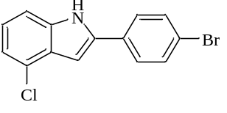 | C₁₄H₉ClN | White crystalline solid | Chloroform | 185-188 | 0.65 | 3h | 74.7
L-B | 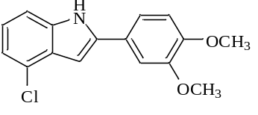 | C₁₆H₁₄ClNO₂ | Orange crystalline solid | Chloroform | 168-170 | 0.3 | 3h30min | 79.36
L-C | 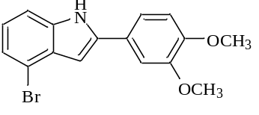 | C₁₆H₁₄BrNO₂ | Yellow crystalline solid | Chloroform | 145-150 | 0.37 | 3h20min | 73.68
L-D | 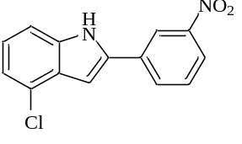 | C₁₄H₉ClN₂O₂ | Orange crystalline solid | Chloroform | 205-210 | 0.30 | 3h | 77.54
L-E | 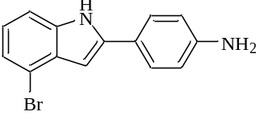 | C₁₄H₁₁BrN₂ | Dark Broun crystalline solid | Chloroform | 155-160 | 0.37 | 2h50min | 5074
L-F | 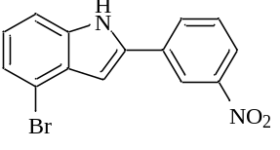 | C₁₄H₉BrN₂O₂ | Yellow crystalline solid | Chloroform | 175-180 | 0.34 | 3h | 76.11

STable2 ADMET predictions using pkCSM tool
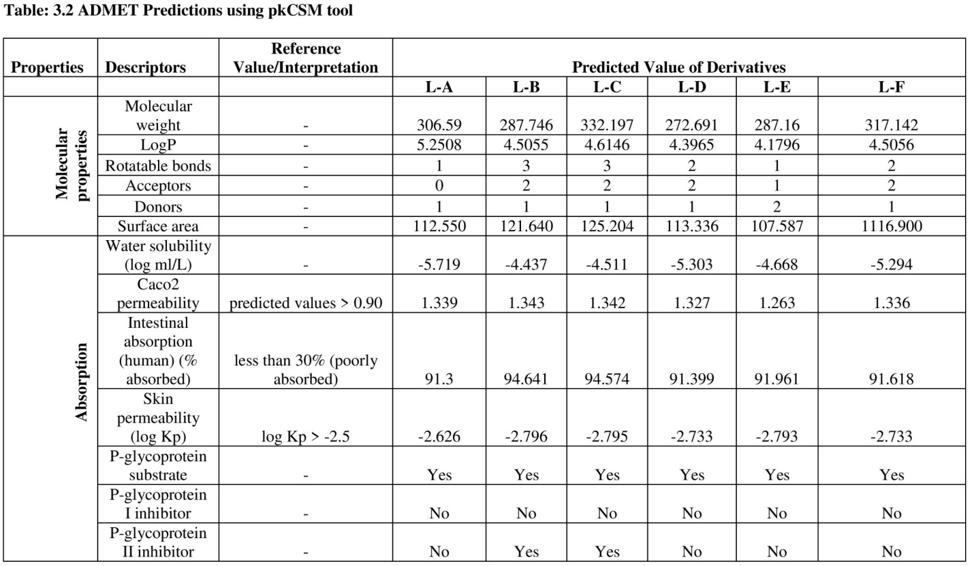
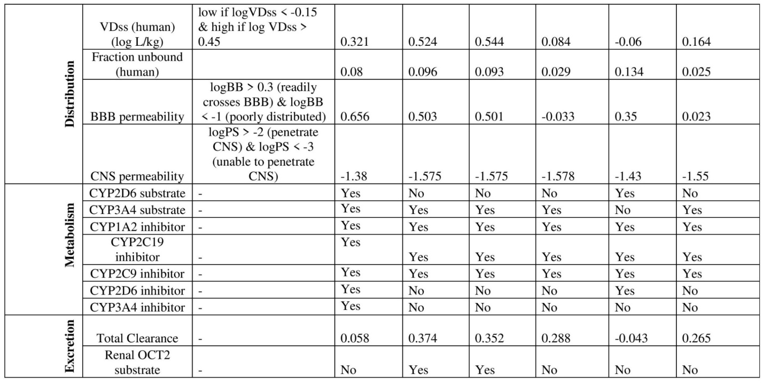

STable 3 ADMET Prediction using Swiss ADME Tool

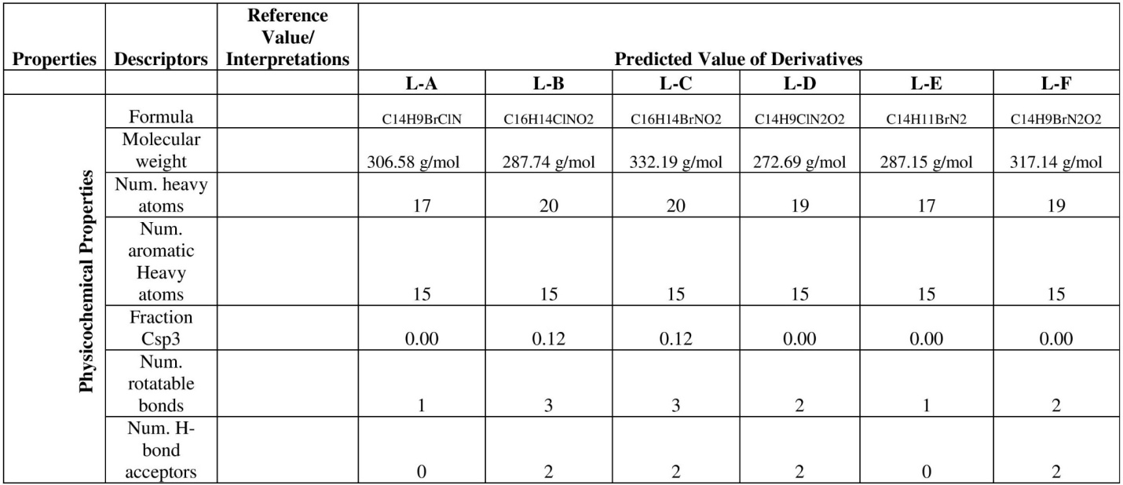

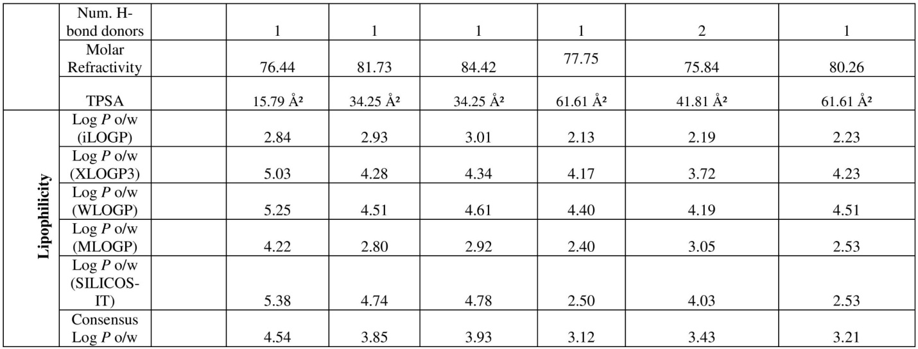
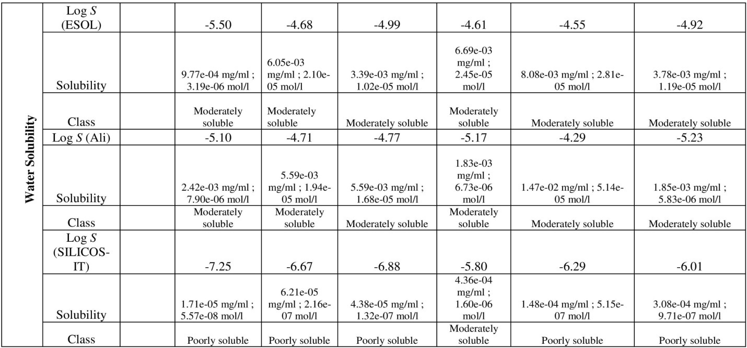

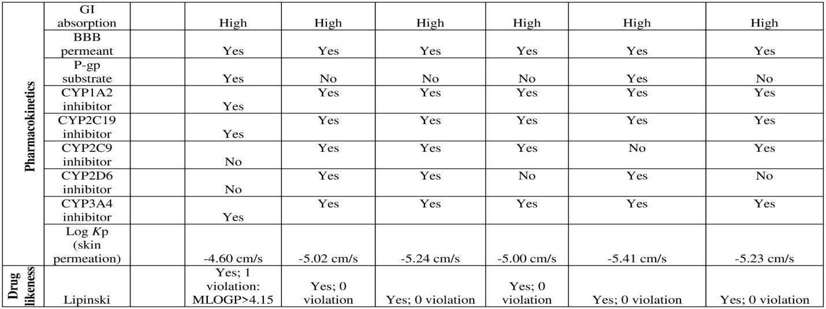

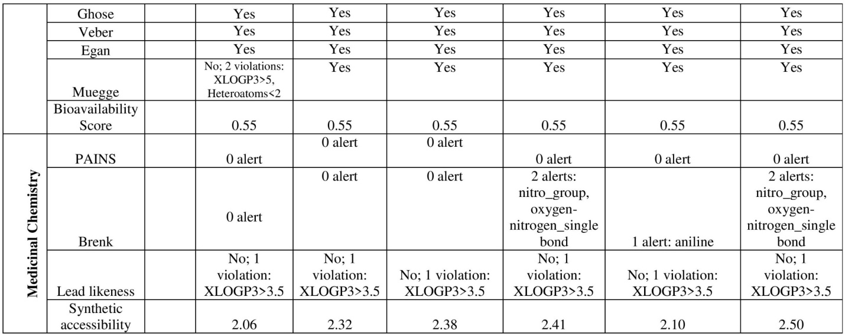

Synthesis of 2-(4-bromophenyl)-4chloro-1H-indole [2a]
IR spectra of the synthesized 2-phenylindole derivatives (L-A to L-F) showed absorption bands in the 3500-3100 cm-1 range for primary amine (N-H stretching) and C-H stretching bands were observed in 3000-3100cm-¹. The C=C and C-C stretching bands were detected in 1440-1625 cm-¹ and 1185-1600 cm-¹, respectively. Other prominent characteristic absorption peaks at 1640-1550 cm- 1 amine (N-H bending) were also observed. MS-ESI [M+ & M⁻] peaks were observed in the mass spectra, consistent with the proposed structures. Similarly, NMR spectra with chemical shifts were consistent with the proposed structure. Rest assured that we have performed rigorous quality control procedures to ensure the accuracy and reliability of our results.
¹H NMR [DMSO-d6] δ (ppm): 6.77 (s, CH-indole, 1H), 6.81-7.55 (m, Ar-indole,3H), 7.66-7.78 (m, Ar-CH,4H), 11.36 (s, NH-indole, 1H).
MS-ESI [M⁺]: 306.6 (70%)

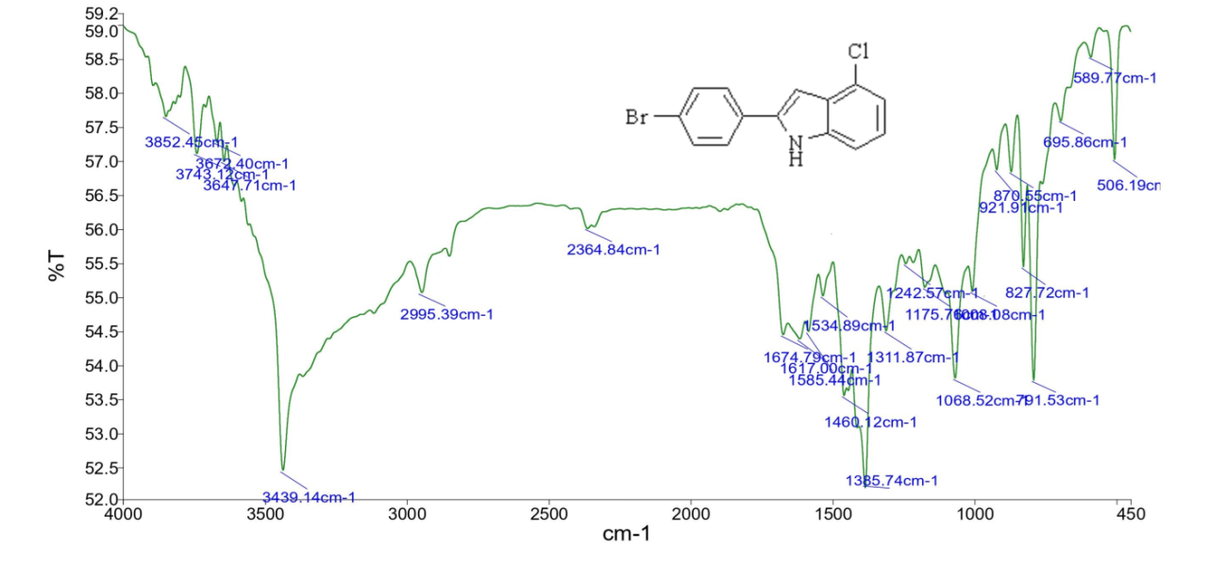
SFig.1 IR Spectrum of compound (2a)
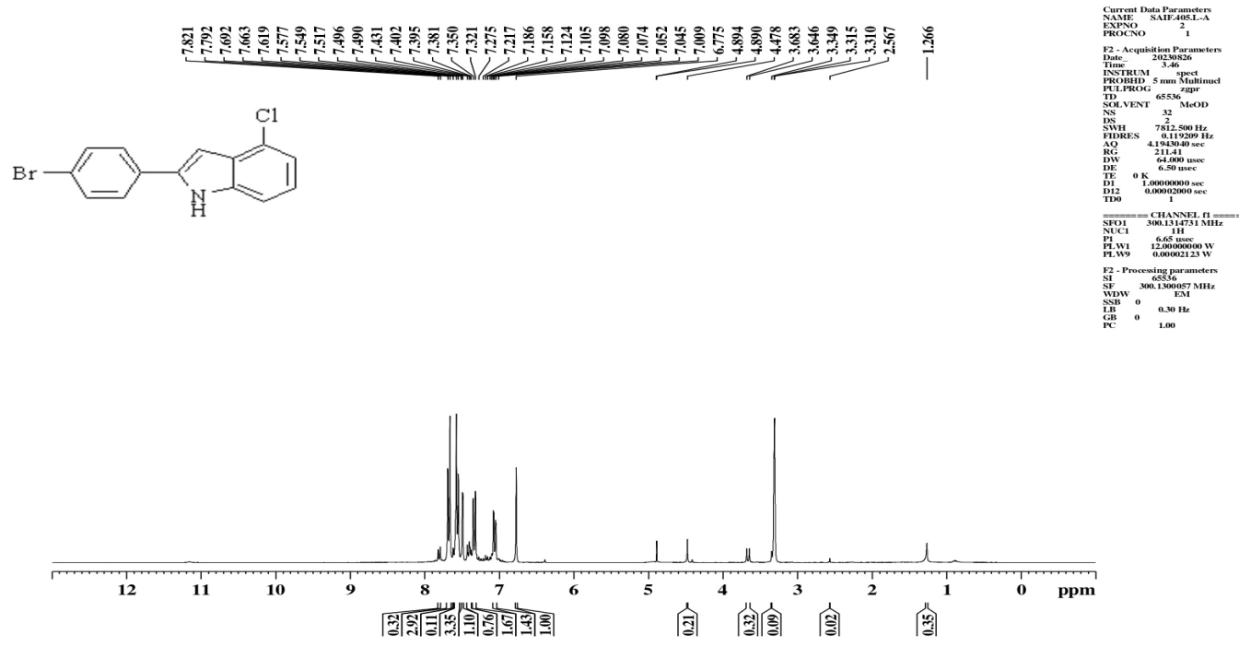
SFig.2. ¹H NMR Spectrum of compound (2a)
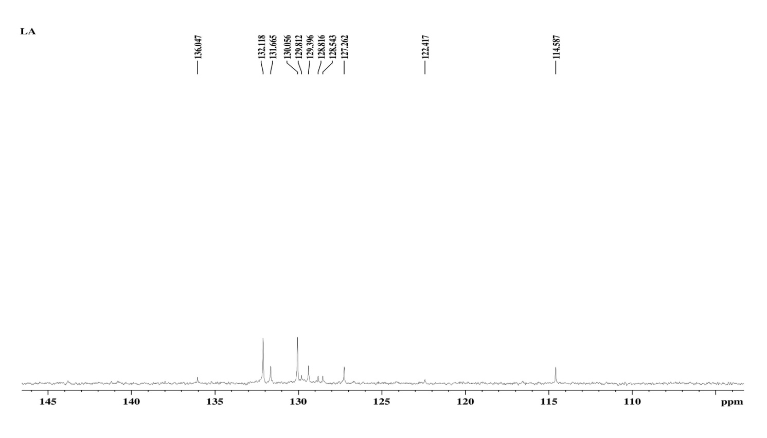
SFig.3. ¹³C NMR Spectrum of compound (2a)

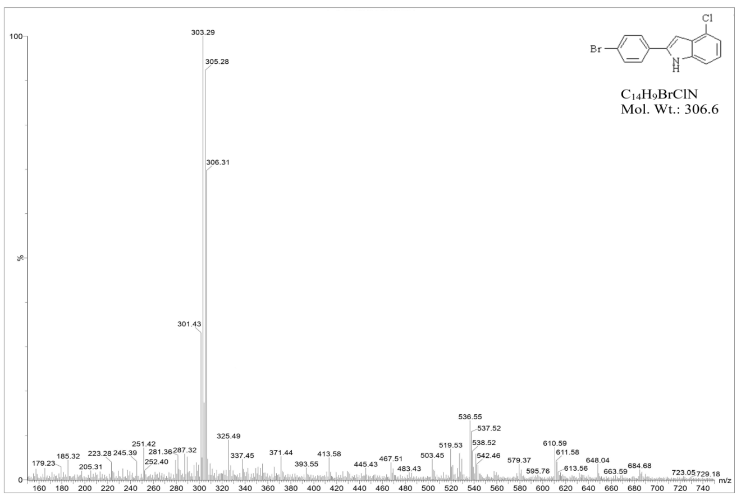
2a
SFig.4 Mass Spectrum of Compound (2a)

Synthesis of 4-chloro-2(3, 4-dimethoxyphenyl)-1H-indole [2b]
IR-C-Cl (Aromatic)-690cm⁻¹, C-N stretching -1253.57cm⁻¹, C=C (Aromatic)- 1464.96, C-C (Aromatic)- 1591.20, C-OCH₃ (Aromatic) stretching-2836, C-H (Aromatic)- 3003.75, N-H (Amine) stretching-3362.96 cm⁻¹
¹H NMR [DMSO-d6] δ (ppm): 3.83 (d, Ar-OCH₃, 6H), 6.77 (s, CH-indole, 1H), 6.81-7.55 (m, Ar-indole, 3H), 6.94-725 (m, Ar-CH, 3H), 12.06 (s, NH-indole, 1H).
MS-ESI [M⁺]: 288.37 (86%)

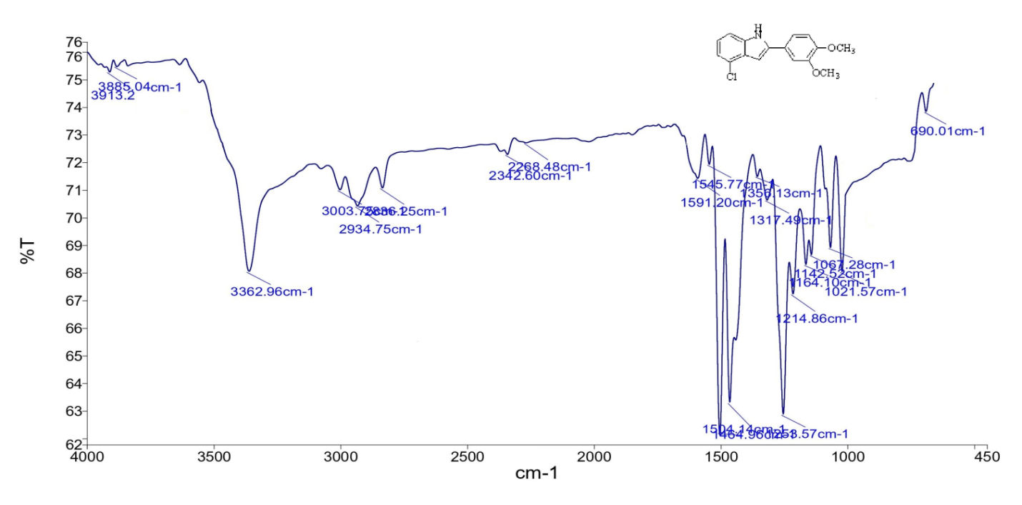
SFig.5 IR Spectrum of compound (2b)

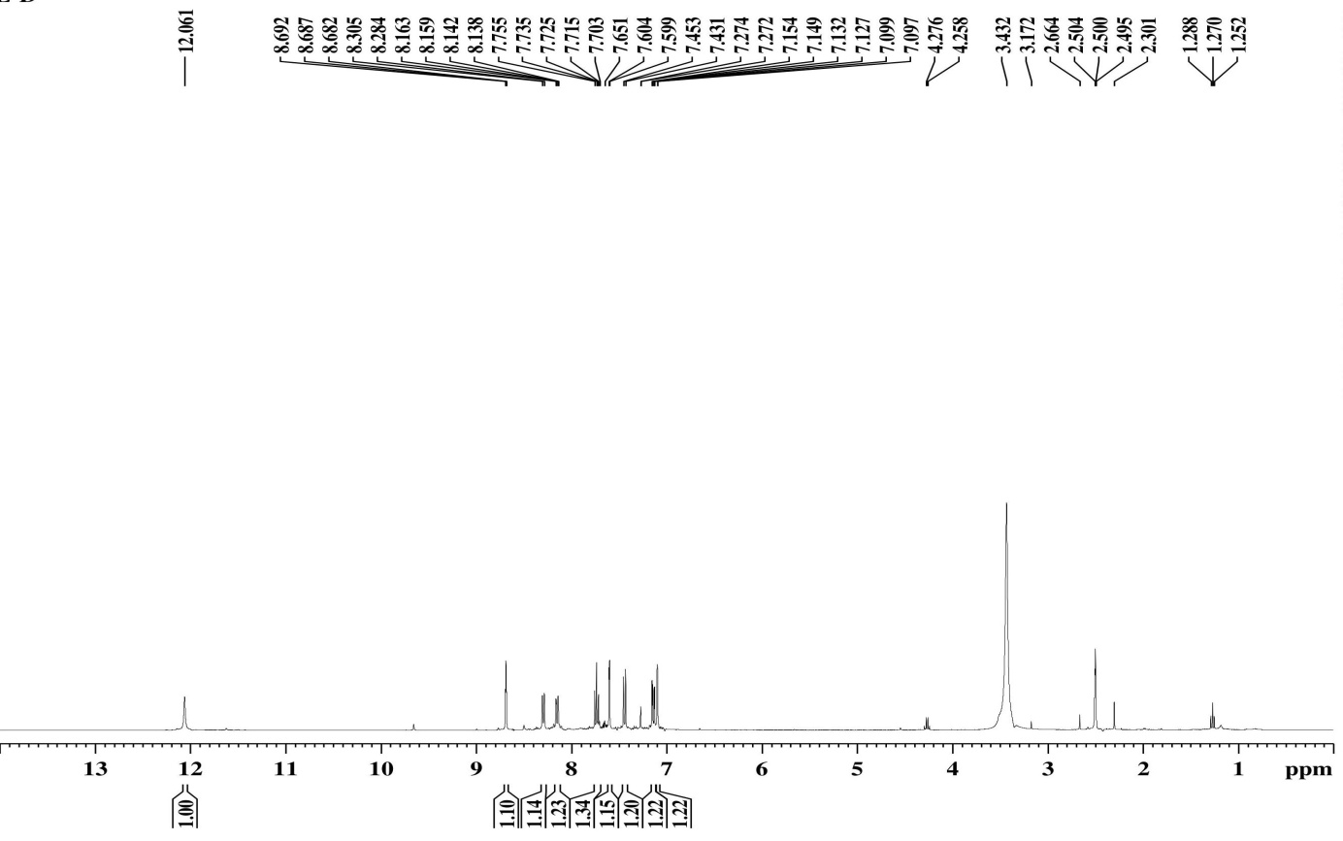

SFig.6 ¹H NMR Spectrum of compound (2b)
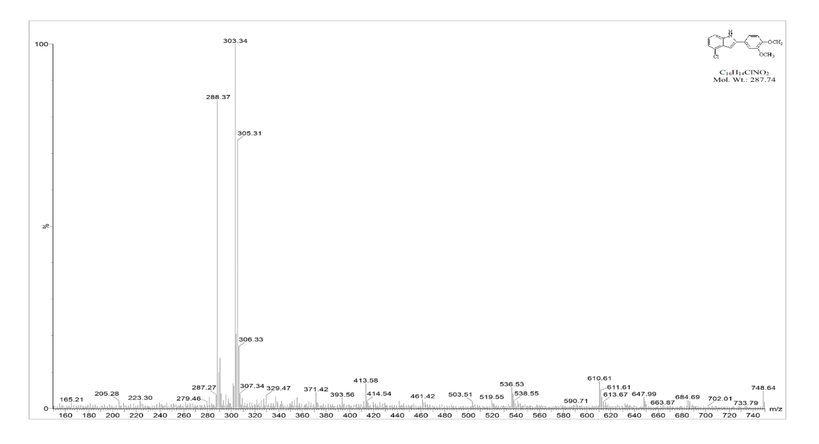
2b

SFig.7. Mass Spectrum of Compound (2b)
Synthesis of 4-bromo-2(3, 4-dimethoxyphenyl)-1H-indole [2c]
C-Br (Aromatic)-667.97m⁻¹, C-N stretching -1253.57cm⁻¹, C=C (Aromatic)- 1464.96, C-C (Aromatic)- 1591.20, C-OCH₃ (Aromatic) stretching-2836, C-H (Aromatic)- 3003.75, N-H (Amine) stretching-3362.96 cm⁻¹
¹H NMR [DMSO-d6] δ (ppm): 3.83 (d, Ar-OCH₃, 6H), 6.77 (s, CH-indole, 1H), 6.88 (s, CH-indole, 1H), 6.94-7.25 (m, Ar-CH, 3H), 7.50-761 (d, Ar- CH-indole, 2H), 11.36 (s, NH- indole, 1H).
MS-ESI [M⁺]: 332.31 (62%)

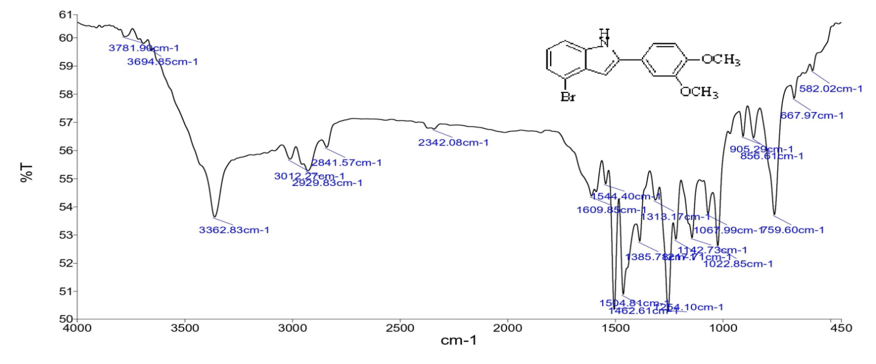
SFig.8 IR Spectrum of compound (2c)

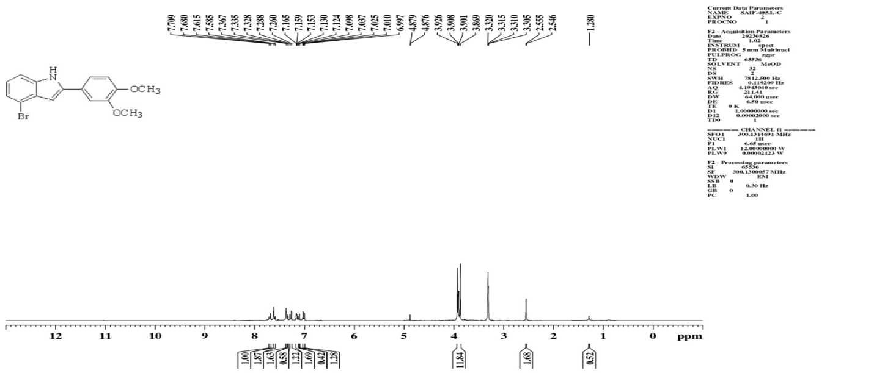

SFig.9 ¹H NMR Spectrum of compound (2c)

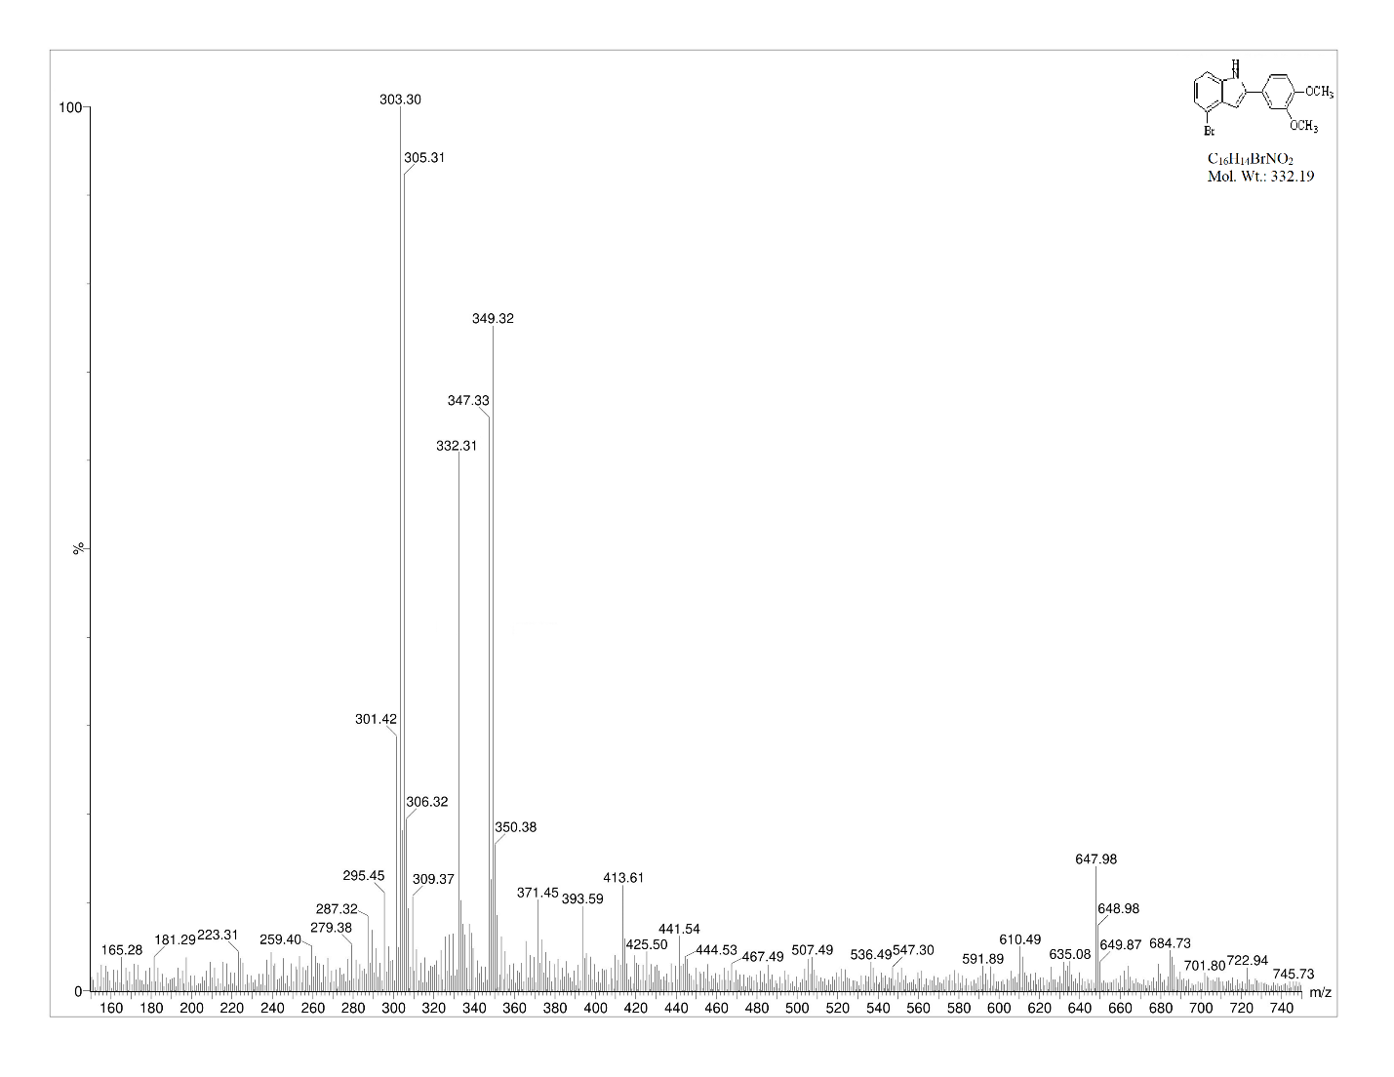
2c
SFig.2.9. Mass Spectrum of Compound (2c)

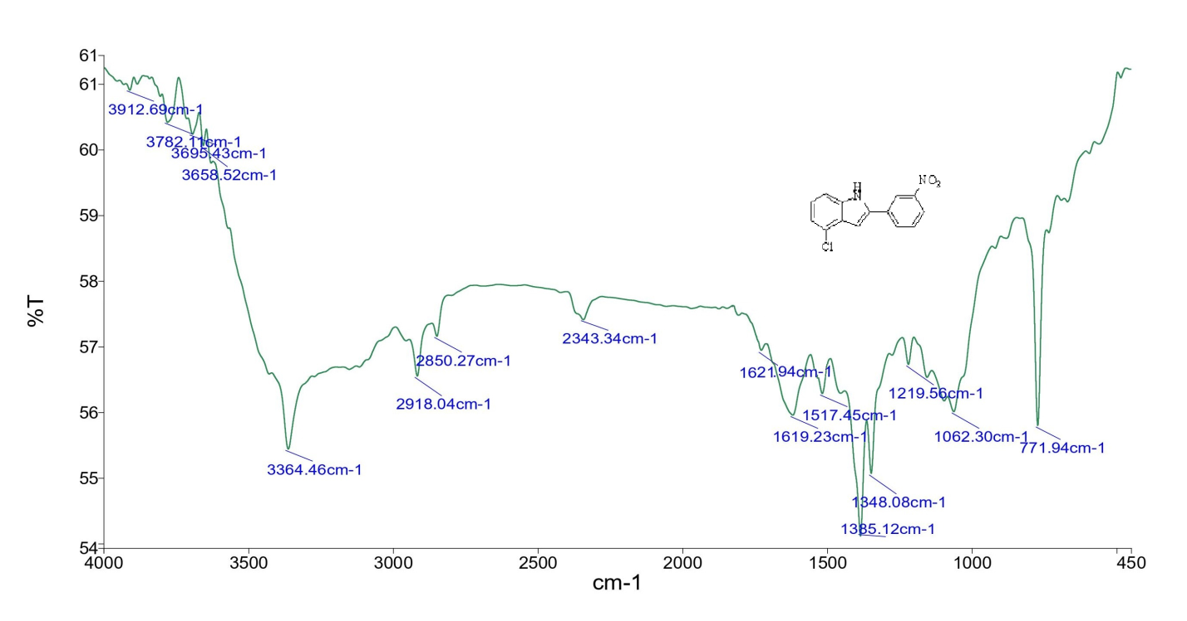

SFig.10 IR Spectrum of compound (2d)
Synthesis of 4-chloro-2(3-nitrophenyl)-1H-indole [2d]
IR-C-Cl (Aromatic)-690cm⁻¹, C-N stretching -1253.57cm⁻¹, C=C (Aromatic)- 1464.96, C-C (Aromatic)- 1591.20, C-NO₂ (Aromatic) stretching-1517.45, C-H (Aromatic)- 3003.75, N-H (Amine) stretching-3362.96 cm⁻¹
¹H NMR [DMSO-d6] δ (ppm): 6.77 (s, CH-indole, 1H), 6.81-7.55 (m, CH-indole, 3H), 7.77-8.65 (m, Ar-CH, 4H), 11.36 (s, NH-indole, 1H).
MS-ESI [M⁺]: 272.32 (75%)

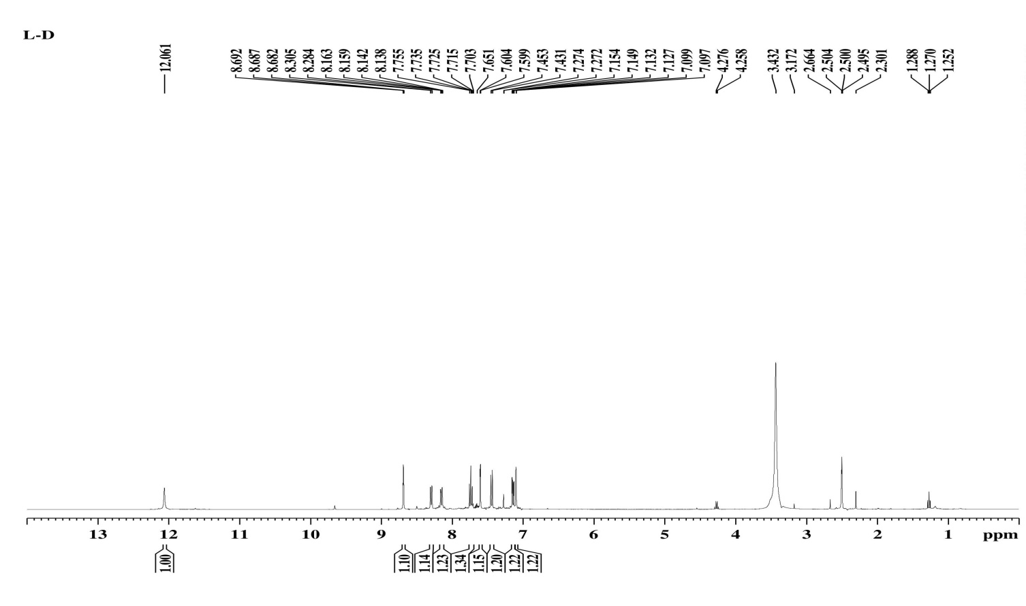

SFig. 11. ¹H NMR Spectrum of compound (2d)
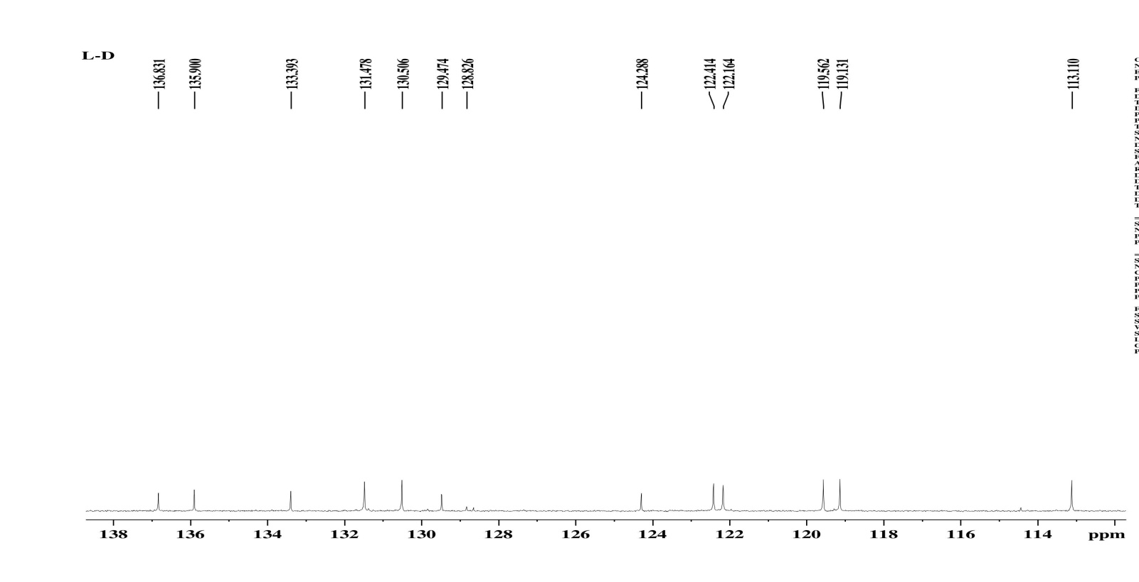
SFig. 12. ¹³C NMR Spectrum of compound (2d)

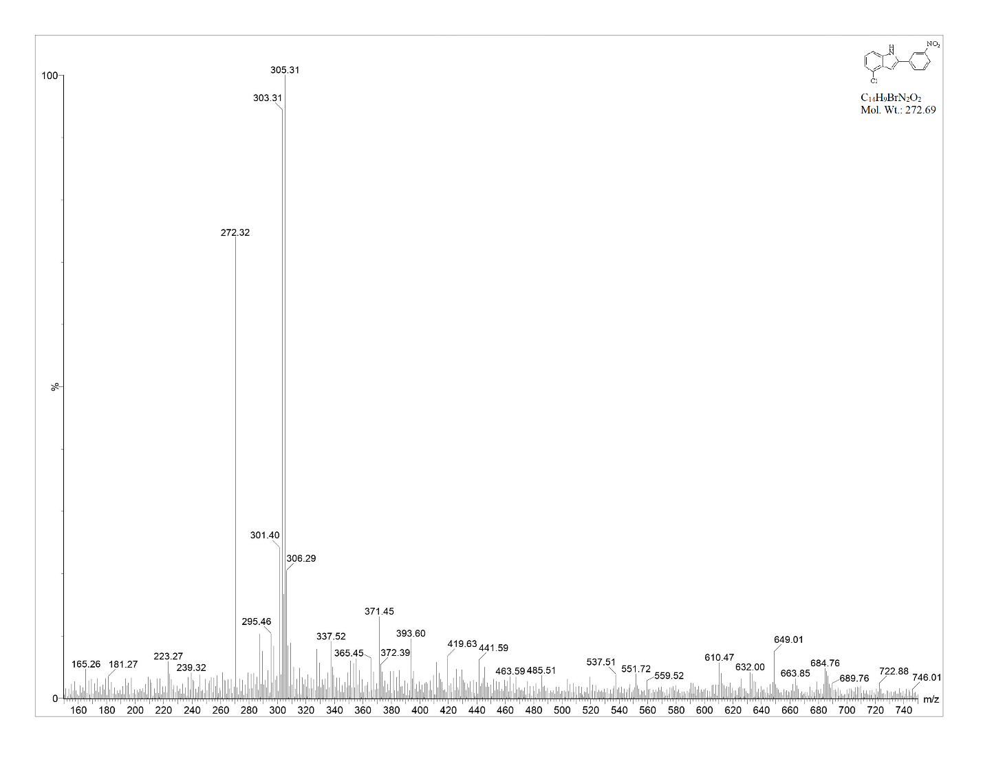
2d
SFig.14 Mass Spectrum of Compound (2d)

Synthesis of 4-(4-bromo-1H-indole-2-yl)benzenamine [2e]
C-Br (Aromatic)-667.97m⁻¹, C-N stretching -1253.57cm⁻¹, C=C (Aromatic)- 1464.96, C-C (Aromatic)- 1591.20, C-H (Aromatic)- 3003.75, N-H (Amine) stretching-3362.96 cm⁻¹, C-NH₂ (Amines) stretching-3341.34cm⁻¹
¹H NMR [DMSO-d6] δ (ppm): 6.27 (s, NH_{2,} 2H), 6.58-7.54 (m, CH, 4H), 6.77 (s, CH-indole, 1H), 6.88-7.61 (m, Ar-CH-indole, 3H), 11.36 (s, NH-indole, 1H).
MS-ESI [M⁺]: 289.3 (100%)
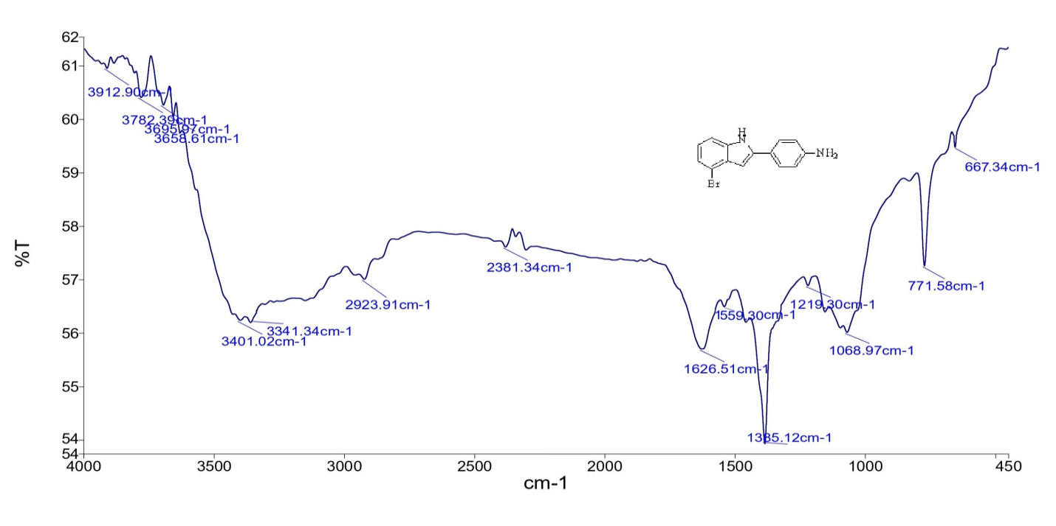
SFig.15 IR Spectrum of compound (2e)

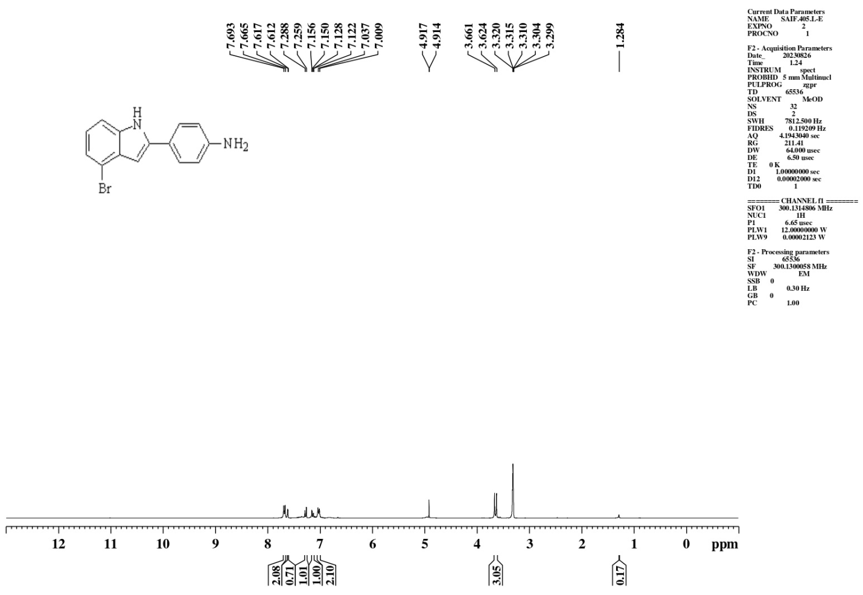
SFig.16 ¹H NMR Spectrum of compound (2e)
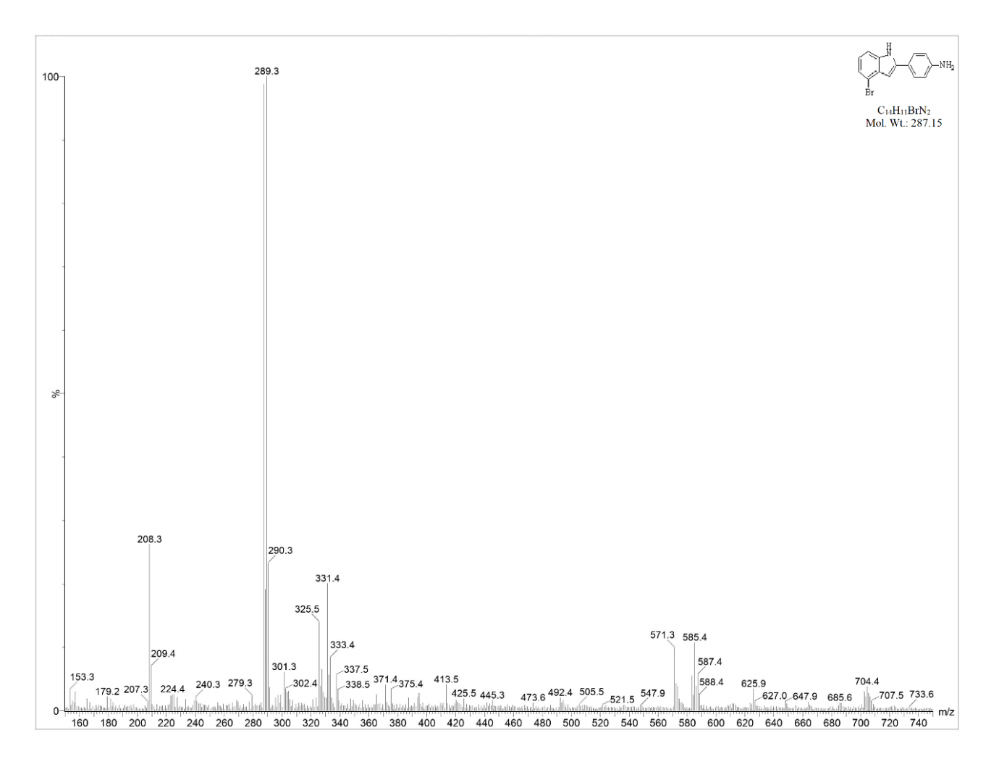
2e
SFig.17 Mass Spectrum of Compound (2e)

Synthesis of 4-bromo-2-(3-nitrophenyl)-1H-indole [2f]
IR-C-Br (Aromatic)- 586.37cm⁻¹, C-N stretching -1253.57cm⁻¹, C=C (Aromatic)- 1464.96, C-C (Aromatic)- 1591.20, C-NO₂ (Aromatic) stretching-1524.45, C-H (Aromatic)- 2996.75, N-H (Amine) stretching-3359.96 cm⁻¹
¹H NMR [DMSO-d6] δ (ppm): 6.77 (s, CH-indole, 1H), 6.88-7.61 (m Ar-CH-indole, 3H), 7.77-8.65 (m, Ar-CH-, 4H), 11.36 (s, NH-indole, 1H).
MS-ESI [M⁺]: 318 (72%)
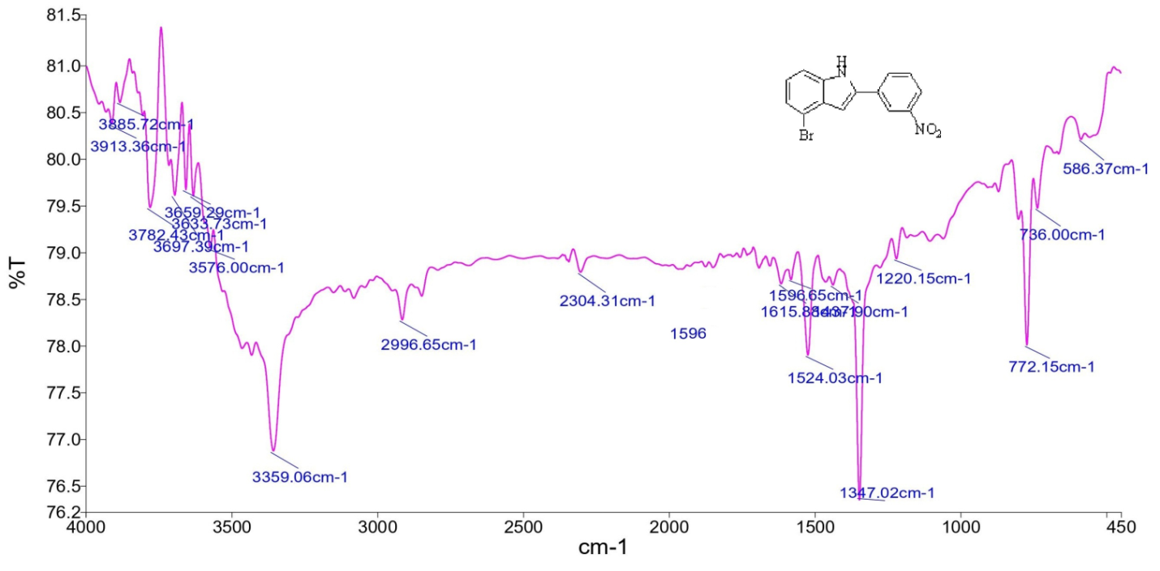
SFig.18 IR Spectrum of compound (2f)

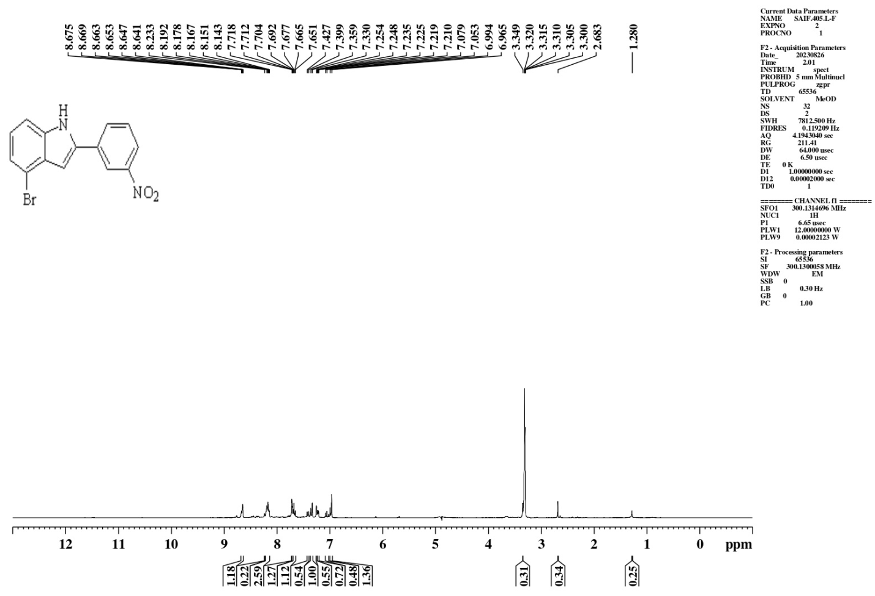
SFig.2.19. ¹H NMR Spectrum of compound (2f)

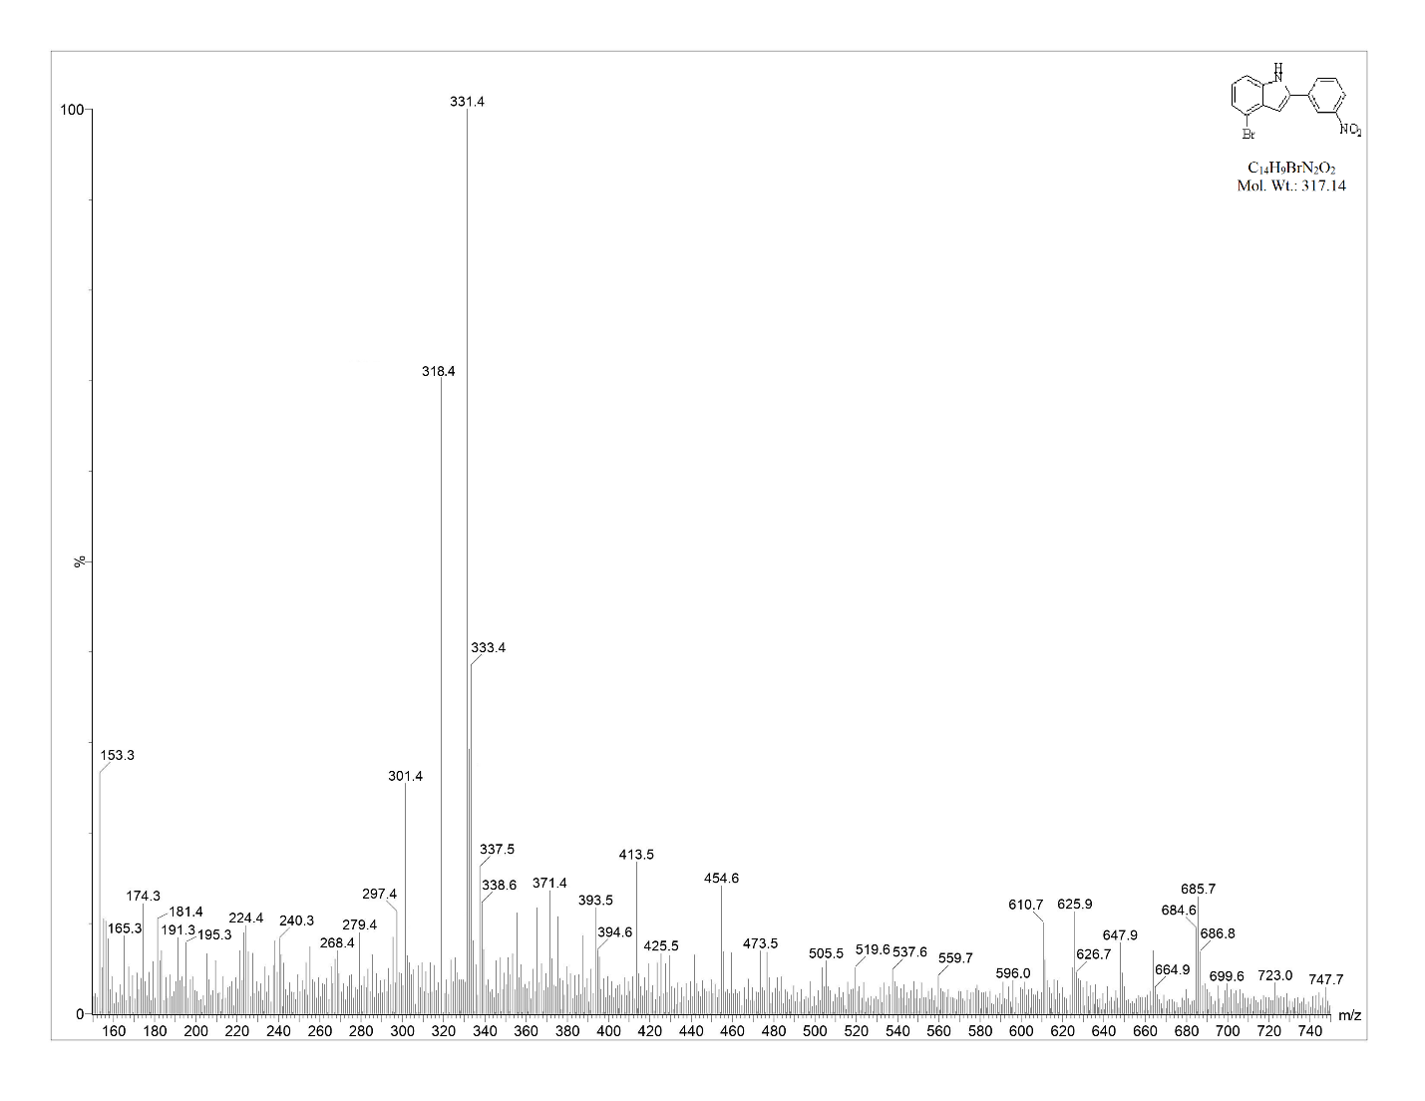
2f
SFig.20. Mass Spectrum of Compound (2f)

