Supplementary Information

Temporal expression signatures of rare variant-harboring genes linked to autism, bipolar disorder, schizophrenia and epilepsy across neurodevelopment

Authors:
Kalyani B. Karunakaran^{1*}, Suhas Ganesh¹, Ashitha SNM¹, Biju Viswanath^{1*}, Meera Purushottam¹, Sanjeev Jain¹
Affiliations:
¹ Molecular Genetics Lab, Department of Psychiatry, National Institute of Mental Health and Neurosciences
*Correspondence to: Kalyani B. Karunakaran (kalyanithepebble@gmail.com) and Biju Viswanath (bijuv1@gmail.com)

This file contains:
- Supplementary Methods
- Supplementary Notes 1 to 5
- Supplementary Discussion
- Supplementary Figures 1 to 8
- Supplementary References 1 to 22

Supplementary Methods
Hierarchical clustering of temporal expression profiles
We examined the developmental transcriptome RNA-sequencing data available in the BrainSpan Atlas¹ to identify gene clusters with distinct temporal expression profiles from the syndrome-associated genes. It contained a total of 524 samples from 31 temporal points spanning ten developmental stages: early prenatal (8-12 pcw): 75 samples, early mid-prenatal (13-17 pcw): 97 samples, late-mid prenatal (19-24 pcw): 43 samples, late prenatal (25-37 pcw): 22 samples, early infancy (4 mos): 33 samples, late infancy (10 mos-1 yr): 26 samples, early childhood (2-4 yrs): 44 samples, late childhood (8-11 yrs): 41 samples, adolescence (13-19 yrs): 50 samples and adulthood (21-40 yrs): 93 samples. The sample sizes employed with the Benjamini-Hochberg method for False Discovery Rate (FDR) correction are sufficient to minimize false positives, as this method robustly controls FDR and produces stronger correlation between raw and FDR-adjusted p-values, thereby enhancing reliability.²
Average RPKM values were calculated for multiple brain samples dissected during each of the ten developmental stages. Log₂ transformation was performed on all the average RPKM values to reduce the influence of extreme values. Note that unexpressed genes showing RPKM = 0 were treated as n/a. The temporal profiles of 344 syndrome-associated genes across the temporal points partitioned into ten developmental stages were processed into a data matrix of genes versus temporal points. Hierarchical clustering was performed on log₂RPKM values in this matrix using the Morpheus software.³ Pairwise distances in the data matrix were calculated using Pearson correlation and closely linked clusters were identified using the average linkage method. The average linkage method, also known as Unweighted Pair Group Method with Arithmetic Mean (UPGMA), hierarchically clusters data points by iteratively merging the closest clusters based on their smallest average pairwise distances until all data points form a single cluster. This method was selected for its capacity to generate more balanced and elongated clusters by calculating the average pairwise distance among all data point pairs, as opposed to the single and complete linkage methods.⁴ We compiled lists of genes showing moderate/high expression (≥ 30 RPKM) in specific developmental stages, and used hypergeometric test to check their enrichment in each of the derived clusters to characterize their temporal profiles.
Hierarchical clustering of spatial expression profiles
To identify clusters of syndrome-associated genes having distinct spatial expression profiles in different brain structures, we examined the RNA-sequencing datasets in BrainSpan Atlas¹ and GTEx,⁵ and the microarray dataset in Allen Brain Atlas.⁶ Note that (a) probes matching multiple genes were excluded, and (b) if the same gene has been detected by multiple probes, the expression levels were averaged across the probes. In the case of the microarray dataset, 232 brain regions (‘tier 2’) – 414 when the samples from the left and right hemispheres are treated separately – were clustered into 13 brain areas (‘tier 1’) based on the structured vocabulary used in Allen Brain Atlas to classify them.⁶ In the case of the RNA-sequencing dataset from BrainSpan Atlas, 26 brain structures (‘tier 2’) were classified into 8 higher tiers (i.e., ‘tier 1’). Log₂ transformation was performed on the RPKM, TPM and probe intensity values respectively extracted from the BrainSpan Atlas, the GTEx and the Allen Brain Atlas microarray datasets to reduce the influence of extreme values.⁷ Hierarchical clustering was performed on a data matrix containing the log₂(RPKM/TPM/probe intensity) values of syndrome-associated genes versus the brain samples using the Morpheus software.³ The data matrix was pre-processed to include only those rows and columns that contained less than 70% missing values. The log₂(expression) values in the matrix were centered using the unit variance scaling method, in which the values are divided by standard deviation so that each row or column has a variance of one. Pairwise distances in the data matrix were calculated using Pearson correlation and closely linked clusters were identified using the average linkage method.
Brain region enrichment analysis
For examining the enrichment of the spatial BrainSpan clusters in the specific structures sampled in the BrainSpan Atlas,¹ we prepared a gene matrix transposed (GMT) file. For this, genes having logRPKM > 2 in 26 brain regions that are not housekeeping genes – i.e. 9,638 genes detected in all the tissues with transcripts per million (TPM) ≥ 1, as identified in the Human Protein Atlas⁸ – were compiled from BrainSpan Atlas.⁶ This included amygdaloid complex (4,278 genes), anterior (rostral) cingulate (medial prefrontal) cortex (7,022 genes), caudal ganglionic eminence (4,303 genes), cerebellar cortex (4,580 genes), cerebellum (4,563 genes), dorsal thalamus (4,271 genes), dorsolateral prefrontal cortex (4,570 genes), hippocampus (hippocampal formation) (4,713 genes), inferolateral temporal cortex – area TEv, area 20 (7,436 genes), lateral ganglionic eminence (4,448 genes), medial ganglionic eminence (4,395 genes), mediodorsal nucleus of thalamus (4,503 genes), occipital neocortex (4,457 genes), orbital frontal cortex (4,617 genes), parietal neocortex (4,443 genes), posterior (caudal) superior temporal cortex – area 22c (4,558 genes), posteroventral (inferior) parietal cortex (4,475 genes), primary auditory cortex (core) (4,540 genes), primary motor cortex – area M1, area 4 (4,545 genes), primary motor-sensory cortex (4,488 genes), primary somatosensory cortex – area S1, areas 3,1,2 (4,520 genes), primary visual cortex-striate cortex – area V1/17 (4,528 genes), striatum (4,628 genes), temporal neocortex (4,384 genes), upper (rostral) rhombic lip (4,480 genes) and ventrolateral prefrontal cortex (4,575 genes).
Next, we examined the regional enrichment patterns of the spatial GTEx clusters.⁵ Genes with high or medium expression (TPM ≥ 9) in 13 brain regions were included in the enrichment analysis, provided that they were not housekeeping genes. A gene matrix transpose (GMT) file was created with amygdala (1,953 genes), anterior cingulate cortex-BA24 (2,269 genes), caudate nucleus (2,229 genes), cerebellar hemisphere (3,978 genes), cerebellum (3,968 genes), cortex (2,706 genes), frontal cortex-BA9 (2,872 genes), hippocampus (1,949 genes), hypothalamus (2,374 genes), nucleus accumbens (2,464 genes), putamen (1,892 genes), spinal cord-cervical c-1 (2,408 genes) and substantia nigra (1,949 genes).
For performing a regional enrichment analysis with the spatial ABA microarray clusters, we compiled a list of genes highly expressed in each of the 232 tier 3 structures in the Allen Brain Atlas⁶ dataset relative to others, as described by Rouillard et al.,⁹ in the form of a GMT file.
The GMT files served as inputs for gene over-representation analyses based on the hypergeometric distribution. In this method, the p-value is computed from the probability of k successes in s draws (without replacement) from a finite population of size N containing exactly M objects with an interesting feature.
$$P\left(X=k\right)=\frac{\left(\begin{aligned}M \\ k\end{aligned}\right)\left(\begin{aligned}N-k \\ s-k\end{aligned}\right)}{\left(\begin{aligned}N \\ s\end{aligned}\right)}$$
N = Total number of genes brain-expressed genes
M = Number of genes expressed in a specific brain region
s = Number of genes in a spatial cluster
k = Number of common genes between M and s (genes in a spatial cluster that are also expressed in a particular brain region)
Cumulative distribution function (CDF) of the hypergeometric distribution was calculated as follows: IF(k>=((s*M)/N),1-HYPGEOM.DIST(k-1,s,M,N,TRUE),HYPGEOM.DIST(k,s,M,N,TRUE)). The formula assesses whether the observed value, k, exceeds or equals the expected threshold value for enrichment calculated as (s*M)/N. If k surpasses this threshold, the cumulative probability is calculated using HYPGEOM.DIST(k-1, s, M, N, TRUE). If k is below the threshold, the cumulative probability is calculated using HYPGEOM.DIST(k, s, M, N, TRUE). The expected threshold for enrichment represents the expected number of successes in a sample of size s drawn from a population of N items, containing M successes. The direction of enrichment is calculated as IF(k=expected,"match",IF(k<expected,"de-enriched","enriched")). This formula categorizes the relationship between the observed value k and the expected value, i.e. (s*M)/N. It indicates whether k matches the expected value, is lower than expected (de-enriched), or is higher than expected (enriched). The fold change of enrichment (or enrichment ratio) is calculated as IF(k<expected,expected/k,k/expected). The formula quantifies the magnitude of change between the observed value k and the expected value. It expresses how many times greater or smaller k is compared to the expected value. If k is less than the expected values, the fold change is calculated as expected/k. If k is greater than the expected value, the fold change is calculated as k/expected.
Functional enrichment analyses
The enrichment of the clusters for the genes associated with specific biological processes (Gene Ontology¹⁰) was computed using WebGestalt.¹¹ WebGestalt computes the distribution of genes belonging to a particular functional category in the input list and compares it with the background distribution of genes belonging to this functional category among all the genes that belong to any functional category in the database selected by the user. Statistical significance of functional category enrichment is computed using the hypergeometric test and corrected using the BH method for multiple test adjustment. Annotations with BH-corrected p-value < 0.05 were considered significant. To examine the enrichment of the clusters in specific cell types, we compiled the lists of marker genes that are specifically expressed in neuronal and non-neuronal cell populations of the prefrontal cortex from a study by Lake et al.,¹² namely, 79 genes in astrocytes, 157 genes in excitatory cells, 303 genes in inhibitory cells, 44 genes in microglial cells, 103 genes in oligodendrocytes and 52 genes in oligodendrocyte precursor cells (OPCs). Only those genes with log₂(fold change) ≥ 1 in a given cell type compared to all the other cell types were considered to be cell-specific. Hierarchical clustering was performed using the cell type specificity scores of 344 syndrome-associated genes in 29 distinct cell types of the human dorsolateral prefrontal cortex available in PsychENCODE.¹³ Pearson correlation was used as the distance metric and the average linkage method was used to identify gene clusters. We used the STRING database¹⁴ to examine the interconnectivity of temporal cluster I and IV genes. Subsequently, we extracted topological modules from the networks of these genes using the Markov Clustering algorithm. Cytoscape was used to visualise the networks.¹⁵

Supplementary Note 1
Validation of the temporal clusters using independent methods
Independent methods, other than hierarchical clustering, recapitulated clusters I and IV, along with the disorders affiliated with these clusters. Firstly, principal component analysis (PCA) identified a division between genes in temporal cluster I (quadrants I and II in Fig. 3a) and those in temporal cluster IV (quadrants III and IV in Fig. 3a). Correspondingly, quadrants I and II exhibited exclusive enrichment for temporal cluster I genes (Fig. 3b, c), with quadrant I enriched for ASD and SCZ genes, similar to the pattern observed between these syndromes in hierarchical clustering results (Fig. 2d and Fig. 2e). Conversely, quadrants III and IV displayed higher enrichment for temporal cluster IV genes (Fig. 3d, e), with quadrant III showing enrichment for BPD genes. Secondly, t-distributed stochastic neighbour embedding (t-SNE) detected a separation between temporal cluster I genes (quadrants II and III in Fig. 3j) and temporal cluster IV genes (quadrant IV in Fig. 3j). Specifically, quadrants II and III exhibited enrichment for temporal cluster I genes (Fig. 3l, m). However, while there was an overlap between quadrant II and ASD genes, it did not reach statistical significance (Fig. 3p). Quadrant IV showed enrichment for temporal cluster IV genes (Fig. 3n) and a significant overlap with BPD genes (Fig. 3r). Lastly, we validated the temporal clusters obtained through hierarchical clustering using Mfuzz time series analysis. Unlike hierarchical clustering, which assigns genes to specific clusters, Mfuzz is a soft clustering method that measures the extent to which a gene follows a predominant clustering pattern based on its expression changes across the different developmental stages.¹⁶ The two time series clusters (Fig. 4a, b) identified with Mfuzz exhibited significant enrichment for the two temporal clusters (Fig. 4c) and associated disorders validating the findings from hierarchical clustering (Fig. 4d).

Supplementary Note 2
Validation of the spatial clusters using independent methods
PCA revealed a distinction between spatial BrainSpan cluster I genes (quadrants I and II in Supplementary Fig. 1a) and spatial BrainSpan cluster II genes (quadrants III and IV in Supplementary Fig. 1a). Correspondingly, quadrants I and II exhibited an enrichment of spatial BrainSpan cluster I genes (Supplementary Fig. 1b, c), with quadrant I being enriched for BPD genes (Supplementary Fig. 1f). Conversely, quadrants III and IV displayed an enrichment for spatial BrainSpan cluster II genes (Supplementary Fig. 1d, e), with quadrant III showing enrichment for ASD genes (Supplementary Fig. 1h). T-SNE similarly identified a division between spatial BrainSpan cluster I genes (quadrants I and IV in Supplementary Fig. 1j) and spatial BrainSpan cluster II genes (quadrants II and III in Supplementary Fig. 1j). Specifically, quadrants I and IV demonstrated an enrichment of spatial BrainSpan cluster I genes (Supplementary Fig. 1k, n). However, enrichment for BPD genes was not observed in either quadrant (Supplementary Fig. 1o, r). Quadrants II and III exhibited an enrichment for spatial BrainSpan cluster II genes (Supplementary Fig. 1l, m), with quadrant II enriched for ASD genes (Supplementary Fig. 1p).

Supplementary Note 3
Validation of the spatial clusters using independent datasets
We investigated the reproducibility of spatial clusters using independent datasets from GTEx⁵ and Allen Brain Atlas (ABA).⁶ The RNA-sequencing dataset in GTEx contained the aggregate TPM values for 35,041 genes across 13 adult brain structures, whereas the ABA microarray dataset contained the probe intensities of 29,130 genes from 3702 dissected brain samples of six healthy adult donors representing 232 structures. Hierarchical clustering identified two GTEx clusters, spatial GTEx clusters I and II, (Supplementary Fig. 2a), aligning significantly with spatial BrainSpan clusters I and II, respectively (Supplementary Fig. 2b). Spatial GTEx cluster I exhibited enrichment for BPD genes (Supplementary Fig. 2c) and postnatal temporal cluster IV (Supplementary Fig. 2d). On the other hand, spatial GTEx cluster II showed significant enrichment for SCZ genes (Supplementary Fig. 2c), and prenatally-expressed temporal I (Supplementary Fig. 2d). In our temporal expression analysis, we found that the enrichment pattern of SCZ genes in temporal cluster I converges with that of ASD genes (Fig. 2e), albeit in a non-significant manner (Fig. 2d). In line with this, the association of the SCZ-enriched spatial GTEx cluster II with temporal cluster I suggests the existence of a subset of SCZ genes displaying prenatal expression. Hierarchical clustering identified two ABA spatial clusters: spatial ABA microarray clusters I and II (Supplementary Fig. 3a), which overlapped with BrainSpan clusters I and II, respectively, although the overlaps were not statistically significant (Supplementary Fig. 3b). However, these ABA clusters demonstrated similar syndrome and temporal cluster affiliations as BrainSpan clusters. Specifically, spatial ABA microarray cluster I showed significant enrichment for BPD genes (Supplementary Fig. 3c) and intersected with temporal cluster IV (Supplementary Fig. 3d), while spatial ABA microarray cluster II showed significant enrichment for ASD genes (Supplementary Fig. 3c) and intersected with temporal cluster I (Supplementary Fig. 3d). Regional specificities of these clusters were further analyzed, revealing significant cerebellar enrichment for spatial GTEx cluster II (Supplementary Fig. 3e) and specific tier 3 structures mapped to key tier 1 regions for spatial ABA clusters I and II.

Supplementary Note 4
Interconnectivity of temporal cluster genes in the interactome
We found that the proteins encoded by the genes in temporal cluster I were connected through 412 edges, which was 2.4 times higher than the number of interactions expected to be found between a randomly selected set of proteins of the same size and degree distribution (p-value < 1E-16) (see Methods) (Fig. 6c). On the other hand, proteins encoded by the genes in temporal cluster IV were connected through 64 edges, which was 2.7 times higher than the expected number of associations (p-value = 1.83E-11) (Fig. 6d).

Supplementary Note 5
miRNAs and transcription factors enriched in temporal cluster I
We identified 19 miRNAs (Supplementary Data File 2) and 23 transcription factors (TFs) (Supplementary Data File 3) that can target temporal cluster I genes. Using BaseSpace Correlation Engine to access differential methylation datasets from Gene Expression Omnibus (GEO),^{17, 18} we found that one of these miRNAs, MIR-200A, was differentially methylated in the DNA derived from the whole blood of ASD-affected monozygotic twins (versus unaffected twins) (GEO ID: GSE108812).¹⁹ MIR-200A can target 14 genes in temporal cluster I (Supplementary Fig. 7). Additionally, 18 TFs showed differential expression across several ASD transcriptomic datasets (Supplementary Data File 4), namely, AHR, CEBPA, CEBPB, FOXC1, FOXF2, GTF2A1, GTF3A, IRF1, IRF7, LEF1, NR3C1, PAX4, POU2F1, SOX5, SPZ1, SRY, VDR, and YY1. The targets of these TFs in temporal cluster I can be seen in Supplementary Fig. 8.

Supplementary Discussion
Ganglionic eminences in ASD
Cortical and striatal interneurons originate from the medial and ganglionic eminences.²⁰ Several interneuron types and basal forebrain cholinergic neurons can be generated using Shh agonist-induced ventralization of hPSC-derived neuroepithelium.²⁰ Additionally, the lateral ganglionic eminence gives rise to medium spiny neurons, which are relevant to Huntington's disease.²⁰ Several protocols have been developed for medium spiny neuron generation, including feeder-based hPSC neuronal induction methods and those involving Shh agonists and Wnt inhibitors.²⁰ Further investigations into the generation, differentiation, and migration of ganglionic eminences are necessary to understand the mechanisms linking the lateral ganglionic eminence with ASD.²¹ These studies could provide insights into the patterns of recovery and resilience mediated by the ganglionic eminences in ASD. Further, they could lead to the testing of new therapeutic strategies, such as grafting of ganglionic eminences (or striatal medium spiny neurons or striatal/cortical interneurons) to restore striatal pathways or modify neural excitation-inhibition imbalances.²⁰⁻²²

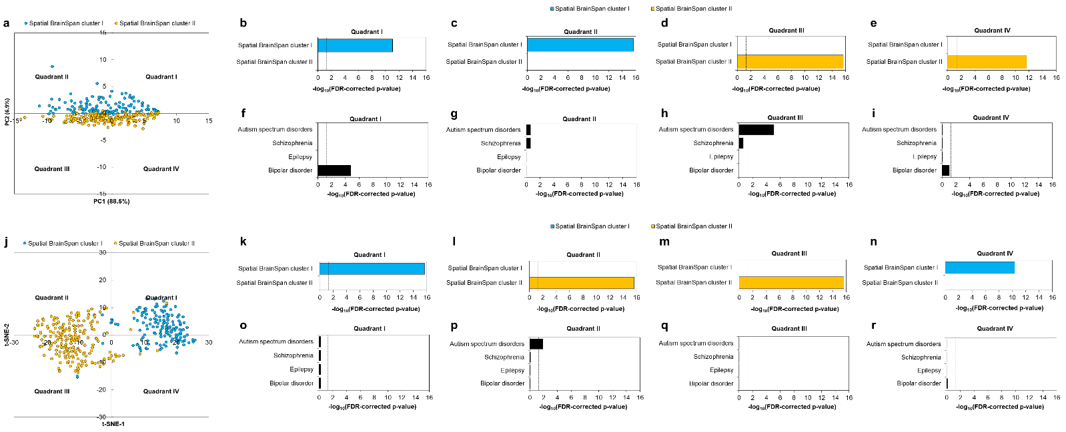
Supplementary Figure 1: Independent dimensionality reduction methods recapitulated the spatial clusters. a PCA was performed with the average RPKM values of the syndrome-associated genes across 26 brain structures in the BrainSpan Atlas. The RPKM values were log₂-transformed and a data matrix with brain regions (rows) and syndrome-associated genes (columns) was constructed. Unit variance scaling was applied across this matrix. Singular value decomposition with imputation was used to extract the PCs. Component scores (n = 344) corresponding to PC1 and PC2 explaining 88.5% and 6.9% of the total variance were plotted along X and Y axes, respectively. The genes in the PC plot have been color-coded based on their membership in spatial BrainSpan clusters I and II. The –log₁₀(p-value) of enrichments (subjected to FDR-correction) of spatial BrainSpan clusters I and II and the four syndromes in quadrants I, II, III and IV of the PC plot have been shown in b-e and f-i, respectively. The dashed black line indicates the cut-off value for –log₁₀(p-value) after FDR correction (p-value < 0.05, i.e., log₁₀(p-value) > 1.30103). j t-SNE plot constructed based on the gene expression of 344 syndrome-associated genes in 26 brain structures (metric = 1 – Pearson Correlation Coefficient, epsilon = 10 and perplexity = 30), color-coded based on their membership in spatial BrainSpan clusters I and II. The –log₁₀(p-value) of enrichments of spatial BrainSpan clusters I and II and the four syndromes in quadrants I, II, III and IV of the t-SNE plot have been shown in k-n and o-r, respectively.

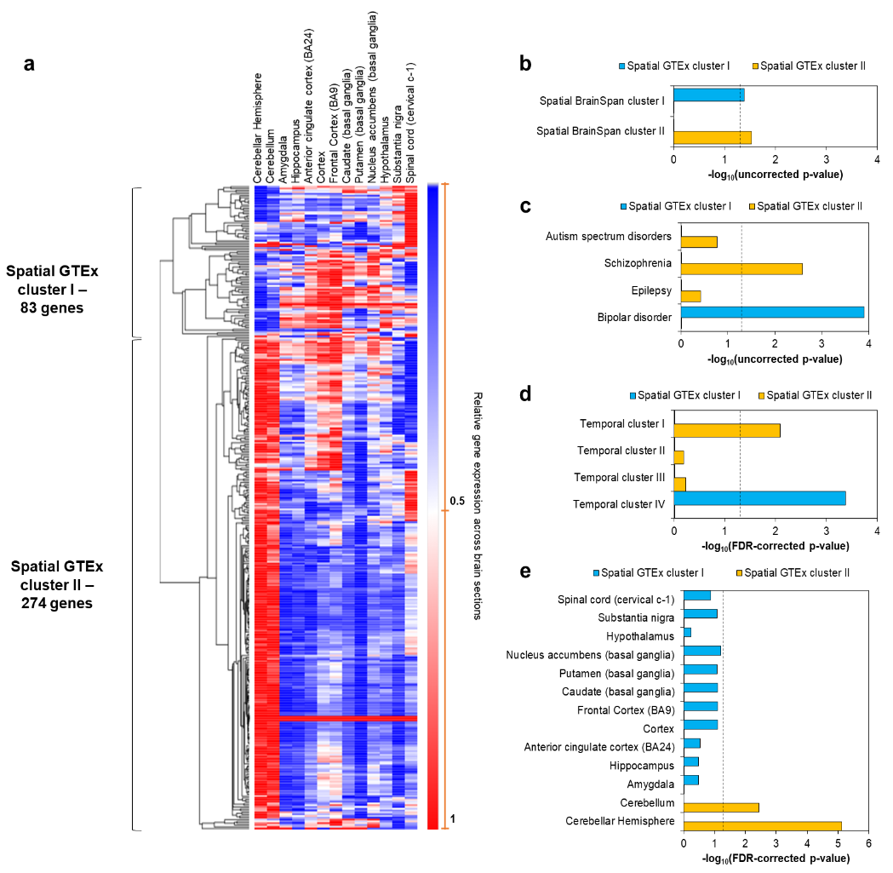
Supplementary Figure 2: Recapitulation of the two spatial clusters using GTEx data. a The dichotomized expression of 357 syndrome-associated genes across 13 brain structures in GTEx. The expression of each of the genes across these structures was hierarchically clustered by computing pairwise distances between the data points (log₂-transformed TPM values) using Pearson correlation and identifying closely linked clusters using the average linkage method. The clustered heat map was generated using the Morpheus software. b Hypergeometric test was used to assess the significance of the intersection of spatial GTEx clusters with the spatial BrainSpan clusters (reported in Fig. 5a). c and d show the enrichment of the spatial GTEx clusters for syndrome-associated genes and genes from the temporal clusters identified in Fig. 2a, respectively. The dashed black line indicates the significance threshold after Benjamini-Hochberg correction for multiple hypotheses (p-value < 0.05, i.e. -log₁₀(p-value) > 1.30103). e The enrichment of the spatial GTEx clusters for genes showing high/moderate expression (TPM ≥ 9) in specific brain structures (excluding housekeeping genes with TPM ≥ 1 in the Human Protein Atlas).

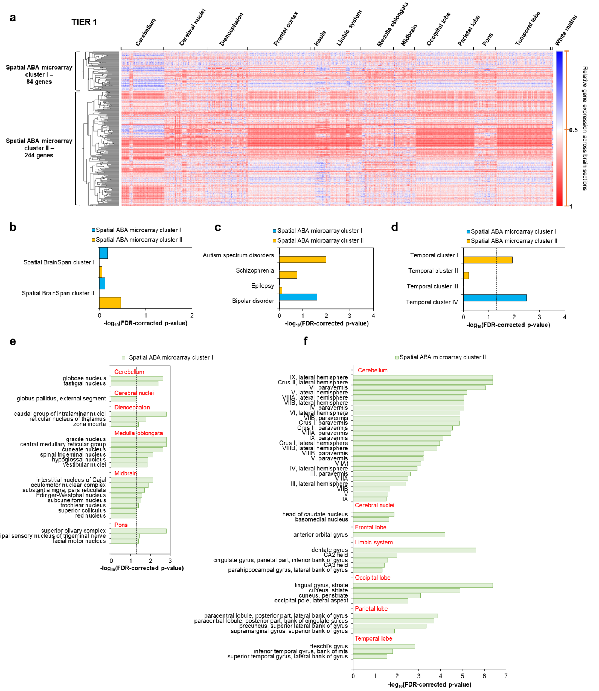Supplementary Figure 3: Recapitulation of the two spatial clusters using Allen Brain Atlas microarray data. a The dichotomized expression of 328 syndrome-associated genes across 3702 samples in the Allen Brain Atlas (ABA), representing 232 tier 2 structures that can be categorized into 13 tier 1 structures (labels on top horizontal axis). The expression of each of the genes across these structures was hierarchically clustered by computing pairwise distances between the data points (log₂-transformed probe intensities) using Pearson correlation and identifying closely linked clusters using the average linkage method. The clustered heat map was generated using the Morpheus software. b Hypergeometric test was used to assess the significance of the intersection of spatial ABA microarray clusters with the spatial BrainSpan clusters (reported in Fig. 5a). c and d show the enrichment of the spatial ABA microarray clusters for syndrome-associated genes and genes from the temporal clusters identified in Fig. 2a, respectively. The dashed black line indicates the significance threshold after Benjamini-Hochberg correction for multiple hypotheses (p-value < 0.05, i.e. -log₁₀(p-value) > 1.30103). The enrichment of spatial ABA microarray cluster I and spatial ABA microarray cluster II for genes showing relatively higher expression in each of the 232 tier 2 structures compared to others has been shown in e and f, respectively. The tier 1 categorization of the enriched tier 2 structures has been shown in red font.

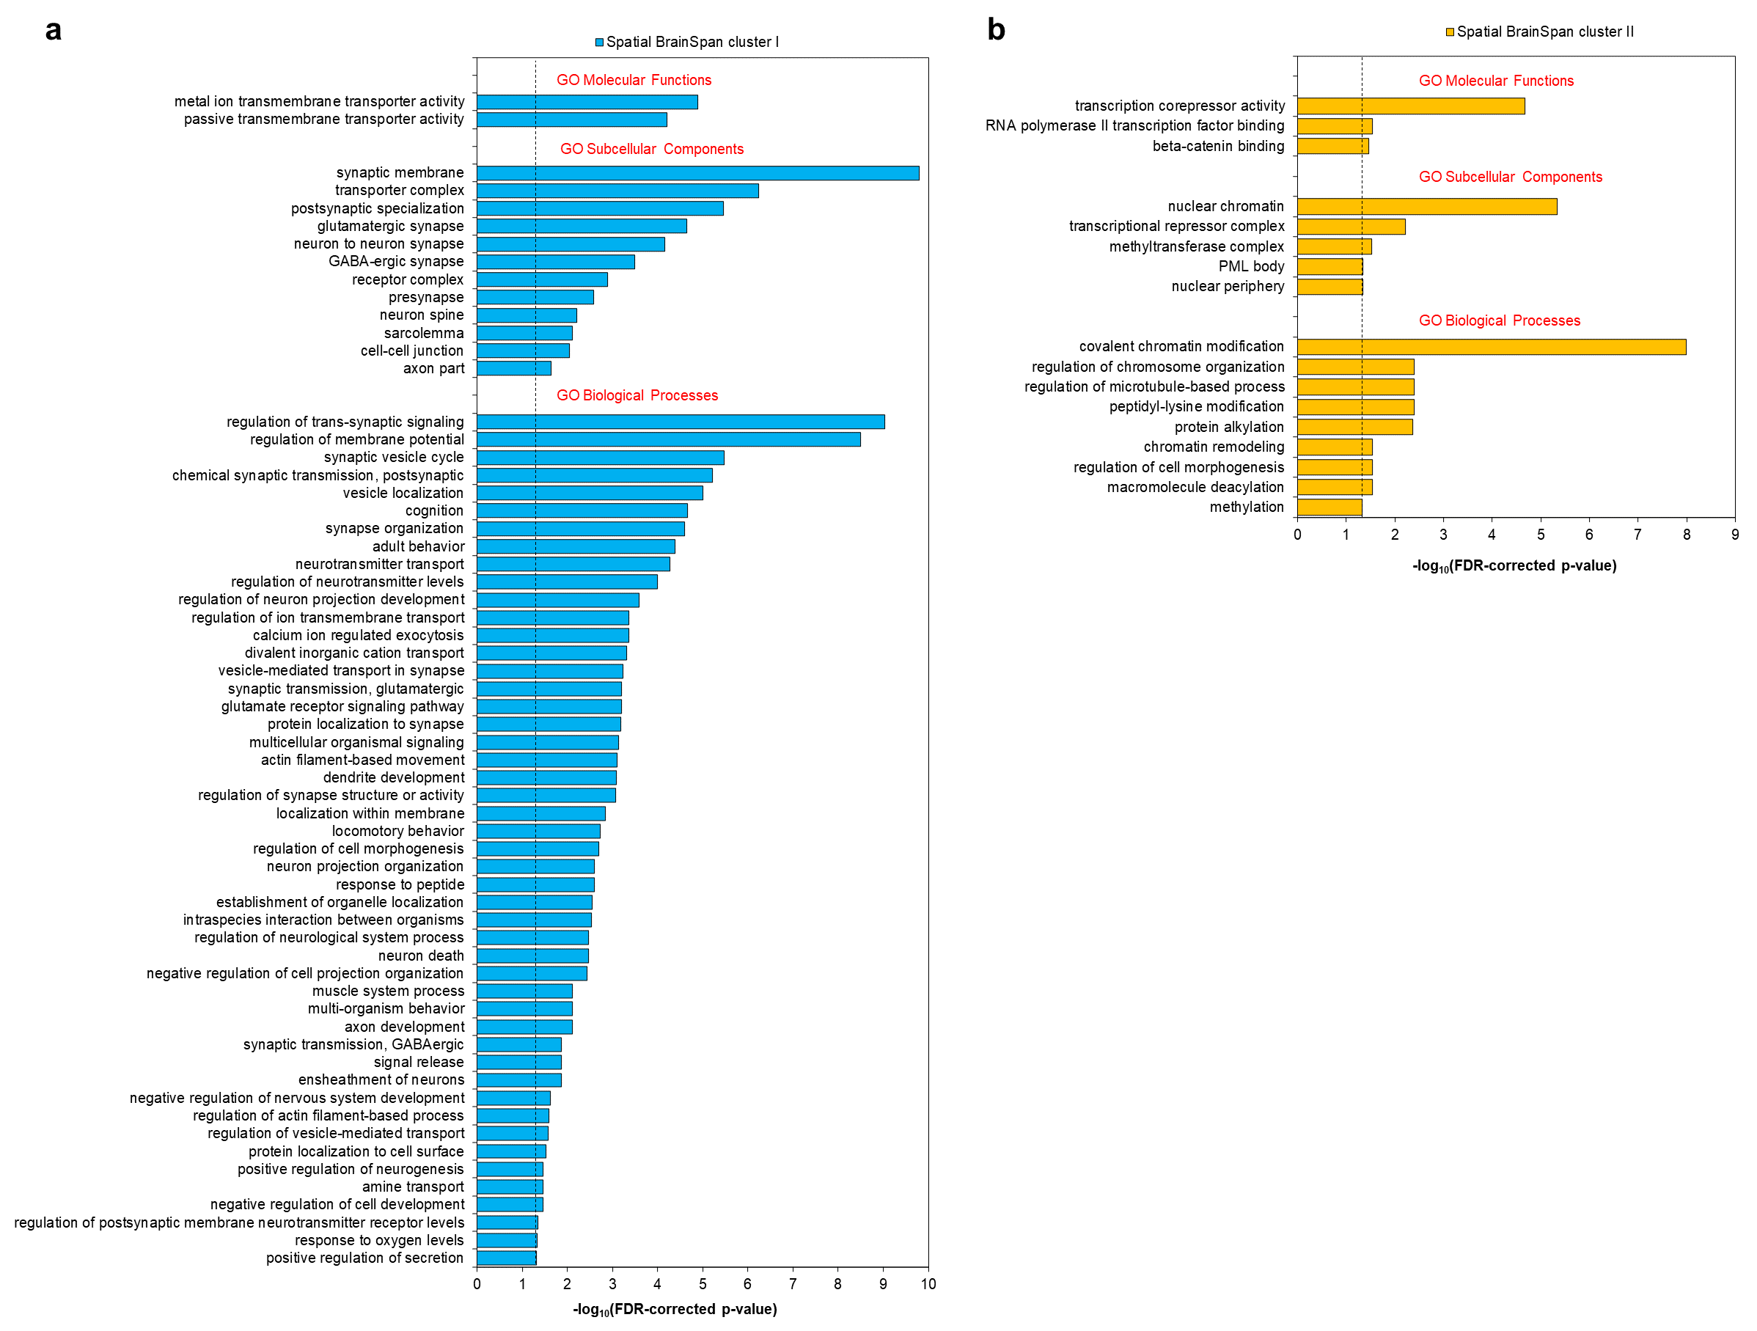
Supplementary Figure 4: Gene Ontology terms enriched in the spatial clusters. The figures show the enrichment of a spatial BrainSpan cluster I and b spatial BrainSpan cluster II in GO biological processes, cellular components and molecular functions (in terms of –log₁₀(p-values)). The dotted black line indicates the cut-off value for –log₁₀(p-value), i.e. 1.30103, after correction for multiple hypotheses using the Benjamini-Hochberg method.

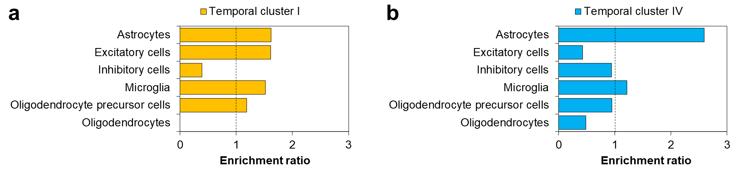
Supplementary Figure 5: Assessment of the cell-type specificity of the temporal clusters using data from Lake et al. The enrichment of a temporal cluster I and b temporal cluster IV for genes expressed in specific brain cell types (in terms of enrichment ratio) has been shown. The dotted black line indicates the cut-off value for enrichment ratio, i.e. 1.

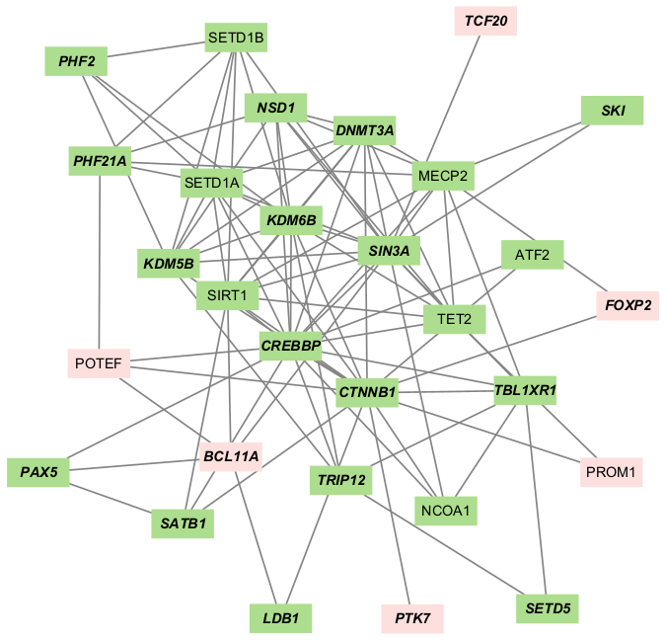
Supplementary Figure 6: Network of temporal cluster I genes expressed in the lateral ganglionic eminence and involved in chromatin modification. Network nodes represent proteins and edges represent protein-protein associations ranging from joint contribution to shared functions to direct physical interactions retrieved from the STRING database. Pink-coloured nodes depict genes expressed in the lateral ganglionic eminence, whereas green nodes depict those involved in chromatin modifications. Genes with labels shown in bold and italics depict ASD genes.

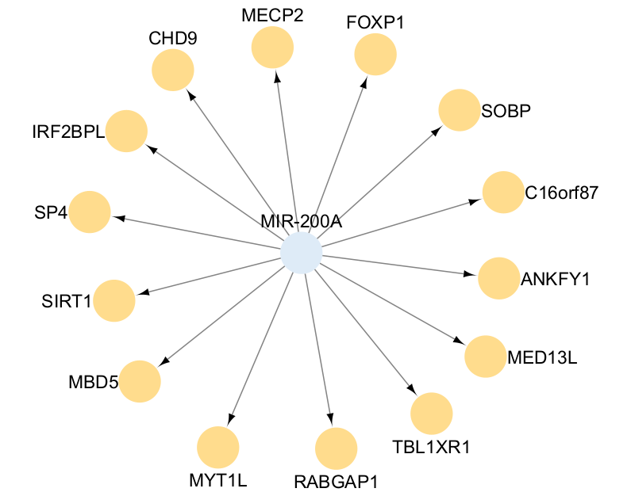
Supplementary Figure 7: Targets of MIR-200A in temporal cluster I. MIR-200A (blue node) and its 14 targets (orange nodes) in temporal cluster 1 have been represented in the form of a network. Edges represent miRNA-target interactions.

Supplementary Figure 8: Transcription factors targeting the genes in temporal cluster I. The transcription factors (purple nodes) and the genes in temporal cluster I (grey nodes) targeted by them have been shown as networks (with edges representing transcription factor – target regulations). The target sequences recognized by the transcription factors can be found below their gene symbols.
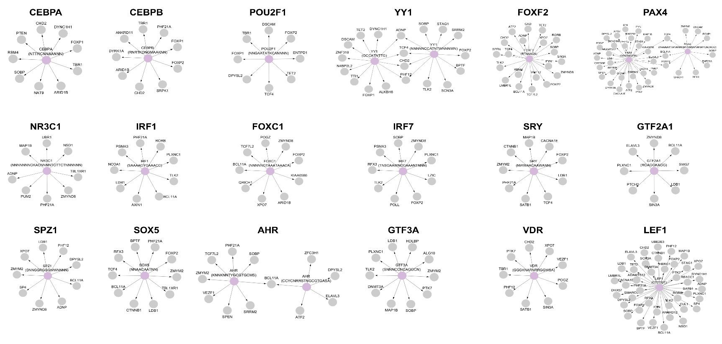

Supplementary References

1. Sunkin SM, Ng L, Lau C, Dolbeare T, Gilbert TL, Thompson CL et al. Allen Brain Atlas: an integrated spatio-temporal portal for exploring the central nervous system. Nucleic acids research 2012; 41(D1): D996-D1008.

2. Jafari M, Ansari-Pour N. Why, when and how to adjust your P values? Cell Journal (Yakhteh) 2019; 20(4): 604.

3. Starruß J, De Back W, Brusch L, Deutsch A. Morpheus: a user-friendly modeling environment for multiscale and multicellular systems biology. Bioinformatics 2014; 30(9): 1331-1332.

4. Nielsen F, Nielsen F. Hierarchical clustering. Introduction to HPC with MPI for Data Science 2016: 195-211.

5. Consortium G. The Genotype-Tissue Expression (GTEx) pilot analysis: Multitissue gene regulation in humans. Science 2015; 348(6235): 648-660.

6. Hawrylycz MJ, Lein ES, Guillozet-Bongaarts AL, Shen EH, Ng L, Miller JA et al. An anatomically comprehensive atlas of the adult human brain transcriptome. Nature 2012; 489(7416): 391.

7. Love MI, Anders S, Kim V, Huber W. RNA-Seq workflow: gene-level exploratory analysis and differential expression. F1000Research 2015; 4.

8. Uhlén M, Fagerberg L, Hallström BM, Lindskog C, Oksvold P, Mardinoglu A et al. Tissue-based map of the human proteome. Science 2015; 347(6220).

9. Rouillard AD, Gundersen GW, Fernandez NF, Wang Z, Monteiro CD, McDermott MG, Ma’ayan A. The harmonizome: a collection of processed datasets gathered to serve and mine knowledge about genes and proteins. Database 2016; 2016.

10. Consortium GO. The Gene Ontology (GO) database and informatics resource. Nucleic acids research 2004; 32(suppl_1): D258-D261.

11. Liao Y, Wang J, Jaehnig EJ, Shi Z, Zhang B. WebGestalt 2019: gene set analysis toolkit with revamped UIs and APIs. Nucleic acids research 2019.

12. Lake BB, Chen S, Sos BC, Fan J, Kaeser GE, Yung YC et al. Integrative single-cell analysis of transcriptional and epigenetic states in the human adult brain. Nature biotechnology 2018; 36(1): 70-80.

13. Zhu Y, Sousa AM, Gao T, Skarica M, Li M, Santpere G et al. Spatiotemporal transcriptomic divergence across human and macaque brain development. Science 2018; 362(6420): eaat8077.

14. Szklarczyk D, Gable AL, Nastou KC, Lyon D, Kirsch R, Pyysalo S et al. The STRING database in 2021: customizable protein–protein networks, and functional characterization of user-uploaded gene/measurement sets. Nucleic acids research 2021; 49(D1): D605-D612.

15. Shannon P, Markiel A, Ozier O, Baliga NS, Wang JT, Ramage D et al. Cytoscape: a software environment for integrated models of biomolecular interaction networks. Genome research 2003; 13(11): 2498-2504.

16. Kumar L, Futschik ME. Mfuzz: a software package for soft clustering of microarray data. Bioinformation 2007; 2(1): 5.

17. Kupershmidt I, Su QJ, Grewal A, Sundaresh S, Halperin I, Flynn J et al. Ontology-based meta-analysis of global collections of high-throughput public data. PloS one 2010; 5(9).

18. Chattopadhyay A, Ganapathiraju MK. Demonstration Study: A Protocol to Combine Online Tools and Databases for Identifying Potentially Repurposable Drugs. Data 2017; 2(2): 15.

19. Liang S, Li Z, Wang Y, Li X, Yang X, Zhan X et al. Genome-wide DNA methylation analysis reveals epigenetic pattern of SH2B1 in Chinese monozygotic twins discordant for autism spectrum disorder. Frontiers in Neuroscience 2019; 13: 712.

20. Steinbeck JA, Studer L. Moving stem cells to the clinic: potential and limitations for brain repair. Neuron 2015; 86(1): 187-206.

21. Hunt CP, Moriarty N, van Deursen CB, Gantner CW, Thompson LH, Parish CL. Understanding and modeling regional specification of the human ganglionic eminence. Stem Cell Reports 2023; 18(3): 654-671.

22. Southwell DG, Seifikar H, Malik R, Lavi K, Vogt D, Rubenstein JL, Sohal VS. Interneuron transplantation rescues social behavior deficits without restoring wild-type physiology in a mouse model of autism with excessive synaptic inhibition. Journal of Neuroscience 2020; 40(11): 2215-2227.

