Functional Group Analysis for Screening Biochars for Nitrogen Recovery from Human Urine: Supporting Information

Table S1: Mole H retained per mol N (sample)

Biochar:urine ratio | Mol H per N retained (AO 12)
0.005 | 0.229052198
0.010 | 3.266114672
0.020 | -2.107794944
0.040 | -0.083208583
0.070 | -3.22931338
0.091 | 3.507043651
0.182 | 3.924286265
0.455 | 5.138563368

Table SI2: Biochar Properties
Concentration of H₂O₂ used to oxidize biochars, elemental O:C, surface O:C from XPS, and ash content of biochars. All samples were oxidized at 80C for 6 hours, except PP7 (15 hours). “a.r.” is the sample “as received”. Samples in bold were used for dilution-based isotherms.
Biochar species | H₂O₂ (%) | C | H | O | N | O:C (bulk) | O:C (XPS) | Ash (%) | SSA (CO₂ BET)
SWP5 | a.r.  5  10  15  20  25  30 | 85.5  75.7  71.9  70.6  68.6  67.3  65.4 | 2.8  3.2  3.2  3.2  3.1  3.0  3.1 | 10.4  19.9  22.4  23.1  24.8  25.4  26.4 | <0.1  <0.1<0.1<0.1<0.1<0.1<0.1 | 0.09  0.20  0.23  0.25  0.27  0.28  0.30 | -  0.24  0.24  0.26  0.24  0.26  0.31 | 1.3  1.2  2.4  3.2  3.5  4.3  5.1 | -  107.0  -  -  100.7  101.1  90.1
SWP7 | a.r.  5  10  15  20/25*  30 | 90.2  81.5  78.7  76.8  75.1  74.4 | 1.8  2.6  2.7  2.7  2.6  2.7 | 6.0  14.4  17.3  18.9  20.5  20.3 | <0.1  0.5  <0.1<0.1<0.1  0.4 | 0.09  0.13  0.17  0.18  0.20  0.21 | -  0.15  0.16  0.18  0.18  0.20 | 1.9  1.1  1.3  1.6  1.9  2.2 | -  119.0  117.4  119.8  130.0  167.1
SS7 | a.r.  0  5  10 | 29.6  29.4  24.8  22.0 | 0.8  1.7  1.6  1.3 | 2.8  6.5  10.7  14.5 | 3.8  3.3  2.6  2.0 | 0.07  0.17  0.32  0.49 | -  0.54  0.79  1.06 | 63.9  59.2  60.3  60.2 | -  43.6  41.5  31.8
PP7 | a.r.  30 | 80.5 | 2.0 | 15.0 | 0.8 | 0.04  0.14 | -  0.15 | 1.9  1.7 | -  120.4
RS5 | a.r.  10  12.5  15  20 | 68.9  69.5  70.4  71.8  67.9 | 1.8  2.7  2.8  2.8  2.7 | 8.9  19.1  18.7  16.2  21.9 | 1.6  1.0  0.9  1.0  0.8 | 0.10  0.22  0.20  0.17  0.25 | -  0.23  0.35  0.28  0.24 | 19.5  7.6  7.1  8.2  6.6 | -  99.2  88.6  83.9  84.0

* This is a combination of SWP7 biochar oxidized with 20 and 25% H₂O₂ .

Table SI3: Characteristics of biochars as received (pristine) and after sorption

 |  |  | Pristine Biochar (%) |  |  | Ground, rinsed, Post-sorption Biochar (%)
Biochar Species (pyrolysis temp.) | O:C Bulk | Ash | C | H | N | C | H | N | Q
Softwood pellet (700) | 0.05 | 1.19 | 90.21 | 1.83 | <0.1 | 87.56 | 2.23 | 0.38 | 0.26
Rapeseed straw (700) | 0.09 | 21.92 | 67.74 | 1.09 | 1.26 | 70.55 | 1.70 | 1.17 | inconclusive
Softwood pellet (550) | 0.09 | 1.25 | 85.52 | 2.77 | <0.1 | 81.45 | 3.19 | 0.72 | 0.44
Sewage sludge (550) | 0.17 | 58.89 | 29.53 | 1.33 | 3.75 | 18.45 | 4.91 | 2.96 | inconclusive

Table SI4: XPS Deconvolution
The relative proportion (%) of carbon species on biochar surfaces, determined from XPS C1s scans, within the associated binding energy range of curve centers. The deconvolution process was based on information from published literature.^{1–4}
Biochar species | H₂O₂ (%) | C-C, C=C (284-285) | C-O, C-OH (286-287) | (C=O)-O,  (C=O)-OH (288.0-288.8) | pi-pi (290-290.6) | K2P (292.4-293.6)
SWP5 | a.r.  5  10  15  20  25  30 | 0.63031  0.63909  0.63527  0.64385  0.62153  0.63309 | 0.16421  0.17055  0.16251  0.15478  0.17834  0.14912 | 0.16421  0.11531  0.11863  0.11565  0.12446  0.14977 | 0.09976  0.04793  0.04892  0.0513  0.04599  0.04513 | 0  0.02712  0.03467  0.03441  0.02968  0.02289
SWP7 | a.r.  5  10  15  20/25*  30 | 0.68725  0.64691  0.65373  0.66949  0.61574 | 0.14327  0.19032  0.16539  0.16378  0.21063 | 0.10032  0.09643  0.10529  0.09643  0.12604 | 0.05253  0.04746  0.0498  0.0491  0.03615 | 0.01662  0.01887  0.02579  0.02119  0.01145
SS7 | a.r.  0  5  10 | 0.62263  0.54851  0.51782 | 0.18738  0.23088  0.20068 | 0.08813  0.13853  0.15719 | 0.0587  0.04917  0.05325 | 0.04317  0.0329  0.07106
PP7 | a.r.  30 | 0.61581 | 0.20597 | 0.09908 | 0.05817 | 0.02098
RS5 | a.r.  10  12.5  15  20 | 0.68149  0.66735  0.66171  0.64819 | 0.14662  0.15881  0.15027  0.16431 | 0.1083  0.10892  0.1288  0.13369 | 0.04497  0.04086  0.04035  0.04007 | 0.01861  0.02405  0.01888  0.01373

Table SI5: Parameters for tested isotherms - dilution
Biochar species | H₂O₂ (%) | Langmuir:  Qmax  KL  R² | Freundlich :  N  KF  R²
 |  | Dilution
SWP5 | a.r.  5  10  15  30 | 1.10  0.016  0.77  1.43  0.035  0.97  1.83  0.011  0.96  1.93  0.045  0.97 | 3.05  0.138  0.82  3.50  0.260  0.90  2.29  0.116  0.93  4.18  0.472  0.92
SWP7 | 5  10  15 | 0.79  0.006  0.89  0.59  0.042  0.87  0.95  0.028  0.86 | 2.01  0.0287  0.93  4.26  0.1431  0.82  3.38  0.1560  0.82
PP7 | 30 | 0.83  0.002  0.76 | 1.44  0.005  0.76
RS5 | 20 | 1.68  0.017  0.97 | 2.75  0.178  0.94

Table SI6: Adjusted R2 for tested dose-based isotherms - dose
Type_ox | Temkin_adj_r2 | Freundlich_adj_r2 | Langmuir_adj_r2 | DR_adj_r2 | Elovich_adj_r2
PP7_30 | 0.81 | 0.91 | 0.85 | 1.00 | 1.00
RS5_10 | 0.58 | 0.98 | 0.99 | 0.94 | 0.91
RS5_12 | 0.66 | 0.93 | 0.91 | 0.88 | 1.00
RS5_15 | 0.89 | 0.88 | 0.89 | 0.89 | 1.00
RS5_20 | 0.83 | 0.97 | 0.97 | 0.95 | 1.00
SS7_00 | 0.49 | 0.65 | 0.57 | 0.66 | 1.00
SS7_05 | 0.65 | 0.92 | 0.83 | 0.89 | 0.84
SS7_10 | 0.67 | 0.87 | 0.77 | 0.93 | 1.00
SW5_05 | 0.46 | 0.61 | 0.57 | 0.61 | 1.00
SW5_10 | 0.75 | 0.87 | 0.87 | 0.86 | 0.93
SW5_15 | 0.96 | 0.95 | 0.96 | 0.96 | 1.00
SW5_20 | 0.71 | 0.98 | 0.98 | 0.93 | 1.00
SW5_25 | 0.68 | 0.99 | 0.99 | 0.95 | 1.00
SW5_30 | 0.76 | 0.99 | 0.99 | 0.96 | 0.99
SW7_05 | 0.92 | 1.00 | 0.97 | 1.00 | 0.97
SW7_10 | 0.92 | 0.92 | 0.92 | 0.92 | 0.93
SW7_15 | 0.91 | 0.94 | 0.94 | 0.95 | 1.00
SW7_20 | 0.50 | 0.94 | 0.76 | 0.91 | 1.00
SW7_30 | 0.73 | 0.97 | 0.95 | 0.95 | 1.00

Table SI7: Mass:Volume Tested

The mass of biochar, volume of urine, and mass to volume ratio used to develop isotherms. To obtain an increasing final ratio, the experiment utilized different masses of biochar, different volumes of urine, and different sized reaction vials.

Biochar Mass (g) | Urine Volume (mL) | Final Ratios
0 | 1.1 | 0.000
0.1 | 20 | 0.005
0.2 | 20 | 0.010
0.1 | 5 | 0.020
0.2 | 5 | 0.040
0.35 | 5 | 0.070
0.1 | 1.1 | 0.091
0.15 | 1.7 | 0.091*
0.2 | 1.1 | 0.182
0.4 | 1.1 | 0.366
0.5 | 1.1 | 0.455

** Mass:volume used for dilution isotherm only

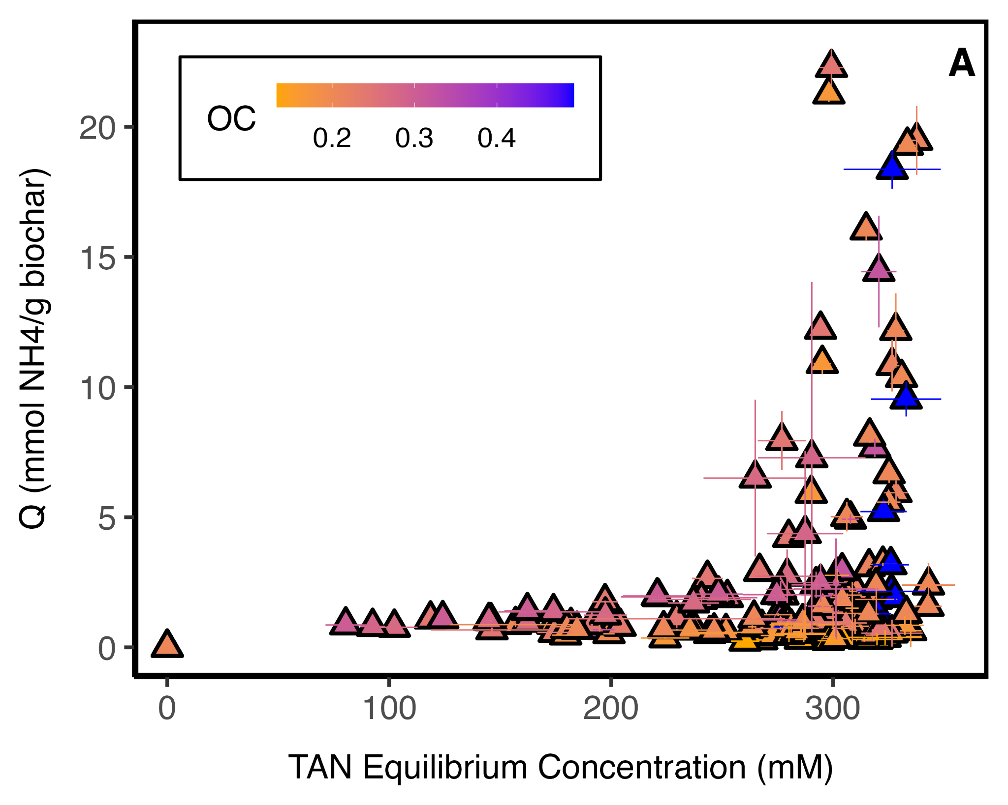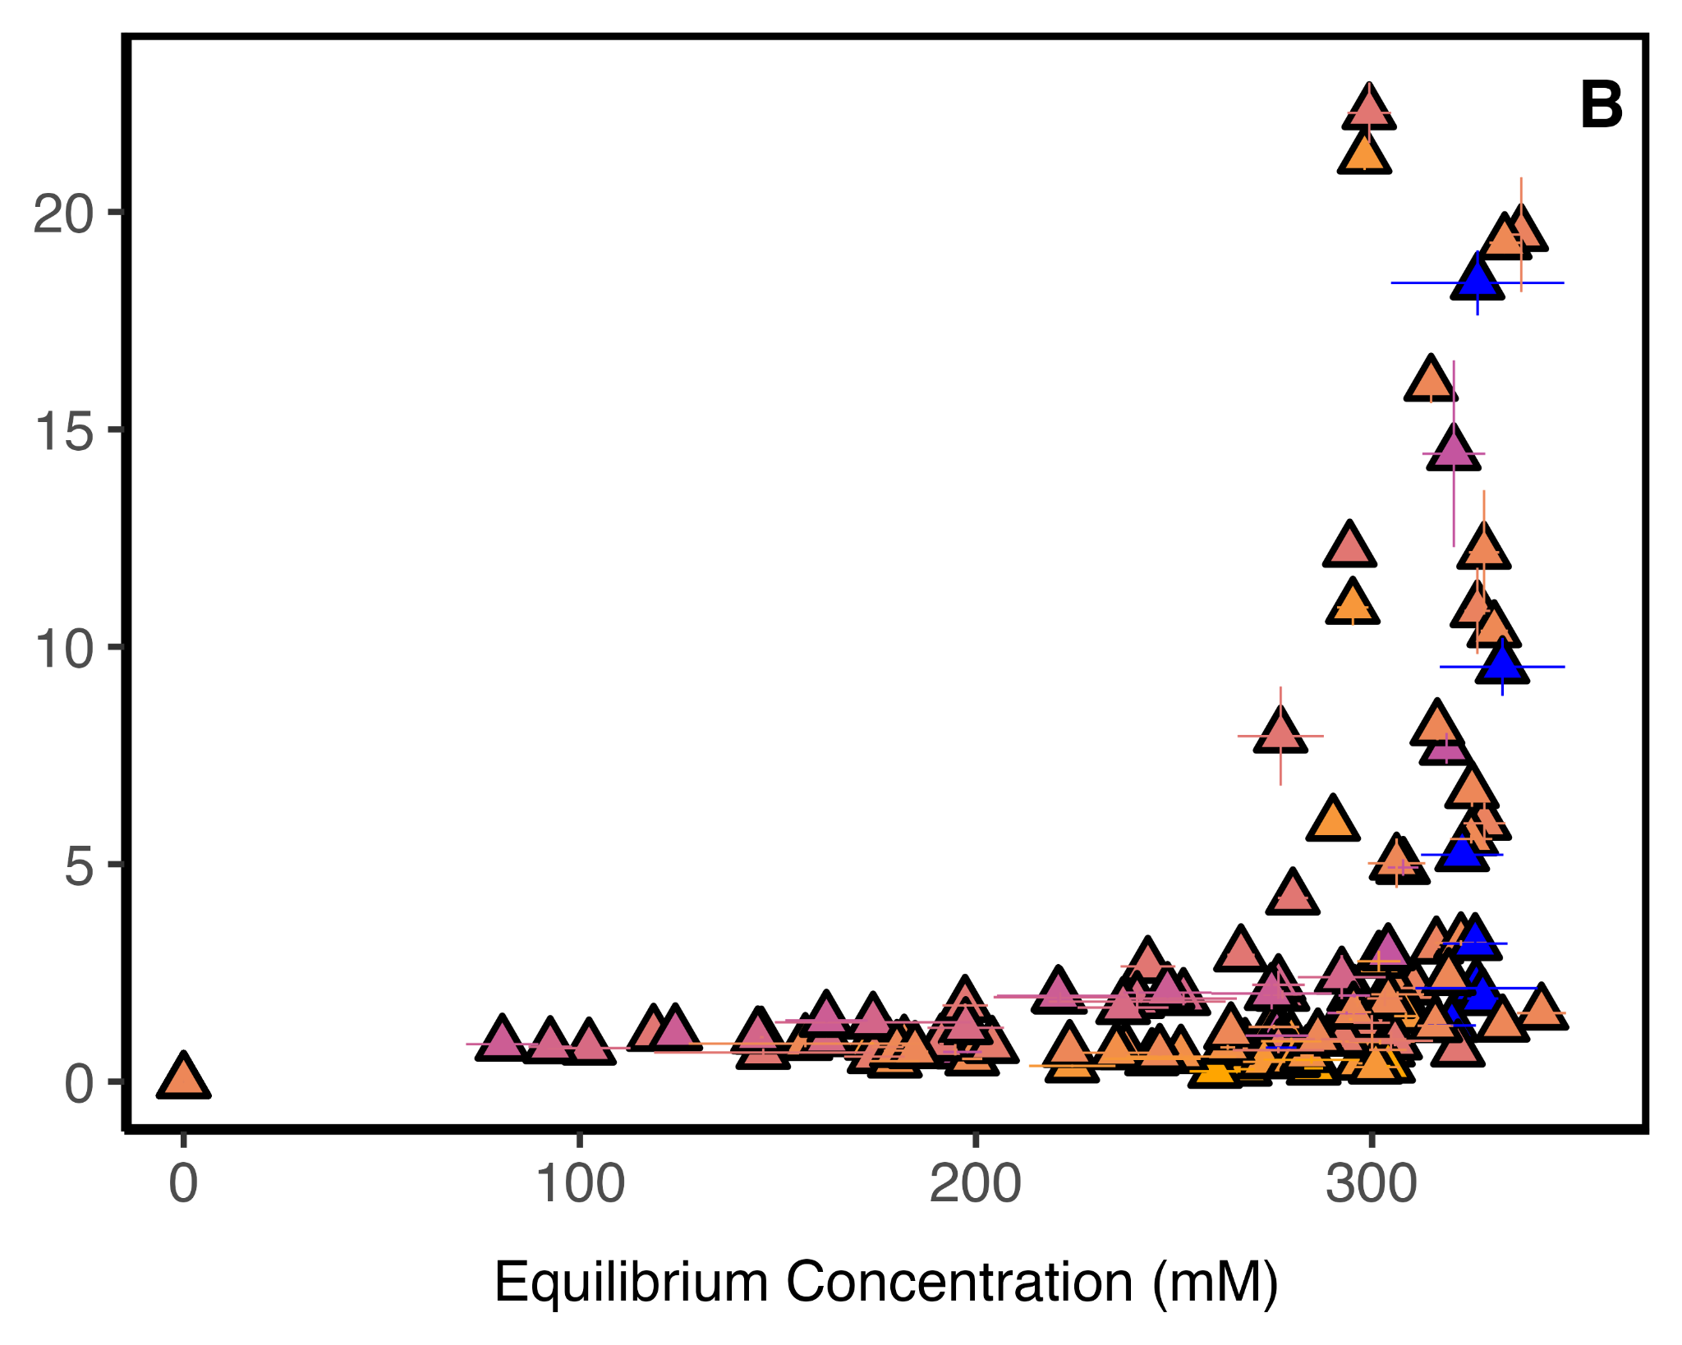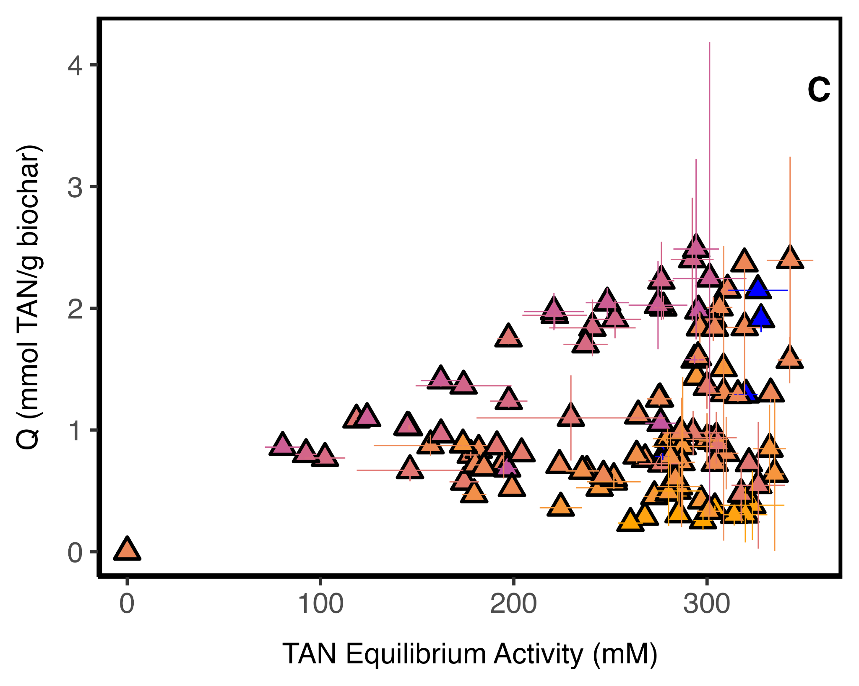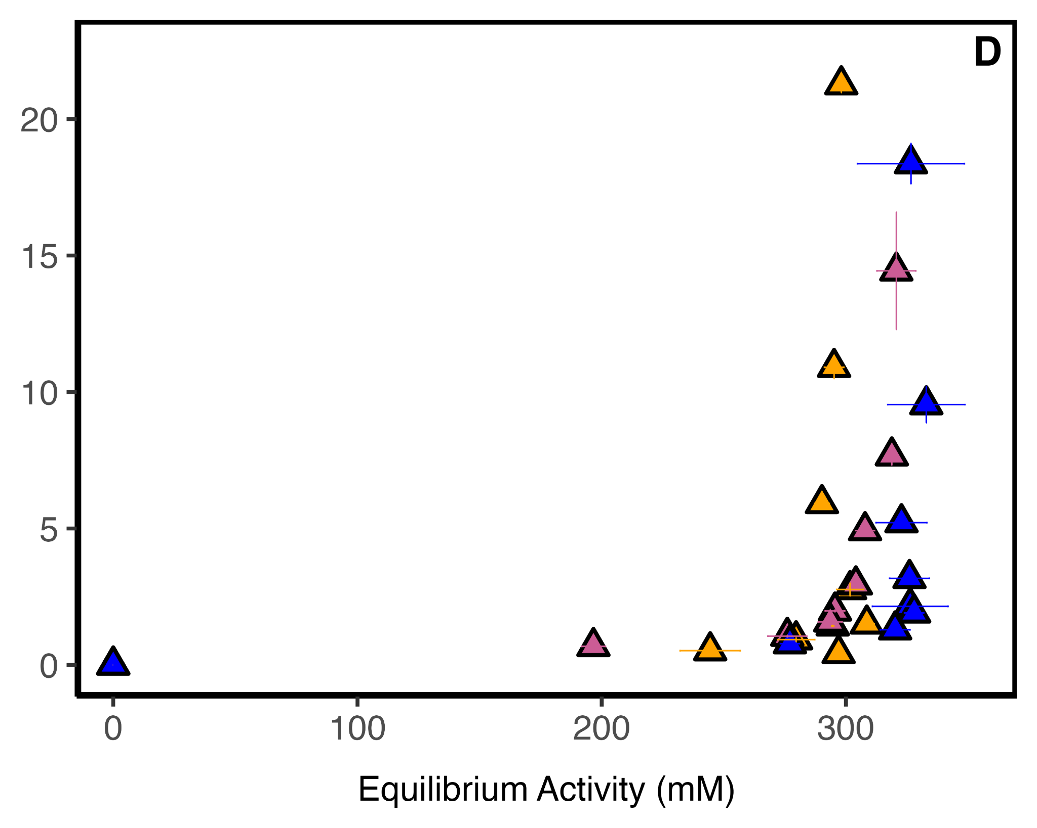
Figure SI1: Dose Isotherms for (A) full dataset including sewage sludge (SS7) biochars (B) with data where the percent standard deviation of the sorption density (Qsd) greater than 25% omitted (C) full data with Q < 2.5 (D) SS7 Biochar only

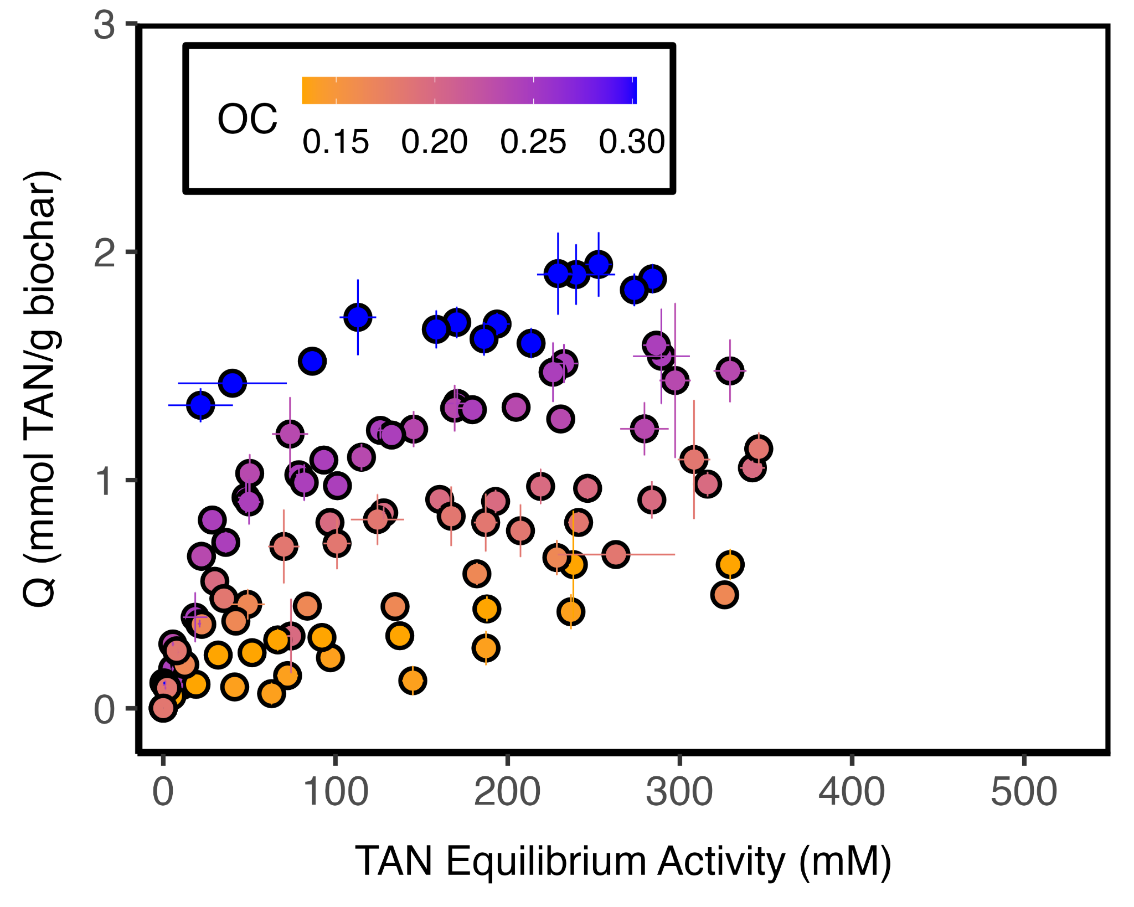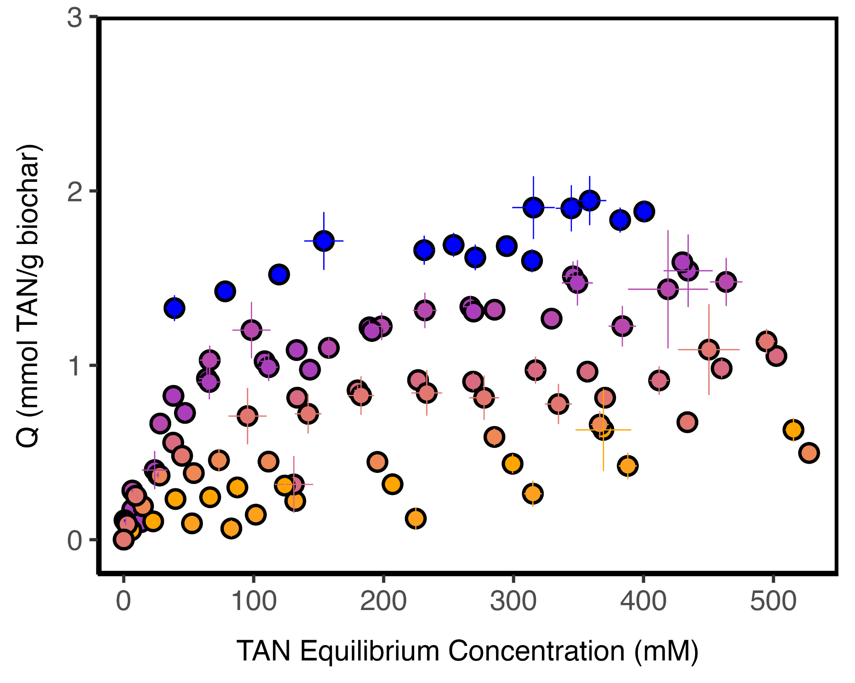

Figure SI2: Comparison of sorption density as a function of equilibrium activity (left) and equilibrium concentration (right) using the dilution-method

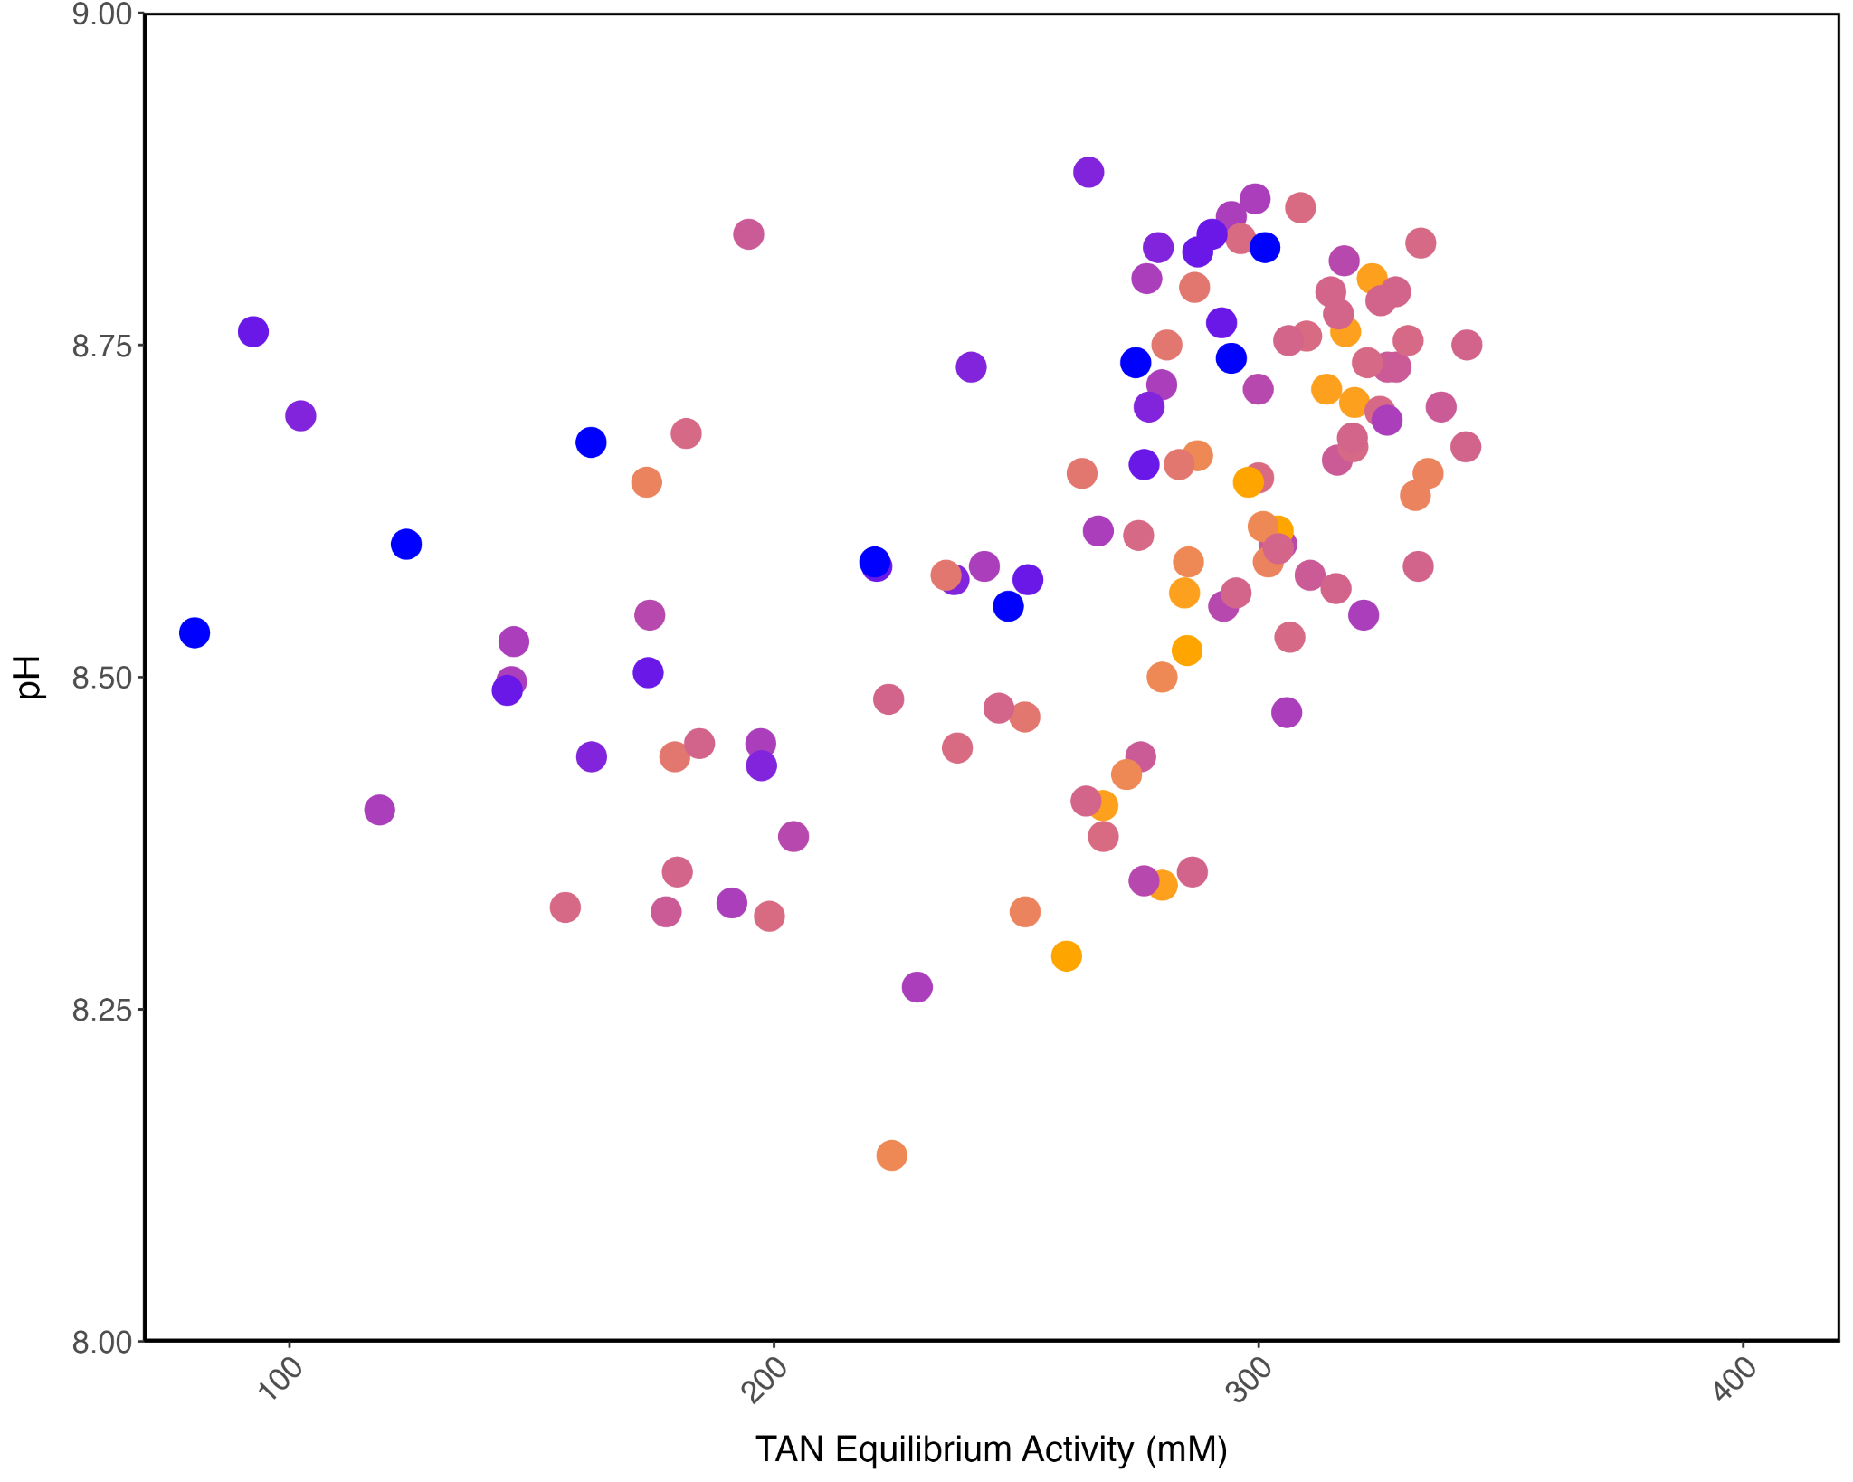

Figure SI3: Solution pH , of urine supernatant post sorption, as a function of equilibrium activity for dose-based data.
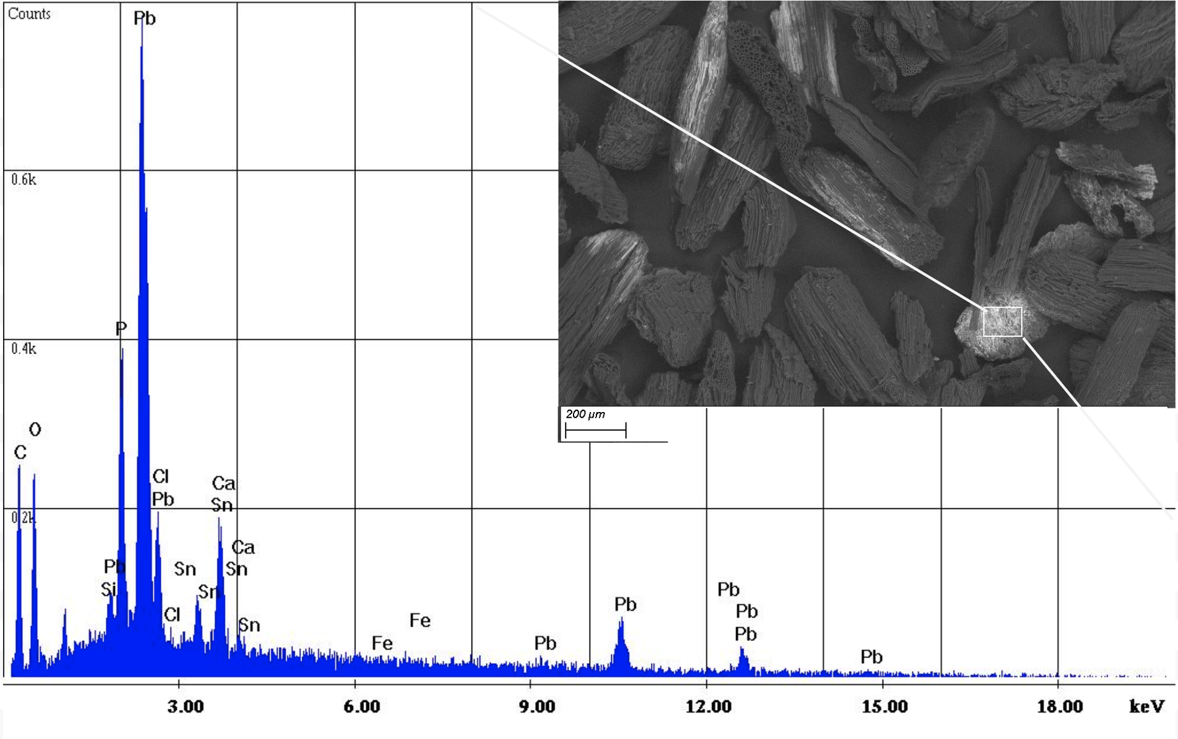

Figure SI4 : SEM image with EDX spectra of sample biochar post equilibration with urine

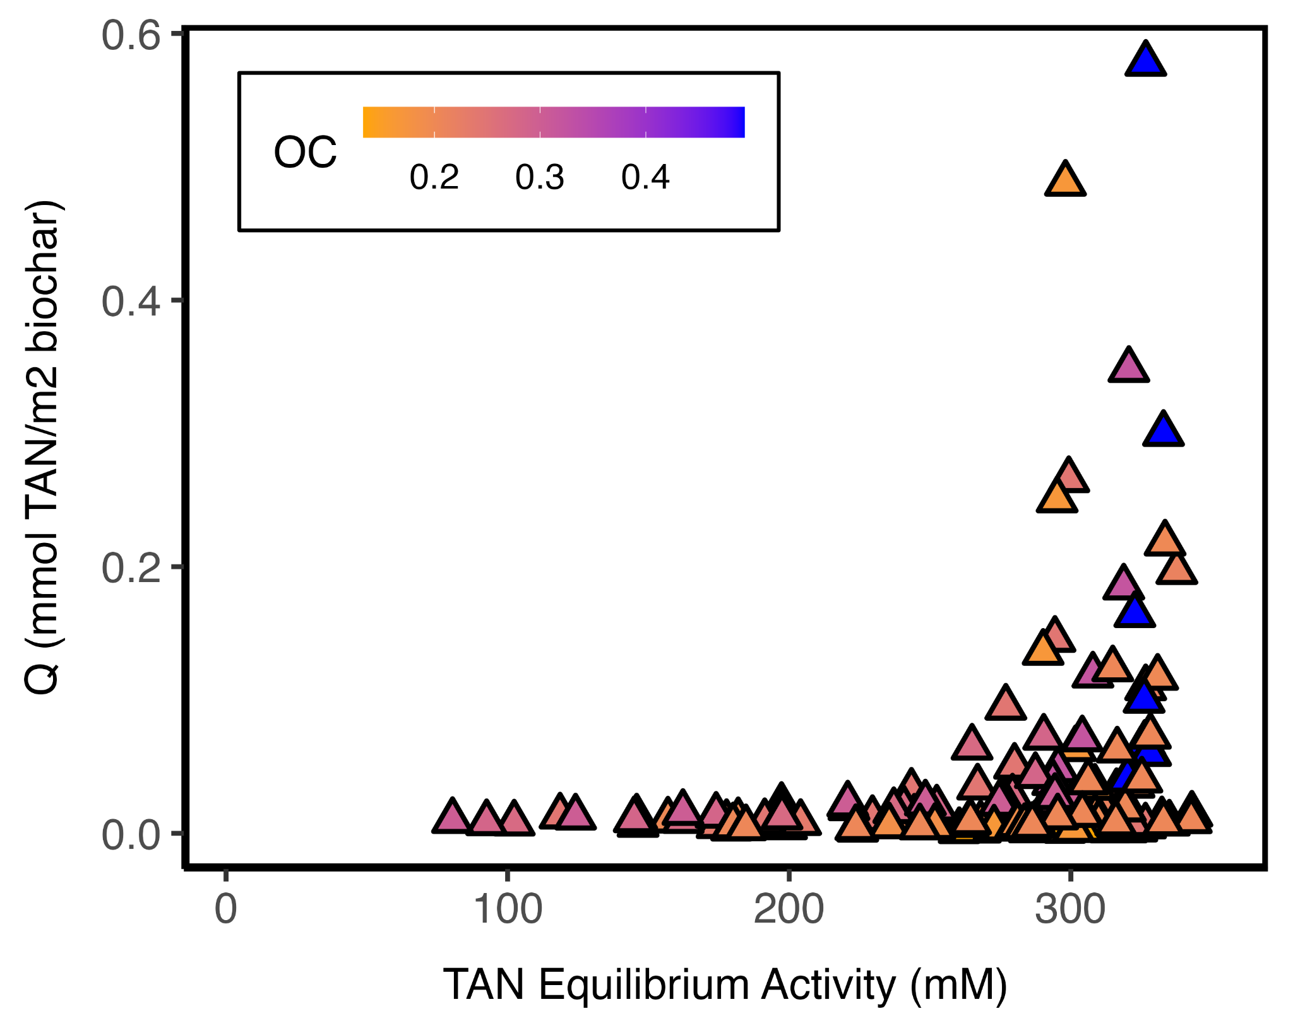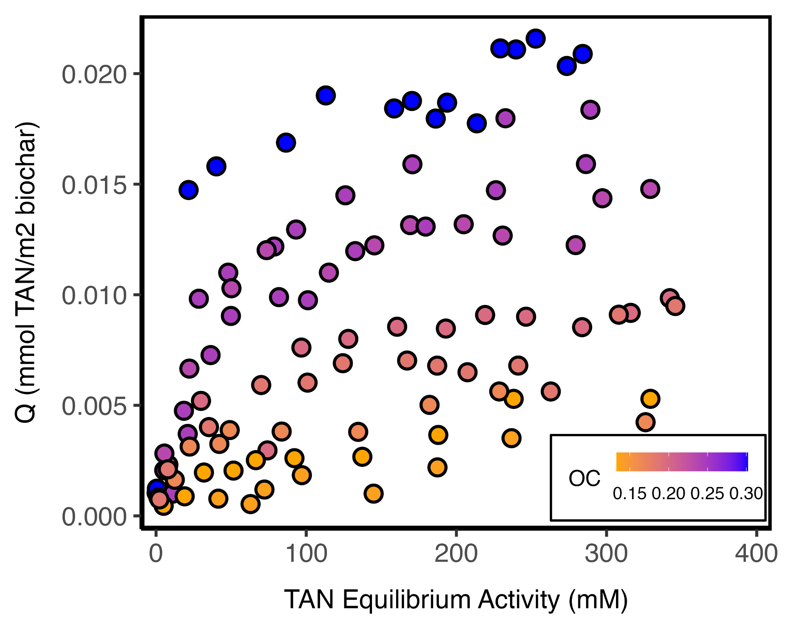
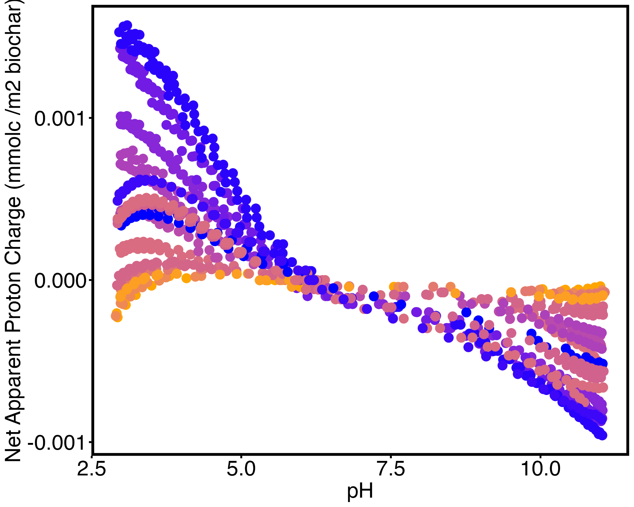

Figure SI5: Specific surface area normalized sorption density for (A) dose- and (B) dilution- based method, as well as (C) specific surface area normalized net apparent proton charge as a function of pH

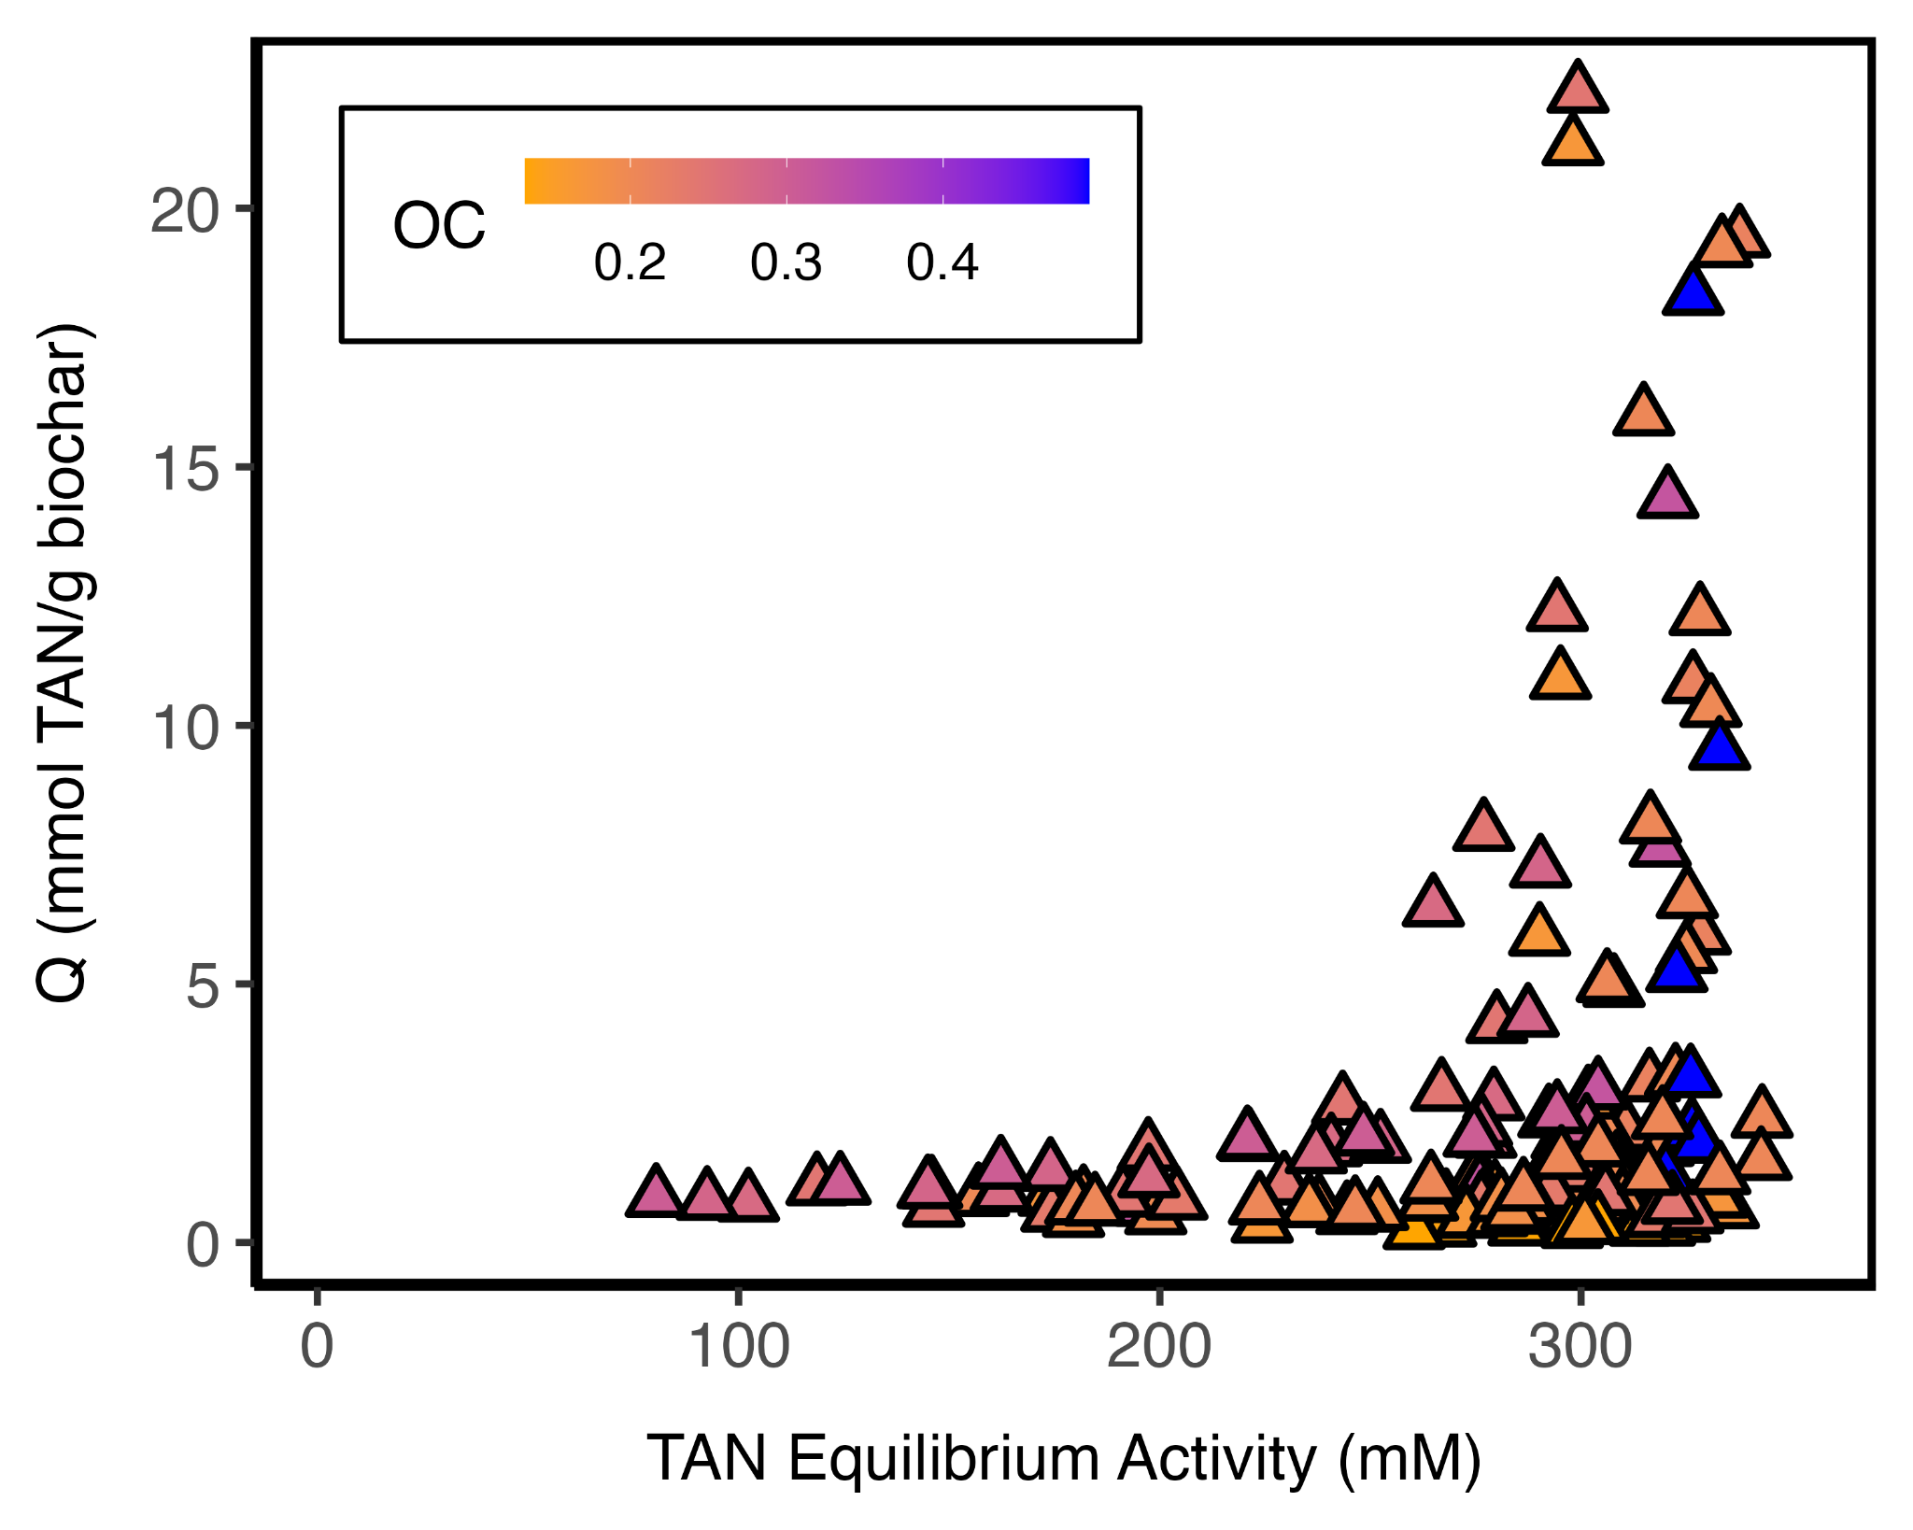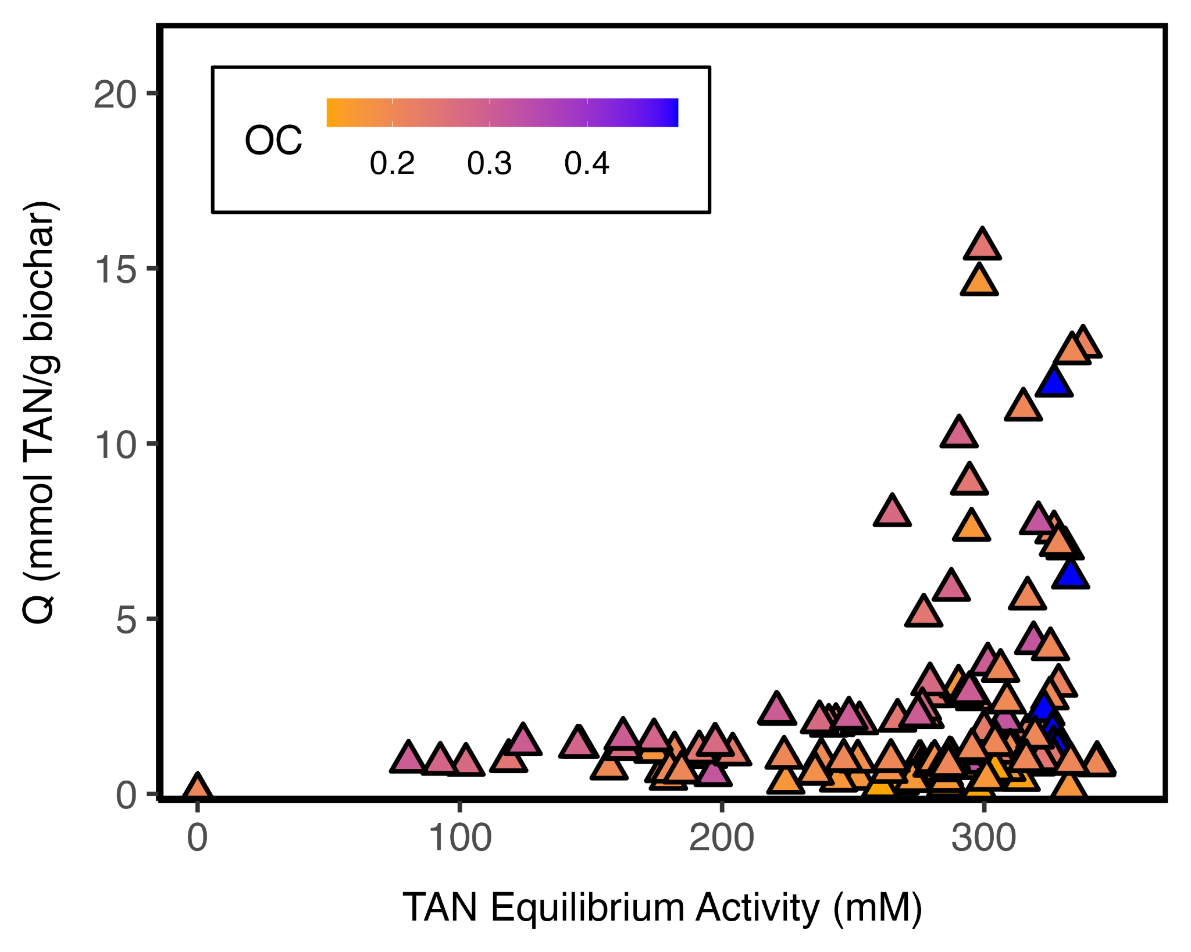

Figure SI6: (A) Henry’s law corrected sorption isotherm using the dose-based method, for all biochars, including sewage sludge. (B) The sorption isotherm accounts for the control by considering the moles of TAN lost relative to the influent. These losses are factored into the calculation of Q , which is based on the equilibrium concentration adjusted for the TAN lost in the control. For all biochar, including sewage sludge

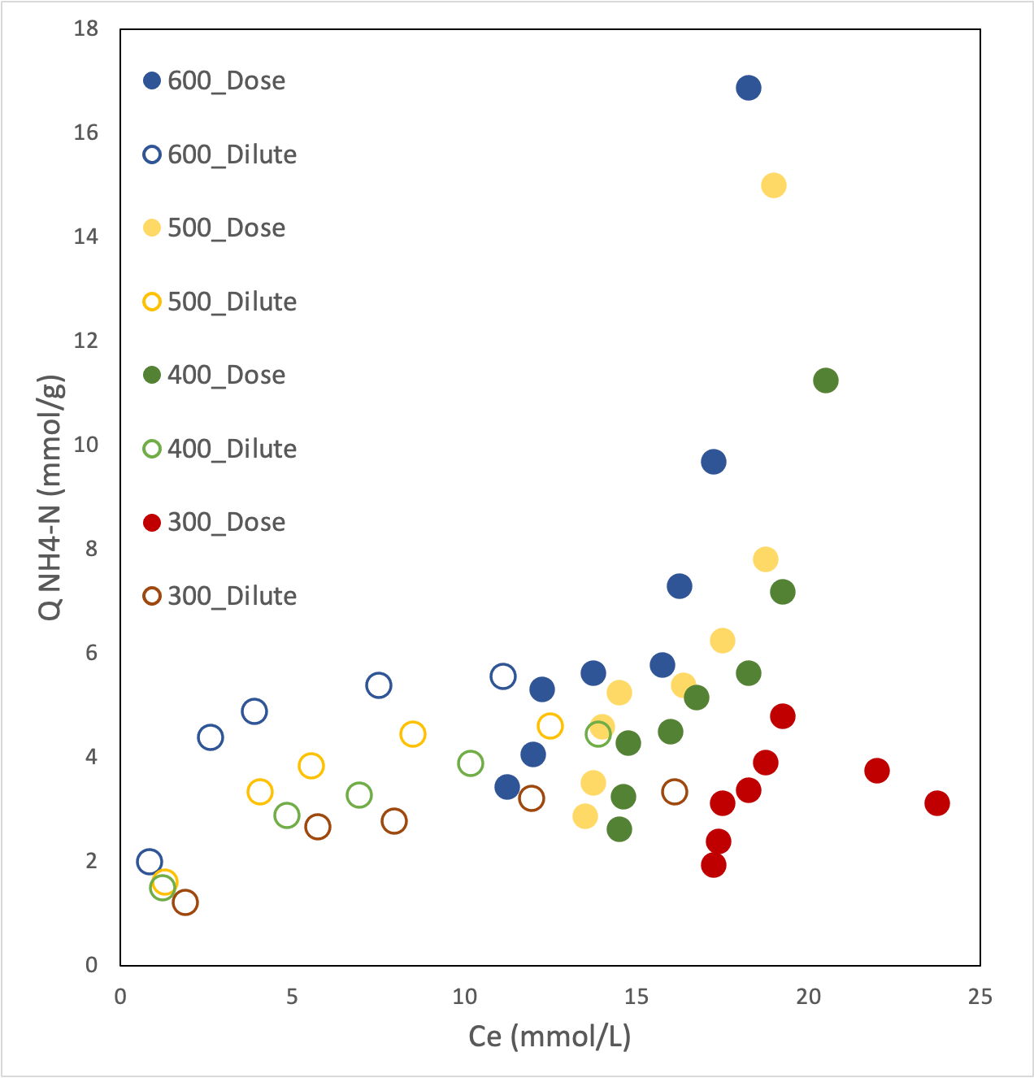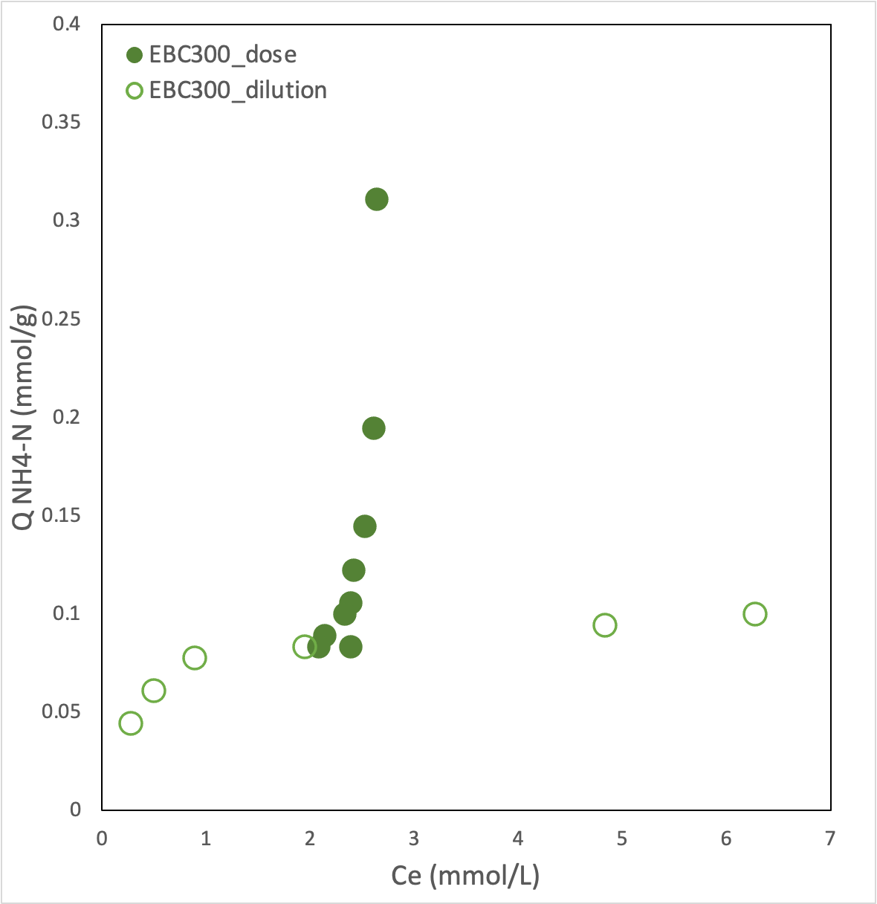
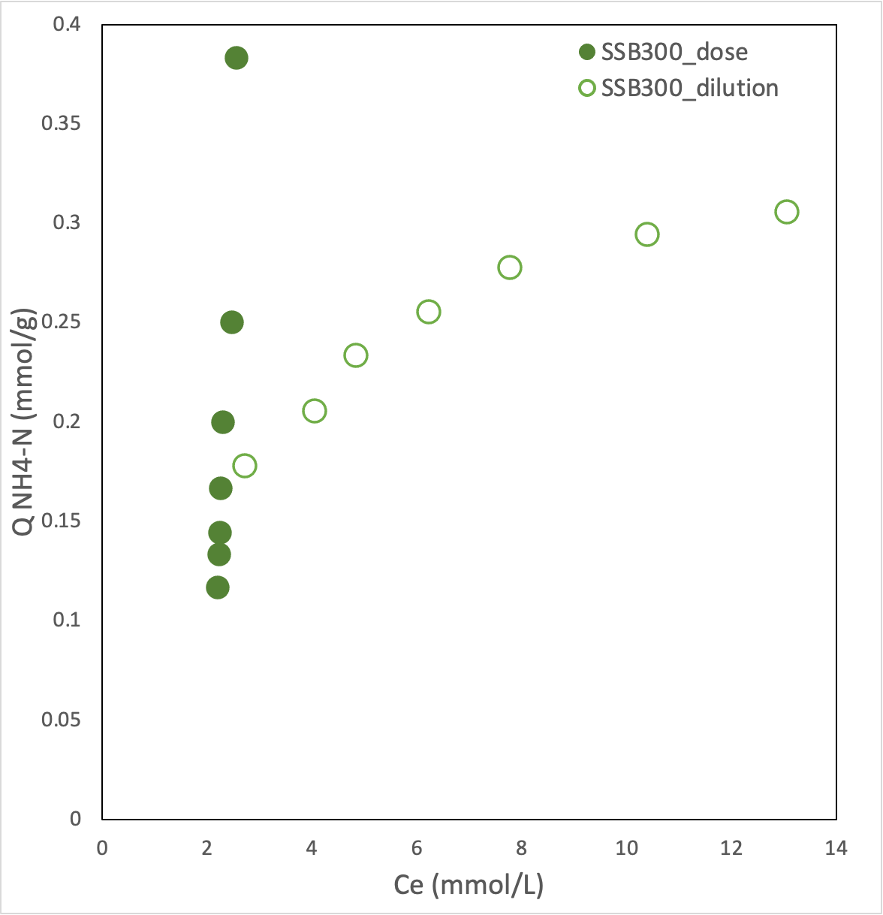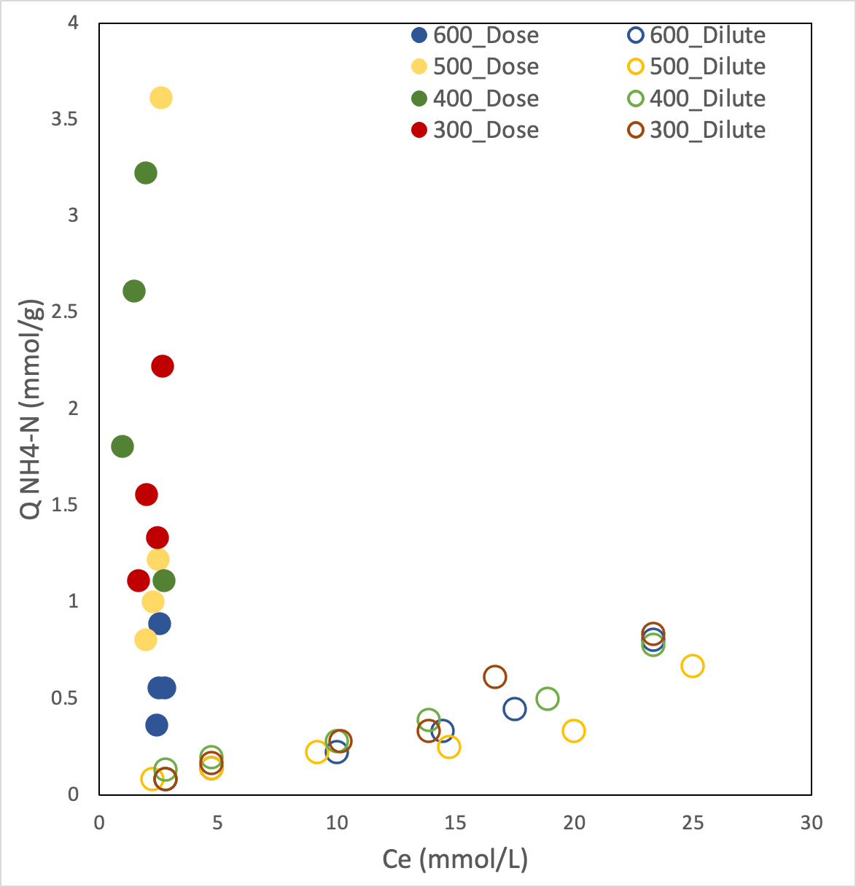
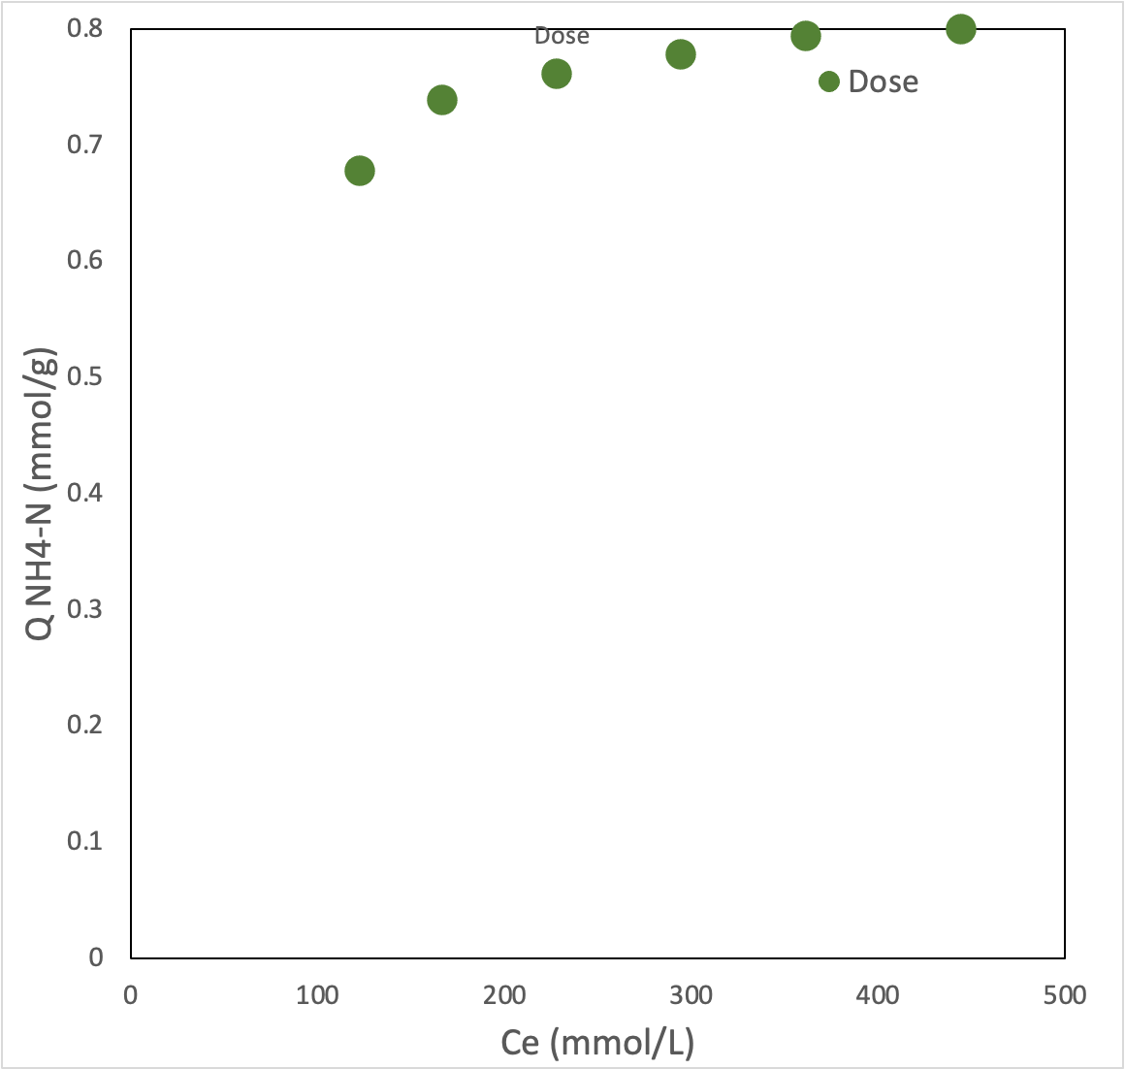

Figure SI7: reanalyzed data of other isotherms using the dose based method.
Replot of studies using biochar and N containing solutions A⁵; real urine (450 mg/L), B⁶: ammonium phosphate (50 mg/L), C⁷; ammonium chloride (50 mg/L) with more concentration solution for dilution, D⁸ (50 mg/L) with more concentration solution for dilution. E⁹; synthetic urine (50 mg/L) with clinoptilolite * and the dose-based method.

A: biochar pH: 6.9; B: solution pH dilution: 8 dose: 7.8 biochar pH: 10.2; C: solution pH: 7; D: solution pH: not reported; E: solution pH: 9.1

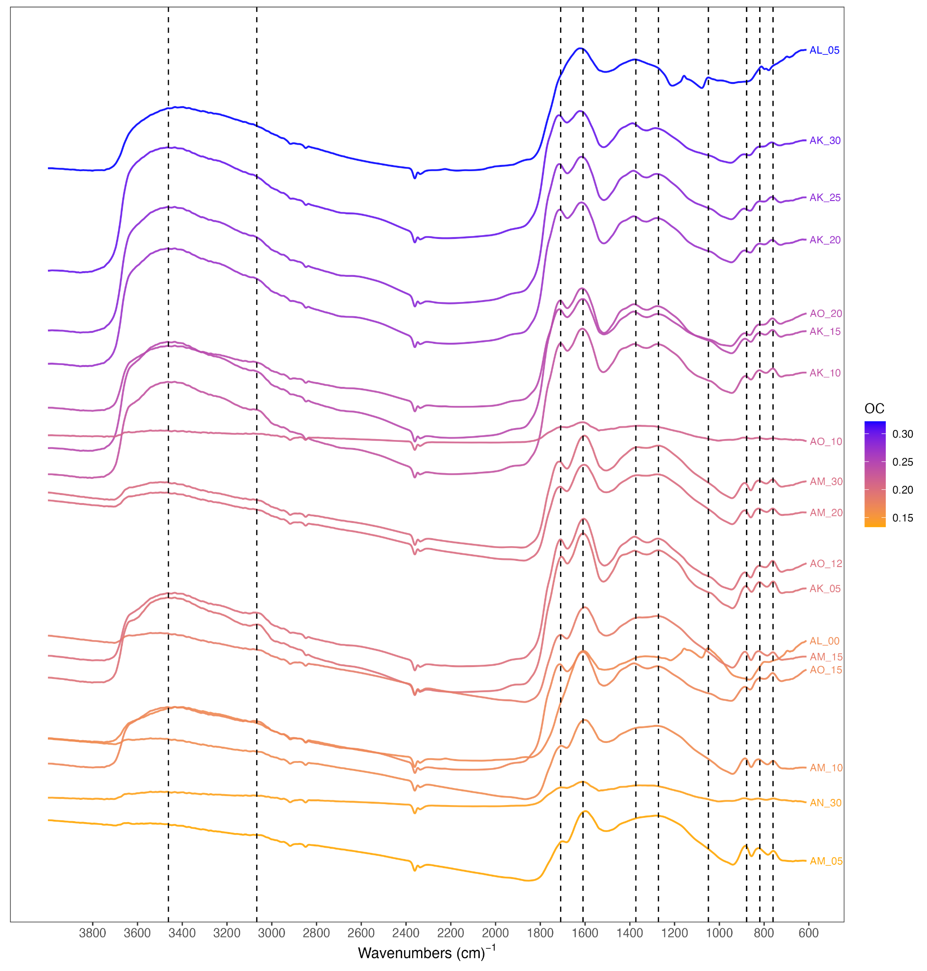

Figure SI8 : FTIR
FTIR spectra showing the changes in functional groups … SS10 not included ^{2,10,11} The broad peak at 3460 is primarily phenolic (−OH) stretching which generally increased with oxidation.¹² The peak at 1709 are attributed to caboxylic acid groups (-COOH), stretching of C=O groups connected to the aromatic ring, including carbonyl and ketonic groups.^{1,2,12–14} The peaks in the 1609 cm-1 region signal −C−C, C=C vibrations and stretching.^{1,2,13,14} Deforming C-H vibrations are visible at 1373.¹⁴ The band at 1210 are assigned to phenolic (-OH) .^{2,10,14} There are aromatic, C-H out of plane deformation peaks at 760, 820, and 878.¹³
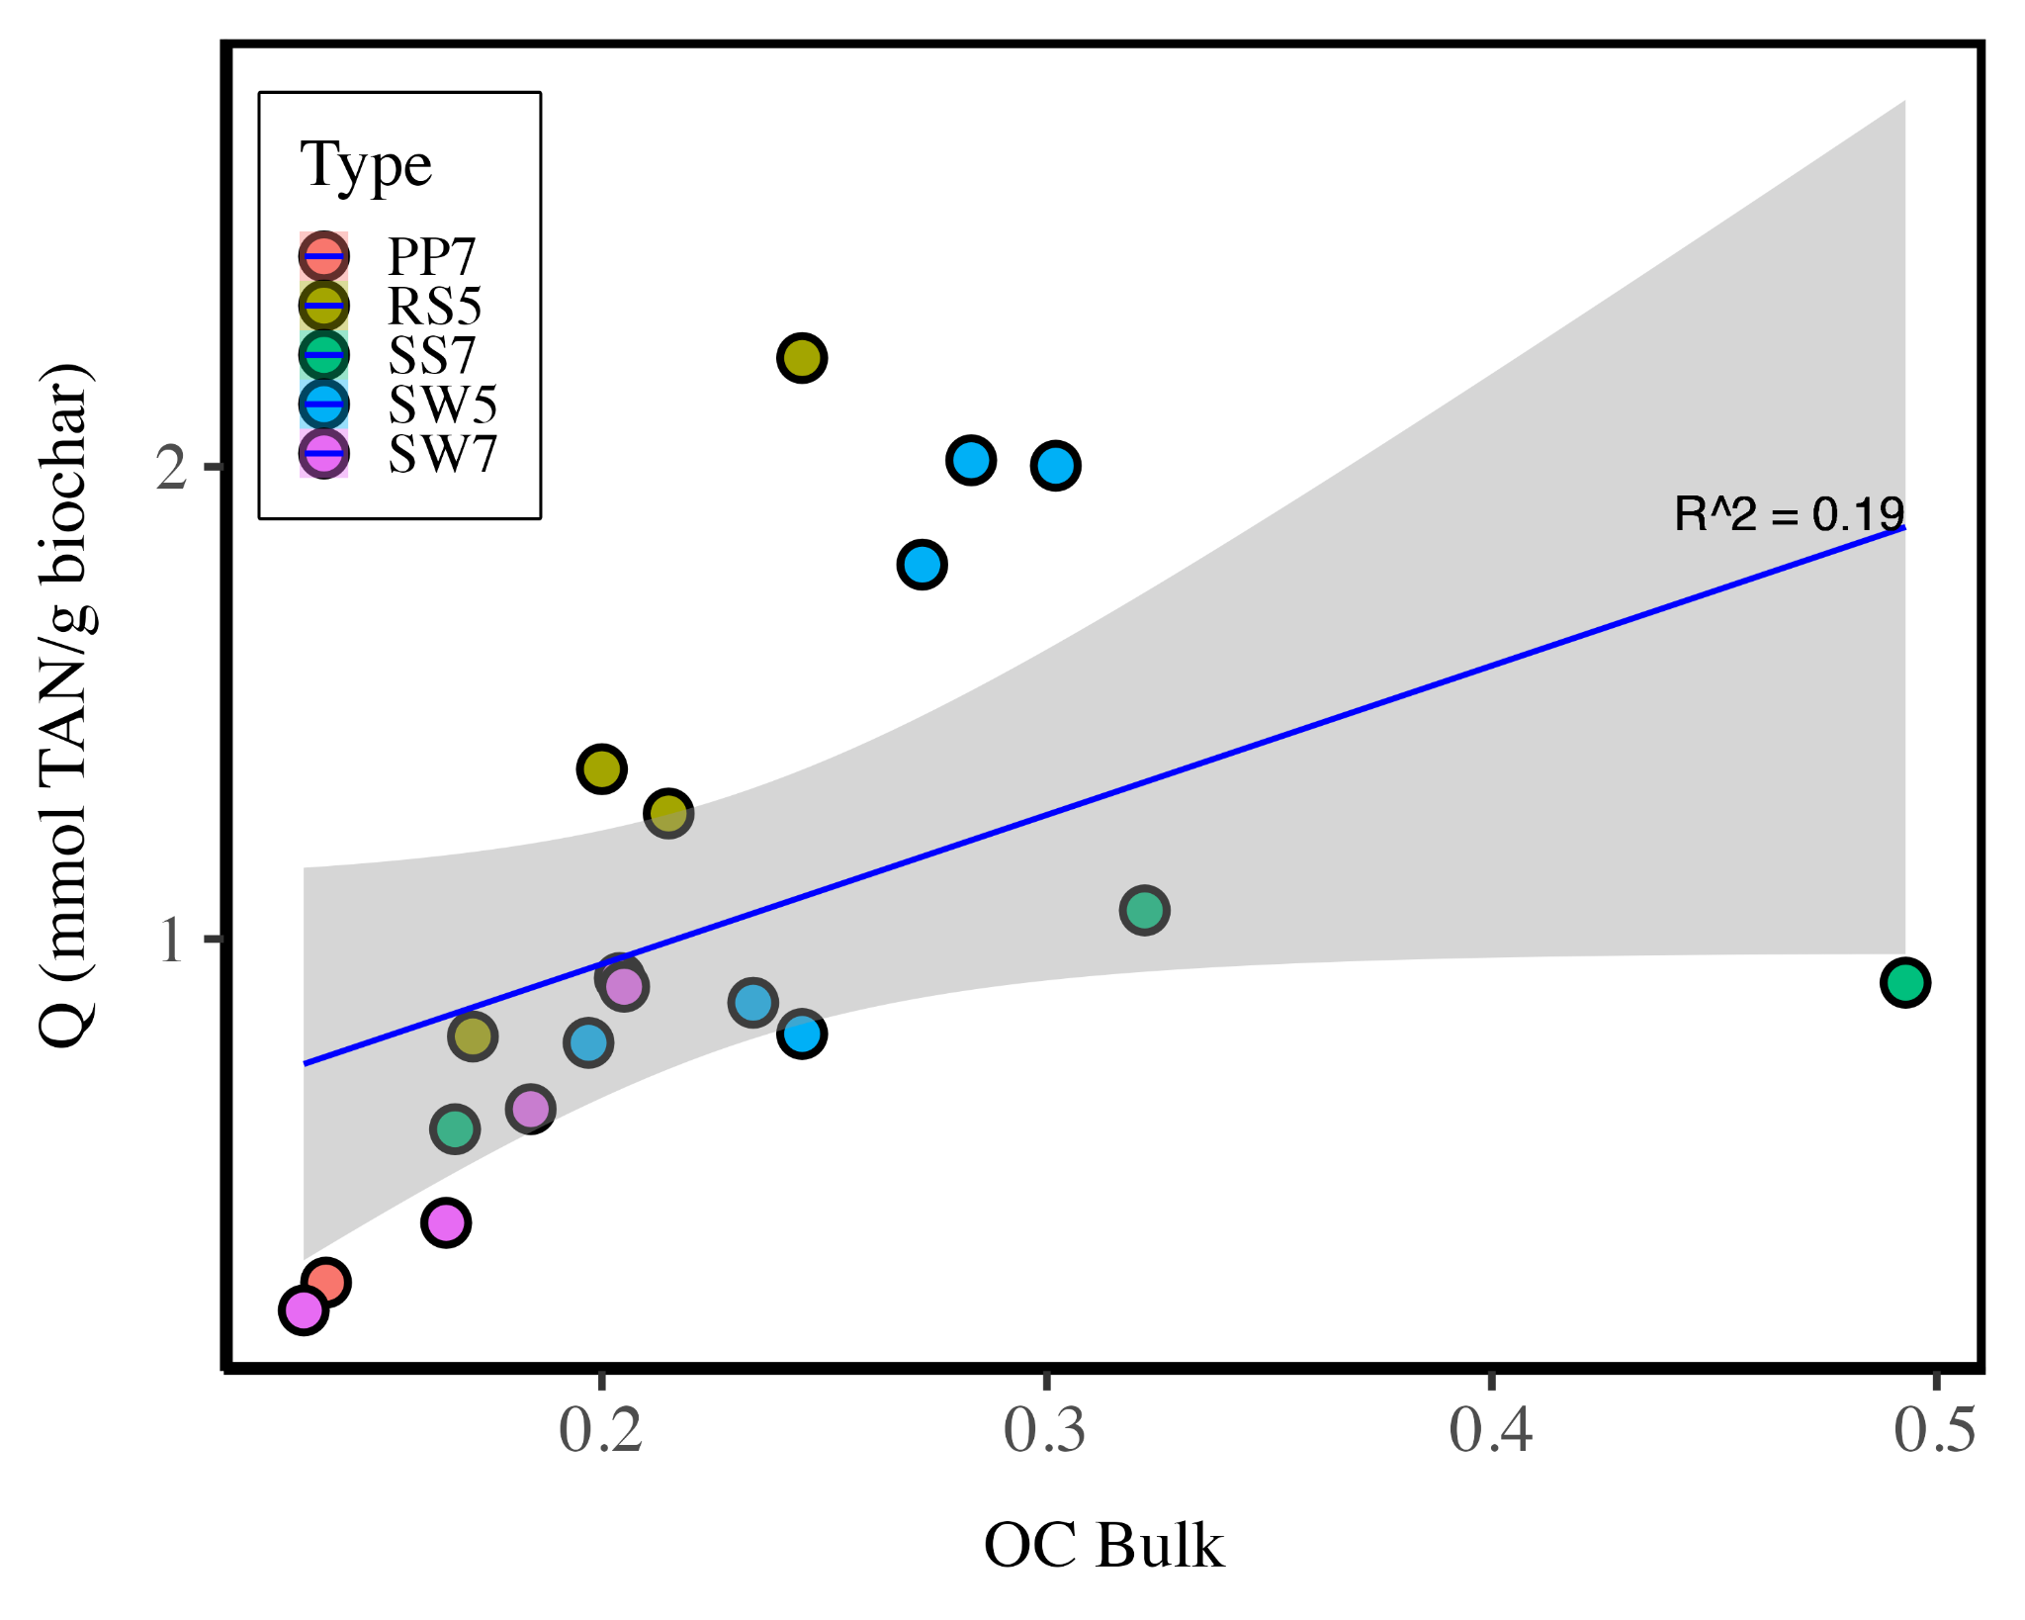

Figure SI9: Freundlich Fit to all biochars, including sewage sludge

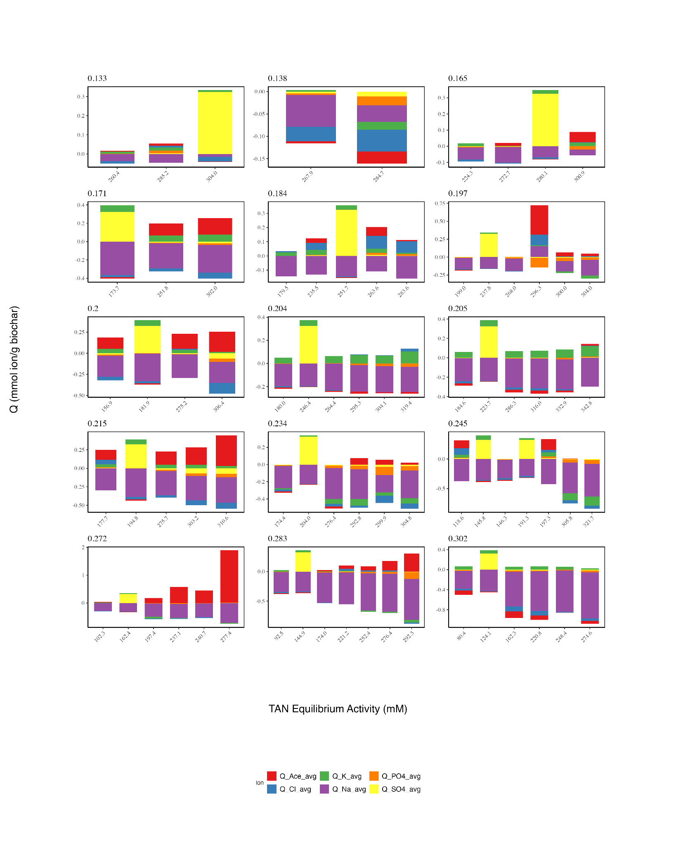

Figure SI10 : Sorption density of other urine ions

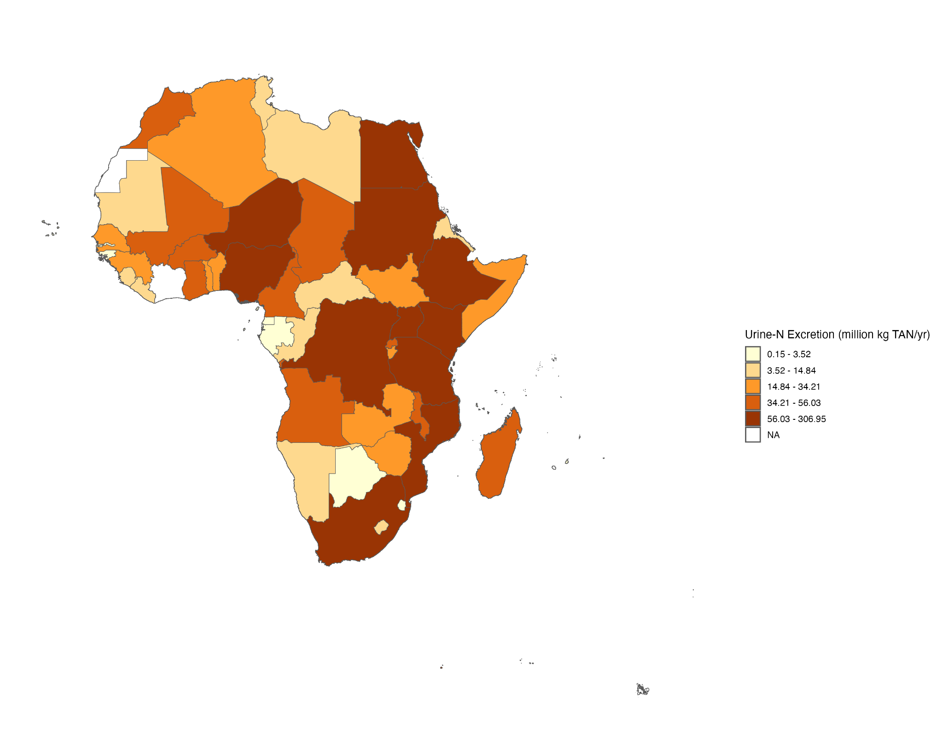
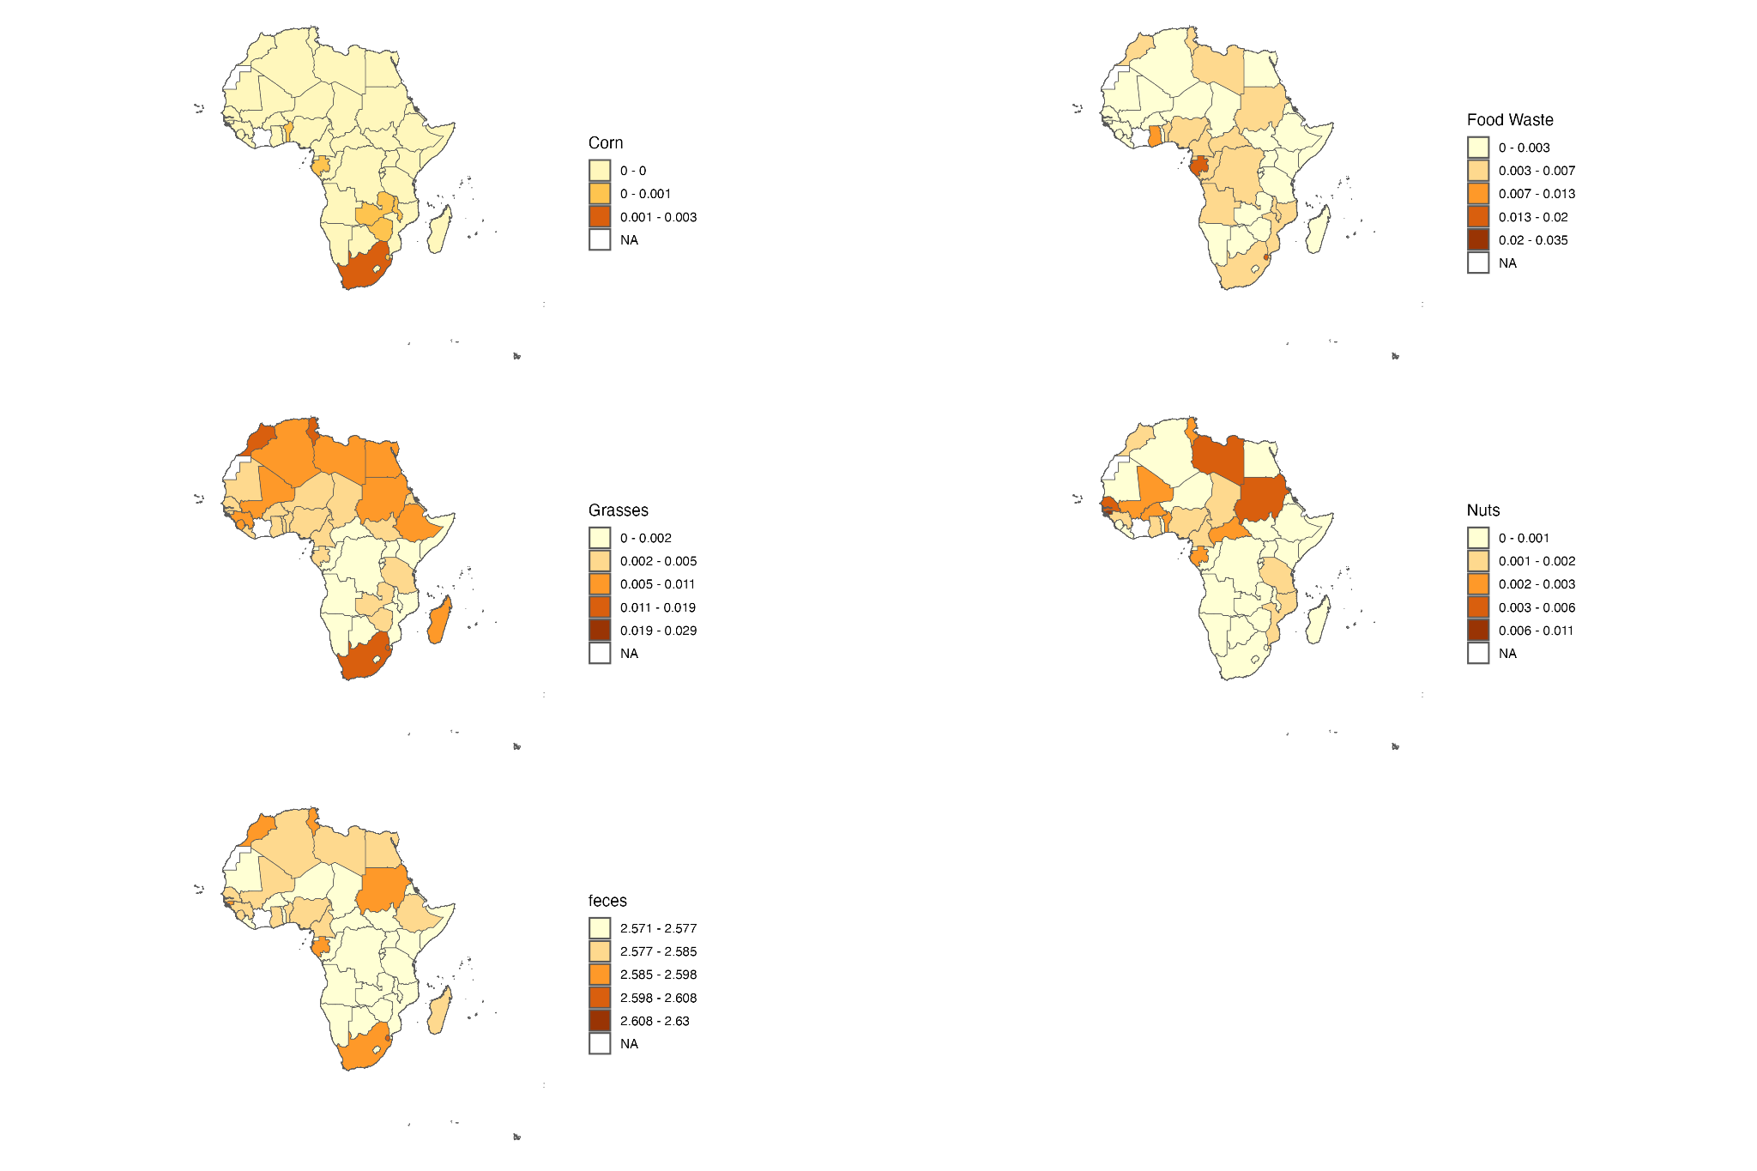
Figure SI11 : (A) mass of TAN in urine (B) percent of A recoverable by various biochar feedstocks

Continental Analysis
Crop production data were sourced from the Food and Agricultural Organization (FAO) database, covering the years 1961-2022. Each crop was categorized into one of four groups: corn, food waste, grasses, and nuts. The mass of agricultural waste generated from crop production was calculated using crop-specific residue-to-product ratios (RPRs) as specified by Röder et al.¹⁵ This mass was then adjusted by the available fraction (15-60%) and dry matter content, and subsequently converted into biochar using a biochar yield of 40%. The calculation for biochar mass is outlined in Equation SI1:

Biochar mass = Mass produced × Residue to product ratio × Available fraction × Dry matter content × Yield

To relate biochar mass to nitrogen sorption capacity, data were utilized from the UC Davis Biochar Database, which includes 291 biochars with reported O:C ratios. These biochars were classified into the same four categories: corn, food waste, grasses, and nuts. The TAN sorption capacity for each biochar was determined using the linear relationship derived from Figure 3A:

Q = 9.129 × OC - 0.787 (Eqn SI1)

Kernel density estimation was then applied to the TAN recovery capacities within each biochar category to generate a distribution of expected nitrogen recovery values per category on a per-mass basis. The expected nitrogen recovery for biochar in each category was determined by integrating these distributions as follows:

Expected N recovery = ∑ (Density × Q) / ∑ Density (Eqn SI2)

The biochar mass calculated in Equation SI1 was then multiplied by the TAN recovery for the respective biochar category:

Total N recovered = Expected N recovery × Biochar mass (Eqn SI3)

Finally, these values were aggregated at the country level to provide an estimate of potential TAN recovery from biochar on a global scale, as depicted in Figure 5. Population data was acquired from the World Bank.
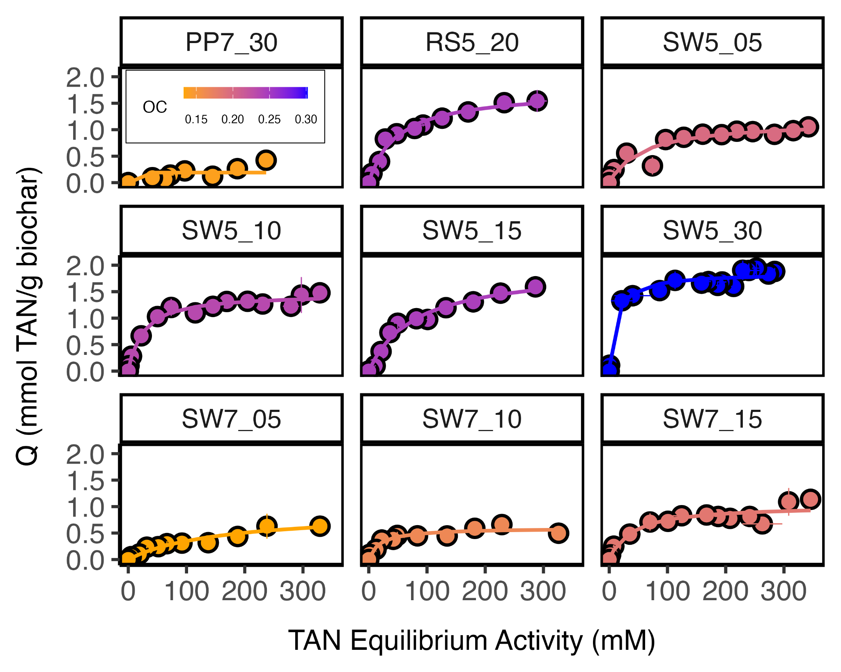Figure SI12: dilution data using Langmuir isotherm fits
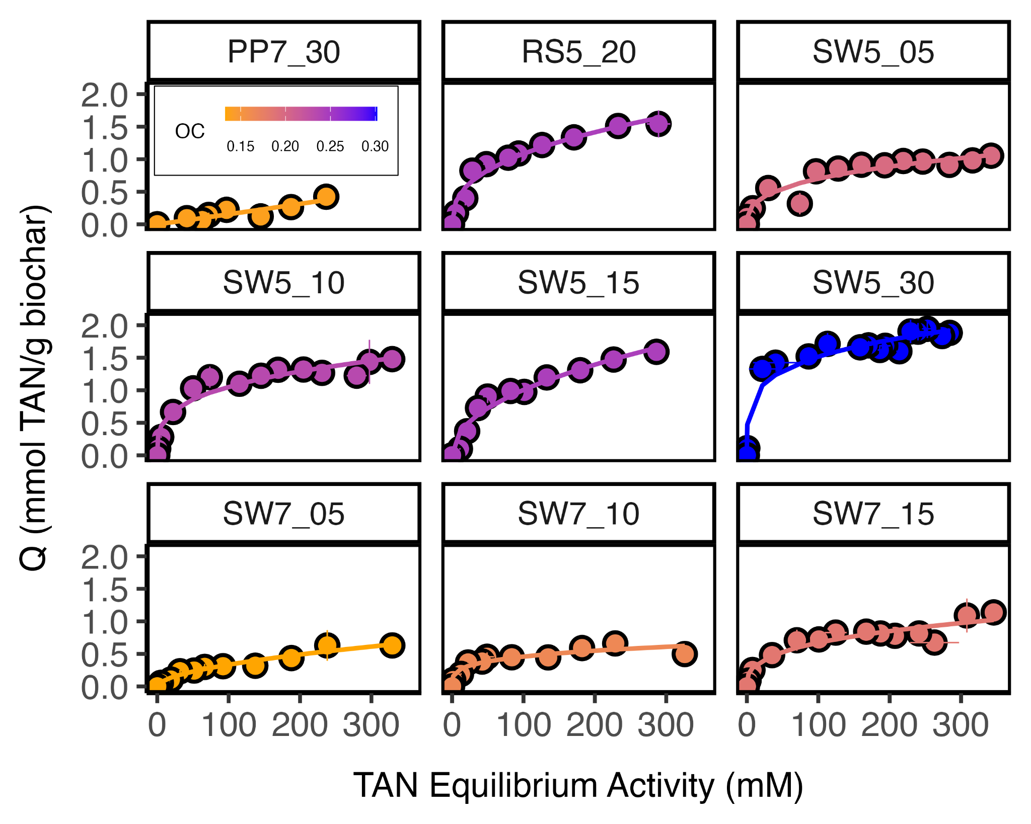

Figure SI13: dilution data using Freundlich isotherm fits

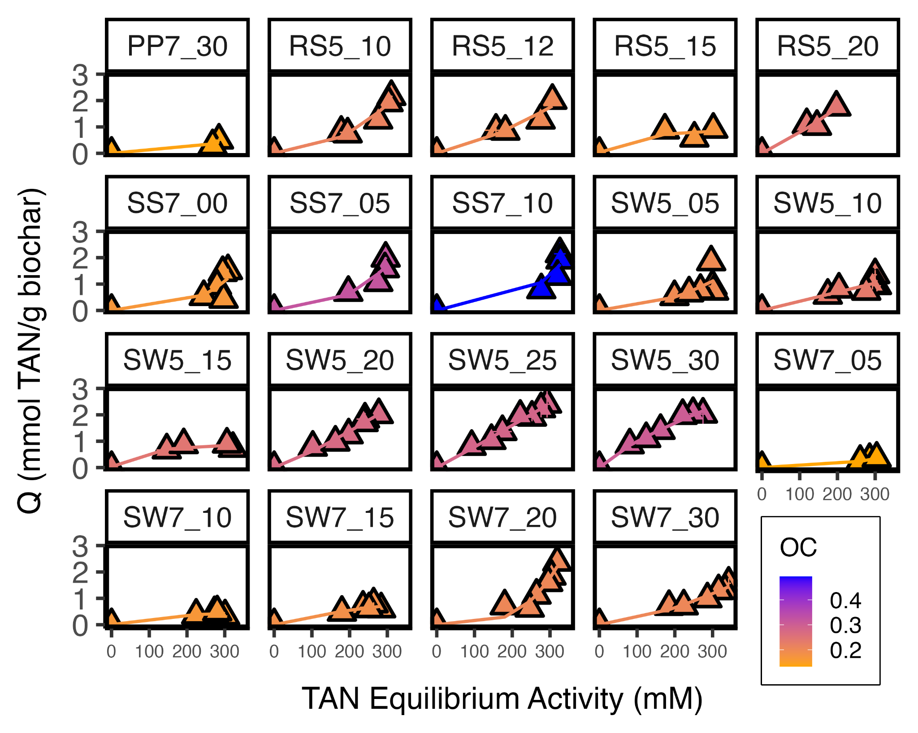

Figure SI14: Freundlich isotherm fits to dose-based data

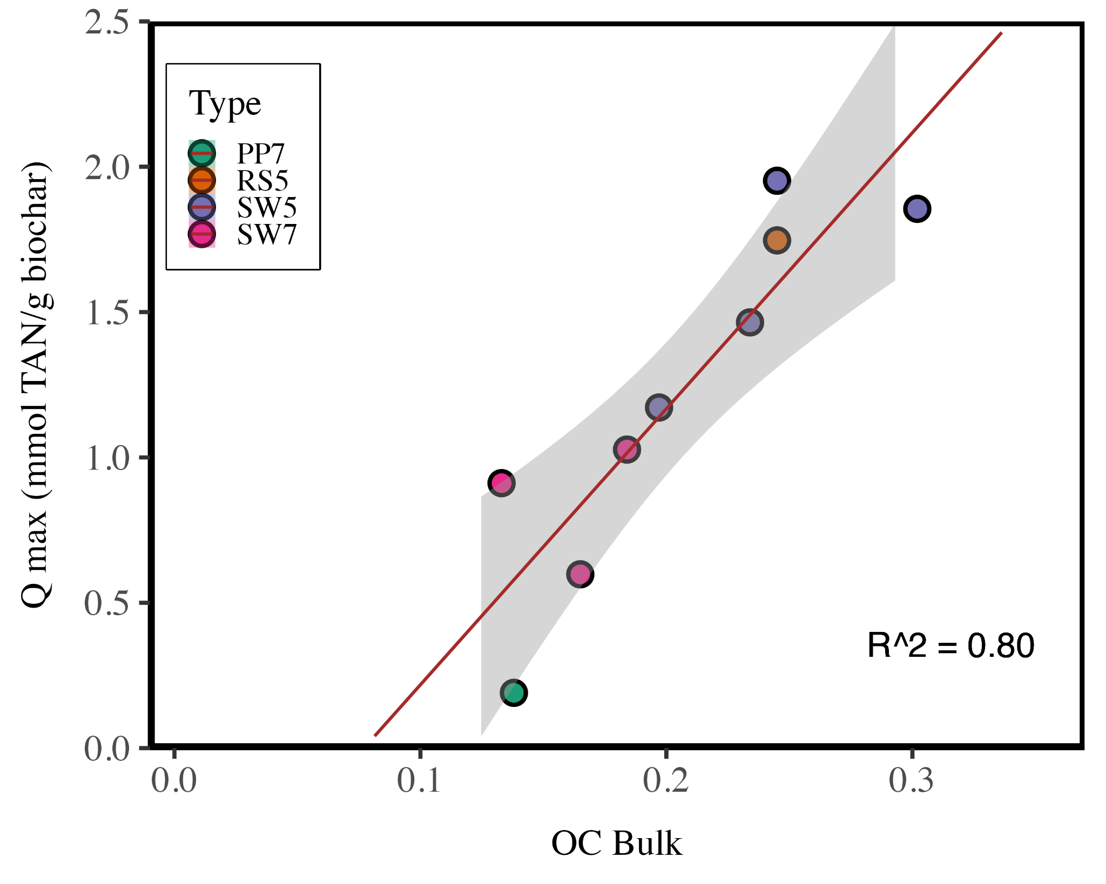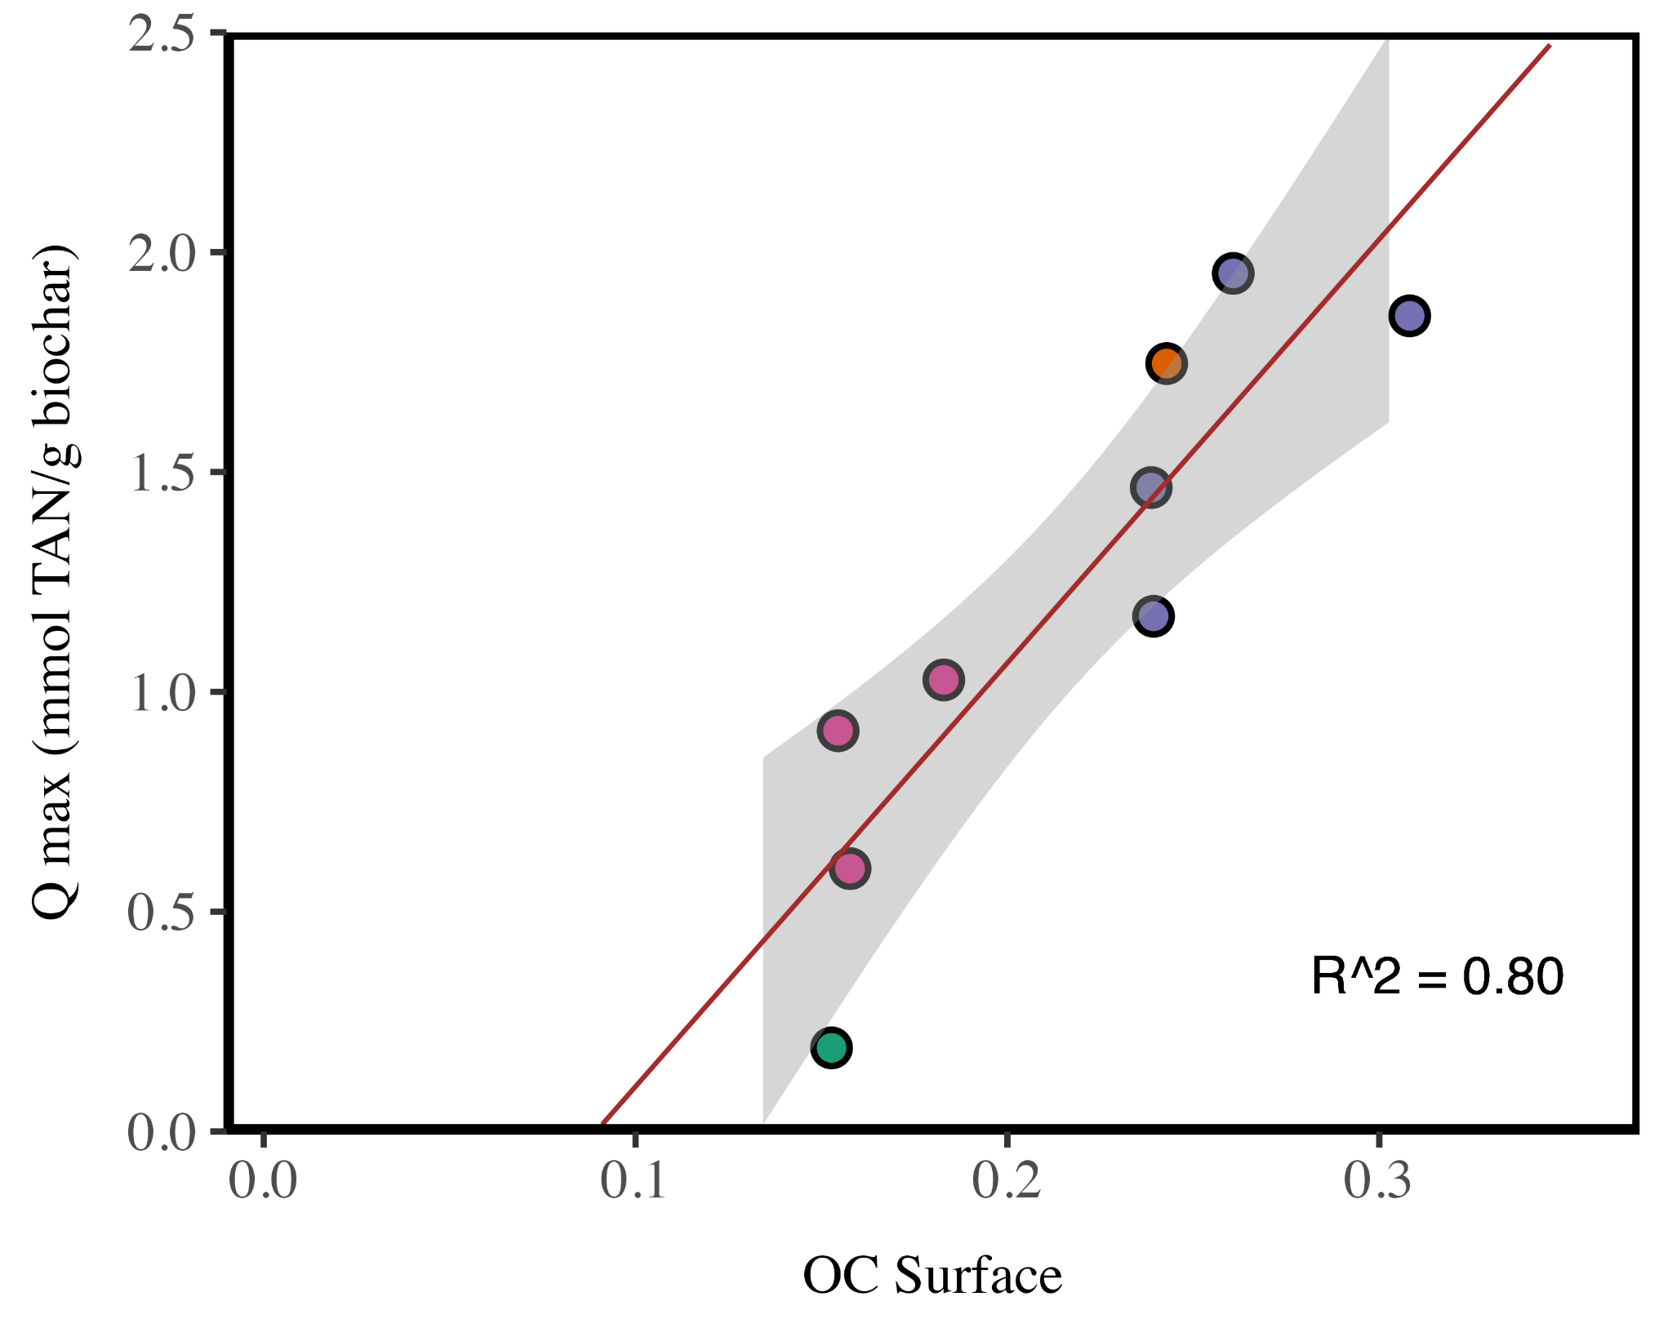
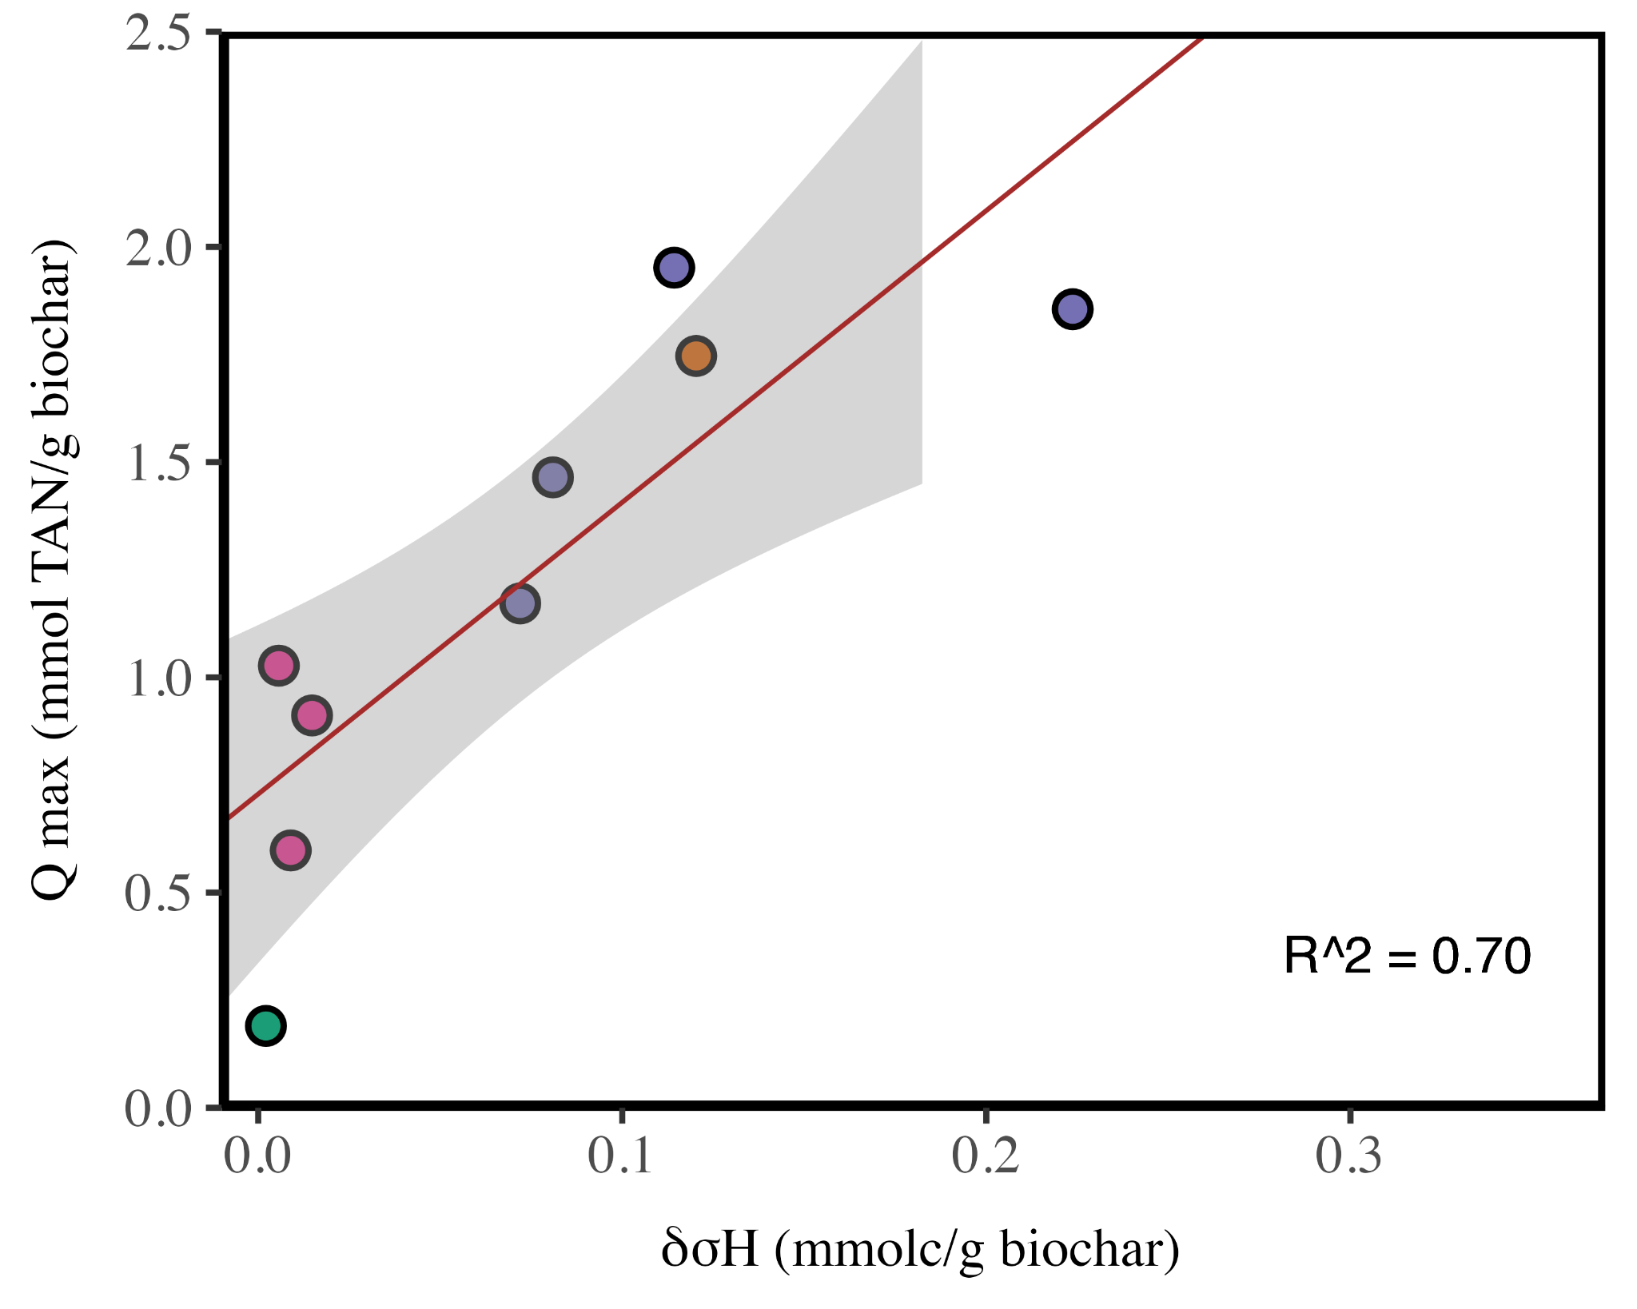
Figure SI15: Correlations between functional group concentration and sorption capacity (Qmax) as determined by the Langmuir fit to data from dilution-based data

References

(1) Mia, S.; Dijkstra, F. A.; Singh, B. Aging Induced Changes in Biochar’s Functionality and Adsorption Behavior for Phosphate and Ammonium. Environ. Sci. Technol. 2017, 51 (15), 8359–8367. https://doi.org/10.1021/acs.est.7b00647.
(2) Krounbi, L.; Enders, A.; Anderton, C. R.; Engelhard, M. H.; Hestrin, R.; Torres-Rojas, D.; Dynes, J. J.; Lehmann, J. Sequential Ammonia and Carbon Dioxide Adsorption on Pyrolyzed Biomass to Recover Waste Stream Nutrients. ACS Sustain. Chem. Eng. 2020, 8 (18), 7121–7131. https://doi.org/10.1021/acssuschemeng.0c01427.
(3) Smith, M.; Ha, S.; Amonette, J. E.; Dallmeyer, I.; Garcia-Perez, M. Enhancing Cation Exchange Capacity of Chars through Ozonation. Biomass Bioenergy 2015, 81, 304–314. https://doi.org/10.1016/j.biombioe.2015.07.012.
(4) Singh, B.; Fang, Y.; Cowie, B. C. C.; Thomsen, L. NEXAFS and XPS Characterisation of Carbon Functional Groups of Fresh and Aged Biochars. Org. Geochem. 2014, 77, 1–10. https://doi.org/10.1016/j.orggeochem.2014.09.006.
(5) Yu, C. Recovery of NH4 +-N and PO4 3--P from Urine Using Sludge-Derived Biochar as a Fertilizer: Performance and Mechanism. RSC Adv. 2022, 12 (7), 4224–4233. https://doi.org/10.1039/d1ra08558a.
(6) Cheng, N.; Wang, B.; Feng, Q.; Zhang, X.; Chen, M. Co-Adsorption Performance and Mechanism of Nitrogen and Phosphorus onto Eupatorium Adenophorum Biochar in Water. Bioresour. Technol. 2021, 340, 125696. https://doi.org/10.1016/j.biortech.2021.125696.
(7) Xu, H.; Wang, B.; Zhao, R.; Wang, X.; Pan, C.; Jiang, Y.; Zhang, X.; Ge, B. Adsorption Behavior and Performance of Ammonium onto Sorghum Straw Biochar from Water. Sci. Rep. 2022, 12 (1), 5358. https://doi.org/10.1038/s41598-022-08591-5.
(8) Park, M. H.; Jeong, S.; Kim, J. Y. Adsorption of NH3-N onto Rice Straw-Derived Biochar. J. Environ. Chem. Eng. 2019, 7 (2), 103039. https://doi.org/10.1016/j.jece.2019.103039.
(9) Zhang, Y.; Aguila, B.; Ma, S.; Zhang, Q. Comparison of the Use of Functional Porous Organic Polymer (POP) and Natural Material Zeolite for Nitrogen Removal and Recovery from Source-Separated Urine. J. Environ. Chem. Eng. 2020, 8 (5), 104296. https://doi.org/10.1016/j.jece.2020.104296.
(10) Domingues, R. R.; Trugilho, P. F.; Silva, C. A.; Melo, I. C. N. A. de; Melo, L. C. A.; Magriotis, Z. M.; Sánchez-Monedero, M. A. Properties of Biochar Derived from Wood and High-Nutrient Biomasses with the Aim of Agronomic and Environmental Benefits. PLOS ONE 2017, 12 (5), e0176884. https://doi.org/10.1371/journal.pone.0176884.
(11) Coates, J. Interpretation of Infrared Spectra, A Practical Approach. In Encyclopedia of Analytical Chemistry; Meyers, R. A., Ed.; Wiley, 2000. https://doi.org/10.1002/9780470027318.a5606.
(12) Cheng, C.-H.; Lehmann, J.; Engelhard, M. H. Natural Oxidation of Black Carbon in Soils: Changes in Molecular Form and Surface Charge along a Climosequence. Geochim. Cosmochim. Acta 2008, 72 (6), 1598–1610. https://doi.org/10.1016/j.gca.2008.01.010.
(13) Hestrin, R.; Torres-Rojas, D.; Dynes, J. J.; Hook, J. M.; Regier, T. Z.; Gillespie, A. W.; Smernik, R. J.; Lehmann, J. Fire-Derived Organic Matter Retains Ammonia through Covalent Bond Formation. Nat. Commun. 2019, 10 (1), 664. https://doi.org/10.1038/s41467-019-08401-z.
(14) Fan, Q.; Sun, J.; Chu, L.; Cui, L.; Quan, G.; Yan, J.; Hussain, Q.; Iqbal, M. Effects of Chemical Oxidation on Surface Oxygen-Containing Functional Groups and Adsorption Behavior of Biochar. Chemosphere 2018, 207, 33–40. https://doi.org/10.1016/j.chemosphere.2018.05.044.
(15) Röder, M.; Chong, K.; Thornley, P. The Future of Residue-Based Bioenergy for Industrial Use in Sub-Saharan Africa. Biomass Bioenergy 2022, 159, 106385. https://doi.org/10.1016/j.biombioe.2022.106385.

