Supplementary Information for
2D/3D Heterostructured Perovskites for Highly Selective Room-Temperature Blue Spin-Polarized Light-Emitting Diodes
Gyumin Jang¹, Sangjun Lee^{1,2}, Sunihl Ma³, Jaehyun Son¹, Junwoo Lee¹, Chan Uk Lee¹, Jeongyoub Lee¹, Wooyong Jeong¹, Chang-Seop Jeong¹, Jeong Hyun Park¹, Seonyoo Kim¹ and Jooho Moon^{1*}

¹Department of Materials Science and Engineering, Yonsei University, Seoul 03722, Republic of Korea
²Institute of Industrial Science, The University of Tokyo, Tokyo 153–8505, Japan
³School of Chemistry and Energy, Sungshin Women’s University, Seoul 01133, Republic of Korea
* Correspondence should be addressed to J.M. (email: jmoon@yonsei.ac.kr)

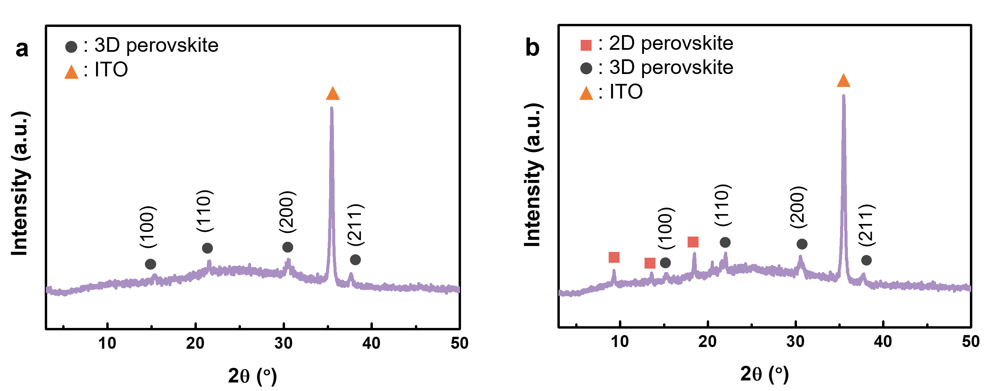
Supplementary Fig. 1 | Crystal structure of Br/Cl-mixed perovskite films. XRD patterns of a, 3D perovskite and b, 2D/3D heterostructured perovskite films prepared with S-2F-MBA 2D chiral cations.

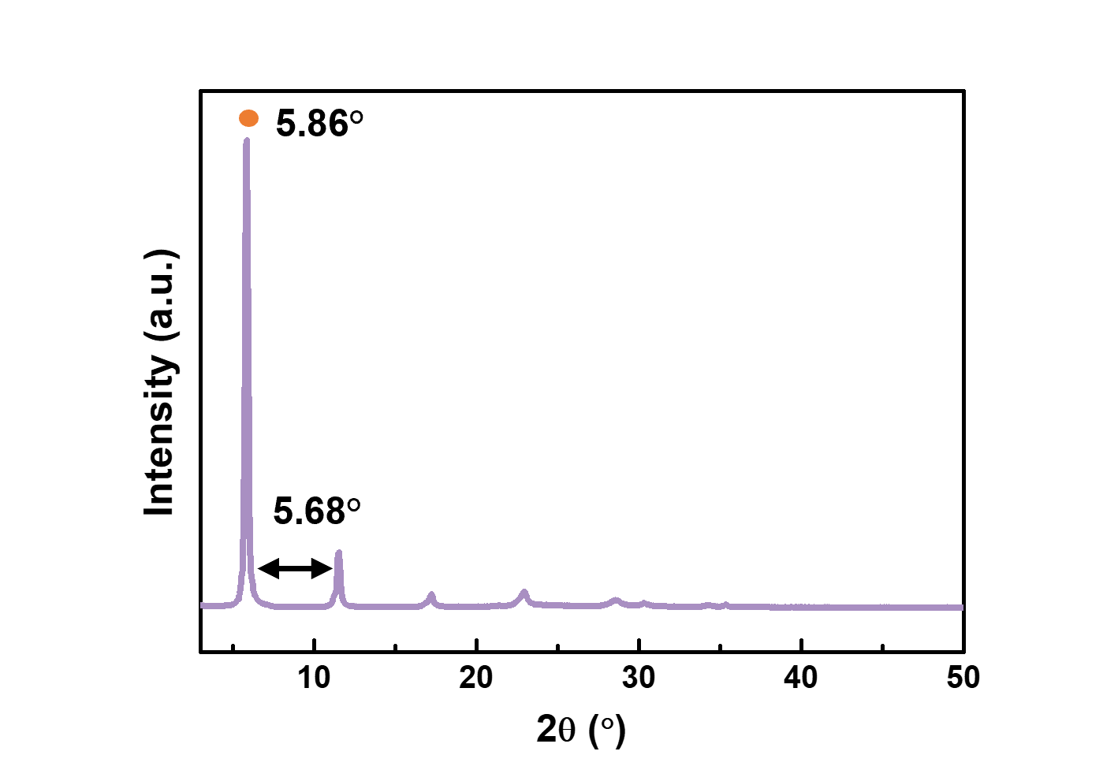
Supplementary Fig. 2 | Crystal structure of iodide perovskite films. XRD patterns of pure 2D chiral perovskite film with an (S-2F-MBA)₂PbI₄ composition.

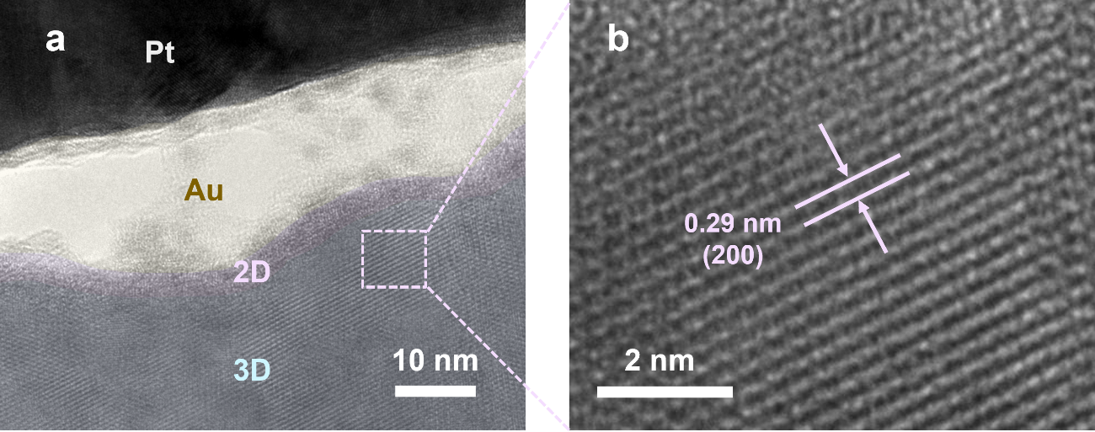
Supplementary Fig. 3 | Structural property of perovskite heterostructured films. a, TEM image of 2D/3D heterostructured perovskite films, where the amorphous 2D chiral perovskite is discernible on the surface of the 3D perovskite layer. b, Lattice spacing of 3D perovskite (purple dotted region)

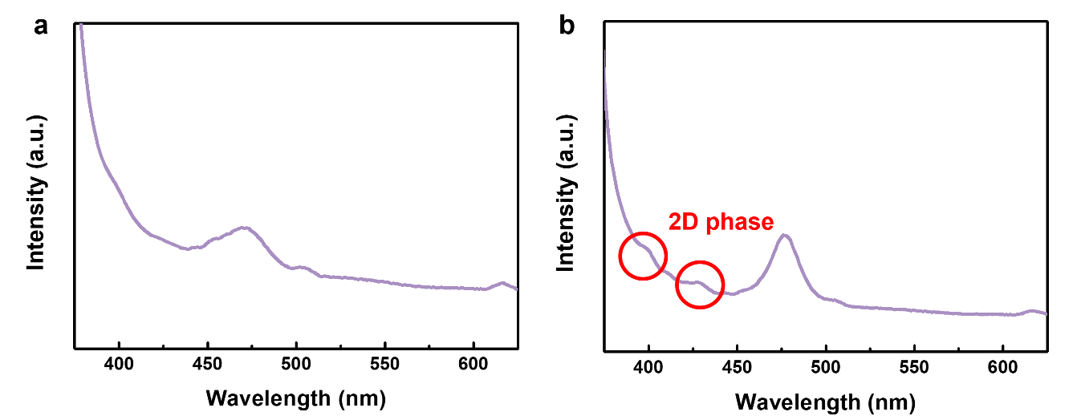
Supplementary Fig. 4 | Emission property of perovskite films. Steady-state PL spectra of a, 3D and b, 2D/3D heterostructured perovskite films.

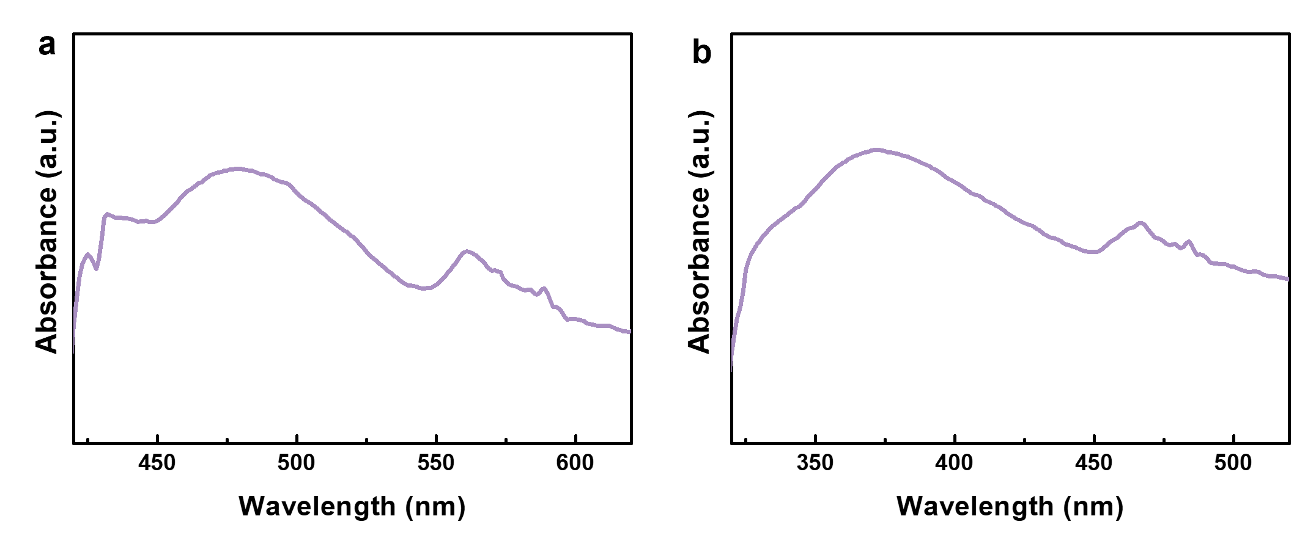
Supplementary Fig. 5 | Optical properties of perovskite films. Absorbance spectra of 2D chiral perovskite films with compositions of a, (S-2F-MBA)₂PbI₄ and b, (S-2F-MBA)₂PbBr_{2.4}Cl_{1.6}.

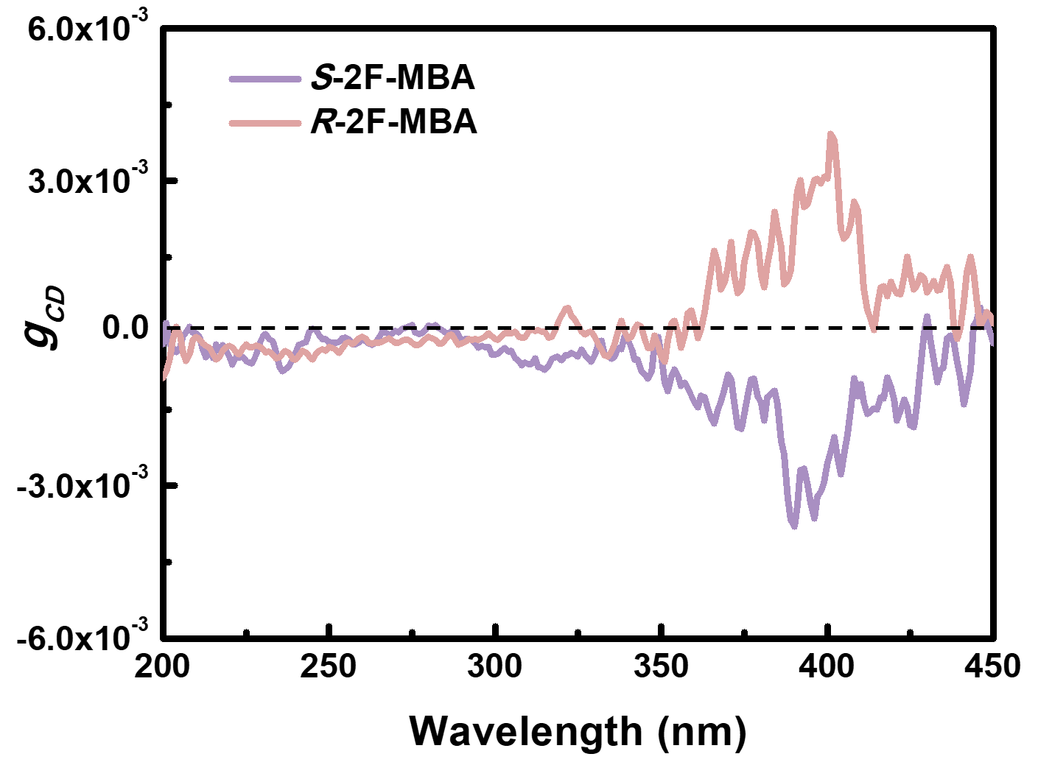
Supplementary Fig. 6 | Chiroptical property of Br/Cl-mixed perovskite films. g_{CD} spectra of (S-2F-MBA)₂PbBr_{2.4}Cl_{1.6} 2D chiral perovskite films.

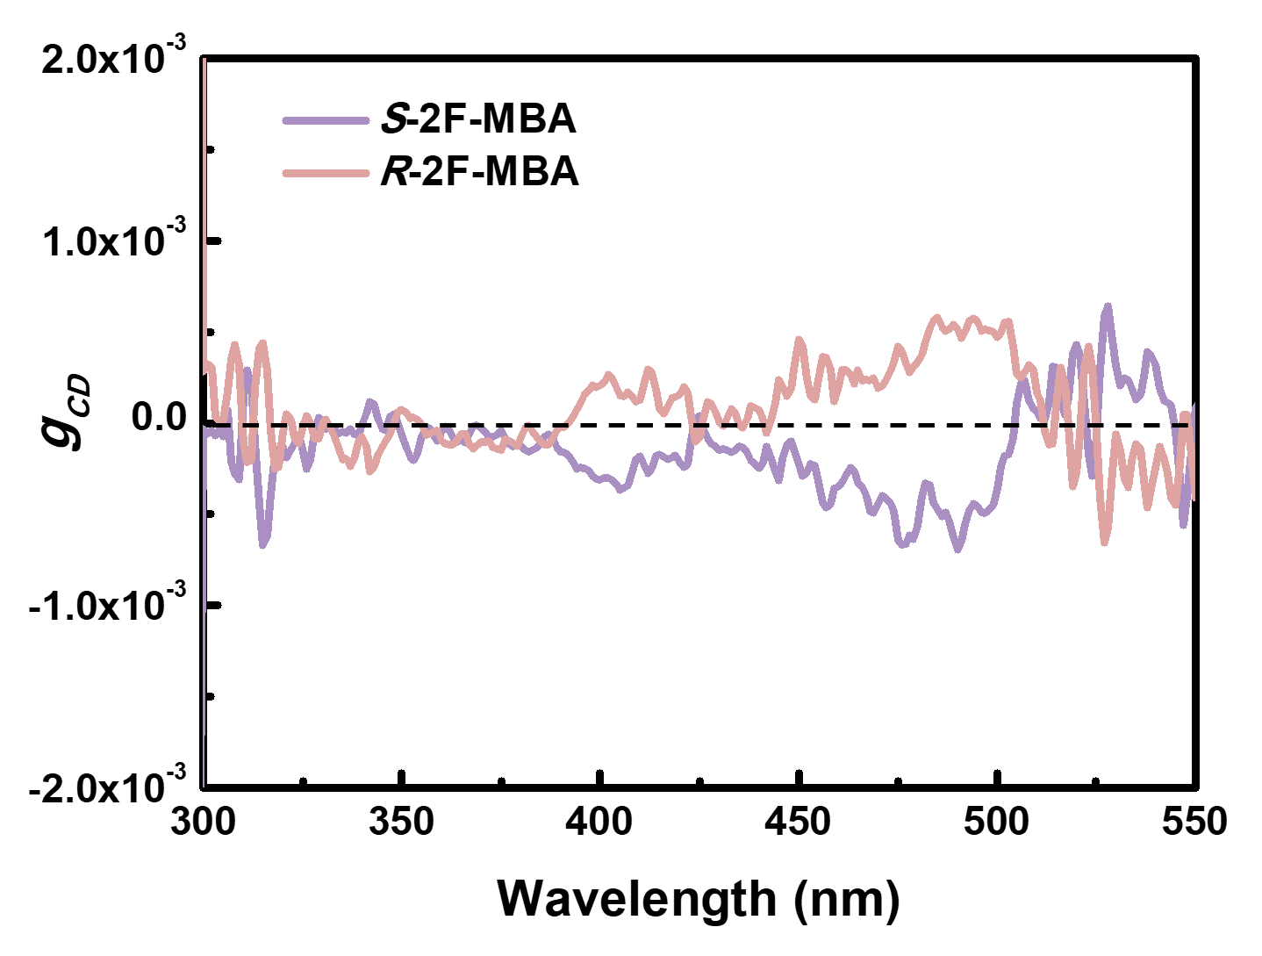
Supplementary Fig. 7 | Chiroptical property of iodide perovskite films. g_{CD} spectra of (S-2F-MBA)₂PbI₄ 2D chiral perovskite films.

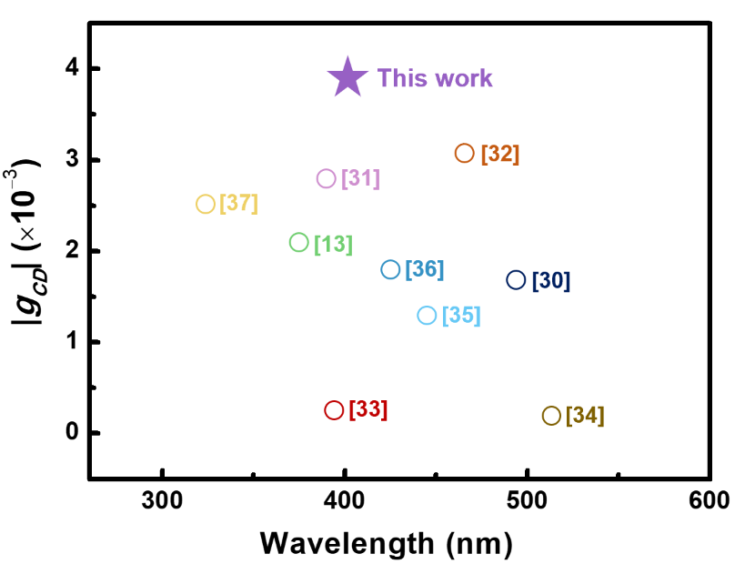
Supplementary Fig. 8 | Benchmark of chiroptical property. Graph showing true g_{CD} values of previously reported 2D chiral perovskites with various chiral cations.

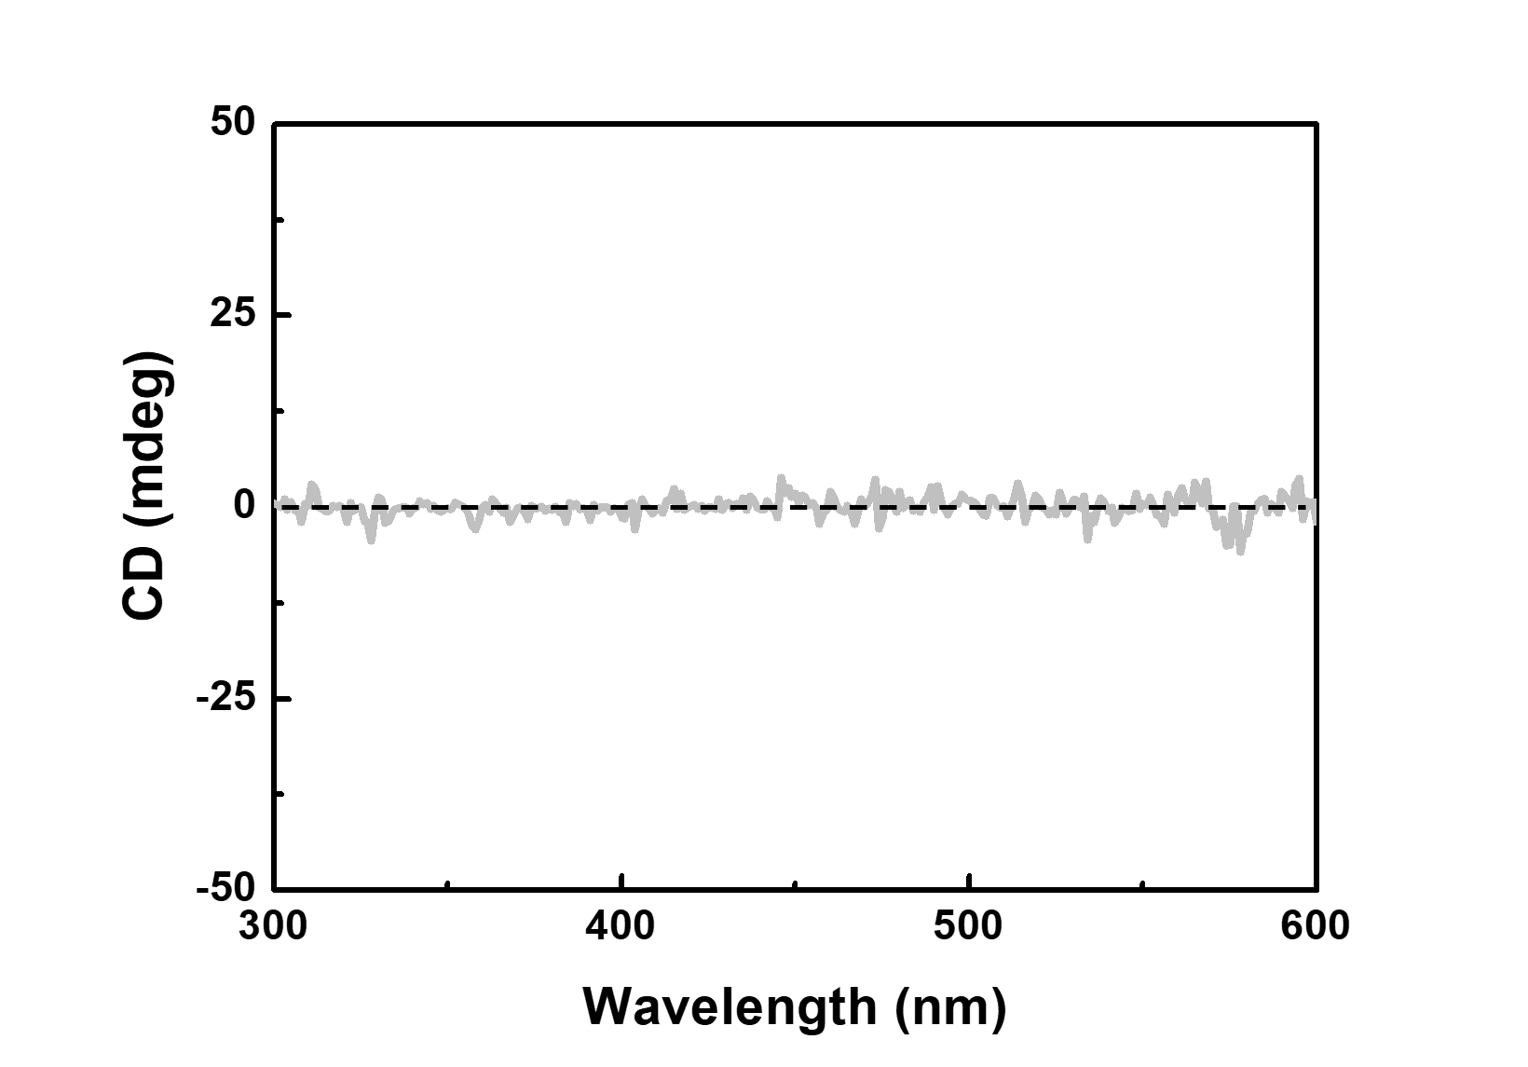
Supplementary Fig. 9 | Chiroptical property of perovskite films based on racemic cations. CD spectra of 2D/3D perovskite films prepared with rac-2F-MBA 2D cations.

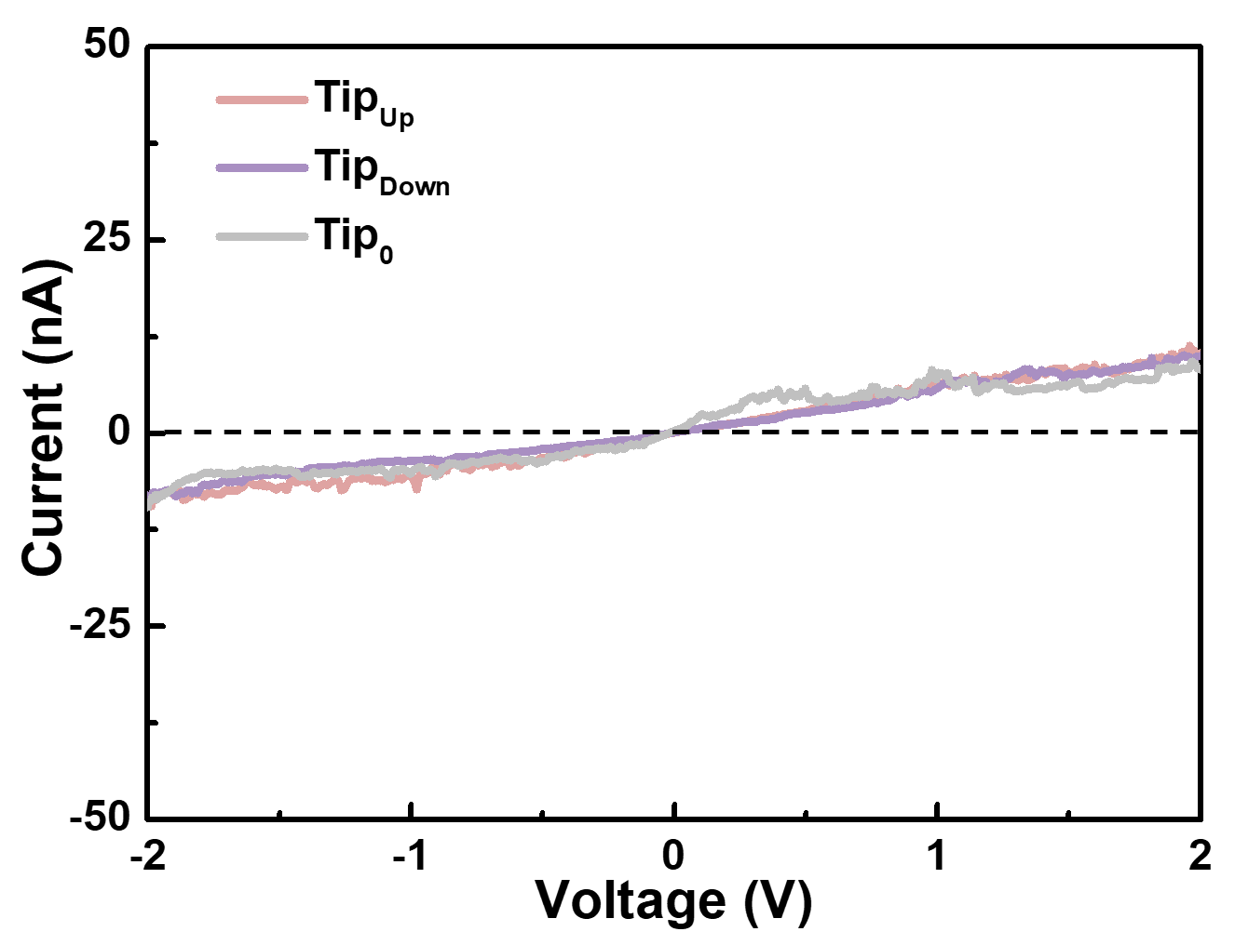
Supplementary Fig. 10 | Spin selectivity of perovskite films based on racemic cations. I–V responses of ITO/PEDOT:PSS/perovskite films prepared with rac-2F-MBA, as obtained through mCP-AFM at room temperature.
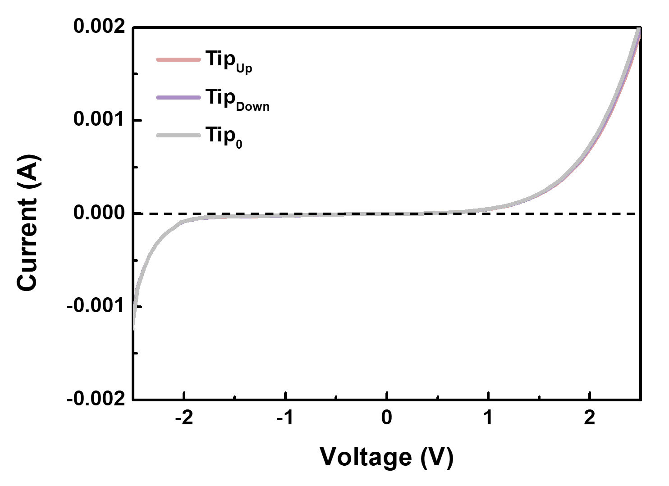
Supplementary Fig. 11 | Spin selectivity of perovskite films based on racemic cations. Average I–V characteristics of CISS devices fabricated with 2D/3D perovskite films featuring rac-2F-MBA 2D cations. The I–V curves were recorded 10 times for each magnetization direction of the Ni electrode.

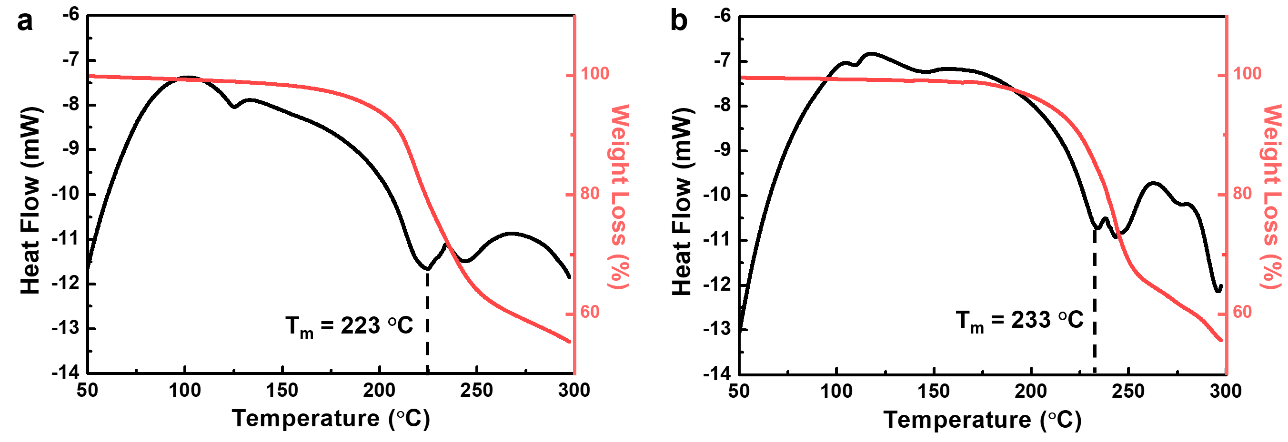
Supplementary Fig. 12 | Thermal property of perovskite films. TG-DSC spectra for 2D perovskite powder with compositions of a, (S-2F-MBA)₂PbI₄ and b, (S-2F-MBA)₂PbBr₄.




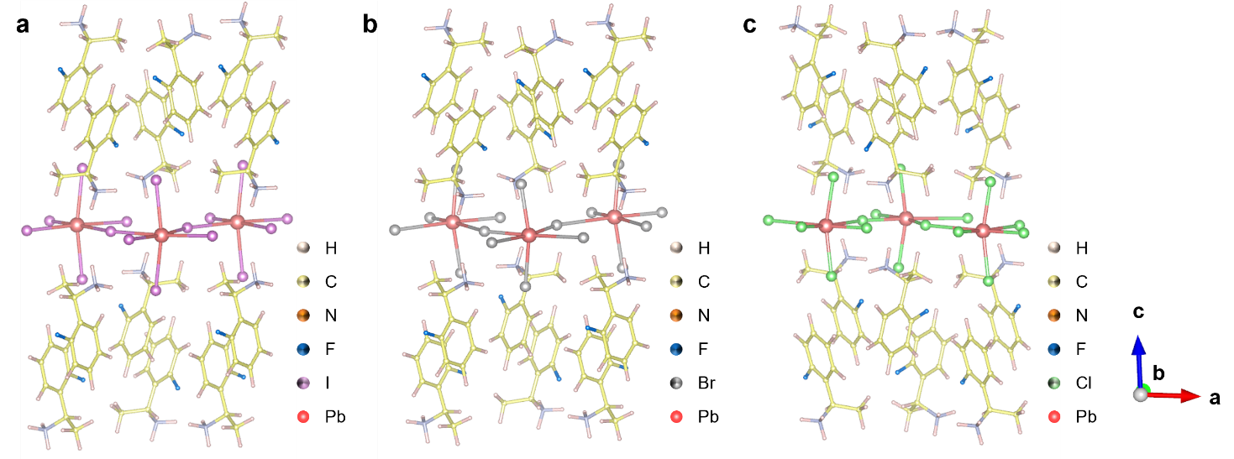

Supplementary Fig. 13 | Crystal structure derived by DFT calculations. Optimized crystal structure of a, (S-2F-MBA)₂PbI₄, b, (S-2F-MBA)₂PbBr₄, and c, (S-2F-MBA)₂PbCl₄ based on DFT calculations, as viewed from b-axis.

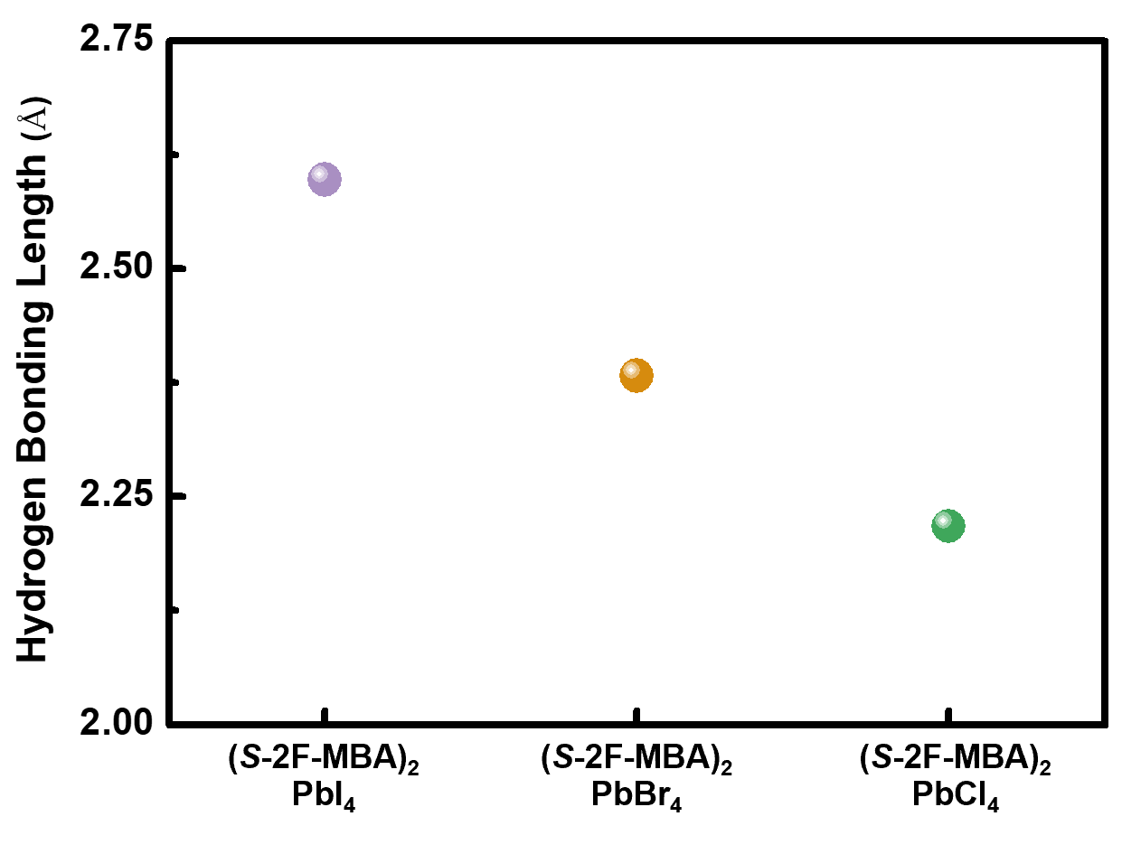
Supplementary Fig. 14 | Strength of hydrogen bonding according to the halide compositions. Average length of the four distinct hydrogen bonds identifiable inside each 2D perovskite crystal.

Supplementary Table 1. van der Waals radius of each halogen atom and the shortest distance between the fluorine atom of the S-2F-MBA cation and the halide anion of the inorganic framework inside 2D chiral perovskite crystals, as derived from DFT calculations.
 | Iodine | Bromine | Chlorine | Fluorine
van der Waals radius | 1.98 Å | 1.85 Å | 1.75 Å | 1.47 Å
d_{F-X} | 3.54 Å | 3.37 Å | 3.29 Å | -

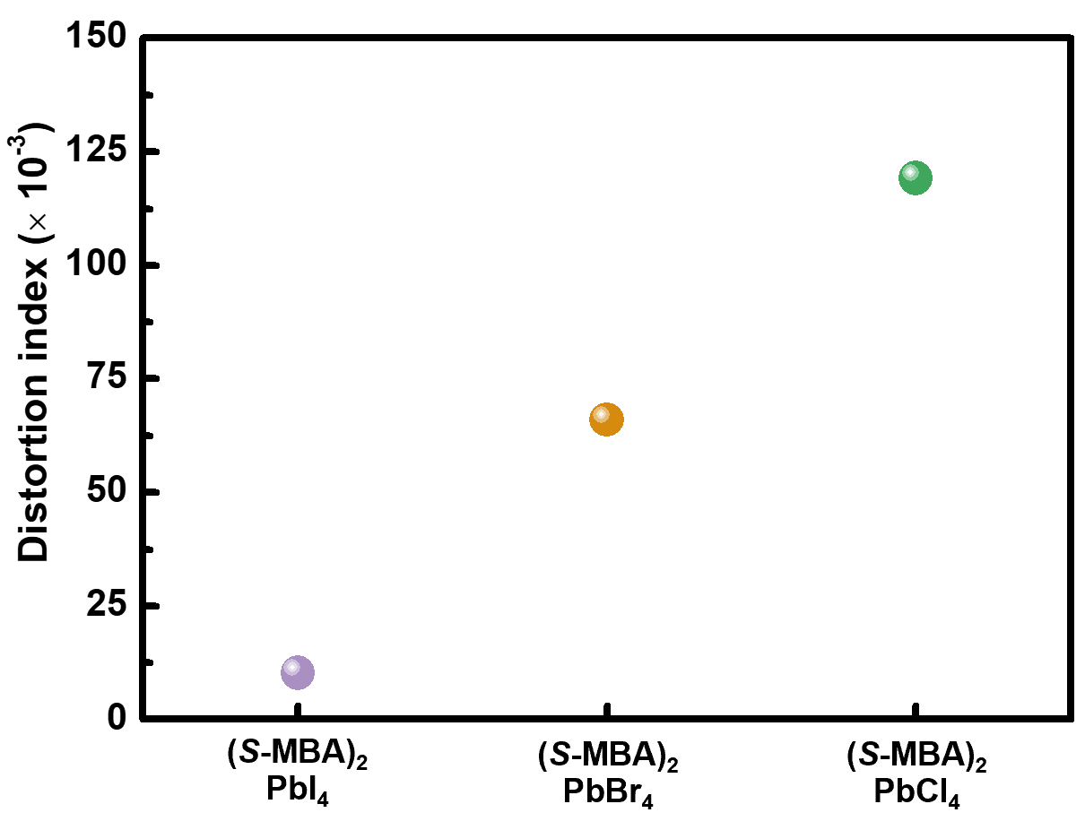
Supplementary Fig. 15 | Distortion of perovskite crystal structure according to the halide compositions. Plot of distortion index calculated from the optimized crystal structures of (S-MBA)₂PbI₄, (S-MBA)₂PbBr₄, and (S-MBA)₂PbCl₄ based on DFT.

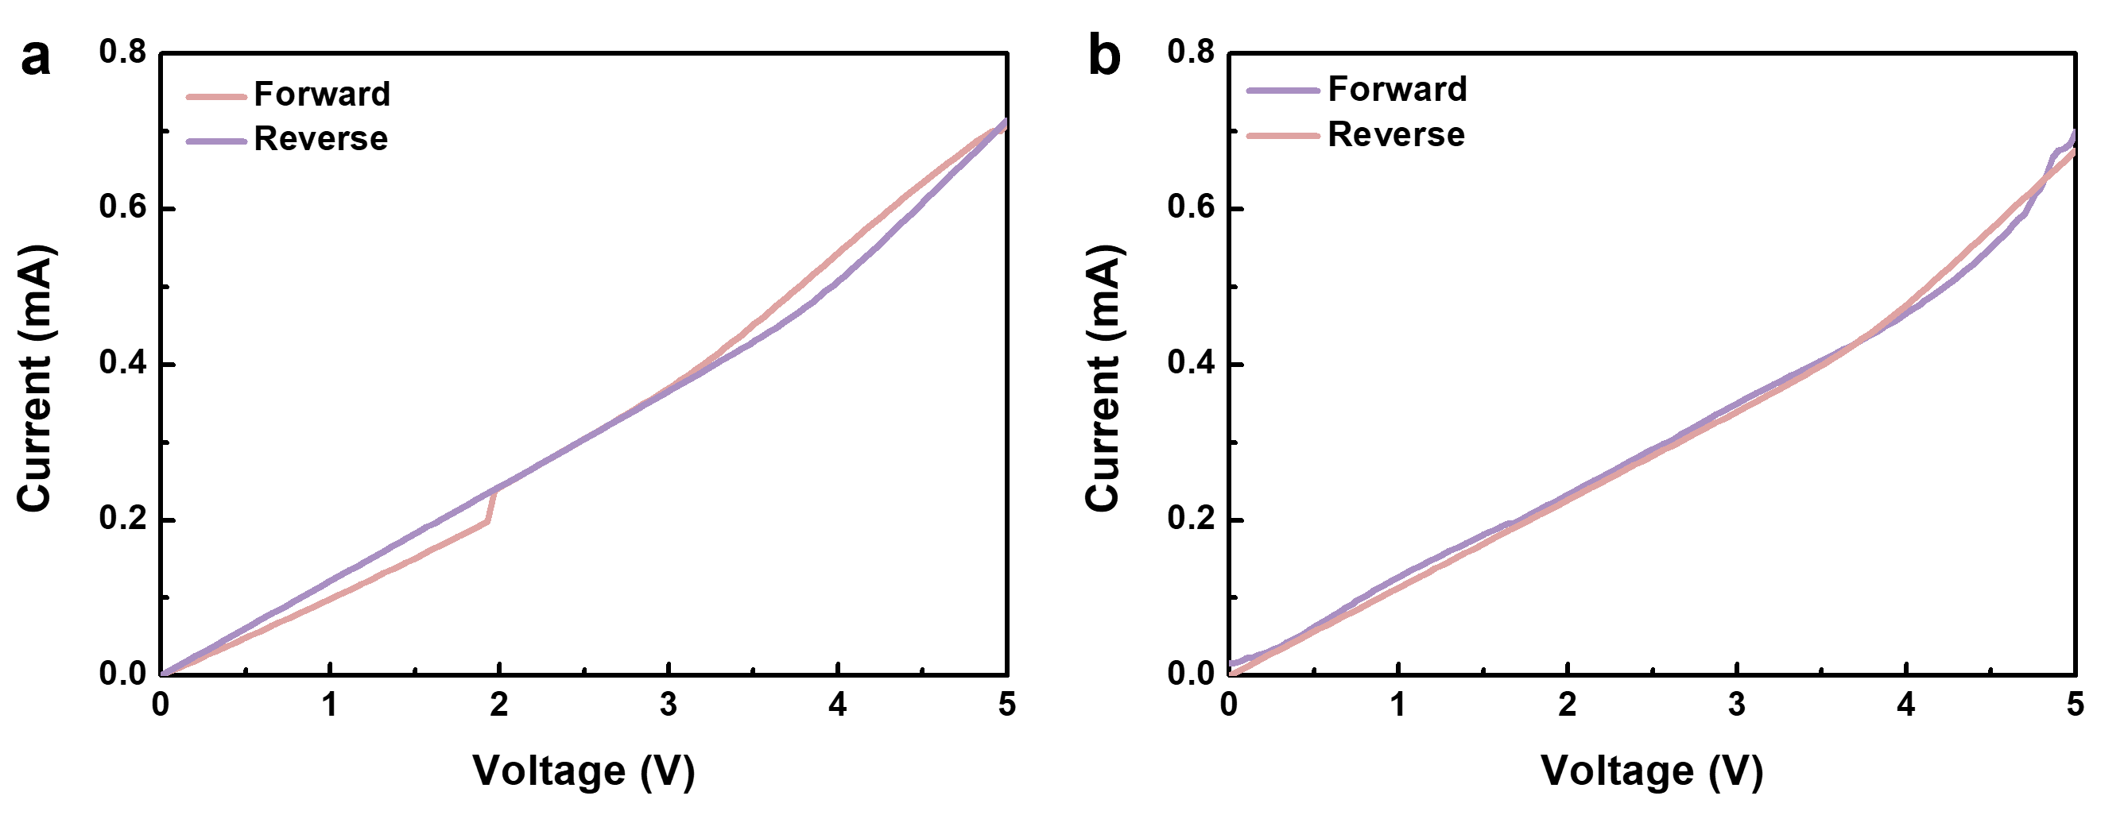
Supplementary Fig. 16 | Characterization of hysteresis induced by ion migration inside perovskite films. I−V curves of a, 3D and b, 2D/3D perovskite films for different sweeping directions (i.e., forward and reverse) under dark conditions with aperture area of 0.1 cm², obtained to validate the SCLC analysis results.

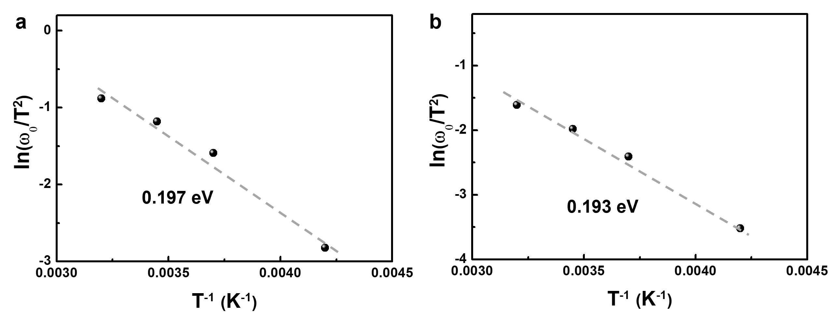
Supplementary Fig. 17 | Inspection of defect energy levels for each perovskite films. Arrhenius plots for examining the defect energy levels, as derived from the TAS results of a, 3D perovskite films and b, 2D/3D heterostructured perovskite films with S-2F-MBA chiral cations.

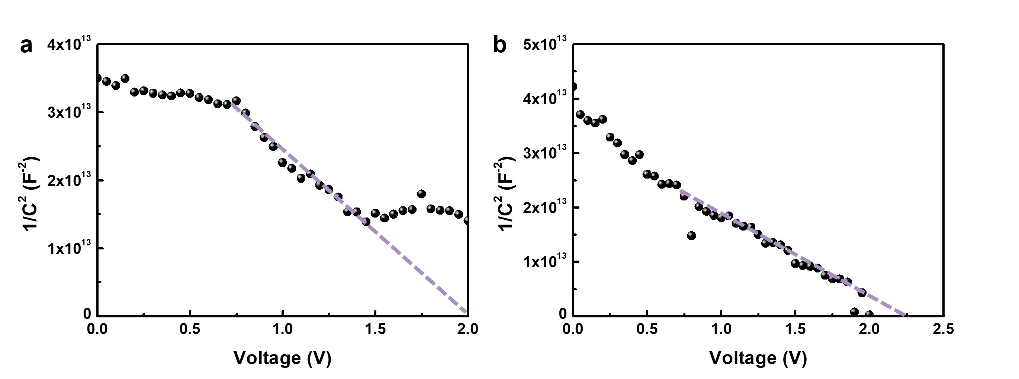
Supplementary Fig. 18 | Mott–Schottky plots for TAS analysis. Mott–Schottky plots of a, 3D perovskite films and b, 2D/3D heterostructured perovskite films with S-2F-MBA chiral cations. The measurements were conducted under a 10 mV AC voltage (1000 Hz) under dark conditions.

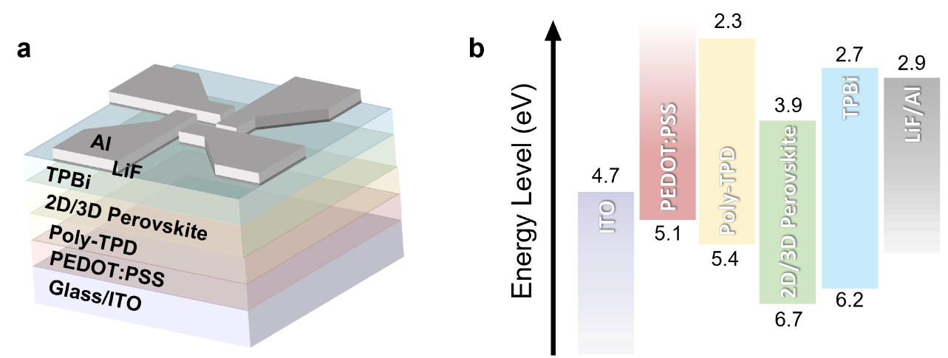
Supplementary Fig. 19 | Schematics about device specifics. a, Device configuration and b, band energy diagram of the prepared pure-blue spin-LEDs.

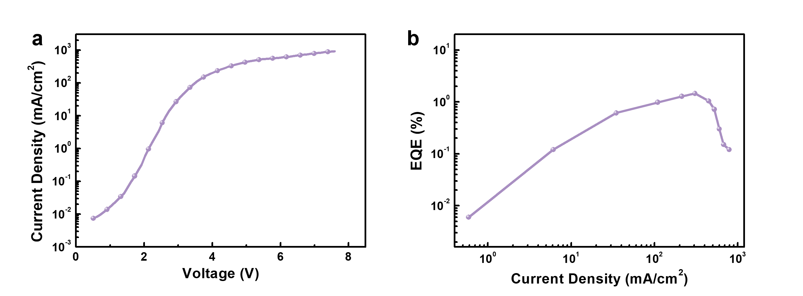
Supplementary Fig. 20 | Performance of pure-blue spin-LEDs. a, J–V and b, EQE−J curves of the spin-LEDs fabricated with 2D/3D perovskite films featuring S-2F-MBA cations.

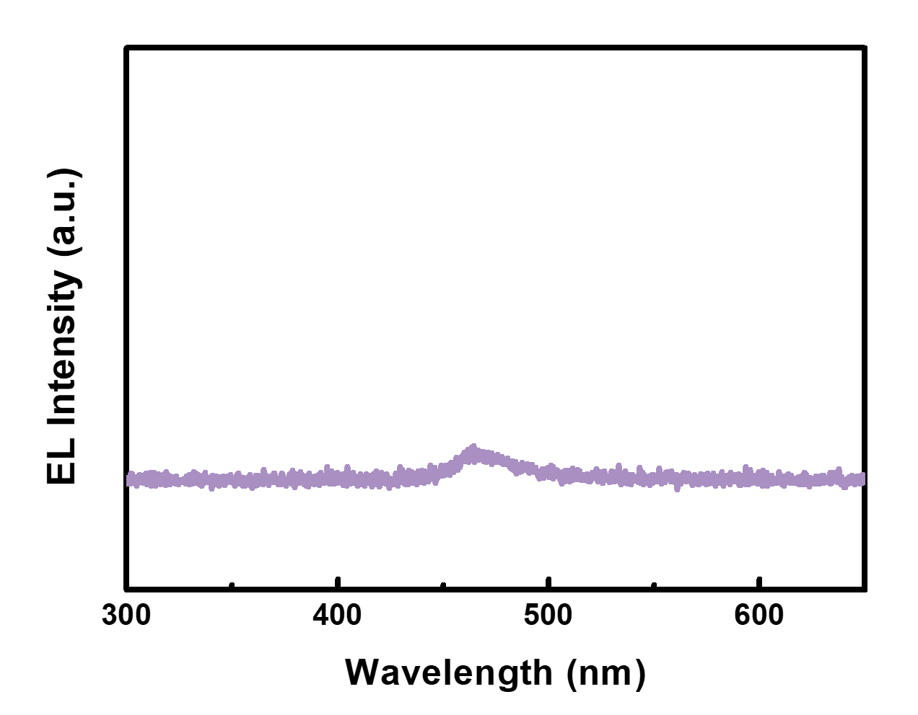
Supplementary Fig. 21 | EL property of perovskite films based on racemic cations. CP-EL spectra of LEDs fabricated with 2D/3D heterostructured perovskite films featuring rac-2F-MBA cations.

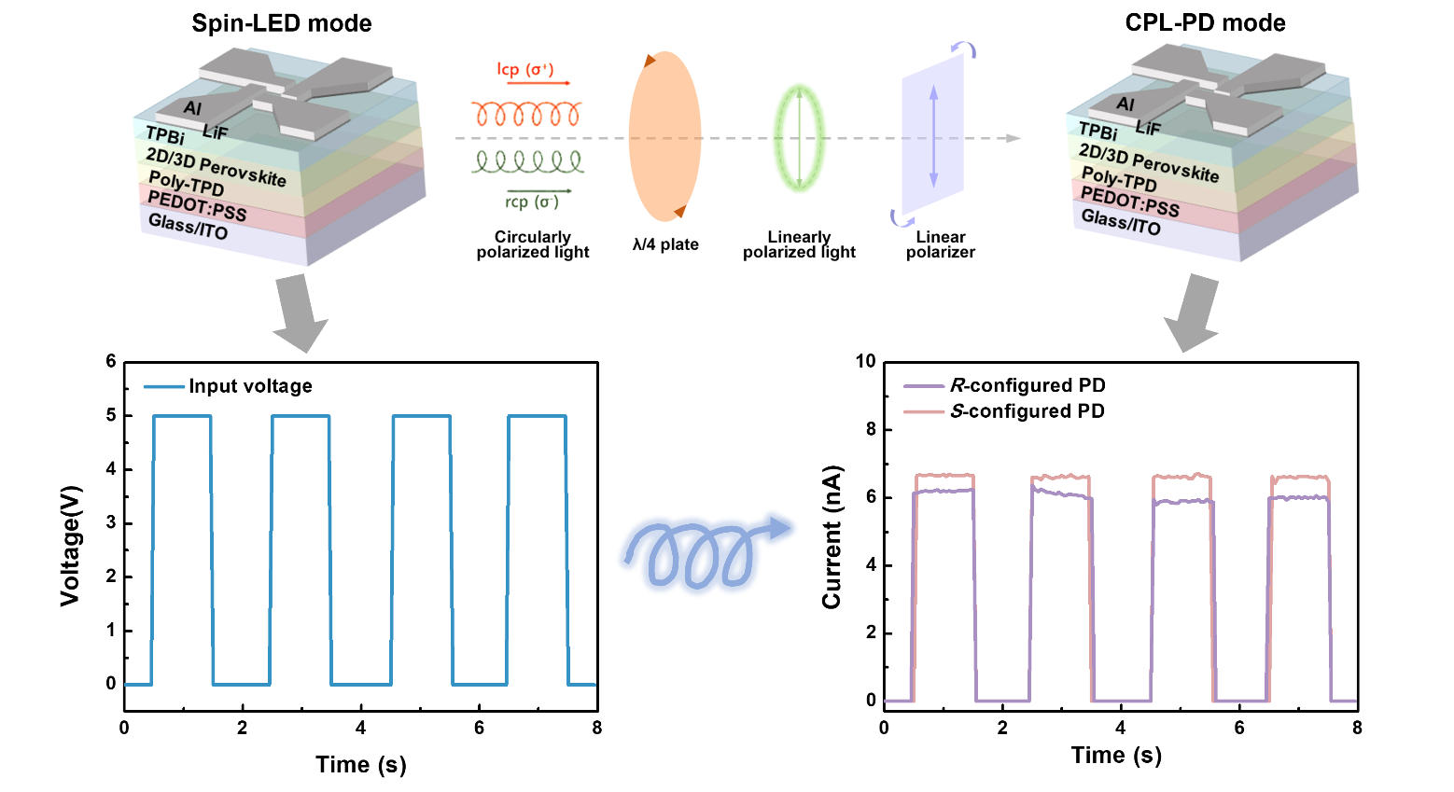
Supplementary Fig. 22 | Schematic illustration of CP-LEPD operation. The CP-EL emitted by the blue spin-LEDs was detected using CPL-PDs with identical configurations featuring cations of each chirality. The S-configured CPL-PDs exhibited a ~9% higher current level than the R-configured CPL-PDs did when detecting the CP-EL emitted by the S-configured spin-LEDs.

