Supplementary Information

Title
Acute Alcohol-Induced Glutamate Changes Measured with Metabotropic Glutamate Receptor 5 Positron Emission Tomography

Authors
Nakul R. Raval^{1,2}, Kelly Smart^{1,2}, Rachel Miller¹, Yiyun Huang^{1,2}, John H. Krystal³, Richard E. Carson^{1,2}, Kelly P. Cosgrove^{2,3}, Stephanie S. O’Malley³, Ansel T. Hillmer^{1,2,3}
^{1.}Yale PET Center, Yale University, New Haven, CT, USA.
^{2.}Department of Radiology and Biomedical Imaging, Yale University, New Haven, CT, USA.
^{3.}Department of Psychiatry, Yale University, New Haven, CT, USA.

For correspondence or reprints contact:
Ansel T. Hillmer
ansel.hillmer@yale.edu

Supp. Table 1. [¹¹C]ABP688 V_{T} before and after the alcohol challenge (n = 4)
Region | Baseline  V_{T} | Post-alcohol  V_{T} | Two-sample t-test  (p value)
Frontal Cortex | 3.75 ± 0.69  (range: 3.05 – 4.73) | 3.77 ± 0.35  (range: 3.63 – 4.22) | 0.938
Temporal Cortex | 3.78 ± 0.71  (range: 3.10 – 4.78) | 3.77 ± 0.34  (range: 3.43 – 4.24) | 0.944
Striatum | 3.53 ± 0.66  (range: 2.91 – 4.47) | 3.51 ± 0.38  (range: 3.24 – 4.06) | 0.890
Hippocampus | 3.46 ± 0.45  (range: 2.72 – 4.77) | 3.41 ± 0.45  (range: 3.01 – 4.06) | 0.8361
Cerebellum | 1.91 ± 0.35  (range: 1.66 – 2.44) | 2.03 ± 0.34  (range: 1.71 – 2.46) | 0.144
V_{T} values were calculated using the two-tissue compartment model
All regions were grey-matter segemented using the CAT segmentation.
Uncorrected p value results are presented.
Data is reported as Mean ± Standard Deviation and range.

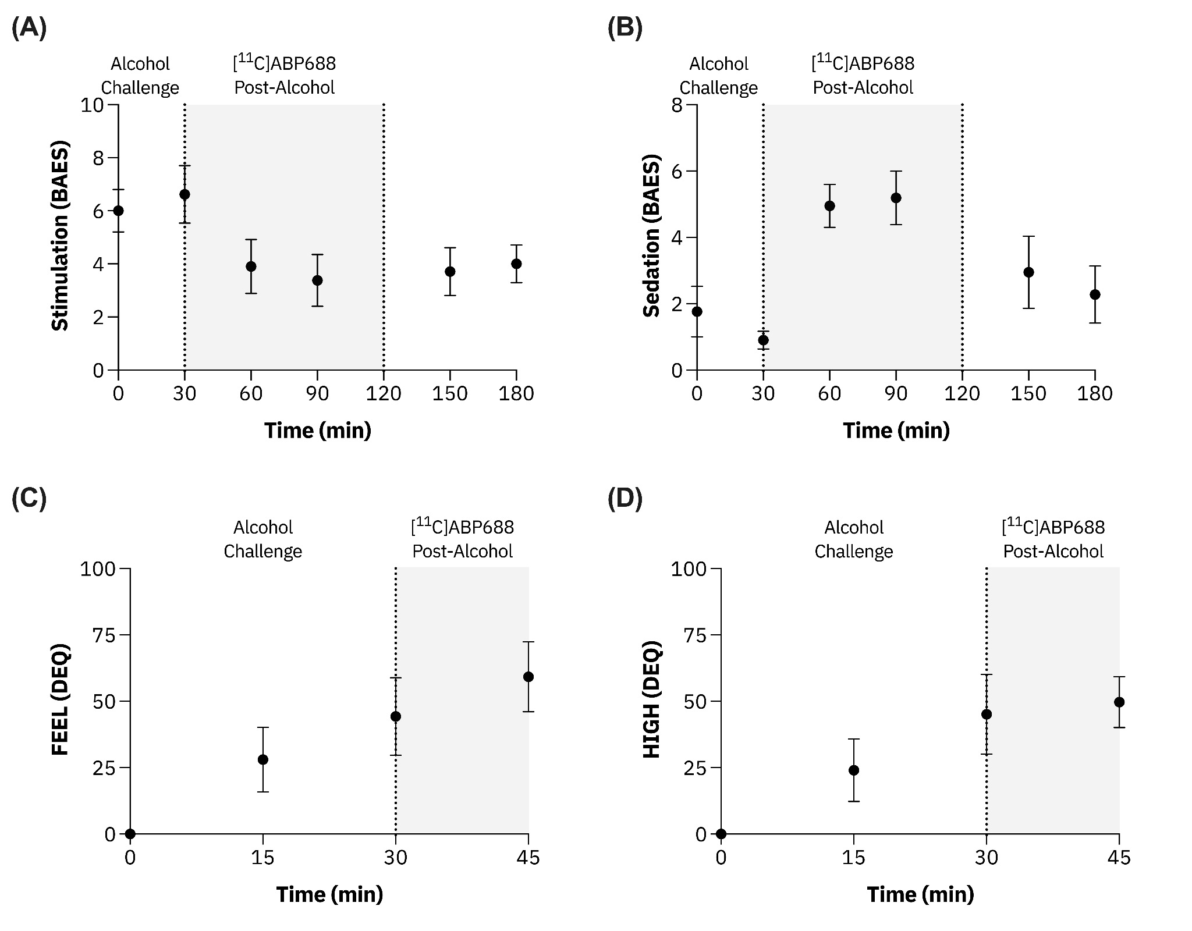
Supp. Fig. 2. Behavioral data showing the effects of alcohol consumption on (A) stimulation and (B) sedation, measured by the Biphasic Alcohol Effects Scale (BAES), and (C) FEEL and (D) HIGH ratings, measured by the Drug Effects Questionnaire (DEQ). Data points represent mean values, and error bars indicate the standard error of the mean (SEM). The shaded areas denote the period of [¹¹C]ABP688 PET imaging post-alcohol challenge.
Supp. Table 2. Partial correlation analysis between post-alcohol ΔBP_{ND} values and peak blood alcohol levels (BAL), drinks in the last 30 days as measures with Alcohol Timeline Followback questionnaire, biphasic alcohol effect scale (BAES) sedation (90 min post-alcohol) and simulation (30 min post-alcohol), drug effect questionnaire (DEQ) FEEL and DEQ HIGH (30 min post-alcohol) (n=7).
Region |  | Peak  BAL | Drinks last 30 days | BAES  Sedation  (90 min) | BAES  Stimulation  (30 min) | DEQ  FEEL  (30 min) | DEQ  HIGH  (30 min)
Frontal | Spearman's rho | 0.04 | -0.07 | 0.68 | 0.68 | -0.36 | -0.36
Frontal | p value | 0.939 | 0.879 | 0.094 | 0.090 | 0.432 | 0.432
Temporal | Spearman's rho | 0.04 | -0.07 | 0.68 | 0.68 | -0.36 | -0.36
Temporal | p value | 0.939 | 0.879 | 0.094 | 0.090 | 0.432 | 0.432
Striatum | Spearman's rho | 0.04 | -0.29 | 0.75 | 0.70 | -0.43 | -0.43
Striatum | p value | 0.939 | 0.535 | 0.052 | 0.078 | 0.337 | 0.337
Hippocampus | Spearman's rho | 0.11 | -0.46 | 0.71 | 0.67 | -0.36 | -0.36
Hippocampus | p value | 0.819 | 0.294 | 0.071 | 0.102 | 0.432 | 0.432

Supp. Table 3. Partial correlation analysis between post-alcohol ΔR₁ values and peak blood alcohol levels (BAL), drinks in the last 30 days as measures with Alcohol Timeline Followback questionnaire, biphasic alcohol effect scale (BAES) sedation (90 min post-alcohol) and simulation (30 min post-alcohol), drug effect questionnaire (DEQ) FEEL and DEQ HIGH (30 min post-alcohol) (n=7).
Region |  | Peak  BAL | Drinks last 30 days | BAES  Sedation  (90 min) | BAES  Stimulation  (30 min) | DEQ  FEEL  (30 min) | DEQ  HIGH  (30 min)
Frontal | Spearman's rho | 0.86 | -0.11 | -0.29 | -0.09 | 0.68 | 0.68
Frontal | p value | 0.014 | 0.819 | 0.535 | 0.848 | 0.094 | 0.094
Temporal | Spearman's rho | 0.79 | -0.50 | -0.36 | -0.23 | 0.43 | 0.43
Temporal | p value | 0.036 | 0.253 | 0.432 | 0.613 | 0.337 | 0.337
Striatum | Spearman's rho | 0.32 | -0.07 | 0.00 | 0.02 | -0.11 | -0.11
Striatum | p value | 0.482 | 0.879 | 1.000 | 0.969 | 0.819 | 0.819
Hippocampus | Spearman's rho | 0.14 | -0.43 | 0.46 | 0.45 | -0.11 | -0.11
Hippocampus | p value | 0.760 | 0.337 | 0.294 | 0.310 | 0.819 | 0.819

