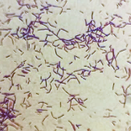
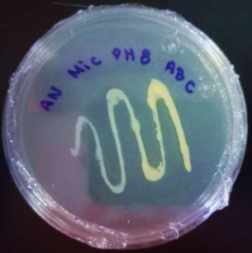

Figure S1. Characteristics of M. hydrocarbonoxydans: Gram Stain (+); colony color: Bright yellow,
size of striae in MS: thin stretch marks; Consistency: viscose; Morphology: short bacilli.

