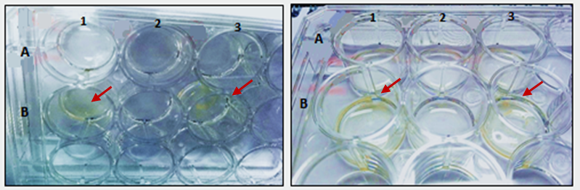
Figure S2. Colorimetric assay with AgNO₃, Bacterial oxidation of arsenite to arsenate. Row A: arsenic-free strains; Row B: Strains exposed to 1mM arsenite. Column 3 (R. gordoniae 1SA) (positive control); Column 2 (E. indicum 4SA) (negative control) y Column 1 (M. hydrocarbonoxydans 11SB).

