Supplemental Information

Simple gangliosides co-localize with amyloid plaques and increase with age in a transgenic mouse model of Alzheimer’s disease

Wenxuan Wang¹, Sarah J. Myers¹, Nikita Ollen-Bittle MSc¹, and Shawn N. Whitehead PhD¹

¹Vulnerable Brain Lab, Department of Anatomy and Cell Biology, Schulich School of Medicine and Dentistry, Western University, London, Ontario, N6A 5C1

Supplemental Table 1: Primer sequences used for qPCR experiments (mus musculus)
Gene | Forward Primer (5”3”) | Reverse Primer (5”3”)
Glb1 | CGGTCGACCTCCAATTCTTCGG | TACTTGACCCTTGGACCACCCA
Hexa | CTACATCCAGACGCTGCTGGAC | TACTGGCATTTCTTCCCGCCAC
B4galnt1 | GAGATATACCAGGTGAACCTGAG | CTGCCGGTTGAGTTTATCCA
B3galt4 | GGTTAAAGCCGTCCTCCCACCT | ACCAGTAGTAGGACCGCCAGGA
Rpl13α | GTTCGGCTGAAGCCTACCAG | TTCCGTAACCTCAAGATCTGCT

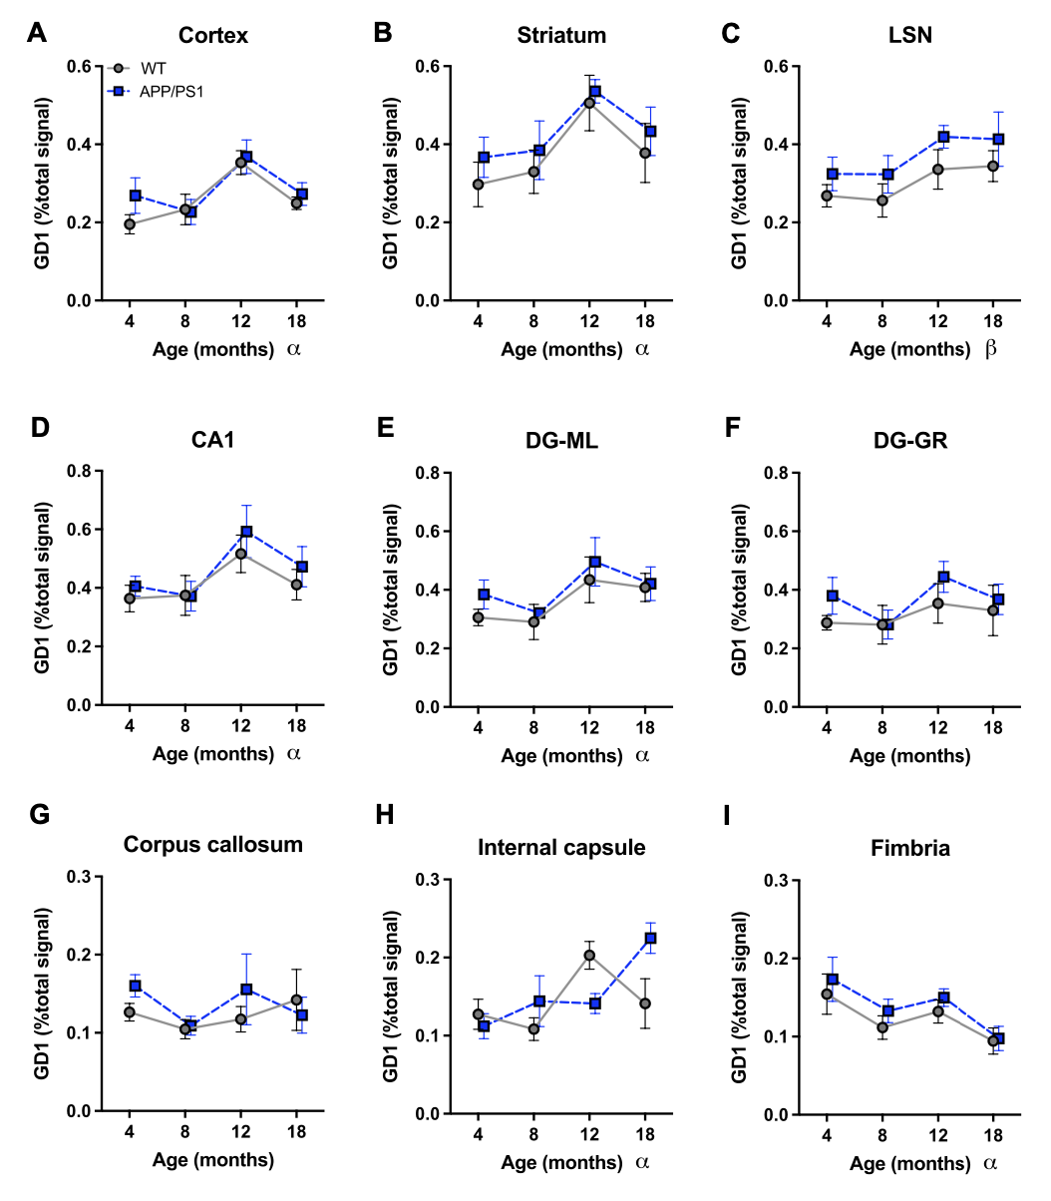
Supplemental Figure 1: Distribution of the GD1a d18:1 species during aging in WT and APP/PS1 mice across brain regions. Signal intensity is normalized to total area under the peak. Statistical analysis is performed using Two-Way ANOVA and Tukey’s multiple comparison post-hoc test with p < 0.05. α indicates statistical significance based on age effects only, β indicates statistical significance based on transgene effects only. Data represents biological n = 4.

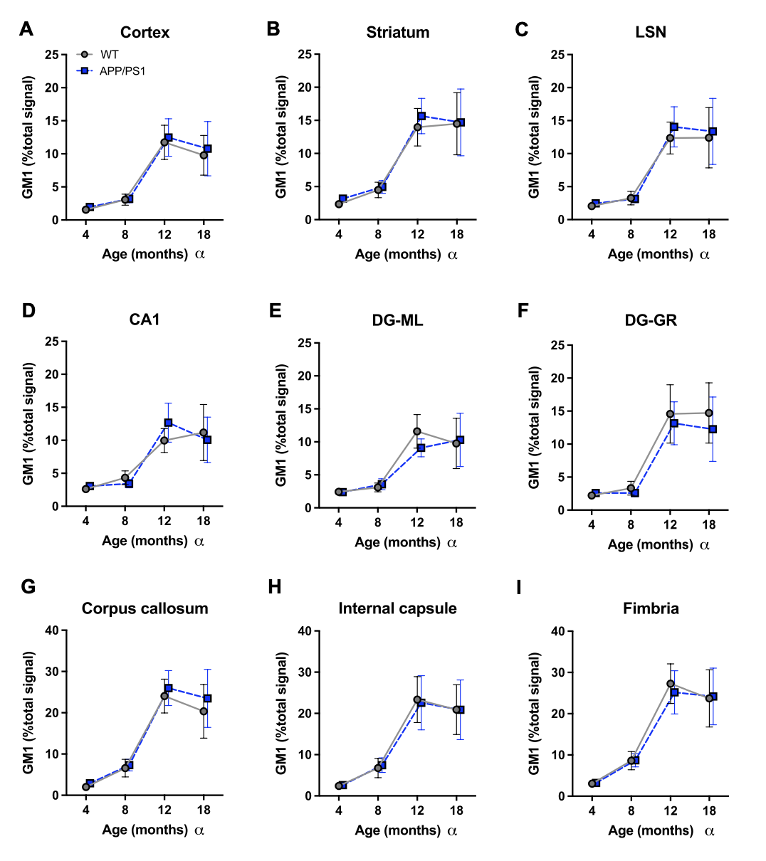
Supplemental Figure 2: Distribution of the GM1 d18:1 species during aging in WT and APP/PS1 mice across brain regions. Signal intensity is normalized to total area under the peak. Statistical analysis is performed using Two-Way ANOVA and Tukey’s multiple comparison post-hoc test with p < 0.05. α indicates statistical significance based on age effects only. Data represents biological n = 4.

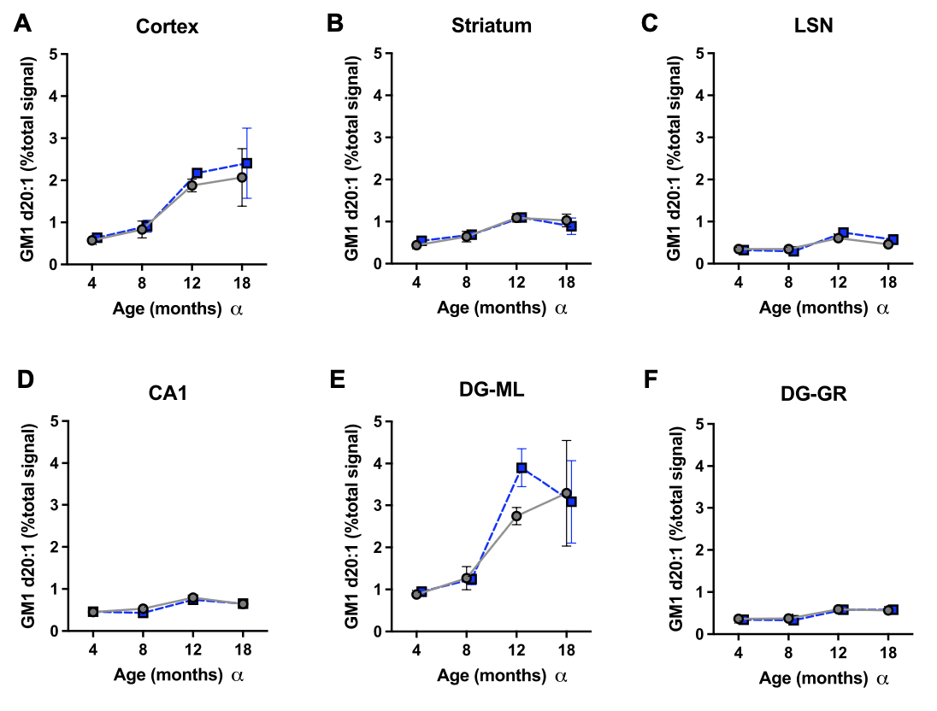

Supplemental Figure 3: Distribution of the GM1 d20:1 species during aging in WT and APP/PS1 mice across brain regions. Signal intensity is normalized to total area under the peak. Statistical analysis is performed using Two-Way ANOVA and Tukey’s multiple comparison post-hoc test with p < 0.05. α indicates statistical significance based on age effects only. Data represents biological n = 3.

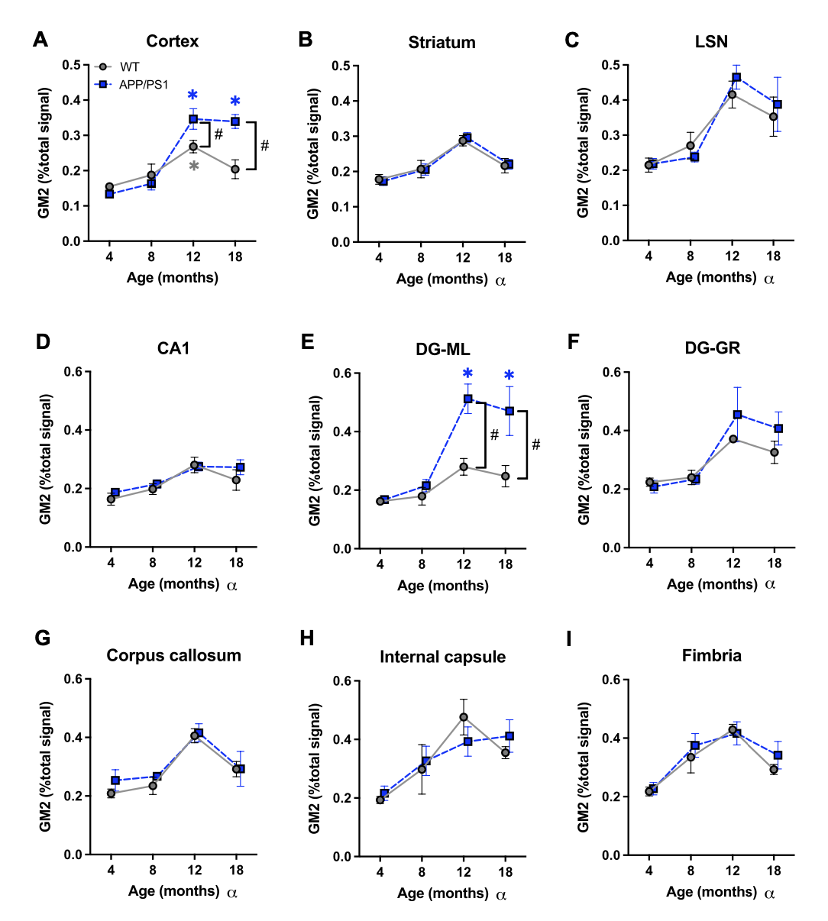
Supplemental Figure 4: Distribution of the GM2 d18:1 species during aging in WT and APP/PS1 mice across brain regions. Signal intensity is normalized to total area under the peak. Statistical analysis is performed using Two-Way ANOVA and Tukey’s multiple comparison post-hoc test with p < 0.05 α indicates statistical significance based on age effects only, *indicates statistical significance from 4 m, # indicates statistical significance between WT and APP/PS1 mice. Data represents biological n = 4.

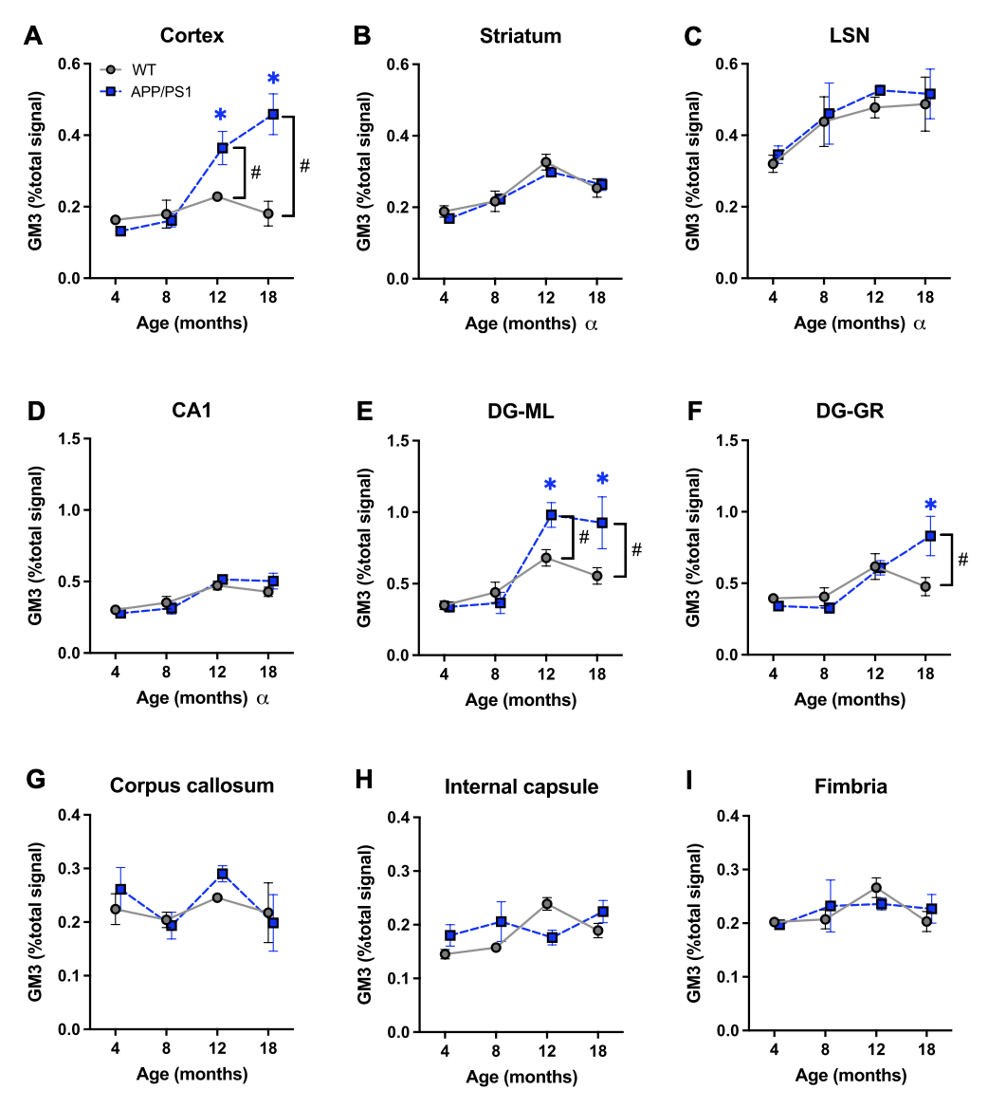
Supplemental Figure 5: Distribution of the GM3 d18:1 species during aging in WT and APP/PS1 mice across brain regions. Signal intensity is normalized to total area under the peak. Statistical analysis is performed using Two-Way ANOVA and Tukey’s multiple comparison post-hoc test with p < 0.05. α indicates statistical significance based on age effects only, *indicates statistical significance from 4 m, # indicates statistical significance between WT and APP/PS1 mice. Data represents biological n = 4.

