Supplementary information

Table of Contents:
Section 1: Formation of Ti₄Au₃C₃ phase
Section 2: Formation of Ti₄AuC₃ phase
Section 3: DFT computations for Ti₄Au_{x+1}C₃ phases
Section 4: Tri-layer stackings of Au in Ti₄Au₃C₃ – Why is three layers of goldene more stable than one, two, four or five?
Section 5: Mechanistic consideration on Ti₄C₃ sheets gliding in Ti₄Au₃C₃
Section 6: Preparation of trilayer goldene
Section 7: DFT and AIMD computations for trilayer goldene
Section 8: Calculated XPS core-level shifts in DFT
Section 9: Surface morphology of Ti₄Au₃C₃ after etching
Section 10: XPS analysis of elements in samples from etching reagents

References

Section 1: Formation of Ti₄Au₃C₃ phase
Fig. S1 shows an intercalation frontline in the annealed Au-covered Ti₄Au₃C₃ film. It can be seen in panels a and b that three layers of Au follow closely to substitute Si and expand the lattice along the c-axis (red square). The bending of Ti₄C₃ sheets, while remaining intact, is apparent when Au layers enter, as indicated by blue lines. It is known that defects such as grain boundaries and dislocations provide paths for the in-diffusion of Au^{1, 2}, as shown in panel c. Thus, exchange intercalation of Si and Au progresses both vertically and laterally in MAX phases.

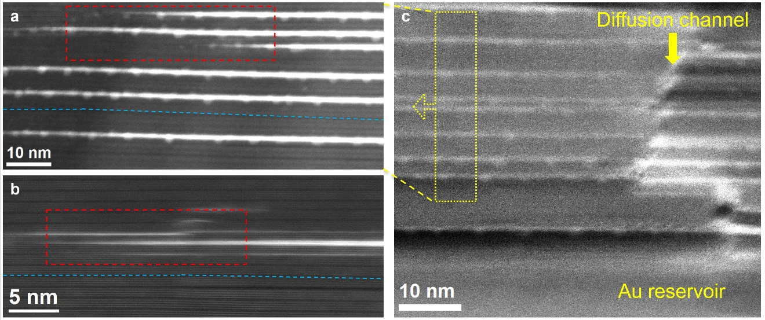
Figure S1 | Intercalation frontline of Au in Ti₄SiC₃. a,b, HRSTEM images of an intercalation frontline of three-atomic-layers Au, where two additional Au layers are inserted closely behind the first layer, as squared by red dashed lines. The blue dashed lines indicate that Ti₄C₃ sheets suffer from vast deformation due to the insertion of three atomic layers of Au, resulting in a large lattice expansion. c, A dislocation region that allows Au to in-diffuse. Panel a is taken from the further left area, indicated by the dotted yellow arrow.

Section 2: Formation of Ti₄AuC₃ phase
To explore the possibility of producing Ti₄AuC₃ phase, we annealed Au-covered Ti₄SiC₃ samples at a lower temperature of 600 °C with a duration of 8 h under a nitrogen gas flow. The STEM image in Fig. S2a shows that the Si layers on the A sites were substituted with monolayer Au, which are periodically mirrored with respect to the Ti₄C₃ sheets. The c-parameter increased from 22.8 Å for Ti₄SiC₃ to 23.6 Å for Ti₄AuC₃ with a 3.5 % lattice swelling. This value is close to a calculated c-parameter for Ti₄AuC₃ of 23.621 (see Table S1) and 23.578 Å¹. The EDX spectrum in Fig. S2b shows the signal of Ti, Au, and Si with a relative atomic ratio of Ti:(Au+Si) is ∼4:1, consistent with a stoichiometric 413 MAX phase. However, this phase exists only a few nanometers along the c-axis and was found very close to the TiC seed layer. It was sandwiched by TiC and other stable phases (Ti₃AuC₂ in most cases, Ti₇Au₂C₅ and excess Au), as seen in Fig. S3. As aforementioned, sufficient space is needed for the lattice expansion (+42.5 %) to form the Ti₄Au₃C₃ phase. These stable phases might limit the lifting space of Ti₄C₃ sheets and impede the insertion of additional Au layers; as a result, the Ti₄AuC₃ phase is confined and stabilized. Among them, the Ti₃AuC₂ phase originated from Au intercalation in Ti₃SiC₂ phase, which is a transition layer when Ti-Si-C nucleated on the TiC seed layer at the initial stage of deposition. The Ti₇Si₂C₅ phase also formed at the initial stage when the ratio of target elements was undulated. Wherein, each Si layer was substituted with single-layer Au, forming the Ti₇Au₂C₅ phase (Fig. S3b). Fig. S2c shows the XRD patterns of this sample before and after annealing. The typical (000l) peaks of the Ti₄Au₃C₃ phase are observed at the same diffraction angles as those in Fig. 1e (main text), whereas the intensities of these peaks are much lower due to less intercalation of Au. The (000l) peaks of the Ti₃AuC₂ phase are found at 9.8°, 19.2° and 29.3°, while the Ti₄AuC₃ phase is hardly detectable. We gradually decreased the duration from 16 h to 1 h of annealing at 670 °C for Au-covered Ti₄SiC₃ films and investigated the impact of annealing temperatures in the range of 580-670 °C with a constant duration of 8 h. The majority of these films are Ti₄Au₃C₃ always with such annealing conditions (Figs. S4 and S5). The substitution reaction cannot be driven for annealing temperatures below 580 °C.
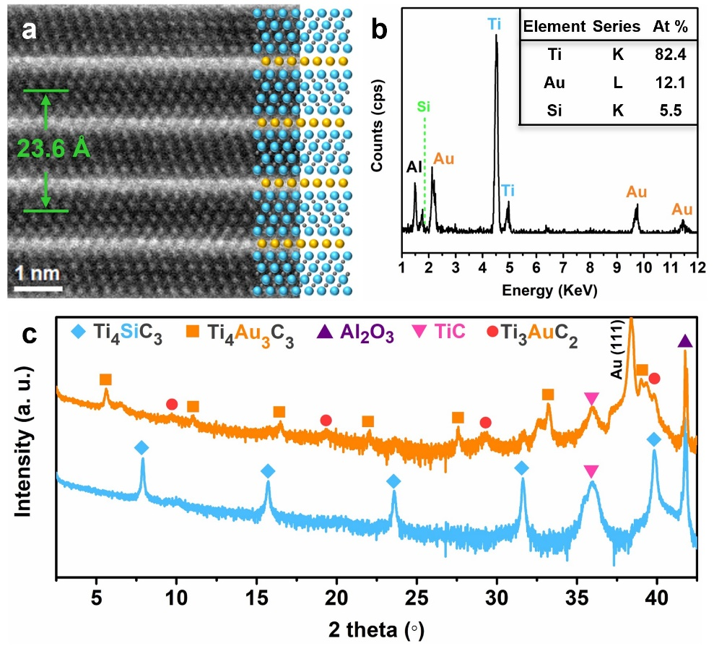
Figure S2 | Synthesis of Ti₄AuC₃ phase. a, HRSTEM image of Ti₄AuC₃ taken along the [$11\overline{2}0$] direction. Blue, yellow, and dark gray balls represent Ti, Au, and C atoms, respectively. b, EDX spectrum of Ti₄AuC₃ phase showing atomic ratio of Ti, Au, and C elements. c, XRD patterns of Ti₄SiC₃ and Au-covered Ti₄SiC₃ after 8 h of annealing at 600 °C.

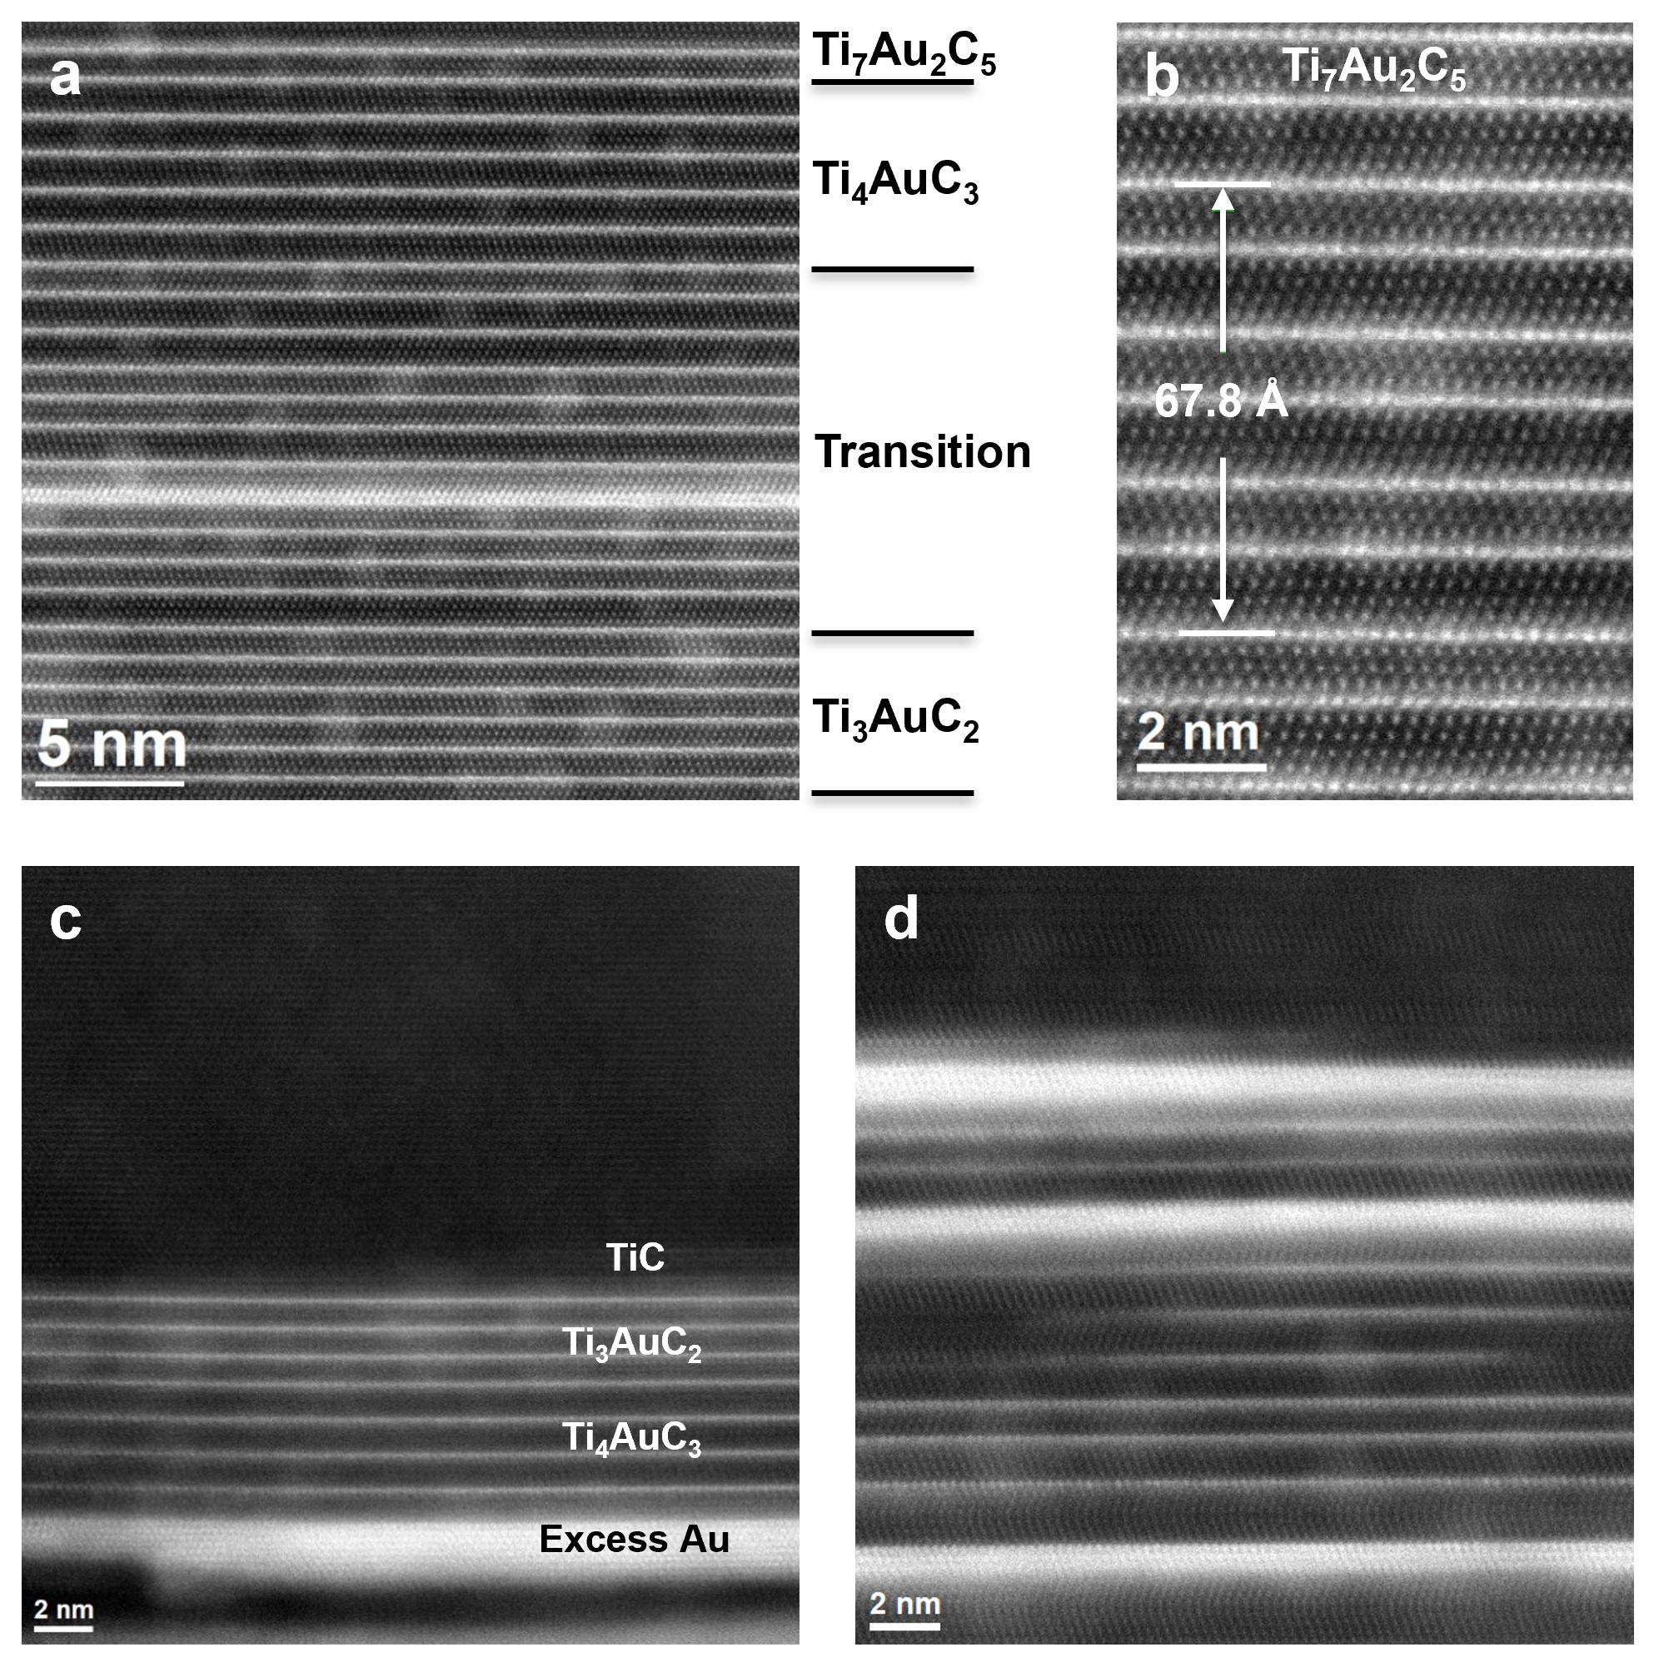
Figure S3 | Formation of Ti₄AuC₃ in-between other stable phases. a, HRSTEM image showing a Ti₄AuC₃ phase that is sandwiched by Ti₇Au₂C₅, Ti₃AuC₂, and a transition region consisting of a mixture of Ti₄AuC₃ and Ti₃AuC₂ subunits. b, Zoomed-in Ti₇Au₂C₅ phase formed from Ti₇Si₂C₅ via substitution reaction after 8 h of annealing at 600 °C. c,d, Examples for Ti₄AuC₃ being sandwiched by Ti₃AuC₂, TiC, and intercalated excess Au.

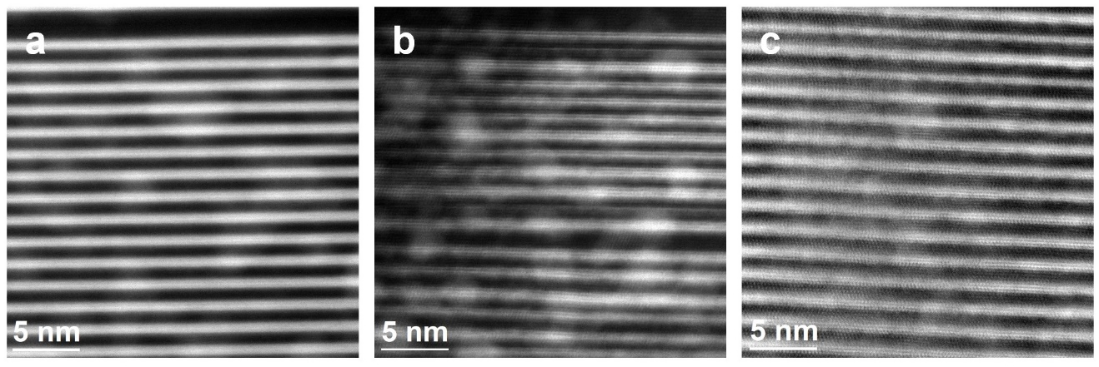
Figure S4 | Formation of Ti₄Au₃C₃ with various annealing durations. HRSTEM images of Au-covered Ti₄SiC₃ annealed at 670 °C for 12 h (a), 8 h (b), and 1 h (c), respectively. All images were recorded along the [$11\overline{2}0$] direction.

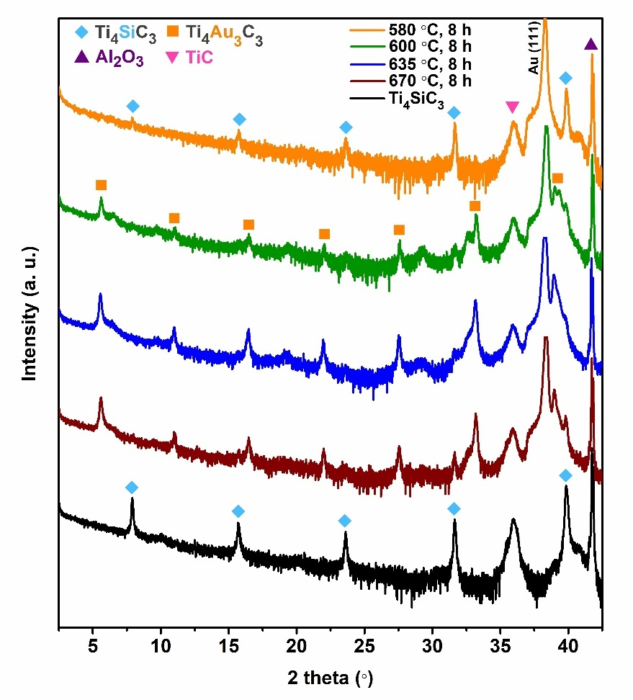
Figure S5 | XRD patterns of Au-capped Ti₄SiC₃ after 8 h of annealing at different temperatures in the range of 580-670 °C.

Section 3: DFT computations for Ti₄Au_{x+1}C₃ phases
The structural relaxation was performed in terms of density functional theory (DFT) calculations using the Vienna Ab initio Simulation Package (VASP)³⁻⁵ with the Perdew–Burke–Ernzerhof⁶ generalized gradient approximation for the exchange-correlation functional. We use Materials Project⁷ recommended projector augmented-wave atom potentials for all elements and a plane-wave cutoff energy of 520 eV for the plane-wave basis set. Reciprocal space sampling was performed using a 0.05 Å⁻¹ k-point density. The total energy is minimized through the relaxation of unit-cell shape and volume, and internal atomic positions until satisfying an energy convergence of 10⁻⁷ eV/atom and a force convergence of 10⁻² eV/Å. Owing to the use of consistent calculation settings, the calculated energies can be directly compared with data in the Materials Project database.
The energy cost or gain by inserting extra Au layers to Ti₄AuC₃ was calculated using
$ΔE_{{Ti}_{4}AuC_{3}}=E_{{Ti}_{4}{Au}_{1+x}C_{3}}-E_{{Ti}_{4}AuC_{3}}-xE_{Au}$, (1)
where the terms $E_{{Ti}_{4}{Au}_{1+x}C_{3}}$, $E_{{Ti}_{4}AuC_{3}}$, $E_{Au}$ represent the calculated total energy of Ti₄Au_{1+x}C₃, Ti₄AuC₃, and Au in their relaxed bulk crystal structure, and x is the number of added Au layers.
Stability for Ti₄Au_{1+x}C₃ has been evaluated in terms of formation enthalpy, ΔH_{cp}, by comparing its calculated energy with respect to the energy of known and hypothetical competing phases within the Ti-Au-C system. Competing phases considered herein include compounds available in the Materials Project database⁷, Ti_{n+1}Au_{1+x}C_{n} compositions with n and x = 1, 2, and 3, considered in Ref. 1, 8 and in this work. To find the combination of competing phases having the lowest energy we apply a linear optimization procedure based on the simplex method. Further details are given in Ref. 9, 10.
Chemical bonding was investigated in terms of crystal orbital Hamiltonian populations (COHP) which were derived using the LOBSTER program¹¹⁻¹³. With this approach, the calculated band-structure energy is reconstructed into orbital interactions. Positive COHP values indicate antibonding interactions while negative COHP values indicate bonding interactions. To facilitate interpretation and to preserve the analogy for crystal orbital overlap population (COOP) analysis, the results are here presented as −COHP. Visualization of atomic structures was done with the VESTA code¹⁴.

Figs. S6-S10 show multiple structures when inserting Au layers into Ti₄SiC₃ including different stackings of the Au layers as well as different stackings of the Ti₄C₃ subunits with respect to the Au layers. Calculated lattice parameters together with space group symmetry and stability for Ti₄Au_{1+x}C₃ phases are listed in Tables S1 and S2. Fig. S11 illustrates the bonding analysis for different Ti₄Au_{1+x}C₃ structures.


Figure S6 | Structures considered for Ti₄AuC₃ with Ti in blue, Au in gold, and C in black. Green rectangle mark structure used for analysis in Fig. 2. Energies given relative Ti₄AuC₃ (left structure).

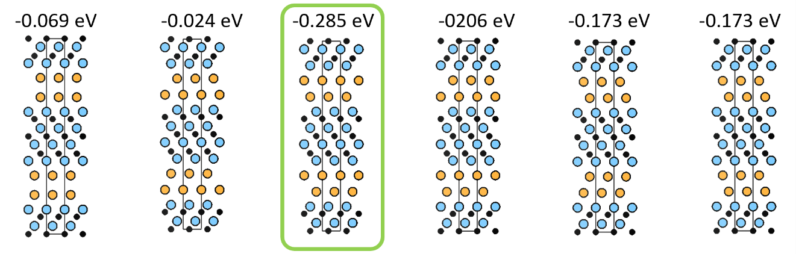
Figure S7 | Structures considered for Ti₄Au₂C₃ with Ti in blue, Au in gold, and C in black. Green rectangle mark structure used for analysis in Fig. 2. Energies given are calculated by using Eq. 1.

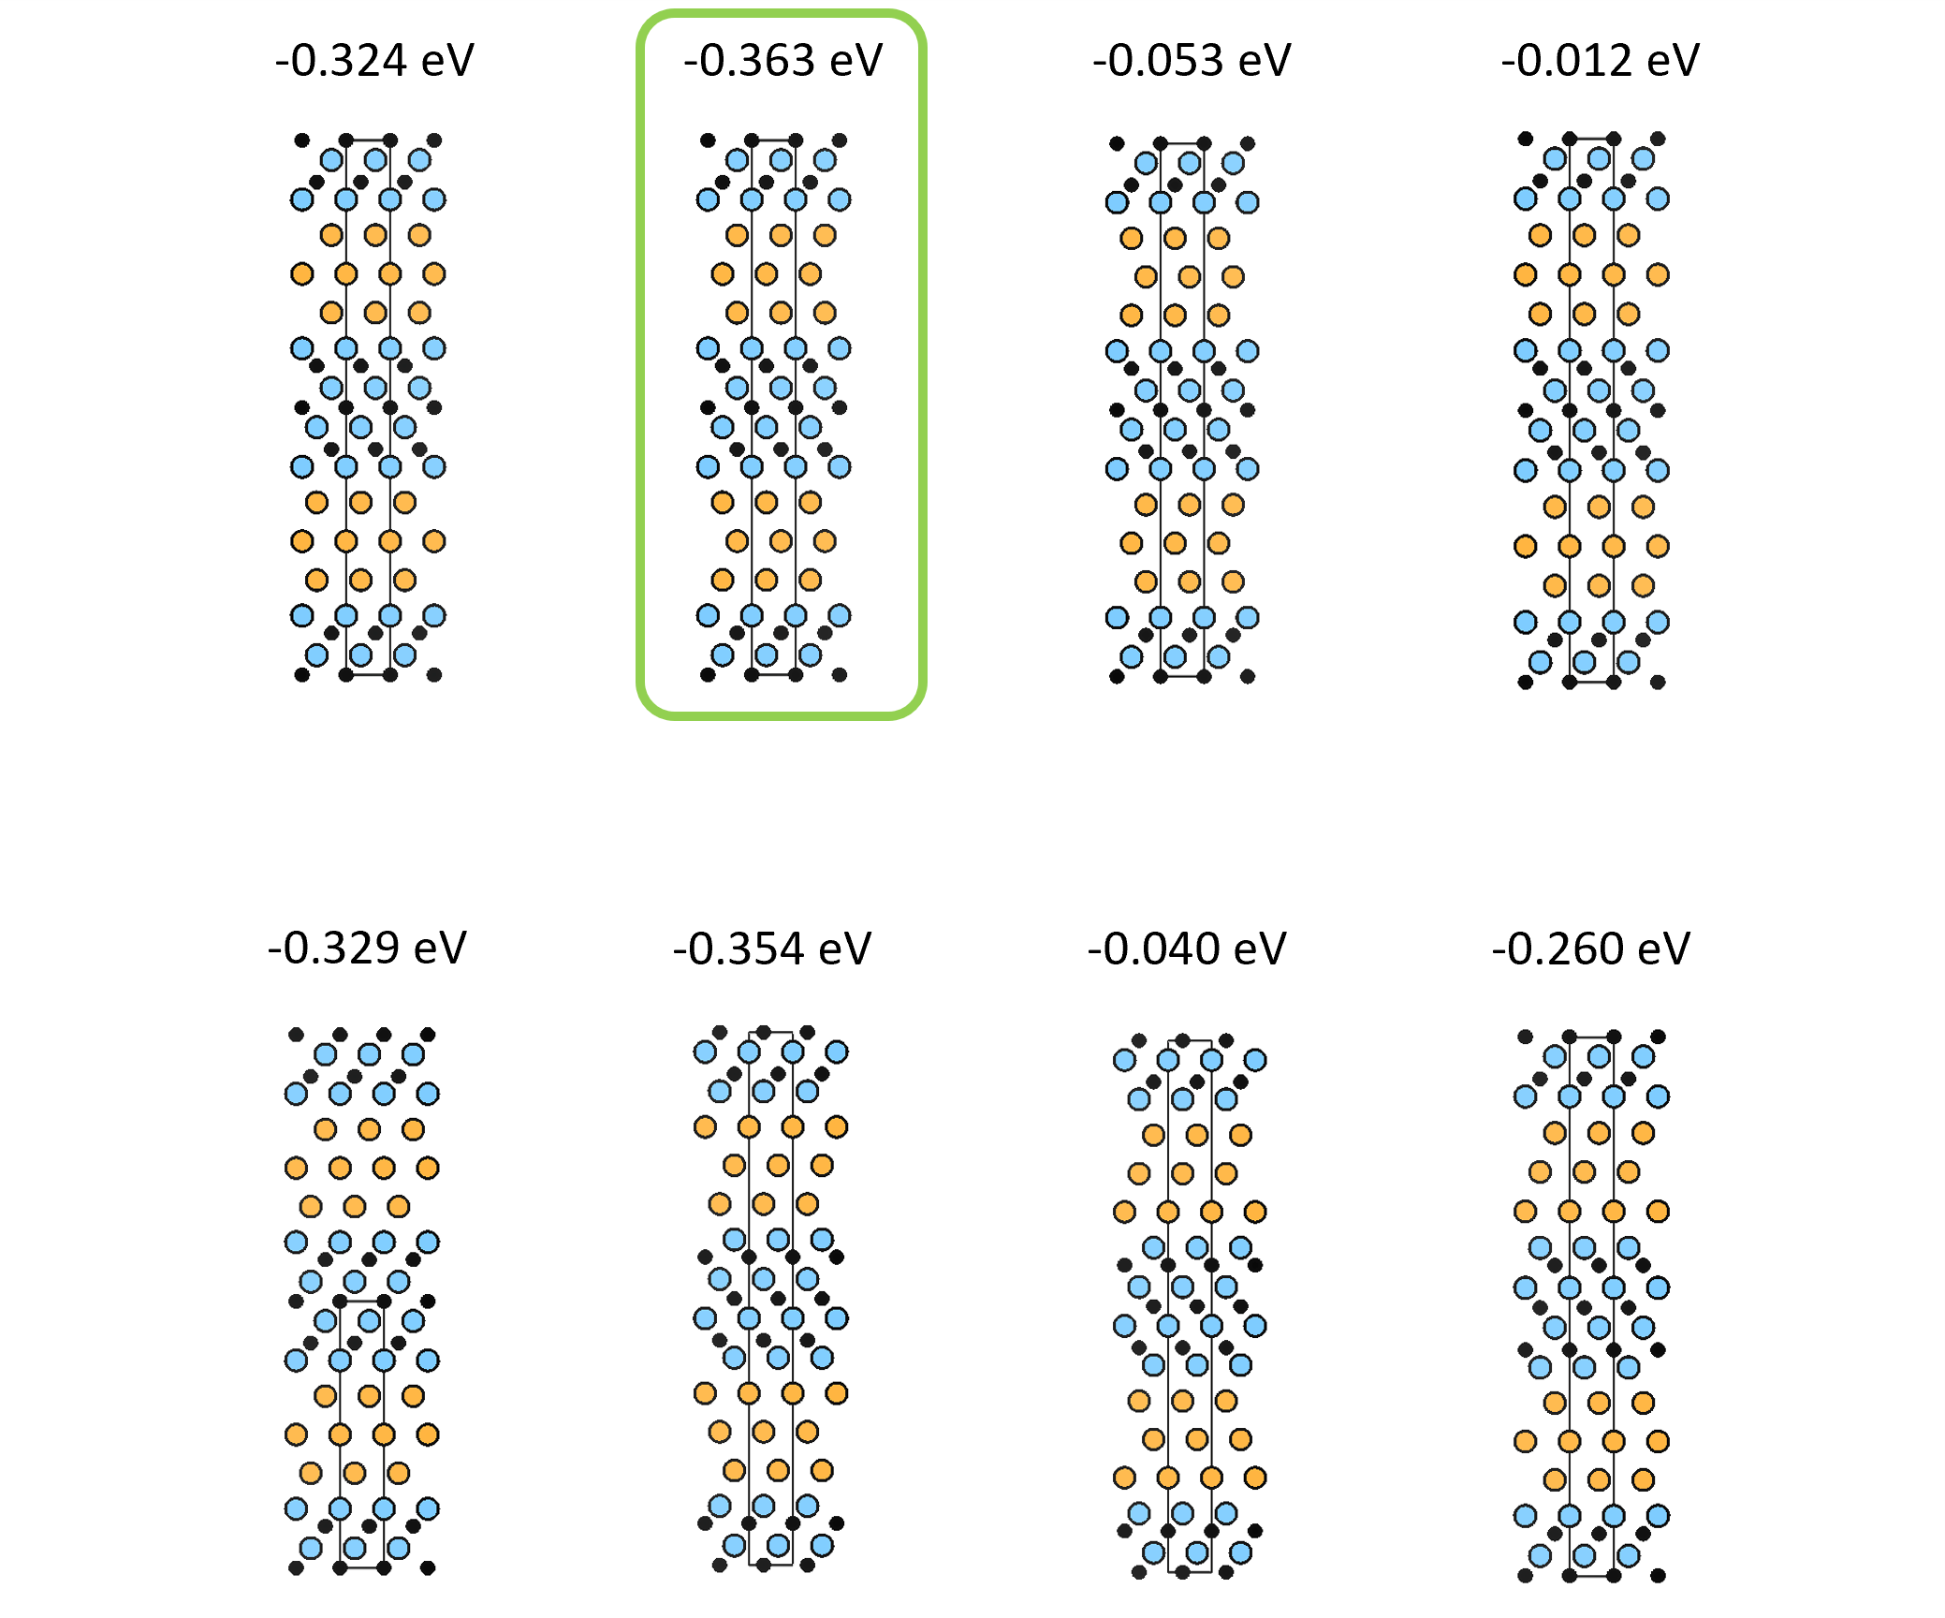
Figure S8 | Structures considered for Ti₄Au₃C₃ with Ti in blue, Au in gold, and C in black. Green rectangle mark structure used for analysis in Fig. 2. Energies given are calculated by using Eq. 1.

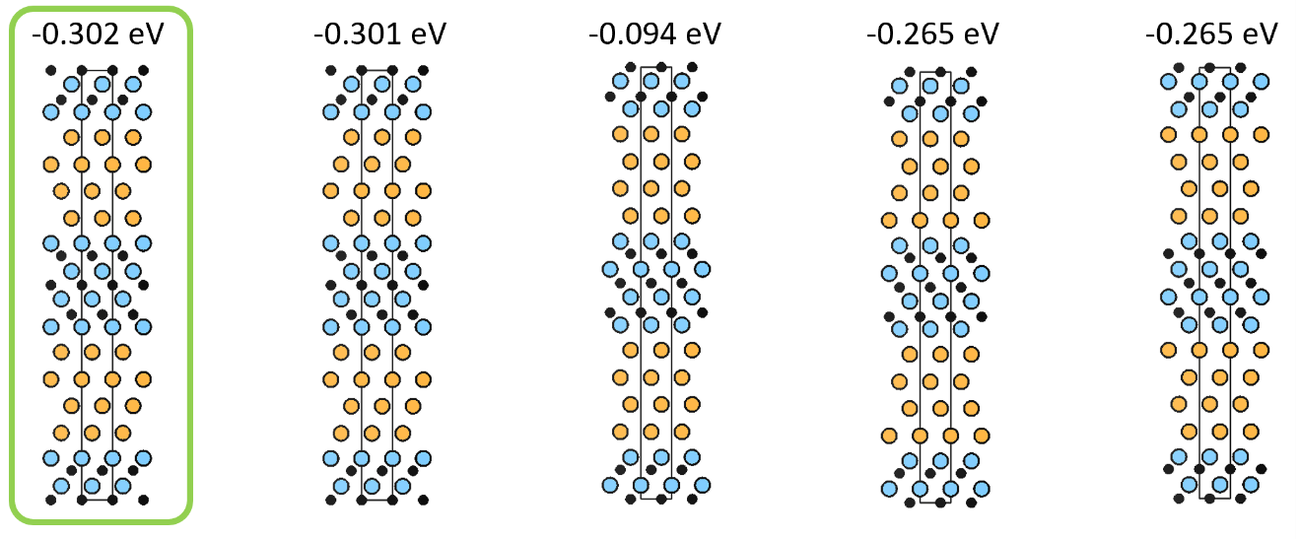
Figure S9 | Structures considered for Ti₄Au₄C₃ with Ti in blue, Au in gold, and C in black. Green rectangle mark structure used for analysis in Fig. 2. Energies given are calculated by using Eq. 1.

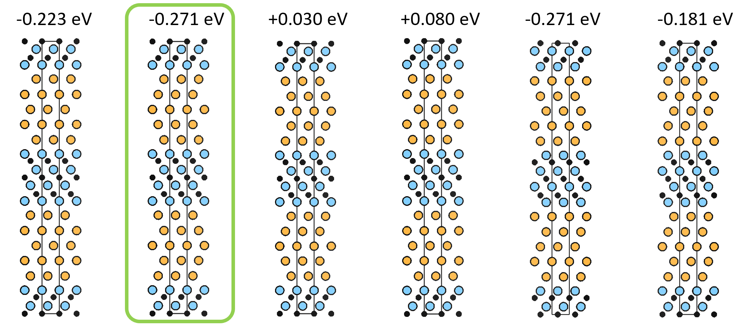
Figure S10 | Structures considered for Ti₄Au₅C₃ with Ti in blue, Au in gold, and C in black. Green rectangle mark structure used for analysis in Fig. 2. Energies given are calculated by using Eq. 1.

Table S1 | Calculated lattice parameters, space group symmetry and Wyckoff sites for structures illustrated in Figure 1a.
Phase | a (Å) | c (Å) | Space group symmetry | Wyckoff sites
Ti₄AuC₃ | 3.087 | 23.621 | P6₃/mmc (no. 194) | Ti @ 4e, 4f  Au @ 2d  C @ 2a, 4f
Ti₄Au₂C₃ | 3.096 | 27.964 | P6₃mc (no. 186) | Ti @ 2a, 2b, 2b, 2b  Au @ 2a, 2b  C @ 2a, 2b, 2b
Ti₄Au₃C₃ | 3.090 | 32.553 | P6₃/mmc (no. 194) | Ti @ 4e, 4f  Au @ 2c, 4f  C @ 2a, 4f
Ti₄Au₄C₃ | 3.081 | 37.225 | P6₃mc (no. 186) | Ti @ 2a, 2a, 2b, 2b  Au @ 2a, 2a, 2b, 2b  C @ 2a, 2b, 2b
Ti₄Au₅C₃ | 3.076 | 41.829 | P6₃/mmc (no. 194) | Ti @ 4e, 4f  Au @ 2b, 4f, 4f  C @ 2a, 4f

Table S2 | Phase stability calculated for Ti₄Au_{1+x}C₃, in terms of formation enthalpy ∆H_{cp}, with three different sets of competing phases.
Phase | Unaries and binaries |  | Unaries, binaries and ternaries (Ti₄Au_{1+x}C₃ excluded) |  | Unaries, binaries and ternaries (Ti₄Au_{1+x}C₃ included)
Phase | ∆H_{cp} (meV/atom) | Most competing phases | ∆H_{cp} (meV/atom) | Most competing  phases | ∆H_{cp} (meV/atom) | Most competing  phases
Ti₄AuC₃ | -41 | TiC, TiAu | -2 | TiC, Ti₃AuC₂ | -2 | TiC, Ti₃AuC₂
Ti₄Au₂C₃ | -22 | TiC, TiAu2 | 0 | TiC, Ti₃Au₂C₂ | 0 | TiC, Ti₃Au₂C₂
Ti₄Au₃C₃ | -20 | TiC, TiAu₂, TiAu₄ | -2 | TiC, Ti₃Au₃C₂ | -2 | TiC, Ti₃Au₃C₂
Ti₄Au₄C₃ | -7 | TiC, TiAu4 | 4 | TiC, Au, Ti₃Au3C₂ | 6 | Au, Ti₄Au₃C₃
Ti₄Au₅C₃ | -3 | TiC, TiAu4, Au | 7 | Au, TiC, Ti₃Au₃C₂ | 8 | Au, Ti₄Au₃C₃

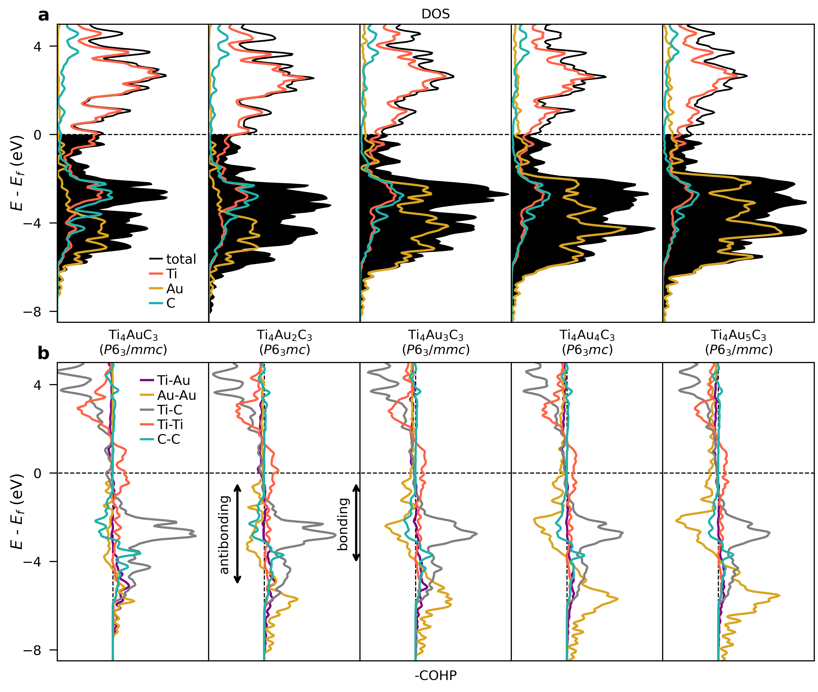
Figure S11 | Bonding analysis for different Ti₄Au_{1+x}C₃ structures. Calculated (a) electronic density of states (DOS) and (b) COHP curves for Ti₄Au_{1+x}C₃ structures illustrated in Fig. 2a (main text).

Section 4: Tri-layer stackings of Au in Ti₄Au₃C₃ – Why is three layers of goldene more stable than one, two, four or five?
Fig. S12 shows a large-scale STEM image of Ti₄Au₃C₃ taken containing some regions of hcp and fcc trilayers Au. The inset indicates a transition region between hcp and fcc Au along a trilayer. The Au atoms in the third layer move from a staggered position to a mirrored position with respect to those in the first layer. Also, slight changes in atomic density in the horizontal direction can be observed at the transition.

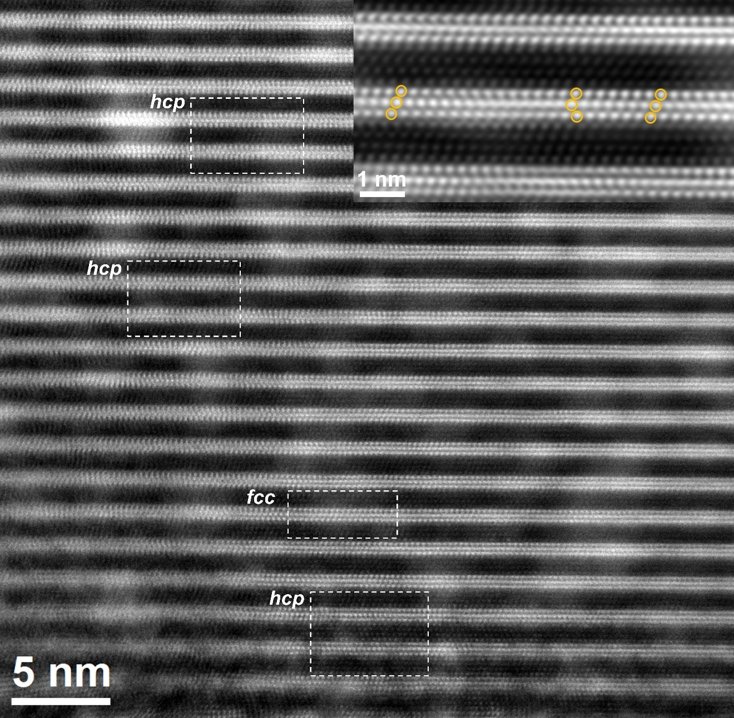
Figure S12 | 2H-hcp and fcc structures of trilayers Au in Ti₄Au₃C₃. Large-scale HRSTEM image of Ti₄Au₃C₃ taken along the [$11\overline{2}0$] direction showing both 2H hcp Au and fcc trilayer Au in-between Ti₄C₃ sheets. The inset shows a transition between hcp and fcc Au along a trilayer, as indicated by yellow circles.
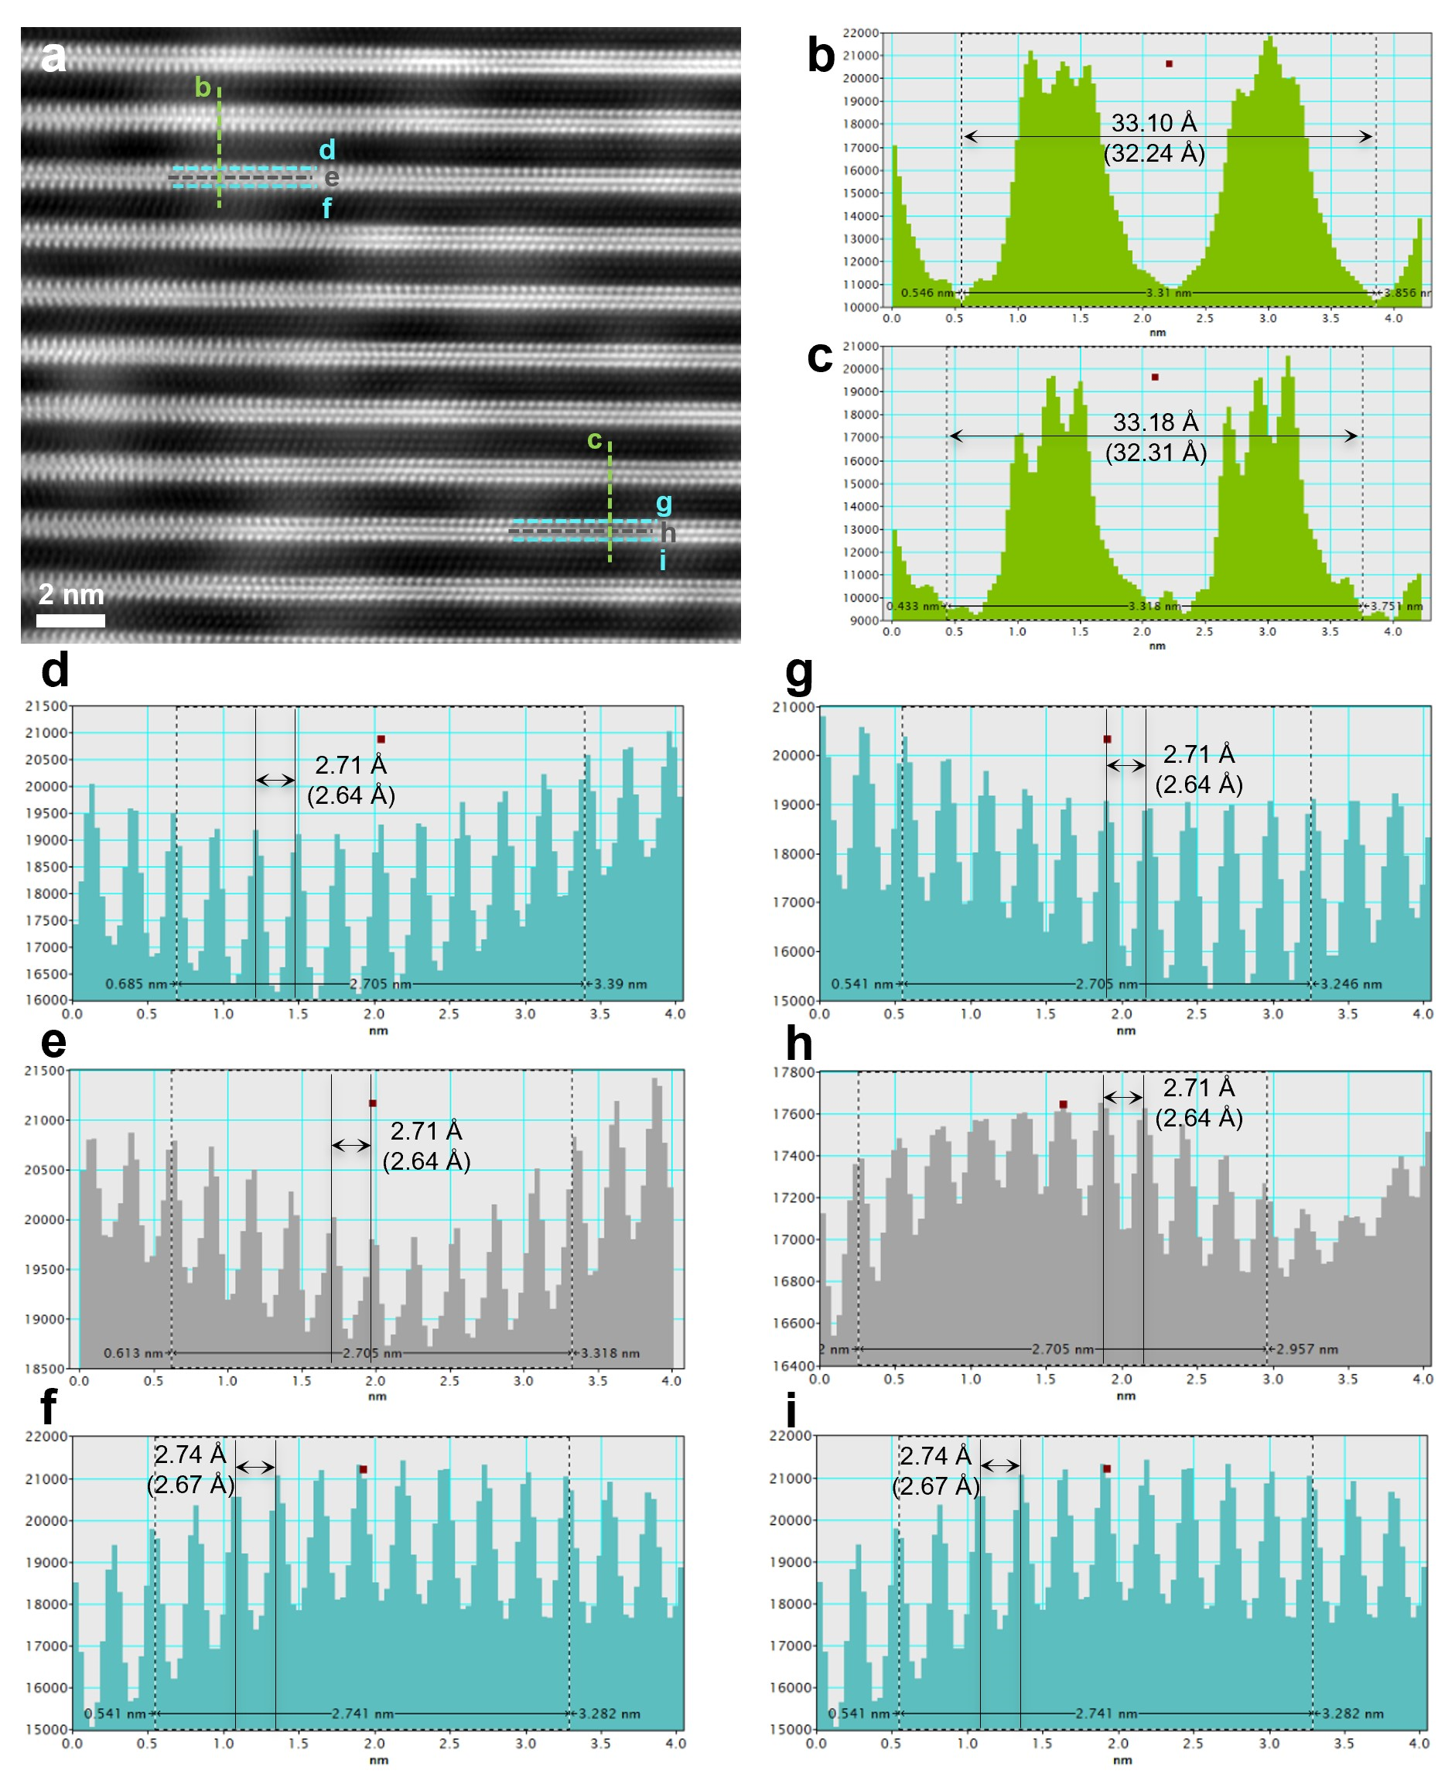
Figure S13 | In-plane Au-Au spacings within trilayers hcp Au and the c-parameter of Ti₄Au₃C₃ with hcp Au. a, HRSTEM image of Ti₄Au₃C₃ along with [$\text{11}\overline{\text{2}}\text{0}$] direction showing two hcp-Au regions. b,c, The measured c lattice parameter of Ti₄Au₃C₃ is 33.15 Å on average. The distances were calibrated using the reference c-parameter value of 32.30 Å. d-i, Line profiles extracted from the dash lines highlighted in a. Values in parentheses are calibrated distances.
Table S3 | Average distances obtained from line profiles in Fig. S13 and calculated in-plane Au-Au distances.
Au layers in Ti₄Au₃C₃ | *Calibrated average distances from line profiles (Å) | Calculated in-plane Au-Au distances (Å)
Next to Ti | 2.65 | 3.06
Middle | 2.64 | 3.05
*The distance of two crests in line profiles is the spacing of ($\text{1}\overline{\text{1}}\text{0}\text{)}$ planes in 2H hcp Au, which is equal to $\text{√}\text{3}\text{/2 }$times the in-plane Au-Au distance.
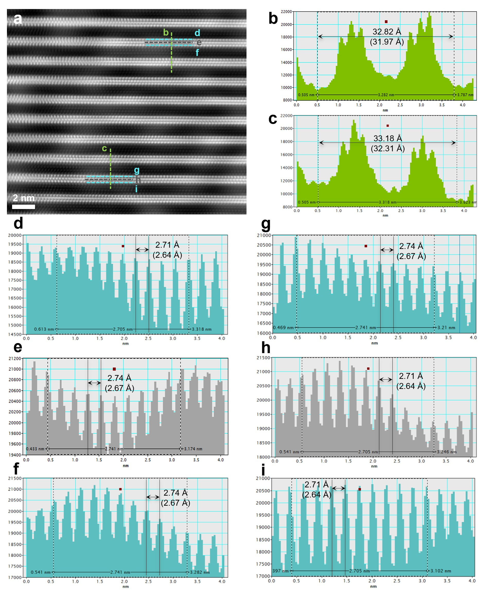
Figure S14 | In plane Au-Au spacings within trilayers fcc Au and the c-parameter of Ti₄Au₃C₃ with fcc Au. a, HRSTEM image of Ti₄Au₃C₃ along with [$\text{11}\overline{\text{2}}\text{0}$] direction showing two fcc-Au regions. b,c, The calibrated c lattice parameter of Ti₄Au₃C₃ is 32.14 Å on average. The distances were calibrated using the reference c-parameter value of 32.30 Å. d-i, Line profiles extracted from the dash lines highlighted in a. Values in parentheses are calibrated distances.
Table S4 | Average distances obtained from line profiles in Fig. S14 and calculated in-plane Au-Au distances.
Au layers in Ti₄Au₃C₃ | *Calibrated average distances from line profiles (Å) | Calculated in-plane Au-Au distances (Å)
Next to Ti | 2.65 | 3.06
Middle | 2.65 | 3.06
*The distance of two crests in line profiles is the spacing of ($\text{1}\overline{\text{1}}\text{0}\text{)}$ planes in fcc Au, which is equal to $\text{√}\text{3}\text{/2 }$times the in-plane Au-Au distance.

We now examine the relative stability of the tri-layer goldene from the difference in electronegativity between Au (2.54), Ti (1.54), and C (2.55) compared to Si (1.90) or Al (1.61). As Au is more electronegative than Ti, there will be electronic charge transfer from Ti to Au. The stability of goldene stacks would then be a delicate balance of charge-transfer for the metal bonding between the Au atoms and a trilayer of Au happens to cause the “right” amount of charge transfer from Ti to Au for its highest stability, compared to less or more gold layers. A monolayer of Au implies too much charge-transfer from Ti to Au which is less energetically favorable compared to trilayer Au, where the middle Au layer does not attract as much charge as the surface interface Au layers. On the other hand, four and five goldene layers implies less charge transfer to Au which is also less favorable for the stability compared to trilayer goldene. The metal bonding weakens if there is too much charge-transfer from a metal. The Au surface should ideally be equally attractive on both sides as in the case of a trilayer hcp or fcc goldene containing a unit cell of three layers while a bilayer or other even number of layers of goldene layers shows different surfaces on each side towards the Ti₄C₃ slabs that is probably less favorable for this stacked system.
DFT calculation combined with Bader analysis¹⁵ was made to study the charge transfer dependence as function of number of goldene layers for the low-energy structures visualized in Fig. 2a (main text). Fig. S15 shows the charge for each layer.

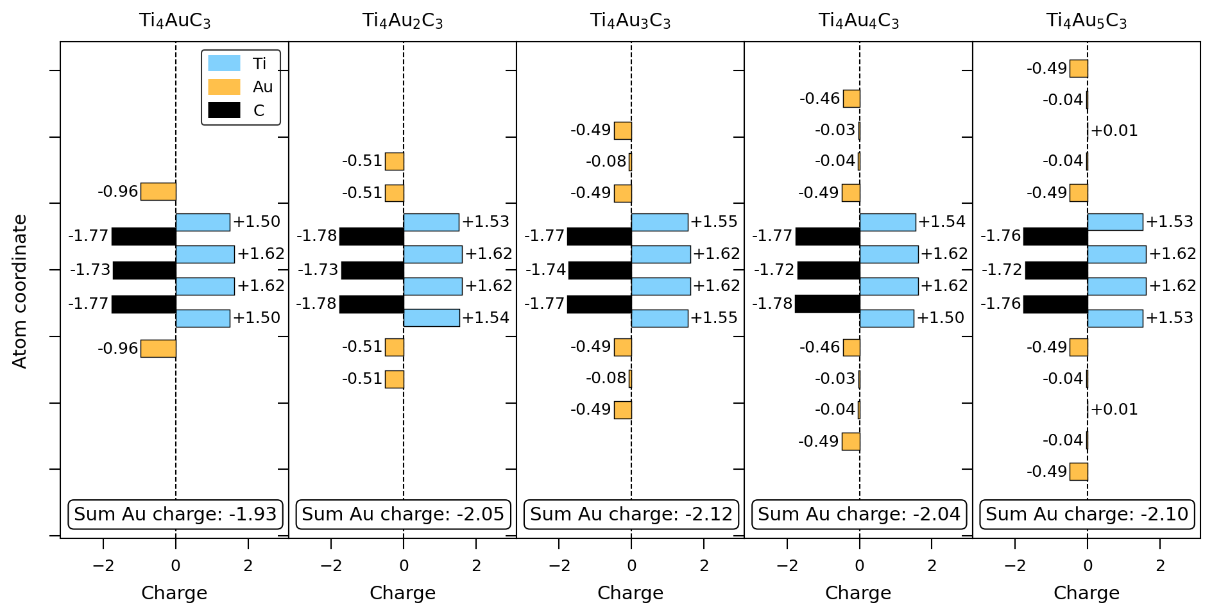
Figure S15 | DFT test calculations of the charge transfer dependence of atomic layers in Ti₄Au_{1+x}C₃ as a function of the number of goldene layers. The low-energy structures are those visualized in Fig. 2a (main text).
Overall, Ti is positive and C negative, which is in line with their electronegativity. Goldene layers next to Ti is always negatively charged while goldene further away from Ti are close to neutral. For Au, we find drastic changes when going from 1 to 2 to 3 (-0.96 to -0.51 to -0.49/-0.08 per goldene layer). For five goldene layers, the central layer is close to neutral. Summing the charge for the goldene gives most negative charge for tri-layer goldene. Note that the results for four layers of goldene looks a bit strange. This can be related to its structure, which is less symmetric compared to the other ones. This is seen upon a closer look at Ti₄Au₄C₃ in Fig. 2a. Ti is found to be most positive for 3 layers of Au. Ti is least impacted when with respect ot monolayer goldene. These arguments may explain why three is the optimum number for stacks of goldene, as experimentally observed in TEM.

Section 5: Mechanistic consideration on Ti₄C₃ sheets gliding in Ti₄Au₃C₃
The progressive displacement of Ti-C sheets was first noted in Ti₃Au₂C₂ when inserting first one and then two Au layers into Ti₃SiC₂¹, and an example is given in Fig. S16. Such deformation in MAX phases was, however, not explained.
The universal mechanism of plastic deformation and diffusional creep in crystalline materials at elevated temperatures is grain boundary (GB) sliding, sometimes coupled with GB migration^{16, 17}. MAX phases have two additional deformation mechanisms: first there are basal plane dislocations, which are mobile and able to multiply at room temperature. Confining the dislocations to the basal planes provokes kink band formation¹⁸. An incipient kink band (IKB)¹⁹ is one in which the walls of opposite sign dislocations are undissociated i.e. still attracted to each other, which ensures that when the load is removed the IKB’s would be annihilated. Second, there are ripplocations; in contrast to dislocations, these have no Burgers vector and no polarity, but are based on the buckling of surfaces in Van der Waals layers. Thus, Au-intercalated MAX phases are expected to be compliant towards mechanical strain from the c-axis expansion of varying degree as the number of Au layers builds up. Note that the a-axis remains more or less constant, so the registry between A (or A’) and MX layers is intact.
In Ti₄Au₃C₃, we observed a dislocation structure that often exists in Ti₄Au₃C₃ phases (Fig. S17a). It should be an IKB since we have not observed separate dislocation walls in extensive samples. The stress that caused this IKB may come from the insertion of additional gold layers from one side (e. g., in the lower right corner of Fig. S17a). Thus, the formation and annihilation of IKBs would be reversible when the number of inserted Au layers is consistent. We also observed a ripplocations region (Fig. S17b) where the crystal responds to the stress along the basal planes by forming surface buckling or ripplocations. However, this case is not common in our observations. We speculate that the shear stress along the basal planes might be mainly introduced by IKBs (or both IKBs and ripplocations) generated from inserting two additional Au layers together with the first layer, and by an inhomogeneous diffusion channel for Au entering.
A GB slides when the two adjacent grains undergo relative displacement parallel to the boundary plane under shear stress. It was reported experimentally and by molecular dynamics simulations that nano-twinned lamellae in Au nanocrystals undergo detwinning in the opposite direction under shear loading and subsequent extensive sliding along the twin boundary (TB) plane; the nanoscale twins exhibited substantial shear deformability along the TB with increased shear strain²⁰. In Ti₄Au₃C₃, the interface between Ti₄C₃ sheets and Au sheets can be regarded as a TB plane due to the perfect symmetry of Ti₄C₃ sheets concerning Au. During temperature varies after Au intercalation, two adjacent Ti₄C₃ sheets glide along the TB because of weak Ti-Au interactions until the internal stress balances the adventive shear stress. As a result, the system energy is minimized, and a stable Ti₄Au₃C₃ phase can form with a zigzag stacking of Ti₄C₃ coupled with ABC-stacked Au. As mentioned in the main text, the horizontal gliding of two adjacent Ti₄C₃ sheets is necessary since they are mirrored with Si in Ti₄SiC₃ but become non-mirrored after the formation of ABC-stacked tri-layers Au. The gliding of Ti₄C₃ sheets may be towards the same direction if the stress originates from only one side, i.e., the same direction as the Au insertion.
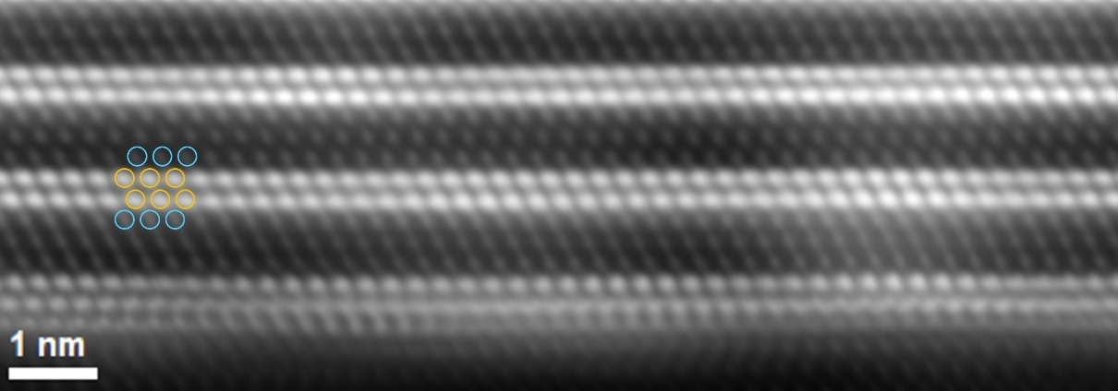
Figure S16 | Structure of Ti₃Au₂C₂. Cross-sectional HRSTEM image of Ti₃Au₂C₂ along with [$\text{11}\overline{\text{2}}\text{0}$] direction. Ti and Au atoms are circled in light blue and yellow, respectively. Ti₃C₂ sheets stack in a zig-zag structure with respect to bilayers Au.

` 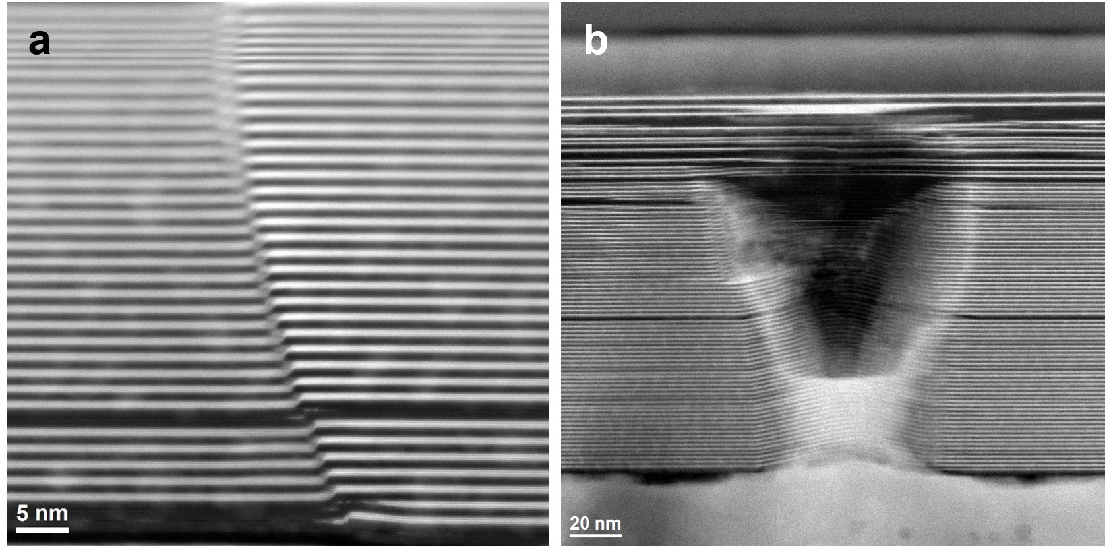
Figure S17 | Dislocations and ripplocations in Ti₄Au₃C₃.
Section 6: Preparation of trilayer goldene
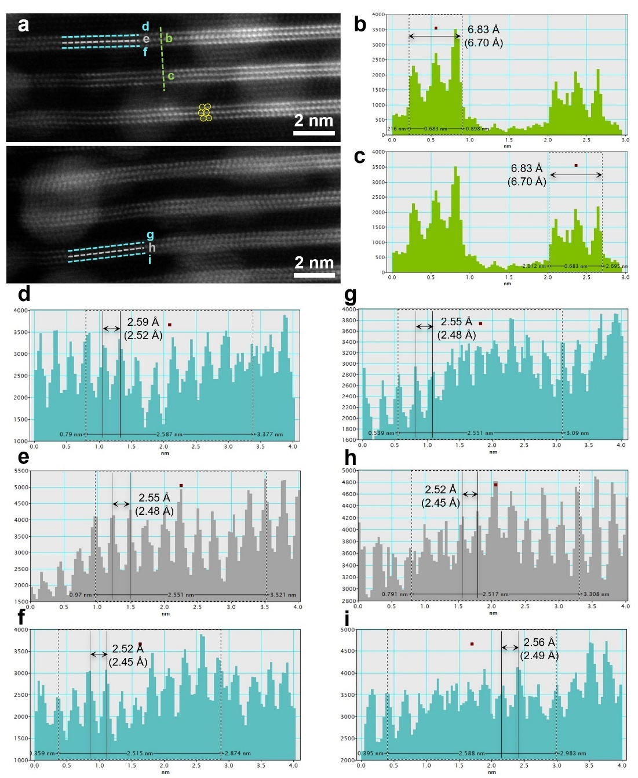
Figure S18 | In-plane Au-Au spacings and the thickness of trilayer goldene. a, Cross-sectional HRSTEM image of the trilayer goldene after etching. Au atoms are circled in yellow. b,c, The measured thickness of trilayer goldene is around 6.70 Å on average. The distances were calibrated using the reference c-parameter of Ti₄Au₃C₃ (32.30 Å). d-i, Line profiles extracted from the dash lines highlighted in a. Values in parentheses are calibrated distances.

Table S5 | Average distances obtained from line profiles in Fig. S18 and calculated in-plane Au-Au distances.
Au layers in Ti₄Au₃C₃ | *Calibrated average distances from line profiles (Å) | Calculated in-plane Au-Au distances (Å)
Both Sides | 2.49 | 2.88
Middle | 2.47 | 2.85
*The distance of two crests in line profiles is equal to $\text{√}\text{3}\text{/2 }$times the in-plane Au-Au distance.
Fig. S19 shows blobs and thicker layers formation of Au at the edges of a Ti₄Au₃C₃ film after etching. Free gold atoms in the solution would be adsorbed on goldene surfaces with many dangling bonds. These Au adatoms tends to coalesce with surface atoms and form 3D blobs and thicker goldene layers.
Coalescence of Au is also driven by the ion milling during TEM sample preparation (Fig. S20). When the ion beam bombards the sample, some of the free gold atoms that are milled away from the film can be re-absorbed and precipitate on the surface of tri-layers Au. Thus, blobs are formed at the edge of a Ti₄Au₃C₃ film (close to the milling hole) before etching.

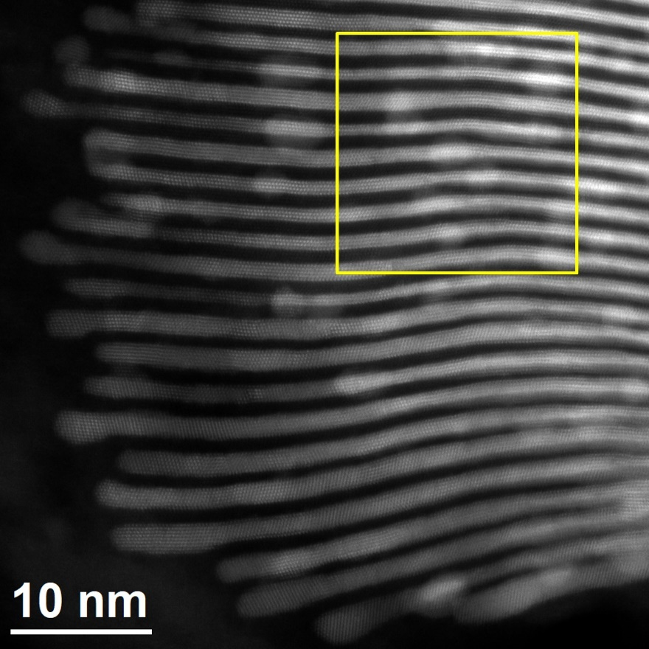
Figure S19 | Blobs and thicker layers formation of Au at the edges of a Ti₄Au₃C₃ film after etching. Cross-sectional HRSTEM image of trilayer goldene obtained from Ti₄Au₃C₃ MAX phase by etching with 0.5 % Murakami’s reagent with 5 mM of CTAB for 168 h. Squared region is magnified and displayed in Fig. 3c.

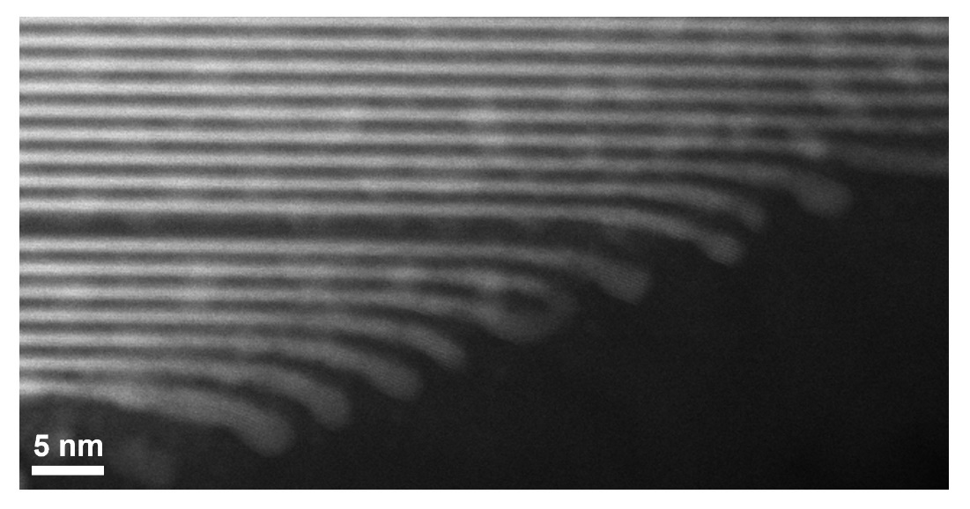
Figure S20 | Blob formation at the edges of a Ti₄Au₃C₃ film. Cross-sectional HRSTEM image of an unetched Ti₄AuC₃ film after ion milling treatment showing blobs and thicker-layers formation of Au at the edges.

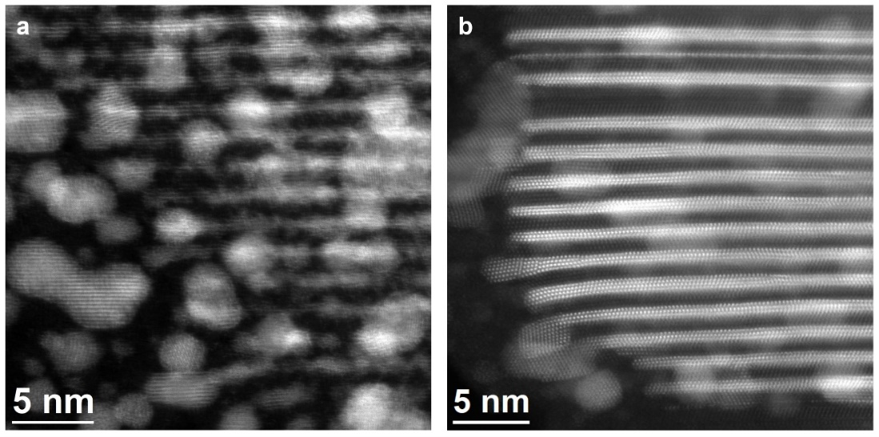
Figure S21 | Etching Ti₄Au₃C₃ films with different etchant concentrations. Cross-sectional HRSTEM image of Ti₄Au₃C₃, after etching by 1 % (a) and 0.2 % (b) Murakami’s reagent with CTAB.

Section 7: DFT and AIMD computations for trilayer goldene
All simulations are performed using the VASP code³ implemented with the projector augmented-wave method⁵. In present density functional theory (DFT) calculations, the electronic exchange and correlation energies are treated in two ways: using the approximation of Perdew-Burke-Ernzerhof (PBE)⁶ and the local density approximation (LDA). Only the PBE approximation is used in our ab initio molecular dynamics (AIMD) simulations. AIMD simulations are assisted by on-the-fly machine-learning (as implemented in VASP.6.4), which allows considerable extension of the simulation time. Spin-orbit effects are neglected in all cases.
Trilayer gold slabs with ABC stacking sequence are alike an fcc Au crystal surface with {111} termination. Trilayer Au with ABA stacking sequence is equivalent to a {0001}- oriented hcp lattice surface. DFT calculations are done using 6-atom supercells. The accuracies are of 10^{–6} eV/supercell for total energies and 10^{–3} eV/Å for forces. Saturation of energy values is achieved with 500 eV cutoff energy for the planewave basis set and 17 × 17 × 1 Γ-centered k-point grids. The supercell area of fcc and hcp trilayer Au is iteratively adjusted until lateral |σ_{xx}| and |σ_{yy}| stresses are smaller than 0.1 GPa. A vacuum region of constant thickness (≈ 12 Å) separates slab replicas along the surface normal direction. Thus, the atoms are allowed to relax to minimize the supercell energy and interatomic forces. In AIMD simulations, each supercell has 224 atoms per layer (surface areas ≈ 4 × 4 nm²), with 672 Au atoms in total. The simulation cells are periodic in-plane (i.e., within {111} and {0001} planes).
AIMD simulations at 300 K allow us to verify the dynamical stability of fcc and hcp-stacked trilayer Au slabs and to assess their difference in free-energy. The simulations are carried out using the PBE functional, 1-fs timestep integration, with 300 eV cutoff energy and Γ-point sampling of the reciprocal space. The NVT ensemble employs the Nose-Hoover thermostat. We construct supercells with in-plane nearest neighbor distance set equal to the one computed by DFT at 0 K. During dynamics, we observe that the lateral stresses |σ_{xx}| and |σ_{yy}| remain small: ≤0.1 GPa for fcc trilayer Au and ≤0.3 GPa for hcp trilayer Au. Thanks to the speed-up provided by on-fly-machine-learning implemented in VASP, we could follow the dynamics for 0.18 ns (fcc structure) and 0.38 ns (hcp structure). ML-assisted AIMD simulations show that the vertical interlayer distance between fcc-like slabs increases to 2.680 Å at 300 K (0.75% increase in relation to DFT). For hcp-structured trilayer Au, the room-temperature interplanar spacing becomes 2.703 Å (1.54% increase in comparison to the 0 K value).
For both Au allotropes, the in-plane Au-Au nearest neighbor distance obtained by DFT+PBE relaxation is 2.807 Å. DFT+LDA calculations predict 2.745 Å. These values are 4.5% and 4.2% smaller than the corresponding ones computed by DFT+PBE (2.940 Å), and DFT+LDA (2.865 Å) for fcc bulk Au. Experimental measurements yield an interatomic spacing (2.884 Å) that is slightly larger/smaller than predicted.
DFT results show that different stacking sequences have different interlayer spacing. For fcc-like trilayer Au, DFT+PBE calculations give an equilibrium interlayer distance of 2.660 Å, while LDA yields a much lower value of 2.517 Å. For hcp-like trilayer Au, the relaxed distances between {0001} lattice planes are 2.662 Å (PBE) and 2.524 Å (LDA).
Besides the time-averaged potential energies, the vibrational free energy F_{vib} also contributes to stabilization of trilayer goldene. The Helmholtz free energy (F) of the two goldene allotropes is calculated by adding F_{vib} to the time-averaged potential energies. As implemented in Ref. ²¹, the F_{vib} is computed by integrating the vibrational density of states (VDOS). The latter is obtained by Fourier-transforming the velocity-velocity autocorrelation function, which is directly extracted from MD trajectories.
Fig. S22 shows that the stabilizing contribution of lattice vibrations in hcp trilayer goldene is largely due to the low-frequency VDOS peak centered at ≈ 0.3 THz. Note that low-frequency anharmonic vibrations give stronger contribution to the vibrational free energy.
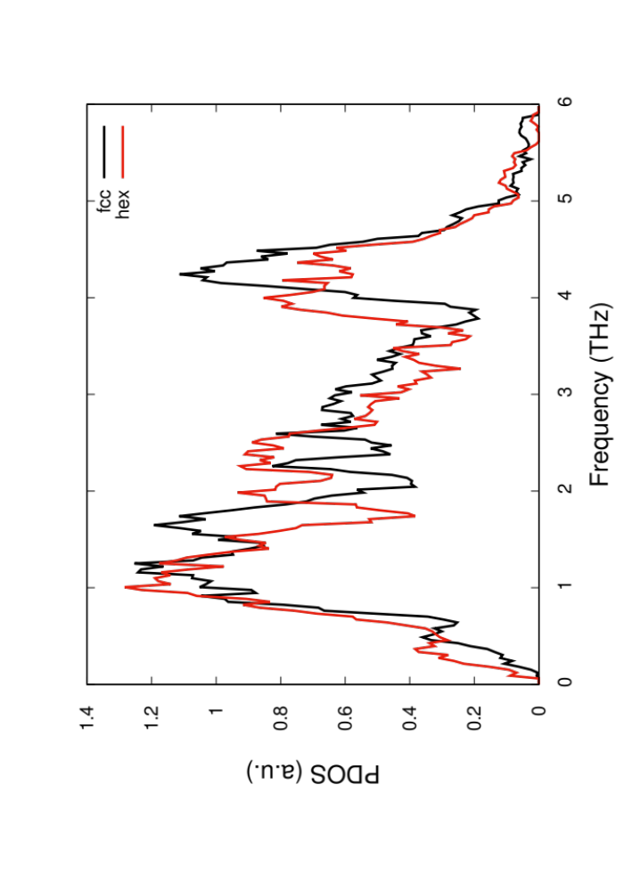
Figure S22 | VDOS spectra of fcc and hcp trilayer goldene.

Time-averaged (±1 ps) atomic positions of fcc and hcp trilayer goldene were extracted during AIMD trajectories at room temperature, as shown in Fig. S23. The atomic positions are consistent with fcc (Fig. S23a, c, e) and hcp (Fig. S23b, d, f) stacking sequences. The Helmholtz free energies (F) calculated for the two allotropes indicate that the hcp trilayer goldene is ≈50 meV/atom more stable than the fcc trilayer goldene at 300 K. Therefore, we predict that the hcp phase would be retained after etching and its stability contributes to the prevalence of trilayer goldene.

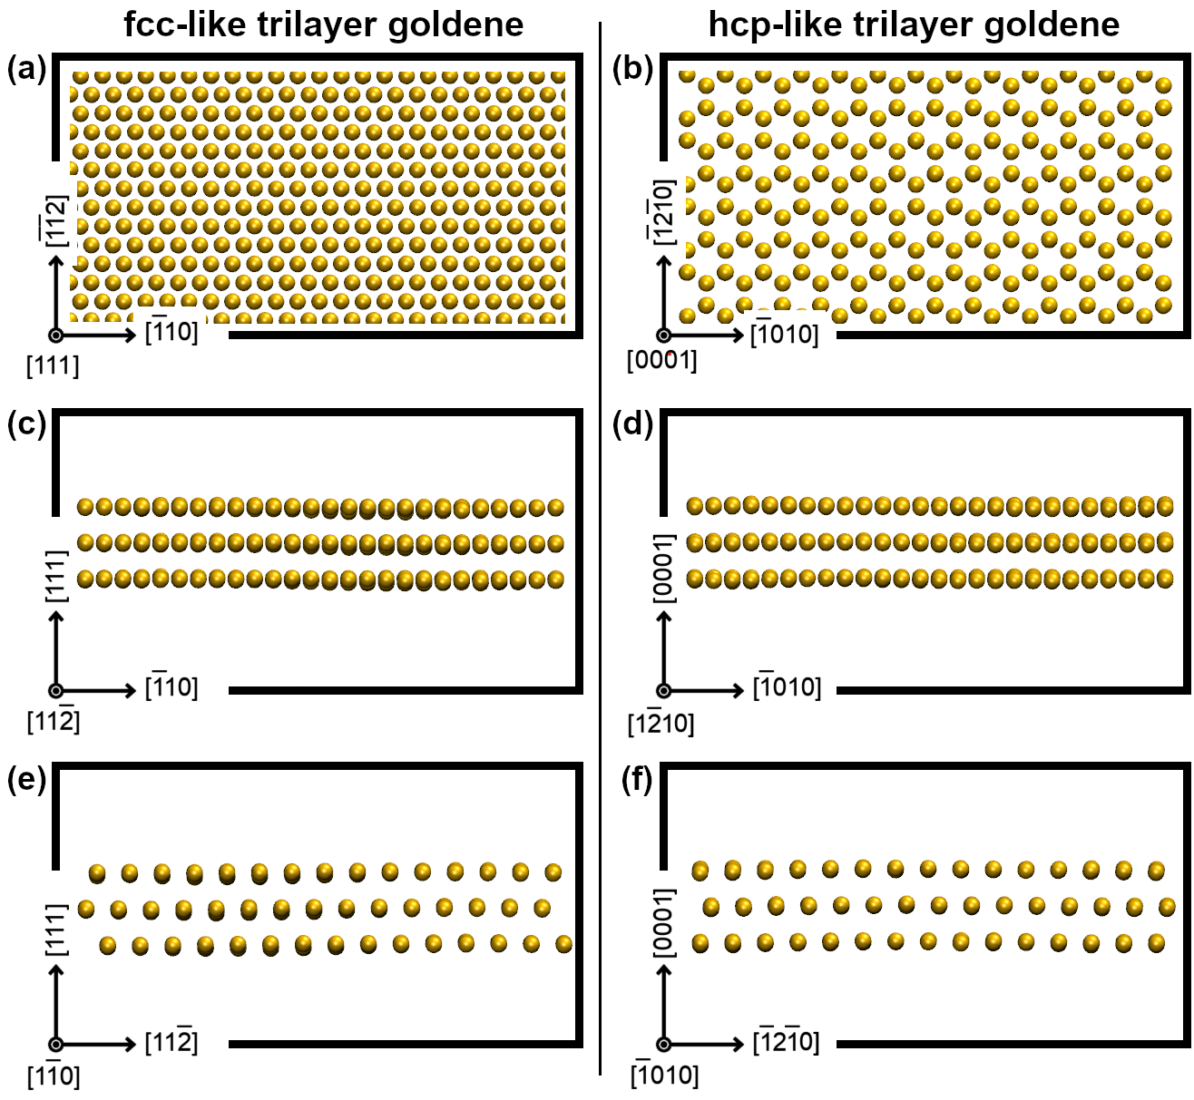
Figure S23 | Dynamic stability of fcc and hcp trilayer goldene. Time-averaged (±1 Picoseconds) atomic positions of fcc (a, c, e) and hcp (b, d, f) trilayer goldene sheets recorded from different projections.

Section 8: Calculated XPS core-level shifts in DFT
Electronic structures were calculated within the density-functional-theory framework and PAW methods. Isolated trilayer and monolayer goldene were calculated using 29×29×3 k-points, while bulk Au was calculated with 29×29×29 k-points sampling of the Brillouin zone using a Monkhorst-Pack scheme²². The energy cut-off for plane waves included in the expansion of wave functions was 400 eV. The Au 4f_{7/2} core level shifts of isolated trilayer and monolayer of goldene with respect to the bulk Au were calculated according to the slater transition state, initial state, and final state approximation²³⁻²⁵ (Table S6). The Slater Transition State of bulk Au was used as a reference to obtain the calculated binding energies without accounting for the 4f spin-orbit splitting of 3.6 eV. The half-occupied Slater Transition State has previously been proven useful for metallic systems^{26, 27}.
Applying the initial state approximation, the Au 4f_{7/2} core level of monolayer goldene exhibits a low-energy shift compared to that of bulk Au due to the lack of charge transfer between the Au atoms in goldene, while the difference between the trends using both initial and final state approximations are small, implying that final-state effects should also be small²⁸. On the other hand, considering the initial state approximation, the calculated Au 4f_{7/2} core level shift of isolated monolayer goldene is toward lower binding energy compared to that of bulk, while that of goldene for the final state effect is smaller than the initial state approximation by 0.376 eV, indicating there is a final state effect for goldene. The lower binding energy using the initial state approximation for goldene in comparison to bulk Au can be attributed to the 2D nature of goldene and lattice distortion²⁹. The reduced coordination number of Au atoms for anisotropic Au nanostructures such as goldene accompanies corresponding charge redistribution, leading to fewer 5d electrons of Au atoms than for bulk Au. Furthermore, a lattice distortion with shorter Au-Au distances in goldene than in bulk Au could also cause a subsequent rehybridization that enhances the initial state effect.
The calculations were made assuming infinite free-standing 2D planes of goldene with 30 Å vacuum on both sides. For comparison, the size of the trilayer goldene sheets observed in the STEM measurements varies from several nm to a hundred nm. Such nanosheets have a much higher edge-to-volume ratio than the infinite 2D structure. The coordination number at the edges is lower than 9, enhancing the final state effect. Therefore, the goldene nanosheets produced by our experimental method show a slightly higher positive binding energy shift of 0.80 eV with respect to the bulk Au than estimated in the calculations.

Table S6 | DFT-simulated Au 4f_{7/2} core level shifts of bulk fcc Au, trilayer Au (middle and surface layers) and goldene monolayer using three different methods.
Sample | Slater transition state approx. [eV] | Initial state approx. [eV] | Final state approx. (incl. initial state approx.) [eV]
Bulk Au | (90.03) | - | -
Trilayer mid  Trilayer surf | +0.018 (90.04)  -0.314 (89.71) | -0.011 (90.01)  -0.422 (89.60) | +0.016 (90.04)  -0.272 (89.75)
Monolayer  goldene | -0.452 (89.57) | -0.645 (89.38) | -0.269 (89.76)

Section 9: Surface morphology of Ti₄Au₃C₃ after etching
Fig. S24 shows the SEM images and corresponding EDX spectra and maps measured on the Ti₄Au₃C₃ surface after chemical-mechanical polishing (CMP) of Au capping layer and selective etching of Ti₄C₃ slabs. Both dark and bright regions in panel a exhibit relatively low content of Au (panel b and d-h), indicating the Au capping layer is highly removed after CMP and chemical etching. However, it may partially remain on top of Ti₄Au₃C₃. The dark domains are Si-rich because Si out-diffuses into Au reservoir and agglomerates near the surface during Au intercalation processes.
After etching, the surface is full of rippling flakes (panel c), which are most likely the trilayer goldene floating in different orientations. When the Ti₄Au₃C₃ film is immersed in the solution, the etchant starts to penetrate into the film from the surface and etch the top few atomic Ti₄C₃ slabs gradually. Meanwhile, the released goldene sheets begin rippling due to the activity of surfactant and the tension of the liquid. The rippling feature illustrates that the trilayer goldene completely separates from the support of the formwork and is able to maintain its original structure. The tendency of goldene sheets curling-up and clustering can be expected.
Therefore, we attribute the less intense high-energy Au 4f doublet in the XPS spectrum from etched Ti₄Au₃C₃ (Fig. 4, main text) to the final state effects due to the decreasing coordination number at the sheet edges of nascent trilayer goldene and conclude that the dominant 4f doublet may originate from residuals of the capping Au layer or from sheets clustering and their curling-up.
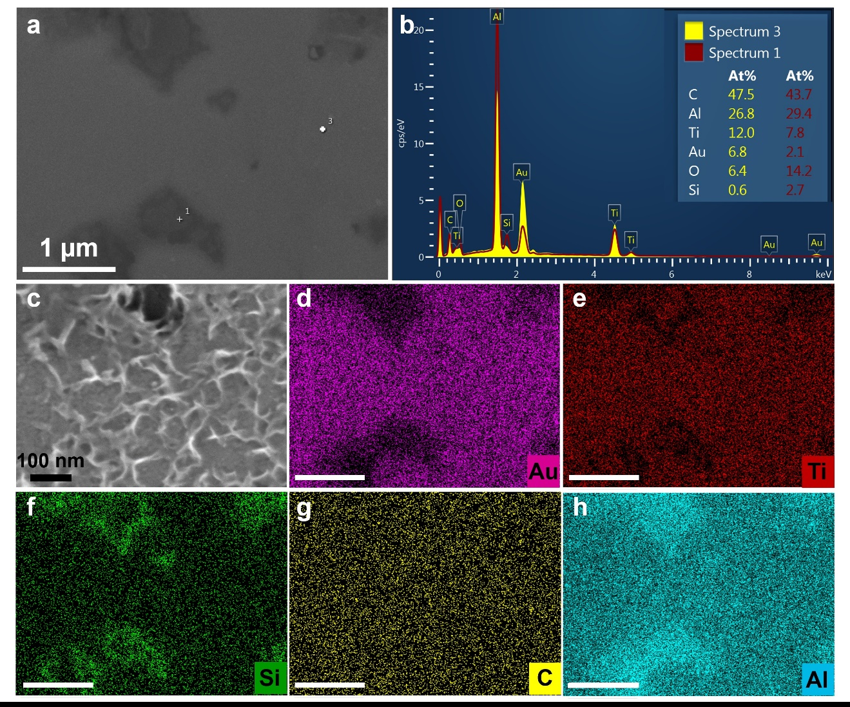
Figure S24 | SEM image with EDX analysis measured on Ti₄Au₃C₃ after etching. a, Plan view SEM electron image of Ti₄Au₃C₃ after etching. b, EDX spectra acquired at two points in a. c, Magnified plan view SEM image of Ti₄Au₃C₃ after etching. d-h, EDX maps taken together with a.

Section 10: XPS analysis of elements in samples from etching reagents
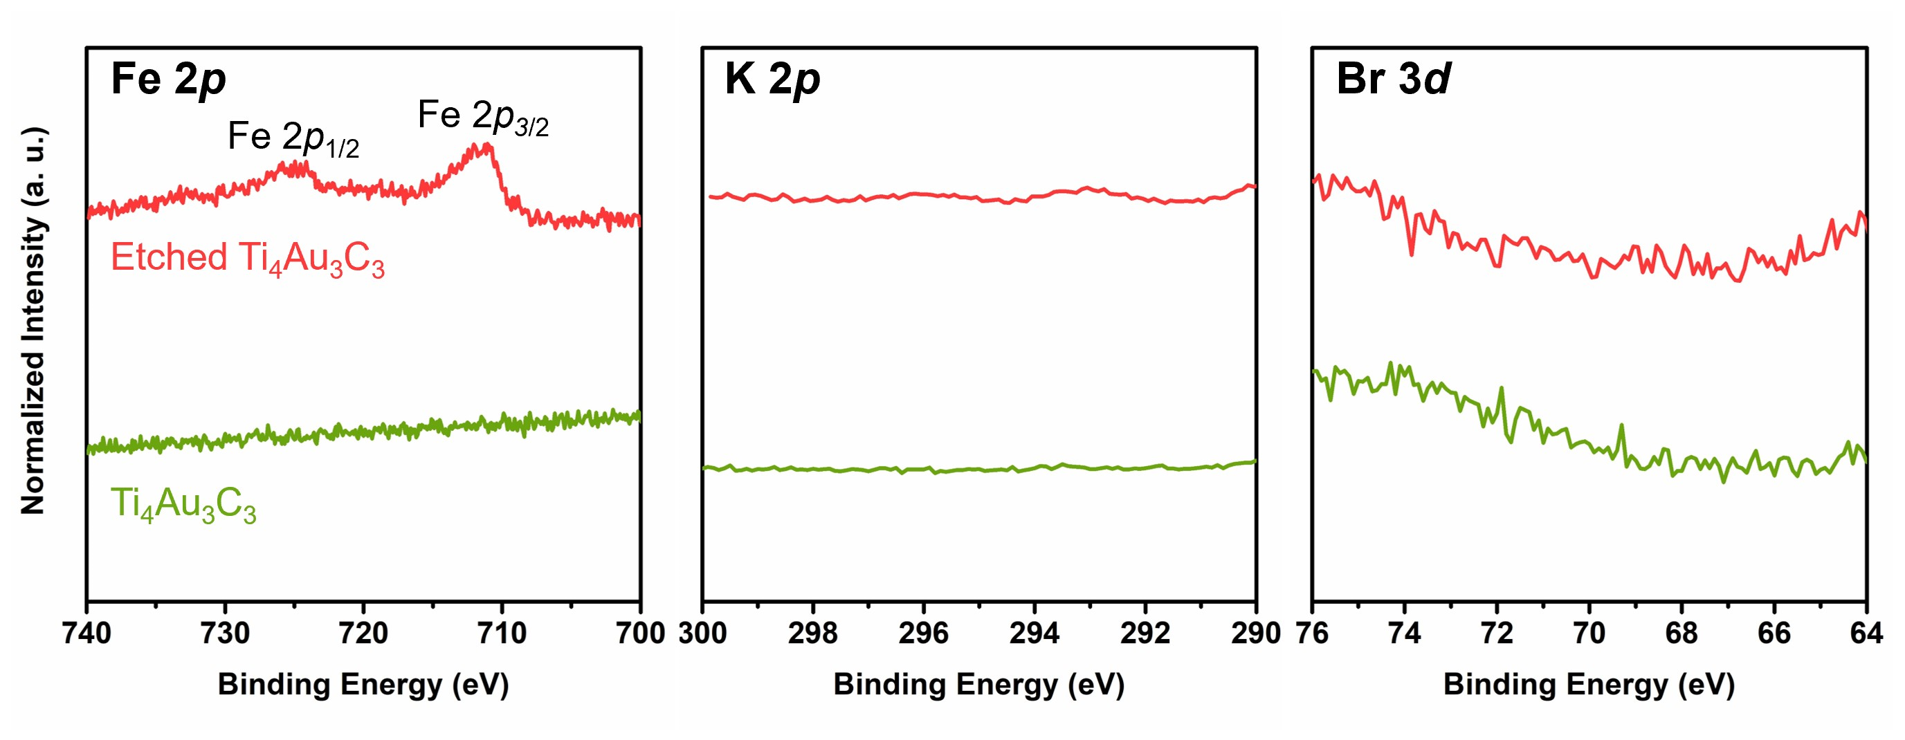
Figure S25 | X-ray photoelectron spectra of the etched Ti₄Au₃C₃ and pristine Ti₄Au₃C₃. Fe 2p (left), K 2f (middle) and Br 3d (right) core level spectra measured on the Ti₄Au₃C₃ (green) and trilayer goldene (red) produced from Ti₄Au₃C₃ via chemical etching.

All XPS spectra were charge-referenced to the Fermi edge recorded from the etched Ti₄Au₃C₃ and pristine Ti₄Au₃C₃ samples (Fig. S26). The exact position of the Fermi edge was determined by taking the spectra derivative in the vicinity of the Fermi level. The such-obtained peaks were shifted to lower binding energy by 0.1 and 0.15 eV for Ti₄Au₃C₃ and etched Ti₄Au₃C₃, respectively. Accordingly, the core level XPS spectra were also shifted towards lower binding energy by corresponding amounts.
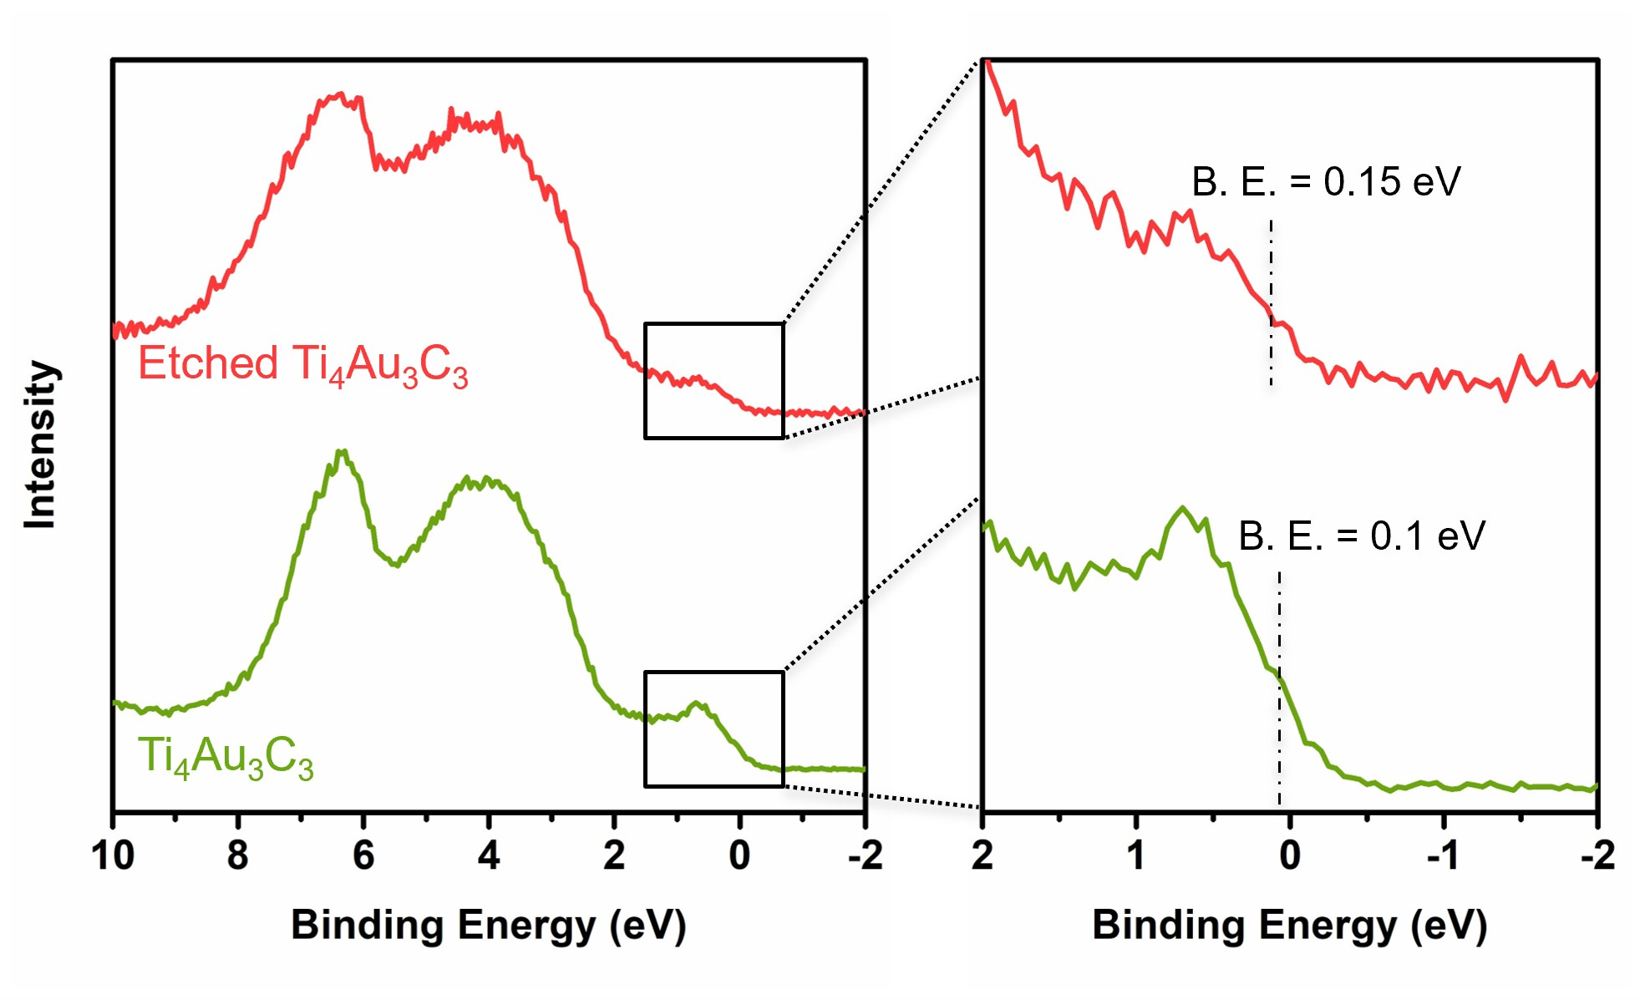
Figure S26 | Valence band XPS spectra of the etched Ti₄Au₃C₃ and pristine Ti₄Au₃C₃.

References
1. Fashandi, H. et al. Synthesis of Ti₃AuC₂, Ti₃Au₂C₂ and Ti₃IrC₂ by noble metal substitution reaction in Ti₃SiC₂ for high-temperature-stable Ohmic contacts to SiC. Nat. Mater. 16, 814-818 (2017).
2. Shi, Y. et al. Synthesis of Cr₂AuC via thermal substitution reaction in Au-covered Cr₂GaC and Cr₂GeC thin films. Results Mater. 18, 100403 (2023).
3. Kresse, G. & Furthmiiller, J. Efficient iterative schemes for ab initio total-energy calculations using a plane-wave basis set. Phys. Rev. B 54, 11169-11186 (1996).
4. Kresse, G. & Joubert, D. From ultrasoft pseudopotentials to the projector augmented-wave method. Phys. Rev. B 59, 1758-1774 (1999).
5. Blochl, P.E. Projector augmented-wave method. Phys. Rev. B 50, 17953-17979 (1994).
6. Perdew, J.P., Burke, K. & Ernzerhof, M. Generalized gradient approximation made simple. Phys. Rev. Lett. 77, 3865-3868 (1996).
7. Jain, A. et al. Commentary: The Materials Project: A materials genome approach to accelerating materials innovation. APL Mater. 1, 011002 (2013).
8. Fashandi, H. et al. Ti₂Au₂C and Ti₃Au₂C₂ formed by solid state reaction of gold with Ti₂AlC and Ti₃AlC₂. Chem. Commun. 53, 9554-9557 (2017).
9. Dahlqvist, M., Alling, B., Abrikosov, I.A. & Rosén, J. Phase stability of Ti₂AlC upon oxygen incorporation: a first-principles investigation. Phys. Rev. B 81, 024111 (2010).
10. Dahlqvist, M., Alling, B. & Rosén, J. Stability trends of MAX phases from first principles. Phys. Rev. B 81, 220102 (2010).
11. Dronskowski, R. & Bloechl, P.E. Crystal orbital Hamilton populations (COHP): energy-resolved visualization of chemical bonding in solids based on density-functional calculations. J. Phys. Chem. 97, 8617-8624 (1993).
12. Deringer, V.L., Tchougréeff, A.L. & Dronskowski, R. Crystal orbital Hamilton population (COHP) analysis as projected from plane-wave basis sets. J. Phys. Chem. A 115, 5461-5466 (2011).
13. Maintz, S., Deringer, V.L., Tchougréeff, A.L. & Dronskowski, R. Analytic projection from plane-wave and PAW wavefunctions and application to chemical-bonding analysis in solids. J. Comput. Chem. 34, 2557-2567 (2013).
14. Momma, K. & Izumi, F. VESTA 3 for three-dimensional visualization of crystal, volumetric and morphology data. J. Appl. Crystallogr. 44, 1272-1276 (2011).
15. Henkelman, G., Arnaldsson, A. & Jónsson, H. A fast and robust algorithm for Bader decomposition of charge density. Comput. Mater. Sci. 36, 354-360 (2006).
16. Zhu, Q. et al. In situ atomistic observation of disconnection-mediated grain boundary migration. Nat. Commun. 10, 156 (2019).
17. Ashby, M.F. Boundary defects, and atomic aspects of boundary sliding and diffusional creep. Sur. Sci. 31, 498-542 (1972).
18. Barsoum, M.W. Ripplocations: A Progress Report. Front. Mater. 7, 146 (2020).
19. Barsoum, M.W., Zhen, T., Kalidindi, S.R., Radovic, M. & Murugaiah, A. Fully reversible, dislocation-based compressive deformation of Ti₃SiC₂ to 1 GPa. Nat. Mater. 2, 107-111 (2003).
20. Zhu, Q. et al. Revealing extreme twin-boundary shear deformability in metalic nanocrystals. Sci. Adv. 7, 1-9 (2021).
21. Pshyk, O.V. et al. Discovery of Guinier-Preston zone hardening in refractory nitride ceramics. Acta Mater. 255, 119105 (2023).
22. Monkhorst, H.J. & Pack, J.D. Special points for Brillouin-zone integrations. Phys. Rev. B 13, 5188-5192 (1976).
23. Köhler, L. & Kresse, G. Density functional study of CO on Rh(111). Phys. Rev. B 70, 165405 (2004).
24. Lizzit, S. et al. Surface core-level shifts of clean and oxygen-covered Ru(0001). Phys. Rev. B 63, 205419 (2001).
25. Tal, A.A., Olovsson, W. & Abrikosov, I.A. Origin of the core-level binding energy shifts in Au nanoclusters. Phys. Rev. B 95, 245402 (2017).
26. Göransson, C., Olovsson, W. & Abrikosov, I.A. Numerical investigation of the validity of the Slater-Janak transition-state model in metallic systems. Phys. Rev. B 72, 134203 (2005).
27. Olovsson, W., Marten, T., Holmström, E., Johansson, B. & Abrikosov, I.A. First principle calculations of core-level binding energy and Auger kinetic energy shifts in metallic solids. J. Elec. Spec. Rel. Phen. 178-179, 88-99 (2010).
28. Weinert, M. & Watson, R.E. Core-level shifts in bulk alloys and surface adlayers. Phys. Rev. B 51, 17168-17180 (1995).
29. Costanzo, E., Faraci, G., Pennisi, A.R., Ravesi, S. & Terrasi, A. Initial and final state effects in photoemission from gold clusters. Solid state commun. 81, 155-158 (1992).

