Supplementary Data

Co-exposure to inhaled tungsten particles and low-dose gamma rays: neurotoxicological outcome in rats
Théo Fréchard¹, Florence Bachelot¹, Véronique Ménard^{2,3}, Chloé Brizais¹, Léo Macé¹, Christelle Elie¹, Nicolas Cailler Gruet¹, Théo Teulade¹, Chloé Havet¹, Frédéric Voyer⁴, Imène Garali¹, Céline Gloaguen¹, François Gensdarmes⁵, Dmitry Klokov¹, and Chrystelle Ibanez¹*

¹Autorité de Sûreté Nucléaire et de Radioprotection, PSE-SANTE/SESANE/LRTOX, F-92262, Fontenay-aux-Roses cedex, France.
²Université Paris Cité, Inserm, CEA, Stabilité Génétique Cellules Souches et Radiations, iRCM/IBFJ, F-92265, Fontenay-aux-Roses, France
³Université Paris-Saclay, Inserm, CEA, Stabilité Génétique Cellules Souches et Radiations, iRCM/IBFJ, F-92265, Fontenay-aux-Roses, France
⁴Autorité de Sûreté Nucléaire et de Radioprotection, PSE-SANTE/SESANE/GSEA, F-92262, Fontenay-aux-Roses cedex, France.
⁵Autorité de Sûreté Nucléaire et de Radioprotection, PSN-RES/SCA/LPMA, F-91400, Saclay, France.

*Corresponding author : Dr. Chrystelle Ibanez
ASNR, PSE-SANTE, SESANE, Laboratoire de Radiotoxicologie et Radiobiologie Expérimentale
Avenue de la Division Leclerc, BP17, 92262 Fontenay aux Roses, France
Tel: +33 (0)1 58 35 82 84; E-mail address: chrystelle.ibanez@asnr.fr
Supplementary section: detailed version of the METHODS section
This study is reported in accordance with ARRIVE guidelines.
Animals
Adult twelve-week-old male Sprague-Dawley rats (weighing 350g ± 15g) were used (Janvier Labs, France). Males were chosen for this study as they are more representative of the population exposed to our two stressors, such as nuclear industry workers who constitute 87% of the INWORKS epidemiological cohort [26]. We used 20 animals per group and per time point in total for different kinds of experiments (5 for histology, 10 for biomolecular assays, 5 for analytical chemistry). These numbers were decided upon use of statistical tools to optimise the statistical power of our study and after careful review of existing literature and past projects results. Animal experiments took place in the specific pathogen free IRSN animal facility (PARADIS Platform) in controlled humidity (55% ± 10%) and temperature (22°C ± 2°C) with a 12-hour day/night cycle. For identification rats were randomly assigned a number written at the base of their tail. They were housed in individually ventilated cages (Double Decker Cages, Tecniplast, Italy) in groups of two or three animals with ad libitum access to food (Rod16R, LASVendi) and tap autoclaved water. All cages were enriched with an internal platform, a red plastic tunnel and a wooden stick. The animals were randomly assigned to four conditions: control, tungsten, irradiated, and co-exposed; and two post-exposure time points: 24 hours (24h) or 28 days (28 days). All animal work within this study was authorized by the French Ministry of Superior Education and Research under the animal protocol number APAFIS#33361-2021100608276923 v1, after ethical evaluation performed by the registered IRSN Ethic Committee on Animal Experimentation (C2EA-IRSN N°81). All experiments were conducted in compliance with European and French regulations on animal use for scientific purposes (EC Directive 2010/63/EU and French Decret 2013-118).

Tungsten particles inhalation and gamma radiation exposure
Upon arrival, the animals were allowed to acclimate to their new environment for one week. After this period, an habituation to nose-only inhalation contention tubes (Ysebaert) began to reduce stress during exposures, which last around 50-60 minutes in total. The habituation lasted two weeks during which the rats were placed in contention tubes 3 times a week (6 in total), with durations gradually increasing from 10 to 60 minutes in 10-minute increments. All rats, including those in control and irradiated groups, were subject to this habituation process.
Upon completion of acclimatation and habituation, all rats were placed in nose-only inhalation contention tubes. Tungsten-only and co-exposed animals were transferred to a glovebox, connected to the inhalation chamber for 30 minutes and exposed to 80 mg.m⁻³ of tungsten metal (W) particles (A-20, A.L.M.T. Corp.) as fully described in Macé et al., 2024 [3]. This concentration was based on the French Occupational Exposure Limit (OEL) for alveolar dust concentration (i.e. particles with diameters mainly below 4 µm) in an inside workspace (5 mg.m⁻³ until 2022) for an 8-hour exposure during a workday. This OEL was decreased to 0.9 mg.m⁻³ for the alveolar fraction of the aerosol on January 1st 2022 [27]. After exposure, the rats had their nose wiped to minimize ingestion from grooming and were returned to their cages. Control and irradiated-only rats were sham exposed by being placed in nose-only inhalation tubes and transferred to a clean glovebox for 30 minutes under similar atmospheric pressure and noise conditions before being returned to their cages. The metrology of the W aerosol generation and design of the inhalation set-up were detailed by Macé et al. [28], this work determined that the particle size distribution follows a lognormal function, having a mass median aerodynamic diameter equal to 1.9 µm and a geometric standard deviation of 1.6.
On the same day, all rats were placed in irradiation boxes (M2E). The boxes were designed to hold 2 rats, had dimensions of 16 cm × 16 cm x 10 cm (W x L x H) and were divided in the middle by an acrylic panel. Irradiation-only and co-exposed rats were irradiated in a GSR D1 irradiator (Gamma Service Medical GmbH) using a Caesium-137 source, which radioactive decay was taken into account, to deliver a single dose of 50 mGy of gamma-rays at a dose-rate of 50 mGy.min⁻¹ with a 92% isodose across the irradiated surface. The irradiation area was set to match the size of the box, ensuring that the rats were fully exposed regardless of their movement within the box. The chosen dose represented a median value within the low-dose range [16]. Control and tungsten-only animals stayed in the irradiation boxes for the same duration (10 to 12 minutes). All animals were then returned to their cages.
Following these procedures, no animal showed any sign of suffering requiring special care or anticipated euthanasia, and all animals were included in this study.
Dosimetry
The GSR D1 used for our irradiations contained three Caesium-137 sources emitting gamma rays (662 KeV) and is self-shielded. The sources total activity was measured at 30 TBq in April 2019. Prior to using it with animals, a dosimetry was performed in the exact conditions of the animal exposure. A cylindrical ionizing chamber (31010, PTW) was used following the recommendations of the American Association of Physicists in Medicine’s TG-61 [29]. The ionizing chamber was calibrated in water with Caesium-137 in the Physikalisch-Technische Bundesanstalt, facility reference number 210382501.

Euthanasia, tissue collection and treatment
Two post-exposure time points were chosen for their recurrence in inhalation toxicological studies: 24 hours (24h) and 28 days (28d). A third time point was added for inductively coupled plasma mass spectrometry (ICP-MS) analysis at 4 hours (4h) post-exposure to measure early transfer of W and biodistribution among different target organs.
At the designated time point, the animals were injected subcutaneously with Buprenorphine (0.05 mg/kg s.c.) 30 minutes before being exposed to isoflurane (Aérane, Baxter) in a mixture of 5% isoflurane and 95% air to reach unconsciousness. The rest of the procedure differed depending on whether the animals were destined for histology or biochemical/molecular assay.
For histology, unconscious animals were injected intraperitoneally with a mix of ketamine (75 mg/kg) and xylazine (10 mg/kg) and removed from isoflurane. Once anaesthesia was confirmed by loss of pedal withdrawal reflex, the animals were perfused intracardially with 200 mL of a 4% paraformaldehyde (PFA) (VWR Chemicals) solution over 10 minutes. Whole brains were collected and placed in a 30% sucrose solution at 4°C overnight. The following day, using a brain matrix (BioSeb, France), brains were cut longitudinally to split the hemispheres and then cut into 2mm thick longitudinal slices. The brain slices were embedded in Cryomatrix (6769006, Epredia) in cassettes and frozen with a FlashFreeze (MicromMicrotech). Cassettes were stored at -80°C until use. Using a cryostat (NX50, Epredia), 14µm thick sagittal sections were cut using a AccuEdge® 4690 blade (Sakura) and placed on SuperFrost Plus™ slides (Thermo Scientific™) which were stored at -80°C until use. To ensure consistency in neuroanatomical level across all slides, each slide used had to include at least a partial rostral migratory stream. Slides meeting this criterion were selected for further analysis, while the remaining slides were stored at -80°C in a separate box for use in tests and optimizations.
For biochemical or molecular biology assays, the rats were euthanized by terminal exsanguination through cardiac puncture using a heparinized needle (Héparine Choay®, CHEPLAFARM) while being maintained under isoflurane. Blood was collected, centrifugated at 3000 g for 15 minutes for future plasma analysis and stored at -80°C. The brain was then extracted and placed on a cold plate where it was dissected into substructures: olfactory bulb (OB), frontal cortex (FC), striatum (ST), hippocampus (HIP), cerebellum (CER) and brain stem (BrSt). The microdissection method was detailed by Macé et al. 2024 [3]. The ethmoid turbinates (ET) were also collected. Tissues were flash frozen in liquid nitrogen immediately after sampling and stored at -80°C until use.
Animals designated for ICP-MS quantification were euthanized similarly to rats destined for molecular biology assays. The brain was extracted and dissected into the same substructures; the ET was also sampled. Additionally, the whole lung and trachea compartment, as well as the left kidney, were collected. All samples were weighted before being stored at -20°C. They were then processed for tungsten mass measurement by ICP-MS as described by Macé et al., 2024.

Immunochemistry
Selected slides were rehydrated and blocked for 1h at room temperature using 5% donkey serum (S30-100ML, MERCK) diluted in 1X PBS prepared from tablets (18912-154, GIBCO) with 0.1% Triton (X100-100ML, Sigma-Aldrich). The blocking solution was then removed and 150µL of primary antibodies at a 1:200 dilution in PBS-Triton 0.1% were added on the slides. Slides were left to incubate overnight in a humid chamber at 4°C. The next day, the slides were washed 3 times for 10 minutes in PBS 1X under agitation. Then 150µL of secondary antibody solution prepared identically to the primary antibody solution were added on the slides, which were then left to incubate in the dark in a humid chamber at room temperature for 2h. The slides were then washed 3 times in PBS 1X for 10 minutes and 2 drops of Vectashield Mounting solution with DAPI (Vector) were added, covered by a glass coverslip, and sealed using nail polish. Once dried, the slides were scanned using a Nanozoomer S60 (Hamamatsu) and quantified using Histolab 12.2 (Microvision Instruments). Areas of quantification included the OB and the second layer of the apex of the FC. To ensure objectivity, all data were blind coded before quantification, and the coding was only revealed and linked back to individual animals once all quantifications for a specific staining were completed.
The primary and secondary antibodies used are detailed in Table 1.
Table 1. Primary and secondary antibodies used for histology
Antibody | Target | Host species | Reference | Supplier
Primary | IBA1 | Goat | ab5076 | Abcam
Primary | NeuN | Mouse | MAB377 | Millipore
Primary | Cleaved Caspase 3 | Rabbit | AB3623 | Millipore
Primary | CD11b/c | Rat | 550546 | BD Pharmingen
Primary | Ki67 | Rabbit | MA5-14520 | Invitrogen
Secondary | Anti-Mouse Alexa Fluor 568 | Goat | A11004 | Invitrogen
Secondary | Anti-Goat Alexa fluor 488 | Donkey | A32814 | Invitrogen
Secondary | Anti-Rabbit Alexa Fluor 594 | Donkey | A21207 | Invitrogen
Secondary | Anti-Rat Alexa Fluo 488 | Donkey | A21208 | Invitrogen

Microglial activation and density scoring
Given the very high microglial density in the OB, we developed a double-blind density scoring method with scores ranging from 0 to 5. We first blindly reviewed all our slides, selected the one with the lowest apparent density as the 0/5 standard, and the one with the highest density as the 5/5 standard. Two persons trained on this scoring method independently compared each blind-coded slide to these standards and assigned scores. If the scores were similar, they were averaged; if there was a disparity, the scores were discussed to reach a consensus.
Microglial activation was scored on a scale from 0 to 3 based on morphological criteria as described in the literature [30] [31]. This scoring was performed both in the FC and in the OB. A rating of 0 was used to describe a microglial population displaying a quiescent phenotype with long and thin dendrites, and a rating of 3 (which was not observed in our study) describing a strongly activated phenotype for the entire microglial population, with no dendrites and an amoeboid shape. These scores were blindly and individually attributed by two persons trained in microglial activation stages identification.

Terminal deoxynucleotidyl transferase dUTP nick end labeling (TUNEL)
TUNEL labelling was combined with microglial marker staining (IBA1) conducted as described above with the following modification. After primary IBA1 and secondary antibody staining and prior to applying Vectashield, the TUNEL labelling was carried out using the Clickit™ Plus TUNEL assay kit (C10618, Invitrogen). A positive control was prepared using DNase 1 (RNAse free DNase set 50, QIAGEN) and left to incubate for 30 minutes at room temperature. TUNEL labelling was done according to the manufacturer’s recommendations with 2 exceptions: step 2 was skipped as our slides were already fixed by PFA, and 100 µL of TdT reaction mixture and Click-it reaction cocktail were used instead of 50 µL to ensure complete coverage of the slides. Slides were then mounted as described above using Vectashield and a glass coverslip, sealed with nail polish and scanned on a Nanozoomer S60.

RNA extraction and RT-qPCR
We used the RNeasy® Lipid Tissue Mini Kit (74408, QIAGEN) for RNA extraction. Frozen OB and FC were cut to obtain pieces of around 30mg which were placed in lysing matrix D tubes (MP biomedicals) which contained 1mL of Qiazol Lysis reagent (provided in the kit). Tissues were homogenized in a liquid nitrogen cooled Precellys® 24 (Ozyme®) with a single 20 second cycle at 5500 rpm. The recommendations of the manufacturer were then followed scrupulously. The RNA concentrations were measured using a NanoDrop One (ThermoFisher) and RNA quality was verified using an RNA 6000 Nano Kit, a 2100 Bioanalyzer and its 2100 Expert software (all manufactured by Agilent).
A sample volume containing 1µg of RNA was transferred into each tube which contained 2µL of reverse transcriptase buffer, 2µL of primers at 1nmol.µL⁻¹, 0.8µL of dNTP and 1µM of multiscribe RT (High-Capacity cDNA Reverse Transcription Kit, Life Technologies). The volume was then adjusted with RNAse-free water to reach 20 µL in total. The tubes were then placed in a thermocycler (SimpliAmp, Applied Biosystem) which was setup to temperatures and durations advised in the kit’s protocol. The cDNA produced were then stored at -20°C until use.
The qPCR was carried out on a QuantStudio 12K Flex Real-Time PCR System (ThermoFisher). We diluted the cDNA to 1/50 and dispensed it into a MicroAmp® Optical 384-well plate (Applied biosystems) using an EpMotion 5073 (Eppendorf). Each well contained 4µL of diluted cDNA and 6µL of a mixture containing 83% SYBR green (Applied Biosystem), 14,5% RNA/DNAse free water, and 2,5% of primers prepared at a concentration of 1nmol/µL (Table 2). The program consisted in 2 minutes at 50°C, 2 minutes at 95°C, followed by 40 cycles of 15 seconds at 95°C and 1 minute at 60°C, as advised by the manufacturer. Two housekeeping genes were systematically used: GAPDH and β-actin. Results were analysed using the double delta Ct method.
Table 2. DNA primers used for qPCR with forward (F) and reverse (R) sequences
Role | Gene | Forward/Reverse | Sequence
Oxidative stress | Sod1 (Cu-Zn SOD) | F | GAT TAA CTG AAG GCG AGC AT
Oxidative stress | Sod1 (Cu-Zn SOD) | R | CCG CCA TGT TTC TTA GAG T
Oxidative stress | Sod2 (Mn SOD) | F | ACG CGA CCT ACG TGA ACA ATCT
Oxidative stress | Sod2 (Mn SOD) | R | CAG TGC AGG CTG AAG AGC AA
Oxidative stress | Catalase | F | GAG AGG AAA CGC CTG TGT GAG
Oxidative stress | Catalase | R | AAG AGC CTG GAC TCG GGC CC
Inflammation | Tnfɑ | F | CAG AGC AAT GAC TCC AAA GTA
Inflammation | Tnfɑ | R | CAA GAG CCC TTG CCC TAA
Inflammation | IL-1β | F | CAC ACT AGC AGG TCG TCA TCA TC
Inflammation | IL-1β | R | ATG AGA GCA TCC AGC TTC AAA TC
Inflammation | Mcp1 | F | CAG CCA GAT GCA GTT AAT GCC
Inflammation | Mcp1 | R | AGC CGA CTC ATT GGG ATC AT

Protein extraction and Western Blot
Around 50 mg of frozen OB and FC were cut from our samples and placed in lysing matrix D tubes (MP biomedicals) containing 600µL of RIPA lysis buffer (Thermo Fisher Scientific®) with protease inhibitors (cOmplete Tablets Easypack, Roche). Tissues were homogenized in Precellys® (Ozyme®) with a single 20 second cycle at 5500 rpm. If any tissue remained visible, a second cycle was performed. After a short centrifugation to eliminate foam, the liquid was transferred to a new tube and vortexed thoroughly. A 150µL aliquot was taken and labelled “total lysate”. The remaining content underwent differential centrifugation at 10 000g for 15 minutes. The supernatant, containing cytosol and organelles, was transferred to a tube labelled “supernatant”. The pellet, containing nuclei and heavy membrane fragments, was resuspended in 100µL of RIPA with protease inhibitors and labelled “pellet”. All samples were then stored at -80°C.
Protein concentration was assessed using a Pierce™ Rapid Gold BCA Protein Assay Kit (Thermo Fisher Scientific®, USA). A dilution of 1/20 was used for the supernatant and total lysate and 1/10 for the pellet. Absorbance readings were performed at 480nm on an Infinite M200 pro (TECAN®).
Samples were prepared for electrophoresis by adjusting the protein concentration with MilliQ® water to obtain 20µg of proteins in a volume of 14µL to which 5µL of Laemmli 4X buffer (Bio-Rad®) and 1µL of Reducing Agent 20X (Bio-Rad®) were added. Samples were denaturated at 37°C for 30 minutes, loaded in 10-well 10% acrylamide gels (Mini-Protean® TGX™, Bio-Rad®) and migrated at 70V for 10 minutes followed by 120V for 60 minutes approximately in a water and TGS 10X buffer (Bio-Rad®). Proteins were then transferred onto a membrane (Trans Blot Turbo™ Mini-PVDF Transfer Packs, Bio-Rad®, France) using a Trans-Blot Turbo (BioRad®). The membranes were blocked for at least 1 hour in a 5% milk (whole milk powder, Régilait) solution made in PBS 1X and 0.1% of Tween®20 (Sigman-Aldrich). The blocking solution was removed and a 2.5% milk in PBS-Tween 0.1% containing the primary antibody was added and left to incubate overnight at 4°C under agitation. The next morning, the membranes were washed 3 times in PBS-Tween 0.1%, 5 minutes each. The secondary HRP conjugated antibody, prepared in 2.5% milk in PBS-Tween 0.1% was added and allowed to incubate for 1.5 h. The detail of primary and secondary antibodies with their dilutions are available in Table 3 in the supplementary material. After washing the membranes 3 times for 5 minutes each in PBS-Tween 0.1%, the protein bands were revealed using chemiluminescence (Supersignal West Pico Plus chemiluminescence substrat PIER34578, Thermo Fischer Scientific) and an ImageQuant™800 (Cytiva) imager. Acquired images were quantified using the ImageQuant™ software (ImageQuant TL 10.0.261, Cytiva). GAPDH (total lysate and supernatant) or β-actin (pellet) were used for normalization.
Table 3. Primary and secondary antibodies used for Western Blot revelations
Antibody | Target | Host species | Dilution | Reference | Supplier
Primary | NRF2 | Rabbit | 1/1000 | Ab137550 | Abcam
Primary | HIF1ɑ | Rabbit | 1/1000 | Ab179483 | Abcam
Primary | GAPDH | Mouse | 1/20 000 | Ab8245 | Abcam
Primary | β-ACTIN | Mouse | 1/1000 | Ab8226 | Abcam
Secondary | Anti-Mouse HRP | Goat | 1/5000 | HAF007 | Novus Biological
Secondary | Anti-Rabbit HRP | Goat | 1/5000 | HAF009 | Novus Biological
Secondary | Anti-Rabbit Poly-HRP | Goat | 1/5000 | 32260 | Invitrogen

Statistical analysis
The statistical analyses were performed on Prism 8.4.2. (GraphPad). Normality was assessed using Shapiro-Wilk test, as recommended for datasets with n<50. Our data was analysed either by a One-way ANOVA or a Kruskal-Wallis test, depending on normality. The low number of conditions and the clear definition in our study design of which comparison would be considered or disregarded placed us in the statistical context described by K.J. Rothman [32] and A.D. Althouse [33]. Therefore, we used post-hoc tests that did not involve multiple comparison correction. All tests were two-tailed and the ɑ significance level was set at 0.05 for all tests. All the data included in the figures is presented ± Standard Error of the Mean (SEM).

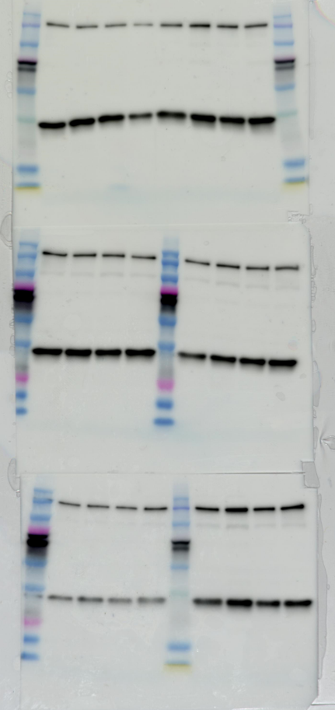
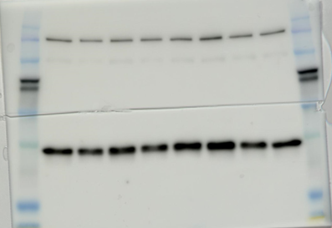
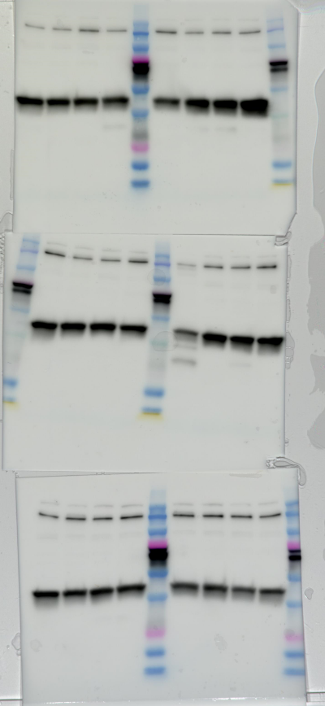
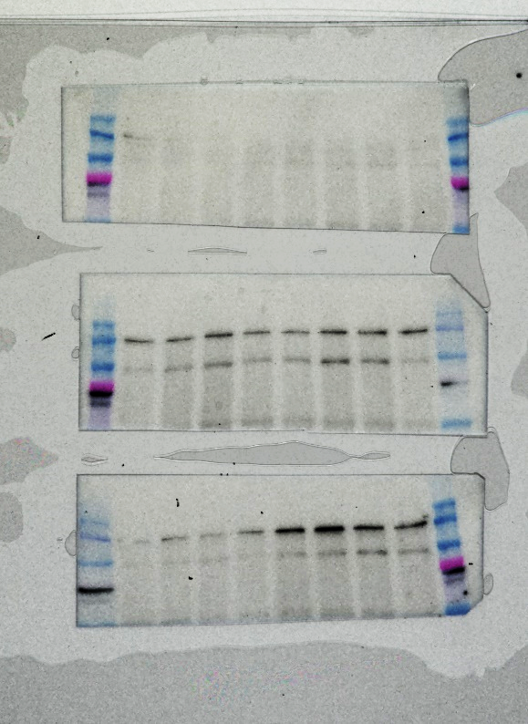
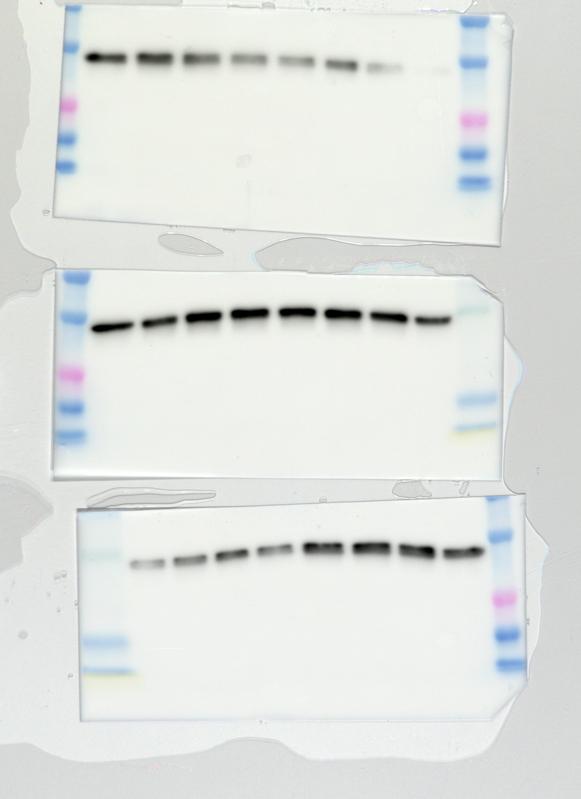
Supplementary figure 1: original blots for figure 3 of the article
NRF2
130-150 kDa -
37 kDa -
GAPDH
Whole cell lysate NRF2
e
NRF2
37 kDa -
GAPDH
Cytosolic fraction NRF2
130-150 kDa -
f
g
NRF2
42 kDa -
β-actin
Nuclear fraction NRF2
130-150 kDa -
h
Whole cell lysate HIF1ɑ
HIF1ɑ
100 kDa -
37 kDa -
GAPDH
As HIF1ɑ expression is quite low compared to GAPDH, two acquisitions were necessary for this gel, hence the background difference

Supplementary figure 2: original blots for figure 5 of the article
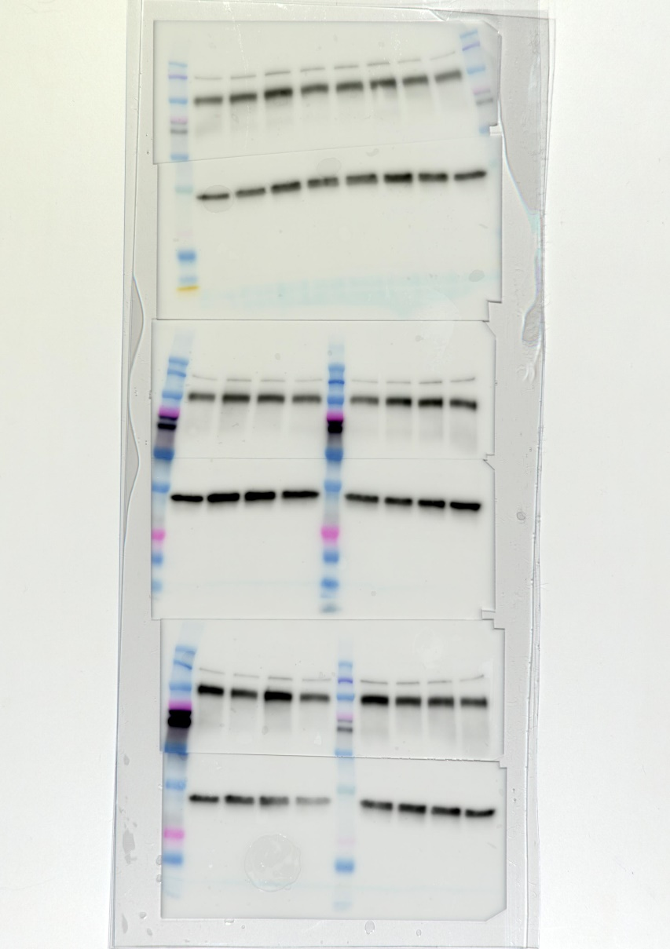
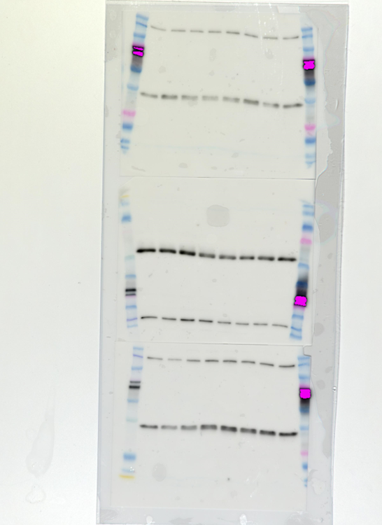
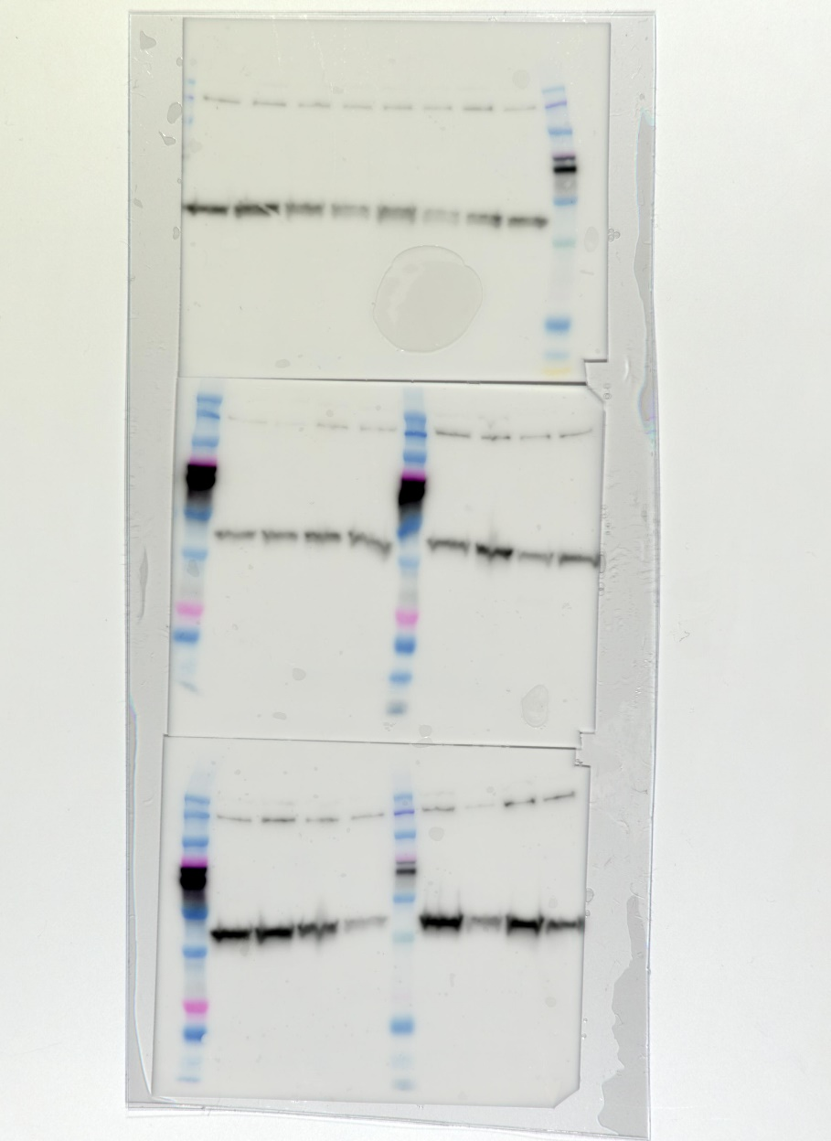
NRF2
130-150 kDa -
37 kDa -
GAPDH
Whole cell lysate NRF2
e
NRF2
37 kDa -
GAPDH
Cytosolic fraction NRF2
130-150 kDa -
f
NRF2
42 kDa -
β-actin
130-150 kDa -
Nuclear fraction NRF2

g

