Monitoring individual rice field flooding dynamics over large scales to inform mosquito surveillance and control
- Supporting Information Appendix -
Mauricianot Randriamihaja^{1,2,3,*,Ɨ}, Tokiniaina M Randrianjatovo^{1,2,Ɨ}, Michelle V Evans^{1,2,4}, Felana A Ihantamalala^{1,4}, Vincent Herbreteau⁵, Christophe Révillion^{6,7}, Eric Delaitre⁶, Thibault Catry⁶, Andres Garchitorena^{1,2}
¹ ONG PIVOT, Ranomafana, Madagascar
² Institut de Recherche pour le Développement, UMR 224 MIVEGEC (IRD, UM, CNRS), Montpellier, France
³ Université de Montpellier, ED 168 CBS2, Montpellier, France
⁴ Department of Global Health and Social Medicine, Harvard Medical School, Boston, USA
⁵ Espace Dev, IRD, Univ Montpellier, Univ. Antilles, Univ Guyane, Univ Réunion, 5 Preah Monivong Blvd, Phnom Penh 12201, Cambodia
⁶ Espace Dev, IRD, Univ Montpellier, Univ Antilles, Univ Guyane, Univ Réunion, Montpellier, France
⁷ Espace-Dev, Univ La Réunion, Saint Denis, La Réunion, France
^{Ɨ} Equal contribution
*Corresponding author: mauricianothr@gmail.com
Figure 1. Map of the study area showing the location of the data collected in the field for the temporal and spatial sampling.
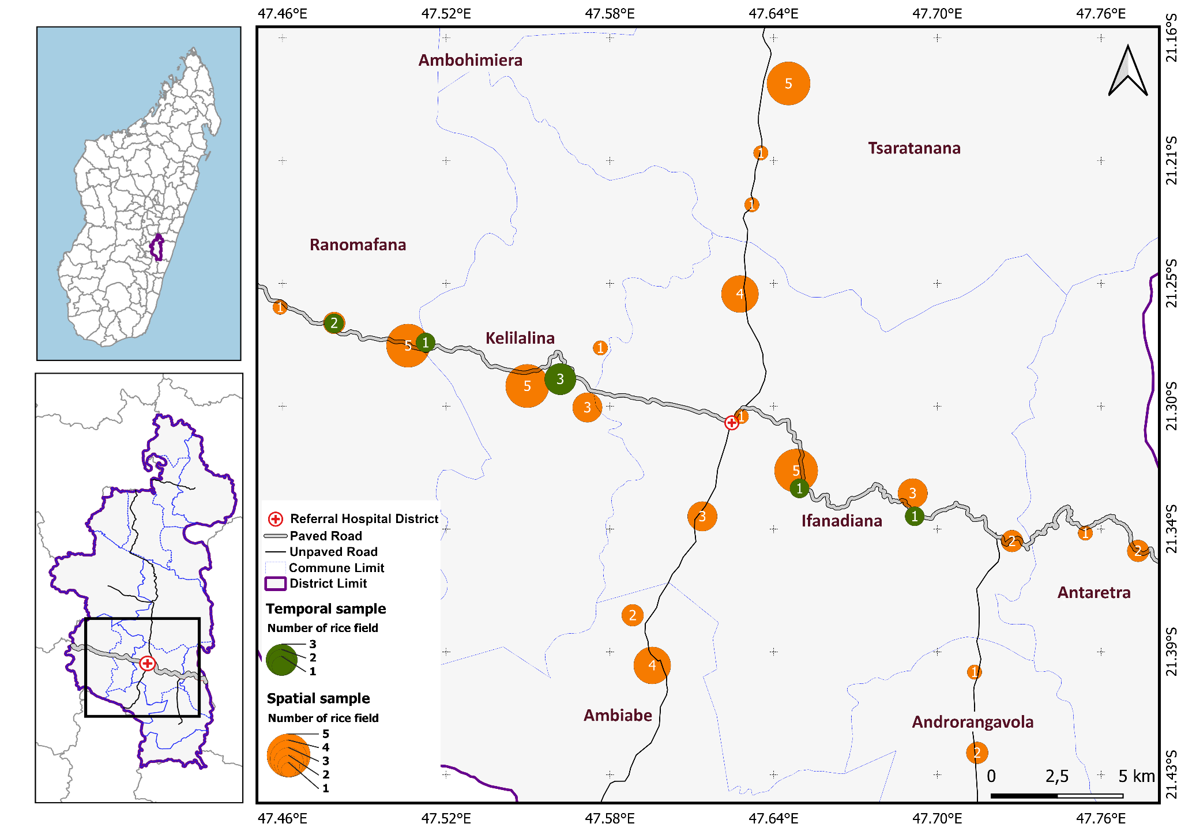
Figure 2. Result of receiver operating characteristic curve (ROC) analyses on the test dataset and resulting threshold in VH polarizations.
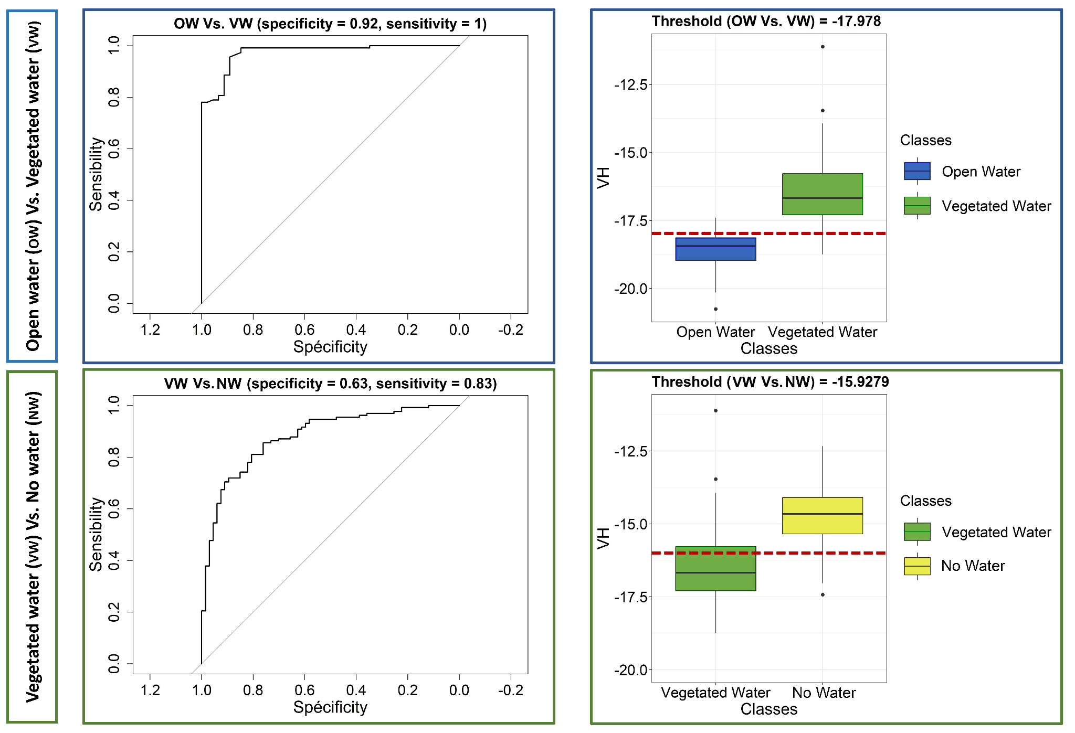
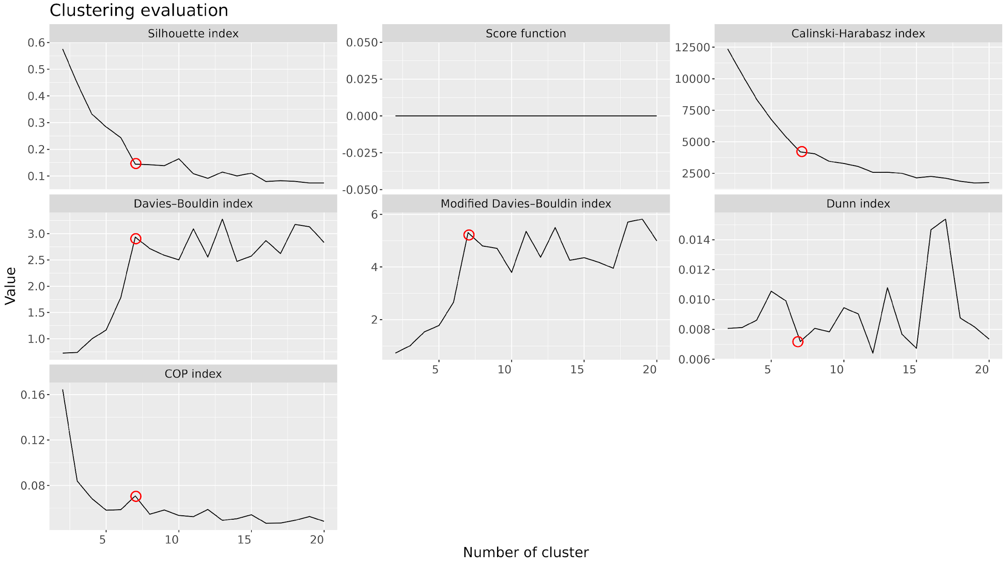
Figure 3. Cluster validity indices (CVI) to identify the optimal number of clusters in dynamic time warping (DTW) and partitioning around the median (PAM) analyses of rice field flooding time series.
Figure 4. Spatial distribution of the timing of peak vegetated water in rice fields in Ifanadiana.
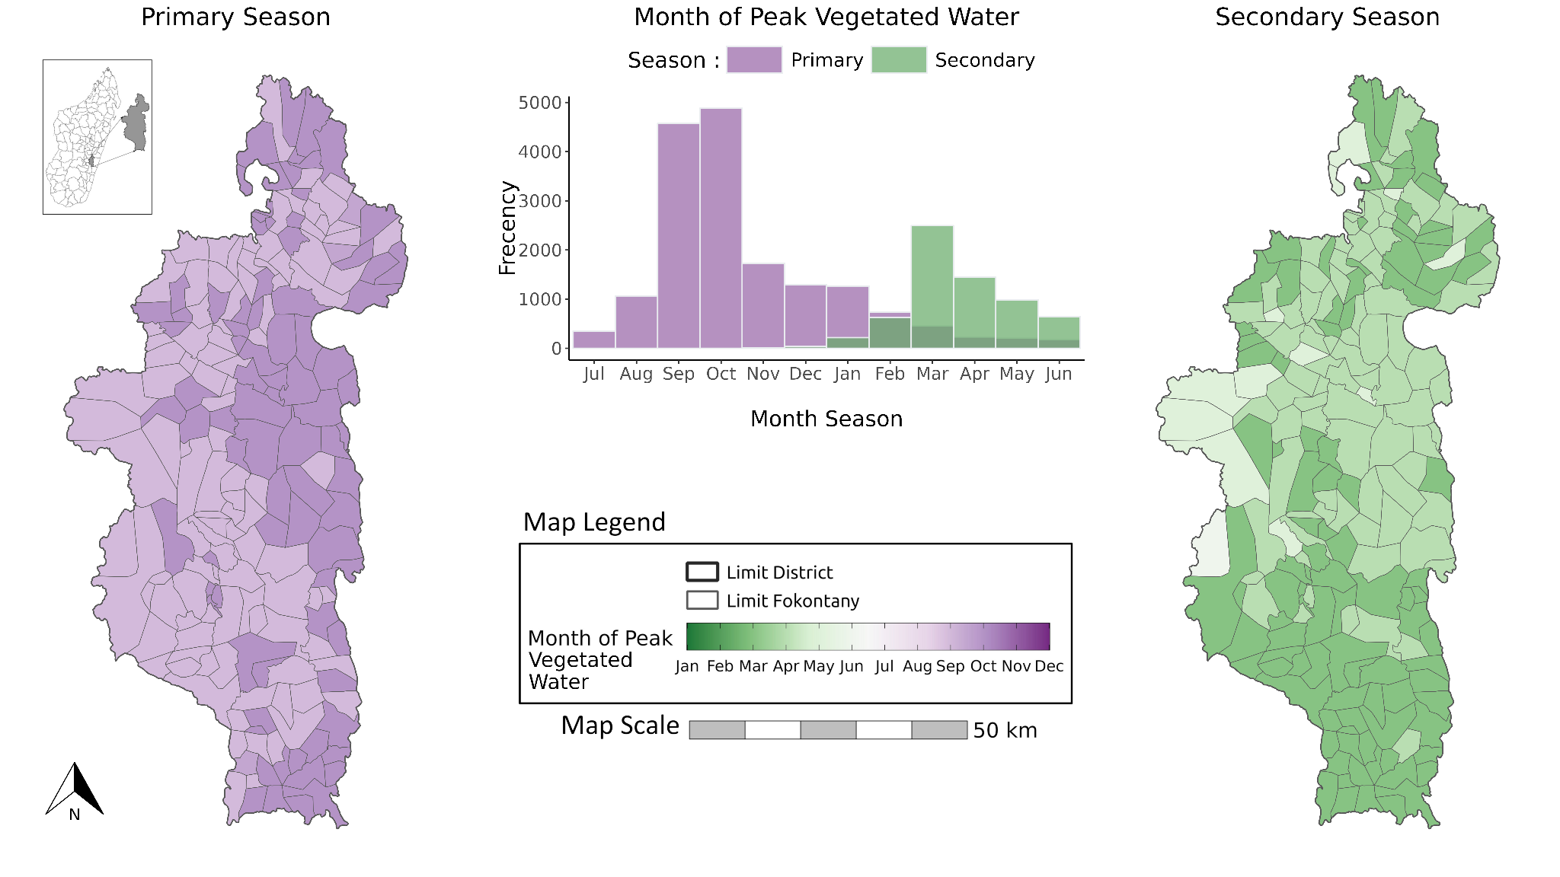
Figure 5. Range in rice field temporal dynamics within the same class.
Darker shaded areas show high overlap between individual rice field flooding time series, while lighter areas indicate low overlap between the time series.
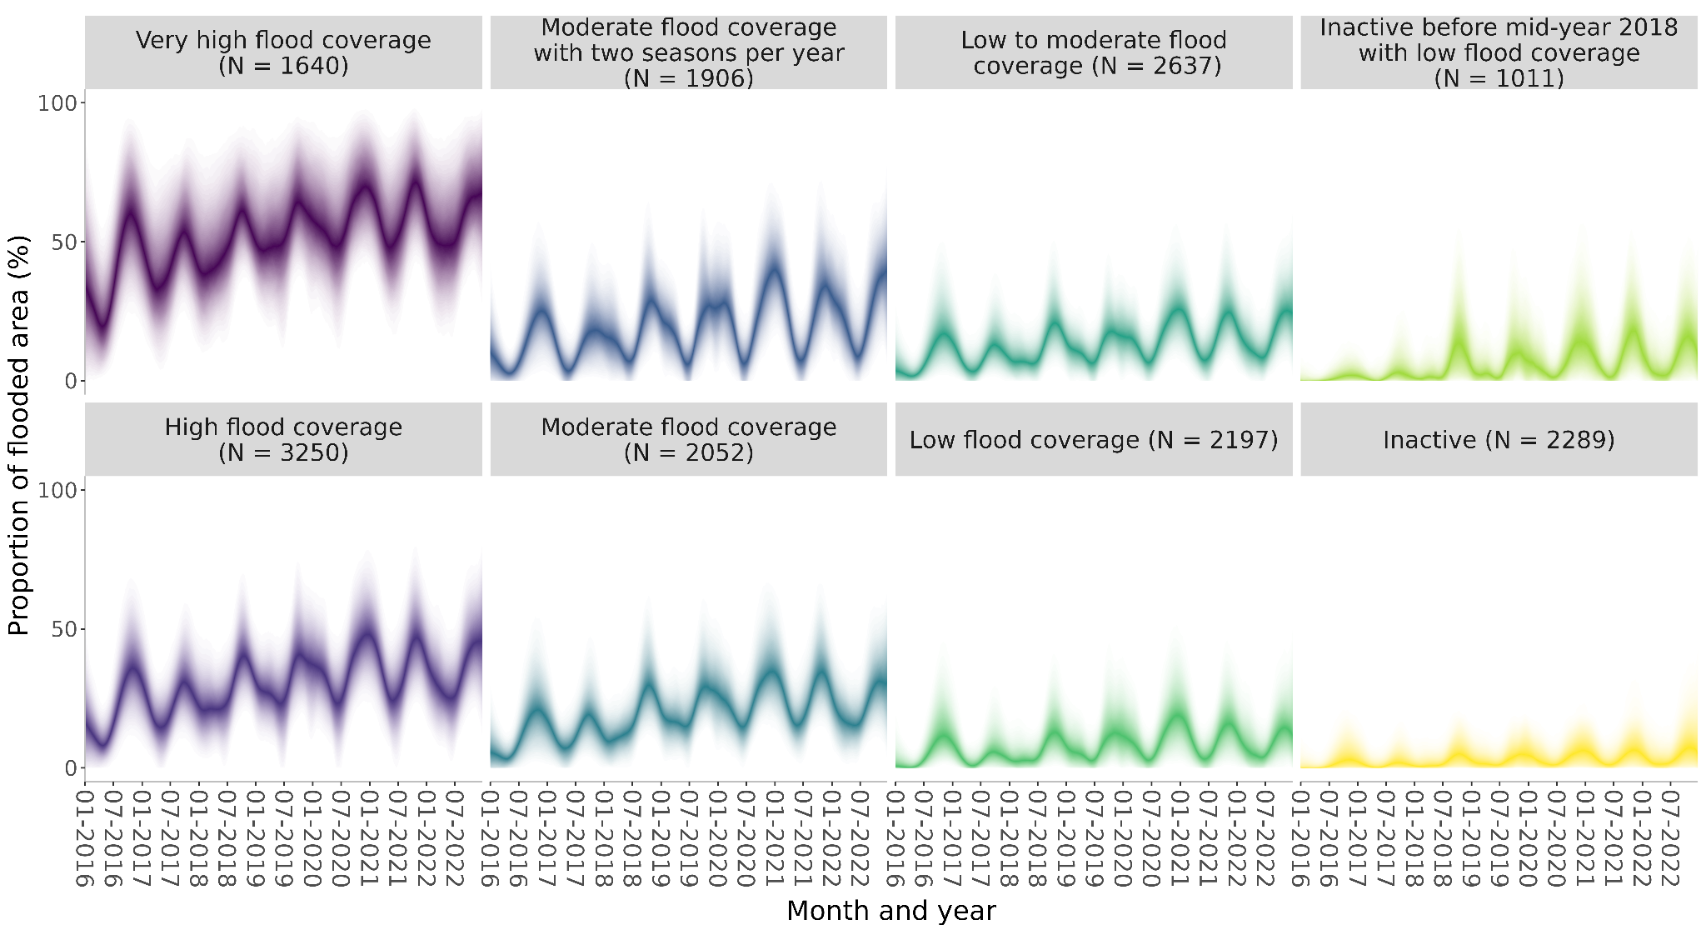
Figure 6. Flooding dynamics from January 2016 to December 2022 by rice field class, Ifanadiana District. Vegetative water only.
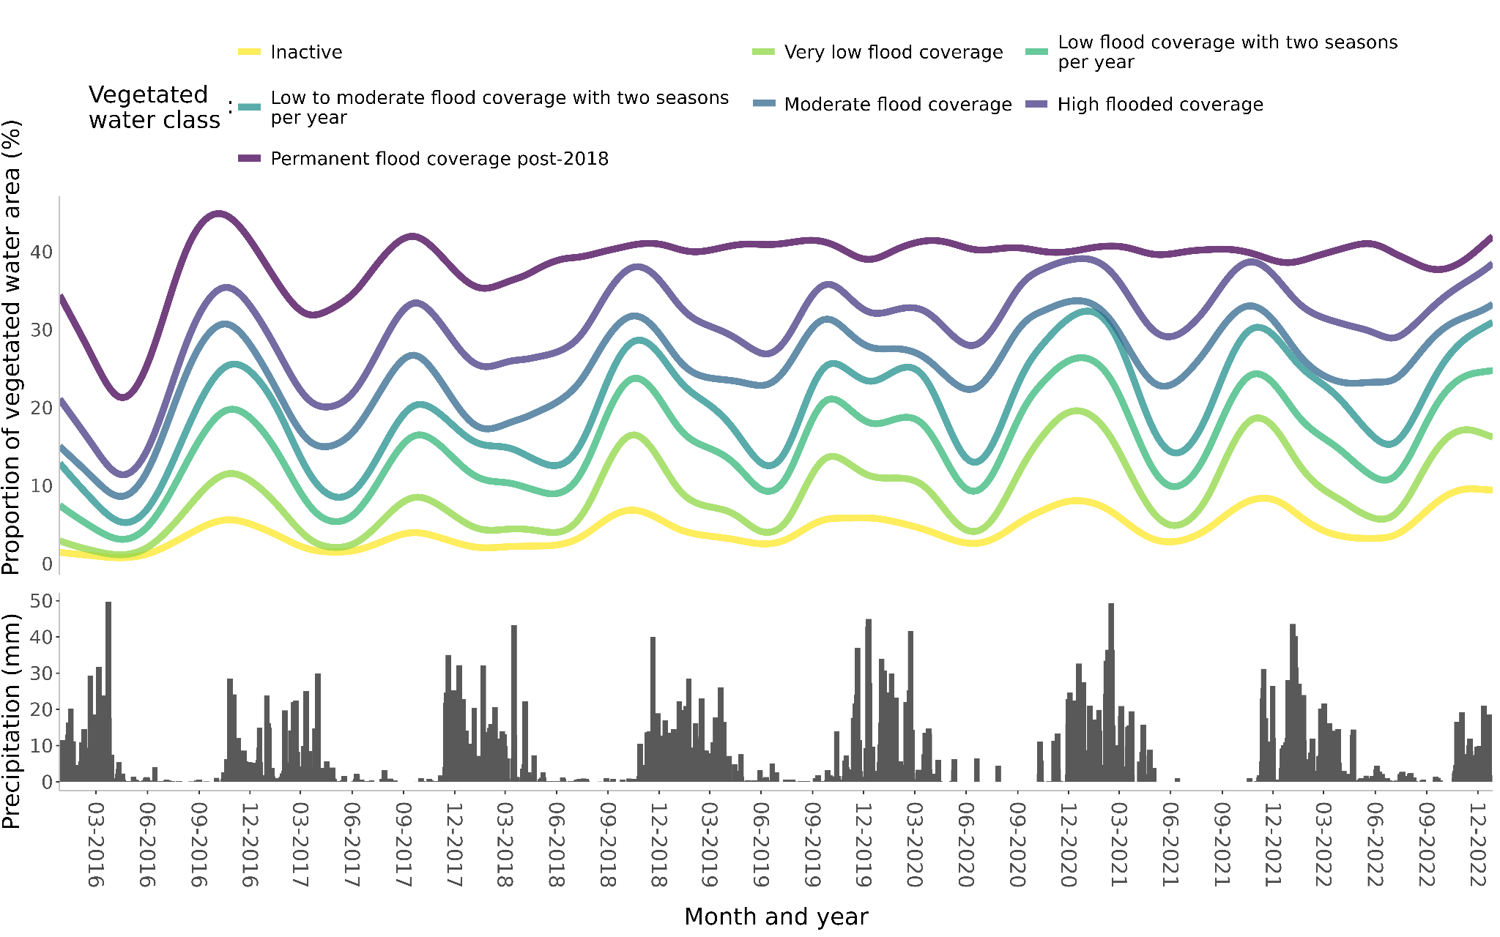
Table 1. Number of rice fields using each smoothing technique (as determined by best fit by minimizing the RSS) for vegetated water and total water.
 |  | Vegetated Water | Total water (open water + vegetated water)
Cubic-spline |  | 12,906 | 12,292
Polynomial |  | 0 | 0
Basis-spline |  | 1,545 | 1,774
Natural-spline |  | 2,531 | 2,916

Table 2. Summary statistics of temporal rice fields dynamics for 16,982 rice fields, vegetated water only.
Description | Mode | Median | IQR  (25%-75%) | Min-Max
Full time period (6 agricultural years, N= 16,982)
Number of seasons | 6 | 6 | 6-7 | 1-11
Number of agricultural years with more than one season | 0 | 0 | 0-1 | 0-5
Number of inactive seasons | 1 | 1 | 0-1 | 0-5
Maximum percentage of flooded area | 36 | 34 | 25-43 | 0-87
Primary season (N = 16,982)
Beginning of season (month of year)¹ | 6 | 5 | 4-6 | 1-12
End of season (month of year)¹ | 6 | 5 | 2-6 | 1-12
Month of highest percentage of flooded area¹ | 10 | 9 | 8-10 | 1-12
Median length of season (days) | 370 | 334 | 289-363 | 140-1,546
Average change in percentage of flooded area during the season (maximum flooded percentage - minimum flooded percentage) | 13 | 17 | 12-23 | 0-67
Secondary season (N = 6,459)
Beginning of season (month of year)¹ | 12 | 10 | 1-12 | 1-12
End of season (month of year)¹ | 6 | 6 | 6-7 | 1-12
Month of highest percentage of flooded area¹ | 3 | 3 | 3-5 | 1-12
Median length of season (days) | 174 | 185 | 167-216 | 98-558
Average change in percentage of flooded area during the season (maximum flooded percentage - minimum flooded percentage) | 8 | 12 | 7-19 | 0-77
¹Each rice field was assigned the mode of the beginning month of each season across the 6 year time period

Table 3. Distribution of 16,982 supervised rice fields by the number of nearby households (within a 500m radius) and time series classification, vegetated water only.
Times series | Number of household  < 50 |  | Number of household  >= 50
 | Number | Total area (Ha) | Number | Total area (Ha)
Inactive | 2,368 (13.94%) | 1,203 | 445 (2.62%) | 255
Very low flood coverage | 3,566 (21%) | 1,983 | 972 (5.72%) | 922
Low flood coverage with two seasons per year | 2591 (15.26%) | 3,158 | 621 (3.66%) | 1,120
Low to moderate flood coverage with two seasons per year | 2,094 (12.33%) | 2,307 | 461 (2.71%) | 689
Moderate flood coverage | 1,473 (8.67%) | 848 | 210 (1.24%) | 124
High flood coverage | 1,019 (6%) | 390 | 165 (0.97%) | 53
Permanent flood coverage post-2018 | 866 (5.1%) | 188 | 131 (0.77%) | 24

Table 4. Descriptive statistics of rice fields by flood season and time series class, vegetated water only.
Description | Inactive (N=2,813) | Very low flood coverage (N=4,538) | Low flood coverage with two seasons per year (N=3,212) | Low to moderate flood coverage with two seasons per year (N=2,555) | Moderate flood coverage (N=1,683) | High flood coverage (N=1,184) | Permanently flooded post- 2018  (N=997)
Full time period (6 agricultural years, N= 16,982)
Number of seasons | 6 (5-7) | 7 (6-8) | 6 (6-7) | 6 (5-7) | 6 (6-7) | 7 (6-8) | 7 (6-8)
Number of agricultural years with more than one season | 0 (0-1) | 0 (0-1) | 0 (0-1) | 0 (0-1) | 0 (0-1) | 0 (0-1) | 1 (0-1)
Number of inactive seasons | 1 (1-2) | 1 (0-2) | 1 (0-1) | 0 (0-1) | 1 (0-1) | 1 (0-1) | 1 (0-2)
Maximum percentage of flooded area | 14 (10-17) | 28 (24-34) | 33 (29-39) | 39 (34-44) | 41 (37-47) | 48 (43-53) | 55 (50-60)
Primary season (N = 16,982)
Beginning of season (month of year)¹ | 5 (4-6) | 6 (4-6) | 6 (4-6) | 6 (5-6) | 5 (3-6) | 5 (4-6) | 5 (3-7)
End of season (month of year)¹ | 5 (3-6) | 5 (3-6) | 5 (2-6) | 5 (3-6) | 4 (2-6) | 4 (2-6) | 4 (2-9)
Month of highest percentage of flooded area¹ | 9 (8-10) | 10 (9-10) | 10 (9-10) | 9 (8-10) | 9 (9-10) | 9 (8-10) | 9 (6-10)
Median length of season (days) | 328 (286-356) | 332 (283-362) | 342 (294-364) | 343  (298-364) | 335 (299-363) | 322 (286-356) | 314  (273-350)
Average change in percentage of flooded area during the season (maximum flooded percentage - minimum flooded percentage) | 8 (5-11) | 17 (14-21) | 19 (15-25) | 22 (16-28) | 18 (14-24) | 20 (15-26) | 19 (15-24)
Secondary season (N = 6,459)
Beginning of season (month of year)¹ | 4 (1-12) | 3 (1-12) | 11 (1-12) | 11 (2-12) | 11 (1-12) | 10 (1-12) | 3 (1-11)
End of season (month of year)¹ | 7 (6-8) | 6 (6-7) | 6 (6-7) | 6 (6-7) | 6 (6-7) | 7 (6-8) | 8 (7-10)
Month of highest percentage of flooded area¹ | 4 (3-5) | 3 (3-4) | 3 (3-4) | 3 (3-4) | 4 (3-5) | 4 (3-5) | 5 (3-6)
Median length of season (days) | 189 (167-223) | 175 (160-196) | 180 (166-199) | 182  (168-203) | 189 (173-231) | 196 (174-251) | 243  (199-293)
Average change in percentage of flooded area during the season (maximum flooded percentage - minimum flooded percentage) | 5 (3-8) | 12 (8-17) | 15(9-22) | 17 (10-25) | 11 (8-18) | 13 (8-20) | 15 (10-21)
¹Each rice field was assigned the mode of the month of each season across the 6 year time period

