SUPPLEMENTAL FIGURES
Supplemental Figure 1. Epitope Mapping of Binding of Iluzanebart to TREM2 by HDX-MS. (A) Heat map depicting results of hydrogen/deuterium exchange (HDX) mass spectrometry (MS) for TREM2 + iluzanebart. Blue indicates areas of antibody binding; three timepoints of incubation are shown (0.25 min, 1 min, and 60 min). (B) Three-dimensional depiction of antibody binding sites on the TREM2 protein after 1 minute of incubation.
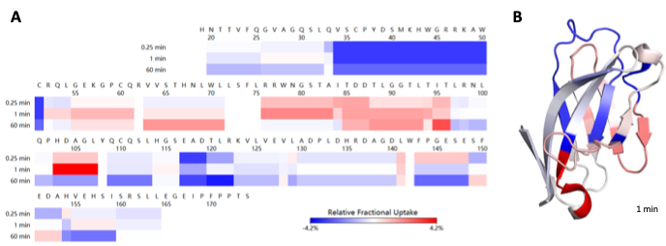

Supplemental Figure 2. TREM2 receptor binding SPR assay. Surface plasma resonance (SPR) demonstrating iluzanebart binding interaction with ligand TREM2 (n=3)
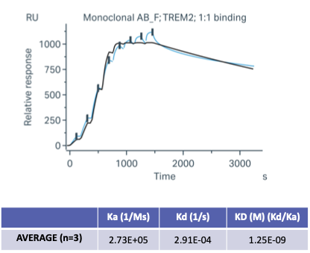
Supplemental Figure 3. Iluzanebart does not activate mouse or rat TREM2. (A) Mouse TREM2-HEK. In HEK293T cells expressing mouse TREM2 and DAP12, pDAP12 in response to iluzanebart for 45 minutes was analyzed, resulting in no activation by iluzanebart (n = 2), while a control mouse TREM2 agonist antibody worked as expected (B) Rat TREM2-HEK. Similarly, in rat HEK293T cell line, iluzanebart showed no ability to activate SYK (n=32), while a rat TREM2 agonist behaved as expected.
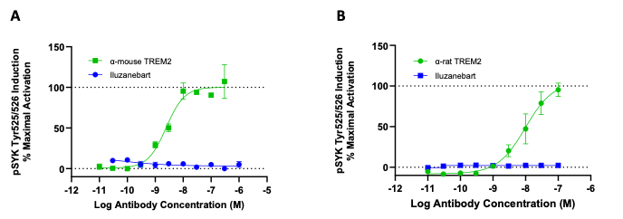

Supplemental Figure 4. Pharmacokinetic analysis of Iluzanebart in hTREM2 mice Terminal iluzanebart brain concentrations and corresponding fold exposures over in vitro sCSF1R EC₅₀ and sTREM2 IC₅₀ pharmacologically align with on-target TREM2 agonism. Values are means +/- standard deviation, n=4-6 mice. (A) Plasma concentrations of iluzanebart. 100 and 200 mg/kg were above limit of quantitation and were excluded.
