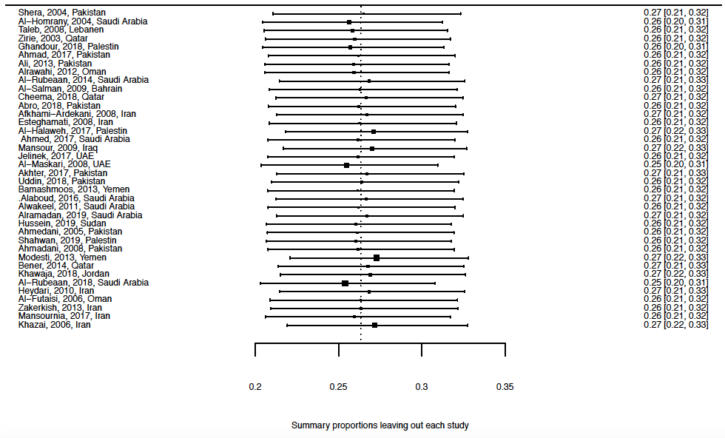
Appendix 7. Forest plot of summary proportions for leaving out each study [Note for interpretation: Each line represents a summary proportion estimated leaving out a study. The reference line denotes the original summary proportion.]

