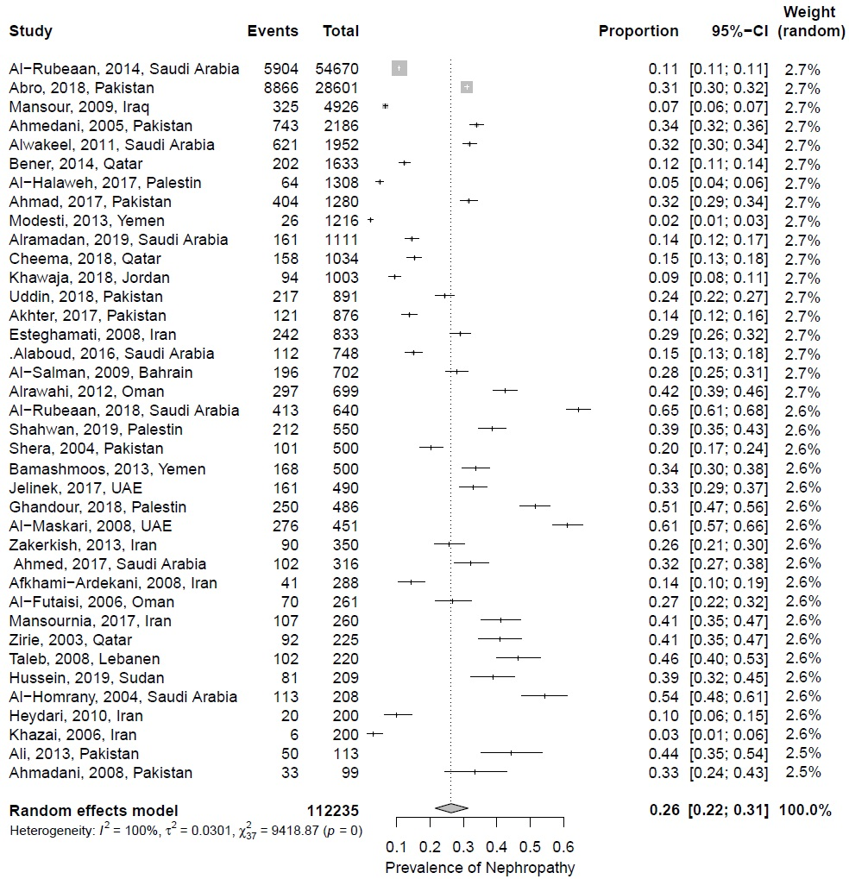
Appendix 4. Forest plot of studies according to their precisions (SE)

