Supplementary Materials
- Basic Variables, Machine Failure, and Statistics Collection Modules of Arena Model
Basic Variables Module View of Arena
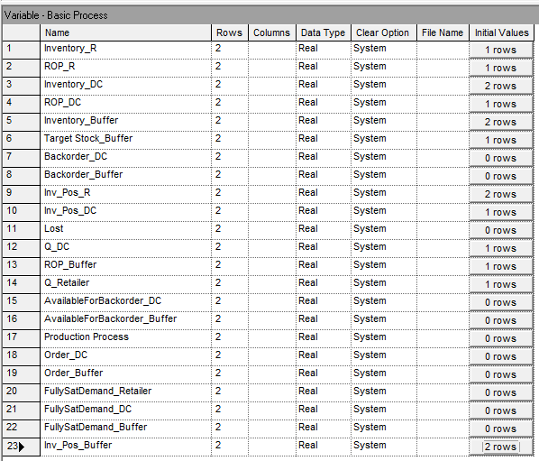
Failure of Machines in Production Process View of Arena
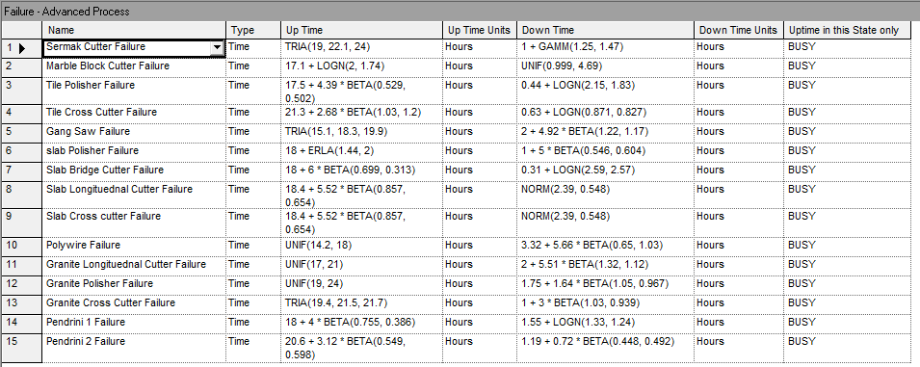

Statistics Collection Module for the system view of Arena
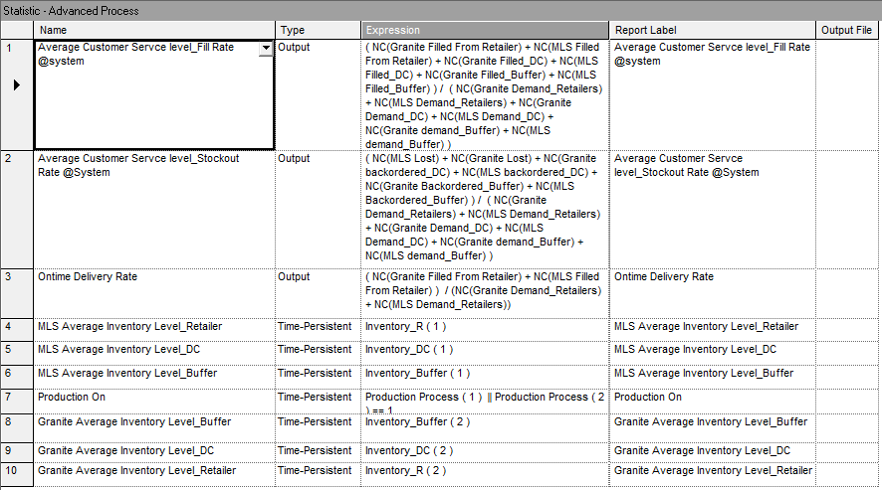
- Simulation Run Report of the existing supply chain system partially
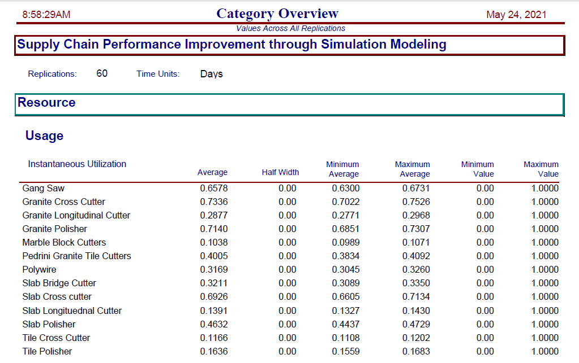
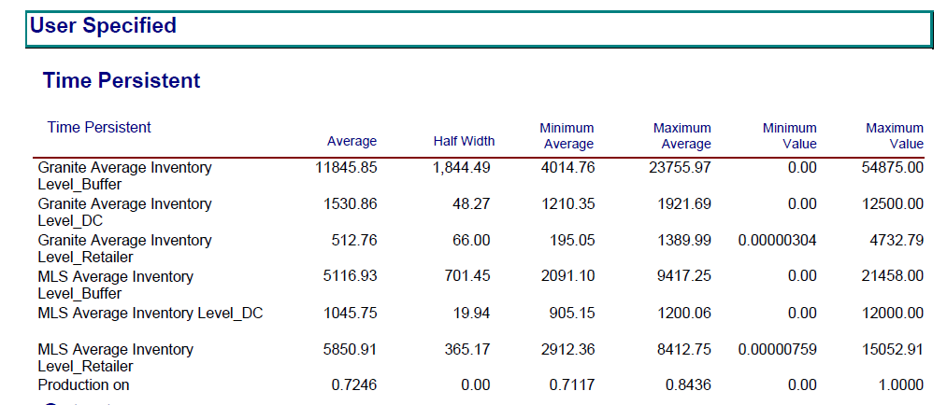
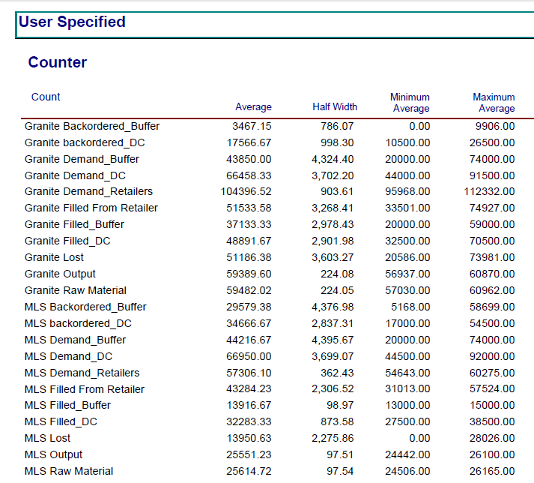
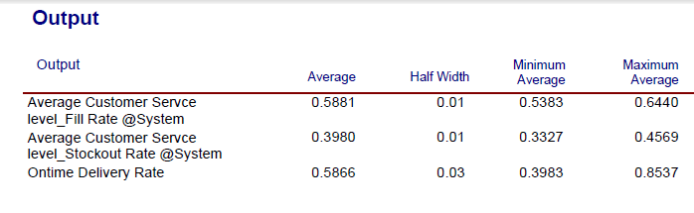

- Simulation Run Report of the proposed supply chain system partially
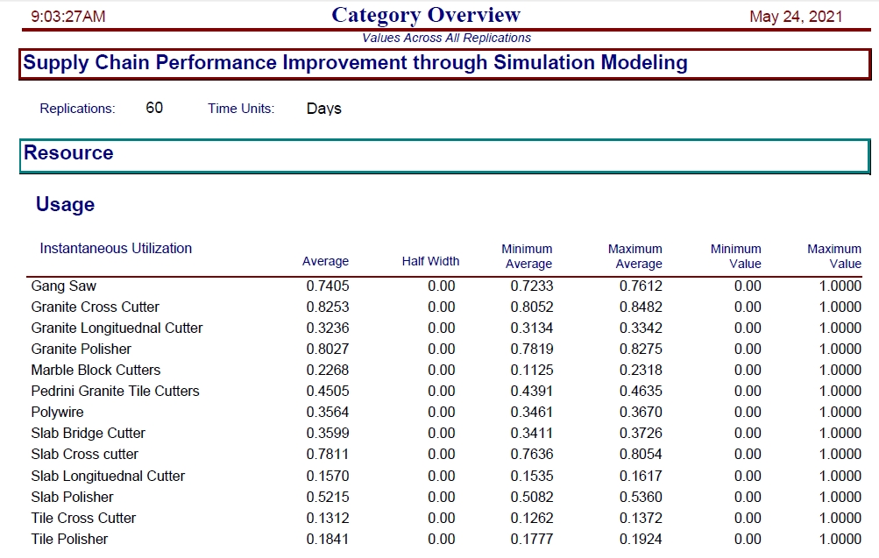
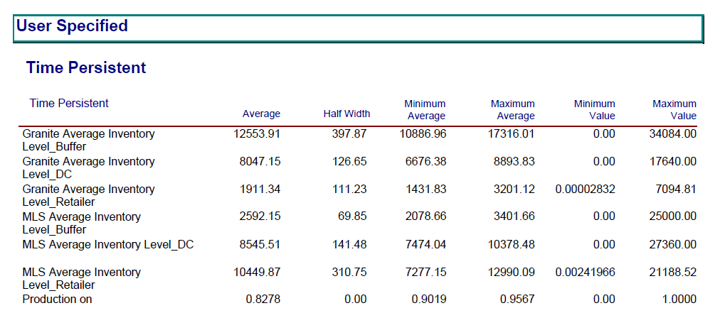
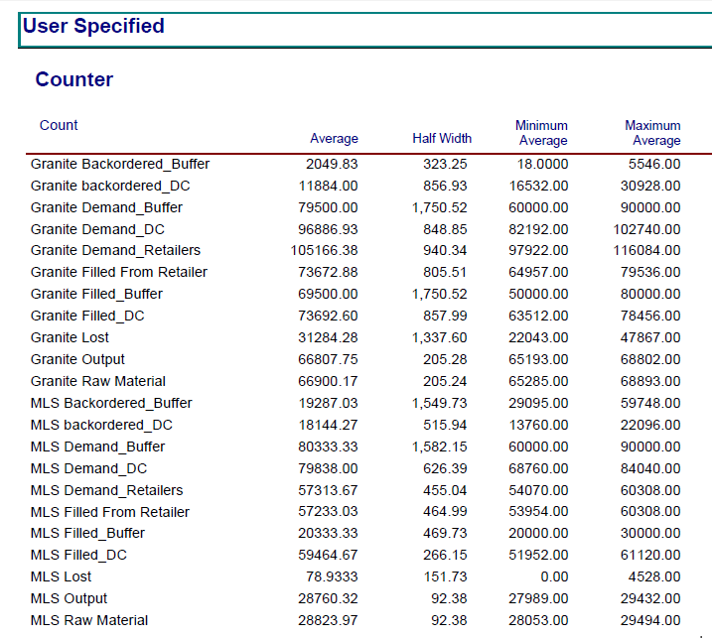
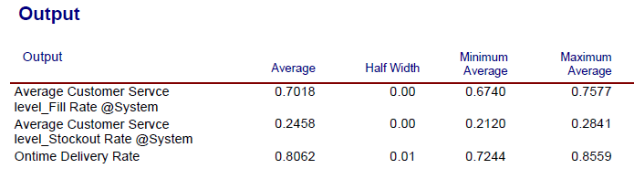

- OptQuest Optimization Elements
OptQuest Window for Control Element
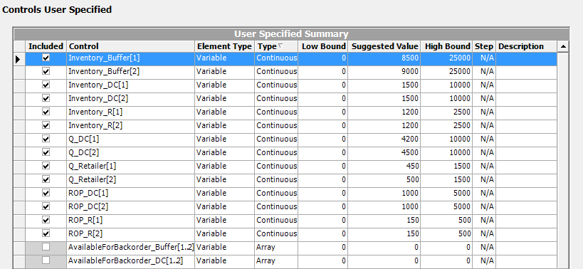
OptQuest Window for Constraints Element
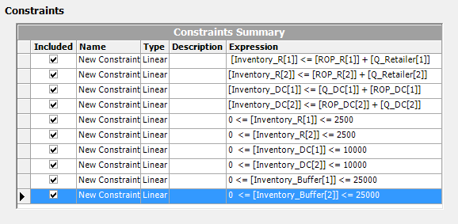

OptQuest Window for Objective Element
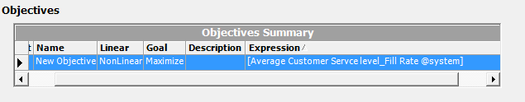
Table 2: OptQuest Window for Best Solutions from Optimization Result
