Supplementary Figures

Ganga river water quality assessment using combined approaches: physico-chemical parameters and cyanobacterial toxicity detection with special reference to microcystins and molecular characterization of microcystin synthetase (mcy) genes carrying cyanobacteria

Vigya Kesari^{1*}, Sanjay Kumar², Indrajeet Yadav², Antra Chatterjee¹, Shweta Rai^{1,3}, Shraddha Pandey¹

¹Centre of Advanced Study in Botany, Institute of Science, Banaras Hindu University, Varanasi, India 221005
²School of Biochemical Engineering, Indian Institute of Technology (BHU) Varanasi, Varanasi, U.P., India
³Department of Botany, Braj Mohan Das College (B.R. Ambedkar Bihar University), Vaishali, Bihar, India

Supplementary Fig. 1. Microscopic images of various types of cyanobacteria species observed in collected phytoplanktonic water samples of river Ganga from 10 sampling sites of Prayagraj and Varanasi. Bar in image showed the 100 µm length.

Supplementary Fig. 2. Doses-responses curves for the inhibition of PP1enzyme by MC-LR. Errors bar represent the standard deviation of the average of triplicate result. IC₅₀ was observed 36.03 μg/L (7.2%) and Hill coefficient was found 1.128 (6.6%).

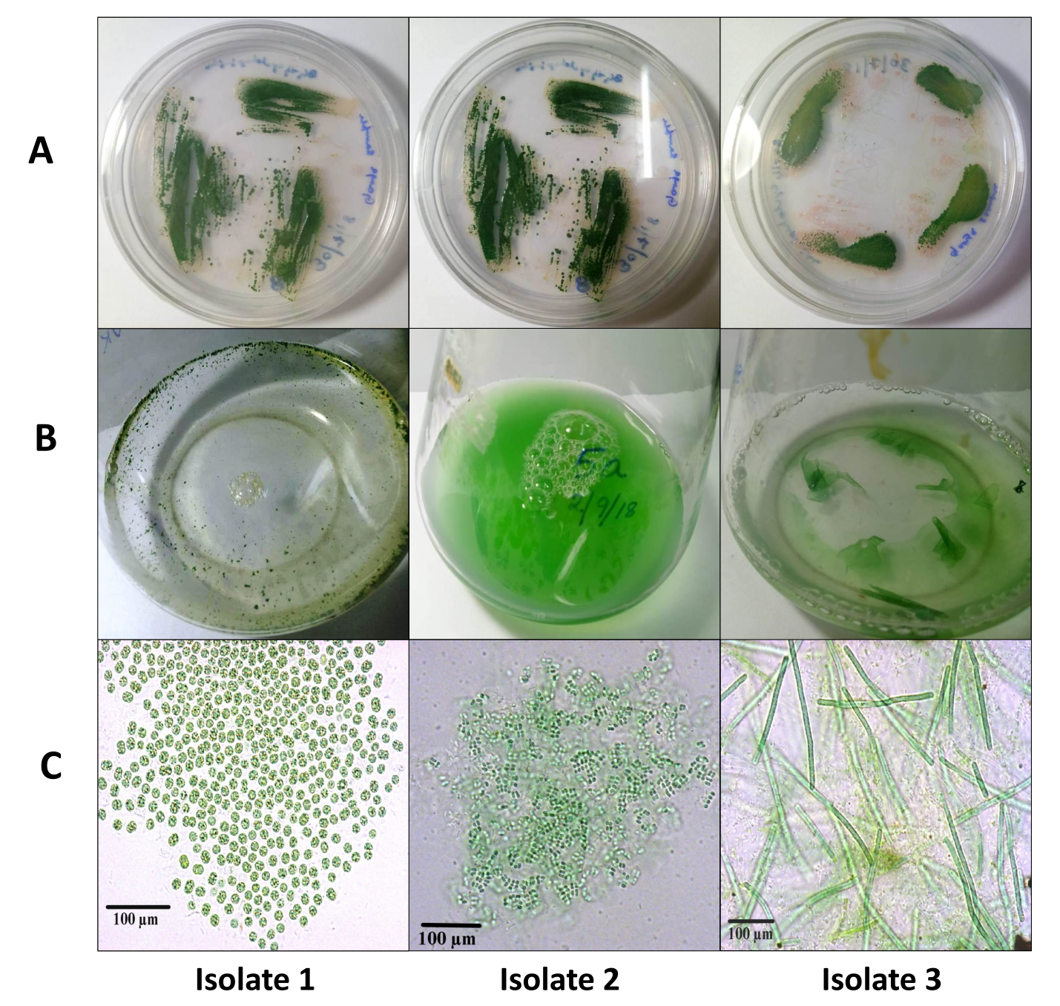
Supplementary Fig. 3. Three different isolated cyanobacterial strains from Ganga water of Prayagraj and Varanasi. A) Growth of isolated strains in BG-11 agar petriplates, B) Growth of isolated strains in BG-11 liquid medium, and C) Morphological images of the isolates.

