TOC Figures:

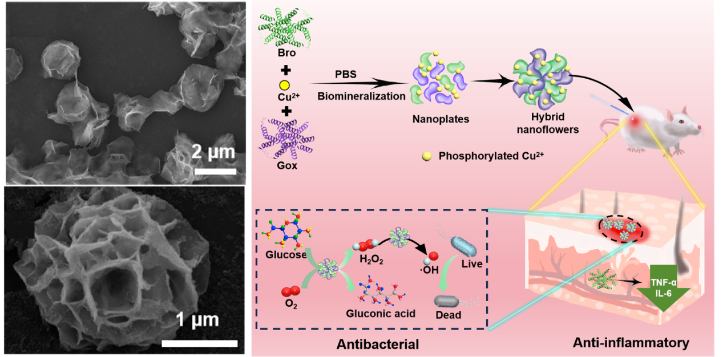

The boosting cascade catalytic antibacterial therapy and relieving inflammation are achieved by the dual natural enzyme-tuned biomineralized nanoflowers.

